**Moderate to Severe Evaluation**

Sample_id : **MCKPGD**

Cats and dogs:

Any two of the following:

(

High Red Flag Megamonas OR (failed)

High Red Flag Sutterella OR (failed)

High Red Flag Collinsella OR (failed)

Low Red Flag Bacteroides OR (passed)

Low Red Flag Blautia (failed)

);

OR

Dogs:

8 or more yellow flags (failed)

OR 8 or more red flags (failed)

High red megamonas,suttrella and collinsella failed.

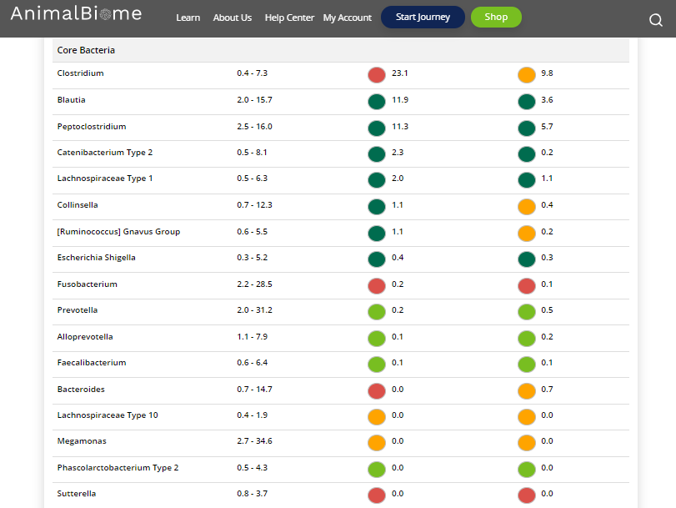

Low group evaluation:

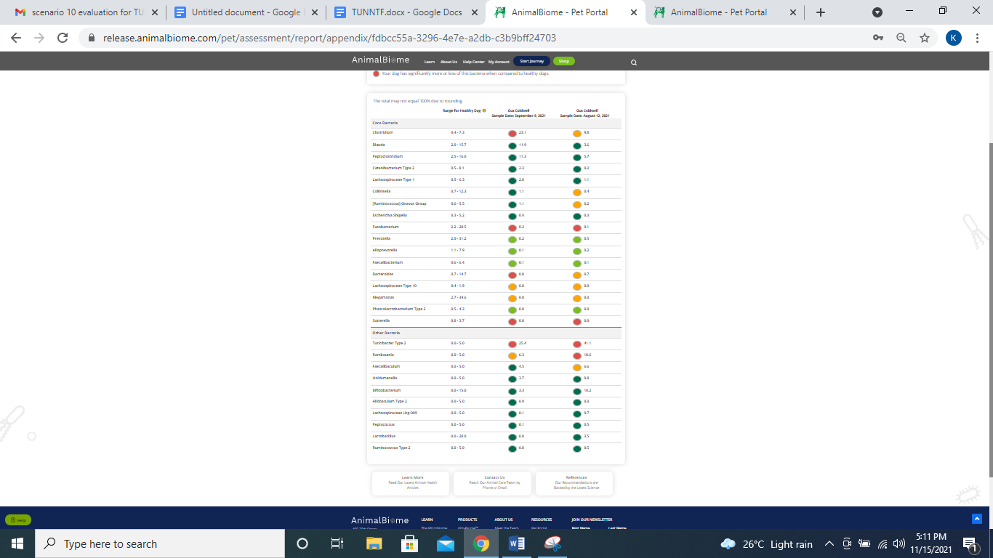

low red blautia : Failed.

Low red bacteroides : Failed (only one condition satisfied ) in the primary group.

Total yellow flags : 3

Red flags : 5

**Mild to Moderate evaluation:**



Mild to moderate

Cats and dogs:

Any Two

(High Yellow Flag Megamonas OR (failed)

High Yellow Flag Sutterella OR (failed)

High Yellow Flag Collinsella OR (failed)

Low Yellow Flag Bacteroides OR (failed)

Low Yellow Flag Blautia (failed)

)

OR

Dogs: 4-7 Yellow Flags (failed)

OR 5-7 Red Flags; (Pass)

OR Cats and dogs: dietary recommendation of increase fiber or protein or decrease carbs;(passed)

The result : False False True True

Mild to moderate evaluation results:Pass

Expected result : Mild to moderate

Achieved result :Passed

