**Arab and Islamic World: Geography**

The Arab world is located in the middle of the Ancient world. The boundaries of the Arab world are: the Atlantic Ocean in the west; Iran and the Arabian Gulf in the east, Turkey and the Mediterranean Sea in the north; and Central Africa, the Indian Ocean, and the Arabian Sea in the south.

The Ancient world is comprised of Asia, Africa, and Europe and is considered ancient because it existed before the discovery and exploration of the Americas and Australia. The Arab world is located on the continents of Asia and Africa. It is comprised of 22 countries. The total area of the Arab world is 14 million km2.

The Arab world is distinguished by its strategic position because it links three continents: Asia, Africa, and Europe. These continents contain 145 of the 195 countries in the world. It is surrounded by important bodies of water, straits and canals. Adding to its value, the Arab world is also a source of oil and other mineral resources.

The term Muslim world is also known as Islamic world and the *Ummah*. In a religious sense, the Islamic [*Ummah*](https://en.wikipedia.org/wiki/Ummah) refers to those who adhere to the teachings of [Islam](https://en.wikipedia.org/wiki/Islam), referred to as [Muslims](https://en.wikipedia.org/wiki/Muslim). [Islam](https://en.wikipedia.org/wiki/Islam) is the world's [fastest growing religion](https://en.wikipedia.org/wiki/Major_religious_groups). As of 2010, over 1.6 billion of the world population are Muslims.

**Why is the location of the Arab and Islamic world significant?**

The Arab and Islamic world extends from the Atlantic Ocean to the west; the Pacific Ocean to the east; Asia to the north, while Africa to the south.

- It’s located in the center of Asia, Africa, and Europe.

- It’s the cradle of three religions: Islam, Christianity, and Judaism.

- It controls the Suez Canal.

- It connects many important straits.

**Examples of important straits:**

* [**Bab-el-Mandeb**](https://en.wikipedia.org/wiki/Bab-el-Mandeb)**-** connects [Red Sea](https://en.wikipedia.org/wiki/Red_Sea) to [Gulf of Aden](https://en.wikipedia.org/wiki/Gulf_of_Aden) / [Arabian Sea](https://en.wikipedia.org/wiki/Arabian_Sea)

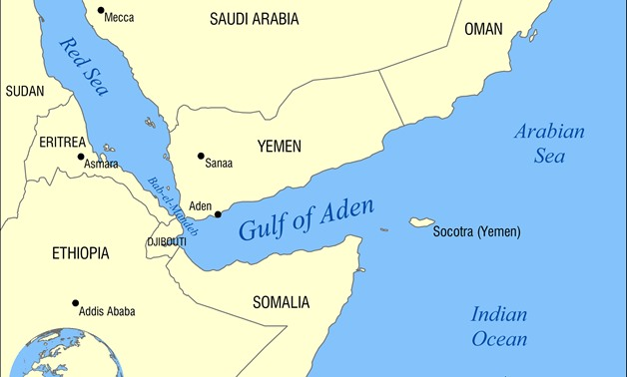

* [**Dardanelles**](https://en.wikipedia.org/wiki/Dardanelles)**-** between [Europe](https://en.wikipedia.org/wiki/Europe) and [Asia](https://en.wikipedia.org/wiki/Asia)
* [**Bosphorus**](https://en.wikipedia.org/wiki/Bosporus)**-** between [Europe](https://en.wikipedia.org/wiki/Europe) and [Asia](https://en.wikipedia.org/wiki/Asia)

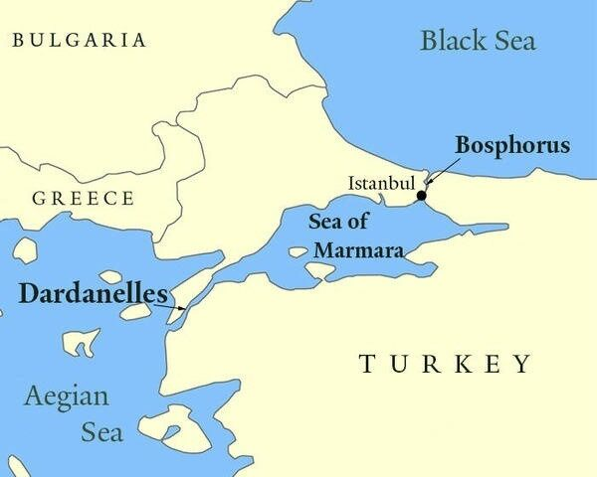

* [**Gibraltar**](https://en.wikipedia.org/wiki/Strait_of_Gibraltar)**-** between [Europe](https://en.wikipedia.org/wiki/Europe) and [Africa](https://en.wikipedia.org/wiki/Africa)

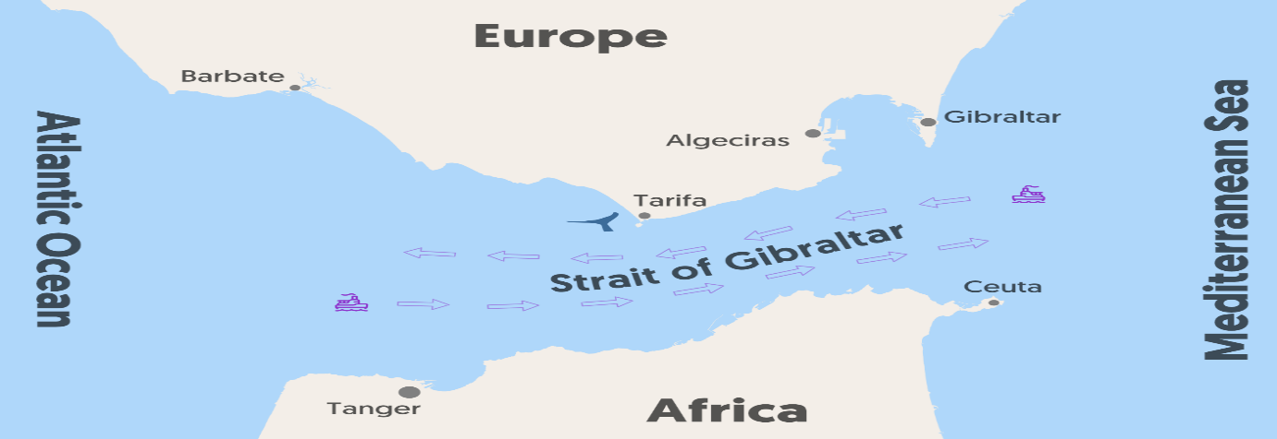

* [**Hormuz**](https://en.wikipedia.org/wiki/Strait_of_Hormuz)**-** between [Oman](https://en.wikipedia.org/wiki/Oman) and [Iran](https://en.wikipedia.org/wiki/Iran)

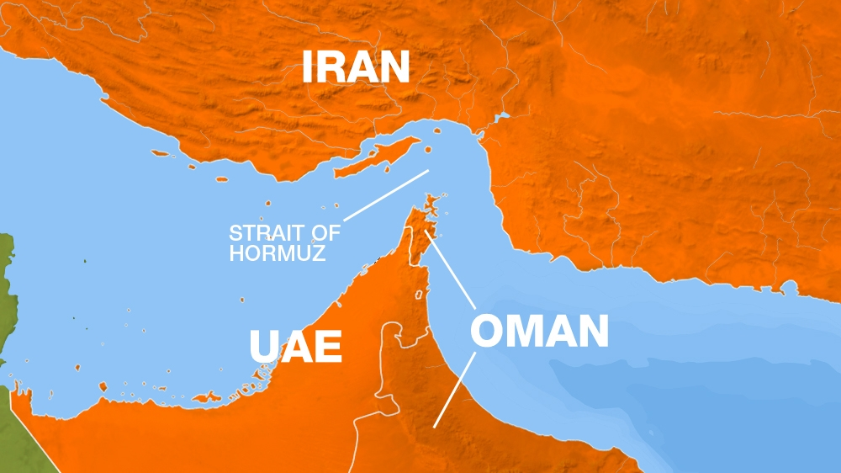

* [**Malacca Strait**](https://en.wikipedia.org/wiki/Malacca_strait)**-** between [Peninsular Malaysia](https://en.wikipedia.org/wiki/Peninsular_Malaysia) and [Sumatra](https://en.wikipedia.org/wiki/Sumatra)

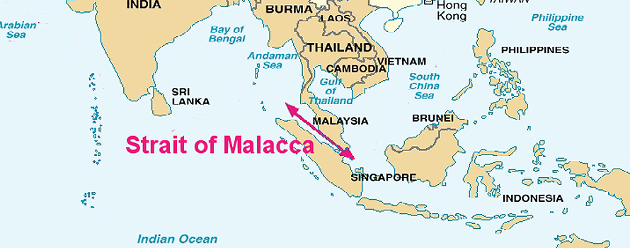

## Countries with the largest Muslim populations:

| **No.** | **Country** | **Muslim Population** | **Population 2021** | **Muslim % of Total Population** | **Muslim % of World Population** |
| --- | --- | --- | --- | --- | --- |
| **1** | Indonesia | 229,000,000 | 276,361,783 | 87.20% | 12.70% |
| **2** | Pakistan | 200,400,000 | 225,199,937 | 96.50% | 11.10% |
| **3** | India | 195,000,000 | 1,393,409,038 | 14.20% | 10.90% |
| **4** | Bangladesh | 153,700,000 | 166,303,498 | 90.40% | 9.20% |
| **5** | Nigeria | 99,000,000 | 211,400,708 | 49.60% | 5.30% |
| **6** | Egypt | 87,500,000 | 104,258,327 | 92.35% | 4.90% |
| **7** | Iran | 82,500,000 | 85,028,759 | 99.40% | 4.60% |
| **8** | Turkey | 79,850,000 | 85,042,738 | 99.20% | 4.60% |
| **9** | Algeria | 41,240,913 | 44,616,624 | 99.00% | 2.70% |
| **10** | Sudan | 39,585,777 | 44,909,353 | 97.00% | 1.90% |
| **11** | Iraq | 38,465,864 | 41,179,350 | 95.70% | 1.90% |
| **12** | Morocco | 37,344,795 | 37,930,989 | 99.00% | 2.00% |
| **13** | Ethiopia | 35,600,000 | 117,876,227 | 33.90% | 1.80% |
| **14** | Afghanistan | 34,836,014 | 39,835,428 | 99.60% | 1.80% |
| **15** | Saudi Arabia | 31,878,000 | 35,340,683 | 97.10% | 1.60% |
| **16** | China | 28,127,500 | 1,444,216,107 | 1.73% | 1.60% |
| **17** | Yemen | 27,784,498 | 30,490,640 | 99.10% | 1.50% |
| **18** | Uzbekistan | 26,550,000 | 33,935,763 | 96.50% | 1.70% |
| **19** | Niger | 21,101,926 | 25,130,817 | 98.30% | 1.00% |
| **20** | Russia | 20,000,000 | 145,912,025 | 13.50% | 1.00% |

_______________________________________________________________________________________

_______________________________________________________________________________________

_______________________________________________________________________________________

_______________________________________________________________________________________

_______________________________________________________________________________________

_______________________________________________________________________________________

_______________________________________________________________________________________

_______________________________________________________________________________________

_______________________________________________________________________________________

_______________________________________________________________________________________

_______________________________________________________________________________________

_______________________________________________________________________________________

_______________________________________________________________________________________

_______________________________________________________________________________________