Password Security

Subtitle
How do length, character set, and guessing method affect cracking difficulty?

Left Panel — Question and Method

Question
How do password length, available characters, and guessing strategy change the number of guesses and time needed to recover a classroom sample password?

Hypothesis
I predicted that longer passwords and larger character sets would require exponentially more brute-force guesses. Dictionary attacks will be faster for predictable words but will fail when the target is missing from their candidate list.

Variables
- Independent: length, character set, and guessing method
- Dependent: guesses, elapsed time, and success or failure
- Controlled: computer, C# program, MD5 comparison, enumeration order, and repetitions

Method
- I wrote a C# password guesser.
- I tested four character sets at lengths one through four.
- I repeated every baseline condition five times.
- I compared brute force, dictionary, word-pair, and pattern methods.
- I tested seven authorized Science Buddies challenge hashes.
- I exhausted all 62^6 candidates for Challenge 6.
- I exported the CSV data and graphed the results.

Safety
Only supplied educational hashes and synthetic passwords were tested. No real account, login page, or private password was accessed.

Center Panel — Results

Headline Result
56,800,235,584 six-character alphanumeric candidates tested
Challenge 6 result: no match
Approximate active wall time: 8.13 hours
Average speed: 1.94 million guesses per second
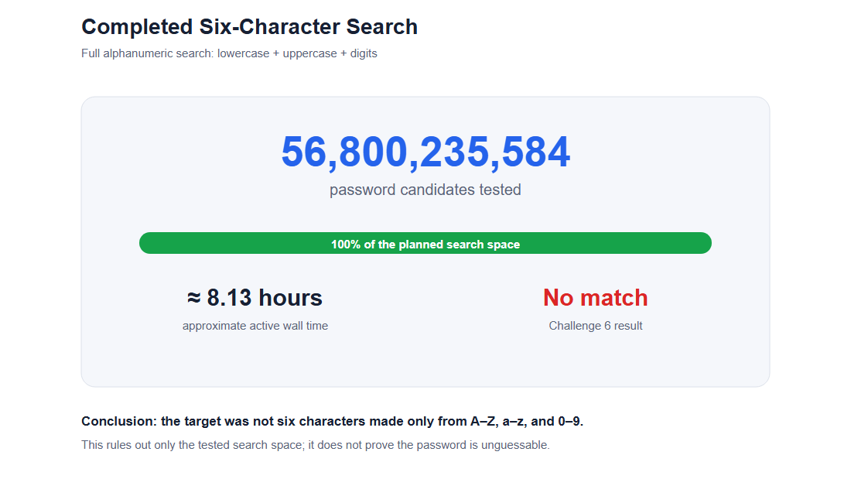
Completed search
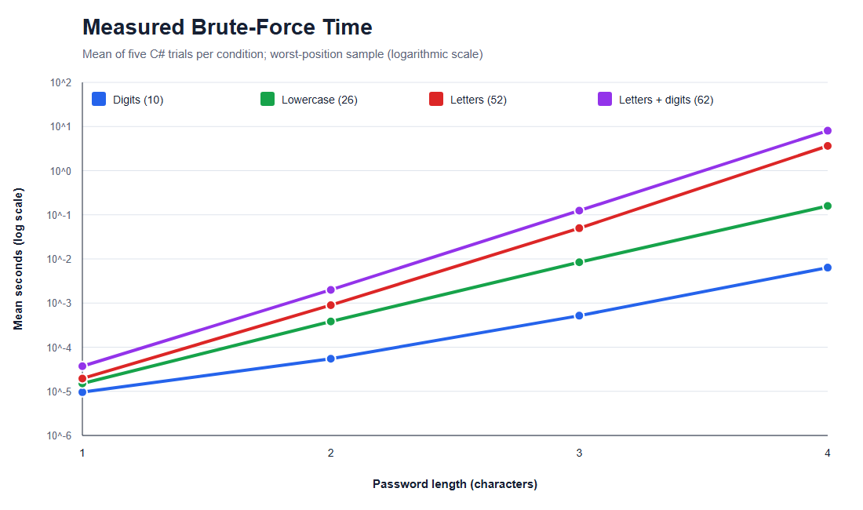
Measured brute-force time
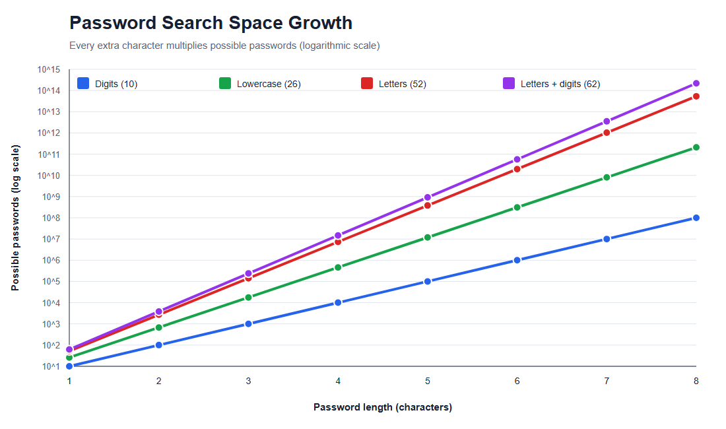
Search-space growth
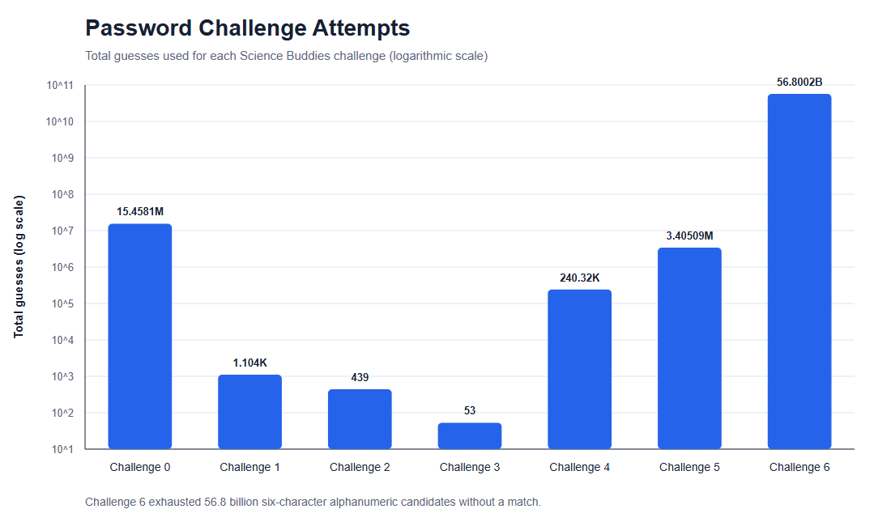
Challenge attempts

Key Measured Comparison
Four-character alphabet | Candidates | Mean time
Digits | 10,000 | 0.006347 s
Lowercase | 456,976 | 0.158177 s
Letters | 7,311,616 | 3.633987 s
Letters + digits | 14,776,336 | 8.026581 s

Right Panel — Analysis and Conclusion

Analysis
- Search spaces grew exponentially instead of linearly.
- The length-four alphanumeric search had about 1,478 times more candidates
than the length-four digit search.
- Dictionary attacks found predictable samples in fewer than 500 guesses.
- Word-pair attacks found longer samples without testing every possible string.
- A failed search proves only that the target was absent from the tested space.

Conclusion
My hypothesis was supported. Longer, less predictable passwords resisted the tested guessing methods better than short passwords and dictionary words. Length was especially powerful because every new character multiplied the number of candidates. Six of seven challenge passwords were recovered, while Challenge 6 was not found after the complete six-character alphanumeric search.

Limitations
- Educational fast MD5, not modern password storage
- One computer and five baseline repetitions
- Background CPU load affected timing
- A 435-word dictionary cannot represent every likely password
- Online accounts normally rate-limit failed attempts

Practical Lesson
Use long, unique passwords or passphrases, avoid common patterns, use a password manager, and enable multi-factor authentication.

Credits
Science Buddies supplied the project idea, original Python materials, sample hashes, and word list. I wrote and tested the commented C# version used for my experiment.

