Password Security: How Do Length, Character Set, and Guessing Method Affect Cracking Difficulty?
Student: [Add your name] School/Class: [Add your school or class] Date: October 2026

Abstract
This project tested how password length, available characters, and guessing strategy affect the effort required to recover classroom sample passwords. A C# program generated guesses locally, hashed each guess with MD5, and compared the result with authorized Science Buddies sample hashes. Controlled brute-force trials tested four character sets and lengths one through four, with five repetitions per condition. Dictionary and word-pair attacks were also tested. Six of seven Science Buddies challenges were recovered. The final challenge was tested against every possible six-character password made from lowercase letters, uppercase letters, and digits: 56,800,235,584 candidates. The search finished without a match. Results showed exponential growth: adding one character multiplied the search space by the alphabet size. Predictable words could be recovered in very few guesses, while short random-looking passwords required millions or billions. The hypothesis was supported: increasing length and reducing predictability increased resistance to the tested attacks. These results apply to a fast educational MD5 comparison and do not represent attempts against real accounts or modern password storage.

Research Question
How do password length, character-set size, and guessing method affect the number of guesses and amount of time required to recover a password?

Objective
Evaluate the difficulty of different password types, write a password-guessing program, compare brute-force and dictionary-based strategies, and explain why longer and less predictable passwords are harder to guess.

Hypothesis
If password length or the number of allowed characters increases, then the number of possible passwords and the time required for brute force will increase exponentially. Dictionary attacks will recover predictable words in fewer guesses than brute force, but they will fail when the target is absent from the dictionary and its generated combinations.

Background Research

Search-space mathematics
If an alphabet contains A possible characters and a password has length L, there are A^L possible fixed-length passwords. A four-digit PIN has 10^4 = 10,000 possibilities. A four-character password made from lowercase letters, uppercase letters, and digits has 62^4 = 14,776,336 possibilities. Each added character multiplies the search space by A, producing an exponential curve.

Guessing methods
- **Brute force** tests every candidate in a defined search space.
- **Dictionary attacks** test common words and passwords before unusual strings.
- **Word-pair attacks** join words with capitalization, numbers, or separators.
- **Pattern attacks** test likely human choices instead of every possible string.
A long password can still be guessed quickly if it follows a predictable pattern. A short random password can resist a small dictionary but remains vulnerable to a sufficiently large exhaustive search.

Hashing
Websites should not store readable passwords. They store values produced by password-hashing systems and compare a new login attempt with the stored result. This project used fast, unsalted MD5 only because that algorithm was used in the supplied classroom challenge. MD5 is unsuitable for modern password storage. Modern services should use salted password-hashing schemes and rate limiting.
Current NIST guidance emphasizes password length, blocking common or compromised passwords, permitting long passphrases, and limiting failed login attempts. The experiment measures offline guessing against sample hashes, so its speed does not represent an online login page.

Variables
Type | Variable
Independent | Password length: one through four characters in measured trials
Independent | Character set: digits, lowercase, mixed-case letters, or letters plus digits
Independent | Guessing method: brute force, dictionary, word pairs, and expanded patterns
Dependent | Number of guesses
Dependent | Elapsed search time
Dependent | Whether the password was recovered
Controlled | Same computer and C#/.NET program
Controlled | Same MD5 comparison method
Controlled | Same enumeration order for repeated conditions
Controlled | Five repetitions and a 15,000,000-guess limit in the baseline experiment

Materials
- Windows computer
- .NET 10 SDK and C# source code
- Science Buddies sample password hashes and supplied word list
- Local CSV result files
- Spreadsheet software for tables and graphs
- Lab notes and process logs

Safety and Ethics
Only authorized classroom sample hashes and synthetic test passwords were used. The program never signed in to a website, contacted an account, or accessed another person's information. No real personal passwords were collected. Testing real accounts without permission would be unethical and potentially illegal. Any future test involving human subjects would require teacher or science-fair approval and careful handling of private information.

Experimental Procedure
- Download the Science Buddies starter files and preserve them in an original
folder for attribution.
- Write a C# program that generates candidate strings, hashes each candidate
with MD5, compares the bytes with a target hash, counts guesses, measures elapsed time, and exports CSV files.
- Run self-tests to confirm the enumeration order, expected guess counts, and
safe import of the supplied challenge data.
- Define four brute-force alphabets: 10 digits, 26 lowercase letters, 52
mixed-case letters, and 62 letters plus digits.
- For each alphabet, test lengths one through four. Place the synthetic target
last in the enumeration order to measure a consistent worst case.
- Repeat each measured condition five times. Record guesses, mean time,
minimum time, and maximum time.
- Test dictionary and word-pair strategies against predictable and
random-looking synthetic samples.
- Run the program against Science Buddies Challenges 0–6. Record every method,
status, guess count, and elapsed time.
- For Challenge 6, test additional capitalization, word combinations,
substitutions, separators, printable ASCII patterns, and other defined spaces.
- Run a resumable search of all 62^6 six-character alphanumeric candidates.
Save progress every one million guesses so an interruption does not erase the completed work.
- Export the measurements to CSV, calculate summary statistics, and graph
the results using logarithmic vertical axes.

Results

Selected brute-force measurements
Alphabet | Size | Length | Candidates/guesses | Mean time
Digits | 10 | 4 | 10,000 | 0.006347 s
Lowercase | 26 | 4 | 456,976 | 0.158177 s
Letters | 52 | 4 | 7,311,616 | 3.633987 s
Letters + digits | 62 | 4 | 14,776,336 | 8.026581 s

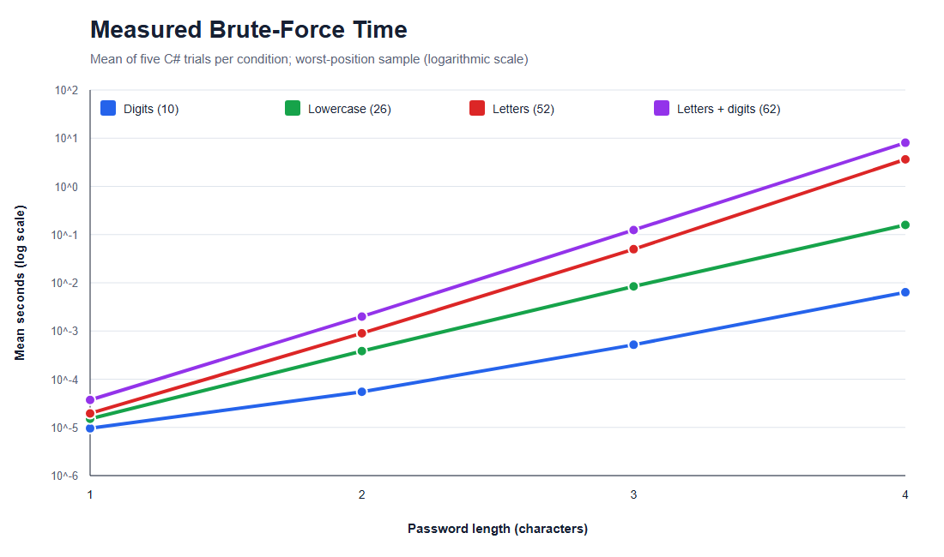
Measured brute-force time
The 62-character, length-four condition contained about 1,478 times as many candidates as the four-digit condition and took about 1,265 times as long on this computer. Differences between these ratios are expected because short timings are affected by .NET warmup, operating-system scheduling, and other background work.

Search-space growth
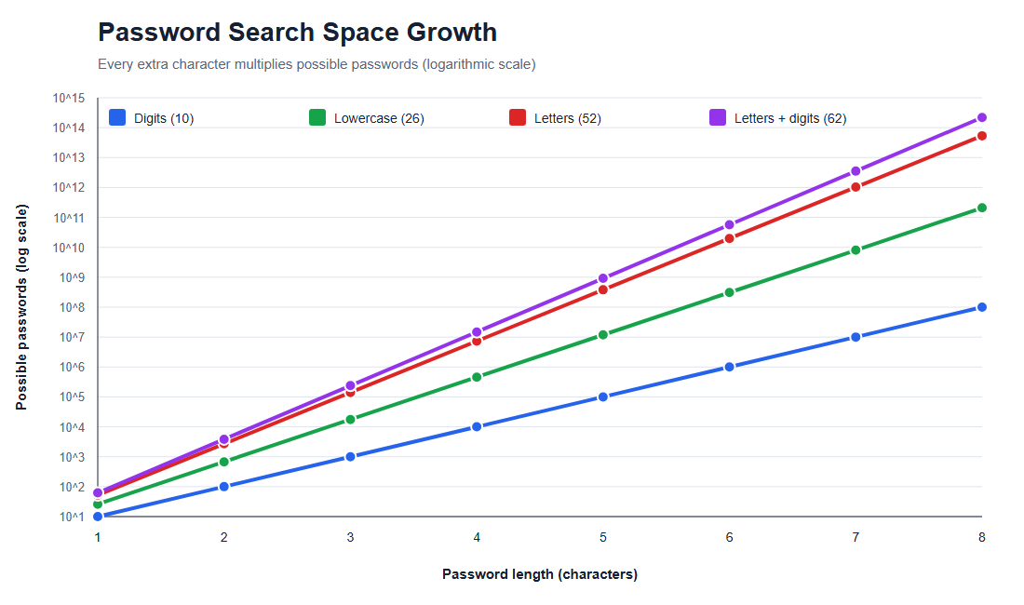
Password search-space growth
For the 62-character alphabet, increasing length from one to four multiplied the search space by 238,328. Measured time increased by about 216,817 times, showing the same rapid overall pattern.

Science Buddies challenges
Challenge | Result | Successful method | Successful guesses | Total guesses in recorded run
0 | Found | Alphanumeric brute force | 446,083 | 15,458,063
1 | Found | Numeric brute force | 234 | 1,104
2 | Found | Dictionary | 439 | 439
3 | Found | Dictionary | 53 | 53
4 | Found | Word pairs | 228,340 | 240,320
5 | Found | Word pairs | 3,393,105 | 3,405,085
6 | Not found | Complete six-character alphanumeric search | — | 56,800,235,584

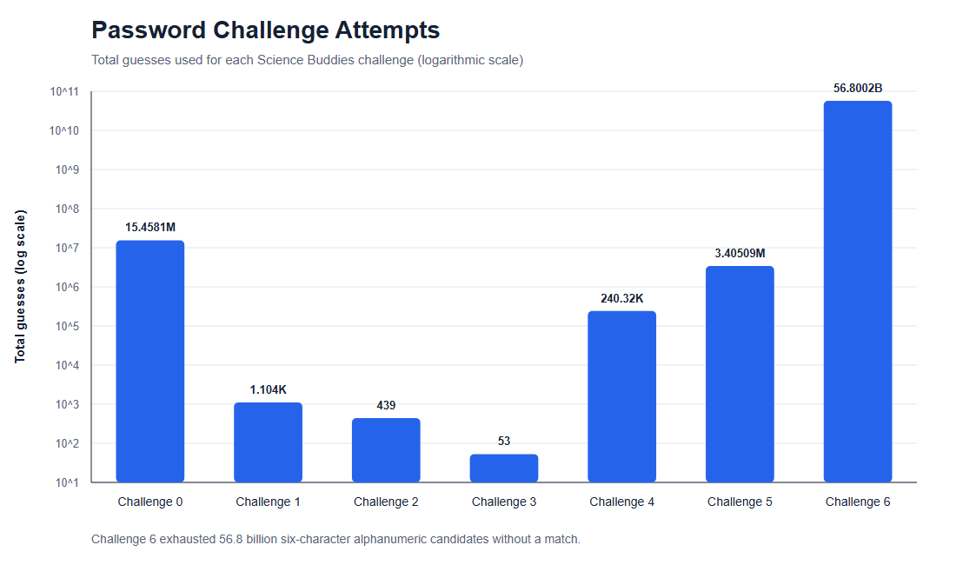
Challenge attempts
Dictionary attacks recovered Challenges 2 and 3 in fewer than 500 guesses. Word-pair methods recovered longer Challenges 4 and 5 without testing the much larger space of every possible string of those lengths. This demonstrates that predictability can matter as much as raw length.

Completed Challenge 6 search
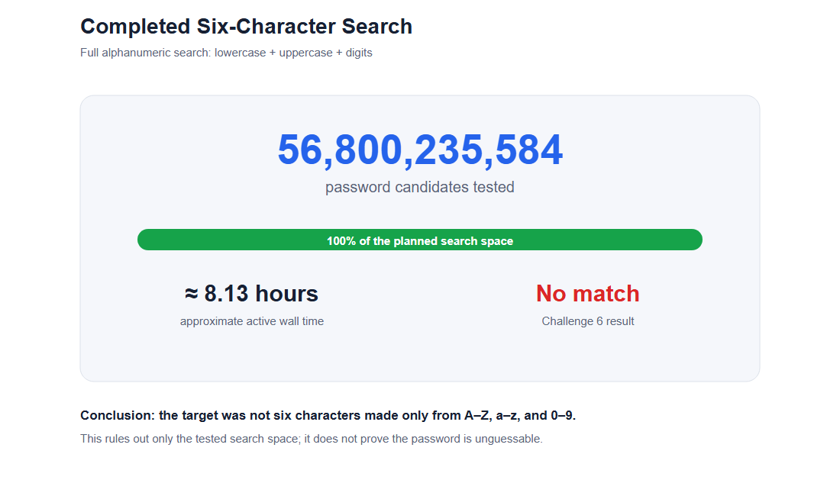
Completed six-character search
The program tested every six-character string made from lowercase letters, uppercase letters, and digits. All 56,800,235,584 candidates were exhausted without a matching hash. The two active process-log intervals totaled about 8.13 hours, producing an approximate average of 1.94 million guesses per second. This rules out that specific length and alphabet; it does not reveal the actual password or prove that it is impossible to guess.

Analysis
The results support exponential search-space growth. A fixed-length brute-force search requires A^L candidates in the worst case, so increasing length has a larger effect than a simple linear increase. Larger alphabets also increase the space, although predictable composition rules do not guarantee a strong human-chosen password.
The method comparisons show why attackers prioritize likely choices. A dictionary found some supplied samples almost immediately, while brute force required millions of candidates for short mixed-character targets. The unsolved challenge demonstrates the limit of negative results: finishing one large search space proves only that the target is not inside that space.

Conclusion
The hypothesis was supported. Longer passwords and larger search spaces required dramatically more guesses and more time in the controlled brute-force experiment. Dictionary and word-pair attacks were much more efficient when the target followed a predictable human pattern. Six of seven Science Buddies challenges were recovered. Challenge 6 remained unsolved even after a complete 56.8-billion-candidate alphanumeric search.
The practical lesson is that password length and unpredictability both matter. A longer passphrase that is not common or personally obvious is more resistant to the tested guessing strategies than a short password or a common dictionary word. Real security also depends on unique passwords, password managers, multi-factor authentication, secure salted storage, and login rate limiting.

Limitations
- The experiment used fast unsalted MD5 because it matched the classroom files.
- Timing results came from one computer and will differ on other hardware.
- Minesweeper training created background CPU load during portions of testing.
- Five repetitions reduce random noise but do not eliminate it.
- Very small durations are especially affected by timer resolution and warmup.
- Synthetic brute-force targets were placed last to create a consistent worst case.
- The word list contained 435 entries and cannot represent every human choice.
- The 8.13-hour final runtime is approximate wall time from two log intervals.
- Offline hash guessing is much faster than a rate-limited online login system.

Improvements and Further Research
- Repeat the experiment on multiple computers.
- Run more timing repetitions after a dedicated warmup.
- Compare MD5 with a modern slow password-hashing algorithm.
- Compare random passwords, common passwords, and multi-word passphrases.
- Expand and document dictionaries while keeping the experiment ethical.
- Measure energy use or guesses per watt in addition to time.
- Test how rate limiting changes online-attack estimates without attacking a real service.

Acknowledgments and Attribution
The project idea, sample Python program, sample hashes, and password list came from Science Buddies. The guessing program used for the experiment was written in C# and adapted the educational goals of the supplied material. AI assistance was used for programming, comments, data processing, graphs, and drafting this report. All numerical conclusions were calculated from saved experiment files.

Bibliography
- Science Buddies. “Password Security: How Easily Can Your Password Be
Hacked?” Accessed October 18, 2026. https://www.sciencebuddies.org/science-fair-projects/project-ideas/CompSci_p046/computer-science/password-security-how-easily-can-your-password-be-hacked
- National Institute of Standards and Technology. *Digital Identity
Guidelines: Authentication and Lifecycle Management*, SP 800-63B-4, 2025. https://pages.nist.gov/800-63-4/sp800-63b.html
- Rivest, Ronald. *The MD5 Message-Digest Algorithm*, RFC 1321, 1992.
https://www.rfc-editor.org/rfc/rfc1321
- Microsoft. “MD5 Class (.NET).” Accessed October 18, 2026.
https://learn.microsoft.com/dotnet/api/system.security.cryptography.md5

Files Submitted with the Report
- Password-Security-Final.xlsx — formatted spreadsheet and charts
- results/final/*.png — poster-ready graph images
- results/baseline/measurements.csv — raw repeated-trial data
- results/baseline/summary.csv — calculated timing summaries
- Program.cs, Challenges.cs, and ResumeSearch.cs — commented C# source

