1a) Explain with reasons if the the same approach to software engineering can be applied to all software categories – System S/W, Application S/W, Engineering S/W etc –
- No, it would depend on the Clarity of requirements, User feedback required etc. – 1 mark for each reason.

1b) Provide 1 example each of software projects for which the following process would be appropriate. Give reasons for the same. (i) Waterfall model (ii) Prototype model. – 3 marks
- Waterfall model – Compiler, Operating System etc. (0.5 mark). Reason – Requirements are clear, No changes expected, Application is not new (1 mark)
- Prototype model – Games, New online applications. (0.5 mark). Reason – Requirements not clear. User feedback essential, Changes expected. (1 mark).

1c) List 6 attributes of good quality software? – 3 marks
- Satisfy requirements
- Secure
- Scalable
- Acceptable performance, Efficient use of resources – CPU, Memory, Disk etc
- Usable
- Maintainable, Extendable, Portable
- Reliable
0.5 mark per item.

1d) Draw a state diagram for Bluetooth file transfer for sending and receiving files. – 2 marks
- State diagram showing transitions between states for sending and receiving files - Idle, Connect, Select File, Transmit, Receive, Store File
0.5 mark for each state transition

2a) Explain with a diagram the Unified Process Phases – 4 marks
- Diagram – 1.5 marks
- Explanation of each Phase Inception, Elaboration, Construction, Transition, Poduction – 0.5 marks each.

2b) Give 4 guidelines for usage of free libraries and code available on the internet? –
- Permission of customer, IP and Copyright issues, Testing of the code, Security issues – 0.5 mark each

2c) Give 4 tips for successful communication –
- Any 4 of Listen, Prepare before you communicate, Have a facilitator, Take notes and document decisions, Strive for collaboration, Stay focussed, Move on, Compromise, Win-win negotiation. – 0.5 mark each
2d) In Entity Relationship Diagrams explain (i) Cardinality (ii) Modality – 2 marks
- Cardinality is the specification of the number of occurrences of one object that can be related to the number of occurrences of another object - 1:1, 1:N, M:N – 1 mark
- Modality of a relationship - 0 - Relationship is optional, 1 - Relationship is mandatory – 1 mark

3a) Explain with a diagram Pipe and Filter Architecture using an example. –
Diagram – 1 mark
- Input data transformed through a set of computational or manipulative components, Input data and Output data formats are clearly defined, Each filter works independently of its neighbors – Any 2 – 1 mark
- Example could be of Compiler, Email processing, Signal Processing – 1 mark

3b) Using the Tabular Design Notation, list the Conditions, Actions and Rules for a module which computes the interest on a Fixed Deposit based on the following rules – 4 marks
- If the period is less than 1-year interest is 5%, 1 year to less than 3 years it is 6% and if it is 3 years or more it is 7%
- If the customer is a bank employee, then an additional 1.0% is paid
- If the customer is a senior citizen, then an additional 0.5% is paid

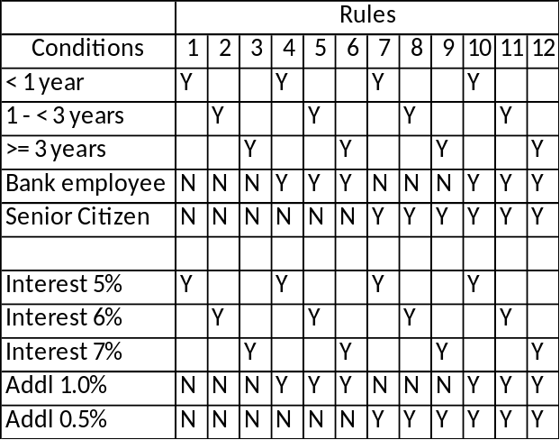
1 mark each for Rules 1-3, 4-6, 7-9. 10-12

3c) Explain the 3 golden rules of UI Design – 3 marks
- Place the User in Control
- Reduce the user’s memory load
- Make the interface consistent
0.5 mark for each point. 0.5 mark for explanation.

4a) Draw the flow graph for the following code. – 2 marks
1. int gcd(int i; int j) {
2. if (i < 0 ||
3. j < 0) {
4. return (0);
5. }
6. while (i != j) {
7. if (i > j)
8. i = i – j;
9. if (j > i)
10. j = j – i;
11. }
12. return (i);
13. }

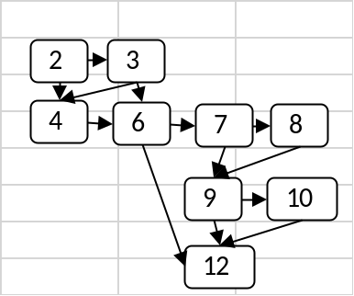

4b) How is cyclomatic complexity computed? What is the cyclomatic complexity of above code? – 2 marks – 2 marks
- Cyclomatic complexity = E – N + 2 or # of regions or #of predicate nodes+1 – 1 mark
- Cyclomatic complexity = 6 – 1 mark

4c) List all the basis paths for the above code. – 3 marks
- 2-3-4-6-12
- 2-4-6-12
- 2-3-6-12
- 2-3-4-6-7-8-9-10-12
- 2-3-4-6-7-9-10-12
- 2-3-4-6-7-9-12
0.5 marks per path

4d) Using Boundary Value Analysis, what would be the test cases for a program which gives the tan() of a number in degrees. – 3 marks
- Based on input - -ve values, 0, +ve values
- Based on output – 0, 45, 90, 135, 180, 225, 270, 315, 360, -45, -90, -135, -180, -225, -270, -315, -360
0.5 mark per item. Max 3 marks.

5a) What is the difference between White box testing and black box testing? Give an example where black box testing might uncover an error which is not detected in white box testing – 3 marks
• Black box testing focuses on the functional requirements of the software. – 1 mark
• White box testing uses the control structure described as part of component-level design to derive test cases. – 1 mark
• Missing functionality will not be detected in white box testing, but will be detected in black box testing. – 1 mark

5b) A system has 10 external inputs, 20 external outputs, processes 20 different queries, manages 6 internal logical files and has 5 different external interfaces. All the parameters are of average complexity. Making reasonable assumptions of the complexity of the system.
Compute (i) Unadjusted Function Points, (ii) Value Adjustment Factors (iii) Total FP in the system. – 3 marks
- UFP = 10*4+20*5+20*4+6*10+5*7 = 315 – 1 mark
- VAF = Make assumptions and get a value between 0 and 70 – 1 mark
- FP = 370 * (.65 + .01 * VAF). If VAF is 35, then FP = 315. – 1 mark

5c) Draw the Gantt chart for the following activities in a project? What is the total elapsed time needed to complete the project? Indicate the slack available for each of the activities. – 4 marks
Task1 – Does not depend on any task. Takes 10 days
Task2 – Does not depend on any task. Takes 5 days
Task3 – Depends on Task1 and Task2. Takes 10 days
Task4 – Depends on Task1. Takes 15 days.
Task5 – Depends on Task3. Takes 10 days.
Task6 – Depends on Task3. Takes 5 days.
- Chart – 2 marks
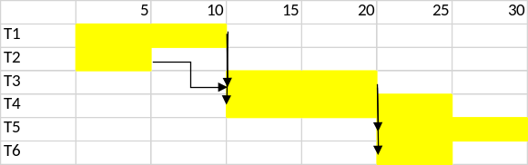
- Total elapsed time = 30 days – 1 mark
- Slack – T1 – 0, T2 – 5, T3 – 0, T4 – 5, T5 – 0, T6 – 5 – 1 mark

Q.1. Identify the software process model that would be followed in developing each of the following systems. Justify your choice, explaining the advantages of using the selected process model.
- Software for a chip to be inserted in hearts of human beings suffering from cardiac ailments.
Ans: Strict Waterfall model to be followed since it requires development of a medical equipment, a life-saving critical equipment. Hence no other answer to be given marks.

- Mobile application for ordering food while travelling to be developed for Indian Railways.
Ans: Agile process models would be the best answer. Since the requirements are unclear. It is a new or emergent system, not in place elsewhere also. Give marks only if proper explanation is given.
Incremental or evolutionary process model are also taken. Give partial marks in this case.

- Desktop-based system for handling guest registration and information management system to be installed at the billing counter of a shopping mall.
Ans: Since the requirements are relatively clear, Incremental or evolutionary process models would be the best answer.
Agile process model are also taken. Give marks only if proper explanation is given.

- Web-based application for tracking the movement of various GPS installed vehicles for a travelling company provider in the vehicles owned by its customers.
Ans: Since the requirements are relatively clear, Incremental or evolutionary process models would be the best answer. Give marks only if proper explanation is given.

- Software to be developed for physically challenged students with visual disabilities. The software aims to translate text written in a document and read it out to the students.
Ans: Evolutionary process models would be the best answer. Give marks only if proper explanation is given. Incremental or waterfall may also be taken, with proper explanation.

Q.2. Consider the scenario of construction of a web-based “Collage Creation” System, with the following specifications:
- Facility to upload images from the computer
- Interface with albums on Facebook
- Generate Collage of the selected images
- Upload collage to Facebook
- Upload collage to mobile image gallery

(a) Draw the Use Case Diagram for the above mentioned system.
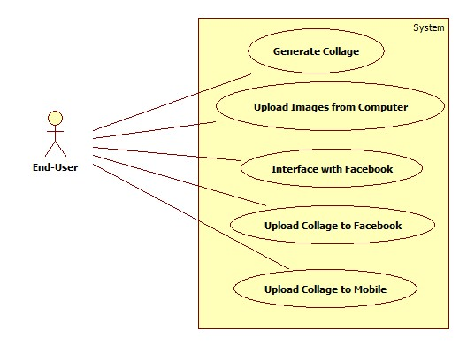
(b) Write one of the main use case text scenario in detail.
Ans: Student should write the complete use case text scenario using the template given on page 160, R. S. Pressman. Do not give full marks if the student does not follow the template.

(c) Draw the activity diagram for the selected use case text scenario.
Ans: Student should draw the activity diagram using correct notations. Do not give full marks if the notations are incorrect.

(d) Consider yourself as the team lead for the team involved in developing this system.
(i) Identify two expected requirements for the system.
Ans:
- User-friendliness of the human-machine interface
- Ease of software installation
- Overall operational correctness and reliability
- Easy and quick interfacing with Facebook
- Ease of selecting images to generate collage etc.

(ii) Add one exciting requirement that would emerge out as a unique selling point of
the product.
Ans: Look for correctness of the answer with respect to the system discussed.
Some possible exciting requirements could be:
- Additional visual effects that can be given to the collage.
- Possibility to convert the generated collage into different file formats.

Q.3. Consider a mobile-based application for transfer of money from one Paytm account to another. Identify (with reason) the two most important non-functional requirements for the same and describe each.
Ans: Security and Usability are the two most important non-functional requirements in this case. Security is most salient since monetary transactions are involved. Usability is important since the target end-users are naïve users and hence would need a user-friendly interface.
Student should explain why these non-functional requirements are most important and explain what each means.
Do not give any marks if students mention some other non-functional attributes.

Q.4. Software Configuration Management is an important umbrella activity being applied during software development process. Explain the need for this activity and the methodology used. Give example of an existing tool (open-source/commercial) used for the same.

Ans: SCM manages the effects of change throughout the software process. Provide a centralized repository of various artifacts, enable collaborative activities and also provide version management of various artifacts created during various phases of SDLC.
Example tools like CVS, SubVersion, GitHub, BitBucket, Perforce etc.

Q.5. List the generic framework activities that are present in every software process. Are these activities missing in agile process models? Explain your answer suitable example.
Ans: Five generic framework activities: Communication, Planning, Modeling, Construction and Deployment.
If the students list these correctly and in correct order, then give 0.5 mark.
Now the students need to discuss an example of a particular agile model (XP, Scrum etc.) and show the mapping between the generic framework activities and phases of the agile model - 1.5 marks

Q.6. ‘Build software that exhibits effective modularity’. Discuss and explain this important principle that guides practice, using suitable example.
Ans: Refer R. S. Pressman, pg 100. Separation of concerns establishes a philosophy for software. Modularity provides a mechanism for realizing the philosophy. Any complex system can be divided into modules (components), but good software engineering practice demands more. Modularity must be effective. That is, each module should focus exclusively on one well-constrained aspect of the system- it should be cohesive in its function and/or constrained in the content it represents. Additionally, modules should be interconnected in a relatively simple manner –each module should exhibit low coupling to other modules, to data source, and to other environmental aspects.

Q.7. What is an XP “story”? How are XP stories used to calculate project velocity in an XP project release? Explain.
Ans: Refer R.S.Pressman, pg 74. In XP, a set of user stories are created that describe the required output, features and functionality for the software to be built. Each story (similar to use case text scenario) is written by the customer and is placed on an index card. The customer assigns a value (priority) to the story based on the overall business value of the feature or function. Members of XP team assess each story; assign a cost to it- measured in development weeks. If any story needs more than 3 development weeks, the customer is asked to split the story into smaller stories and the cost is recalculated.

Project Velocity is the number of customer stories implemented during the first release. It helps to 1) estimate delivery dates and schedule for subsequent releases and 2) determine whether an over commitment has been made for all stories across the entire development project. If an over commitment occurs, the content of releases is modified or end delivery dates are changed.

Q.1. Give reasons for the following: (3*5= 15 marks)

- “Use patterns to capture knowledge and experience for future generations of software engineers”. In the light of above statement, explain what design patterns are. Discuss at least one design pattern of your choice and explain it with the help of an example.
Answer: Correct definition of design patterns is a must. Whatever design pattern the student may chose to describe, make sure that the student explains the design pattern correctly using a valid case-study. DO NOT give any marks only for scribbling. DO NOT give any marks if the example case-study is NOT given.

- How does a swimlane diagram differ from activity diagram? Would it be more beneficial to draw a swimlane diagram or activity diagram? Explain with the help of an example.
Answer: Swimlane is a useful variation of the activity diagram and allows one to represent the flow of activities described by the use case and at the same time indicate which actor (if there are multiple actors involved in a specific use case) or analysis class has responsibility for the action described by an activity rectangle. Responsibilities are represented as parallel segments that divide the diagram vertically, like the lanes in a swimming pool.
<<DO NOT give marks if the student does not give a detailed example to explain the same>>

- “Software designers focus on the problem to be solved. They forget the FURPS attributes are also a part of the problem”. Discuss FURPS quality attributes and explain each with the help of an example.
Answer: Student should explain clearly each of the FURPS quality attribute.
<<R. S. Pressman, pg. 403 >>

- Various process models differ from one another in ‘certain aspects’. Discuss, in detail, the ‘certain aspects’ that make the software process models different from each other.
Answer: <<R. S. Pressman, pg. 16, last para>>
A process model adopted for one project might be significantly different than a process adopted for another project. Among the differences are:
- Overall flow of activities, actions, and tasks and the interdependencies between them
- Degree to which actions and tasks are defined within each framework activity
- Degree to which work products are identified and required
- Manner in which quality assurance activities are applied
- Manner in which project tracking and control activities are applied
- Overall degree of detail and rigor with which the process is described
- Degree to which the customer and other stakeholders are involved with the project
- Level of autonomy given to the software team
- Degree to which team organization and roles are prescribed

- Debugging occurs as a consequence of successful testing. Discuss at least two debugging strategies used by developers to identify bugs.
Answer: Student should explain atleast two techniques: brute-force and backtracking. <<R. S. Pressman, pg. 476>>

Q.3. Consider the matrix addition algorithm given below for adding two 2X2 matrices: (3+3+2= 8 marks)
algoMatrixAddition(firstMatrix, secondMatrix, addMatrix)
{
int i=0;
int j=0;
for (i = 0; i < firstMatrix.rowLength; i++)
{
for (j = 0 ; j < firstMatrix.colLength; j++)
{
addMatrix[i][j] = firstMatrix [i][j] + secondMatrix [i][j];
output (addMatrix[i][j]);
}
output("\n");
}
return;
}

Answer the following questions:
  - Draw the control flow graph for the given algorithm.
  - Calculate Cyclomatic Complexity using all the three methods.
  - Find the basis set of the execution paths.

algoMatrixAddition(firstMatrix, secondMatrix, addMatrix)
{
int i=0;
1
int j=0;
2
for (i = 0; i < firstMatrix.rowLength; i++)
{
3
for (j = 0 ; j < firstMatrix.colLength; j++)
{
4
addMatrix[i][j] = firstMatrix [i][j] + secondMatrix [i][j];
5
output (addMatrix[i][j]);
}
6
output("\n");
}
7
return;
}

1
2
3
4
5
6
R1
R2
R3
7

b) [1 mark each for the correct formula and calculation of V(G)]
V(G) = P + 1= 2 + 1= 4 ( Nodes 5 and 6 are predicate nodes)
V(G) = Number of regions = 3 (should be marked in the diagram)
V(G) = E – N +2 = 8-7+2 =3

c) Find the basis set of all the execution paths.[1 mark each for the correct path]
Basis Set:
Path 1: 1-2-3-4-5-6-7
Path 2: 1-2-3-4-5-3-4-5-6-7
Path 3: 1-2-3-4-5-6-2-3-4-5-6-7

Q.4. A software team of around 20 diligent and hardworking people, proficient in developing software using Waterfall model receives a mobile application development project, which is to be implemented using Agile Process Model. You being the head of this team, is entrusted the responsibility to prepare this team for the same. List at least 5 important tasks/activities that you would undertake in order to do so. (3 marks)

Answer:
The student is expected to discuss the important aspects of Agile Process Models as compared to Waterfall.
Some of these could be:
1: Less or light documentation
2: Quick time to market
3: Enhanced customer collaboration
4: ………

