Birla Institute of Technology & Science, Pilani
Work Integrated Learning Programmes Division
M. Tech (Software Engineering) at Wipro Technologies (WASE)
II Semester 2015 - 2016
Comprehensive Examination (Makeup)_ANSWER KEY
Course Number : SEWP ZC322
Course Title : Data Base Management Systems
No. of Pages :4
No. of Questions : 6
Type of Exam : Open Book
Weightage : 60 %
Duration : 3 Hours
Date of Exam : 3rd August, 2016 Session : FN( 9 to 12 Noon)

Note:
- Please read and follow all the instructions given on the cover page of the answerscript.
- Start each answer from a fresh page. All parts of a question should be answered consecutively.

Q1 (Marks 10)

Consider the following information about a university database:
- Professors have an SSN, a name, an age, a rank, and a research specialty.
- Projects have a project number, a sponsor name (e.g., NSF), a starting date, an
ending date, and a budget.
- Graduate students have an SSN, a name, an age, and a degree program (e.g., M.S.
or Ph.D.).
- Each project is managed by one professor (known as the project's principal investigator).
- Each project is worked on by one or more professors (known as the project's co-investigators).
- Professors can manage and/or work on multiple projects.
- Each project is worked on by one or more graduate students (known as the project's research assistants).
- When graduate students work on a project, a professor must supervise their work on the project. Graduate students can work on multiple projects, in which case they will have a (potentially di_erent) supervisor for each one.
- Departments have a department number, a department name, and a main o_ce.
- Departments have a professor (known as the chairman) who runs the department.
- Professors work in one or more departments, and for each department that they work in, a time percentage is associated with their job.
- Graduate students have one major department in which they are working on their degree.
- Each graduate student has another, more senior graduate student (known as astudent advisor) who advises him or her on what courses to take.

Design and draw an ER diagram that captures the information about the university.
Use only the basic ER model here, that is, entities, relationships, and attributes. Be
sure to indicate any key and participation constraints.
ER Diagram
Evaluation of marks are based upon showing ER Diagram, Cardinality ratio,Keys. No Partial Marks should be offer

Entities correctly identified: [3 Mark]
Attributes correctly identified: [2 Mark]
Primary keys correctly identified: [1 Mark]
Relationships and cardinality correctly identified: [4 Mark]

ER/ERR Schema (variations are possible to this answer)

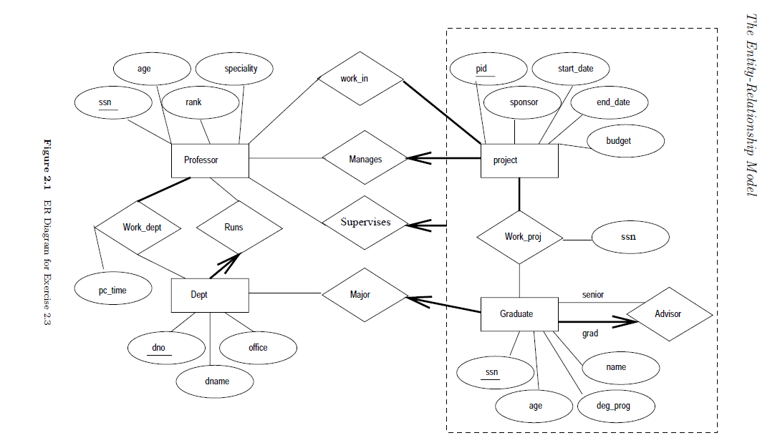

Q2: (10 Marks)
Consider the following relations:
Student(snum: integer, sname: string, major: string, level: string, age: integer)
Class(name: string, meets at: string, room: string, fid: integer)
Enrolled(snum: integer, cname: string)
Faculty(fid: integer, fname: string, deptid: integer)
The meaning of these relations is straightforward; for example, Enrolled has one record
per student-class pair such that the student is enrolled in the class.

Write the following queries in SQL. No duplicates should be printed in any of the
answers.
1. Find the names of all Juniors (level = JR) who are enrolled in a class taught by
I. Teach.
2. Find the age of the oldest student who is either a History major or enrolled in a
course taught by I. Teach.
3. Find the names of all classes that either meet in room R128 or have five or more
students enrolled.
4. Find the names of all students who are enrolled in two classes that meet at the
same time.
5. Find the names of faculty members who teach in every room in which some class
is taught.

The answers are given below: (2 marks Each total 10 Marks)
1. SELECT DISTINCT S.Sname
FROM Student S, Class C, Enrolled E, Faculty F
WHERE S.snum = E.snum AND E.cname = C.name AND C.fid = F.fid AND
F.fname = ‘I.Teach’ AND S.level = ‘JR’

2. SELECT MAX(S.age)
FROM Student S
WHERE (S.major = ‘History’)
OR S.snum IN (SELECT E.snum
FROM Class C, Enrolled E, Faculty F
WHERE E.cname = C.name AND C.fid = F.fid
AND F.fname = ‘I.Teach’ )

3. SELECT C.name
FROM Class C
WHERE C.room = ‘R128’
OR C.name IN (SELECT E.cname
FROM Enrolled E
GROUP BY E.cname
HAVING COUNT (*) >= 5)
SQL: Queries, Constraints, Triggers 47

4. SELECT DISTINCT S.sname
FROM Student S
WHERE S.snum IN (SELECT E1.snum
FROM Enrolled E1, Enrolled E2, Class C1, Class C2
WHERE E1.snum = E2.snum AND E1.cname <> E2.cname
AND E1.cname = C1.name
AND E2.cname = C2.name AND C1.meets at = C2.meets at)

5. SELECT DISTINCT F.fname
FROM Faculty F
WHERE NOT EXISTS (( SELECT *
FROM Class C )
EXCEPT
(SELECTC1.room
FROM Class C1
WHERE C1.fid = F.fid ))

Q3A (2.5 For Each total 5 Marks)

Consider a database with objects X and Y and assume that there are
two transactions T1 and T 2. Transaction T 1 reads objects X and Y and then writes
object X. Transaction T 2 reads objects X and Y and then writes objects X and Y .
1. Give an example schedule with actions of transactions T1 and T 2 on objects X
and Y that results in a write-read conflict.
2. Give an example schedule with actions of transactions T1 and T 2 on objects X
and Y that results in a read-write conflict.

The answer to each question is given below:- (2.5 For Each total 5 Marks)

1. The following schedule results in a write-read conflict:
T2:R(X), T2:R(Y), T2:W(X), T1:R(X) ...
T1:R(X) is a dirty read here.

2. The following schedule results in a read-write conflict:
T2:R(X), T2:R(Y), T1:R(X), T1:R(Y), T1:W(X) ...
Now, T2 will get an unrepeatable read on X.
Now, T2 has overwritten uncommitted data.

Q.3 B) Consider the following two tables T1 and T2. Show the results of the following operations:
Table T1
P | Q | R
10 | a | 5
15 | b | 8
25 | a | 6
Table T2:
A | B | C
10 | B | 6
25 | C | 3
10 | B | 5

Answers:
- T1 T1.P=T2.A T2 (1Marks)
P | Q | R | A | B | C
10 | A | 5 | 10 | b | 6
10 | A | 5 | 10 | b | 5
25 | A | 6 | 25 | c | 3
- T1 T1.Q=T2.B T2 (1Marks)
P | Q | R | A | B | C
15 | B | 8 | 10 | B | 6
15 | B | 8 | 10 | B | 5

(c) T1UT2 (1Marks)
P | Q | R
10 | A | 5
15 | B | 8
25 | A | 6
10 | B | 6
25 | C | 3
10 | B | 5

(d) T1 (T1.P=T2.A AND T1.R=T2.C)T2 (2Marks)
P | Q | R | A | B | C
10 | A | 5 | 10 | B | 5

Q4 (10 Marks )

Construct a B+ tree with given specifications. The order of the tree, p=3 and p_{leaf} =2. The tree should be such that all the keys in the subtree pointed by a pointer which is preceding the key must be equal to or less than the key value , and all the keys in the subtree pointed by a pointer which is succeeding the key must be greater than the key.

Insert the following keys in same order- 56, 22, 78, 42, 102, 90, 96, 35. Show how the tree will expand after each insertion, and the final tree.
Next, delete 56, 46, 22 in the same order and show the status of the tree after each deletion.

Ans:-
Note:- there is a typo this is answer of Question 4
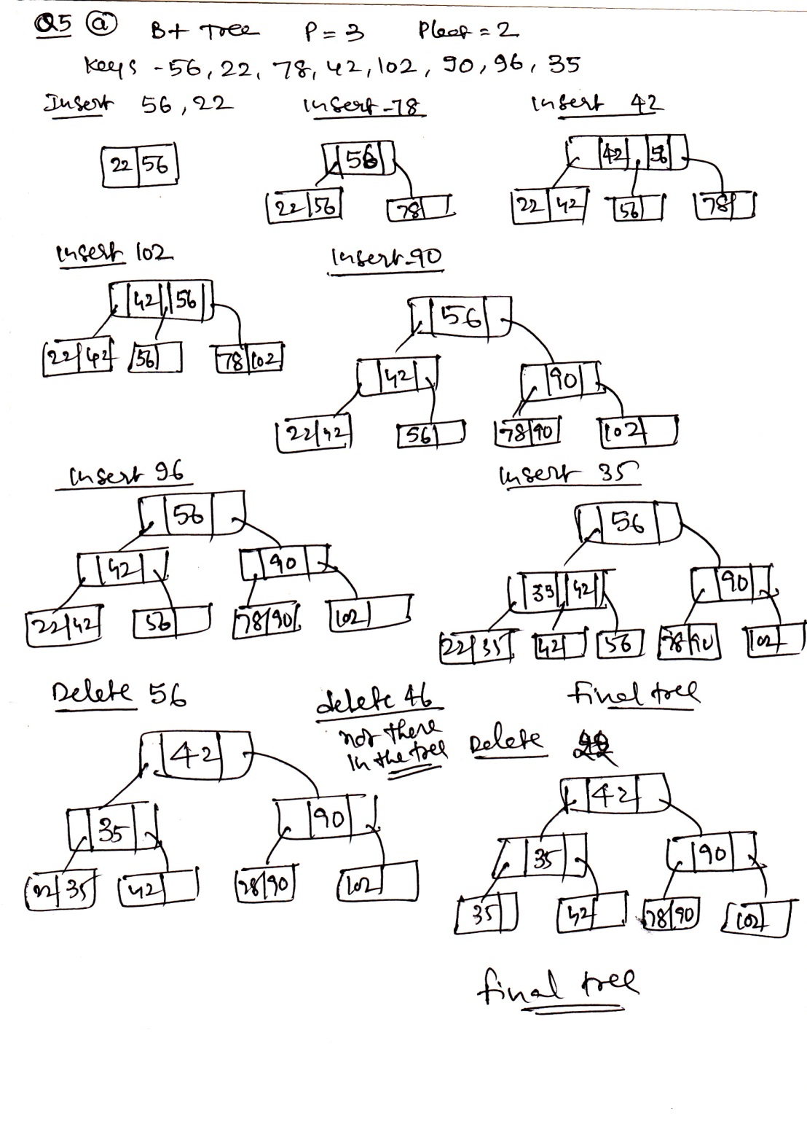
Q.5A. Consider the universal relation R={A,B,C,D,E,F,G,H,I,J} and the set of FDs
F={{A,B}->{C},{A}->{D,E},{B}->{F},{F}->{G,H},{D}->{I,J}} (5Marks)

D3 = {R1, R2, R3, R4, R5} ;
R1 = {A, B, C, D} ,
R2 = {D, E} ,
R3 = {B, F} ,
R4 ={F, G, H} ,
R5 = {D, I, J}
Determine whether each decomposition has
- the dependency preservation property, and
- the lossless join property, with respect to F.

Answer: 1.dependency preservation property is not there as A->D,E is not preserved based on R1(2.5 Marks)
- Lossless join property is not there. (2.5 Marks)
A | B | C | D | E | F | G | H | I | J
a1 | a2 | a3 | a4 | b15 | B16/a6 | B17/a7 | B18/a8 | B19/a9 | B20/a10
b21 | b22 | b23 | a4 | a5 | b26 | b27 | b28 | b29 | b30
b31 | a2 | b33 | b34 | b35 | a6 | b37 | b38 | b39 | b40
b41 | b42 | b43 | b44 | b45 | a6 | a7 | a8 | b49 | b50
b51 | b52 | b53 | a4 | b55 | b56 | b57 | b58 | a9 | a10

Q5B We have a file sorted on Primary key (PK), the key size is10 bytes, the record length is 101 bytes and the record pointer takes 8 bytes and block pointer takes 6 bytes. The disk block size is 512 bytes. Assuming there are 50000 ordered records in the file.
Use the above information and answer the following questions:
(1 Marks Each total 5 Marks)

(i). Calculate the blocking factor and the number of file blocks assuming an unspanned organization (1 Mark)

Answer:

Blocking factor bfr = floor(B/R) = floor(512/101) = 5 records per block
Number of blocks needed for file = ceiling(r/bfr) = ceiling(50000/5) = 10000

ii) calculate the index blocking factor(1 Mark)

Index record size Ri = (V PK + blockpointer) = (10 + 6) = 16 bytes
Index blocking factor bfri = fo = floor(B/Ri ) = floor(512/16) = 32

iii. Calculate the no. of first level index entries and first level index blocks(1 Mark)

Number of first-level index entries r1 = number of file blocks b = 10000 entries
Number of first-level index blocks b1 = ceiling( 1 /bfri ) = ceiling(10000/32)= 312 blocks

iv) If we consider multilevel index, how many levels are possible. (1 Mark)

Number of second-level index entries r2 = number of first-level blocks b1=312 entries
Number of second-level index blocks b2 = ceiling(r2 /bfri ) = ceiling(312/32)=9 blocks
Number of third-level index entries r3 = number of second-level index blocks b2=9
Number of third-level index blocks b3 = ceiling(r3 /bfri ) = ceiling(9/32) = 1
Since the third level has only one, max level possible are 3

v) total no. of blocks required by the multi level index(1 Mark)

Total number of blocks for the index bi = b1 + b2 + b3 = 312 + 9 + 1=322blocks

Q.6 (2+4+4=10 Marks)

Consider the execution shown in Figure In addition, the crashes system during recovery after writing two log records to stable storage and again after writing another two log records.  1. What is the value of the LSN stored in the master log record?  2. What is done during Analysis?  3. What is done during Redo? | 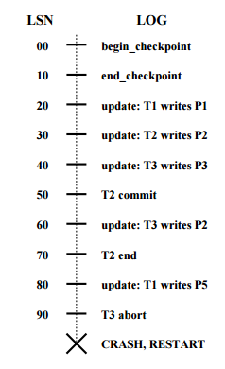
Q.6 Ans:-
1). LSN 00 is stored in master log record. It is the LSN of the begin checkpoint record. (2 Marks)
2). At the end of analysis, the transaction table contains the following entries: (T1,80), and (T3,60). The Dirty Page Table has the following entries: (P1,20), (P2,30), (P3,40), and (P5,80)
LSN 20  LSN 30  LSN 40  LSN 50  LSN 60  LSN 70  LSN 80  LSN 90 | Add (T1,20) to TT and (P1,20) to DPT  Add (T2,30) to TT and (P2,30) to DPT  Add (T3,40) to TT and (P3,40) to DPT  Change status of T2 to C  Change (T3,40) to (T3,60)  Remove T2 from TT  Change (T1,20) to (T1,70) and add (P5,70) to DPT  No action
(4 Marks)
3). Redo starts from LSN20 (minimum recLSN in DPT).
LSN 20  LSN 30  LSN 40  LSN 50  LSN 60  LSN 70  LSN 80  LSN 90 | Check whether P1 has pageLSN more than 10 or not. Since it is a committed transaction, we probably need not redo this update  Redo the change in P2  Redo the change in P3  No action  Redo the changes on P2  No action  Redo the changes on P5  No action
(4 Marks)

