Birla Institute of Technology & Science, Pilani
Work Integrated Learning Programmes Division
M. S (Software Engineering) at Wipro Technologies (WASE)
II Semester 2014 - 2015
Comprehensive Examination (Regular_ ANSWER KEY)
Course Number: SEWP ZG512
Course Title: DATABASE MANAGEMENT SYSTEMS
No. of Pages: 3
No. of Questions: 8
Type of Exam: Open Book
Weightage: 60%
Duration: 3 Hours
Date of Exam: 30 Aug 2015 Session – FN

Note:
1. Please read and follow all the instructions given on the cover page of the answer script.
2. Start each answer from a fresh page. All parts of a question should be answered consecutively.
3. Please answer the questions in the order in which they appear in the question paper.

1. Please read the information given below before attempting the questions that follow. [3+3]

EmpMaster (eid: number, ename: varchar, sal: number, age: number, deptid: number)
Dept(deptid: number, budgetAmt: number, floor: number, mgreid: number)

Salaries range from Rs.10,000 to Rs.100,000, ages vary from 20 to 80, each department has about five employees on average, there are 10 floors, and budgets vary from RS.10,000 to Rs 100,000. You can assume uniform distribution of values.

Query1: Print ename, age, and sal for all employees.
Query2: Find the deptids of departments that are on the 10th floor and have a budget of less than Rs25,000

1.1 For each of the following queries, which index would you choose to speed up the query? [2.5]

1.2 If your database system does not consider index-only plans (i.e.,data records are always retrieved even if enough information is available in the index entry), how would your answer change? [2.5]

Explain your answers briefly.

Answer

We should create an unclustered hash index on ename, age, sal fields of EmpMaster since then we could do on index only scan. If our system does not include index only plans then we should not create index for this query. Since this query requires us to access all the Emp records, an index won’t help us any, and so should we access the records using a filescan.

We should create a clustered dense B+tree index on floor, budget fields of Dept, since the records would be ordered on these fields then. So when executing this query, the first record with floor=10 must be retrieved, and then the other records with floor =10 can be read in order of budget. This plan, which is the best for this query, is not an index-only plan

2. Consider the following relations: [1x5=5]

Student (snum: integer, sname: string, major: string, level: string, age: integer)
Class (name: string, meets at: string, room: string, fid: integer)
Enrolled (snum: integer, cname: string)
Faculty (fid: integer, fname: string, deptid: integer)

The meaning of these relations is straightforward; for example, Enrolled has one record per student-class pair such that the student is enrolled in the class.

Write the following queries in SQL. No duplicates should be printed in any of the answers.

2.1 Find the age of the oldest student who is either a History major or enrolled in a course taught by 'I. Teach'.
2.1 Find the names of all classes that either meet in room R128 or have five or more students enrolled.
2.1 Find the names of all students who are enrolled in two classes that meet at the same time.
2.1 Find the names of students enrolled in the maximum number of classes.
2.1 For each age value that appears in Students, find the level value that appears most often. For example, if there are more FR level students aged 18 than SR, JR, or SO students aged 18, you should print the pair (18, FR).

Answers:

1. SELECT MAX(S.age) [2]
FROM Student S
WHERE (S.major = ‘History’)
OR S.snum IN (SELECT E.snum
FROM Class C, Enrolled E, Faculty F
WHERE E.cname = C.name AND C.fid = F.fid
AND F.fname = ‘I.Teach’ )

2. SELECT C.name [2]
FROM Class C
WHERE C.room = ‘R128’
OR C.name IN (SELECT E.cname
FROM Enrolled E
GROUP BY E.cname
HAVING COUNT (*) >= 5)
SQL: Queries, Constraints, Triggers 47

3. SELECT DISTINCT S.sname [2]
FROM Student S
WHERE S.snum IN (SELECT E1.snum
FROM Enrolled E1, Enrolled E2, Class C1, Class C2
WHERE E1.snum = E2.snum AND E1.cname <> E2.cname
AND E1.cname = C1.name
AND E2.cname = C2.name AND C1.meets at = C2.meets at)

4. SELECT DISTINCT S.sname [2]
FROM Student S
WHERE S.snum IN (SELECT E.snum
FROM Enrolled E
GROUP BY E.snum
48 Chapter 5
HAVING COUNT (*) >= ALL (SELECT COUNT (*)
FROM Enrolled E2
GROUP BY E2.snum ))

5. SELECT S.age, S.level [2]
FROM Student S
GROUP BY S.age, S.level,
HAVING S.level IN (SELECT S1.level
FROM Student S1
WHERE S1.age = S.age
GROUP BY S1.level, S1.age
HAVING COUNT (*) >= ALL (SELECT COUNT (*)
FROM Student S2
WHERE s1.age = S2.age
GROUP BY S2.level, S2.age))

3. Construct a B+-tree for the following set of key values: [2+2+1=5]
(2, 3, 5, 7, 11, 17, 19, 23, 29, 31)
Assume that the tree is initially empty and values are added in ascending order.
Construct B+-trees for the cases where the number of pointers that will fit
in one node is as follows:
a. Four
b. Six
c. Eight
Answer:The following will be generated by inserting values into the B+-tree inascending order. A node (other than the root) will never be allowed to have fewerthan n/2! Values/pointers.
- Four Node
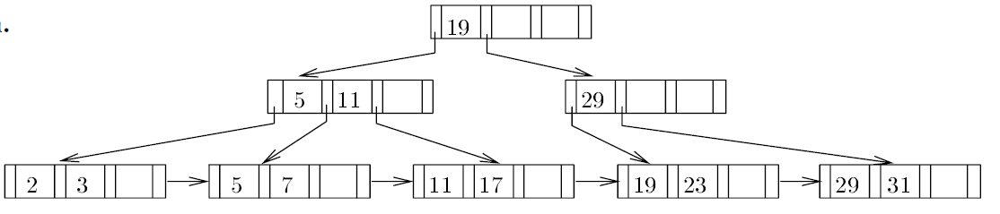

- Six Node
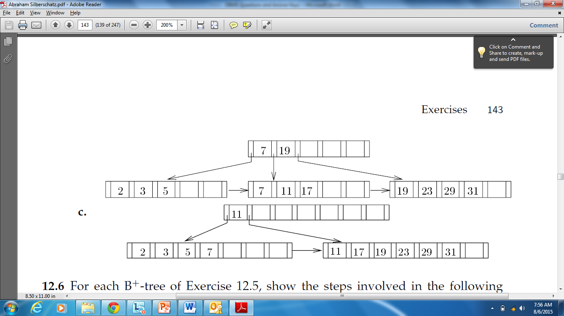

- Eight Node

4 Determine whether the following decomposition of SP(S#,Sname,Scity,Status,P#,Pname,Price,qty) is a loss less join decomposition? Write the matrix and show the steps. [5]
Decomposition:
CS(Scity,Status)
SUPP(S#,Sname,Scity)
Part(P3,Pname,Price)
SPN(S#,P#,Qty)
FDs Holding on SP:
S#-->Sname,Scity
ScityStatus
P#-->Pname,Price
{S#,P#}Qty
Answer:
Ans Since S#-->Scity and ScityStatus,thus S3Status
Therefore, S#Sname,Scity,Status

Make matrix
 | S# | Sname | Scity | Status | P# | Pname | Price | qty
CS | b₀₀ | b₀₁ | a₂ | a₃ | b₀₄ | b₀₅ | b₀₆ | b₀₇
SUPP | a₀ | a₁ | a₂ | b₁₃ | b₁₄ | b₁₅ | b₁₆ | b₁₇
PART | b₂₀ | b₂₁ | b₂₂ | b₂₃ | a₄ | a₅ | a₆ | b₁₇
SPN | a0 | b₃₁ | b₃₂ | b₃₃ | a₄ | b₃₅ | b₃₆ | a₇
Applying FD ScityStatus,row 0 and 1 match on the value of Scity,So force these two rows to match on the values of Status.Thus replaced b13 in row 1 by a3.
 | S# | Sname | Scity | Status | P# | Pname | Price | qty
CS | b₀₀ | b₀₁ | a₂ | a₃ | b₀₄ | b₀₅ | b₀₆ | b₀₇
SUPP | a₀ | a₁ | a₂ | a₃ | b₁₄ | b₁₅ | b₁₆ | b₁₇
PART | b₂₀ | b₂₁ | b₂₂ | b₂₃ | a₄ | a₅ | a₆ | b₁₇
SPN | a0 | b₃₁ | b₃₂ | b₃₃ | a₄ | b₃₅ | b₃₆ | a₇
Now,applying the FD P#-->Pname,Price,row 2 and 3 match on the value of P#,so force these two rows to match on the value of Pname ,Price.Thus replace b35 in row 3 by a5 and replace b36 in row 3 by a6
 | S# | Sname | Scity | Status | P# | Pname | Price | qty
CS | b₀₀ | b₀₁ | a₂ | a₃ | b₀₄ | b₀₅ | b₀₆ | b₀₇
SUPP | a₀ | a₁ | a₂ | a₃ | b₁₄ | b₁₅ | b₁₆ | b₁₇
PART | b₂₀ | b₂₁ | b₂₂ | b₂₃ | a₄ | a₅ | a₆ | b₁₇
SPN | a0 | b₃₁ | b₃₂ | b₃₃ | a₄ | b₃₅ | a₆ | a₇
Now,applying the FD S#-->Sname,Scity,Status, row 1 and 3 match on the value of S#,so force these two rows to match on the value of Sname,Scity and Status.Thus replace b31 in row 3 by a1:replace b32 in row 3 by a2:replace b33 in row 3 by a3
 | S# | Sname | Scity | Status | P# | Pname | Price | qty
CS | b₀₀ | b₀₁ | a₂ | a₃ | b₀₄ | b₀₅ | b₀₆ | b₀₇
SUPP | a₀ | a₁ | a₂ | a₃ | b₁₄ | b₁₅ | b₁₆ | b₁₇
PART | b₂₀ | b₂₁ | b₂₂ | b₂₃ | a₄ | a₅ | a₆ | b₁₇
SPN | a0 | a₁ | b₂ | a₃ | a₄ | a₅ | a₆ | a₇
The row 3 contains only “a” values:therefore,the above decomposition is a loss less join decomposition of SP.
(Each step must be shown by student)

5. Suppose you are given a relation R with four attributes ABCD. For each of the following sets of FDs, assuming those are the only dependencies that hold for R. [10]

(a) Identify the candidate key(s) for R.
(b) Identify the best normal form that R satisfies (1NF, 2NF, 3NF, or BCNF).
(c) If R is not in BCNF, decompose it into a set of BCNF relations that preserve the dependencies.

Perform the above tasks for the following set of functional Dependencies:

5.1. C → D, C → A, B → C
5.2. B → C, D → A
5.3. ABC → D, D → A
5.4. A → B, BC → D, A → C
5.5. AB → C, AB → D, C → A, D → B

Answers:
1. (a) Candidate keys: B [2]
(b) R is in 2NF but not 3NF.
(c) C → D and C → A both cause violations of BCNF. One way to obtain a (lossless) join preserving decomposition is to decompose R into AC, BC, and CD.

2. (a) Candidate keys: BD [2]
(b) R is in 1NF but not 2NF.
(c) Both B → C and D → A cause BCNF violations. The decomposition: AD, BC, BD (obtained by first decomposing to AD, BCD) is BCNF and lossless and join-preserving.

3. (a) Candidate keys: ABC, BCD [2]
(b) R is in 3NF but not BCNF.
(c) ABCD is not in BCNF since D → A and D is not a key. However if we split up R as AD, BCD we cannot preserve the dependency ABC → D. So there is no BCNF decomposition.

4. (a) Candidate keys: A [2]
(b) R is in 2NF but not 3NF (because of the FD: BC → D).
(c) BC → D violates BCNF since BC does not contain a key. So we split up R as in: BCD, ABC.

5. (a) Candidate keys: AB, BC, CD, AD [2]
(b) R is in 3NF but not BCNF (because of the FD: C → A).
(c) C → A and D → B both cause violations. So decompose into: AC, BCD but this does not preserve AB → C and AB → D, and BCD is still not BCNF because D → B. So we need to decompose further into: AC, BD, CD. However, when we attempt to revive the lost functional dependencies by adding ABC and ABD, we that these relations are not in BCNF form. Therefore, there is no BCNF decomposition.

6. Which of the following schedules is (conflict) serializable? Explain with the help of precedence graph. [10]
For each serializable schedule, determine the equivalent serial schedules.

6.1 r1 (X); r3 (X); w1(X); r2(X); w3(X) (2Marks)
6.2 r1 (X); r3 (X); w3(X); w1(X); r2(X) (2Marks)
6.3 r3 (X); r2 (X); w3(X); r1(X); w1(X) (2Marks)
6.4 r3 (X); r2 (X); r1(X); w3(X); w1(X)(2Marks)

Soln [2 marks for each 2 marks for the equivalent serial of (c)]
Let there be three transactions T1, T2, and T3. They are executed concurrently and produce a schedule S. S is serializable if it can be reproduced as at least one serial schedule.
A schedule S is to be conflict serializable if it is (conflict) equivalent to some serial schedule S’. In such a case, we can reorder the nonconflicting operations in S until we form the equivalent serial
schedule S’.(2 Marks)
(a) This schedule is not serializable because T1 reads X (r1(X)) before T3 but T3 reads X
(r3(X)) before T1 writes X (w1(X)), where X is a common data item. The operation
r2(X) of T2 does not affect the schedule at all so its position in the schedule is
irrelevant. In a serial schedule T1, T2, and T3, the operation w1(X) comes after r3(X),
which does not happen in the question..(2 Marks)
(b) This schedule is not serializable because T1 reads X ( r1(X)) before T3 but T3 writes X
(w3(X)) before T1 writes X (w1(X)). The operation r2(X) of T2 does not affect the
schedule at all so its position in the schedule is irrelevant. In a serial schedule T1, T3,
and T2, r3(X) and w3(X) must come after w1(X), which does not happen in the question.
.(2 Marks)

(c) This schedule is serializable because all conflicting operations of T3 happens before
all conflicting operation of T1. T2 has only one operation, which is a read on X (r2(X)),
which does not conflict with any other operation. Thus this serializable schedule is
equivalent to r2(X); r3(X); w3(X); r1(X); w1(X) serial schedule.
.(2+2 Marks)

(d) This is not a serializable schedule because T3 reads X (r3(X)) before T1 reads X (r1(X))
but r1(X) happens before T3 writes X (w3(X)). In a serial schedule T3, T2, and T1, r1(X)
will happen after w3(X), which does not happen in the question..(2 Marks)

7 Consider the below snapshot of concurrent execution for immediate update of recovery. [10]
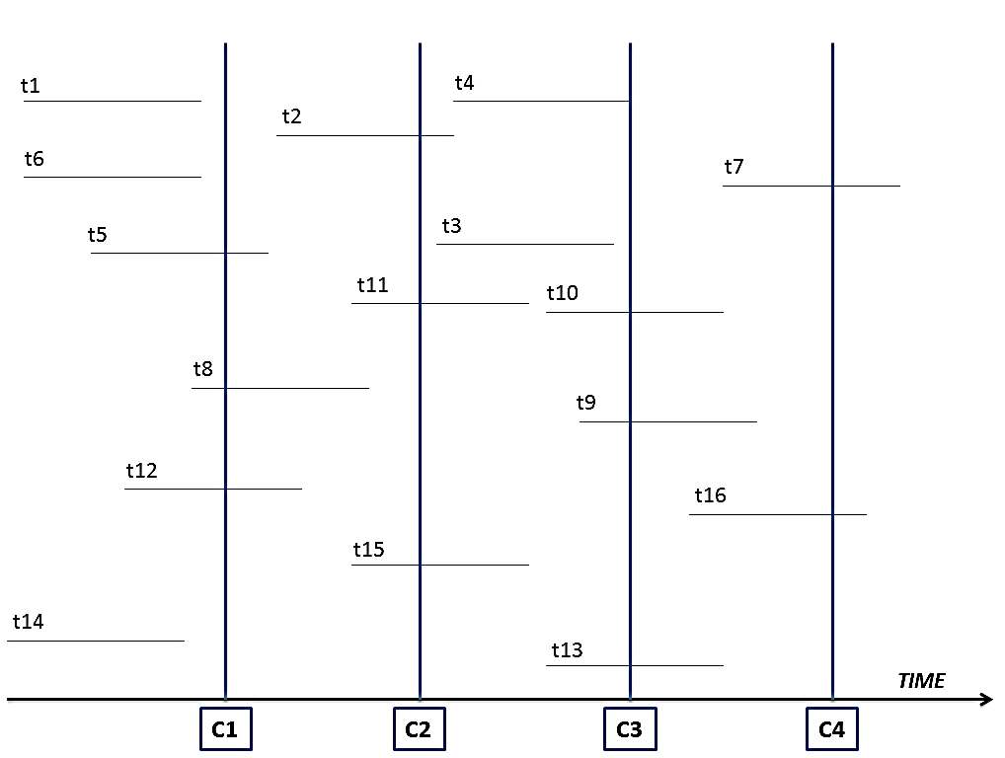
Assuming Check Points: C1, C2, C3, C4 and Transactions: t1, t2…. t16; what are the outcomes of the following tables at all the above 4 check points? (2.5X 4= 10 Marks)
- Active Table
- Commit Table
Answer:
C1 | Active Table | Commit Table
C1 | t5, t8, t12 | t1, t6, t14

C2 | Active Table | Commit Table
C2 | t2, t11, t15 | t1, t6, t5, t8, t12, t14

C3 | Active Table | Commit Table
C3 | t4, t10, t9, t13 | t2, t11, t15, t1, t6, t5, t8, t12, t14

C4 | Active Table | Commit Table
C4 | t7, t16 | t4, t10, t9, t13 ,t2, t11, t15, t1, t6, t5, t8, t12, t14

- Consider the Extendible Hashing index shown in Figure below. Answer the following questions about this index: [10]

  - What can you say about the last entry that was inserted into the index?
  - What can you say about the last entry that was inserted into the index if you know that there have been no deletions from this index so far?
  - Suppose you are told that there have been no deletions from this index so far. What can you say about the last entry whose insertion into the index caused a split?
  - Show the index after inserting an entry with hash value 68.
  - Show the index after inserting entries with hash values 17 and 69.
  - Show the index after deleting the entry with hash value 21. (Assume that the full deletion algorithm is used.)
  - Show the index after deleting the entry with hash value 10. Is a merge triggered by this deletion? If not, explain why. (Assume that the full deletion algorithm is used.)
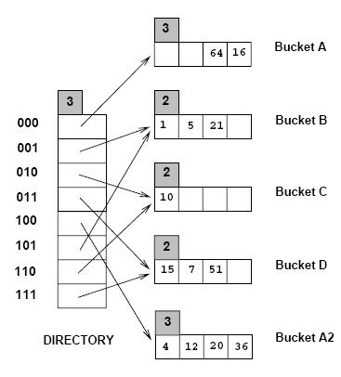

Answer Q8
ANS 7)

- It could be any one of the data entries in the index. We can always find a sequence of insertions and deletions with a particular key value, among the key values shown in the index as the last insertion. For example, consider the data entry

- and the following sequence:

- 5 21 10 15 7 51 4 12 36 64 8 24 56 16 56D 24D 8D

The last insertion is the data entry 16 and it also causes a split. But the sequence of deletions following this insertion cause a merge leading to the index structure shown in Fig 11.1.
- The last insertion could not have caused a split because the total number of data entries in the buckets A and A2 is 6. If the last entry caused a split the total would have been 5.
- The last insertion which caused a split cannot be in bucket C. Buckets B and C or C and D could have made a possible bucket-split image combination but the total number of data entries in these combinations is 4 and the absence of deletions demands a sum of at least 5 data entries for such combinations. Buckets B and D can form a possible bucket-split image combination because they have a total of 6 data entries between themselves. So do A and A2. But for the B and D to be split
images the starting global depth should have been 1. If the starting global depth is 2, then the last insertion causing a split would be in A or A2.
- See Fig 11.2.

- See Fig 11.3.

- See Fig 11.4.

- The deletion of the data entry 10 which is the only data entry in bucket C doesn’t trigger a merge because bucket C is a primary page and it is left as a place holder. Right now, directory element 010 and its split image 110 already point to the same bucket C. We can’t do a further merge. See Fig 11.5.
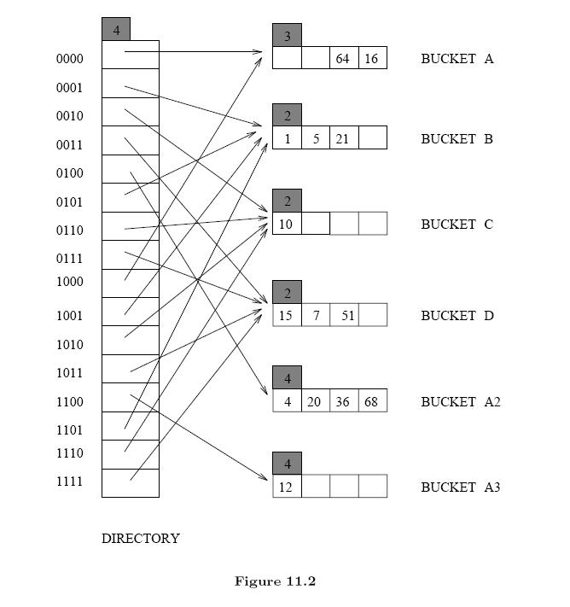
Hash‐Based Indexing & Overview of Query Evaluation
