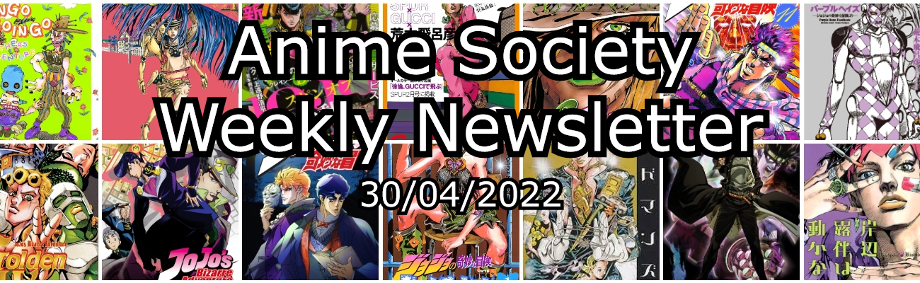**If this e-mail doesn't work for you formatting-wise use the link** [**here**](https://www.nottsanime.co.uk/newsletter) **to view the Newsletter - this link will change every week to the current week's newsletter**

[**PRE-ORDER YOUR COPY OF THE ZINE 13**](https://docs.google.com/forms/d/1JoTZivJb-SkGHg9b690o7uXw6RYjbNI2UX9IT03QYcY)

To communicate with your fellow members - [**JOIN THE DISCORD**](https://www.nottsanime.co.uk/discord)

For an informational hub of all anime society events, zines and newsletters - [**CHECK OUT THE WEBSITE**](https://www.nottsanime.co.uk/)

As my tenure as Communications Officer slowly comes to a close, I bring you my penultimate newsletter. We've still got a last spurt of events to go before the exam season though, and more importantly...

**Pre-Order Your Copy of the Zine Now!**

The Zine, the Anime Society's yearly (maga)zine, is a collection of articles, art and stories made by the membership. The 13th Issue of the Zine has now been finished and is awaiting printing. Before we print it however, as it comes in at a whopping **80 pages,**by far our biggest Zine yet, the printing is fairly expensive, so instead of guesstimating the amount we need to print I have attached a pre-order form to this e-mail for you to fill out if you wish to own a physical copy of the Zine 13. Unless there is great demand it is unlikely to be printed again, so for the low price of **£5** or **£7** if you are unable to collect in-person make sure you get your hands on this piece of Anime Society history. It should get printed for sometime in the week commencing the 9th of May.

**Anime Monday Session**

**7pm A46 Trent Building - (02/05/2022)**

With our set series, Bake and Nisemonogatari, now finished, we move on to our final 2 Anime Monday sessions. As the coming Monday is a bank holiday, the room has been moved to **A46 in Trent Building** but it will be at the same time as always. The session on the 9th will be in the usual A41 Clive Granger. We will be watching 1 episode of 5 voted in series for the last 2 sessions, so if you've got a series you've been burning to show off that hasn't gotten in yet this year, these last 2 weeks are your chance!

**Wednesday Manga Book Club**

**7pm A41 Clive Granger Building -(05/05/2022)**

As it was almost a month ago now, I won't go too in-depth on the last session. In summary, **Shuumatsu no Walkuure** godly action proved to be decently liked, receiving an average rating of **6.31.** For the next session on the 5th of May, we will be reading the utter masterpiece manga that is **Immortal Hounds** all 6(?) volumes of it. Understandably with exam season coming up some of you might not have read all 6 volumes, but even if you only read 1 please do show up anyway to discuss this manga. I've yet to read much more than a few chapters myself, but one thing's for sure, it will be bloody!

**Anime Karaoke Night**

**7pm B46 Trent Building - (14/05/2022)**

For our very last event this year, we shall be going out with a bang with some Anime Song Karaoke! Just a bit of fun to cap off the year, so if you want to flex how well you know your favourite anime's opening or ending song, this is the event to do it!

That's all, have a good weekend everyone and good luck with your coursework and exams!

- Matt (Communications Officer)

