Art Style Guide
Negative Space
Team: Something About Space
Version 1.0

Team Roster
Name | Position | Signature
Anthony Adorno | Artist, Animator
Keston Gregory | UI Designer
Ryan Hill | Art Lead
Johnny Humberto | Programmer
Ryan McAllister | Lead Programmer
Daniel Morelli | Producer

Document Revision Table
Version | Updates | Advocate | Date
1.0 | Initial Document | Ryan Hill | 09/04/2014

Art Style

Aesthetic Summary
The game’s level of detail will be a realistic adaptation of the vacuum of space representing it inherent lack in color to begin with. The planetoid environment, scattered asteroid debris and the characters with or without a spaceship will have a lifelike quality to them. The lighting will be dark representing space with many stars twinkling in the distance. The player controlled spaceship will show bright glowing lights in different colors ranging from red, orange, yellow, green, blue, indigo and violet.
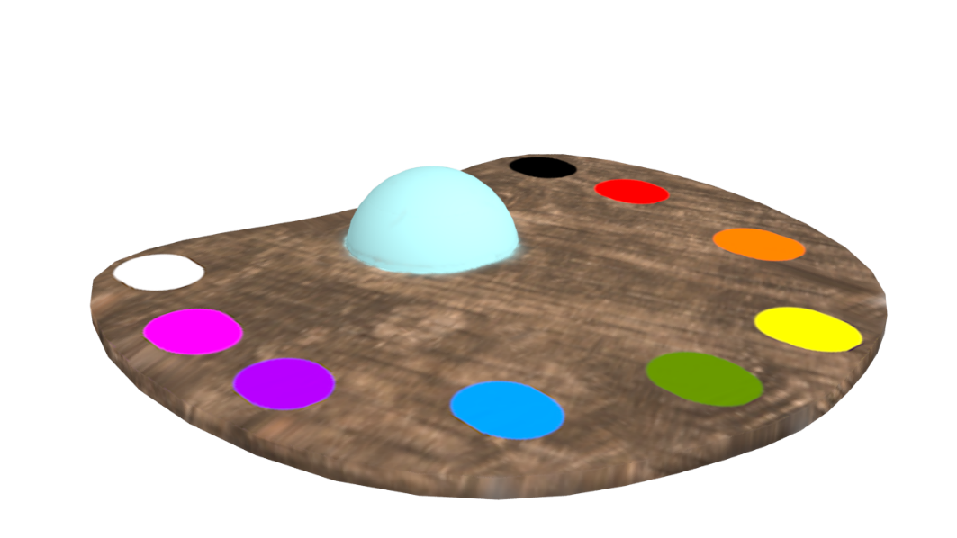
Character Art
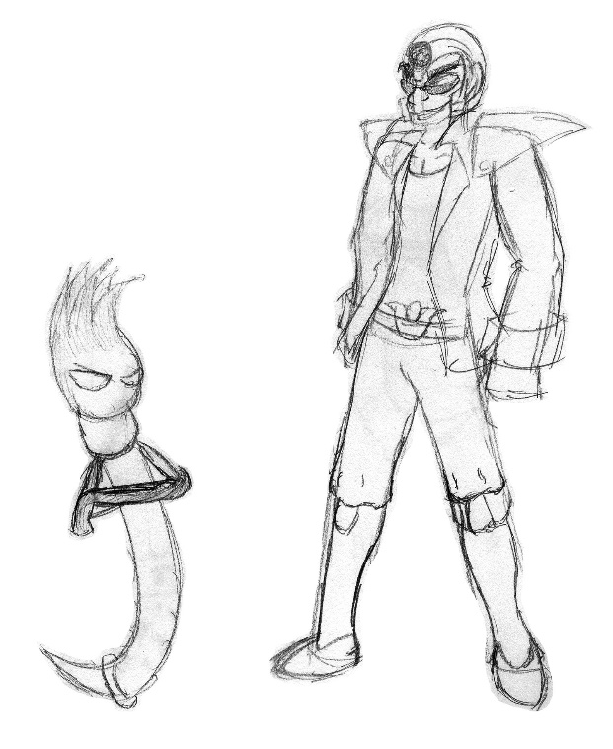
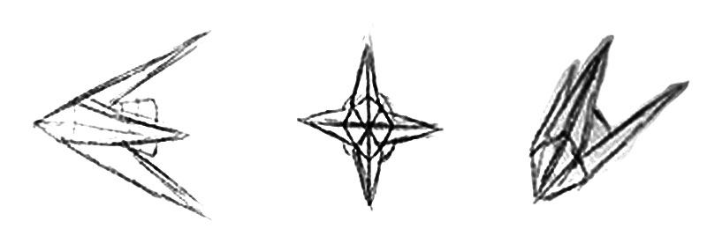
The player will be controlling a spaceship that looks like a painter’s color palette. Captain Palette Tin will sit in a cockpit set in thumb hole of the palette. Will likely not be seen on model but his face will be shown in the Health Bar.

Level Art
The biggest differences between levels will be enemy count, asteroid count, and planet shapes. Each planet will have a new painting on it with the paintings getting more complex while the player progresses levels in the game. Enemy count and asteroid count will increase by level.

Environment
Dark space with many stars all around. There will be asteroids and enemies all around. Asteroid and comet dust will create noise off the black background of space.

Technical Guidelines

Materials/Textures
Wood texture
Grass
Water
Clouds
Stars
Rocks
Metallic Shading

Color Palette

Nine Main Colors
Red
Orange
Yellow
Green
Blue
Indigo
Violet
White
Black
Captain Palette Tin – Changes color based on power up but is primarily made out of one of the main colors. “Colorless” form is a flat Gray. 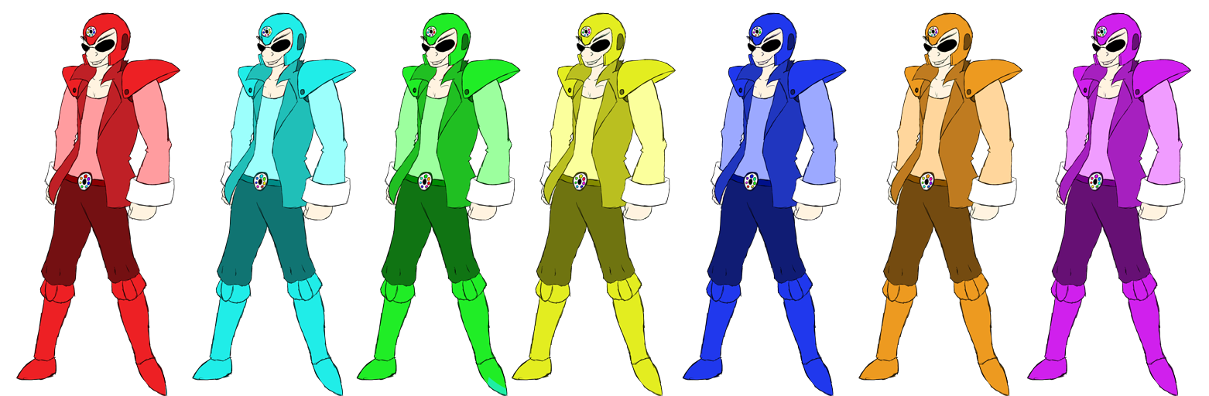

Ketone – Black White and Brown
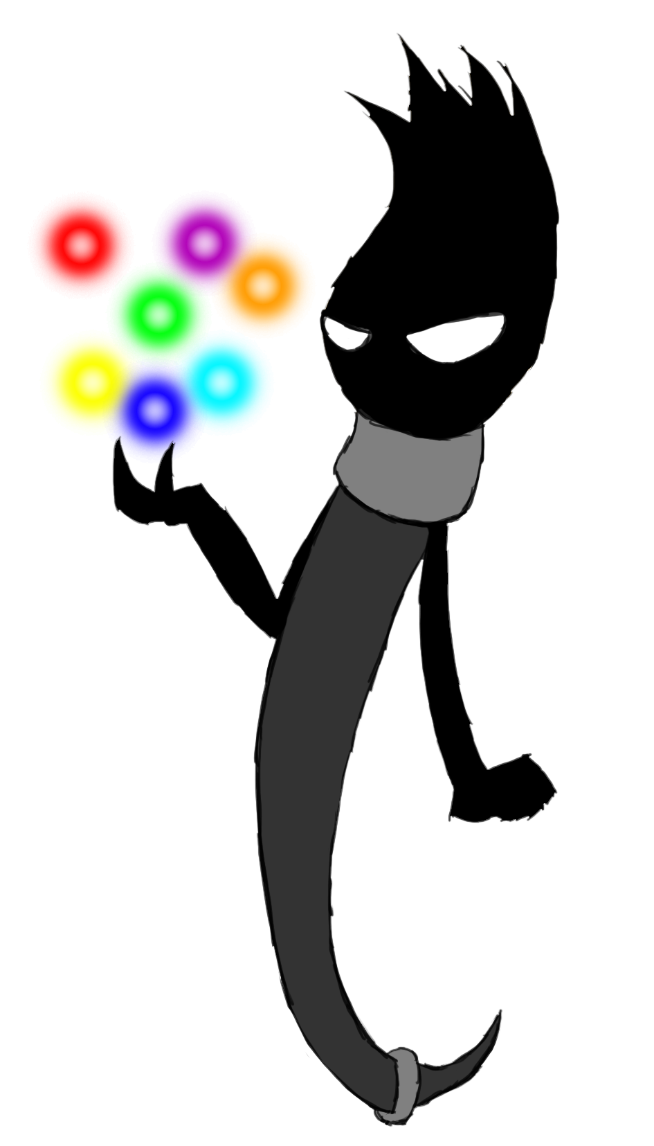

Color Eaters – The nine Main Colors with Black Linings.
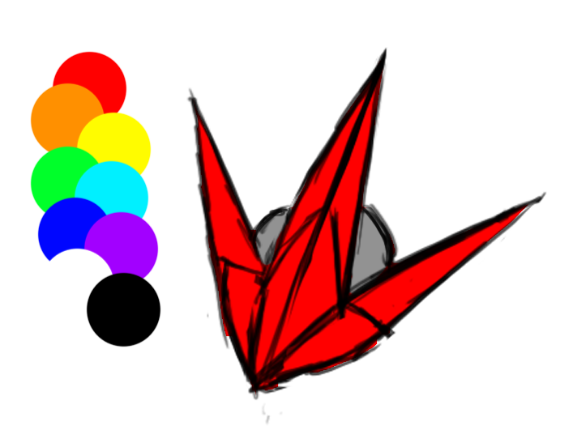
Asteroids – Brown

Comets – Light Blue

Planets Mid-Painting – A mixture of the Main Nine Colors depending on landmarks and ocean. Changes colors based on where the player shot and when.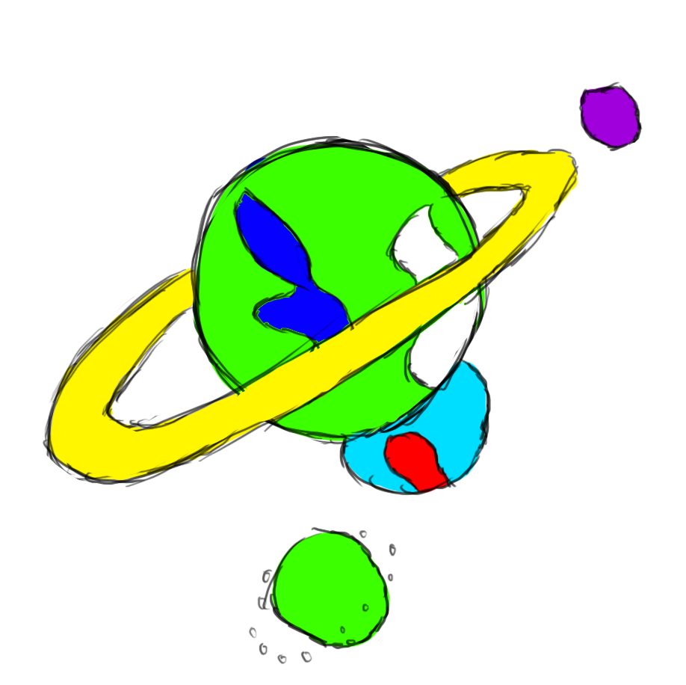

Finished Planets – Fully shaded planets with the correct colors in place with realistic textures.
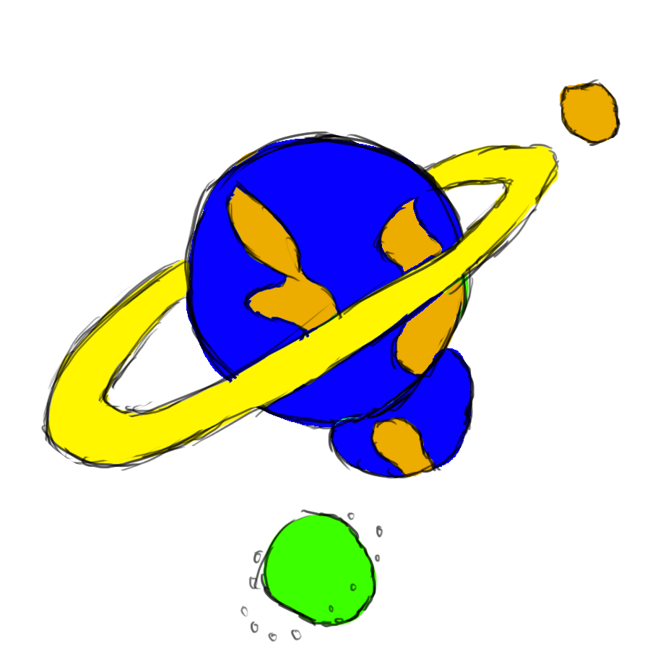
Assets List

Player Controlled Spaceship | A color palette designed spaceship that shots paint. | 5000 poly
Enemy | A black and white space creature that shoots the player. | 3000 poly
Ketone | Thinner brush that steals away the color from the painting. | 3000 poly
Asteroid | Space rock that can damage the player on contact or be destroyed by the player. | 500 poly
Paint Can | A can full of one type of paint color that the player can fly over to obtain and use the paint as ammo for the spaceship’s paint gun. | 300 poly
Painting piece | A model that fits in with a collection of other painting pieces that contain hit colliders. | 300 poly
Planets | Large sphere sized to look like a planet. This acts as the painting background. The painting piece | 1500 poly
Rainbow Brush | Another paint can that gives one free color shot to the player. The player should try to not miss his target. | 500 poly

Player animation requirements
Ketone
Fly in loose and freely.
Steal painted painting piece’s color.
Fly away
Kill Ketone

