Negative Space
Team: Something About Space
Version 1.0

Team Roster
Name | Position | Signature
Anthony Adorno | Artist Animator
Keston Gregory | UI Design
Ryan Hill | Art Lead
Ryan McAllister | Lead Programmer
Daniel Morelli | Producer
Johnny Humberto | Programmer

Document Revision Table
Version | Updates | Advocate | Date
1.0 | Initial Document | Daniel Morelli | 09/01/2014

Concept

Color the worlds while fighting against an onslaught of color coded enemies.

Market Analysis

The game is acceptable for all ages. Our target audience is men and women who enjoy rail shooting and space games. This may potentially help with those with issues seeing different colors too.

As for competition there are not many rail shooters of this style in recent time. The main competition for the genre are any new rail shooters on the main consoles, if they come out. There truly isn’t much to compete with currently and this would be a first after a long lack of such games.

Story

The “Ambassador of Color” Captain Palette Tin must fly through the vastness of space on his special Ship - the ROY G. BIV - to bring color to the worlds that lost them through the evil clutches of Ketone, the Thinner alien’s Leader, and his armada of Color Eaters.

Genre

Rail Shooter with elements of painting programs.

Environment

Most of the game will be in outer space. At the start of each level the player will be positioned in front of a planet and will shoot at it to color it. The worlds will typically be rather vibrant in color when colored in order to pick out which part of the planet is colored. Asteroids and shooting stars may pass by which the player can destroy for points or a special item to help go through the levels.

Once the planet is colored in, the proper shading and exact details of the planet will show, proving the player has finished the level.

Gameplay Overview

The player avoids enemies and enemy fire as they try to shoot onto a picture to give it color. When the correct color matches the portion of the picture then that segment will lock into that color. When the entire picture is painted, the player wins and moves on to the next level.

Core Gameplay Mechanics

Movement – The player will be able to move around the screen from corner to corner. The ship will aim towards where it turns.

Shoot – The player can shoot color coded bullets to destroy the enemies, and they can also shoot the painting in the background to color in the white space.

Key Features

Color Eaters – The enemy ships will fly towards the player and attempt to shoot them. There are nine different ships, each color coded based on the different colors of the rainbow. Each color may have different bullet types.
- Red shoots single straight lasers.
- Orange shoots three lasers in a horizontal orientation.
- Yellow shoots a long beam that lingers for three seconds.
- Green shoots three lasers in a vertical orientation.
- Blue shoots large slow moving homing orbs.
- Indigo shoots a long beam that lingers and follows the player slowly for seven seconds.
- Violet shoots rings for the player to weave through.
- White shoots a Plus shaped beam that will cover the screen except for the four corners.
- Black shoots an X shaped beam that will cover the screen except for the top bottom and sides.

Ketone – A rare Boss character that will appear in later levels. He will steal the color the player currently has and/or steals color from a section of the planet. If the player manages to drive him off, they can get a Rainbow Color shot, as well as recover the colors that were stolen.

Painting Planets – The backgrounds will typically be a planet from afar. And the different continents and shapes within the black and white planet will be colored by the different colored shots. When the correct color is brought up, that segment will be colored. The planet will slowly rotate in one direction as the game goes on. Moons and other satellites may revolve around it too.

Color Change – Whenever an enemy is destroyed, a paint bucket/pack will appear. If a player touches the pack it will always change into the color pack’s color. This will change what colors will be shot and the aura of the ship. There are nine colors and a wild card to receive: Red, Orange, Yellow, Green, Blue, Indigo, Violet, White, Black and Rainbow. All colors will have limited ammo (Rainbow being a single shot for example). These colors may also alter what colors can hit the player and what ships can be hit. (Red lasers cannot hit red colored objects, for example)

Controls

Movement/Select – WASD or arrows (if computer) or control stick (if controller is provided)
Shoot/Confirm – Z or G or Left Click (if computer) or A Button (Or bottom face buttons if controller)

Platforms

Mac, PC, and Linux, Unity’s overall compiler.
Unity 4.5.3

Interface

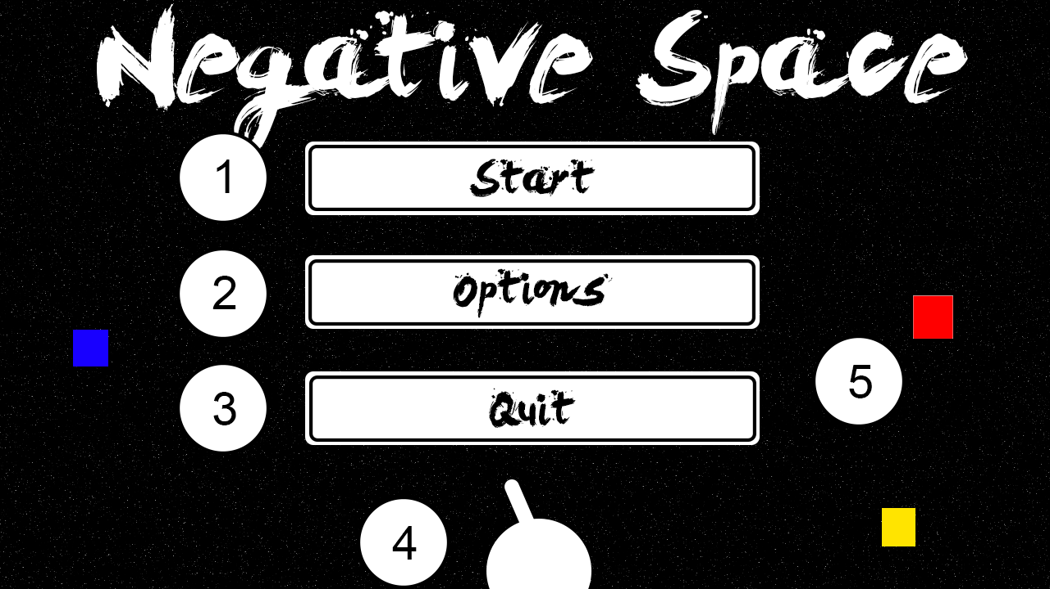

- Starts the main game. As levels are completed the player may choose specific levels.
- Options menu will open. Will include audio changes, a potential color blind mode switch, and whether the player wants inverted controls or not.
- Quit the game.
- The ship can be moved around and aim at the selections above.
- Color drops to show the different colors the player can shoot.

The Main Menu Interface will be controlled the same as the main game. You move the space ship and aim and shoot at the desires selection to move on to the game, options, or closing the game. There will also be some extra flare such as coloring the individual letters of the title screen by picking up random item drops. This functions as a tutorial of the game’s key controls.

The only other menu is the pause screen which will be a simple selection through arrow/WASD controls. It will have resume game, options, and return to main menu within it.

HUD

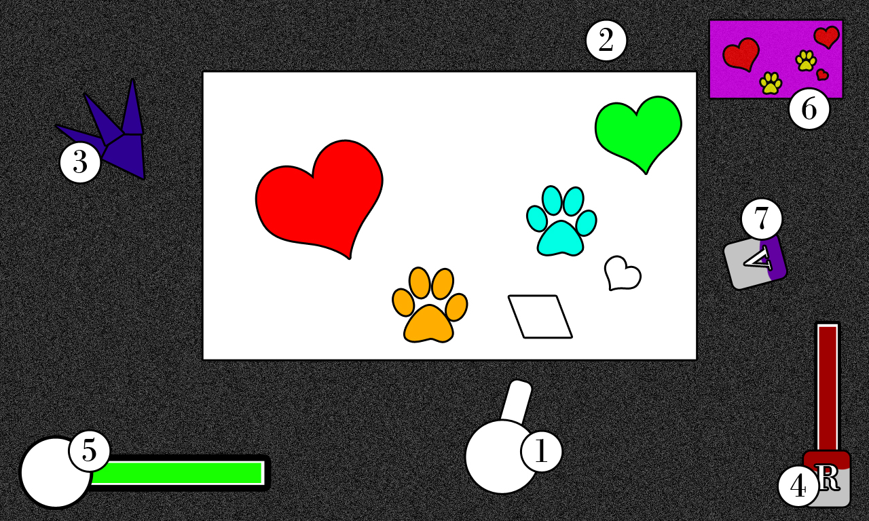

- Player Ship – Currently colorless. Can get a Red, Orange, Yellow, Green, Blue, Indigo, Violet, White, or Black aura when it picks a color drop up. There is also a rainbow aura arrangement if a rainbow paint.
- Painting – Currently flat planet. Will be full 3D worlds later. Objective is to color the world in the correct colors.
- Enemy Ship – Current color Indigo, can come as Red, Orange, Yellow, Green, Blue and Violet too.
- Paint Energy Bar – Currently Red
- Health Bar – Circle would have main character’s face in it. May change expression depending on health.
- Finished Painting Example – Displays the exact colors you may need to win.
- Color Change Drop – Currently Violet, player can pick it up to go from one color to another.

Technical Analysis

Experimental Features
- Recoloring objects in real time in unity. Specifically certain parts of the models instead of the entire model at once.

Major Development Tasks
September 9th – Prototype Move and Shoot
September 30th – Alpha – Enemies and Planets should be complete, at least one full level should be prepared.
October 17th – Beta – Animations should be complete.
November 20th – full game is finished.

Risks and Alternatives
- Color Changing may be difficult to maintain with multi polygonal objects and might have to just settle with flat planes instead of planets of various shapes and sizes if rendering becomes a problem.
- Multiple Enemy shot types might have to be reduced from nine to three or potentially just a simple shot type if they prove to be too elaborate to fire.
- Absolute worst scenario would be to remove color changing application to a painting and change it to a simple color themed space shooter against many colored enemies.

Reference

Star Fox
Mario Power Tennis
Captain EO
F-Zero
Space Dandy

