Git is a powerful version control system that allows developers to track changes in their code and collaborate seamlessly. In this article, we'll walk through the creation of a simple project and cover some essential Git commands.

**Step 1: Initializing a Git Repository**

To start, navigate to your project folder in the terminal and run:

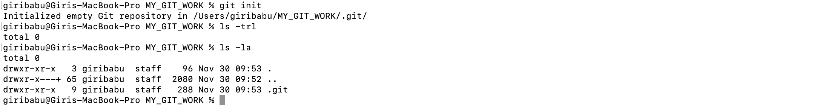

**Step 2: Creating and Editing a File**

Create a new HTML file:



## Step 3: Tracking Changes

Check the status of your repository:

Add changes to the staging area:

Commit the changes:

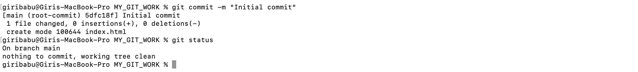

## Step 4: Branching

Create a new branch:

git branch feature-branch



Switch to the new branch

Make changes in the branch and commit them.

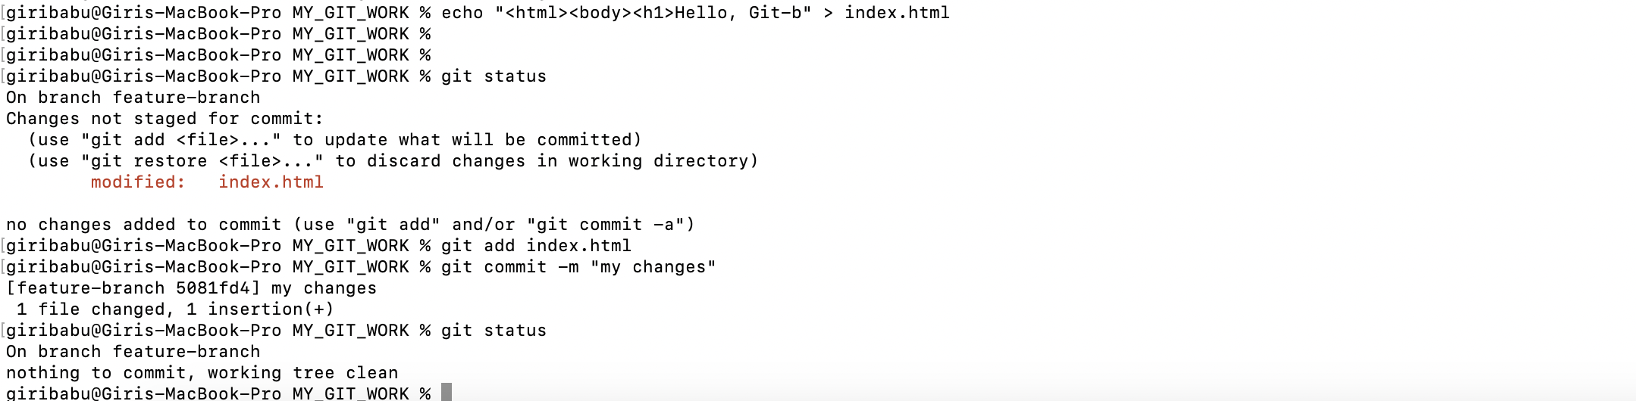

**Step 5: Merging**

Switch back to the main branch:

Merge the feature branch into the main branch:

## Step 6: Remote Repository (GitHub)

Create a new repository on GitHub.

Link your local repository to the remote repository:

git remote add origin https://github.com/AnimelaD/Git_Basics.git

Push changes to the remote repository:

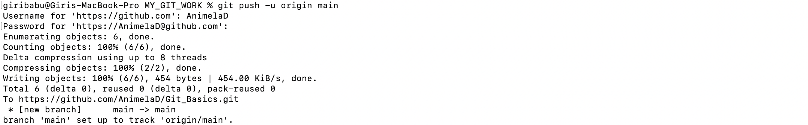

**Step 7: Clean Up**

Delete the feature branch:



## Step 8: View History

