ADAMAS UNIVERSITY
eBook Management System (EMS)
Software Engineering Practical Record

Problem statement: | eBook Management System (EMS)
Group No: | 9
Course Name/Code: | Software Engineering Lab (CSE12168)

Group Members
Sl No. | Name | Roll No.
1 | Animesh Maiti | UG/SOET/30/24/214
2 | Debajyoti Pan | UG/SOET/30/24/225
3 | Ankan Bhowmik | UG/SOET/30/24/248
4 | Sattwik Das | UG/SOET/30/24/274
5 | Sk Mohsin Baksh | UG/SOET/30/24/289
6 | Subhrajyoti Mondal | UG/SOET/30/24/303
7 | Sagnik Sarkar | UG/SOET/30/24/304
8 | Dennis Maibam | UG/SOET/30/24/390

WEEK No. – 01

Introduction to Problem Statement
The eBook Management System (EMS) is designed to overcome the difficulties of managing digital reading material manually or through scattered file storage. The software provides an organized way for students and users to discover, read, download and track eBooks, while giving administrators a centralized way to maintain the book catalogue. The project follows the same academic structure as a typical evolutionary-prototyping practical — requirements, prototype, feedback, improvement and final product — but is deliberately scoped to remain small, focused and achievable.

Problem Identification
- Manual or scattered management of eBook files without a central catalogue.
- Difficulty for students in searching and filtering books by category or author.
- Lack of a proper login/registration system to distinguish users from administrators.
- No systematic way to track which books a user has bookmarked or previously read/downloaded.
- Risk of unauthorized users accessing administrative functions such as adding or deleting books.
- Difficulty for administrators in organizing books into categories and keeping catalogue information up to date.
- Lack of visibility into basic usage statistics (most viewed/downloaded books, registered users).
- No structured way to collect user feedback or ratings on available eBooks.
- Absence of role-based dashboards suited to what a student user and an administrator each need to do.

WEEK No. – 02

Rapid Throwaway Prototype
A Rapid Throwaway Prototype (RTP) is a simple, temporary model of a software system created from preliminary information, used to gather user feedback and clarify requirements. The prototype built in this phase is not intended to become part of the final product and is discarded once requirements are finalized.

1. Requirements
The requirements of the eBook Management System were collected from the expected users — students/readers and administrators. The major requirements included user registration and login, browsing and searching eBooks, category-based filtering, bookmarking, reading/download history, and an admin panel for managing books, categories and users.

2. Quick Prototype
A quick prototype was developed to represent the main screens and workflows: login, user dashboard, book listing, book details, and a basic admin panel. The prototype focused on demonstrating the proposed system rather than implementing complete functionality.

3. Customer Feedback
The prototype was presented to group members acting as stakeholders for evaluation. They reviewed the interface, navigation, book-browsing workflow, role-based access and the information displayed for each book. Their feedback helped identify missing requirements such as bookmarking and history tracking.

4. Requirement Finalize
Based on the feedback, the requirements were reviewed and finalized. Changes were made to user roles, access permissions, and the fields required for each book and category. The finalized requirements became the basis for the actual system.

5. Prototype Discarded
After the requirements were finalized, the quick prototype was considered temporary and was discarded. Its purpose was only to validate the requirements, not to serve as the production system. The finalized requirements and design decisions were carried forward to the next phase.

6. Develop Final Product
The final eBook Management System is developed using the finalized requirements and proper software engineering practices, built on the existing Node.js + Express + MongoDB backend. It includes actual database connectivity, authentication, role-based access, book and category management, and the other required modules. The final product is designed to be maintainable, secure and extensible.
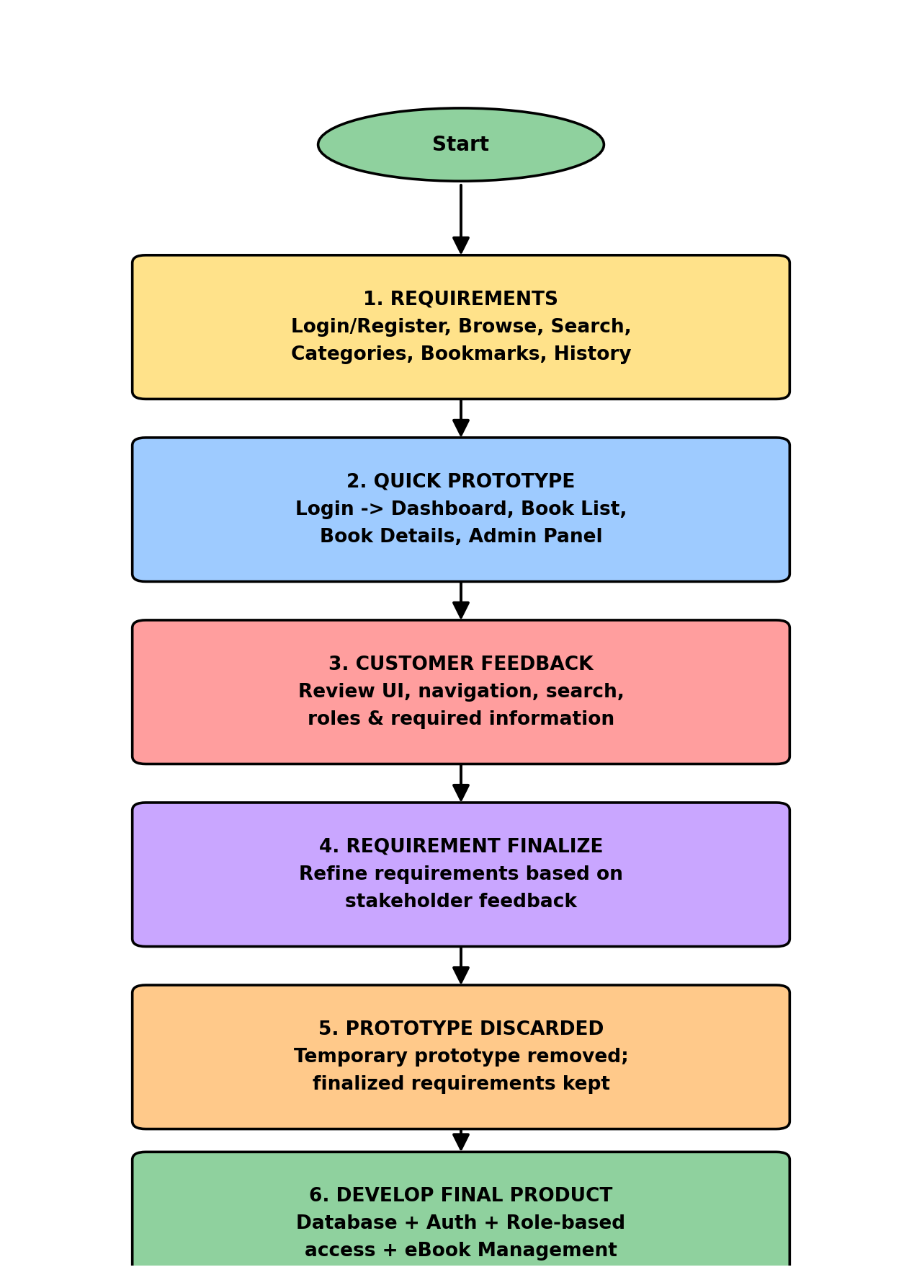
Fig 2.1 — Rapid Throwaway Prototype flow for the eBook Management System

WEEK No. – 03

Evolutionary Prototype

1. Introduction
The eBook Management System (EMS) is a software system designed to manage a digital book catalogue and related user activity in a structured, computerized manner. The system replaces scattered manual file storage with a centralized platform for browsing, searching, bookmarking and tracking eBooks, along with an administrative panel for managing the catalogue.
As with the reference Personnel Management System practical, the requirements of the EMS become clearer once users can actually interact with the software. The Evolutionary Prototyping Model is therefore used: an initial working prototype is built with the most important requirements, users evaluate it and give feedback, the team improves the prototype, and this cycle repeats until the system is complete.

2. Objectives of the EMS
- To maintain the eBook catalogue in an organized and centralized manner.
- To provide secure authentication and controlled access to the system.
- To implement role-based access control so students and administrators see only the functions relevant to them.
- To allow users to browse, search and filter eBooks by category or author.
- To allow users to open/read or download an eBook.
- To allow users to bookmark eBooks and view their reading/download history.
- To allow administrators to add, edit and delete eBooks and manage categories.
- To allow administrators to view registered users and basic book statistics.
- To continuously improve the system based on stakeholder feedback.

3. Evolutionary Prototyping Model
Definition: Evolutionary Prototyping is a software development approach in which a basic working prototype is developed first and then continuously improved through repeated user feedback, modification, enhancement and testing. Unlike a throwaway prototype, the evolutionary prototype is not discarded — it is gradually transformed into the final software product. For the EMS, development starts with the most essential functions (authentication, book listing), and additional modules (bookmarks, history, admin panel) are incorporated in successive iterations.
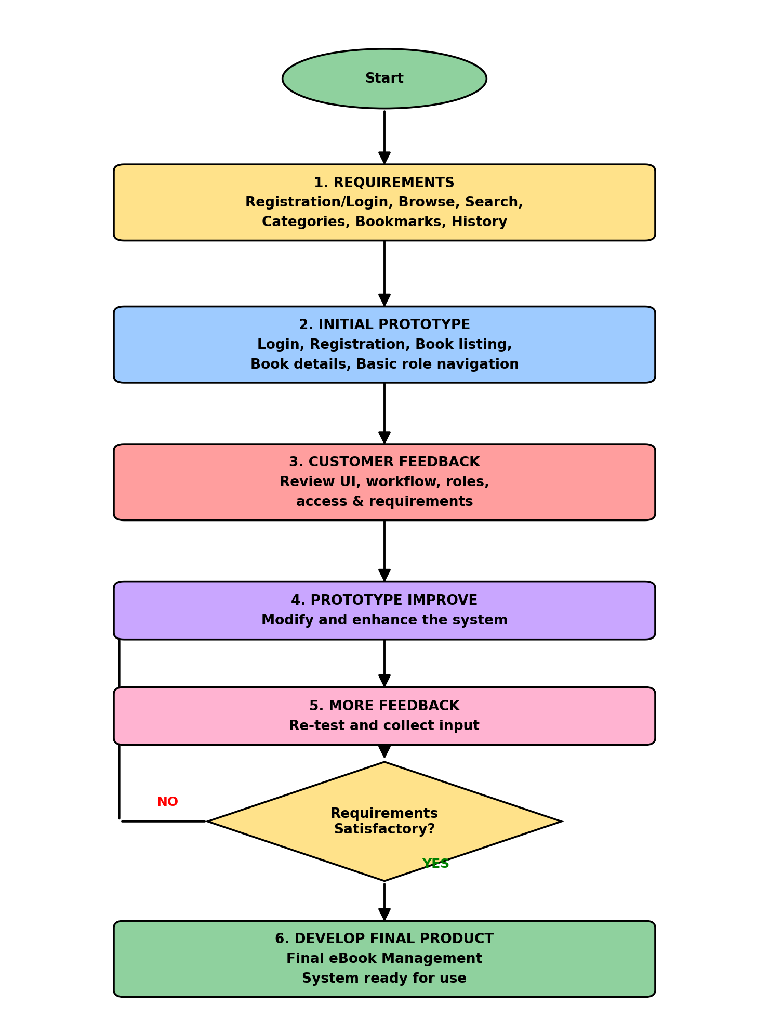
Fig 3.1 — Evolutionary Prototyping Model flow for the eBook Management System

4. Why Evolutionary Prototyping is Used for the EMS
- Requirements can evolve: users may initially describe only basic browsing but later realize they need bookmarks, history or ratings.
- Users can evaluate an actual system rather than only a written specification.
- Role requirements become clearer: a student should not have the same access as an administrator, and a working prototype lets stakeholders verify this.
- Workflow requirements can be refined, such as how search/filter and the admin catalogue screens behave.
- Features can be added progressively — core browsing first, followed by bookmarks, history and admin tools.
- Problems such as usability issues, missing validation, or inappropriate permissions can be identified early.

5. Development of the EMS Using Evolutionary Prototyping
Stage | Name
1 | Requirements
2 | Initial Prototype
3 | Customer Feedback
4 | Prototype Improve
5 | More Feedback
6 | Develop Final Product

a. Requirements
Initial EMS requirements include: secure registration and login; browsing available eBooks; searching and filtering by category/author; viewing book details; opening/reading or downloading a book; bookmarking; viewing reading/download history; and, for administrators, adding, editing and deleting books, managing categories, viewing registered users and basic statistics. Non-functional requirements include security, data integrity, usability, reliability and maintainability.

b. Initial Prototype
The initial prototype is a small but functional version of the EMS. It does not attempt every feature of the final system — its purpose is to give users something they can interact with and evaluate. It may contain: login page, user authentication, basic book listing, book details page, and basic role-based navigation separating the student dashboard from the admin dashboard.
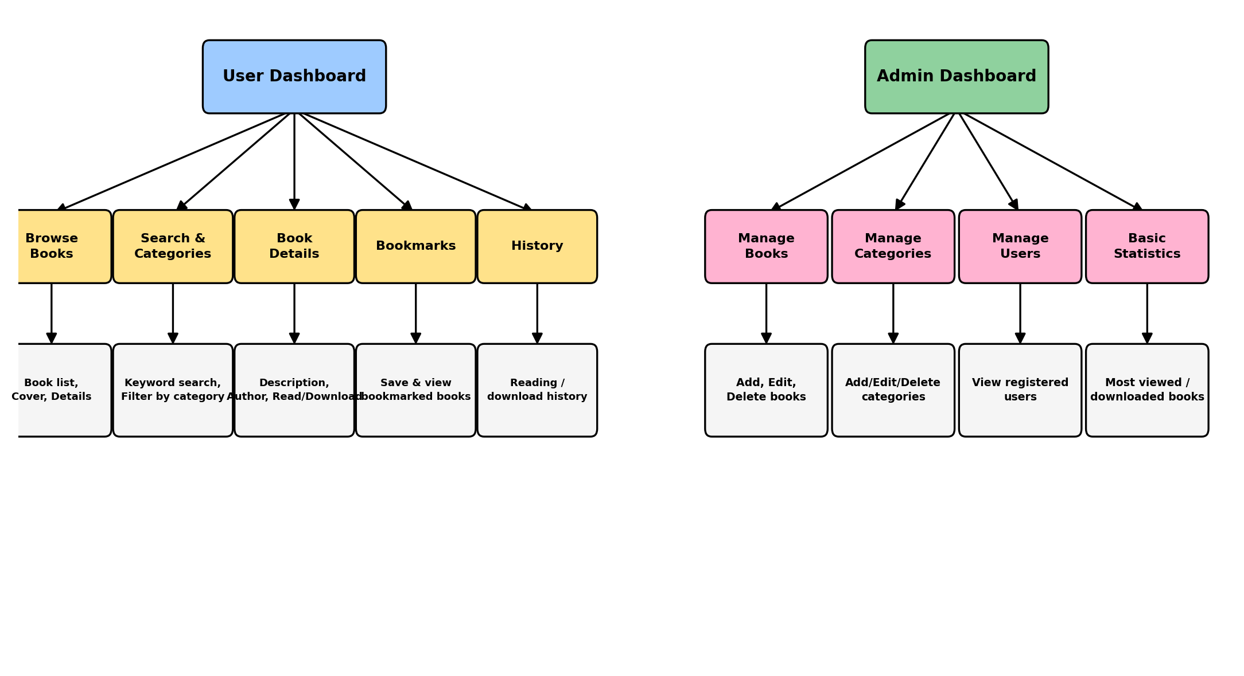
Fig 3.2 — Role-based dashboards: User (left) and Admin (right)

c. Customer Feedback
After developing the initial prototype, it is presented to group members acting as stakeholders. The purpose is to identify missing features, incorrect assumptions, usability problems, access-control problems and additional requirements.
Area | Example Feedback
Login | Authentication should be more secure
Book Details | Users should see cover, author and description clearly
Search | Users should be able to filter by category as well as keyword
Bookmarks | Users should be able to remove a bookmark easily
Admin Panel | Admin should not be able to see other admins' credentials
Statistics | Admin needs simple counts, not complex analytics

d. Prototype Improve
The prototype is not discarded. The development team modifies the existing system and incorporates validated feedback — adding bookmarks and history, refining search/filter, improving validation on the admin forms, and correcting access-control gaps.

e. More Feedback
After the prototype has been improved, it is again provided to stakeholders for evaluation. This stage determines whether previous problems have been solved, whether new features work correctly, whether new problems have appeared, and whether the system is becoming closer to the expected EMS.

f. Develop Final Product
At this point the prototype is converted into the complete, operational eBook Management System containing authentication, book and category management, bookmarks, history, feedback/ratings, and the admin dashboard.

6. Complete Evolution Cycle of the EMS
The EMS follows the same six-stage cycle shown in Fig 3.1: Requirements → Initial Prototype → Customer Feedback → Prototype Improve → More Feedback → (Requirements Satisfactory? No → loop back / Yes →) Develop Final Product.

7. Example Evolution of EMS Features
Iteration | Main Features | Purpose
Iteration 1 | Login, Registration | Establish basic authentication
Iteration 2 | Book Listing, Book Details, Categories, Search | Establish the core book library
Iteration 3 | Admin Panel: Add/Edit/Delete Book, Manage Categories | Give administrators catalogue control
Iteration 4 | Bookmarks, Reading/Download History | Add personalized user features
Iteration 5 | Feedback & Ratings, bug fixes (UI, auth, search, permissions) | Test with stakeholders and refine
Final | Complete eBook Management System | Deploy the evolved EMS

8. Advantages of Evolutionary Prototyping for the EMS
- User Feedback: users can directly interact with the prototype and give practical feedback.
- Early Requirement Identification: missing requirements (e.g. bookmarks) can be found before the final system is complete.
- Gradual Development: the EMS can be developed module by module (auth → catalogue → admin → personalization).
- Improved Usability: interface and workflow problems are identified and corrected during development.
- Progressive Feature Addition: modules such as bookmarks, history and feedback can be introduced progressively.

9. Disadvantages
- Continuous changes can increase development time.
- Frequent modifications can make project management difficult.
- Uncontrolled requirements can cause scope expansion (which is why this project intentionally excludes payments, subscriptions and complex recommendation AI).
- Repeated feedback cycles require additional effort.

10. Conclusion
The Evolutionary Prototyping Model provides a systematic, iterative approach for developing the eBook Management System. Instead of building the complete EMS in a single step, the system begins with a small working prototype and progressively evolves through user interaction and feedback. The six stages — Requirements, Initial Prototype, Customer Feedback, Prototype Improve, More Feedback and Develop Final Product — are applied exactly as in the reference practical, but scoped to a deliberately small and achievable system: a functional eBook library rather than a full commercial publishing platform.

WEEK No. – 04

Entity–Relationship Diagram

1. Identify Entities
The major entities in the eBook Management System are:
- User
- Book
- Category
- Bookmark
- History
- Feedback
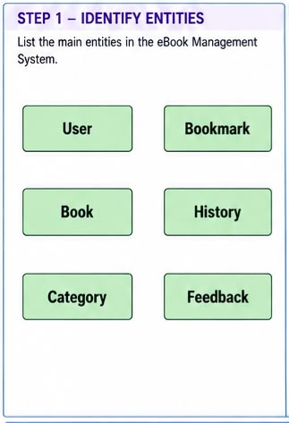

2. Attributes of Each Entity
The important attributes of each entity are given below. Primary keys are marked (PK).

a. User
- user_id — Primary Key
- name
- email
- password
- role
- created_at

b. Book
- book_id — Primary Key
- title
- author
- description
- category_id
- file_path
- cover_image
- uploaded_by
- created_at

c. Category
- category_id — Primary Key
- category_name
- description

d. Bookmark
- bookmark_id — Primary Key
- user_id
- book_id
- created_at

e. History
- history_id — Primary Key
- user_id
- book_id
- action
- timestamp

f. Feedback
- feedback_id — Primary Key
- user_id
- book_id
- rating
- comment
- created_at

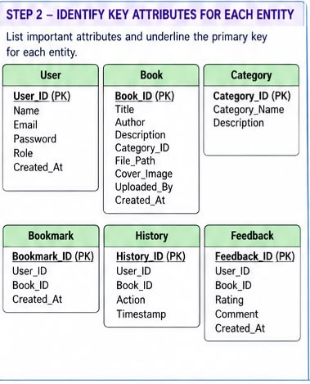

3. Basic Relationships
- User has Bookmark
- User has History
- User gives Feedback
- Book bookmarked_in Bookmark
- Book recorded_in History
- Book receives Feedback
- Book belongs_to Category

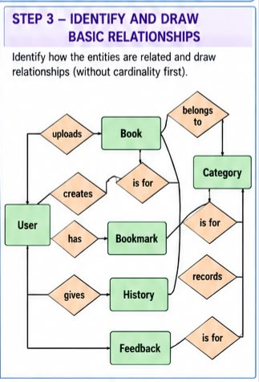

4. Cardinality (Min : Max)
Relationship | Cardinality
User — has — Bookmark | 1 : M
User — has — History | 1 : M
User — gives — Feedback | 1 : M
Book — bookmarked_in — Bookmark | 1 : M
Book — recorded_in — History | 1 : M
Book — receives — Feedback | 1 : M
Book — belongs_to — Category | M : 1

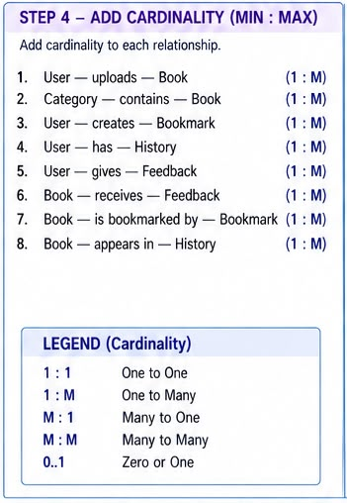

Step 5 – Add More Relationships:

This step extends the ER diagram by establishing remaining relationships and cardinalities (such as 1:M) between core entities like Category, User, Book, Bookmark, History, and Feedback. It maps out how users interact with books, track their history, and provide feedback within a simplified database layout.

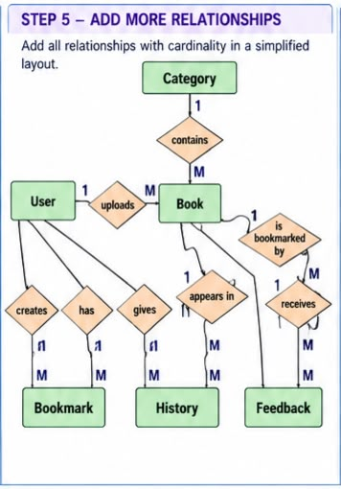

Step 6 – Add Key Attributes:

This step defines the structural details of the entities by attaching relevant attributes, identifying primary keys (underlined attributes like User_ID, Book_ID, and Category_ID), and illustrating main entity connections like user uploads and category classifications.

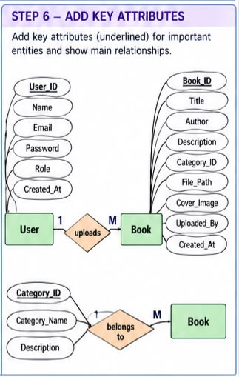

7. Complete ER Diagram with Cardinality

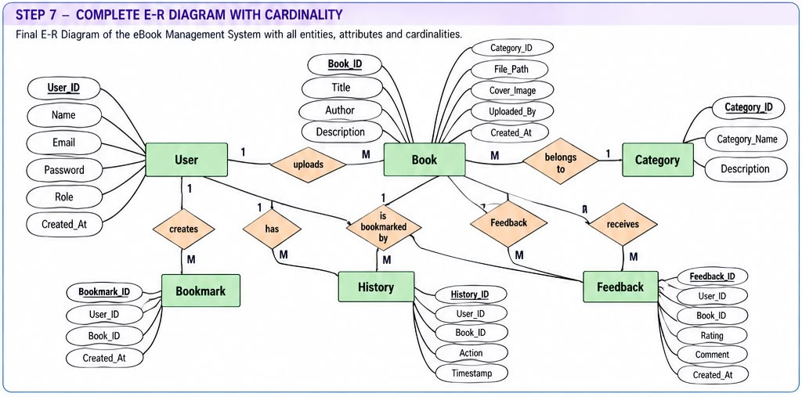

WEEK No. – 05

COCOMO Model
For the COCOMO (Constructive Cost Model):
- Effort = a (KLOC)^b [Person-Months]
- Development Time = c (Effort)^d [Months]
- Staff = Effort / Development Time
Project Type | a | b | c | d
Organic | 2.4 | 1.05 | 2.5 | 0.38
Semi-detached | 3.0 | 1.12 | 2.5 | 0.35
Embedded | 3.6 | 1.20 | 2.5 | 0.32

The eBook Management System is a small, single-team academic project with a limited feature set (authentication, book catalogue, categories, bookmarks, history, feedback, and a lightweight admin panel), covering roughly 6 entities and 5 development iterations. The estimated size of the project is therefore taken as 6 KLOC (Kilo Lines of Code), noticeably smaller than the reference PMS project's 19 KLOC, reflecting the deliberately reduced scope described in Week 1.

For the Organic Project:
- Effort = 2.4 × (6)^1.05 = 15.75 P.M
- Development Time = 2.5 × (15.75)^0.38 = 7.13 Months
- Staff = (15.75 / 7.13) = 2.21 ≈ 2 persons
- Effective Development Time = 0.5 × Development Time = 3.57 Months
- Effective Staff = (Effort / Effective Development Time) = 4.42 ≈ 4 persons

For the Semi-detached Project:
- Effort = 3.0 × (6)^1.12 = 22.32 P.M
- Development Time = 2.5 × (22.32)^0.35 = 7.41 Months
- Staff = (22.32 / 7.41) = 3.01 ≈ 3 persons
- Effective Development Time = 0.5 × Development Time = 3.71 Months
- Effective Staff = (Effort / Effective Development Time) = 6.02 ≈ 6 persons

For the Embedded Project:
- Effort = 3.6 × (6)^1.20 = 30.91 P.M
- Development Time = 2.5 × (30.91)^0.32 = 7.49 Months
- Staff = (30.91 / 7.49) = 4.13 ≈ 4 persons
- Effective Development Time = 0.5 × Development Time = 3.75 Months
- Effective Staff = (Effort / Effective Development Time) = 8.25 ≈ 8 persons

Compared to the reference PMS project (19 KLOC, requiring an estimated 5–21 effective staff depending on project mode), the eBook Management System's smaller estimated size of 6 KLOC results in a proportionally smaller effort and team size — consistent with the project being deliberately scoped as a functional eBook library rather than a full-scale commercial platform.

