

**Module Code & Module Title**

**CS5004NA Emerging Programming Platforms and Technologies**

**Assessment Weightage & Type**

**50% Individual Coursework**

**Year and Semester**

**2019-20 Spring**

**Student Name: Animesh Gautam**

**London Met ID: 18029830**

**College ID: NP01CP4A180083**

**Assignment Due Date: 3rd June 2020**

**Assignment Submission Date: 3rd June 2020**

**Title: Online Used Car Shop**

**Word Count (Where Required): \***

*I confirm that I understand my coursework needs to be submitted online via Google Classroom under the relevant module page before the deadline for my assignment to be accepted and marked. I am fully aware that late submissions will be treated as non-submission and a mark of zero will be awarded.*

**Contents**

**1.** **Introduction** 1

**2.** **XML Content** 2

**2.1** **Tree Diagram** 2

**2.2** **XML Content** 4

**3.** **Schema** 14

**4.** **Testing** 18

**5.** **Tools and Technologies** 26

**6.** **Limitation of DTD and CSS** 30

**7.** **Critical Evaluation** 32

**8.** **Conclusion** 35

9. **References** 36

**Table of Figures**

Figure 1-Tree diagram sample (W3schools, 2020) 2

Figure 2-Tree Diagram 3

Figure 3_Keeping the file in XML validator 18

Figure 4-Validating XML file 18

Figure 5- Displaying XML file in browser without any external CSS 20

Figure 6-Displaying XML file in browser with CSS 21

Figure 7-Error in schema file 22

Figure 8-Error while validating schema file with XML file 23

Figure 9-Keeping Schema file in XML validator to validate with XML file 24

Figure 10-Validated XML and Schema file 25

Figure 11-Visual Studio Code 26

Figure 12-Google Chrome 27

Figure 13-draw.io 28

Figure 14-xmlvalidation.com 29

Figure 15-w3schools 32

Figure 16-Design of XML document 33

Figure 17-Error while validating schema file 33

**Table of Tables**

Table 1-Test 1 18

Table 2-Test 2 20

Table 3-Test 3 21

Table 4-Test 4 22

Table 5-Test 5 24

# **Introduction**

XML stands for extensible Markup Language is a markup language much like HTML. It was created by the World Web Consortium (W3C) in which we can create our own tag. Though Hypertext Markup Language (HTML) being the basis for all web pages, XML was introduced to overcome the limitation of HTML. Like HTML, XML is also based on SGML (Standard Generalized Markup Language) which was designed to store and transport data. (Tidwell, 2020)XML is just information wrapped in tags that was designed to be self-descriptive. XML does not Do anything. XML does not use predefined tags; it is defined by author both tags and the document structure. XML is extensible. XML is popular nowadays as it simplifies things like simplifies data sharing, data transport, platform changes, and data availability. (w3schools.com, 199-2020)

This project was given to us to model a system for an online used vehicle as an XML developer. Scenario was given to us; additional information was to be added as our wish and prepare data in XML. Different data, attributes and optional data fields were to be used according to the condition given to us. Using the data structure and using real time scenario an XML document was created. We were given to create a schema filed based on the structure of an XML. Applying schema to the contents of XML file, it was to be validate using an online validator. A CSS file was to be created to render the XML data file in web browser. Design was to be done as our wish and also fulfilling the criteria given to us for creating CSS. Report was to be generated showing how we designed and implemented the coursework with proper structure, and evidences. Tree diagram was created and testing was also done.

# **XML Content**

## **Tree Diagram**

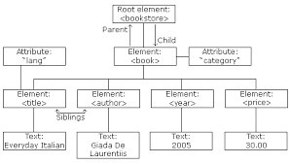Tree Diagram is a tree like structure which helps to describe an XML document. It contains root elements which is also called as parent element, child element and so on. Root element is at the top and the child elements are connected to root elements, the same way, how leaves are connected to tree through branches. (javaTpoint, 2018)Tree Diagram looks like following:

Figure -Tree diagram sample (W3schools, 2020)

The diagram show below, is tree diagram of second-hand online shop named as Second Hand Motors. Here, the root element is shop following with its child elements head and body. Both head and body element have their child classes and further on.

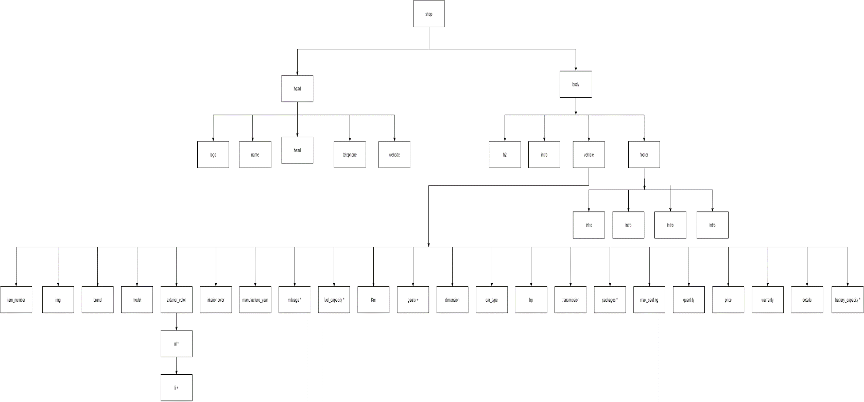

Figure -Tree Diagram

## **XML Content**

 <?xml version= "1.0"?>

<!--Author: Animesh Gautam-->

<!--Giving locayion of CSS file-->

<?xml-stylesheet type="text/css" href="catalog_18029830.css"?>

<!--Declearing root eleement anf giving location of schema document-->

<shop xmlns:xsi="http://www.w3.org/2001/XMLSchema-instance" xsi:noNamespaceSchemaLocation="catalog_18029830.xsd">

<!--Declaring head element and its child element where the information of shop is kept-->

<head>

<logo></logo>

<name>Second Hand Motors</name>

<address>Location: Sorhakhuutya</address>

<telephone>Telephone Number: 01-45414741</telephone>

<Website>Website: www.secondhandmotors.com</Website>

</head>

<!--Declaring body element and its child element which contains the information of cars and further more-->

<body>

<h2>Welcome to Second Hand Motors</h2>

<intro>

<![CDATA[

Hello and welcome to Second Hand Motor, that provides the best deals in buying, selling re-conditioned vehicles with true valuation and on the spot exchange facility along with amiable after sales support.

Feel free to visit our showroom and give us chance to provide you with wide ranges of our services.

]]>

</intro>

<!--Declearing vechicle element and its child elements which stores the data of the car along with attributes and elements that are optional-->

<vehicle type="Hatchback">

<item_number id="C001">01</item_number>

<img picture="Toyota"/>

<brand B_id="HT5">Toyota</brand>

<model m_no="PPX20">Model: Prius Prime XLE</model>

<exterior_color>Exterior Color:

<ul>

<li>Blue Magnetism</li>

<li>Red</li>

<li>Black</li>

</ul>

</exterior_color>

<interior_color>Interior Color: Brown</interior_color>

<manufacture_year>Manufacture Year: 2020</manufacture_year>

<mileage>Mileage: 54 MPG</mileage>

<fuel_capacity>Fuel Capacity: 11.3 gallons</fuel_capacity>

<Km>KM Covered: 5000</Km>

<gears>Gears: 6</gears>

<dimension>Dimension: 4530/1700/1350 mm</dimension>

<car_type>Car Type: Fuel</car_type>

<hp>Horsepower: 121 @ 5200 RPM</hp>

<transmission>Transmission: Automatic, ECVT</transmission>

<packages>Packages: Paint Protection, Floor Liner</packages>

<max_seating>Max Seating: 5</max_seating>

<quantity>Quantity:<value>2</value></quantity>

<price p_id="P001">Price: 50 Lakh</price>

<warranty>Warranty: 3 years</warranty>

<details>

<![CDATA[

Description: A world-class plug-in hybrid, the 2020 Toyota Prius Prime promises a modern style and an ultra-efficient powertrain that is made even more exciting with vibrant exterior colors.

]]>

</details>

</vehicle>

<vehicle type="Sedan">

<item_number id="C002">02</item_number>

<img picture="Hyundai" />

<brand B_id="SH1"> Hyundai</brand>

<model m_no="VS1.5">Model: Verna S 1.5 VTVT</model>

<exterior_color>Exterior Color: Phantom Black</exterior_color>

<interior_color>Interior Color: Black</interior_color>

<manufacture_year>Manufacture Year: 2019</manufacture_year>

<mileage>Mileage: 57 MPG</mileage>

<fuel_capacity>Fuel Capacity: 45 liters</fuel_capacity>

<Km>KM Covered: 10000</Km>

<gears>Gears: 6</gears>

<dimension>Dimension: 4440/1729/1470 mm</dimension>

<car_type>Car Type: Hybrid</car_type>

<hp>Horsepower: 113 @ 6300 RPM</hp>

<transmission>Transmission: Manual, Automatic, ECVT</transmission>

<packages>Packages: Paint Protection</packages>

<max_seating>Max Seating: 5</max_seating>

<quantity>Quantity:<value>1</value></quantity>

<price>Price: 9.31 Lakh</price>

<warranty>Warranty: 3 years</warranty>

<details>

<![CDATA[

Description: The Avg. Ex-Showroom price of Verna S 1.5 VTVT is ₹ 9.31L.The Diesel Manual variants are S Plus 1.5 CRDi, SX 1.5 CRDi and SX (O) 1.5 CRDi. The Petrol Manual variants are SX 1.5 VTVT and SX (O)1.5 VTVT. The Petrol Automatic (CVT) variants are SX 1.5 VTVT IVT and SX (O) 1.5 VTVT IVT. The Diesel Automatic variants are SX 1.5 CRDi AT and SX (O) 1.5 CRDi AT. The Petrol Automatic variants are SX (O) 1.0 Turbo DCT.

]]>

</details>

</vehicle>

<vehicle type="SUV">

<item_number id="C003">03</item_number>

<img picture="Kona" />

<brand B_id="HK20"> Hyundai</brand>

<model m_no="KE2">Model: Kona Electric</model>

<exterior_color>Exterior Color: White</exterior_color>

<interior_color>Interior Color: Premium Black</interior_color>

<manufacture_year>Manufacture Year: 2020</manufacture_year>

<battery_capacity>Battery Capacity: 39.2kWh</battery_capacity>

<Km>KM Covered: 2000</Km>

<dimension>Dimension: 4180/1800/1570 mm</dimension>

<car_type>Car Type: Electric</car_type>

<hp>Horsepower: 134.1bhp</hp>

<transmission>Transmission: Automatic</transmission>

<packages>Packages: Paint Protection, Floor Liner</packages>

<max_seating>Max Seating: 5</max_seating>

<quantity>Quantity:<value>5</value></quantity>

<price>Price: 23.9 Lakh</price>

<warranty>Warranty: 3 years</warranty>

<details>

<![CDATA[

The Hyundai Kona Electric has 1 Electric Engine on offer. It is available with the Automatic transmission. The Kona Electric is a 5 seater SUV and has a length of 4180, width of 1800 and a wheelbase of 2600.

]]>

</details>

</vehicle>

<vehicle type="Sports Car">

<item_number id="C004">04</item_number>

<img picture="Mustang"/>

<brand B_id="FM5"> Ford</brand>

<model m_no="MSGT500">Model: Mustang Shell GT500</model>

<exterior_color>Exterior Color: Red</exterior_color>

<interior_color>Interior Color: Black</interior_color>

<manufacture_year>Manufacture Year: 2013</manufacture_year>

<mileage>Mileage: 24 MPG</mileage>

<fuel_capacity>Fuel Capacity: 10.5 gallons</fuel_capacity>

<Km>KM Covered: 20000</Km>

<gears>Gears: 6</gears>

<dimension>Dimension: 4730/1500/1150 mm</dimension>

<car_type>Car Type: Fuel</car_type>

<hp>Horsepower: 650 hp@6250 RPM</hp>

<transmission>Transmission: Manual</transmission>

<max_seating>Max Seating: 4</max_seating>

<quantity>Quantity:<value>1</value></quantity>

<price>Price: 70 Lakh</price>

<warranty>Warranty: 2 years</warranty>

<details>

<![CDATA[

The GT500 was developed by Ford’s SVT division, the same loon lab responsible for the Ford GT and F-150 SVT Raptor. Like a lot of SVT products, it seems dominated by its engine. The 5.8-liter, supercharged V-8 with 631 lb-ft underhood is a punched-out version of the aluminum-block 5.4 used in the 2011–12 GT500, which was itself essentially a wet-sump evolution of the V-8 used in the GT.

]]>

</details>

</vehicle>

<vehicle type="Crossover">

<item_number id="C005">05</item_number>

<img picture="Mercedes"/>

<brand B_id="MG5">Mercedes-Benz</brand>

<model m_no="Gla7">Model: Gla</model>

<exterior_color>Exterior Color: White</exterior_color>

<interior_color>Interior Color: Beige</interior_color>

<manufacture_year>Manufacture Year: 2018</manufacture_year>

<mileage>Mileage: 17.9 km/Litre</mileage>

<fuel_capacity>Fuel Capacity:50 Litres</fuel_capacity>

<Km>KM Covered: 56,000</Km>

<gears>Gears: 7</gears>

<dimension>Dimension: 4417/1804/1494 mm</dimension>

<car_type>Car Type: Fuel</car_type>

<hp>Horsepower: 136Ps@3400-4000 RPM</hp>

<transmission>Transmission: Automatic</transmission>

<packages>Packages: Leather interior furnishing</packages>

<max_seating>Max Seating: 5</max_seating>

<quantity>Quantity:<value>2</value></quantity>

<price>Price: 25.6 Lakh</price>

<warranty>Warranty: 5 years</warranty>

<details>

<![CDATA[

This is a used Mercedes-Benz GLA 200 Sport 2018 Premium / Super Car model with Petrol variant.The specifications of the Premium / Super Car include engine displacement 1991 cc , fuel efficiency level 17.9 km/litre , fuel tank capacity of 50 litres, maximum power of 136Ps@3400-4000rpm , maximum torque of 300Nm@1600-3000rpm and transmission is Automatic.

]]>

</details>

</vehicle>

<vehicle type="Coupe">

<item_number id="C006">06</item_number>

<img picture="BMW"/>

<brand B_id="BMW2">BMW</brand>

<model m_no="M240i">Model: 2 Series 3.0 M240i</model>

<exterior_color>Exterior Color: Solid Alpine White</exterior_color>

<interior_color>Interior Color: Black</interior_color>

<manufacture_year>Manufacture Year: 2020</manufacture_year>

<mileage>Mileage: 39.8 MPG</mileage>

<fuel_capacity>Fuel Capacity: 52 Litres</fuel_capacity>

<Km>KM Covered: 5000</Km>

<gears>Gears: 5</gears>

<dimension>Dimension: 4454/1984/1408 mm</dimension>

<car_type>Car Type: Fuel</car_type>

<hp>Horsepower: 335 bhp</hp>

<transmission>Transmission: Automatic</transmission>

<packages>Packages: Sun protection Glass</packages>

<max_seating>Max Seating: 4</max_seating>

<quantity>Quantity:<value>6</value></quantity>

<price>Price: 60.5 Lakh</price>

<warranty>Warranty: 5 years</warranty>

<details>

<![CDATA[

The 2 Series Coupe looks and feels decidedly old-school, though for some buyers and long-time BMW fans that will be exactly the appeal, especially in its most potent M240i form. The lower-spec versions face a tougher challenge though, be that from trendy Minis or more up-to-date Audi TTs.

]]>

</details>

</vehicle>

<vehicle type="Convertible">

<item_number id="C007">07</item_number>

<img picture="Audi"/>

<brand B_id="AA3">Audi</brand>

<model m_no="A3C40">Model: A3 Cabriolet </model>

<exterior_color>Exterior Color: Red</exterior_color>

<interior_color>Interior Color:Grey</interior_color>

<manufacture_year>Manufacture Year: 2015</manufacture_year>

<mileage>Mileage: 45 MPG</mileage>

<fuel_capacity>Fuel Capacity: 50 Litres</fuel_capacity>

<Km>KM Covered: 43,000</Km>

<gears>Gears: 7</gears>

<dimension>Dimension: 4421/1793/1409 mm</dimension>

<car_type>Car Type: Fuel</car_type>

<hp>Horsepower: 118Kw @ 6200 RPM</hp>

<transmission>Transmission: Automatic</transmission>

<max_seating>Max Seating: 4</max_seating>

<quantity>Quantity:<value>1</value></quantity>

<price>Price: 40.5 Lakh</price>

<warranty>Warranty: 1 years</warranty>

<details>

<![CDATA[

This is a used Audi A3 Cabriolet 40 TFSI 2015 Premium / Super Car model with Petrol variant.he specifications of the Premium / Super Car include , fuel tank capacity of 50 litres, maximum power of 118Kw@6200rpm , maximum torque of 250Nm @ 1500rpm and transmission is Automatic.

]]>

</details>

</vehicle>

</body>

<footer>

<author>Designed by: Animesh Gautam</author>

<patent>© 2020 Second Hand Motors Pvt.Co</patent>

<Location>Sorhakhuutya, Kathmandu Nepal </Location>

<Phone_Number>Contact Number: 98415676544</Phone_Number>

</footer>

</shop>

 <?xml version= "1.0"?>

<!--Author: Animesh Gautam-->

<!--Giving locayion of CSS file-->

<?xml-stylesheet type="text/css" href="cw.css"?>

<!--Declearing root eleement anf giving location of schema document-->

<shop xmlns:xsi="http://www.w3.org/2001/XMLSchema-instance" xsi:noNamespaceSchemaLocation="cw.xsd">

<!--Declaring head element and its child element where the information of shop is kept-->

<head>

<logo></logo>

<name>Second Hand Motors</name>

<address>Location: Sorhakhuutya</address>

<telephone>Telephone Number: 01-45414741</telephone>

<Website>Website: www.secondhandmotors.com</Website>

</head>

<!--Declaring body element and its child element which contains the information of cars and further more-->

<body>

<h2>Welcome to Second Hand Motors</h2>

<intro>

<![CDATA[

Hello and welcome to Second Hand Motor, that provides the best deals in buying, selling re-conditioned vehicles with true valuation and on the spot exchange facility along with amiable after sales support.

Feel free to visit our showroom and give us chance to provide you with wide ranges of our services.

]]>

</intro>

<!--Declearing vechicle element and its child elements which stores the data of the car along with attributes and elements that are optional-->

<vehicle type="Hatchback">

<item_number id="C001">01</item_number>

<img picture="Toyota"/>

<brand B_id="HT5">Toyota</brand>

<model m_no="PPX20">Model: Prius Prime XLE</model>

<exterior_color>Exterior Color:

<ul>

<li>Blue Magnetism</li>

<li>Red</li>

<li>Black</li>

</ul>

</exterior_color>

<interior_color>Interior Color: Brown</interior_color>

<manufacture_year>Manufacture Year: 2020</manufacture_year>

<mileage>Mileage: 54 MPG</mileage>

<fuel_capacity>Fuel Capacity: 11.3 gallons</fuel_capacity>

<Km>KM Covered: 5000</Km>

<gears>Gears: 6</gears>

<dimension>Dimension: 4530/1700/1350 mm</dimension>

<car_type>Car Type: Fuel</car_type>

<hp>Horsepower: 121 @ 5200 RPM</hp>

<transmission>Transmission: Automatic, ECVT</transmission>

<packages>Packages: Paint Protection, Floor Liner</packages>

<max_seating>Max Seating: 5</max_seating>

<quantity>Quantity:<value>2</value></quantity>

<price p_id="P001">Price: 50 Lakh</price>

<warranty>Warranty: 3 years</warranty>

<details>

<![CDATA[

Description: A world-class plug-in hybrid, the 2020 Toyota Prius Prime promises a modern style and an ultra-efficient powertrain that is made even more exciting with vibrant exterior colors.

]]>

</details>

</vehicle>

<vehicle type="Sedan">

<item_number id="C002">02</item_number>

<img picture="Hyundai" />

<brand B_id="SH1"> Hyundai</brand>

<model m_no="VS1.5">Model: Verna S 1.5 VTVT</model>

<exterior_color>Exterior Color: Phantom Black</exterior_color>

<interior_color>Interior Color: Black</interior_color>

<manufacture_year>Manufacture Year: 2019</manufacture_year>

<mileage>Mileage: 57 MPG</mileage>

<fuel_capacity>Fuel Capacity: 45 liters</fuel_capacity>

<Km>KM Covered: 10000</Km>

<gears>Gears: 6</gears>

<dimension>Dimension: 4440/1729/1470 mm</dimension>

<car_type>Car Type: Hybrid</car_type>

<hp>Horsepower: 113 @ 6300 RPM</hp>

<transmission>Transmission: Manual, Automatic, ECVT</transmission>

<packages>Packages: Paint Protection</packages>

<max_seating>Max Seating: 5</max_seating>

<quantity>Quantity:<value>1</value></quantity>

<price>Price: 9.31 Lakh</price>

<warranty>Warranty: 3 years</warranty>

<details>

<![CDATA[

Description: The Avg. Ex-Showroom price of Verna S 1.5 VTVT is ₹ 9.31L.The Diesel Manual variants are S Plus 1.5 CRDi, SX 1.5 CRDi and SX (O) 1.5 CRDi. The Petrol Manual variants are SX 1.5 VTVT and SX (O)1.5 VTVT. The Petrol Automatic (CVT) variants are SX 1.5 VTVT IVT and SX (O) 1.5 VTVT IVT. The Diesel Automatic variants are SX 1.5 CRDi AT and SX (O) 1.5 CRDi AT. The Petrol Automatic variants are SX (O) 1.0 Turbo DCT.

]]>

</details>

</vehicle>

<vehicle type="SUV">

<item_number id="C003">03</item_number>

<img picture="Kona" />

<brand B_id="HK20"> Hyundai</brand>

<model m_no="KE2">Model: Kona Electric</model>

<exterior_color>Exterior Color: White</exterior_color>

<interior_color>Interior Color: Premium Black</interior_color>

<manufacture_year>Manufacture Year: 2020</manufacture_year>

<battery_capacity>Battery Capacity: 39.2kWh</battery_capacity>

<Km>KM Covered: 2000</Km>

<dimension>Dimension: 4180/1800/1570 mm</dimension>

<car_type>Car Type: Electric</car_type>

<hp>Horsepower: 134.1bhp</hp>

<transmission>Transmission: Automatic</transmission>

<packages>Packages: Paint Protection, Floor Liner</packages>

<max_seating>Max Seating: 5</max_seating>

<quantity>Quantity:<value>5</value></quantity>

<price>Price: 23.9 Lakh</price>

<warranty>Warranty: 3 years</warranty>

<details>

<![CDATA[

The Hyundai Kona Electric has 1 Electric Engine on offer. It is available with the Automatic transmission. The Kona Electric is a 5 seater SUV and has a length of 4180, width of 1800 and a wheelbase of 2600.

]]>

</details>

</vehicle>

<vehicle type="Sports Car">

<item_number id="C004">04</item_number>

<img picture="Mustang"/>

<brand B_id="FM5"> Ford</brand>

<model m_no="MSGT500">Model: Mustang Shell GT500</model>

<exterior_color>Exterior Color: Red</exterior_color>

<interior_color>Interior Color: Black</interior_color>

<manufacture_year>Manufacture Year: 2013</manufacture_year>

<mileage>Mileage: 24 MPG</mileage>

<fuel_capacity>Fuel Capacity: 10.5 gallons</fuel_capacity>

<Km>KM Covered: 20000</Km>

<gears>Gears: 6</gears>

<dimension>Dimension: 4730/1500/1150 mm</dimension>

<car_type>Car Type: Fuel</car_type>

<hp>Horsepower: 650 hp@6250 RPM</hp>

<transmission>Transmission: Manual</transmission>

<max_seating>Max Seating: 4</max_seating>

<quantity>Quantity:<value>1</value></quantity>

<price>Price: 70 Lakh</price>

<warranty>Warranty: 2 years</warranty>

<details>

<![CDATA[

The GT500 was developed by Ford’s SVT division, the same loon lab responsible for the Ford GT and F-150 SVT Raptor. Like a lot of SVT products, it seems dominated by its engine. The 5.8-liter, supercharged V-8 with 631 lb-ft underhood is a punched-out version of the aluminum-block 5.4 used in the 2011–12 GT500, which was itself essentially a wet-sump evolution of the V-8 used in the GT.

]]>

</details>

</vehicle>

<vehicle type="Crossover">

<item_number id="C005">05</item_number>

<img picture="Mercedes"/>

<brand B_id="MG5">Mercedes-Benz</brand>

<model m_no="Gla7">Model: Gla</model>

<exterior_color>Exterior Color: White</exterior_color>

<interior_color>Interior Color: Beige</interior_color>

<manufacture_year>Manufacture Year: 2018</manufacture_year>

<mileage>Mileage: 17.9 km/Litre</mileage>

<fuel_capacity>Fuel Capacity:50 Litres</fuel_capacity>

<Km>KM Covered: 56,000</Km>

<gears>Gears: 7</gears>

<dimension>Dimension: 4417/1804/1494 mm</dimension>

<car_type>Car Type: Fuel</car_type>

<hp>Horsepower: 136Ps@3400-4000 RPM</hp>

<transmission>Transmission: Automatic</transmission>

<packages>Packages: Leather interior furnishing</packages>

<max_seating>Max Seating: 5</max_seating>

<quantity>Quantity:<value>2</value></quantity>

<price>Price: 25.6 Lakh</price>

<warranty>Warranty: 5 years</warranty>

<details>

<![CDATA[

This is a used Mercedes-Benz GLA 200 Sport 2018 Premium / Super Car model with Petrol variant.The specifications of the Premium / Super Car include engine displacement 1991 cc , fuel efficiency level 17.9 km/litre , fuel tank capacity of 50 litres, maximum power of 136Ps@3400-4000rpm , maximum torque of 300Nm@1600-3000rpm and transmission is Automatic.

]]>

</details>

</vehicle>

<vehicle type="Coupe">

<item_number id="C006">06</item_number>

<img picture="BMW"/>

<brand B_id="BMW2">BMW</brand>

<model m_no="M240i">Model: 2 Series 3.0 M240i</model>

<exterior_color>Exterior Color: Solid Alpine White</exterior_color>

<interior_color>Interior Color: Black</interior_color>

<manufacture_year>Manufacture Year: 2020</manufacture_year>

<mileage>Mileage: 39.8 MPG</mileage>

<fuel_capacity>Fuel Capacity: 52 Litres</fuel_capacity>

<Km>KM Covered: 5000</Km>

<gears>Gears: 5</gears>

<dimension>Dimension: 4454/1984/1408 mm</dimension>

<car_type>Car Type: Fuel</car_type>

<hp>Horsepower: 335 bhp</hp>

<transmission>Transmission: Automatic</transmission>

<packages>Packages: Sun protection Glass</packages>

<max_seating>Max Seating: 4</max_seating>

<quantity>Quantity:<value>6</value></quantity>

<price>Price: 60.5 Lakh</price>

<warranty>Warranty: 5 years</warranty>

<details>

<![CDATA[

The 2 Series Coupe looks and feels decidedly old-school, though for some buyers and long-time BMW fans that will be exactly the appeal, especially in its most potent M240i form. The lower-spec versions face a tougher challenge though, be that from trendy Minis or more up-to-date Audi TTs.

]]>

</details>

</vehicle>

<vehicle type="Convertible">

<item_number id="C007">07</item_number>

<img picture="Audi"/>

<brand B_id="AA3">Audi</brand>

<model m_no="A3C40">Model: A3 Cabriolet </model>

<exterior_color>Exterior Color: Red</exterior_color>

<interior_color>Interior Color:Grey</interior_color>

<manufacture_year>Manufacture Year: 2015</manufacture_year>

<mileage>Mileage: 45 MPG</mileage>

<fuel_capacity>Fuel Capacity: 50 Litres</fuel_capacity>

<Km>KM Covered: 43,000</Km>

<gears>Gears: 7</gears>

<dimension>Dimension: 4421/1793/1409 mm</dimension>

<car_type>Car Type: Fuel</car_type>

<hp>Horsepower: 118Kw @ 6200 RPM</hp>

<transmission>Transmission: Automatic</transmission>

<max_seating>Max Seating: 4</max_seating>

<quantity>Quantity:<value>1</value></quantity>

<price>Price: 40.5 Lakh</price>

<warranty>Warranty: 1 years</warranty>

<details>

<![CDATA[

This is a used Audi A3 Cabriolet 40 TFSI 2015 Premium / Super Car model with Petrol variant.he specifications of the Premium / Super Car include , fuel tank capacity of 50 litres, maximum power of 118Kw@6200rpm , maximum torque of 250Nm @ 1500rpm and transmission is Automatic.

]]>

</details>

</vehicle>

</body>

<footer>

<author>Designed by: Animesh Gautam</author>

<patent>© 2020 Second Hand Motors Pvt.Co</patent>

<Location>Sorhakhuutya, Kathmandu Nepal </Location>

<Phone_Number>Contact Number: 98415676544</Phone_Number>

</footer>

</shop>

1. **Schema Content**

<?xml version="1.0"?>

<xs:schema xmlns:xs="http://www.w3.org/2001/XMLSchema">

<!--Creating schema for the 'shop' element in sequentical order which is of complex type-->

<xs:element name="shop">

<xs:complexType>

<xs:sequence>

<!--Referencing the child elements of 'shop'-->

<xs:element ref="head"/>

<xs:element ref="body"/>

<xs:element ref="footer"/>

</xs:sequence>

</xs:complexType>

</xs:element>

<!--Creating schema for the 'head' element in sequentical order which is of complex type-->

<xs:element name="head">

<xs:complexType>

<xs:sequence>

<!--Creating schema for the child elements of 'head'-->

<xs:element name="logo"/>

<xs:element name="name" type="xs:string"/>

<xs:element name="address" type="xs:string"/>

<xs:element name="telephone" type="xs:string"/>

<xs:element name="Website" type="xs:string"/>

</xs:sequence>

</xs:complexType>

</xs:element>

<!--Creating schema for the 'body' element in sequentical order which is of complex type-->

<xs:element name="body">

<xs:complexType>

<xs:sequence>

<!--Creating schema for the child elements of 'body' and also referencing them-->

<xs:element name="h2" type="xs:string"/>

<xs:element name="intro" type="xs:string"/>

<xs:element ref="vehicle" minOccurs="0" maxOccurs="7"/>

</xs:sequence>

</xs:complexType>

</xs:element>

<!--Creating schema for the child elements of 'body' in sequenctial order which is of complex type-->

<xs:element name="vehicle">

<xs:complexType>

<xs:sequence>

<!--Creating schema for the child elements of 'vehicle' and also referencing them-->

<xs:element ref="item_number"/>

<xs:element ref="img"/>

<xs:element ref="brand"/>

<xs:element ref="model"/>

<xs:element ref="exterior_color"/>

<xs:element name="interior_color" type="xs:string"/>

<xs:element name="manufacture_year" type="xs:string"/>

<!--minOcuurs and maxOcuurs means that the data has been repated and is optiional-->

<xs:element name="battery_capacity" type="xs:string" minOccurs="0" maxOccurs="unbounded"/>

<xs:element name="mileage" type="xs:string" minOccurs="0" maxOccurs="unbounded"/>

<xs:element name="fuel_capacity" type="xs:string" minOccurs="0" maxOccurs="unbounded"/>

<xs:element name="Km" type="xs:string"/>

<xs:element name="gears" type="xs:string" minOccurs="0" maxOccurs="unbounded"/>

<xs:element name="dimension" type="xs:string"/>

<xs:element ref="car_type"/>

<xs:element name="hp" type="xs:string"/>

<xs:element name="transmission" type="xs:string"/>

<xs:element name="packages" type="xs:string" minOccurs="0" maxOccurs="unbounded"/>

<xs:element name="max_seating" type="xs:string"/>

<xs:element ref="quantity" />

<xs:element ref="price"/>

<xs:element name="warranty" type="xs:string"/>

<xs:element name="details" type="xs:string"/>

</xs:sequence>

<!--Creating schema for attribute of 'vehicle' which is of type string and is required in each vehicle element -->

<xs:attribute name="type" type="xs:string" use="required"/>

</xs:complexType>

</xs:element>

<!--Creating schema for the child elements of 'vehicle' which contains both compplex and simple type data-->

<xs:element name="item_number">

<xs:complexType>

<xs:simpleContent>

<xs:extension base="xs:integer">

<!--Creating schema for attribute of 'item_number' which is of type string and is required in each vehicle element -->

<xs:attribute name="id" type="xs:string" use="required"/>

</xs:extension>

</xs:simpleContent>

</xs:complexType>

</xs:element>

<!--Creating schema for the child elements of 'vehicle'-->

<xs:element name="img">

<xs:complexType>

<!--Creating schema for attribute of 'img' which is of type string and is required in each vehicle element -->

<xs:attribute name="picture" type="xs:string" use="required"/>

</xs:complexType>

</xs:element>

<!--Creating schema for the child elements of 'vehicle' which contains both compplex and simple type data-->

<xs:element name="brand">

<xs:complexType>

<xs:simpleContent>

<xs:extension base="xs:string">

<!--Creating schema for attribute of 'brand' which is of type string and is required in each vehicle element -->

<xs:attribute name="B_id" type="xs:string" use="required"/>

</xs:extension>

</xs:simpleContent>

</xs:complexType>

</xs:element>

<!--Creating schema for the child elements of 'vehicle' which contains mixed type of data-->

<xs:element name="model">

<xs:complexType mixed="true">

<!--Creating schema for attribute of 'model' which is of type string and is required in each vehicle element -->

<xs:attribute name="m_no" type="xs:string" use="required"/>

</xs:complexType>

</xs:element>

<!--Creating schema for the child elements of 'vehicle' which contains mixed type of data-->

<xs:element name="exterior_color">

<xs:complexType mixed="true">

<xs:sequence>

<xs:element ref="ul" minOccurs="0" />

</xs:sequence>

</xs:complexType>

</xs:element>

<!--Creating schema for the child elements of 'vehicle' which contains complex type of data-->

<xs:element name="ul">

<xs:complexType>

<xs:sequence>

<xs:element name="li" type="xs:string" minOccurs="1" maxOccurs="unbounded"/>

</xs:sequence>

</xs:complexType>

</xs:element>

<!--Creating schema for the child elements of 'vehicle' which contains simple type of data-->

<xs:element name="car_type">

<xs:simpleType>

<!--Adding restriction to "car_type" element-->

<xs:restriction base="xs:string">

<!--Defining a pattern for restriction using regex-->

<xs:enumeration value="Car Type: Fuel"/>

<xs:enumeration value="Car Type: Hybrid"/>

<xs:enumeration value="Car Type: Electric"/>

</xs:restriction>

</xs:simpleType>

</xs:element>

<!--Creating schema for the child elements of 'vehicle' which contains mixed type of data-->

<xs:element name="quantity">

<xs:complexType mixed="true">

<xs:sequence>

<xs:element ref="value"/>

</xs:sequence>

</xs:complexType>

</xs:element>

<!--Creating schema for the child elements of 'vehicle' which contains simple type of data-->

<xs:element name="value">

<xs:simpleType>

<!--Adding restriction to "value" element-->

<xs:restriction base="xs:integer">

<!--Defining a pattern for restriction using regex-->

<xs:pattern value="[0-9]"/>

</xs:restriction>

</xs:simpleType>

</xs:element>

<!--Creating schema for the child elements of 'vehicle' which contains mixed type of data-->

<xs:element name="price">

<xs:complexType mixed="true">

<!--Creating schema for attribute of 'price' which is of type string and is optional -->

<xs:attribute name="p_id" type="xs:string" use="optional"/>

</xs:complexType>

</xs:element>

<!--Creating schema for the 'footer' element in sequentical order which is of complex type-->

<xs:element name="footer">

<xs:complexType>

<xs:sequence>

<xs:element name="author" type="xs:string"/>

<xs:element name="patent" type="xs:string"/>

<xs:element name="Location" type="xs:string"/>

<xs:element name="Phone_Number" type="xs:string"/>

</xs:sequence>

</xs:complexType>

</xs:element>

</xs:schema>

# **Testing**

Table -Test 1

|  |  |
| --- | --- |
| **Test No** | 1 |
| Activity | Validating XML file using XML validator website. |
| Expected Output | No errors were found. |
| Actual Output | No errors were found. |

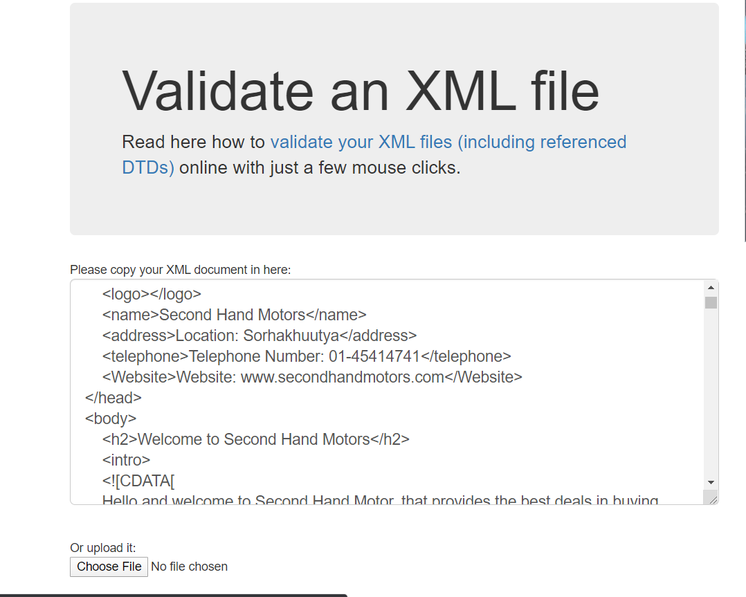

Figure _Keeping the file in XML validator

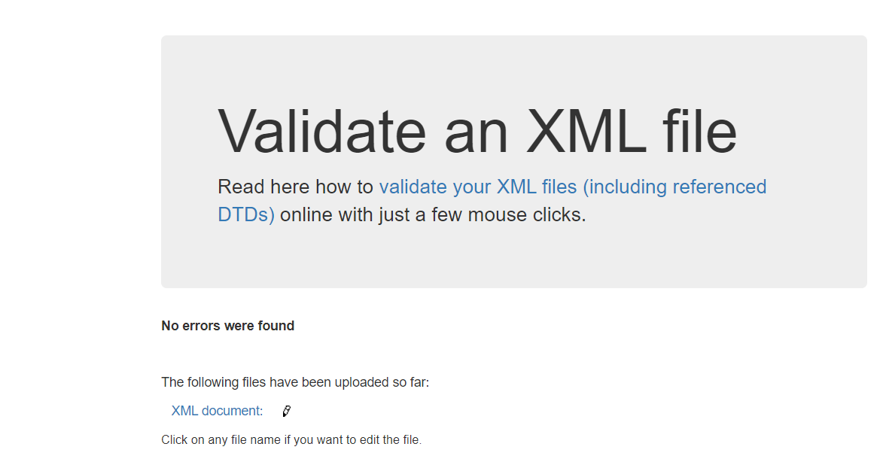

Figure -Validating XML file

Table -Test 2

|  |  |
| --- | --- |
| **Test No** | 2 |
| Activity | Running XML file in web browser without any external CSS. |
| Expected Output | All the elements with their respective data should be displayed. |
| Actual Output | All the elements with their respective data should be displayed. |

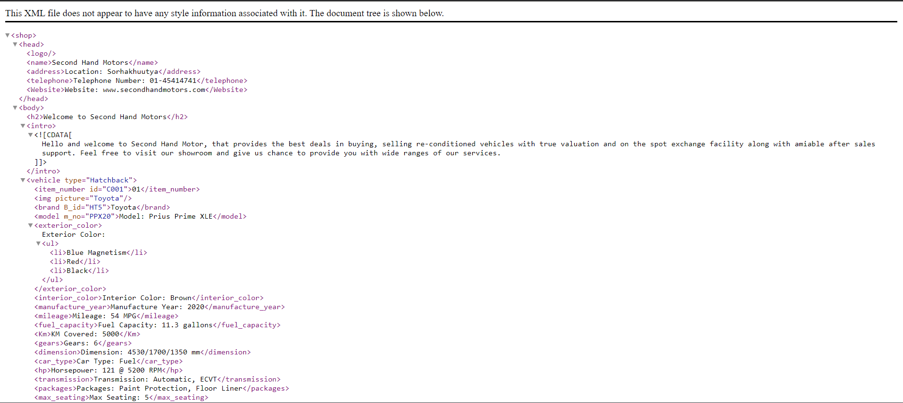

Figure - Displaying XML file in browser without any external CSS

Table -Test 3

|  |  |
| --- | --- |
| **Test No** | 3 |
| Activity | Running XML file in web browser with external CSS. |
| Expected Output | All data should be displayed with proper design and structure. |
| Actual Output | All data are displayed with proper design and structure. |

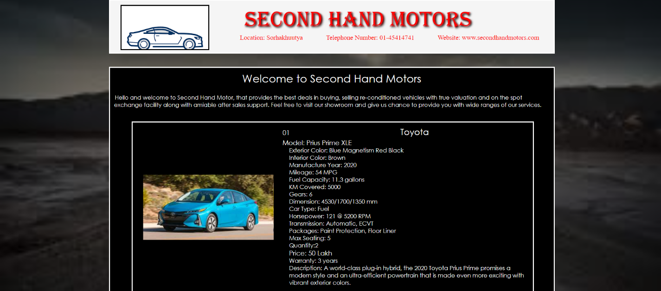

Figure -Displaying XML file in browser with CSS

Table -Test 4

|  |  |
| --- | --- |
| **Test No** | 4 |
| Activity | Validating XML file with external schema by giving invalid type of an element. |
| Expected Output | An error should be displayed showing invalid type of an element. |
| Actual Output | An error is displayed showing invalid type of an element. |

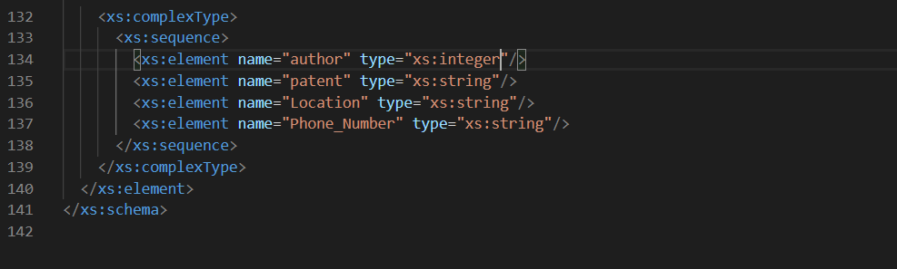

Figure -Error in schema file

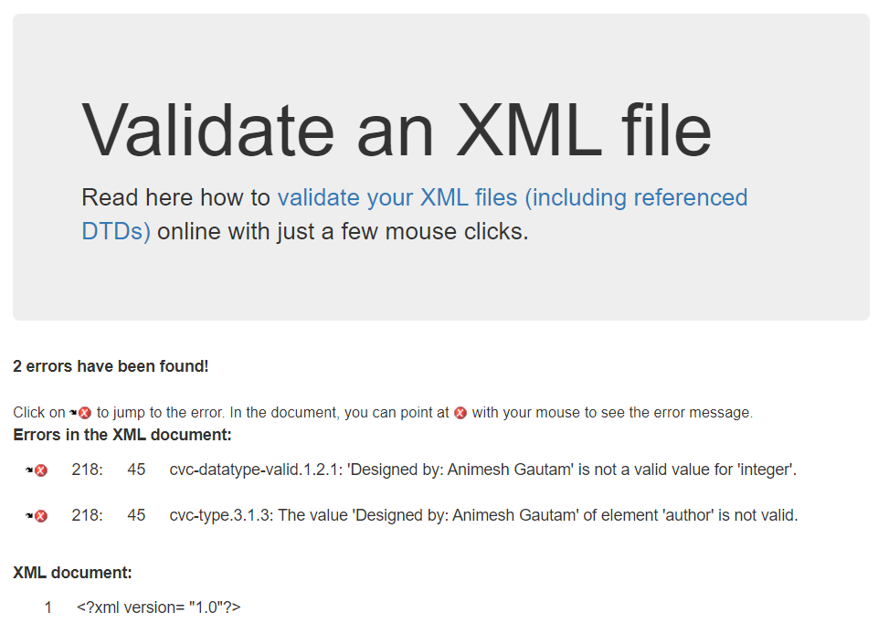

Figure -Error while validating schema file with XML file

Table -Test 5

|  |  |
| --- | --- |
| **Test No** | 5 |
| Activity | Validating XML file with external schema. |
| Expected Output | No errors were found. |
| Actual Output | No errors were found. |

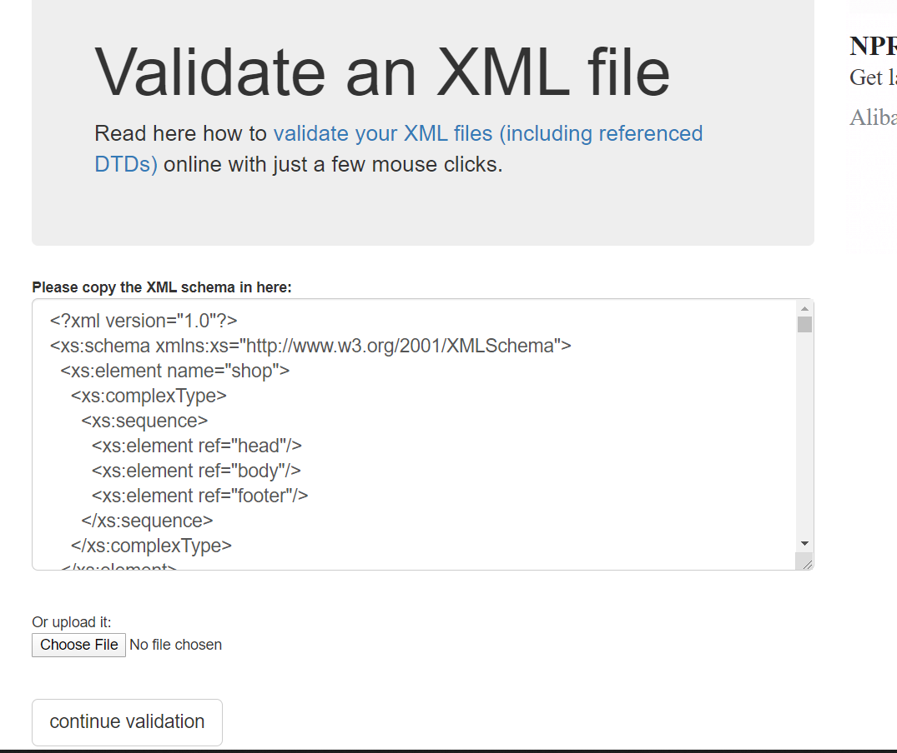

Figure -Keeping Schema file in XML validator to validate with XML file

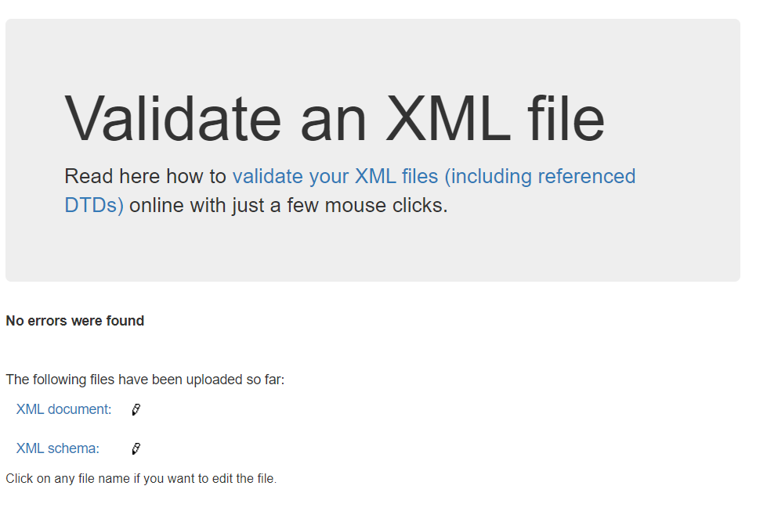

Figure -Validated XML and Schema file

# **Tools and Technologies**

While doing this coursework different tools and technologies were used which helped me to finish my coursework faster. These tools and technologies were very useful and helpful. It helped me to design, develop and test the document successfully. These tools and technologies are easily available on internet nowadays. The tools and technologies that I used for developing my coursework are:

* Visual Studio Code: Visual Studio Code is a code editor redefined and optimized for building and debugging modern web and cloud application. It is very powerful editor that supports different programming language. It is very easy to use and is high customizable with various extensions. All the XML document, CSS, and Schema was created using Visual Studio Code. (Lorenz, 2019)

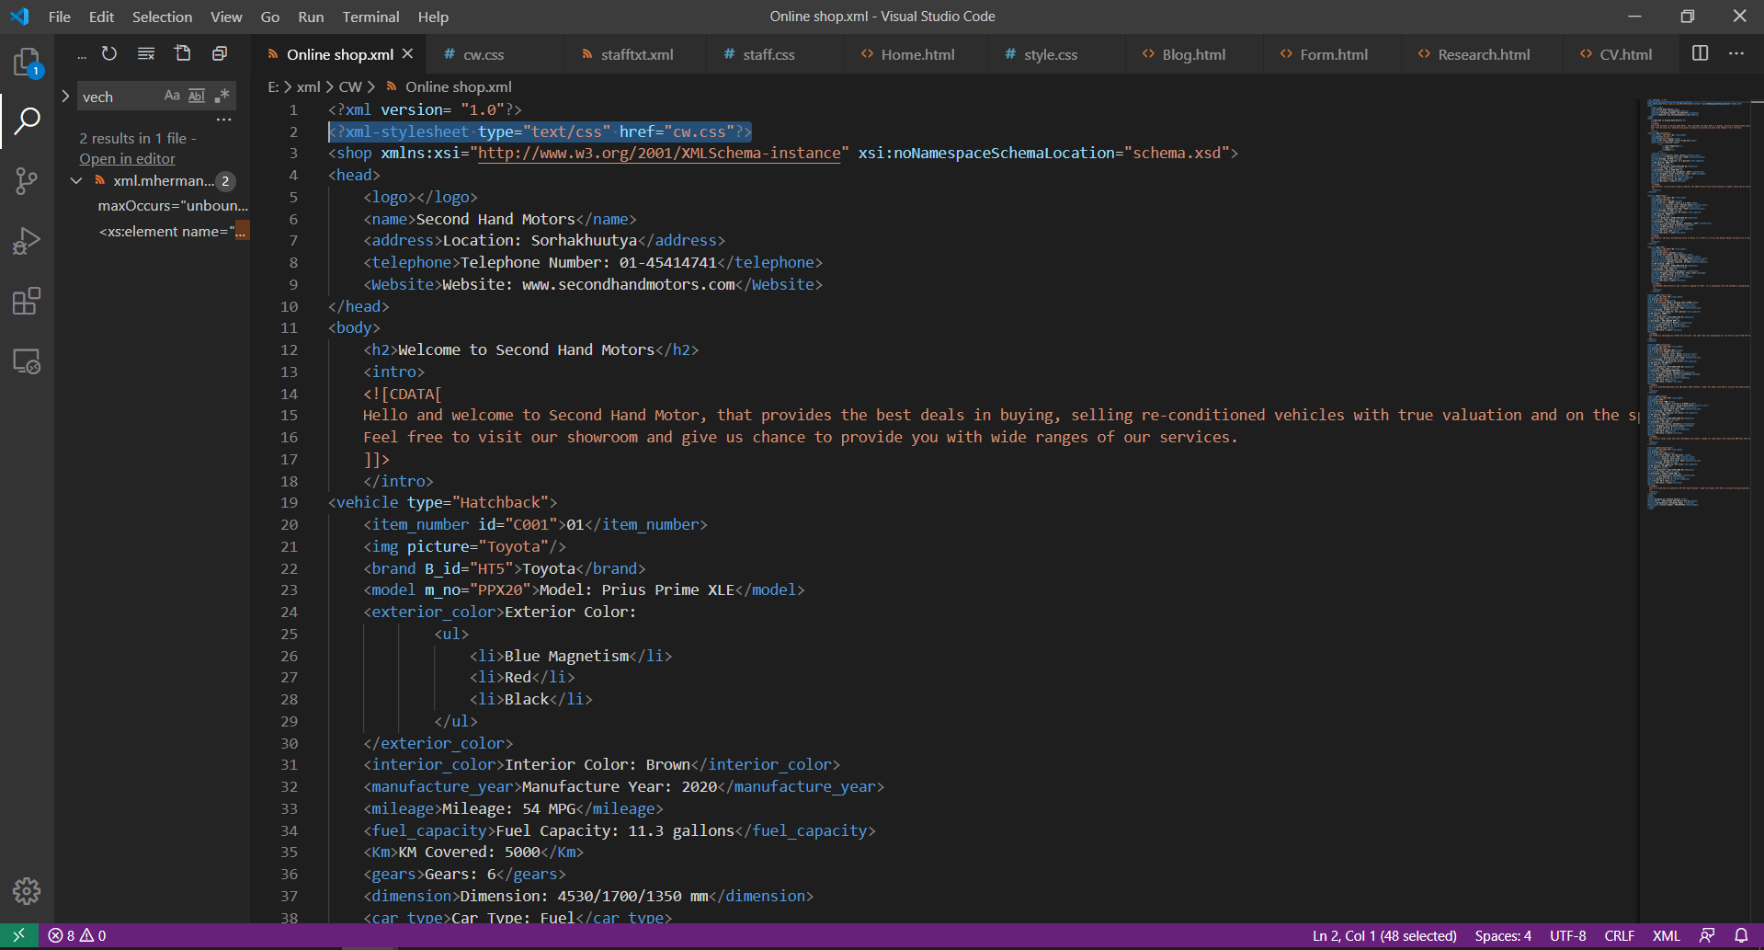

Figure -Visual Studio Code

* Google Chrome: Chrome is a free internet browser for accessing the World Wide Web and running Web-based applications. All those XML files and CSS were displayed using chrome. It is also used for testing whether the data and design are displayed properly or not. It is available for Windows, Mac OS X, Linux, Android and iOS. (Rouse, 2013)

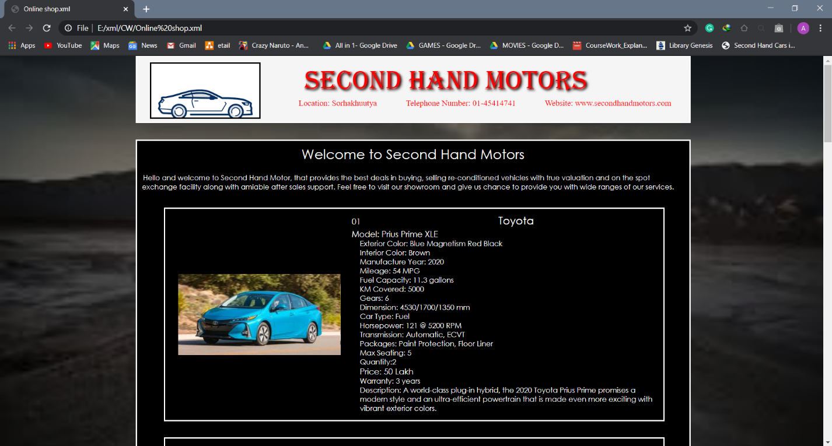

Figure -Google Chrome

* draw.io: draw.io is a free online diagram software which is used for making several diagrams. It is very easy to use and can be used to create flowchart, network diagram, UML, ER diagram and many more. The drawn images can be downloaded in several extensions. (GitHub, 2020) The tree diagram was build using draw.io.

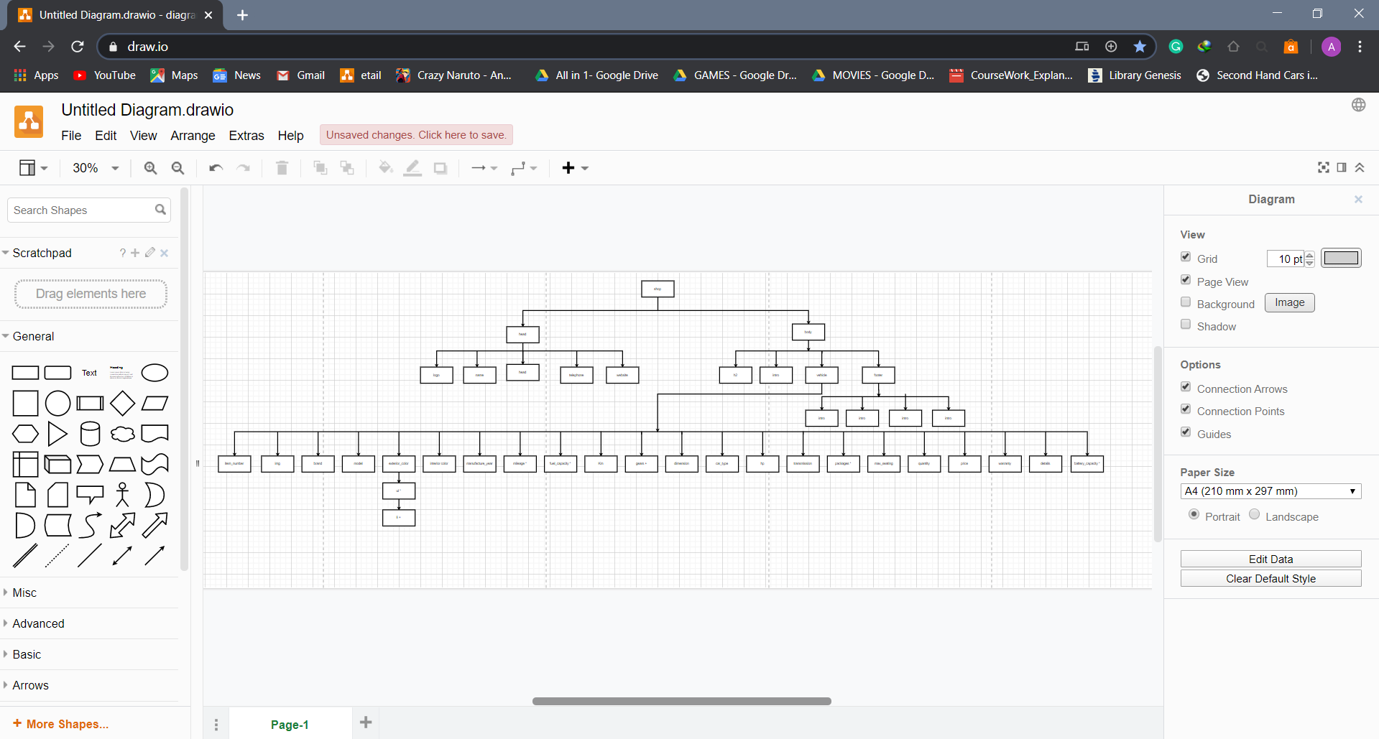

Figure -draw.io

* Other tools: Some other websites were also used that helped to complete the project. XML validator was used to check the XML file and schema file. <https://www.xmlvalidation.com/> is the URL of the XML validator that I used to validated XML file, and XML file with schema. There were other several websites that helped me with the idea of creating XML document, designing it, and developing it.

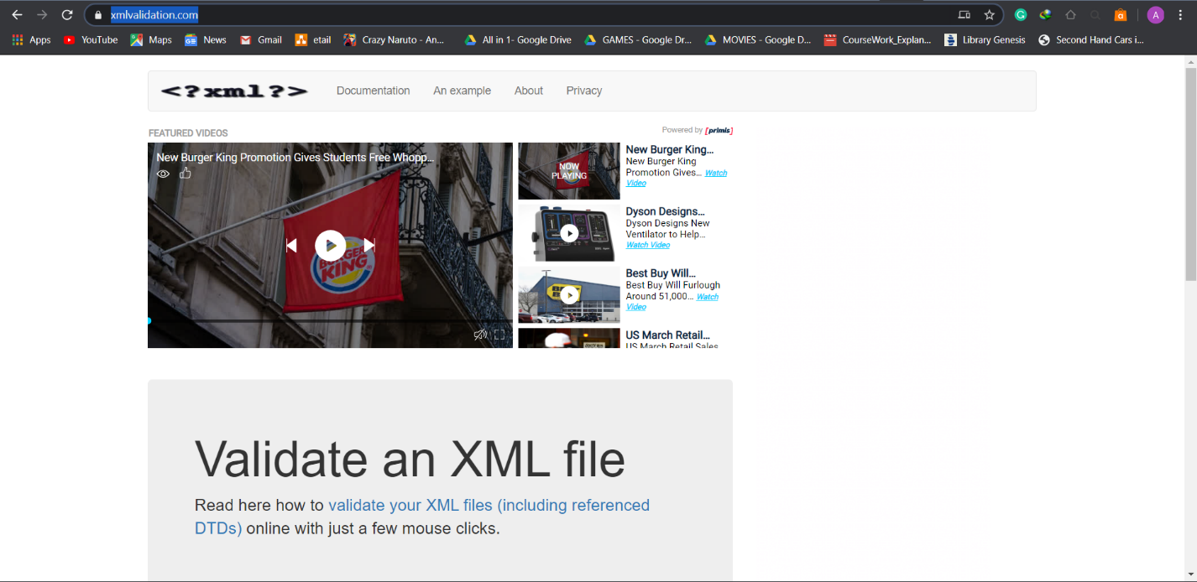

Figure -xmlvalidation.com

# **Limitation of DTD and CSS**

DTD also know as Document Type Definition It defines the is used to describe the XML languages. It defines the structure and the legal elements and attributes of an XML document. It checks the validity of structure and vocabulary of an XML document against the grammatical rules of the appropriate XML language. DTD can be categorized into Internal DTD and External DTD. If the DTD is within the file then it is Internal DTD, and if the DTD is declared in a separate file it is External DTD. Even though DTDs defines and checks the validity of structure, it has some limitations. The limitations are:

* DTDs basically support only one data type: the text string. DTDs have weak data typing.
* There can only be one single DTD per document. Though there are two types of DTD, internal and external only one DTD can be referenced to XML document. If we reference both DTDs to XML document, then the inter DTD overrides the external DTD.
* DTD do not support namespace very well. Namespace is the process by which the attributes and element names can be assigned to groups. If a namespace is to be used, the entire namespace must be defined within the DTD.’
* DTDs are not object oriented. Inheritance concept cannot be applied to DTDs. (tutorilaspoint, 2020)

CSS also know as Cascading Style sheets is a simple design language used for describe the look and formatting of document written in markup language. CSS handles the look and feel part of a web page making web pages presentable. It is used to define styles for our web pages, including design, layout and variations in display for different devices and screen sizes. CSS is easy to learn, understand and use. It saves a lot of work. (tutorialspoint, 2020) The limitations of CSS are:

* CSS works differently on different browsers. The design that works on one browser may not always work on another.
* CSS is more vulnerable because being an open text-based system, there is a risk of file being overridden. Those who have read/write access to website can change the file of CSS and alter the formatting.
* CSS cannot perform any logical perorations like if/else, for/while, +/-, etc.
* CSS is unable to interact with databases. (Chief, 2016)

# **Critical Evaluation**

During the completion of this coursework, a lot of problems were faced which were later on solved. Going through the lecture slide, tutorial slides, doing a lot of research, watching videos made it a lot easier than expected. There was no such problem while developing the XML document thought some minor confusion risen up which was solved by consulting with friends and teachers. During the development of CSS there were few problems regarding the design and the structure of XML document. The problem was later solved by going through the websites like w3schools as shown below in the diagram.

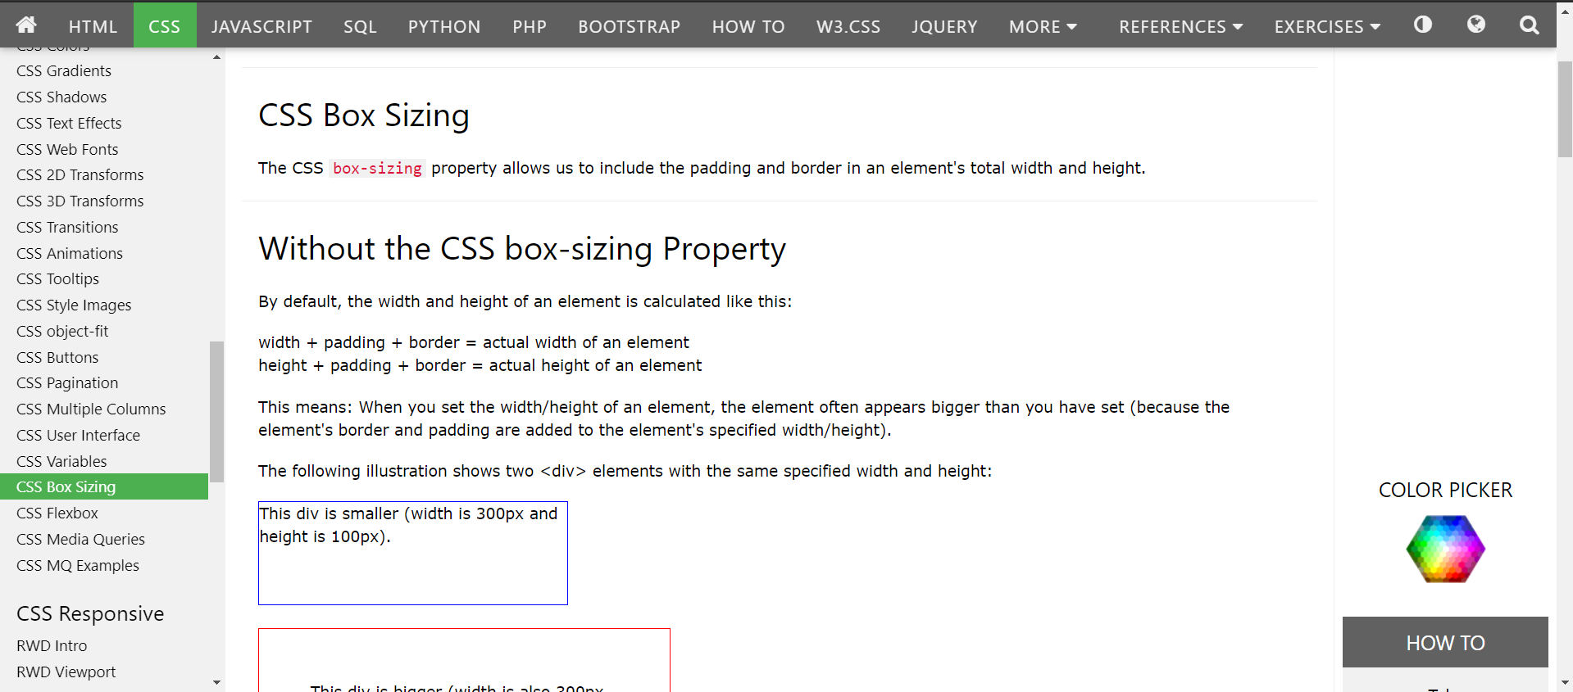

Figure -w3schools

There were no such major problems while designing and the design was as expected as I thought it would be. The XML document after designing with CSS is shown below.

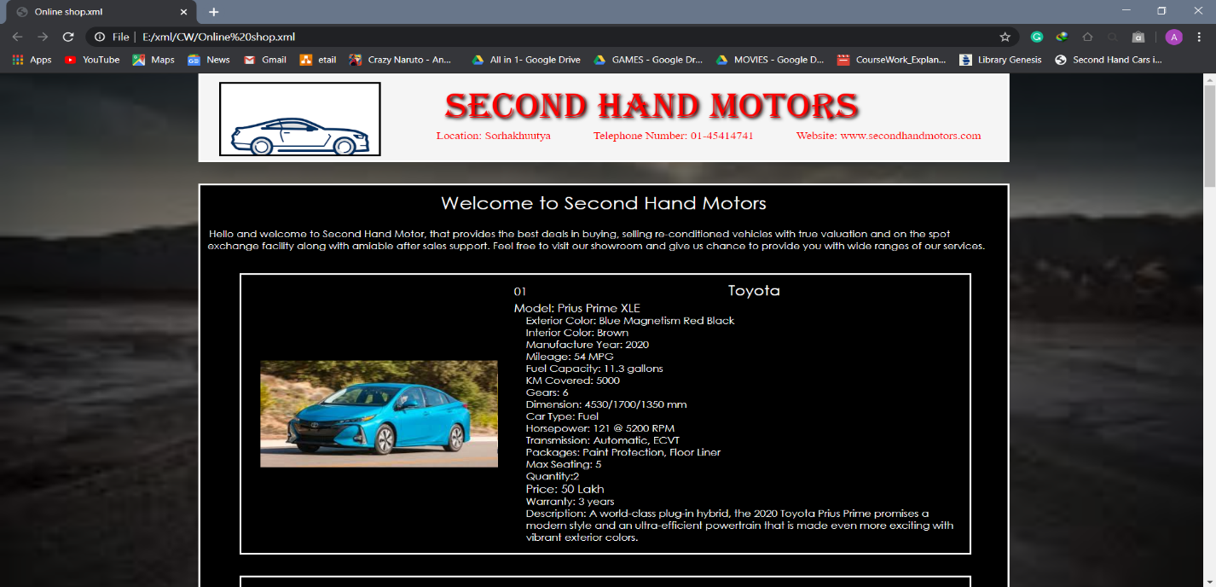

Figure -Design of XML document

After completing CSS, Schema was to be developed. Schema part was one of the toughest part while developing this coursework because I only had a few concepts regarding schema. Going through the lecture slides, tutorial slides, online class video, consulting with friends and teachers helped me to get more concept. Though schema was developed, there were many errors initially. Some of the errors occurred are show in diagram below.

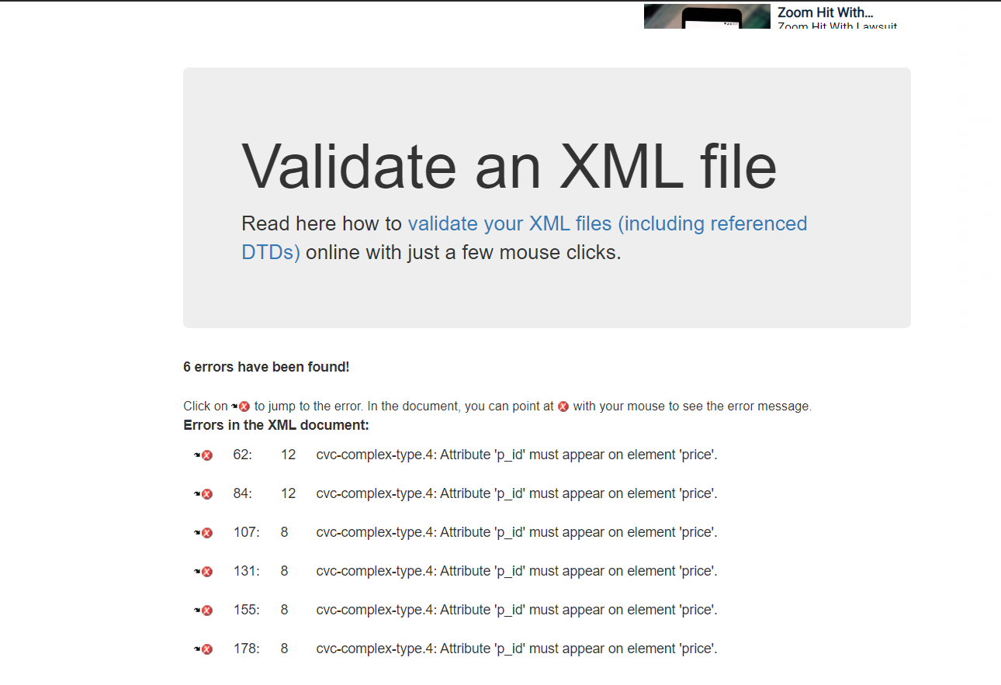

Figure -Error while validating schema file

By doing some research and consulting with friends helped me to create the schema successfully without any errors. There were no such problems while writing documentation. So, with the help of research materials, lecture, tutorial and lab material, friends, and module teachers helped me tackle with the problem that I was facing. Online sites like draw.io and schema validator also helped me to created diagram and validate schema with XML due to which my coursework was completed successfully.

# **Conclusion**

Developing a second-hand online vehicle shop using XML, CSS and Schema sure was a tough work. After completing this coursework, I individual got a lot of knowledge regarding XML, their elements, the designing, and how the schema works etc. I got idea on how to work with the elements and the data of XML. Though the CSS was already learnt and given to us for designing HTML page in our previous coursework, working on them and designing the XML was a fun part, besides it made me more creative working on designs. Schema sure was a one difficult part but after completing the coursework and validating it with XML validator I was able to get ideas regarding the element defining and their use. Overall lots of knowledge and skills was learnt doing this coursework. Other skills like: testing, tackling with problems were also learnt. Now, I can say I am more skilled and knowledgeable person than before and more skilled.

# **References**

Chief, E. i., 2016. [Online]   
Available at: https://connectusfund.org/6-advantages-and-disadvantages-of-cascading-style-sheets  
[Accessed 5 May 2020].

GitHub, 2020. [Online]   
Available at: https://github.com/jgraph/docker-drawio  
[Accessed 5 May 2020].

javaTpoint, 2018. [Online]   
Available at: https://www.javatpoint.com/xml-tree-structure  
[Accessed 5 May 2020].

Lorenz, M., 2019. [Online]   
Available at: https://academind.com/learn/web-dev/visual-studio-code-introduction/  
[Accessed 5 May 2020].

Rouse, M., 2013. [Online]   
Available at: https://searchmobilecomputing.techtarget.com/definition/Google-Chrome-browser  
[Accessed 5 May 2020].

Tidwell, D., 2020. [Online]   
Available at: https://www.ibm.com/developerworks/xml/tutorials/xmlintro/xmlintro.html  
[Accessed 5 May 2020].

tutorialspoint, 2020. [Online]   
Available at: https://www.tutorialspoint.com/css/what_is_css.htm  
[Accessed 5 May 2020].

tutorilaspoint, 2020. [Online]   
Available at: https://www.tutorialspoint.com/dtd/dtd_quick_guide.htm  
[Accessed 5 May 2020].

w3schools.com, 199-2020. [Online]   
Available at: https://www.w3schools.com/xml/xml_whatis.asp  
[Accessed 5 May 2020].

W3schools, 2020. [Online]   
Available at: https://www.w3schools.com/xml/xml_tree.asp  
[Accessed 5 May 2020].