Market Research - Consumer behavior towards packaged food items

# Abstract –

The Packaged food sector has witnessed exponential growth in the Indian retail market in recent years. According to ‘’India Ready-to-eat Food Market Forecast & Opportunities, 2019’’, the Indian RTE food market have grown at a CAGR of 21.99% from 2014-19. According to data from Indian Brand Equity Foundation (IBEF), there have been major investments are planned by e-commerce giant Amazon, Parle Agro Pvt. Ltd., Cargill Inc., Mad Over Donuts, Danone SA in the food sector of India. Most of this growth has been attributed towards the changing lifestyle and the urbanization of Indian population along with increase in their buying capacity. This study focuses on the observed inferences of the preferences of families from various demographics towards packaged food industry. The study is performed on a sample of 50 respondents from different families from various economic backgrounds to enhance the soundness of the conclusions of this survey for the firms of packaged food industry.

# Introduction –

According to Index of Industrial Production (IIP) data, India’s packaged food retail market has seen high growth at a rate of 14.5% over the last year. The packaged food and beverages segment accounts for 70% of the volume traded in FMCG market. The packaged food industry comprises of “Ready Meals”, “instant-cooking” meals, baked goods, breakfast cereals, soups, diet snacks, baby foods, potato chips, nuts, instant noodles, pasta, biscuits, chocolate confectioneries, cheese, paneer, yogurt, ice creams, processed meat, sauces, dressings & condiments, non-alcoholic drinks like fruit juices and canned cold drinks, edible oils, staples such as dairy, rice, wheat and pulses by product category.

This increasing trend towards packaged food along with shifts in the demographic of Indian families and lifestyle has led to many companies betting big investments in the retail packaged food sector of India. The people in urban areas and metropolitan cities are living in a very fast paced world with little time for themselves. More and more peoples are migrating to urban areas in search of stable job and are living alone. They continue to live as a nuclear family in urban and semi-urban areas after marriage with either none, one or two children. Most of these nuclear families have both the spouses working thereby increasing their spending capacity but have little time for themselves. Also, there is a growing awareness towards healthy and organic food products due to the growing awareness among people for common illnesses, increasing adoption of vitamin and protein supplements, insurgence of substantial marketing spending done by brands. These nuclear families and migrants are major contributors towards the growth of packaged food sector of India.

With the Indian food industry being set for huge growth and high-profit sector in the coming years, the packaged food sector has seen increased investments by multinational companies. It has been observed that most of these companies are relying on marketing their products with an image as a healthy choice for increasing brand loyalty among consumers. The objective of this research paper it to analyze whether consumer’s choice towards packaged food items is affected by their brand awareness or loyalty, pricing, convenience, health awareness, easy accessibility, safety and security of food standards. This research also aims at developing the factors that has the most influence on the consumers from various demographics and lifestyle affecting their consumption of packaged food items.

# Literature Review –

Both the incumbent and future entrant firms into the retail packaged food industry, or for that matter any industry rely heavily on market research on the consumer behavior towards the wide variety of products available in that industry. Companies either routinely carry out consumer survey to find consumer’s preferences, shift in their taste and lifestyle to segment and establish a target market for their existing as well as newly launched products. Yet, these companies usually spend billions of dollars on advertising, discounts and promotional offers in order to compete with other players in the industry and at often times, disregard the projection of image of firm’s brand or product into the minds of consumer.

Also, with the society’s ever-increasing focus on swelling percentage of obese population and rise of common diseases has led to consumer’s increased awareness towards his own physical and psychological well-being which in turn has dictated his decision making and his food choices. Various researchers have carried out studies and survey to establish relationships between users’s attitude, lifestyle and habits with his preferences towards food products.

Lumala Jokitalo et al. (2015), carried out a study to establish a framework for understanding the ambivalence of health and taste perceptions in food consumption. And further concludes that the consumer’s health motives, taste perceptions shape the perception of inclusivity and exclusivity of health and taste in the food consumption of the consumer.

Sanjay Kumar (2015) studied the consumer behavior and perception towards the marketing strategies of different retailer chains as well as small mom-n-pop retail shops and assessing the impact of the retailer’s marketing on the buying behavior of consumers. While Brent McFerran (2009) conferred in his research that consumers selection of food products and the quantity is greatly affected by the other person’s body type as well as his choice of food quantity. The consumer’s preferences are even more pronounced when consumers exhibit low self-esteem.

Bhatt S, Bhatt A. (2015) carried out research in a rural areas of Ahmedabad district in an attempt to understand different aspects of rural consumer behavior towards packaged food products. They also establish that the factors for selecting packaged food include health, convenience, proximity, mood, price, brand, and sensory appeal among rural areas. They also conclude that health, convenience and mood, have notable relationship with age, while identifying the four factors, namely, health, mood, price and brand as having a notable relationship with consumer’s monthly income.

Mr. Rajiv Vyas, Dr. JK Sharma, Dr. R. B. Sharma (2016) conducted a study on consumer behavior towards branded food items and examines the relationship between demographics like age, annual income, size of family, profession, education with the factors identified as influencing buyer’s decisions. The study determined that consumer’s age and income effect their buying behavior and established a need for placing branded products at low price points at local mom-n-pop retail shops. The study also establishes a need for campaign to educate consumer regarding consumer right and Consumer forum must be expedited.

We found that while various studies have been conducted on the consumer’s preferences towards food in both urban and rural areas, certain studies have been conducted on emphasizes the impact firm’s marketing strategies on their user’s buying decision and establishes a need for better brand building activities by these firms. There is still necessity of conducting a study on the consumers choices towards packaged food products and the decision-making criterion that govern various customer segments. The objective of this research is to study India’s growing consumer segment with higher purchase power and their lifestyle. And to establish the key factors that influences the consumer behavior towards packaged food in the Indian context.

# Methodology –

The sample for survey questionnaire is selected in a random fashion in order to strengthen the study findings by eliminating any kind of biases. The dependent variable for this study is “preference towards packaged foods” which is explained by independent variables: “growing awareness towards Good and Healthy products”, “easy to cook”, “advertising & promotional offers”, “good ambience”, “Hygienic”, “value for money” and “organic farming”. The conceptual mapping diagram (Fig. 1) below explains the relationship between the dependent variable “preferences towards packaged food” and the various independent variables

Preference towards Packaged Food.

Growing Health Awareness

Easier to Cook

Advertising and promotional offers

Good Ambience

Hygienic

Value for money

organic farming

**Figure 1.** Conceptual Mapping explaining the relationship between Dependent and independent variables.

## Survey Questionnaire:

The survey questionnaire consisted of 25 statements on a 5-point likert scale measuring the responses of a sample of 50 respondents across 25 different variables. The questionnaire also comprised of an ordinal scale statement to measure the ranking of various factors. And a set of questions for collecting demographic data of the respondents to further perform cluster analysis to find the customer segment and the factor that most explained and is primary reason behind their packaged food preferences.

The sample of 50 respondents comprised large percentage of males (62%) as against females (38%). Also, most of the respondents are from young and working populations with approximately 87% comprising of age brackets of 26 to 31 and 32 to 45.

# Analysis –

Cronbach’s Alpha is the measure of reliability index and used to measure the internal consistency of the questionnaire when it is comprised of multiple Likert scale questionnaire. We used IBM SPSS to measure Cronbach’s Alpha and to check if any further analysis can be performed on the data points of this survey. Cronbach’s Alpha value is 0.859 which is an indicator of good consistency within the survey questions and further analysis can be performed.

|  |  |  |
| --- | --- | --- |
| **Reliability Statistics** | | |
| **Cronbach's Alpha** | Cronbach's Alpha Based on Standardized Items | N of Items |
| **.859** | .866 | 25 |

Factor Analysis is multi-variate data mining technique with the objective of data reduction and data summarization. The different variables represented by the interval scale questions of the questionnaire are reduced into various factors based on the similarity in their attributes and if they are associated as part of factor analysis. None of the variables will have duplicated between factor variables. Then the data summarization is carried out and the nomenclature of the factor is decided based on the similar attributes of the multiple variables consolidated under the factor variable.

The Kaiser-Meyer-Olkin (KMO) Index measures the sampling adequacy that is the number of variables and the number of sample data points are adequate. The KMO index at 0.670 has been found to be greater than 0.6 implying that the sample is adequate for further analysis.

The Bartlett's test of Sphericity tests the significance of correlations. It has been found to be highly significant at 5% level of significance implying that the correlations are significant.

|  |  |  |
| --- | --- | --- |
| **KMO and Bartlett's Test** | | |
| **Kaiser-Meyer-Olkin Measure of Sampling Adequacy.** | | **.670** |
| **Bartlett's Test of Sphericity** | Approx. Chi-Square | 536.110 |
| df | 300 |
| **Sig.** | **.000** |

Based on responses from 50 respondents to the 25 likert scale questions in survey, the factor analysis converged 25 variables into seven factor variables along with their contribution towards percentage of variance explained – “Factor 1” = 12.15%, “Factor 2” = 11.53%, “Factor 3” = 10.59%, “Factor 4” = 9.37%, “Factor 5” = 8.47%, “Factor 6” = 7.90% and “Factor 7” = 7.83% . These seven factor variables exhibited a total variance explained of 67.84% which means that these seven factors can be attributed towards the main objective of our study “consumer’s preference towards packaged food” by 67.84% as shown in Table 1.

**Table 1: Total Variance Explained**

|  |  |  |  |  |  |  |  |  |  |
| --- | --- | --- | --- | --- | --- | --- | --- | --- | --- |
| **Total Variance Explained** | | | | | | | | | |
| Component | Initial Eigenvalues | | | Extraction Sums of Squared Loadings | | | Rotation Sums of Squared Loadings | | |
| Total | % of Variance | Cumulative % | Total | % of Variance | Cumulative % | Total | **% of Variance** | Cumulative % |
| **1** | 6.631 | 26.525 | 26.525 | 6.631 | 26.525 | 26.525 | 3.038 | **12.153** | 12.153 |
| **2** | 2.709 | 10.835 | 37.360 | 2.709 | 10.835 | 37.360 | 2.882 | **11.528** | 23.681 |
| **3** | 1.879 | 7.517 | 44.877 | 1.879 | 7.517 | 44.877 | 2.647 | **10.590** | 34.270 |
| **4** | 1.872 | 7.489 | 52.366 | 1.872 | 7.489 | 52.366 | 2.341 | **9.365** | 43.636 |
| **5** | 1.440 | 5.760 | 58.126 | 1.440 | 5.760 | 58.126 | 2.118 | **8.471** | 52.107 |
| **6** | 1.327 | 5.310 | 63.435 | 1.327 | 5.310 | 63.435 | 1.976 | **7.903** | 60.010 |
| **7** | 1.100 | 4.400 | 67.835 | 1.100 | 4.400 | 67.835 | 1.956 | **7.826** | **67.835** |
| 8 | .953 | 3.812 | 71.647 |  |  |  |  |  |  |
| 9 | .875 | 3.499 | 75.147 |  |  |  |  |  |  |
| 10 | .858 | 3.431 | 78.577 |  |  |  |  |  |  |
| 11 | .703 | 2.813 | 81.390 |  |  |  |  |  |  |
| 12 | .662 | 2.648 | 84.039 |  |  |  |  |  |  |
| 13 | .613 | 2.452 | 86.490 |  |  |  |  |  |  |
| 14 | .521 | 2.084 | 88.575 |  |  |  |  |  |  |
| 15 | .483 | 1.932 | 90.507 |  |  |  |  |  |  |
| 16 | .421 | 1.686 | 92.192 |  |  |  |  |  |  |
| 17 | .357 | 1.428 | 93.620 |  |  |  |  |  |  |
| 18 | .320 | 1.282 | 94.902 |  |  |  |  |  |  |
| 19 | .265 | 1.060 | 95.962 |  |  |  |  |  |  |
| 20 | .248 | .993 | 96.955 |  |  |  |  |  |  |
| 21 | .214 | .858 | 97.812 |  |  |  |  |  |  |
| 22 | .172 | .688 | 98.500 |  |  |  |  |  |  |
| 23 | .151 | .604 | 99.104 |  |  |  |  |  |  |
| 24 | .138 | .553 | 99.657 |  |  |  |  |  |  |
| 25 | .086 | .343 | 100.000 |  |  |  |  |  |  |

Below factors were converged upon from the analysis of the sample data points upon referring to Table 2: -

**Factor One –**

It can be seen that the variables 10, 9 and 6 have loadings of 0.827, 0.770 and 0.616 on factor one. This proposes that factor one is a combination of “Better packaging of food items”, “the way they are displayed in retail stores” and “Known Brand associated with Product”. This factor can be named as “Brand awareness”.

**Factor Two -**

The variables 20 and 3 have loadings of 0.750 and 0.710 respectively on factor two. This proposes that factor two is a combination of “Known expiry date of packaged food” and “Packaged food are good for health”. This factor can be named as “Consciousness towards Health and healthy products”.

**Factor Three -**

The variables 16, 17 and 22 namely “Packaged food grown using better farming methods”, “Packaged food do not cause food allergies” and “Packaged food are safe for children” with loadings of 0.643, 0.811 and 0.640 respectively constitute factor three. This factor can be named as “Organic Farming”.

**Factor Four -**

The variables 2 and 4 namely “Cleanliness associated with Packaged food” and “Packaged food are sold in clean places” with loadings of 0.666 and 0.799 respectively constitute factor four. This factor can be named as “Hygiene”.

**Factor Five -**

The variables 8 and 23 namely “Packaged food tastes good” and “Children influence buying decision towards packaged food” with loadings of 0.774 and 0.495 respectively constitute factor five, and hence this factor can be named as “Tastier food”.

**Factor Six -**

The variables 14 namely “Preference towards packaged food is influenced by good ambience of placed where it is sold” with loadings of 0.625 constitute factor six, and hence this factor can be named as “Good Ambience”.

**Factor Seven -**

The variables 1 and 24 namely “Packaged food are easier to cook” and “Packaged food is preferred because everyone in family is working” with loadings of 0.784 and 0.553 respectively constitute factor seven. Hence this factor can be named as “Convenience to cook”.

**Table 2: Rotated Component Matrix used for determining factor variables**

|  |  |  |  |  |  |  |  |
| --- | --- | --- | --- | --- | --- | --- | --- |
| **Rotated Component Matrixa** | | | | | | | |
|  | Component | | | | | | |
| 1 | 2 | 3 | 4 | 5 | 6 | 7 |
| I prefer packaged food items since they take less time and are easier to cook | -.084 | .119 | .005 | .093 | .049 | .017 | .784 |
| I prefer packaged food because of the cleanliness associated with them. | .008 | .363 | .142 | .666 | -.036 | .241 | -.185 |
| I prefer packaged food products since they are good for health. | -.142 | .710 | .175 | .143 | .263 | .121 | .094 |
| I prefer packaged food product since they are sold in clean places. | .145 | .159 | .127 | .799 | .029 | -.045 | .159 |
| I prefer packaged food items because they are value for money | .257 | .099 | .342 | .444 | .413 | -.350 | .222 |
| I prefer packaged food product because there is a known brand associated with it. | .616 | .116 | .099 | .445 | .240 | .091 | .040 |
| I prefer packaged food items because of the quality (safe from pesticides, free from preservatives or coloring) associated with them. | -.014 | .451 | .492 | .364 | .069 | -.030 | -.139 |
| I prefer packaged food items because it tastes good. | .018 | .288 | -.209 | .122 | .774 | .253 | -.056 |
| I prefer packaged food items because of the way they are displayed in organized retail stores like shops and shopping malls. | .770 | .042 | -.058 | .084 | .047 | -.070 | .116 |
| I prefer packaged food items due to their better packaging. | .827 | .054 | .077 | .067 | .150 | .168 | -.080 |
| Packaged food items are easily accessible. | -.127 | .188 | -.152 | .286 | .331 | .598 | .194 |
| Advertising does not influence my buying decision of packaged food items. | -.571 | -.368 | .322 | .408 | .000 | .098 | -.016 |
| Promotional offer influences my buying decisions of packaged food items. | .310 | -.024 | .093 | .001 | .666 | .042 | .126 |
| I prefer buying packaged food items because of the places where it is sold have good ambiance. | .309 | -.083 | .286 | .025 | .047 | .625 | .060 |
| I prefer buying packaged food items because the shop's owner personally knows us. | -.074 | .334 | .363 | -.087 | .247 | .590 | .091 |
| I prefer packaged food items since I consider that they are grown using better farming methods. | .205 | .264 | .643 | .211 | -.036 | .226 | -.037 |
| Packaged food items are not known to cause food poisoning or food allergies. | -.085 | -.052 | .811 | -.027 | -.055 | .075 | .102 |
| Packaged food items provide me with more variety to choose from. | .258 | .533 | .124 | .403 | .116 | .129 | .434 |
| I prefer buying packaged food items because I can get all the items in one place. | .213 | .588 | -.113 | .172 | .274 | .250 | .440 |
| I prefer buying packaged food items because I know their expiry date. | .195 | .750 | .090 | .154 | -.137 | -.092 | .091 |
| I prefer buying packaged food items because I can purchase them in bulk. | .401 | .511 | .248 | .121 | .217 | .369 | .037 |
| I prefer buying packaged food items because they are safe for children. | -.043 | .192 | .640 | .348 | .135 | -.004 | .122 |
| Children influence my buying decision towards packaged food items. | .084 | -.016 | .321 | -.091 | .495 | .138 | .461 |
| I prefer buying packaged food item because everyone in family is working. | .379 | .180 | .343 | -.106 | .104 | .225 | .553 |
| I prefer packaged food because I don't know how to cook food. | .463 | -.083 | -.101 | -.051 | -.372 | .462 | .422 |
| Extraction Method: Principal Component Analysis. | | | | | | | |
| Rotation Method: Varimax with Kaiser Normalization. | | | | | | | |
| a. Rotation converged in 21 iterations. | | | | | | | |

## Result -

On performing an analysis of the demographic data of the respondents of this survey, we can infer relative importance of each of these factors with respect to various groups and their lifestyle and attitudes. Based on the summary of responses shown in Figure 1, it can be observed that 86% of the respondents prefer to eat packaged food during snacks followed by 28% respondents preferring during breakfast. This will help the firms competing in the packaged food sector to launch more healthy products for consuming around these times.

Also, almost 72% of the respondents have preferred for packaged food items due to the lack of time in their busy lifestyle as seen in Figure 2. It is worth noting that 70% of the respondents have a negative sentiment towards health aspects of the packaged food items as noted in Figure 3.

Factor one “Brand awareness” deals with the consumer’s preference towards branded products, the better packaging and ostentatious way that is usually associated with the high valued brands. For this, most respondents agreed that “they preferred to buy the packaged food because there was a known brand associated with it” with 50% in agreement of it. And, 48% preferred to buy products with better packaging. So, it could be inferred that the advertisers should also care about providing food with good packaging apart from spending on marketing activities towards brand building.

Factor two “Consciousness towards Health and healthy products” describes the growing awareness of consumers towards their health with changing fast-paced lifestyle and check the nutritional and expiry date of the packaged food while making the buying decision. Almost 64% of the respondents agreed to checking the expiry date of the product before buying it. From this, it can be concluded that incumbent firms need to provide more information about nutritional values and ingredients of the product in order to influence the growing health-aware consumer. For any firms like MTR, Parle launching new products should consider the health awareness of the consumer and their brand and tag line of advertisements should prominently display the healthy characteristics of their products.

Factor three “Organic Farming” describes the consumers preference towards packaged food that promises to be comprised of quality raw material that has been prepared using organic farming methods. Since better farming methods ensure that the packaged food is free from pesticides, it is not known to cause allergies and is safe for children. From this, we can conclude that firms with baby food products or snacks for small children should make sure that their product is safe for consuming by children to make it to the consideration set of their primary target segments, married couples with children.

Factor four “Hygiene” describes the consumer’s behavior towards buying the packaged food items only from clean places and there is a cleanliness associated with the product as well. This factor becomes of increased importance for firms which are having packaged meat products as they need to ensure that there is a cleanliness associated with the product itself and they also need to ensure that the retail chains or stores with whom they associate for sale of these products keep their products in a clean environment.

Factor five “Tastier food” describes the consumer’s preferences towards packaged food is also influenced by their children and hence tastier food becomes their main criterion for the married couples with children while making buying decisions. This concludes that the companies which have products for children, need to keep their food tasted by children in order to find the taste preferences of the children. These companies should have advertisements that associate the “Tasty” adjective for their product to entice children towards their food products.

Factor six “Good Ambience” describes the consumer’s preferences towards good ambience of the places where the product is sold ultimately also affects his or her preference towards buying packaged food products.

Factor seven “Convenience to cook” is about consumer’s preferences towards packaged food because all the family members are working, and they have less time due to their fast-paced lifestyle. So, they prefer to buy those packaged food that take less time and are easier to cook.

From the factor analysis, we can conclude that the present Indian consumers prefers packaged food if it uses organic farming methods since organic food is considered to be of healthy and nutritious content which abodes well with the health consciousness of the present consumer. The packaged food must be prepared using methods which reinforces cleanliness and sold in clean places with good ambience to improve the overall brand image of quality food product into the minds of customers. Also, the packaged food should be tastier and easy to cook so that it fits well into the fast-paced lifestyle of working parents with children. This is evidenced in the Table 3 of “summary of all responses” that 58% of the respondents with children had their buying criterion influenced by the children’s choice. Also, it can be seen in the Table 3 that promotional offers have impacted 60% of the respondent’s preferences towards packaged food.

# Conclusion from the study:

The India’s packaged food industry is set to grow at an exponential growth with many multinational companies competing for a bigger chunk of the revenues. The packaged food comprises of myriad of food types along with consumer’s changing preferences due to their lifestyle. In order to success in this competitive environment, the companies cannot just rely on heavy marketing and sales expenditure but need to create own image of providing nutritious products produced by better farming methods among its consumers. Another changing aspect of the Indian family structure to nuclear families as well as the fast-paced lifestyle of family members with high purchasing power is to be factored in by the competing firms. This study will help the companies to understand the various factors which impact their identified target segments for their food products and employ marketing strategies that influences these buyers.

## Limitation

The study had a limited sample of respondents. The questionnaire of the survey is found to be reliable and with high significance, hence the study with enough respondents might have reveled more factors that affect consumer’s preferences apart from the factors already identified in this study and the weightage that each target segment associate with those factors. The incumbent and aspiring new entrant firms in Indian’s packaged food industry can use the survey questionnaire to broaden the sample size and establish their marketing strategies based on the factors identified.

# Annexures –

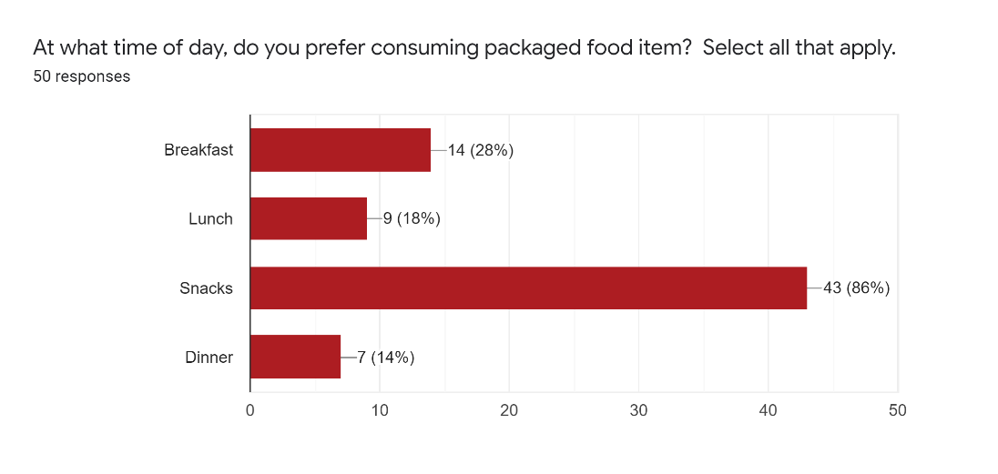**Figure 1:**

**Figure 2:**

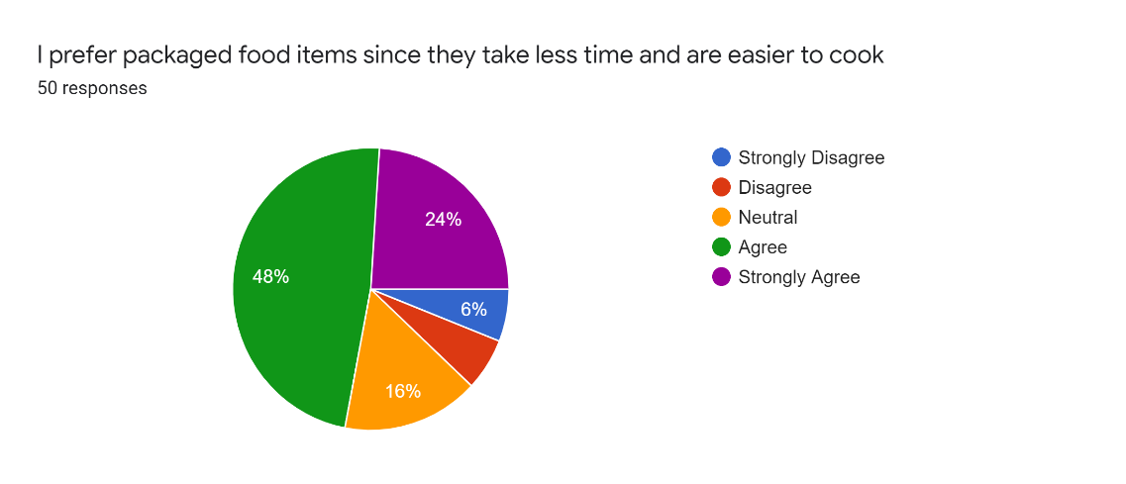

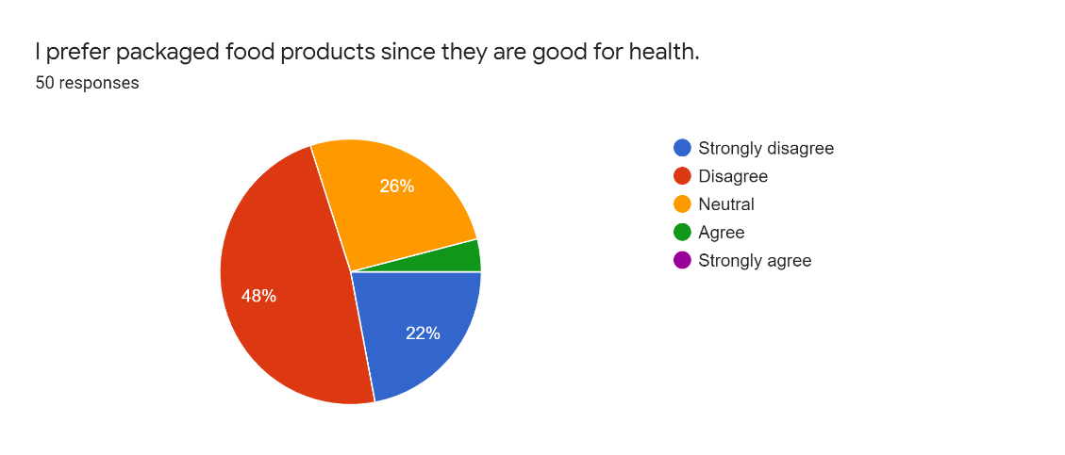**Figure 3:**

**Table 4: Summary of all responses given by respondents in terms of overall weightage**

|  |  |  |  |
| --- | --- | --- | --- |
| **Summary of Responses** | | | |
| **Statements** | **% of Agree** | **% of Neutral** | **% of Disagree** |
| I prefer packaged food items since they take less time and are easier to cook | 72% | 16% | 12% |
| I prefer packaged food because of the cleanliness associated with them. | 22% | 52% | 26% |
| I prefer packaged food products since they are good for health. | 4% | 26% | 70% |
| I prefer packaged food product since they are sold in clean places. | 32% | 28% | 40% |
| I prefer packaged food items because they are value for money | 30% | 26% | 44% |
| I prefer packaged food product because there is a known brand associated with it. | 50% | 30% | 20% |
| I prefer packaged food items because of the quality (safe from pesticides, free from preservatives or coloring) associated with them. | 38% | 22% | 40% |
| I prefer packaged food items because it tastes good. | 62% | 20% | 18% |
| I prefer packaged food items because of the way they are displayed in organized retail stores like shops and shopping malls. | 34% | 24% | 42% |
| I prefer packaged food items due to their better packaging. | 48% | 34% | 18% |
| Packaged food items are easily accessible. | 80% | 12% | 8% |
| Advertising does not influence my buying decision of packaged food items. | 38% | 20% | 42% |
| Promotional offer influences my buying decisions of packaged food items. | 60% | 30% | 10% |
| I prefer buying packaged food items because of the places where it is sold have good ambiance. | 40% | 28% | 32% |
| I prefer buying packaged food items because the shop's owner personally knows us. | 12% | 16% | 72% |
| I prefer packaged food items since I consider that they are grown using better farming methods. | 16% | 22% | 62% |
| Packaged food items are not known to cause food poisoning or food allergies. | 38% | 12% | 50% |
| Packaged food items provide me with more variety to choose from. | 76% | 14% | 10% |
| I prefer buying packaged food items because I can get all the items in one place. | 66% | 16% | 18% |
| I prefer buying packaged food items because I know their expiry date. | 64% | 30% | 6% |
| I prefer buying packaged food items because I can purchase them in bulk. | 48% | 26% | 26% |
| I prefer buying packaged food items because they are safe for children. | 28% | 24% | 48% |
| Children influence my buying decision towards packaged food items. | 58% | 26% | 16% |
| I prefer buying packaged food item because everyone in family is working. | 42% | 18% | 40% |
| I prefer packaged food because I don't know how to cook food. | 34% | 16% | 50% |

## Demographic Details of the respondents: -

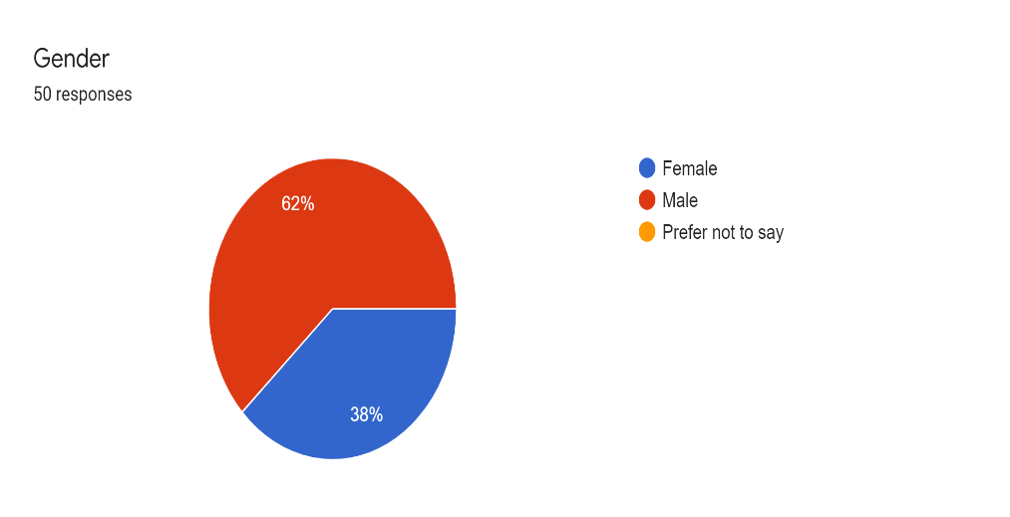

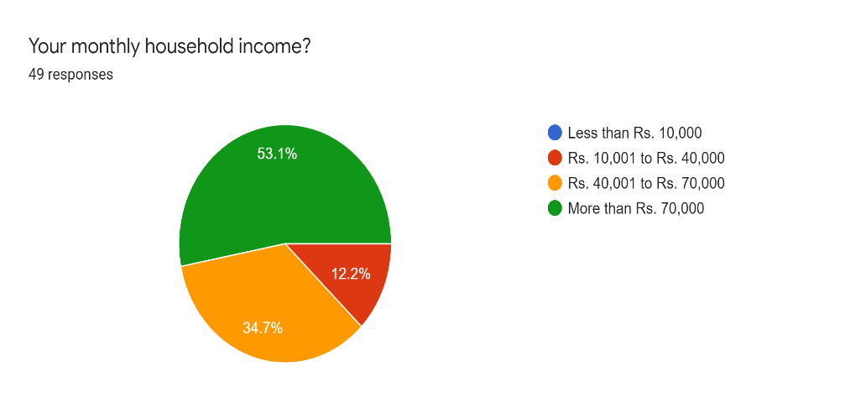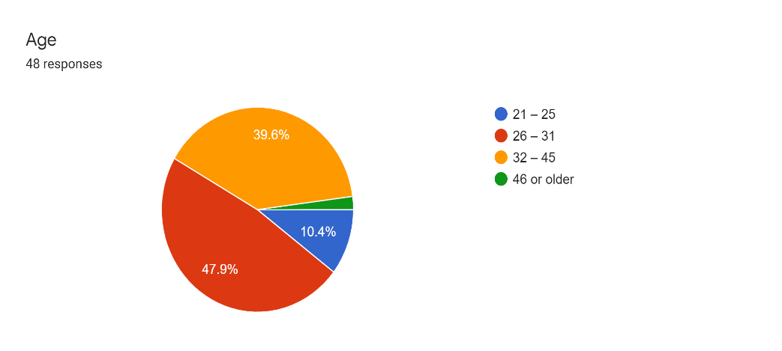

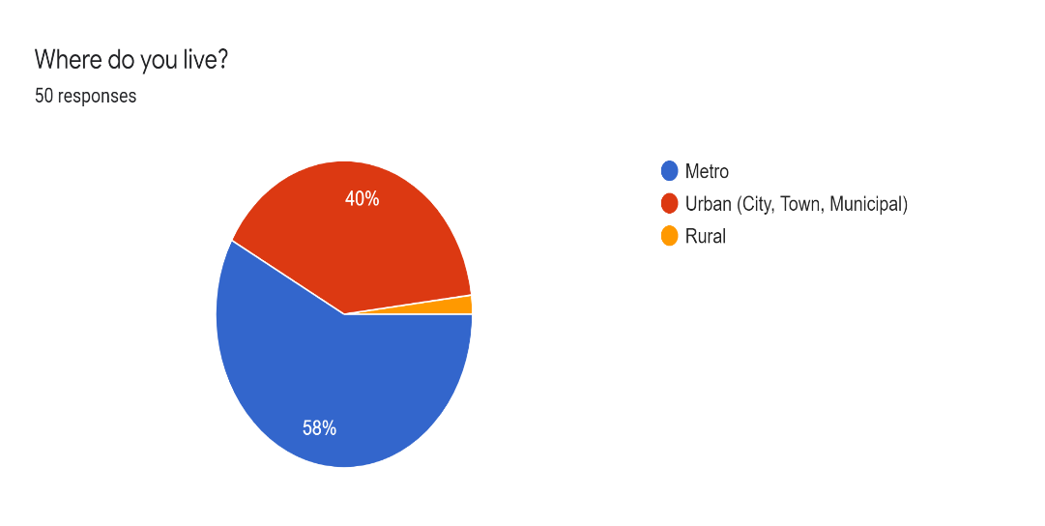

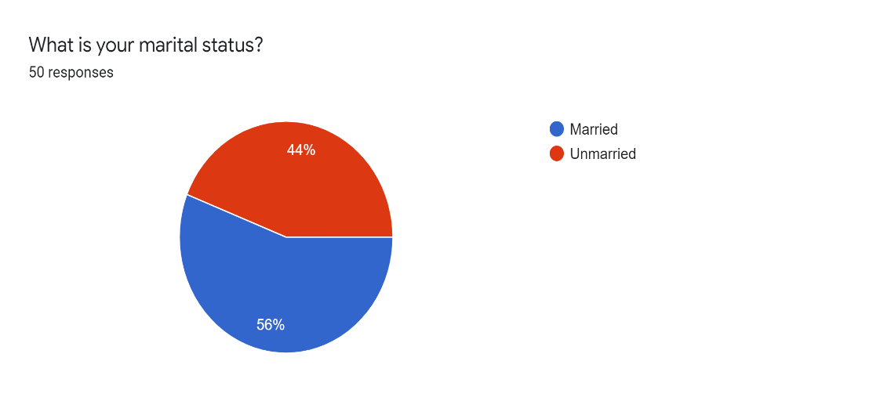

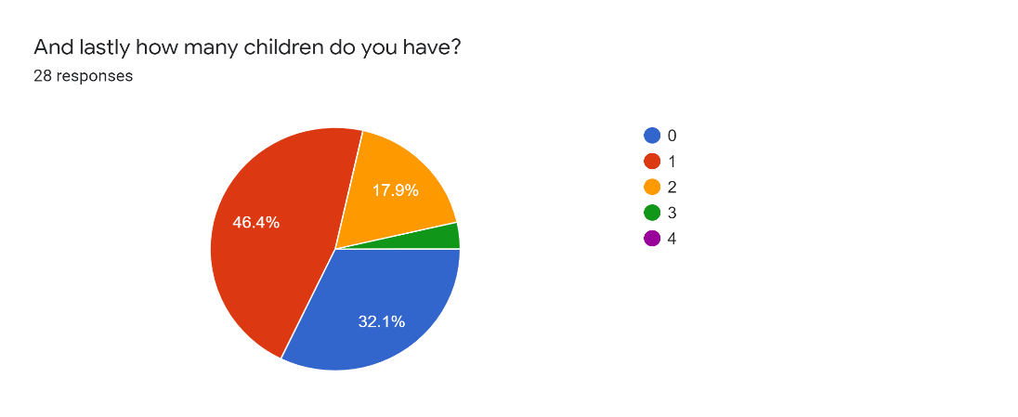

## Survey Question used for this research: -

1. Age. 21 – 25, 26 – 31, 32 – 45, >45.
2. Gender. Male / Female / Other.
3. Highest educational qualification. Undergraduate / Graduate / Post Graduate / Doctoral.
4. Where do you live? Metro / Urban (City, Town, Municipal) / Rural.
5. What is your marital status? Married / Unmarried.
6. What is your household size? 1/2/3/4/5/6/7/8 OR Living alone/Living with Friends/Nuclear Family/Joint Family.
7. What is your monthly household income? <10,000 / 10K-40K / 40K-70K / >70K.
8. At what time of day, do you prefer consuming packaged food item? Checkbox -> Breakfast / Lunch / Snacks / Dinner.
9. When do you prefer consuming packaged food items? Checkbox -> Weekdays / Weekends.
10. What are the factors that affect your preference for packaged food item? (Rank in order of preference where “Highest Preference”: 7, “Lowest Preference”: 1)

options are: - Lack of time/Easier to cook/For Taste/Healthy/Organic/Safety & Surety by Brands/Easily available.

**Rate the below statements on a scale of – Strongly Agree / Agree / Neutral / Deny / Strongly Deny.**

1. I prefer packaged food items since they take less time and are easier to cook.
2. I prefer cook-n-eat food products (like soups, idli or dosa batter etx) due to cumbersome preparation process.
3. I prefer packaged food because of the cleanliness associated with them.
4. I prefer packaged food products since they are good for health.
5. I prefer packaged food product since they are sold in clean places.
6. I prefer packaged food items because they are value for money.
7. I prefer packaged food product because there is a known brand associated with it.
8. I prefer packaged food items because of the quality (safe from pesticides, free from preservatives or coloring) associated with them.
9. I prefer packaged food items because it tastes good.
10. I prefer packaged food items because of the way they are displayed in organized retail stores like shops and shopping malls.
11. I prefer packaged food items due to their better packaging.
12. Packaged food items are easily accessible.
13. Advertising does not influence my buying decision of packaged food items. **(Reverse Scale)**
14. Promotional offer influences my buying decisions of packaged food items.
15. I prefer buying packaged food items because of the places where it is sold have good ambience.
16. I prefer buying packaged food items because the shop’s owner personally knows us.
17. I prefer packaged food items since I consider that they are grown using better farming methods.
18. Packaged food items are not known to cause food poisoning or food allergies.
19. Packaged food items provide me with more variety to choose from.
20. I prefer buying packaged food items because I can get all the items in one place.
21. I prefer buying packaged food items because I know their expiry date.
22. I prefer buying packaged food items because I can purchase them in bulk.
23. I prefer buying packaged food items because they are safe for children.
24. Children influence my buying decision towards packaged food items.
25. I prefer buying packaged food item because everyone in family is working.
26. I prefer packaged food because I don’t know how to cook.

# References –

1. Luomala, Harri & Jokitalo, Maijastiina & Karhu, Hannu & Hietaranta-Luoma, Hanna-Leena & Hopia, Anu & Hietamäki, Sanna. (2015). Journal of Consumer Marketing Perceived health and taste ambivalence in food consumption Article information: For Authors. Journal of Consumer Marketing. 32. 290-301. 10.1108/JCM-11-2014-1233. ER -
2. Sanjay Kumar (2015) Indian Consumers’ Perception for Packaged Food and the Strategies of Food and Grocery Retailers in India—An Analysis, Journal of Food Products Marketing, 21:3, 306-318, DOI: [10.1080/10454446.2012.730496](https://doi.org/10.1080/10454446.2012.730496).
3. Brent McFerran, Darren W. Dahl, Gavan J. Fitzsimons, Andrea C. Morales, I’ll Have What She’s Having: Effects of Social Influence and Body Type on the Food Choices of Others, *Journal of Consumer Research*, Volume 36, Issue 6, April 2010, Pages 915–929, <https://doi.org/10.1086/644611>.
4. Bhatt S, Bhatt A. Consumer Behavior Towards Packaged Food in Rural Areas: An Empirical Study in Ahmedabad District, Gujarat. IUP Journal of Marketing Management. 2015;14(1):7-20. https://ezproxy.svkm.ac.in:2195/login.aspx?direct=true&db=buh&AN=101857933&site=ehost-live. Accessed February 18, 2020.
5. “A Study on Consumer Behavior Towards Food Items of Popular Brands” by Mr. Rajiv Vyas1, Dr. JK Sharma2, Dr. R. B. Sharma3. IOSR Journal of Business and Management (IOSR-JBM) e-ISSN: 2278-487X, p-ISSN: 2319-7668. Volume 18, Issue 8 .Ver. IV (Aug. 2016), PP 01-08 www.iosrjournals.org.

***Dr. A. Aparna*** *is a PhD in Statistics. Currently, she is the Associate Professor at NMIMS, Bangalore. She has*

*published various papers on Statistics and Supply Chain. Dr. A. Aparna can be reached at*

[*aparna.a@nmims.edu*](mailto:aparna.a@nmims.edu)*.*

***Animesh Tamrakar*** *is an Executive PGDM student (General Management) from NMIMS, Bangalore. Currently he is working with EMC Software & Services Pvt. Ltd. Animesh can be reached at* [*animesh.tamrakar@gmail.com*](mailto:animesh.tamrakar@gmail.com)*.*

***Ajay Mutgekar*** *is an Executive PGDM graduate (General Management) from NMIMS, Bangalore. Currently he is working with Tata Elxis. Ajay can be reached at* [*ajay.mutgekar11@gmail.com*](mailto:ajay.mutgekar11@gmail.com)*.*

***Pratik Singh*** *is an Executive PGDM graduate (General Management) from NMIMS, Bangalore. Currently he is working with State Street. Pratik can be reached at* [*pratik.singh.474@gmail.com*](mailto:pratik.singh.474@gmail.com)*.*

***Balaji G.S.*** *is an Executive PGDM graduate (General Management) from NMIMS, Bangalore. Currently he is working with Bosch. Balaji can be reached at* [*balu.gsb@gmail.com*](mailto:balu.gsb@gmail.com)*.*