|  |  |
| --- | --- |
| e:\Users\USER\Desktop\BurgerLogo.jpg  BURGER KING – ANALYSIS OF SERVICE BRAND | ABSTRACT  This study develops the key determinants of service quality in the fast food restaurant segment and scrutinizes the positioning of Burger King w.r.t SERVQUAL, MDS. And further suggest areas of improvement for Burger King to succeed in Indian Market.  Ajay Mutgekar Animesh Tamrakar Pratik Singh Balaji G. S.  Course: Managing Service Success |

# Fast Food Restaurants in India: Overview

The Indian market is a traditional market with most consumers favoring home cooked foods. This posed a major challenge to the global fast food giants such as Burger King, McDonalds, Pizza Hut, etx to establish their business in India. In the past few years, the Indian fast food industry has undergone rapid changes with the bigger purchase power, open economy, transition to nuclear families and lifestyle changes. These sweeping changes have brought in a wide variety of services which have fast-tracked and extended the opportunities for fast food restaurants in India. The global retailers are facing stiff competition from the local fast food retailers who offer traditional foods according to their tastes at reasonable prices. In order to succeed in the Indian fast food service industry, these global giants are acclimatizing to local taste. The fast food service industry is gaining huge traction predominantly from the Indian younger generations who have started their high paying jobs with a fast lifestyle.

Indian fast food market is expected to grow at a CAGR of 18% by 2020 due to changing consumer behavior and demography. Fast food market in India is expected to be worth US$ 27.57 billion by 2020. About 10% of the fast food market in India is organized. It is estimated that the organized fast food market in India is expected to grow at a CAGR of 27% by 2020. Quick Service Restaurants (QSRs) market in the organized fast food sector in India is projected to grow at a CAGR of 20% by 2019-20. The QSR’s (Quick Service Restaurants) and the casual dining restaurants together constitute over 74 percent of the market and are growing exponentially. The QSR industry has spearheaded restaurant trends such as expansion to small cities in India, and different formats such as dine-in, in-mall outlets which has provided the customers an easy access to eating out.

# Burger King: Introduction

Burger King is a global chain of hamburger fast food restaurants headquartered in unincorporated Miami-Dade County, Florida, United States. The company began in 1953 as Insta-Burger King. Later it was purchased by David Edgerton and James Mclamore. In 2002, Burger King was converted into a public company where the 3G capital holds 71%, Justice Founders 13% and Shareholders 16%. In late 2010, 3G Capital of Brazil acquired a majority stake in Burger King. Burger kings holdings is the parent company of Burger King, also known as Burger King Corporation and abbreviated BKC, and is a Delaware corporation formed on 23 July 2002.

Most Burger King Restaurants are franchises. What this means is that a local owner owns the restaurant. The owner pays Burger King to use the Burger King name on the restaurant. In addition, the owner also pays a percentage of the profits to Burger King. Burger King mostly follows the Master Franchise. A master franchise is a franchising contract in which the master franchisor (the owner of the brand name) hands over the control of the franchising activities in a specified territory to a person or entity, called the ‘master franchisee’.

Burger King designs and deploys corporate training systems while overseeing brands standards such as building design and appearance. The company also develops new products and deploys them after presenting them to its franchises for approval. Burger King has limited approval over franchise operations such as minimum hours of operations and promotional pricing. Additionally, Burger King designates approved vendors and distributors while ensuring safety standards at the production facilitates of its vendors.

Burger King’s main product lines are as follows:

1. Burgers.

2. Chicken and fish.

3. Sides.

4. Salads and veggies.

5. Beverages.

6. Sweets/Desserts.

# Drivers of Customer Satisfaction

For our investigation, these factors were adapted or adjusted to each one of the dimensions of

the Service performance measurement tool that was designed to be applied to the hamburgers sector consumers.

|  |  |  |
| --- | --- | --- |
| **Dimension** | **Variable** | **Definition** |
| **Facilities** | Internal and external  appearance (colors,  design, decoration)  Comfort  Cleanliness  Location | Physical characteristics  that the customer  perceives at a glance  such as: colors,  decoration and design.  Comfortable furniture  and spaces.  Cleanliness in facility  and tableware.  Easiness to reach the  restaurant. |
| **Accessibility** | Parking Lot Payment  alternatives  Courtesy and welcome  Proficiency and ability | Easiness and safe car  parking. Payment  alternatives and  facilities  Welcome greetings  received by customers  Personnel’s level of  knowledge of the food. |
| **Personal** | Presentation Promptness  Empathy | Personnel  appearance. Personnel  level of proficiency to  attend customers’  needs.  Perception of familiarity,  needs’ understanding,  reliability, attitude. |
| **Environment** | Audiovisual  Ambiance Lighting  Smells  Room temperature  Aroma  Variety | Background music, TV  programs. Lighting  according to the type if  restaurant.  Smells perception at  the moment of arrival.  Room’s temperature is manipulated for more  comfort.  Perception of a  pleasant aroma.  Options to choose. |
| **Food** | Taste Presentation  Food hygiene  Food freshness  Temperature  Prestige | Food and beverages  must have a pleasant  taste. Food visually  attractive  Foods look clean and  disinfected.  Foods with a pleasant  appearance and  keeping its natural  properties.  Foods with the proper  temperature  Clients’ perception of a  restaurant with a  prestige. |
| **Consistency**  **and Honesty** | Accomplishment  Attention to complaints | The clients received  what they ordered and  have in inventory what  is offered.  Fast and adequate  solution to client’s  complaints. |

# Service Quality Measurement

Service Quality is the customer’s perception about the superiority in the service received, containing two dimensions, the “intangibles” and the “tangibles. For measuring service quality in this study, we have used the survey questionnaire instrument to measure responses of diners on the SERVQUAL scale.

Also, for the purpose of this study we define the term “fast food” is defined as reasonably priced food which are prepared and served quickly such as hamburgers, sandwiches, doughnuts, chicken wings, pizzas, etc. Consequently, we considered only McDonalds, KFC, Burger King, Subway and Pizza Hut for mapping competitive positioning of the brand Burger King in Indian fast-food restaurant landscape. We conducted the survey comprised of two sets of questionnaires – one used to identify the determinants of service quality in fast food restaurants, and another set of similar questions to assess the perceived service from Burger King experienced by the same set of customers. Also, we surveyed what is the overall satisfaction score perceived by customers and would they recommend Burger King to friends and family. The survey questionnaire is available in the Annexures. Also, we conducted focused interviews with a couple of customers to identify the journey map for diners, and the attributes that a fast food restaurant must exhibit for good service quality.

The Survey link is still active and link is given below:

https://forms.gle/PLwg1xQEBfBATeFC8

## SERVQUAL of Burger King

The SERVQUAL for Burger King was determined by conducting an online survey from randomly selected respondents who have experience of Burger King outlet. The survey questionnaire had questions along the 5 dimensions of SERVQUAL – Tangibility, Reliability, Responsiveness, Assurance and Empathy. And the individual scores are obtained by computing the average score of all responses in all the questions relating to that dimension. Once the scores are calculated for each dimension, then the average score of all the dimensions is calculated to arrive at the SERVQUAL for each customer. And at the end, we have calculated the average score across all survey questionnaires, all 5 dimensions along with the overall average score of SERVQUAL. The findings of the survey along the five dimensions of SERVQUAL are listed below: -

1. TANGIBLES – measures the comfortable seating arrangement of diners, aesthetic appeal of the outlet including the music volume, cleanliness of cups, saucers, plates, and cleanliness maintained by staff.

The company outlets are visually appealing and have good ambience. The company outlets have modern-looking equipment but there have been a few instances, where customers found the tables were not clean. Since the company outlets are mostly franchisee run, they do not have much control on daily operations. This has resulted in a negative score for tangibility dimension.

1. RELIABILITY – measures the ability of Burger King and its employees to provide right food at the right time as promised consistently, whether they keep record of their regular diners and their preferences, the quality of food delivered as promised.

The Reliability score is also negative for Burger King. The customers have observed that the employees are not well-trained, or the ordering system went offline or crashed leaving the orders in unsaved mode. When customers have a problem, the ﬁrm will/does show sincere interest in solving it.

1. RESPONSIVENESS – measures whether Burger King employees inform the diners about the time to prepare & serve food, whether a genuine intent is shown to help diners, and they are not made to wait for long periods unnecessarily.

The responsiveness of the employees and Burger King is just slightly negative, inferring that they are on the right track. Usually the employees inform the time taken to serve food. The employees are usually not busy serving customers with very little waiting time.

1. ASSURANCE – measures whether Burger King and its employees have knowledge and skills to answer diners’ queries, give enough information to customers to let them know of the safety standards followed during procuring of ingredients as well as during preparation of food.

The assurance score For Burger King is negative due to the same reason as customers have found employees are not well-trained and well-informed to be able to answer the customer queries about ingredients of dishes.

1. EMPATHY – measures whether the employees have the diner’s best interest at heart and give distinct and special attention to their diners.

Burger King has faired well in the empathy dimension with a score of 0.25. Personal needs of customers are taken noted while subscribing to the services.

**SERVQUAL** – The average score along the 4 dimensions of tangibility, reliability, responsiveness and assurance as well as overall average score of SERVQUAL has been found to be rather disappointing for Burger King brand. Burger King only performed better in the empathy dimension of SERVQUAL. The overall average score for SERVQUAL for Burger King stood at negative 0.26.

## Net Promoter Score

The Net Promoter Score (NPS) was also determined from the questionnaire by asking the respondents on their overall satisfaction for Burger King. The overall average value of NPS is also rather disappointing at **6.55 on a scale of 10**, which is below the ideal score of 9 or 10.

## Impact of Service Quality & Customer Satisfaction on Customer Loyalty

The customer’s perceived service quality and his overall satisfaction has a bearing on the customer loyalty. And, it has been found from the survey that Burger King does not generate enough positive word of mouth communication from its existing clients which is a measure of customer’s loyalty. The overall average word-of-mouth communication stands at a disappointing value of **6.74 on a scale of 10**, again below the ideal score of 9 or 10.

# Mapping Competitive Positioning

For competitive positioning of brand “Burger King”, we asked the same set of 30 respondents to rate the various combinations of competitive brands “McDonalds”, “KFC”, “Burger King”, “Subway” and “Pizza Hut” on a scale of 1 (Least Similar) to 10 (Most Similar) as per their past experience. We asked for which of the combinations of fast food brands are most similar in terms of food quality, timeliness, cleanliness, services, etc. And then ran the Multi-dimensional scaling (PROXSCAL) in IBM SPSS, to attain the below 2-dimensional graph: -

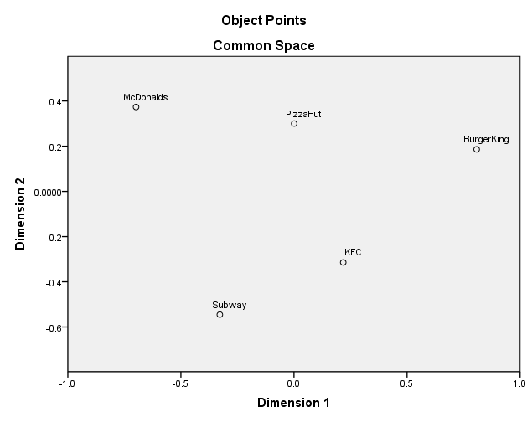

Service Blueprint

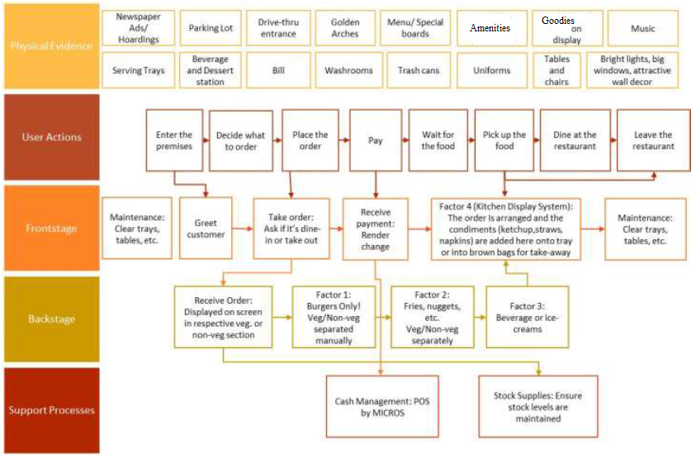

Flower of Service

**Information Elements**

· Banners and Holdings providing directions to Burger King Restaurants are available.

· Service hours are clearly displayed at the reception counter and entrance wall.

· Menu prices are clearly displayed on Price boards

· Instructions are communicated to the Customer about the services provided at Burger King

· Employee reminds Customer to pick up their order based on token provided

· Warnings regarding usage and maintenance of facilities are indicated to the customers using warning signs.

· There is enough information that Burger King provides in terms of products, prices and offers.

· All its customers are aware of its offers and wide variety of options in the menu.

· Terms and Conditions of Sales/Service are communicated to customers during the purchase of services.

· Changes of any king in any of the service is informed to the Customers at Sales counter or Entrance using sign boards

· Proper documentation of features associated with services is available

· Reservations are available to facilitate customers with special needs like parties, birthday celebrations etc.

· Confirmation on reservations is communicated to customers in a timely manner.

· Legitimate Bills/Receipts are provided to customers.

· All its customers are aware of its offers and wide variety of options in the menu

· Information is available online as well as in store.

**Order Taking Elements**

· The order taking mechanism is adequate and the attendants also use force functionality along with providing information to customers about various options available in the menu.

· Burger King can consider taking orders, providing token and then delivering the order at some other counter.

· This would avoid long queues. However in doing so, it has to make significant improvement in its operations to make this happen and the delivery of orders is carried out smoothly.

· Burger King has to take special care to bring the number of complaints down, reduce queues for normal order and take away and train employees to make organization more customers centric.

APPLICATIONS

· Details about Membership/Subscription programs and benefits of the same are clearly communicated to customers

ORDER ENTRY

· Online website order processing facility is available

· Application based order placement facility is available

RESERVATIONS AND CHECK-IN

· Separate Reservations are available for customers with special needs like special occasions of Birthdays, Anniversary celebrations etc.

**Billing Elements**

· If Customers subscribe to Burger King’s application then customers can be provided with periodic statements of their activity which reflects critical information like their preferences, buying behavior, new products, health info etc.

· Invoices for individual transactions are provided to the customer

· Sales executive inform the customer the amount due verbally

· The amount due is also displayed on digital payment machines

· Online orders provide a self-billing facility.

· Similarly the billing procedure is adequate and accurate and needs no improvement.

**Payment Elements**

SELF SERVICE

· The payment procedure is simple and multiple modes of payment are available like Debit/Credit cards, Cash, Wallets, Electronic funds transfer and Mobile Application based Money Transfer etc.

DIRECT TO PAYEE OR INTERMEDIARY

· Right amount of Cash to be received and change to provided back to the customer is clearly displayed on the payment recording machine.

· Customers are asked for any promotion codes or offers available for redemption.

AUTOMATIC DEDUCTION FROM FINANCIAL DEPOSITS

· Automatic deduction from partnered Wallets services for the products/services availed at Burger King.

**Consultation Elements**

· Employees often assist customers to inform them of other products available in their menus.

· Employees should be trained to have flawless and fluent communication with its customers.

· But wages of employees isn’t enough for them to show loyalty and so they might not put up their heart and soul to serve the customers.

· Burger King should look forward to rectifying this and train its employees to become advocates and thus provide better service in creating Brand Value.

**Hospitality Elements**

· Customers are greeted well by Employees at their arrival at the sales counter

· Toilets and washrooms in Burger King Restaurants are always maintained clean and hygienic.

· Chairs and other seating facilities are provided to customers who are waiting to receive their desired services.

· Amenities are designed to be customer friendly

**Safekeeping Elements**

CARING FOR GOODS PURCHASED BY CUSTOMERS

· The packaging provided for the products is environment friendly and of good quality.

· Products are kept under observation while awaiting for customer to pick up their orders

· Delivery of products are made keeping in mind that the products are intact and not deformed.

· Quality inspections are carried out by Store Managers regularly.

· The kitchen premises are always kept clean

· Maintenance repair and renovation of kitchen appliances are always carried out on time.

· Necessary facility upgrades based on demand are always facilitated.

**Exceptions Elements**

SPECIAL REQUESTS IN ADVANCE OF SERVICE DELIVERY

· Burger designs are altered based on children’s needs.

· Dietary information about the product is provided to the customers in the form of leaflets on demand.

HANDLING SPECIAL COMMUNICATIONS

· Complaint handling mechanism is in place. Restaurant Managers are proactive to resolve any kind of complaints received from customers.

· Feedback forms are available for customers to provide their experience of the services available.

· Compliments are highlighted and displayed on the wall of fame to motivate employees.

PROBLEM SOLVING

· All Burger King Products are produced using fresh ingredients.

· Guarantee of freshness is clearly communicated to the customer

· Managers and Employees are proactive in resolving difficulties that arise from using the products.

· Employees are friendly and helpful to resolve difficulties caused by accidents, failures, etc.

RESTITUTION

· Refunds/Compensation is available in case of an unsatisfied customer due to poor services/ products.

· The standardization followed by Burger King is appreciated everywhere. Its efficiency to provide fast service at low price is exceptional.

# Annexures

## Survey Questionnaire:

### Fast Food Restaurant Questionnaire

1. The fast food restaurants should have comfortable seats and clean utensils.

2. The fast food restaurants should have aesthetic appeal.

3. Their employees should be well dressed and appear neat.

4. The fast food restaurants should have seating arrangements in line with the type of services provided.

5. The music volume of the fast food restaurants should be to your liking.

6. When their employees promise to deliver within a certain time, they should do so.

7. When diners have problems, their employees should be sympathetic and reassuring.

8. The employees at the fast food restaurants should be reliable.

9. They should provide their services at the time as they promise to do so.

10. They should keep their records about regular diners and their choices accurately.

11. They should not be expected to tell diners exactly when services will be performed. (-)

12. It is not realistic for diners to expect prompt service from employees of fast food restaurants. (-)

13. Their employees don't always have to be willing to help diners. ( - )

14. It is okay if the employees are too busy to respond to customer requests promptly. ( —)

15. Diners should be able to trust employees of fast food restaurants.

16. The foods offered by fast food restaurants should be safe to eat.

17. Their employees should be consistently courteous with customers.

18. Their employees should get adequate support from the fast food restaurants to do their jobs well.

19. These fast food restaurants should not be expected to give diners individual attention. ( - )

20. The food servers and managers at the fast food restaurants cannot be expected to give personal attention to the diners. ( —)

21. It is unrealistic to expect food servers to know what the needs of their diners are. ( - )

22. It is unrealistic to expect the fast food restaurants to have their diners' best interests at heart. ( - )

23. They shouldn't be expected to have operating hours convenient to all their diners. (-)

24. The fast food restaurants should keep less waiting time for their diners.

25. The fast food restaurants should deliver the food of good quality at all times.

26. The employees at Fast food restaurants must be inline with increasing the trust of the diners.

27. The employees at fast food restaurants should have the knowledge about the menu to answer my questions.

28. Fast food restaurants should have a wide variety of food items for the diners to choose from.

29. The employees at fast food restaurants should be able to tell diners exactly when the food will be delivered.

30. Fast food restaurants should use good quality ingredients while preparing food.

31. Fast food restaurants should strengthen personal hygiene in preparing foods.

### Burger King Questionnaire

1. Burger King has comfortable seats and clean utensils.
2. Burger King has been visually appealing food joints.
3. Burger King’s employees are well dressed and appear neat.
4. The Burger King outlets are designed to provide efficient and faster services to clients.
5. The music volume at Burger King outlets is audible yet allows us to indulge in conversation.
6. Burger King serves food within the time as promised by them.
7. The employees at Burger King outlets are genuinely interested in resolving my issues.
8. I can trust the employees at Burger King outlets.
9. Burger King provides its services to me at the right time as promised.
10. The employees at Burger King outlets keep record of my preferences and give suggestions on the order accurately.
11. Burger King employees at the counters do not tell me exactly when services will be performed.
12. I did not receive quick services from Burger King’s employee.
13. Employees of Burger King are not always willing to help me or others.
14. Employees of Burger King are too busy to respond to my requests on time.
15. You can trust servers and managers working at Burger King outlets.
16. The employees at Burger King’s outlets reinforce safety measures while preparing food for me.
17. Caterer and manager at Burger King outlets are polite to me.
18. Employees at counters have all the information available from Burger King as well as the right equipment to do their jobs well.
19. Burger King does not give personal attention to me.
20. Employees at Burger King do not give personal attention to me.
21. Employees of Burger King do not know about my requirements.
22. Burger King does not have my best interests at heart.
23. The opening and closing time of Burger King outlets are not convenient to me.
24. Burger King does not keep their diners waiting for a longer time compared to other restaurants.
25. The foods offered by Burger King are of consistent quality.
26. The behavior of employees in Burger King instills confidence in diners.
27. Burger King’s employees have the knowledge to answer my questions.
28. Burger King offers a variety of food items to diners to choose from.
29. The employees of Burger King tell diners exactly when the services will be performed.
30. The quality of the ingredients used by Burger King is good.
31. Burger King employees use proper hygienic methods in preparing foods.

### Rating personal experience or performance at burger king: -

1. Whenever I think of visiting a restaurant, Burger King comes first to my mind.
2. How likely are you to recommend Burger King to your friends and family?