Lab Exercise 2

Animesh Sundriyal

Roll no. R177219031

SAP: 500075335

Batch-1 AI&ML

TITLE: Basic Java Programming

1) Write a program to find largest of 3 numbers

**Code:**

class EX2Q1{

public static void main(String args[])

{

int x=1,y=9,z=5,l=0;

if(x>y && x>z)

l=x;

if(y>z && y>x)

l=y;

if(z>x && z>y)

l=z;

System.out.println("The greatest of the 3 numbers is : "+l);

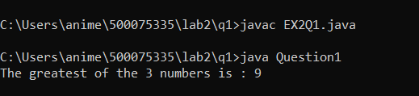

2) Write a program to implement a command line calculator

**Code:**

public class EX2Q2

{

public static void main(String[] args)

{

int x=Integer.parseInt(args[0]);

String operator=args[1];

int y=Integer.parseInt(args[2]);

int a=0;

if(operator.equals("+"))

a=x + y;

if(operator.equals("-"))

a=x - y;

if(operator.equals("*"))

a=x * y;

if(operator.equals("/"))

a=x / y;

System.out.println(a);

}}

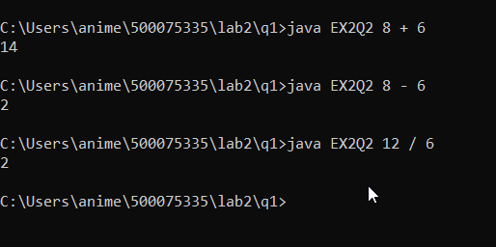

3) Write a program using classes and objects in Java

**Code:**

class EX2Q3{

boolean x;

void Green(){

x=true;

System.out.println("Vehicle can move- "+x);

}

void Red(){

x=false;

System.out.println("Vehicle can move- "+x);

}}

class EX2Q3Object{

public static void main(String [] args)

{

EX2Q3 car=new EX2Q3();

EX2Q3 bus=new EX2Q3();

car.Green();

bus.Red();

}}

