Lab Exercise 4

Animesh Sundriyal

Roll no. R177219031

SAP: 500075335

Batch-1 AI&ML

**AIM**:

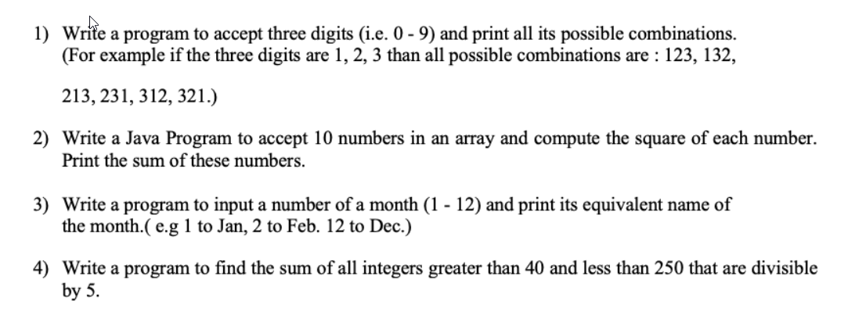

**Q1)**

**CODE:**

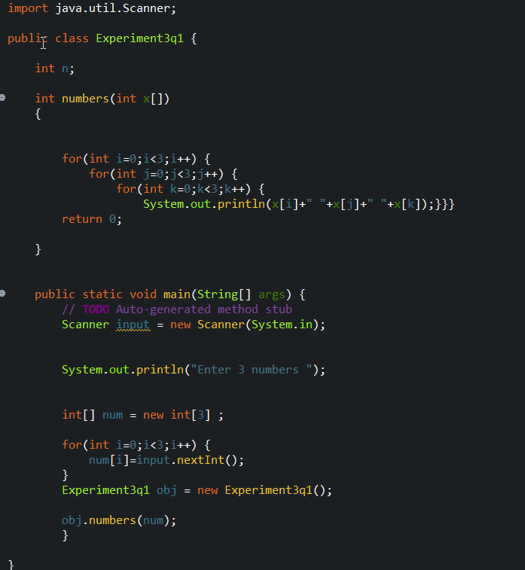

**OUTPUT:**

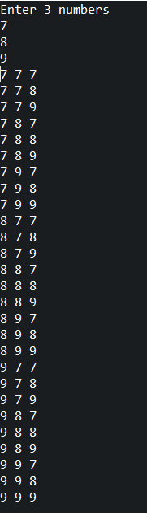

**Q2)**

**CODE:**

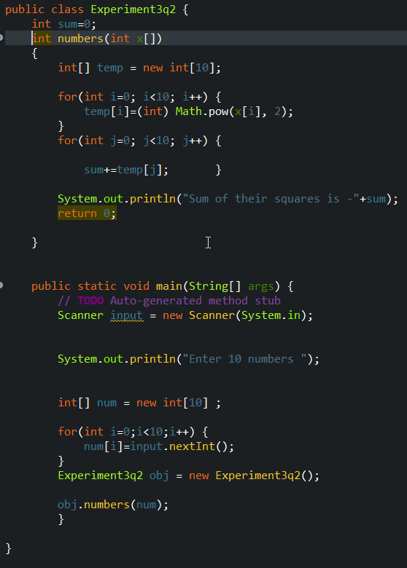

**OUTPUT :**

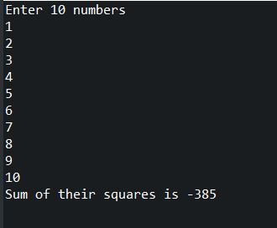

**Q3)**

**CODE:**

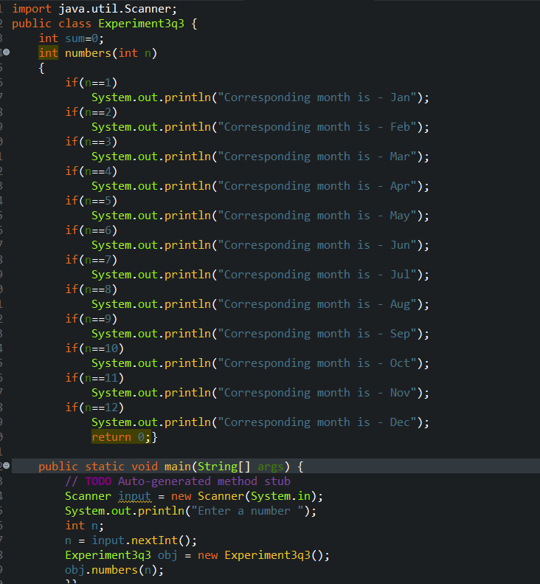

**OUTPUT:**

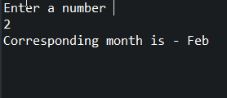

**Q4)**

**CODE & OUTPUT:**

