Lab Exercise 4

(GitHub)

Animesh Sundriyal

Roll no. R177219031

SAP: 500075335

Batch-1 AI&ML

1. **Installing Git** :

- Download git from “[https://git-scm.com/download/](https://git-scm.com/download/win)” according to your OS.

- Run the exe file and install it

To check if it is installed or not, Go to command prompt/terminal and write the command **git**

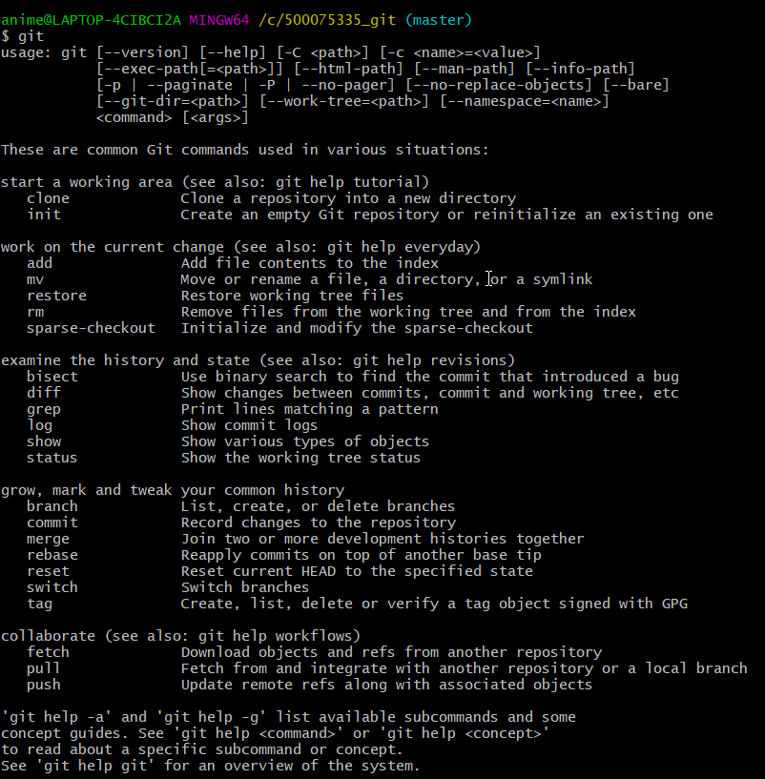

2. Git Initialize your folder done in previous exercises :

- Go to the directory of your folder in cmd

- write the command git init to initialize your folder

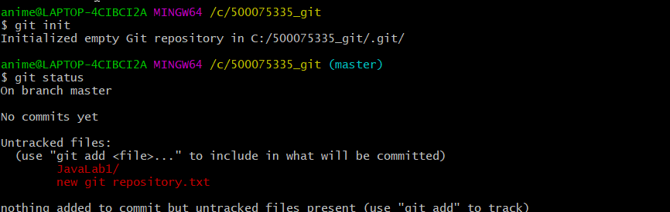

3. Add:

- Use command git add . to add all files to git

- Use command git add <filename> to add a particular file

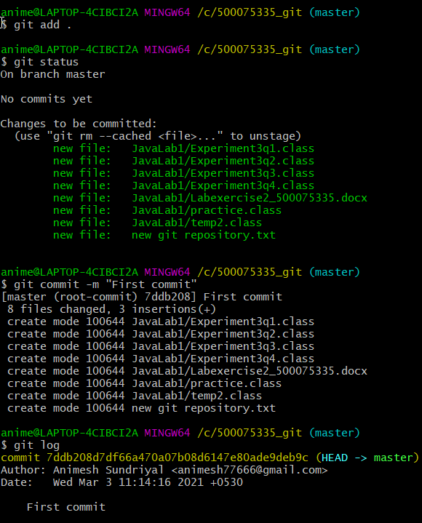

4. **Commit:**

- Use command **git commit** to commit

- Add message using **git commit -m “<Your message>”**

- Using **git log** you can check all the commits

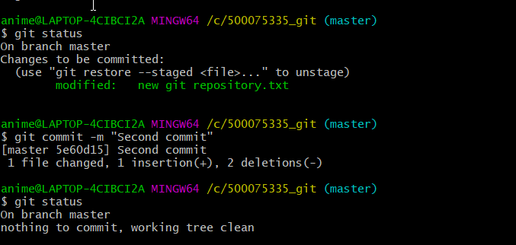

6. **Create an account on** [**github.com**](https://github.com/)

- Create a new repository

- Set it to public

- copy the url

- Connect local to the remote using origin and URL

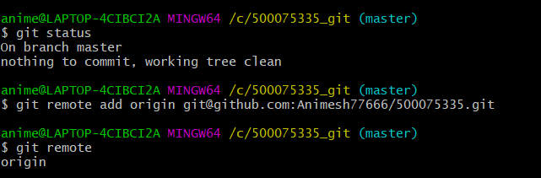

8. **Pushing to Github :**