import pandas as pd
import numpy as np
import matplotlib.pyplot as plt
import seaborn as sns
df=pd.read_csv('mymoviedb (1).csv',lineterminator='\n')
df.sample(3)
Release_Date Title \
104 2021-04-22 Wrath of Man
2099 2021-08-19 Reminiscence
1399 2014-02-13 Tinker Bell and the Pirate Fairy
Overview Popularity \
104 A cold and mysterious new security guard for a... 273.622
2099 Nicolas Bannister, a rugged and solitary veter... 39.419
1399 Zarina, a smart and ambitious dust-keeper fair... 52.890
Vote_Count Vote_Average Original_Language Genre \
104 3376 7.7 en Action, Crime, Thriller
2099 1090 6.9 en Science Fiction, Mystery
1399 777 6.8 en Animation, Family
Poster_Url
104 https://image.tmdb.org/t/p/original/M7SUK85sKj...
2099 https://image.tmdb.org/t/p/original/17siH6wJRQ...
1399 https://image.tmdb.org/t/p/original/qZLBe9Z8Y6...
#view the dataset info
print('information of datastet:\n',df.info())
#chackinjg any duplicated rows
df.duplicated().sum() # no duplicate rows is present
<class 'pandas.core.frame.DataFrame'>
RangeIndex: 9827 entries, 0 to 9826
Data columns (total 9 columns):
# Column Non-Null Count Dtype
--- ------ -------------- -----
0 Release_Date 9827 non-null object
1 Title 9827 non-null object
2 Overview 9827 non-null object
3 Popularity 9827 non-null float64
4 Vote_Count 9827 non-null int64
5 Vote_Average 9827 non-null float64
6 Original_Language 9827 non-null object
7 Genre 9827 non-null object
8 Poster_Url 9827 non-null object
dtypes: float64(2), int64(1), object(6)
memory usage: 691.1+ KB
information of datastet:
None
0
# desription
df.describe()
Popularity Vote_Count Vote_Average
count 9827.000000 9827.000000 9827.000000
mean 40.326088 1392.805536 6.439534
std 108.873998 2611.206907 1.129759
min 13.354000 0.000000 0.000000
25% 16.128500 146.000000 5.900000
50% 21.199000 444.000000 6.500000
75% 35.191500 1376.000000 7.100000
max 5083.954000 31077.000000 10.000000

Data cleaning
# extracting year,month and day from 'Releae_Date' column
df['Release_Date']=pd.to_datetime(df['Release_Date']) # 'Release_date' is of string types , it is converted to datetime datatype
df['Release_year']=df['Release_Date'].dt.year # Extracting the year
df['Release_month']=df['Release_Date'].dt.month # Extracting month
df['Release_day']=df['Release_Date'].dt.day # extracting the day of the month
df['Release_dow_name']=df['Release_Date'].dt.day_name() # extracting the day name of the week
df['Release_is_weekened']=np.where(df['Release_dow_name'].isin(['Sunday','Saturday']),1,0)
df.drop(columns=['Release_Date'])
df.sample(5)
Release_Date Title \
1318 2014-03-07 Noah
2799 1973-12-01 Fantastic Planet
3458 2019-05-04 47 Hours to Live
3844 2014-02-05 Jack and the Cuckoo-Clock Heart
1454 2013-08-07 Elysium
Overview Popularity \
1318 A man who suffers visions of an apocalyptic de... 55.213
2799 On the planet Ygam, the Draags, extremely tech... 31.790
3458 Two socially awkward teenage girls, are bored ... 27.174
3844 In Scotland 1874, Jack is born on the coldest ... 25.178
1454 In the year 2159, two classes of people exist:... 51.533
Vote_Count Vote_Average Original_Language \
1318 5292 5.6 en
2799 643 7.7 fr
3458 43 6.2 en
3844 570 7.2 fr
1454 7365 6.5 en
Genre \
1318 Drama, Adventure
2799 Animation, Science Fiction
3458 Thriller, Horror
3844 Animation, Romance, Adventure, Drama, Fantasy
1454 Science Fiction, Action, Drama, Thriller
Poster_Url Release_year \
1318 https://image.tmdb.org/t/p/original/trtD17IqSW... 2014
2799 https://image.tmdb.org/t/p/original/prq0j1S0K0... 1973
3458 https://image.tmdb.org/t/p/original/x2iAQLgwvd... 2019
3844 https://image.tmdb.org/t/p/original/ZSrU2mvlzM... 2014
1454 https://image.tmdb.org/t/p/original/aRjuJuPXHt... 2013
Release_month Release_day Release_dow_name Release_is_weekened
1318 3 7 Friday 0
2799 12 1 Saturday 1
3458 5 4 Saturday 1
3844 2 5 Wednesday 0
1454 8 7 Wednesday 0

Dropping the unwanted column
# dropping 'overview','Poster_Url' column
df=df.drop(columns=['Overview','Poster_Url'])
df.sample(3)
Release_Date Title Popularity Vote_Count \
6267 1985-07-03 Day of the Dead 18.003 900
2149 2003-06-27 Charlie's Angels: Full Throttle 38.715 2508
371 2011-04-21 Thor 129.237 17866
Vote_Average Original_Language Genre \
6267 7.0 en Horror, Thriller
2149 5.4 en Action, Adventure, Comedy
371 6.8 en Adventure, Fantasy, Action
Release_year Release_month Release_day Release_dow_name \
6267 1985 7 3 Wednesday
2149 2003 6 27 Friday
371 2011 4 21 Thursday
Release_is_weekened
6267 0
2149 0
371 0
- categorizing Vote_Average column
def categorize_col (df,col,labels):
edges=[df[col].describe()['min'],
df[col].describe()['25%'],
df[col].describe()['50%'],
df[col].describe()['75%'],
df[col].describe()['max']]
df[col]=pd.cut(df[col],edges,labels=labels,duplicates='drop')
return df
labels=['not_popular','below_avg','average','popular']
categorize_col(df,'Vote_Average',labels)
df['Vote_Average'].unique()
['popular', 'below_avg', 'average', 'not_popular', NaN]
Categories (4, object): ['not_popular' < 'below_avg' < 'average' < 'popular']
# exploring the column
print(df['Vote_Average'].value_counts())
df.head(3)
df.dropna(inplace=True) # removing the missing values
df.isnull().sum()
# Now no missing values are present
Vote_Average
not_popular 2467
popular 2450
average 2412
below_avg 2398
Name: count, dtype: int64
Release_Date 0
Title 0
Popularity 0
Vote_Count 0
Vote_Average 0
Original_Language 0
Genre 0
Release_year 0
Release_month 0
Release_day 0
Release_dow_name 0
Release_is_weekened 0
dtype: int64
- working on 'Genre' column
# extract the part of the string before the comma
df['Genre']=df['Genre'].str.split(', ')
df=df.explode('Genre').reset_index(drop=True)
df.sample(2)
#casting column into category
df['Genre']=df['Genre'].astype('category')
df['Genre'].dtypes
df.nunique()
Release_Date 5846
Title 9415
Popularity 8088
Vote_Count 3265
Vote_Average 4
Original_Language 42
Genre 19
Release_year 100
Release_month 12
Release_day 31
Release_dow_name 7
Release_is_weekened 2
dtype: int64
df.shape
(25552, 12)

data visualization
- most frequent genre
df['Genre'].describe()
count 25552
unique 19
top Drama
freq 3715
Name: Genre, dtype: object
sns.catplot(data=df,y='Genre',kind='count',order=df['Genre'].value_counts().index,color='green')
<seaborn.axisgrid.FacetGrid at 0x290727018b0>
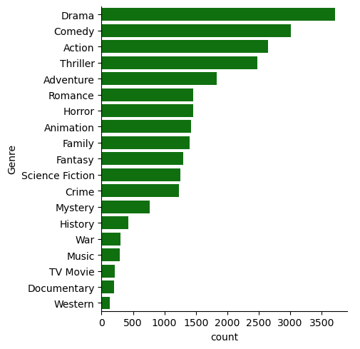
- genre which has highest votes
# visualizing vote_Average column
sns.catplot(data=df,y='Vote_Average',kind='count',order=df['Vote_Average'].value_counts().index)
<seaborn.axisgrid.FacetGrid at 0x2907233f860>
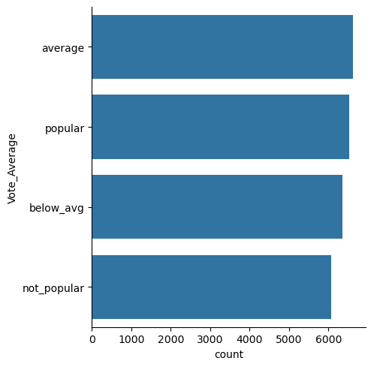
- movie got highest popularity // what is its genre
# checking max popularity in dataset
df[df['Popularity']==df['Popularity'].max()]
Release_Date Title Popularity Vote_Count Vote_Average \
0 2021-12-15 Spider-Man: No Way Home 5083.954 8940 popular
1 2021-12-15 Spider-Man: No Way Home 5083.954 8940 popular
2 2021-12-15 Spider-Man: No Way Home 5083.954 8940 popular
Original_Language Genre Release_year Release_month \
0 en Action 2021 12
1 en Adventure 2021 12
2 en Science Fiction 2021 12
Release_day Release_dow_name Release_is_weekened
0 15 Wednesday 0
1 15 Wednesday 0
2 15 Wednesday 0
df[df['Popularity']==df['Popularity'].min()]
Release_Date Title Popularity \
25546 2021-03-31 The United States vs. Billie Holiday 13.354
25547 2021-03-31 The United States vs. Billie Holiday 13.354
25548 2021-03-31 The United States vs. Billie Holiday 13.354
25549 1984-09-23 Threads 13.354
25550 1984-09-23 Threads 13.354
25551 1984-09-23 Threads 13.354
Vote_Count Vote_Average Original_Language Genre \
25546 152 average en Music
25547 152 average en Drama
25548 152 average en History
25549 186 popular en War
25550 186 popular en Drama
25551 186 popular en Science Fiction
Release_year Release_month Release_day Release_dow_name \
25546 2021 3 31 Wednesday
25547 2021 3 31 Wednesday
25548 2021 3 31 Wednesday
25549 1984 9 23 Sunday
25550 1984 9 23 Sunday
25551 1984 9 23 Sunday
Release_is_weekened
25546 0
25547 0
25548 0
25549 1
25550 1
25551 1
- most filmmed movies
df['Release_year'].hist()
plt.title('Release year')
plt.show()
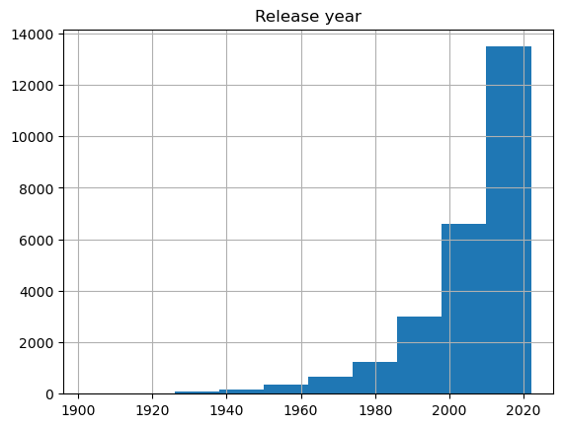
df.sample()
Release_Date Title Popularity Vote_Count Vote_Average \
22120 1994-04-29 With Honors 14.745 147 average
Original_Language Genre Release_year Release_month Release_day \
22120 en Comedy 1994 4 29
Release_dow_name Release_is_weekened
22120 Friday 0

