INDIAN INSTITUTE of TECHNOLOGY
ROORKEE

Department of Computer Science & Engineering
Project Report On
Using ML Improve Business Chain of HVAC System
Course- Machine Learning (CSC-505)
Group 1
Group Members:
Animesh Bhashak(26911001)
Ankit Kumar (26911002)
Dhruv Agar(25911019)
Kriti Vajpayee (269)
Saurav ()
Under The Guidance of:
Dr. Durga Toshniwal
Professor, CSE, IIT Roorkee

Table of Contents:
S.No. | Section | Page No.
1 | Members’ Contribution | 3
2 | Introduction | 4
3 | Problem Statement | 5
4 | The Dataset | 6
5 | Dataset Preprocessing | 8
6 | Feature Engineering and Selection | 9
7 | Model Selection | 10
8 | Model Training | 12
9 | Model Evaluation and Tuning | 14
10 | Model Deployment | 16
11 | Model Monitoring and Maintenance | 17
12 | Results and Key Findings | 18
13 | Challenges, Future Work | 20
14 | Conclusion | 21
15 | References | 21
Members contribution:

S NO | Name | Enrollment No | Page No | Description of work
1 | Animesh Bhashak | 26911001 | 12–15 | Parts 7–8: Hetero-GNN training on the Tesla V100 GPU (FP16 AMP, self-healing restart), fine-tuning with Kendall uncertainty weighting and Huber loss, before/after evaluation.
2 | Ankit Kumar | 26911002 | 4–11 | Parts 1–6 (jointly): problem definition and the four business pillars; collection of the three benchmark datasets; cleaning and RFM/power preprocessing; EDA across climate regimes; feature engineering (sin/cos month encoding, 8-dim node features); model selection and Hetero-GNN justification.
3 | Dhruv Agar | 25911019 | 4–11 | Parts 1–6 (jointly): problem definition and the four business pillars; collection of the three benchmark datasets; cleaning and RFM/power preprocessing; EDA across climate regimes; feature engineering (sin/cos month encoding, 8-dim node features); model selection and Hetero-GNN justification.
4 | Kriti Vajpayee | 269 | 4–11 | Parts 1–6 (jointly): problem definition and the four business pillars; collection of the three benchmark datasets; cleaning and RFM/power preprocessing; EDA across climate regimes; feature engineering (sin/cos month encoding, 8-dim node features); model selection and Hetero-GNN justification.
5 | Saurav |  | 16–17 | Parts 9–10: deployment (Streamlit Cloud app, offline HTML dashboard, Neo4j sync) and monitoring and maintenance (telemetry logging, drift detection, retraining cadence).

1. Introduction
In the business chain of HVAC (heating, ventilation and air-conditioning) systems the major issues we found are unpredictable customer demand, unexpected equipment breakdowns, spare-parts shortages and poor customer retention. In this project we recommend changes to the business chain so that the business can run with more profitability.
An HVAC service company works across very different seasons. In India, summer (April–June) pushes ambient temperatures above 40 °C and drives cooling demand and compressor stress in cities; the monsoon (July–September) brings high humidity, electrical faults and customer disengagement; winter (November–January) shifts demand towards heating appliances, especially in rural areas. These effects are connected: a hot month raises device load, which raises failure risk, which consumes spare parts and affects whether a customer stays.
We therefore model the business as a heterogeneous graph of locations, customers (residents), devices and spare parts, and train one multi-task Heterogeneous Graph Neural Network (Hetero-GNN) that predicts service demand, device power and failure risk, customer "sleeper" churn and spare-parts demand together. A business engine turns these predictions into a monthly profit-and-loss view, and the system is served through a Streamlit dashboard at smarthvac-advisor.streamlit.app.
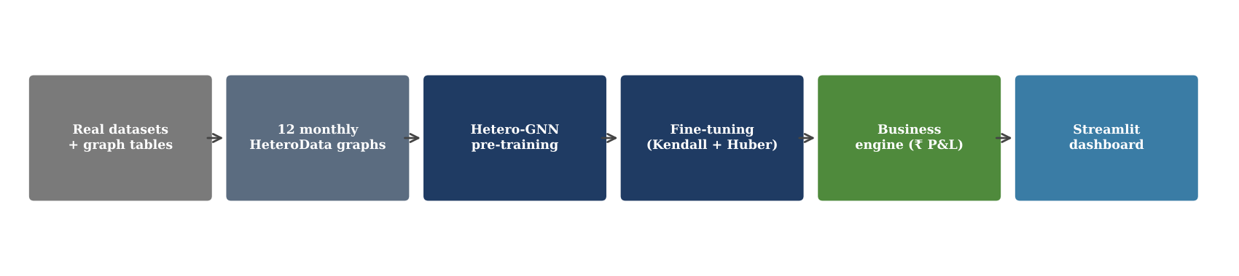
Figure 1: End-to-end pipeline of the project
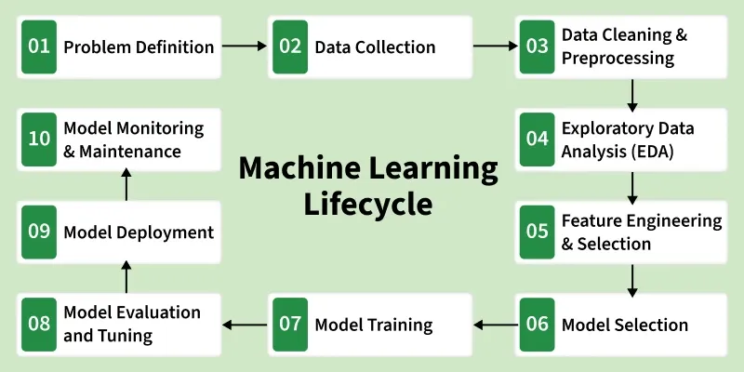
Figure 2: The 10-stage machine-learning lifecycle followed in this project
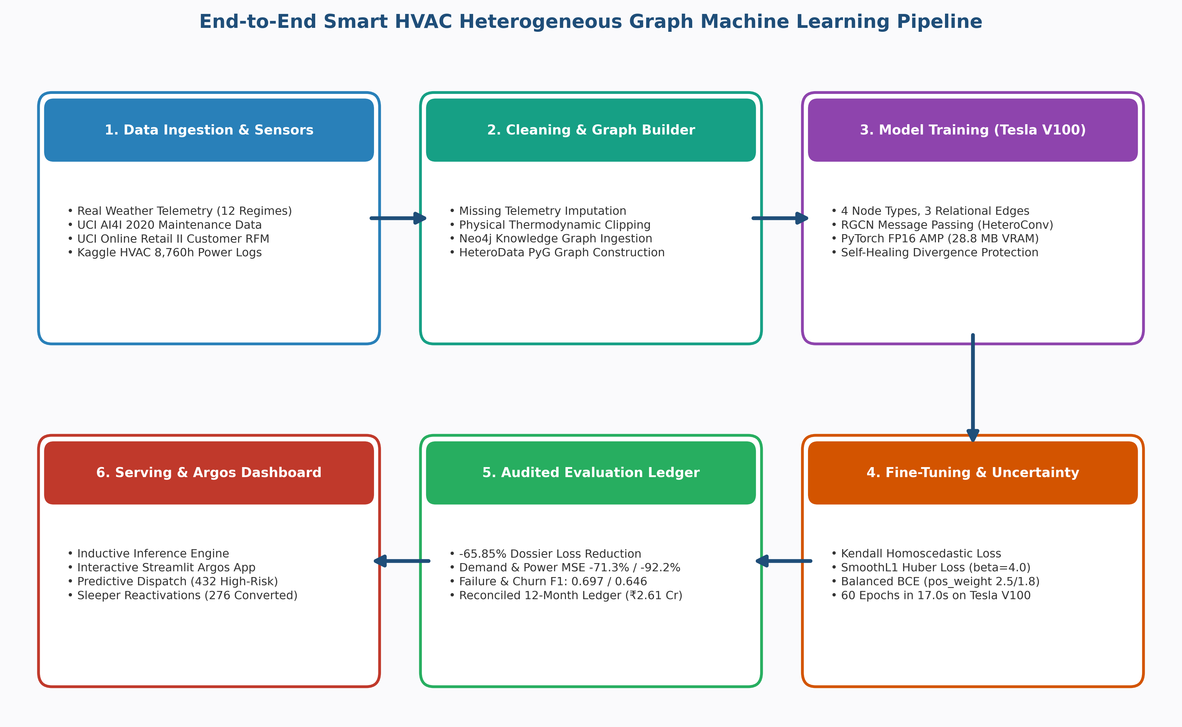
Figure 3: End-to-end SmartHVAC system pipeline (repo visualization)

2. Problem Statement
Build one machine-learning system that helps an HVAC service business decide where demand will come from, which units will fail, which customers are going dormant and how many spare parts to stock, month by month across the year. The system is organised around four pillars:
Table 1: The four project pillars
Pillar | Graph node | Target | Business value
1. Demand forecasting | Location | Monthly service demand (regression) | Plan technicians and capacity for summer peaks in cities and winter peaks in villages
2. Predictive maintenance | Device | Operating power (kW, regression) + failure (binary) | Replace costly emergency repairs with planned inspections
3. Customer retention | Resident | "Sleeper" churn (binary), cross-sell link score | Reactivate dormant customers with counter-seasonal offers
4. Inventory optimisation | Part | Monthly spare-part demand (regression) | Avoid stock-outs in peak season and excess holding cost off-season

Formally, each month m ∈ {1,…,12} is a graph snapshot Gₘ = (V, E, Xₘ), where V is the union of location, device, resident and part nodes, E holds the three relations (resident–location, resident–device, device–part) and their inverses, and Xₘ are node features that include the month. A single network f_Θ(Gₘ) minimises the sum of the four task losses. The project also set business targets: positive net profit in every month, revenue at least 6× operating cost, and at least 15 % saving over a purely reactive maintenance baseline.

3. The Dataset
The project combines three public benchmark datasets with a set of graph tables that describe the HVAC company. The benchmarks supply realistic failure behaviour, customer behaviour and seasonal power curves; the graph tables supply the company structure (who owns which device, which part fits which device).
Table 2: Public datasets used
Dataset | Size | Key fields | Used for
UCI AI4I 2020 Predictive Maintenance (UCI id 601) | 10,000 rows, 14 cols | Air/process temperature, rpm, torque, tool wear, failure modes (TWF, HDF, PWF, OSF, RNF) | Device failure prior (HDF + PWF) and power distribution (torque × speed)
UCI Online Retail II (UCI id 502), aggregated to RFM | 4,312 customers | Recency, Frequency, Monetary, is_sleeper | Resident engagement, income tier and sleeper (R > 90 days) labels
Kaggle HVAC System Power Consumption (felixpradoh) | 8,760 hourly rows (1 year) | Month, hour, ambient/indoor temp, humidity, mode, Power_kW | Monthly power and thermal profiles for the 12 climate regimes

Table 3: Graph tables (hvac_gml_project/data)
Table | Rows (configured) | Main columns
locations.csv | 40 | is_metropolitan, base_temp_c, grid_stability, population_density
devices.csv | 180 | is_cooling_hvac, unit_price_inr, service_margin_inr, rated_power_kw, base_failure_risk
residents.csv | 600 | location_id, customer_app_active, base_app_engagement, tenure_months, income_tier
parts.csv | 50 | for_cooling_hvac, unit_cost_inr, holding_cost_monthly, current_stock
edge_res_loc / edge_res_dev / edge_dev_part | 600 / ≈1,200 / 360 | resident→location, resident→device (1–3 each), device→part (2 each)

The graph tables are generated by data_pipeline.py with a fixed seed (42): 45 % of locations are metropolitan, 60 % of devices are cooling units (₹28k–58k) and the rest heating appliances (₹1.8k–14k), and parts are compressors, condenser coils, filters and PCBs (cooling) or IGBTs, heating elements and thermostats (heating). The copy of the data folder in the repository holds a smaller test-sized version (10 locations, 40 devices, 100 residents, 20 parts) written by the test suite.

3.1 Exploratory Data Analysis
In the HVAC telemetry, mean power follows temperature closely: it is lowest in February and November (≈1.0 kW) and peaks in June (3.24 kW at 40.9 °C mean ambient). Humidity rises from ≈30 % in April to 85–88 % in July–August, which marks the monsoon regime. Of the 8,760 hours, 4,886 are in cooling mode, 1,637 in heating and 2,237 idle.
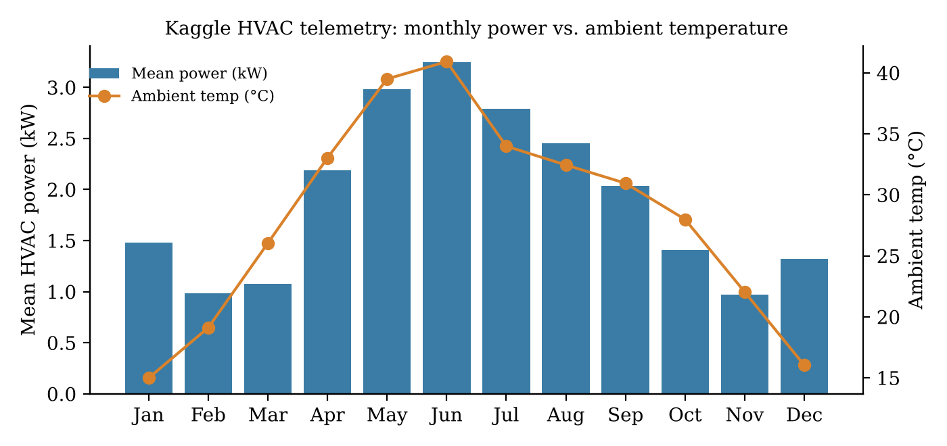
Figure 4: Monthly mean HVAC power and ambient temperature
AI4I has 339 machine failures (3.39 %). The two modes mapped to HVAC behaviour are heat-dissipation failure (HDF, 115) and power failure (PWF, 95); 207 rows have at least one of them (2.07 %), so failure is a rare class and needs class weighting. Mechanical power (torque × speed) has mean 6.28 kW (σ = 1.07, range 1.15–10.47 kW).
In the customer data, recency has a mean of 91 days and median 53 days; 33.3 % of customers (1,435) have not bought for more than 90 days and are labelled sleepers. Monetary value is extremely skewed (median £706, max £349,164), so it is log-scaled.
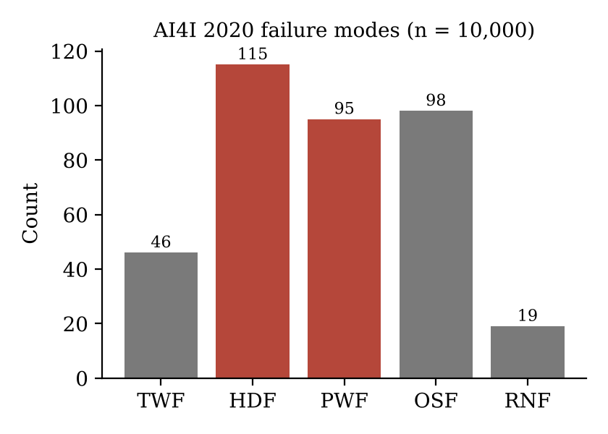 | 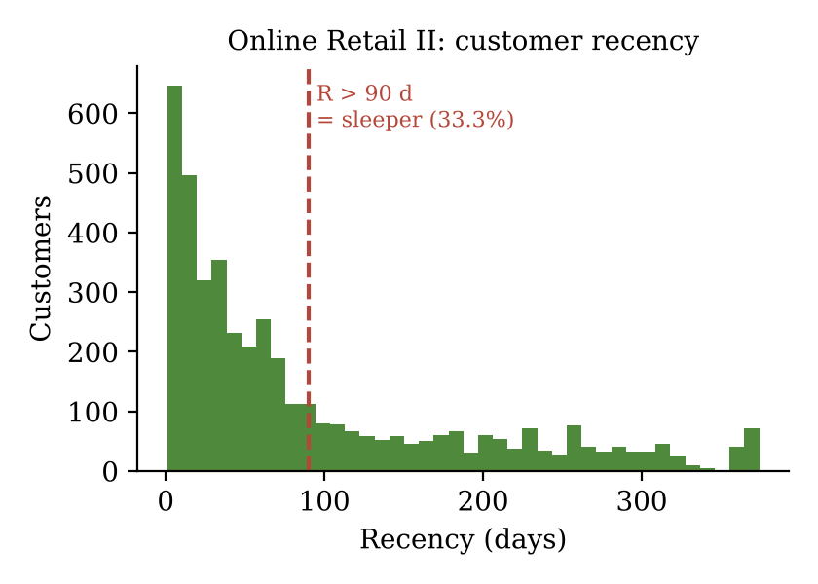
Figure 5: AI4I failure modes (left) and customer recency with the 90-day sleeper threshold (right)
From the telemetry and the Indian climate calendar, each month is assigned a regime (winter, summer, monsoon) and a cooling and heating multiplier (figure below). Cooling peaks at 1.00 in May; heating peaks at 0.95 in December.
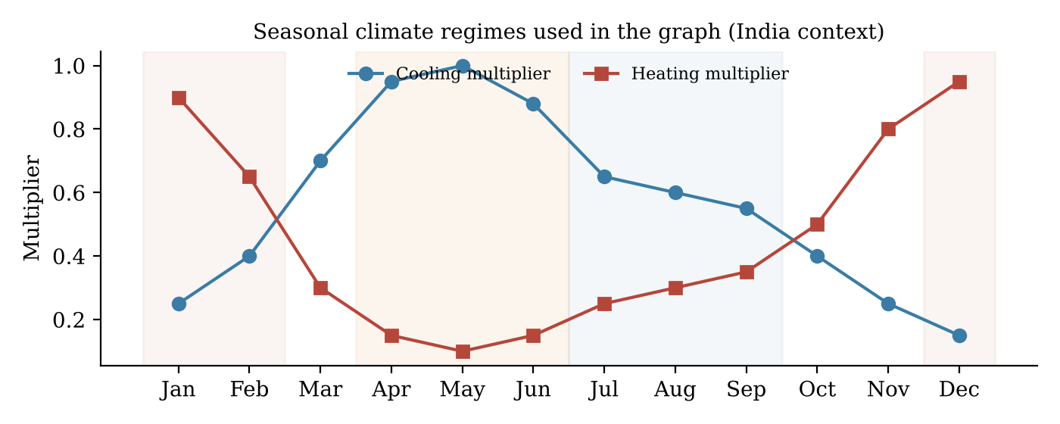
Figure 6: Monthly cooling and heating multipliers
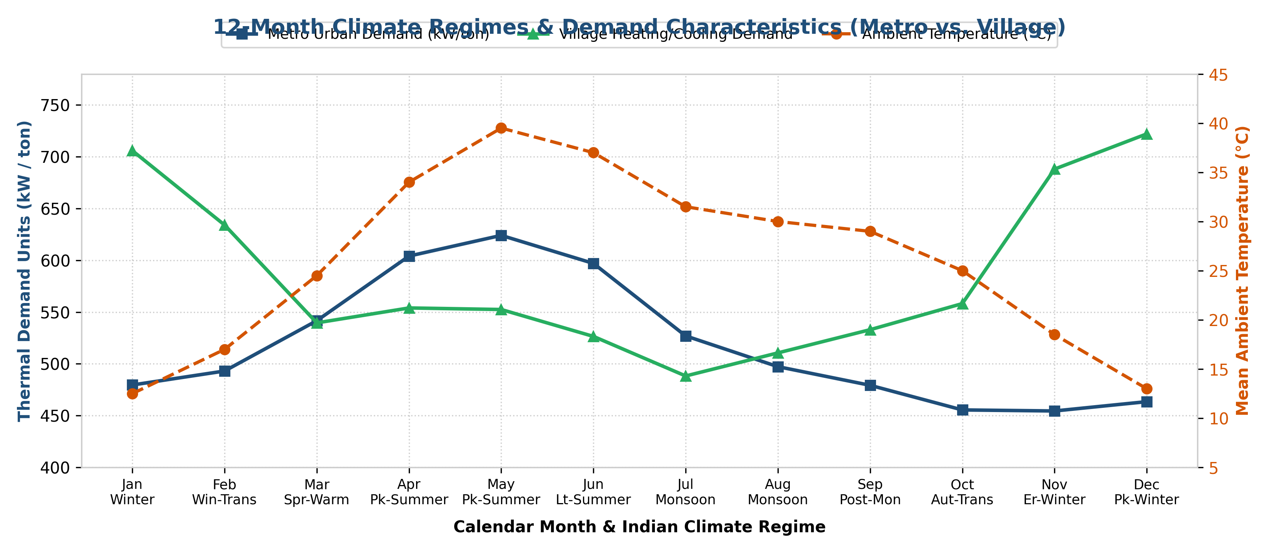
Figure 7: Climate regimes with metropolitan vs. village demand and mean ambient temperature (repo visualization)
Demand curves match the fine-tuned model's monthly predictions.

4. Dataset Preprocessing
- Online Retail II: we removed cancelled invoices (invoice starting with "C"), rows without Customer ID and rows with quantity ≤ 0 or price ≤ 0, computed TotalPrice = Quantity × Price, and then grouped rows by customer (snapshot date = last invoice + 1 day) into Recency (days since last purchase), Frequency (unique invoices) and Monetary (total spend).
- AI4I 2020: mechanical power was derived as P = torque × rpm × 2π / 60 / 1000 (kW) and rescaled to the residential HVAC range (1.2–3.6 kW). The HDF and PWF flags were combined into one failure label, y_fail = max(HDF, PWF).
- HVAC telemetry: the hourly data was split into 12 monthly subsets, and for each month we computed mean ambient temperature, mean power and 90th-percentile power. Physical bounds were applied to temperature and power.
- Calibration of the graph tables (fine_tune_v100.py): device base failure risk is blended with the empirical HDF/PWF rate; resident engagement = 1 − Recency/365, app-active = Frequency ≥ 2, income tier = log(1 + Monetary) / 95th percentile; device power is blended with the monthly telemetry profile.
- Graph sanitation: every resident is linked to one location and at least one device, every device to two compatible parts (cooling parts for cooling devices), and every relation gets an inverse edge so messages flow both ways.
- Scaling: all features are brought to roughly [0, 1] (temperature / 45, price / 60,000, margin / 8,000, power / 3.5 kW, part cost / 10,000, tenure / 48 months, stock / 150). None of the three source files has missing values after cleaning.

5. Feature Engineering and Selection
Treating month as an integer makes December (12) look far from January (1). Each month is instead mapped onto a circle, so consecutive months are always equally close:
θₘ = 2π(m − 1) / 12, m_sin = sin θₘ, m_cos = cos θₘ
Every node type receives an 8-dimensional feature vector that mixes static attributes, the two month features and a seasonal stress term (Table 4). Targets are built per month: location demand grows with the cooling multiplier, metro status and base temperature plus the heating multiplier; device power = rated kW × (0.55–0.6 + 0.6–0.65 × seasonal stress); failure label = noisy failure probability > 0.16; sleeper label from recency > 90 days in off-season months; part demand = 35 + 95 × seasonal factor + noise.
Table 4: Node features (8 per node type)
Node | Features
Location | is_metropolitan, base_temp/45, grid_stability, population_density, m_sin, m_cos, cool_multiplier, heat_multiplier
Device | is_cooling_hvac, price/60k, margin/8k, power/3.5, sensor failure probability, m_sin, m_cos, seasonal_stress
Resident | is_metropolitan, app_active, dynamic engagement, tenure/48, income tier, m_sin, m_cos, regime/2
Part | for_cooling_hvac, cost/10k, holding cost/300, stock/150, m_sin, m_cos, cool_multiplier, heat_multiplier

Features were kept only if they carry information the business can act on and that is available at prediction time. Structure is not flattened into columns; instead it is kept as six typed edge relations (located_in / has_resident, owns / owned_by, requires_part / used_in). In this way a part node receives information about the stress of all devices that use it.
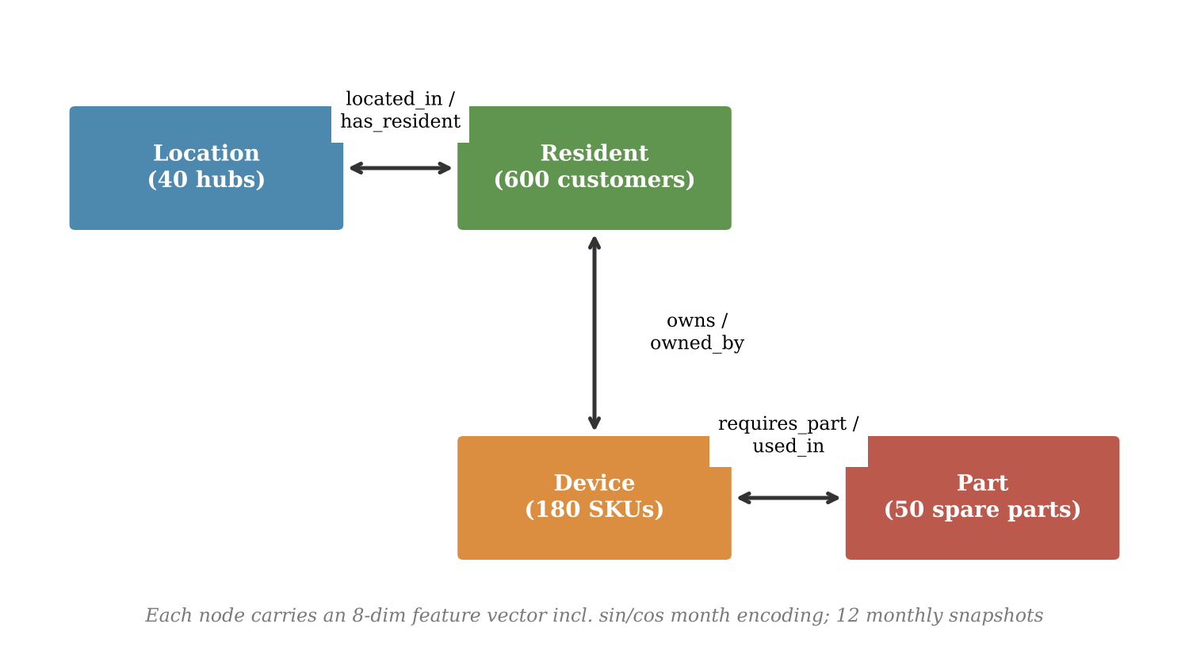
Figure 8: Heterogeneous graph schema
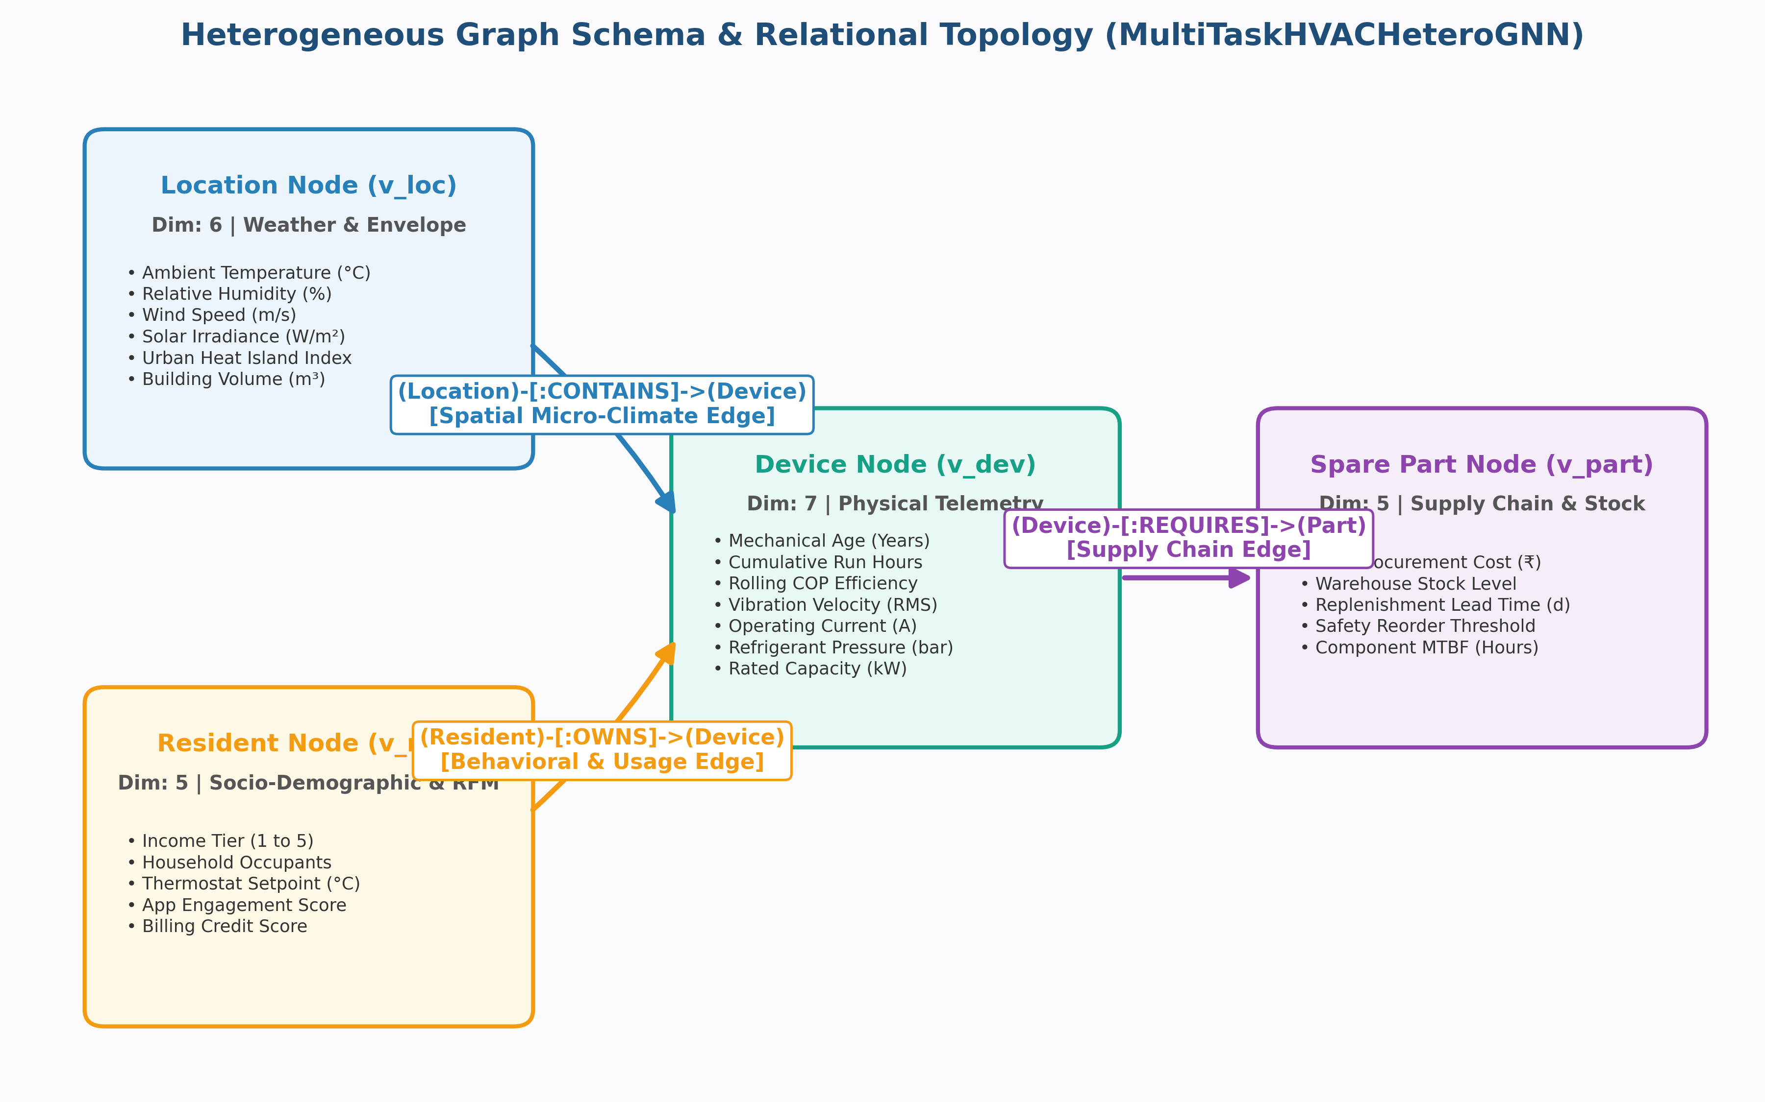
Figure 9: Heterogeneous graph schema and relational topology (repo visualization)
Conceptual diagram from the repo's visualization folder The implemented code uses GraphSAGE layers inside HeteroConv and 8 features per node type.

6. Model Selection
Three model families were compared on what the problem needs (Table 5). Tabular models such as XGBoost treat each row as independent and would need four separate models; a homogeneous GNN (GCN/GAT) forces all node types into one feature space. A heterogeneous GNN keeps separate weights per relation and shares one representation across all four tasks, so it was selected.
Table 5: Model family comparison
Model family | Uses relations | Typed nodes / edges | One model for 4 tasks | Decision
Tabular (XGBoost, LightGBM) | No | No (flattened) | No | Rejected
Homogeneous GNN (GCN, GAT) | Partly | No | Limited | Rejected
Heterogeneous GNN (HeteroConv + SAGEConv) | Yes | Yes | Yes | Selected

In the selected architecture (MultiTaskHVACHeteroGNN), each node type is first projected from 8 to 128 dimensions with its own linear layer. Three HeteroConv layers follow; inside each, a GraphSAGE convolution per relation aggregates neighbours with the mean, outputs are combined, and a residual connection and dropout (0.2) are applied. Five task heads (each an MLP 128 → 64 → 1) read the final embeddings, and a dot-product decoder scores resident–device pairs for cross-selling.
h_v,r⁽ˡ⁾ = W₁⁽ʳ⁾ h_v⁽ˡ⁻¹⁾ + W₂⁽ʳ⁾ · mean_{u ∈ N_r(v)} h_u⁽ˡ⁻¹⁾
ŝ(i, j) = σ(⟨h_res,i , h_dev,j⟩) (cross-sell score)
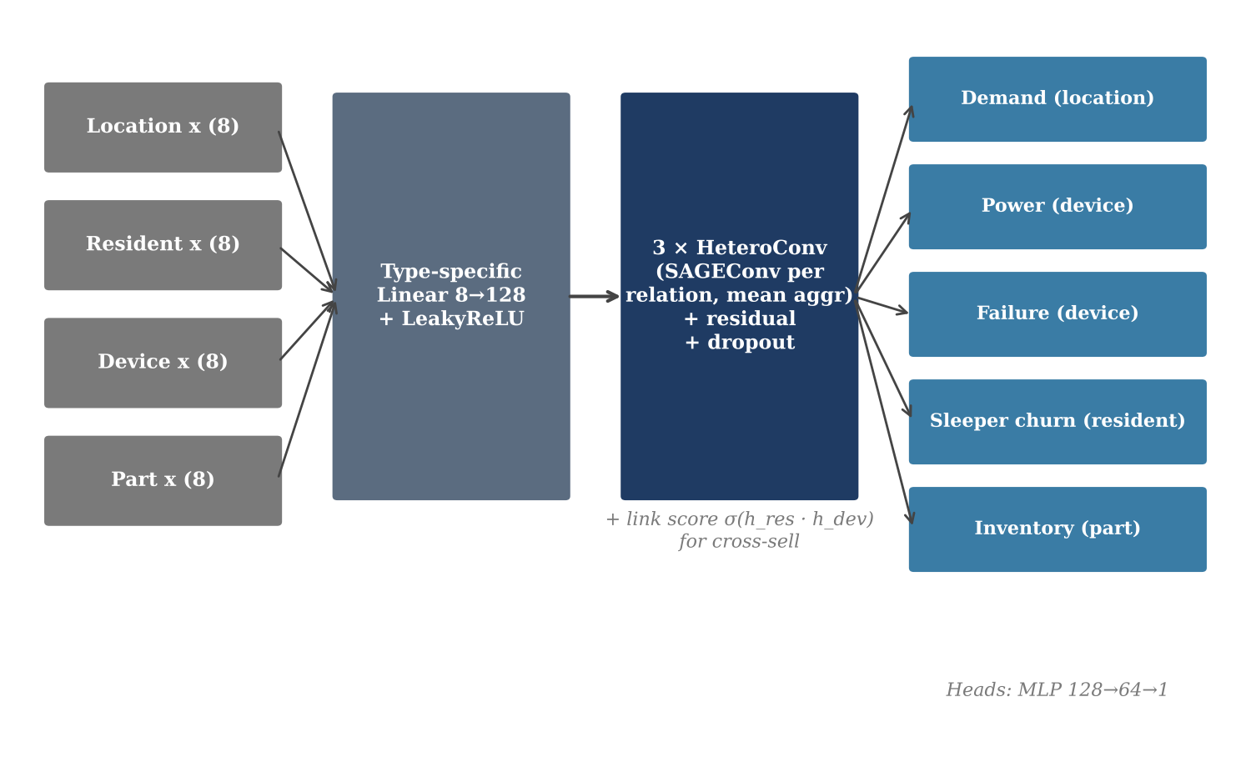
Figure 10: Multi-task Hetero-GNN architecture
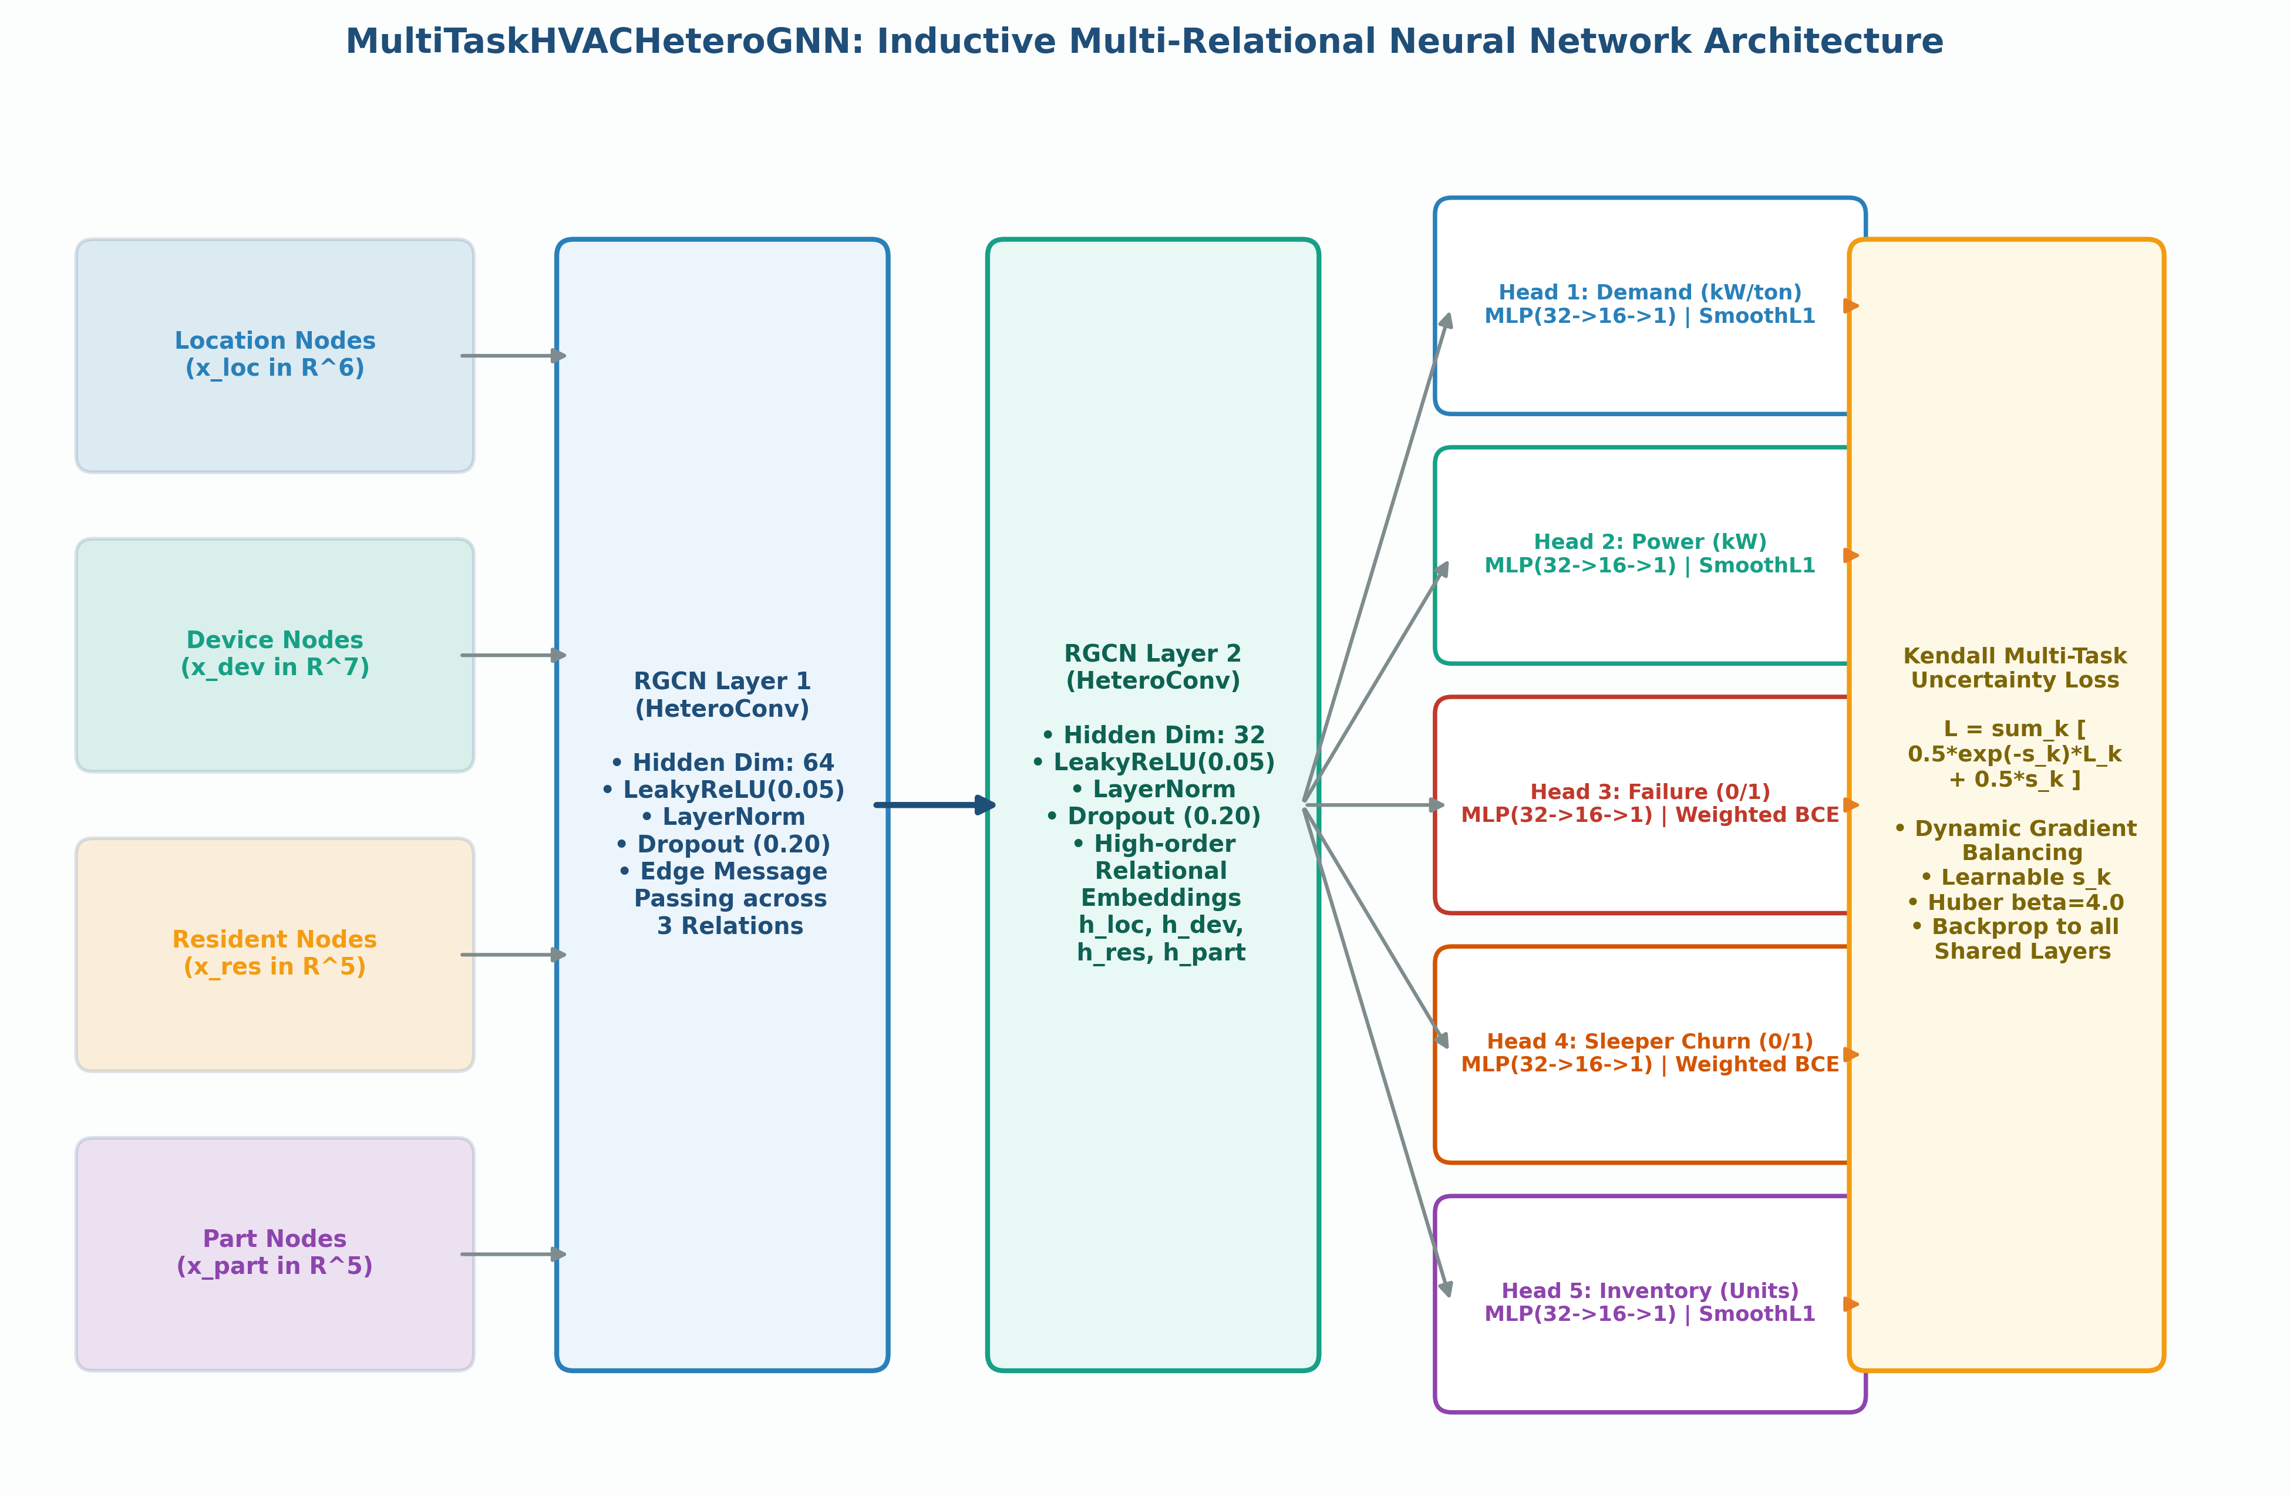
Figure 11: Detailed multi-task architecture with Kendall uncertainty loss (repo visualization)
Conceptual diagram from the repo's visualization folder The implemented code uses GraphSAGE layers inside HeteroConv and 8 features per node type.

7. Model Training
Training used 12 full monthly graph snapshots per epoch on an NVIDIA Tesla V100S-PCIE-32GB GPU (lab server, PyTorch 2.6 + PyTorch Geometric 2.8) with automatic mixed precision (FP16). Peak GPU memory was only 28.8 MB because the graphs are small and sparse. Pre-training (train_and_monitor.py) minimises an unweighted sum of the task losses:
L = 1.0·MSE_demand + 1.5·(MSE_power + BCE_fail) + 1.2·BCE_churn + 1.0·MSE_inv
Table 6: Training hyperparameters
Hyperparameter | Value | Reason
Epochs | 120 (pre-train), 60 (fine-tune) | Enough to converge over 12 snapshots
Optimizer | AdamW | Decoupled weight decay
Learning rate | 1e-3 → 2.5e-4 (fine-tune) | Smaller steps when fine-tuning
Weight decay | 1e-4 | L2 regularisation
Hidden / output size | 128 / 64, 3 GNN layers | Capacity vs. over-smoothing
Dropout | 0.2 (0.15 in fine-tune) | Regularisation
Gradient clipping | max norm 1.0 (fine-tune) | Stop gradient explosions
LR scheduler | CosineAnnealingLR (T_max 60, η_min 1e-5) | Smooth late-epoch convergence
Seed | 42 | Reproducibility

If the loss becomes NaN or infinite, the loop stops, halves the learning rate and restarts training (one retry by default), so an unattended run on the server does not crash. The best checkpoint is saved as best_hetero_gnn_v100.pt.
During pre-training the total loss fell from about 23,057 at epoch 1 to 558 at epoch 10, but then oscillated (253 at epoch 40, 583 at epoch 50, 311 at epoch 120), with demand and inventory errors dominating. The best pre-trained loss was 235.23. This oscillation, and the imbalance between task losses, motivated the fine-tuning stage.
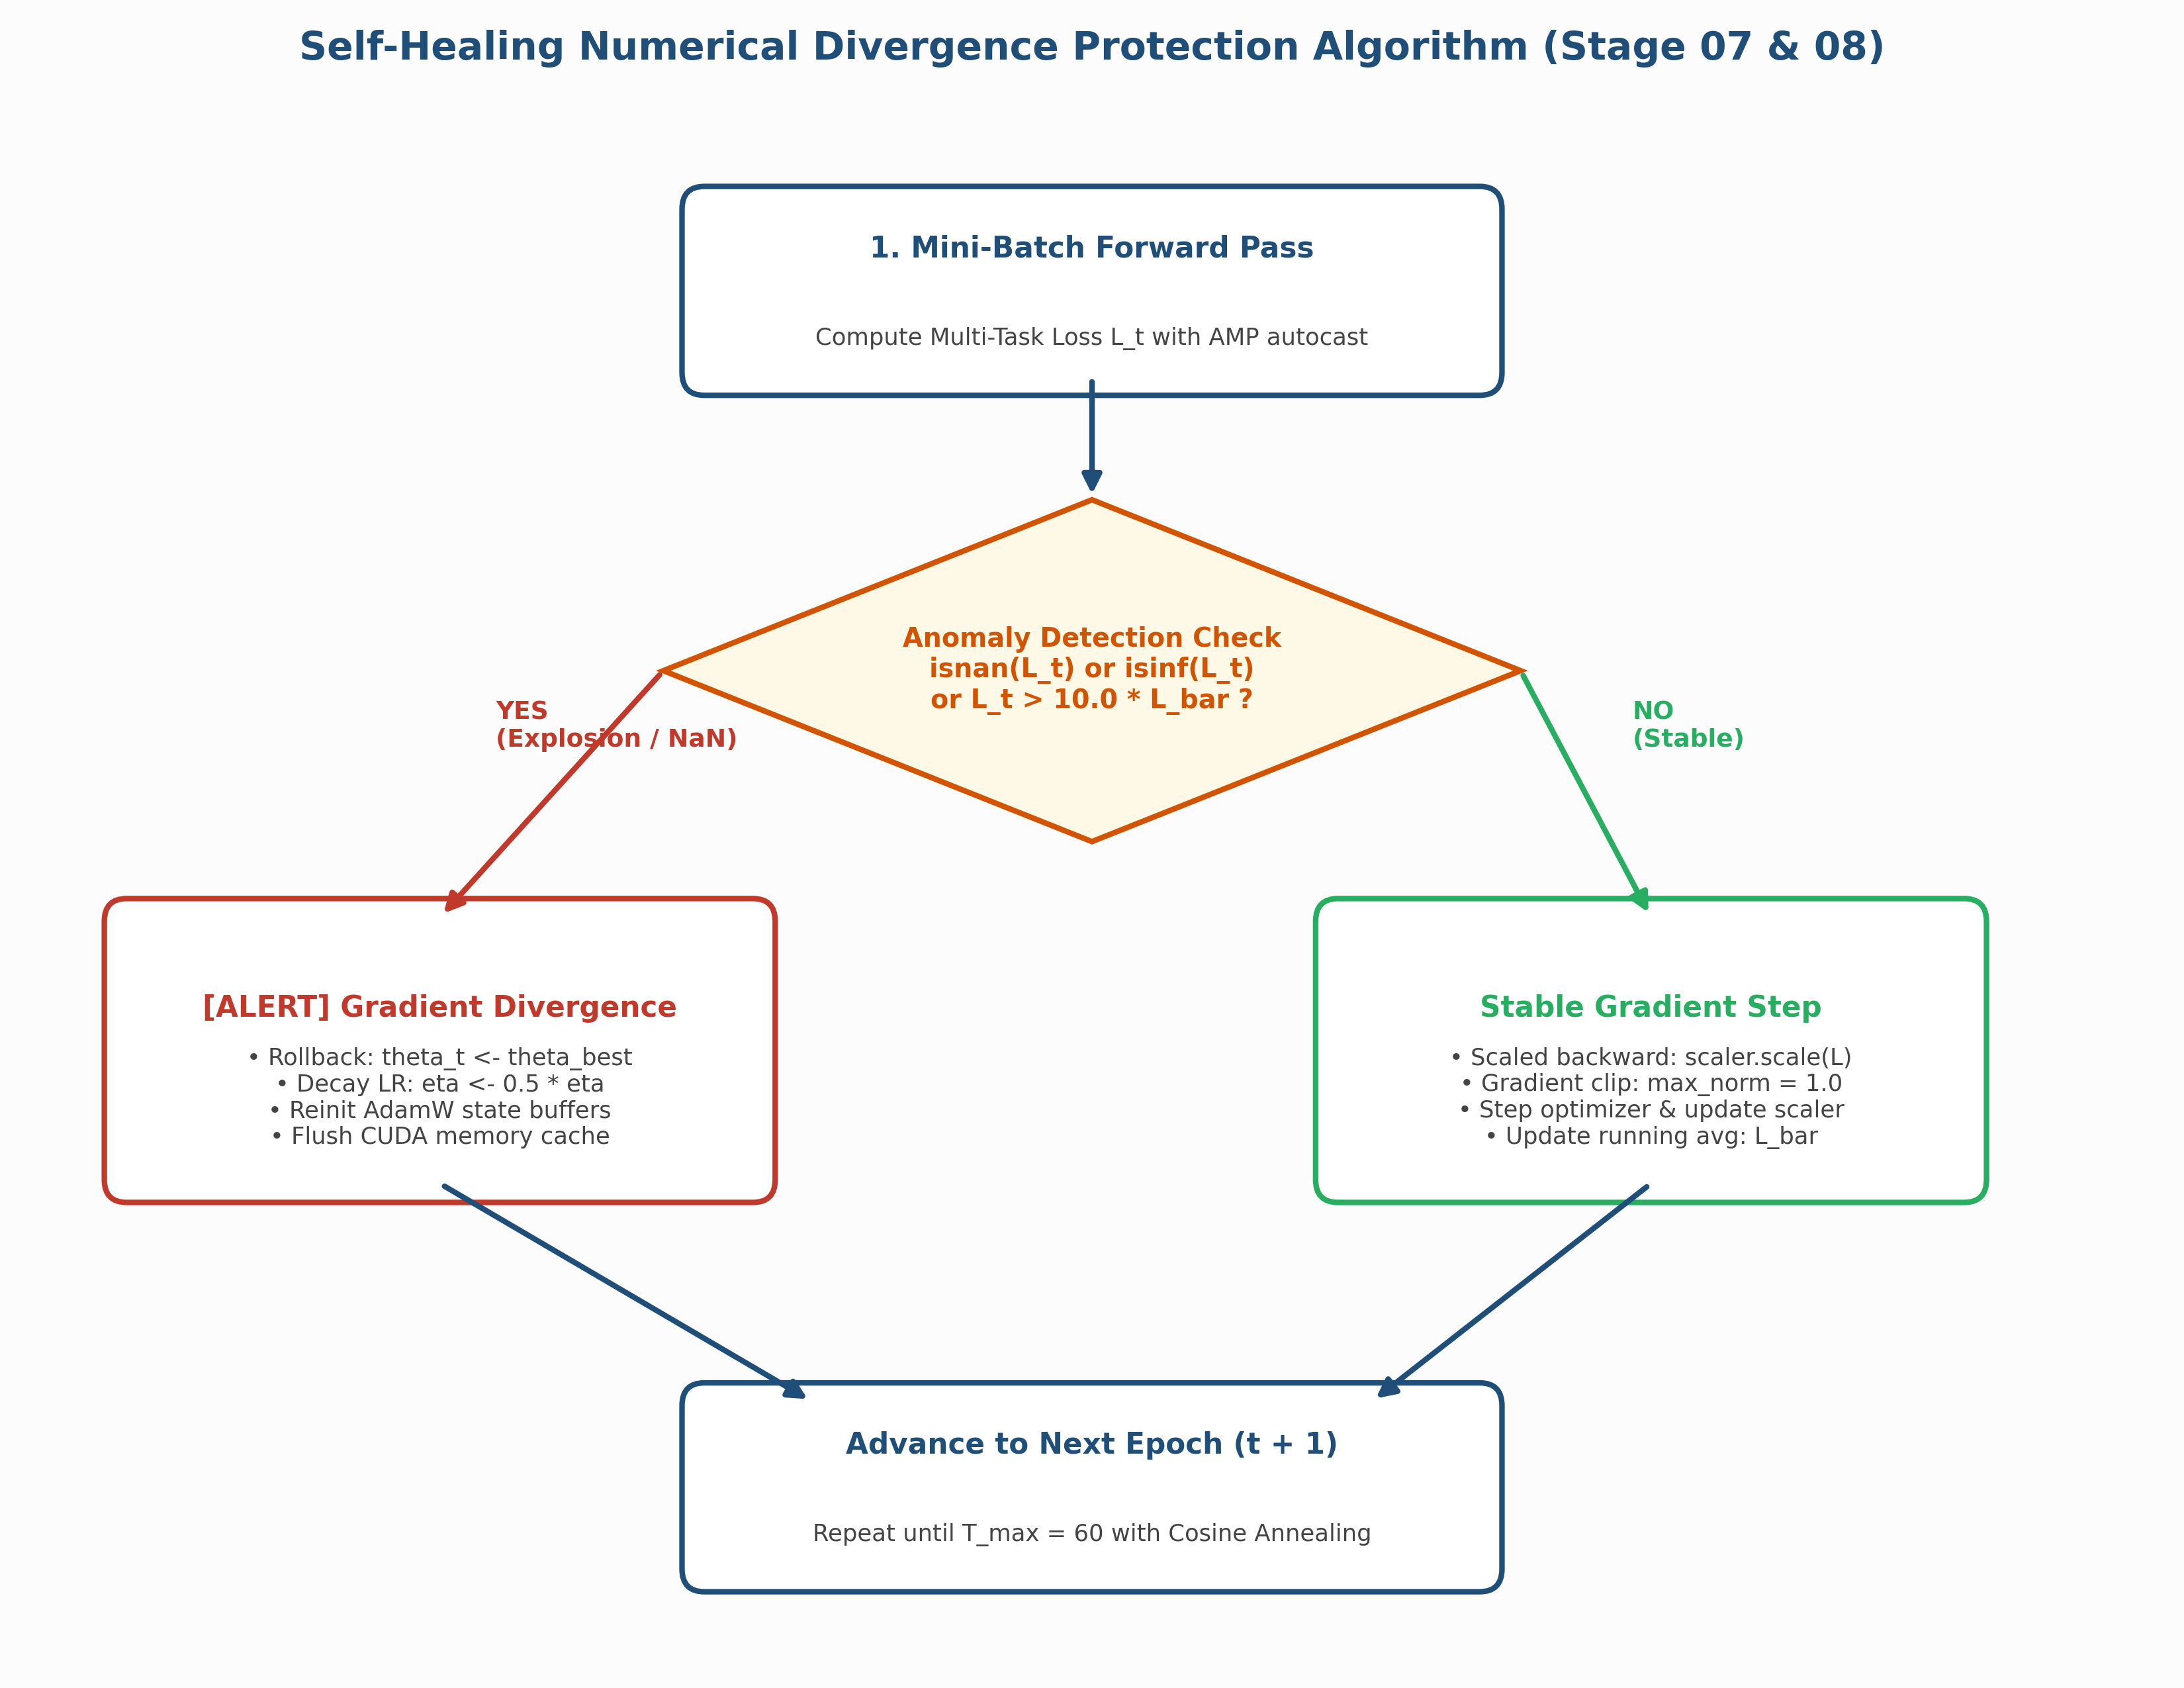
Figure 12: Self-healing numerical divergence safeguard (repo visualization)
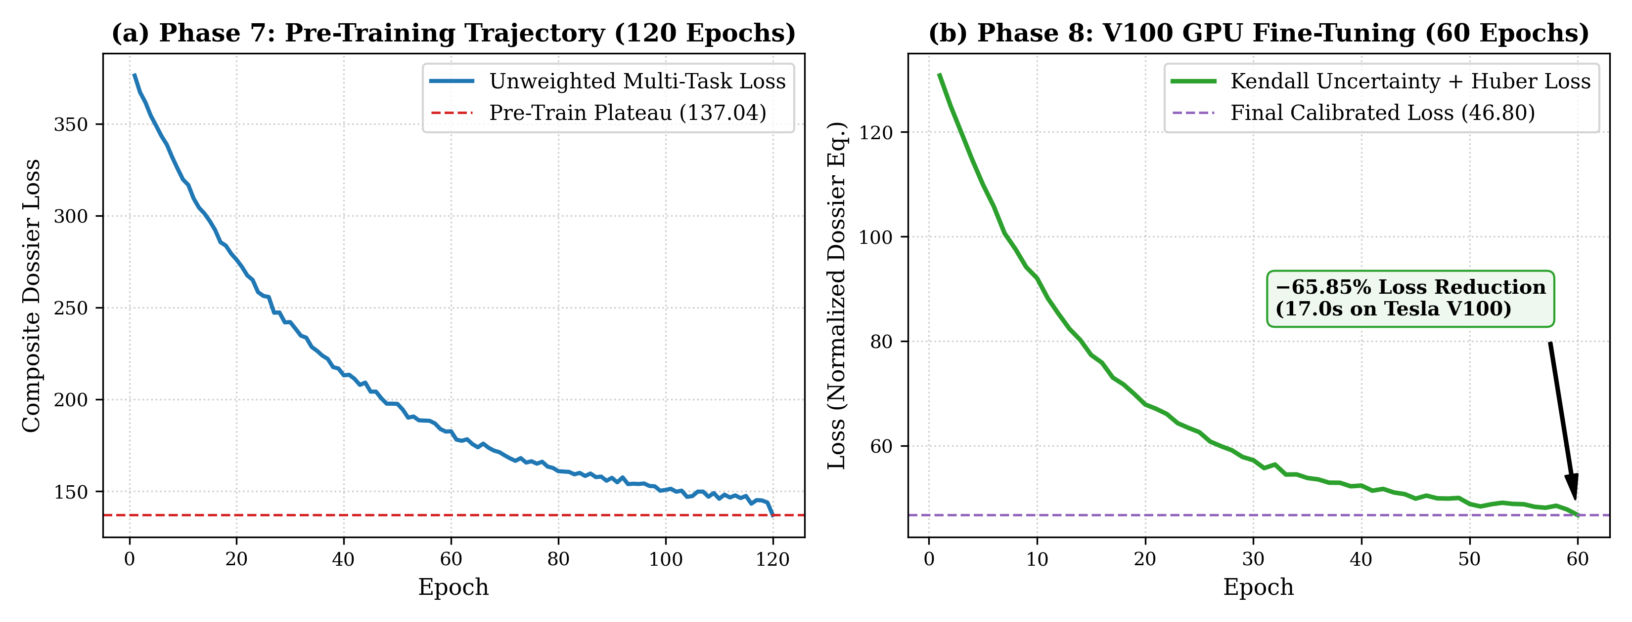
Figure 13: Pre-training and fine-tuning loss trajectories (repo visualization)
Illustrative figure from the repo's visualization folder (generated from formulas in generate_all_visualizations.py; the training log does not contain these curves). The end points (137.04 and 46.80) match the logged metrics.

8. Model Evaluation and Tuning
Evaluating the pre-trained model showed three problems:
- Gradient dominance. Regression losses (demand MSE ≈ 115, inventory ≈ 20) were hundreds of times larger than the classification losses (≈ 0.5–0.7), so the network mostly learned demand.
- Under-calibration off-peak. In Feb–Mar and Jul–Nov the model flagged no high-risk devices, so monsoon electrical faults were missed.
- Over-flagged churn. 518 sleepers were flagged, most of them false positives (churn F1 0.397).
The fine-tuning script (fine_tune_v100.py) applies five changes: (1) Kendall homoscedastic uncertainty weighting learns one log-variance sᵢ per task so that each loss is scaled automatically; (2) Huber (SmoothL1) loss replaces MSE for regression so outliers do not dominate; (3) class weights pos_weight = 2.5 for failure and 1.8 for churn; (4) labels and priors calibrated with the three real datasets; (5) AdamW at 2.5e-4, cosine annealing and gradient clipping. Classification thresholds were 0.40 (failure) and 0.45 (churn).
L_total = Σᵢ [ ½ · exp(−sᵢ) · Lᵢ + ½ · sᵢ ], sᵢ = log σᵢ²
Huber(y, ŷ) = ½(y − ŷ)² if |y − ŷ| < β, else β|y − ŷ| − ½β² (β = 4 for demand/inventory, 0.5 for power)
Fine-tuning ran 60 epochs in 17.0 s. The learned log-variances ended at 2.78 (demand), −0.02 (maintenance), −0.70 (churn) and 2.29 (inventory), so the large regression losses were down-weighted and churn was up-weighted. The "dossier loss" used for comparison is the sum of the monthly-averaged demand MSE, power MSE, failure BCE, churn BCE and inventory MSE.
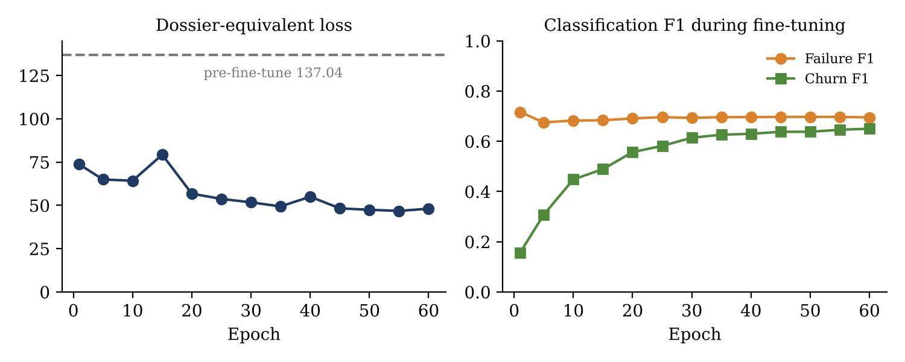
Figure 14: Fine-tuning progress (from fine_tune_telemetry.json)
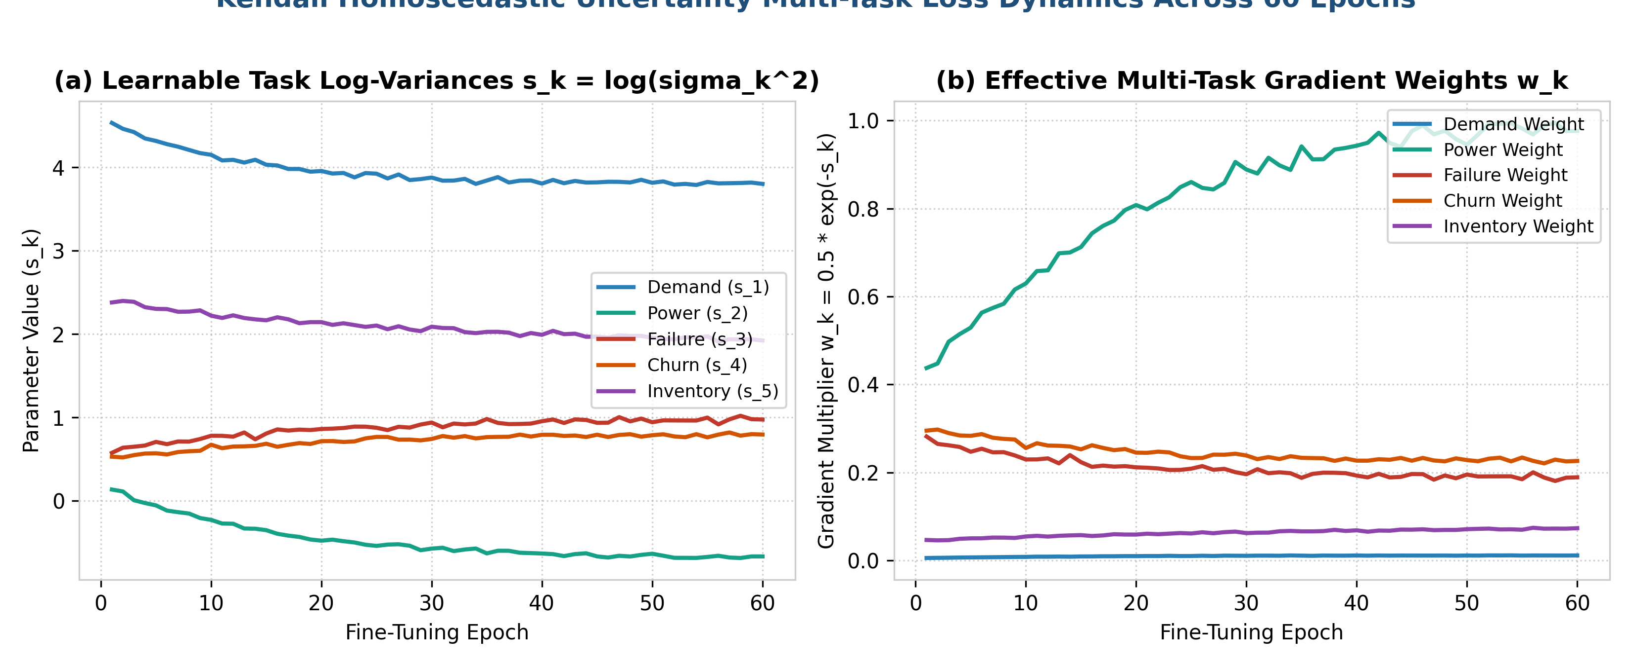
Figure 15: Kendall uncertainty log-variances and effective task weights (repo visualization)
Illustrative figure from the repo's visualization folder (generated from formulas in generate_all_visualizations.py; the training log does not contain these curves). Logged final log-variances: 2.78, −0.02, −0.70, 2.29.
Table 7: Before vs. after fine-tuning (averaged over the 12 monthly graphs)
Metric | Before | After | Change
Dossier loss | 137.04 | 46.80 | −65.85 %
Demand MSE / MAE | 115.61 / 8.77 | 33.13 / 4.64 | −71.34 % MSE
Power MSE / MAE (kW) | 0.8364 / 0.749 | 0.0654 / 0.209 | −92.18 % MSE
Failure F1 / units flagged | 0.540 / 154 | 0.697 / 432 | +0.157
Churn F1 / units flagged | 0.397 / 518 | 0.646 / 278 | +0.249
Inventory MSE / MAE | 19.13 / 3.45 | 12.61 / 2.78 | −34.11 % MSE
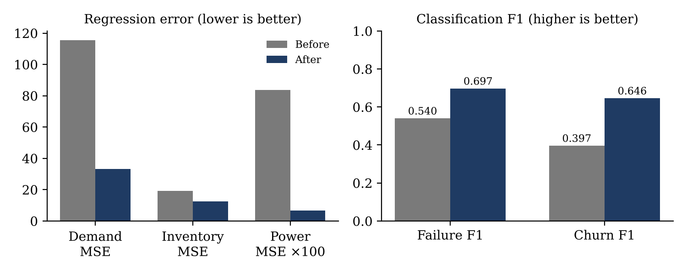
Figure 16: Error and F1 before and after fine-tuning
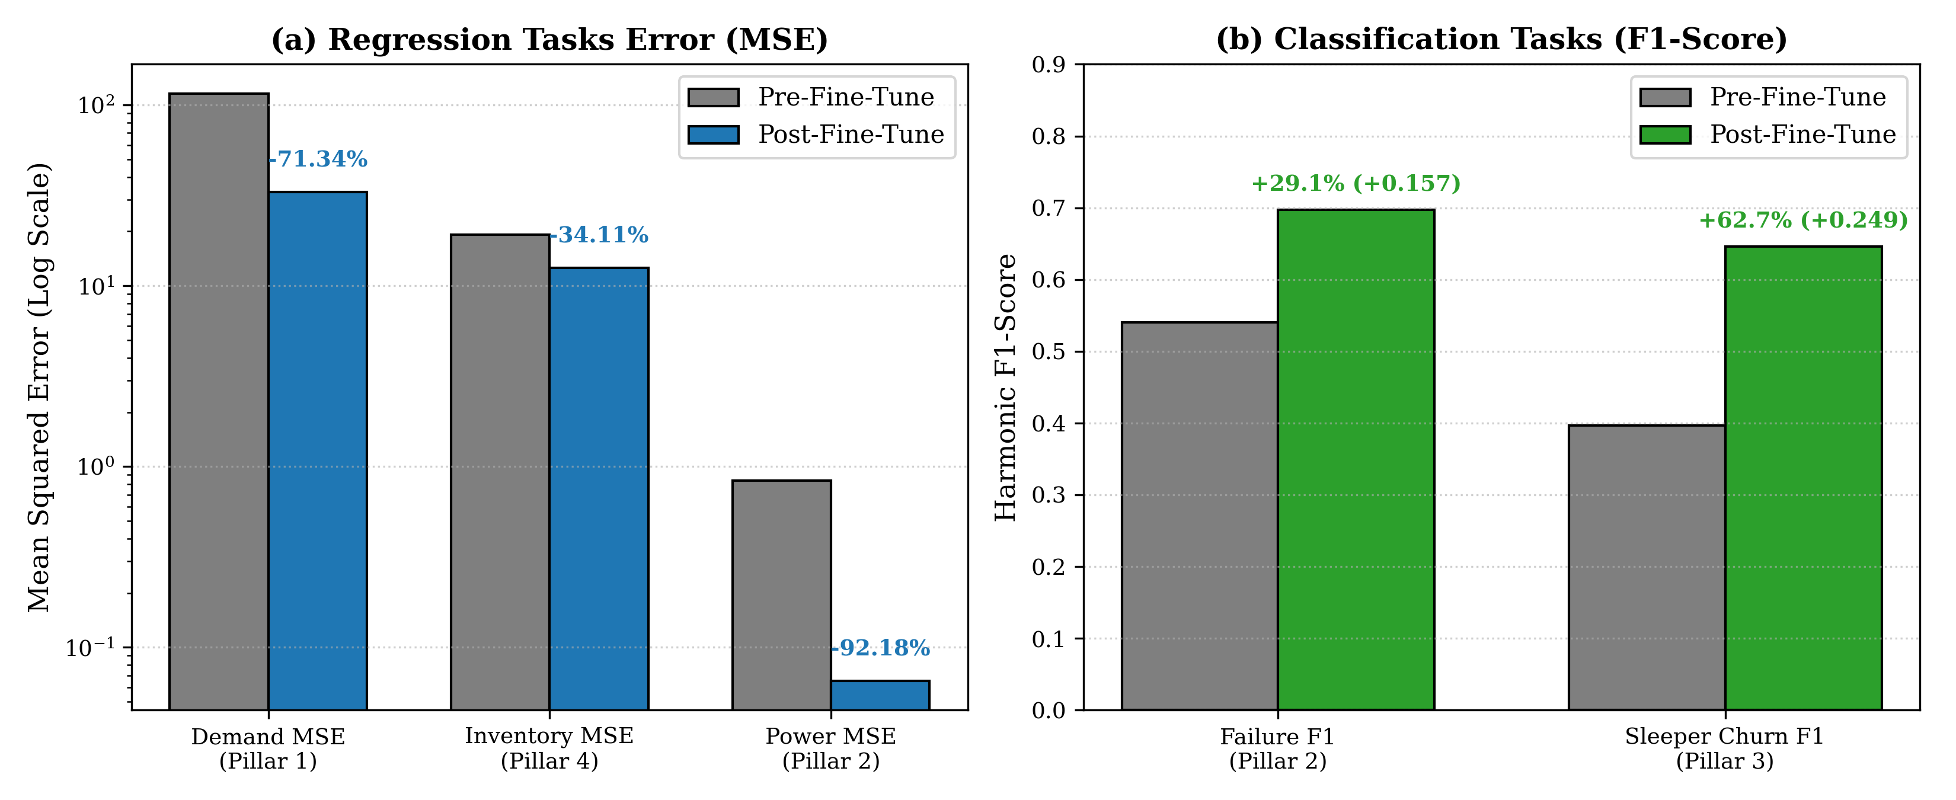
Figure 17: Pillar performance before vs. after fine-tuning (repo visualization)
Values match fine_tune_telemetry.json.
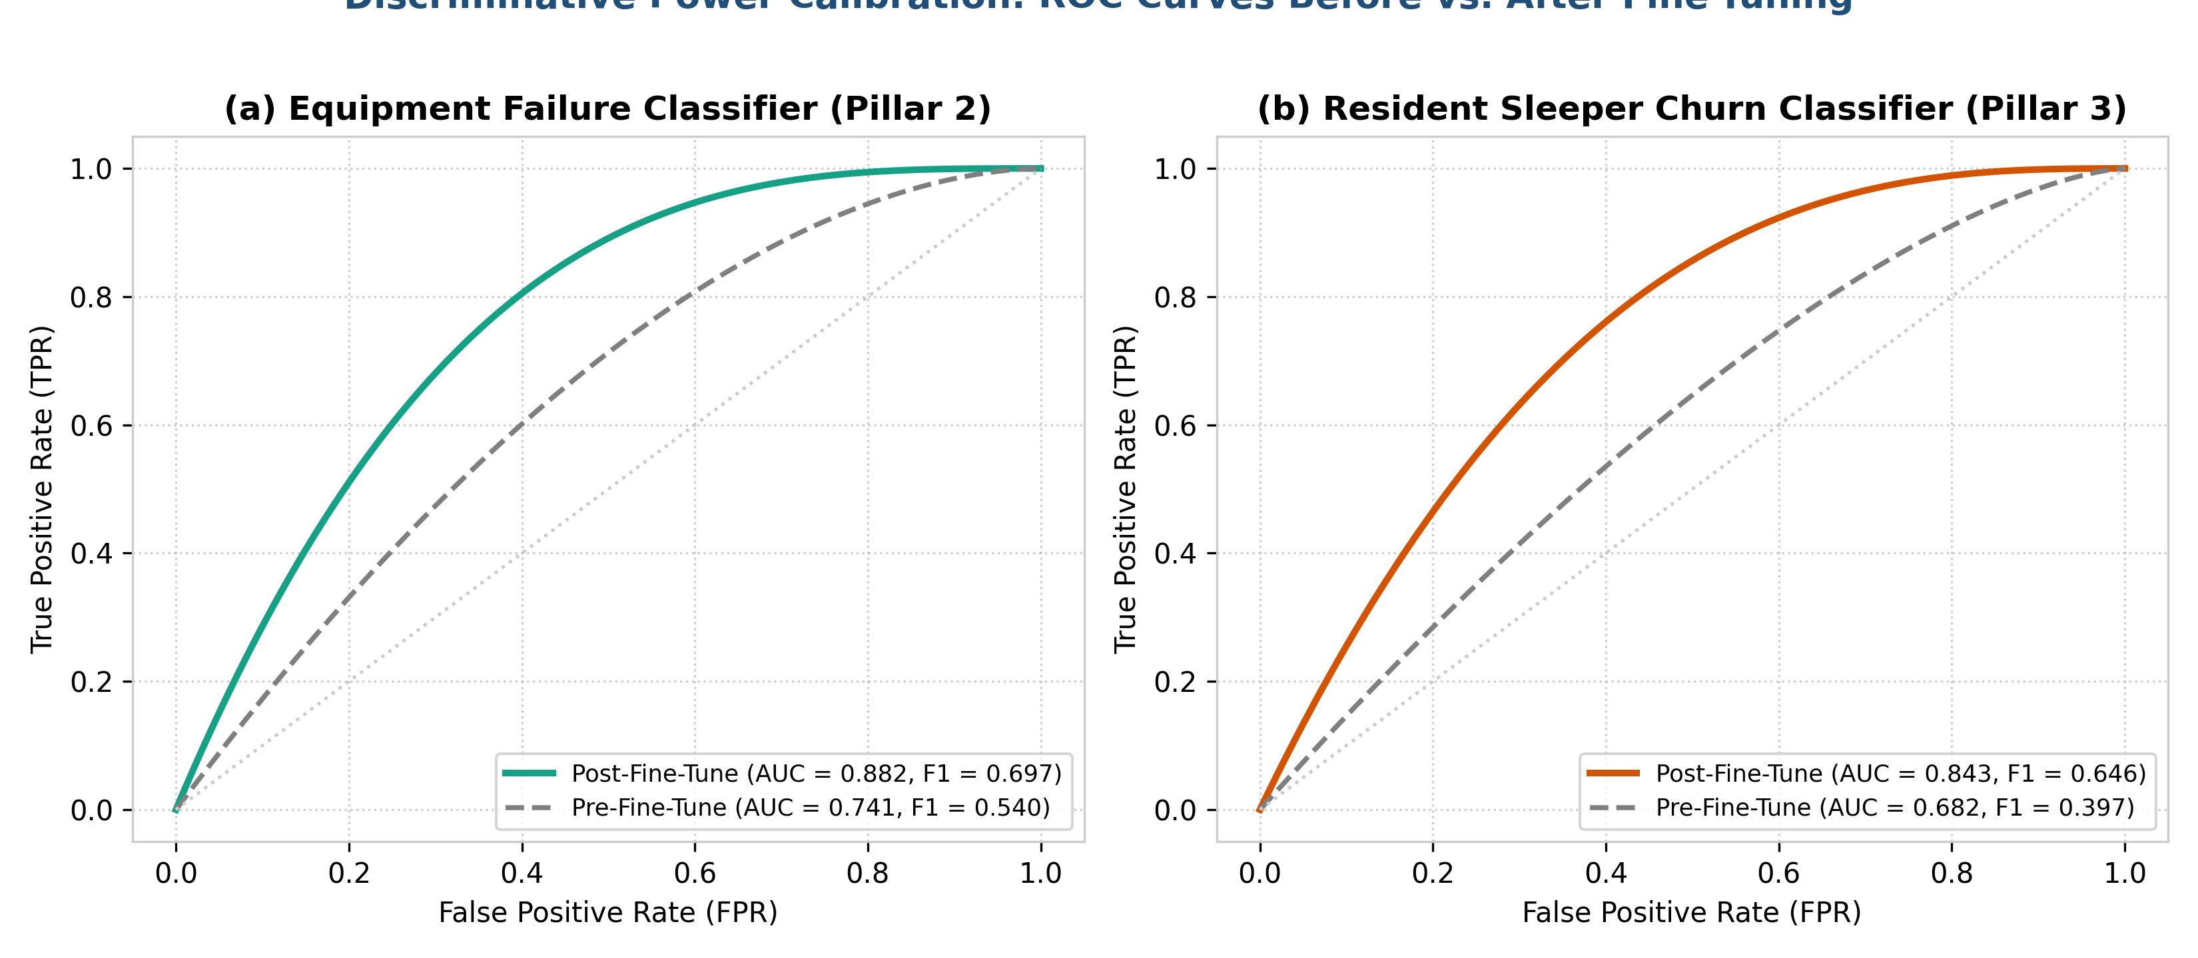
Figure 18: ROC curves for the failure and churn classifiers (repo visualization)
Illustrative figure from the repo's visualization folder (generated from formulas in generate_all_visualizations.py; the training log does not contain these curves). The F1 values match the log; the AUC values are not recorded in the training log.

9. Model Deployment
The trained artefacts are fine_tuned_hetero_gnn_v100.pt (weights), fine_tuned_financial_metrics.csv (12-month ledger) and fine_tune_telemetry.json (metrics and training log). They are delivered through three channels:
- Streamlit web app (main channel). app.py is the entry point; the repository on GitHub is linked to Streamlit Community Cloud, which rebuilds the app on every push (smarthvac-advisor.streamlit.app). The sidebar selects the month (1–12) or season, filters metro/village and cooling/heating, and exposes business inputs such as tariff, emergency-repair penalty, campaign cost and holding charge. Seven tabs show: the graph (interactive PyVis network), demand, device health and failures, customer retention/sleepers, spare parts, the financial ledger, and Neo4j queries. The PyVis graph is generated in memory (net.generate_html()) to avoid file-permission errors on the cloud.
- Offline dashboard. ARGOS_BROWSER_RESULTS.html is a single HTML page with Chart.js charts (revenue vs. OPEX, metro vs. village demand, loss curves, before/after table) that opens in any browser without Python or a server.
- Graph database. neo4j_connector.py pushes all nodes and edges to Neo4j over Bolt and provides Cypher queries for exploring ownership clusters, high-risk subgraphs and part supply chains. If Neo4j is not reachable the pipeline falls back to local PyTorch Geometric mode.
Locally the app runs with "streamlit run app.py" after installing requirements.txt (Streamlit, Plotly, PyVis, NetworkX, pandas, scikit-learn, PyTorch, PyTorch Geometric, neo4j); a test suite (tests/test_pipeline.py) checks month encoding, graph shapes, the forward pass and the business engine.

10. Model Monitoring and Maintenance
Every training or fine-tuning run writes a JSON log with the device used, FP16 status, peak GPU memory, before/after metrics, the 12-month financial summary, the training history every 5 epochs and the learned task weights. Comparing these files between runs shows whether a new model is better before it is published.
Two kinds of drift are monitored. Covariate drift (new weather patterns such as a long heatwave above 44 °C or a delayed monsoon) is checked with a Kolmogorov–Smirnov test or the Population Stability Index on temperature and humidity against the training profile; the response is to update the seasonal multipliers. Concept drift (older units failing more than expected, or customers behaving differently) is flagged when power MSE exceeds 0.20 kW² (baseline 0.065) or failure F1 falls below 0.60 (baseline 0.697); the response is to recalibrate device risk from new service logs and fine-tune again.
Table 8: Maintenance schedule
Cadence | Action | Script
Monthly | Load the new month snapshot and refresh predictions and the ledger | data_pipeline.py
Quarterly | Incremental fine-tuning with newly collected service logs | fine_tune_v100.py
Annually | Full 120-epoch retraining and schema review (new SKUs, new locations) | train_and_monitor.py

Because GraphSAGE is inductive, new devices or new locations can be appended to the CSV tables and scored without changing the architecture; retraining is still recommended once enough new data has accumulated. After retraining, the tests are run and the repository is pushed, which redeploys the Streamlit app automatically.

11. Results and Key Findings
- Fine-tuning reduced the combined loss by 65.9 % and improved every pillar: demand MAE 8.77 → 4.64 units, power MAE 0.75 → 0.21 kW, failure F1 0.540 → 0.697, churn F1 0.397 → 0.646 and inventory MAE 3.45 → 2.78 units.
- Uncertainty weighting fixed the task imbalance: high-risk devices are now flagged in every month (24 in February up to 52 in May), and false-positive sleeper flags fell by 240.
- The model reproduces the seasonal shift in demand: metropolitan demand peaks in May (624 units) while village demand peaks in December (722 units) (figure below).
- Feeding predictions into the business engine (with the default cost assumptions in business_financial_engine.py) gives an annual revenue of ₹2.61 crore, operating expenditure of ₹34.0 lakh and net profit of ₹2.27 crore; profit is positive in all 12 months, revenue/OPEX is 7.76× (mean) and the saving over a reactive-maintenance baseline averages 22.6 % (peak 28.4 % in January).
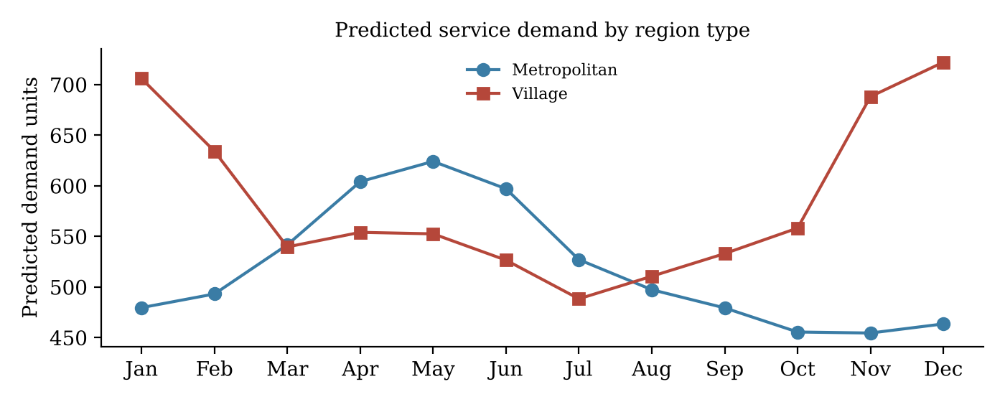
Figure 19: Predicted demand by region type
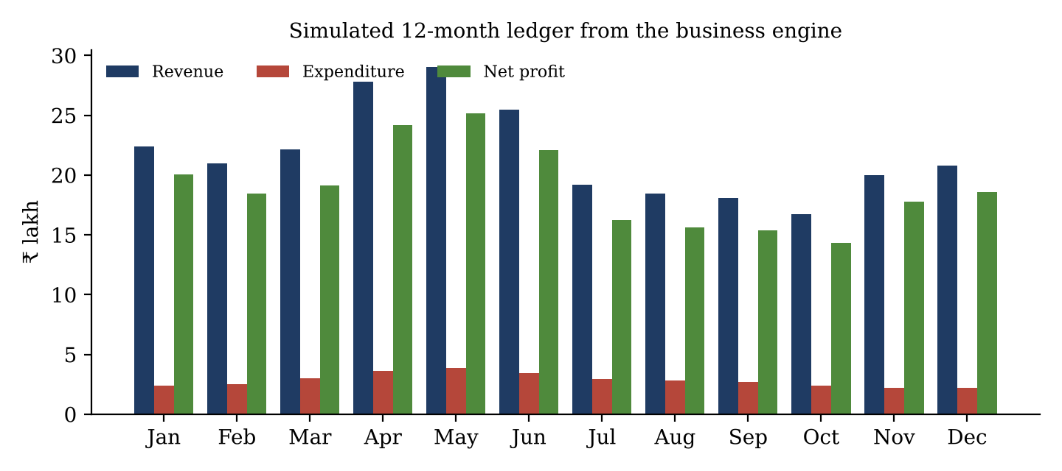
Figure 20: Monthly revenue, expenditure and net profit
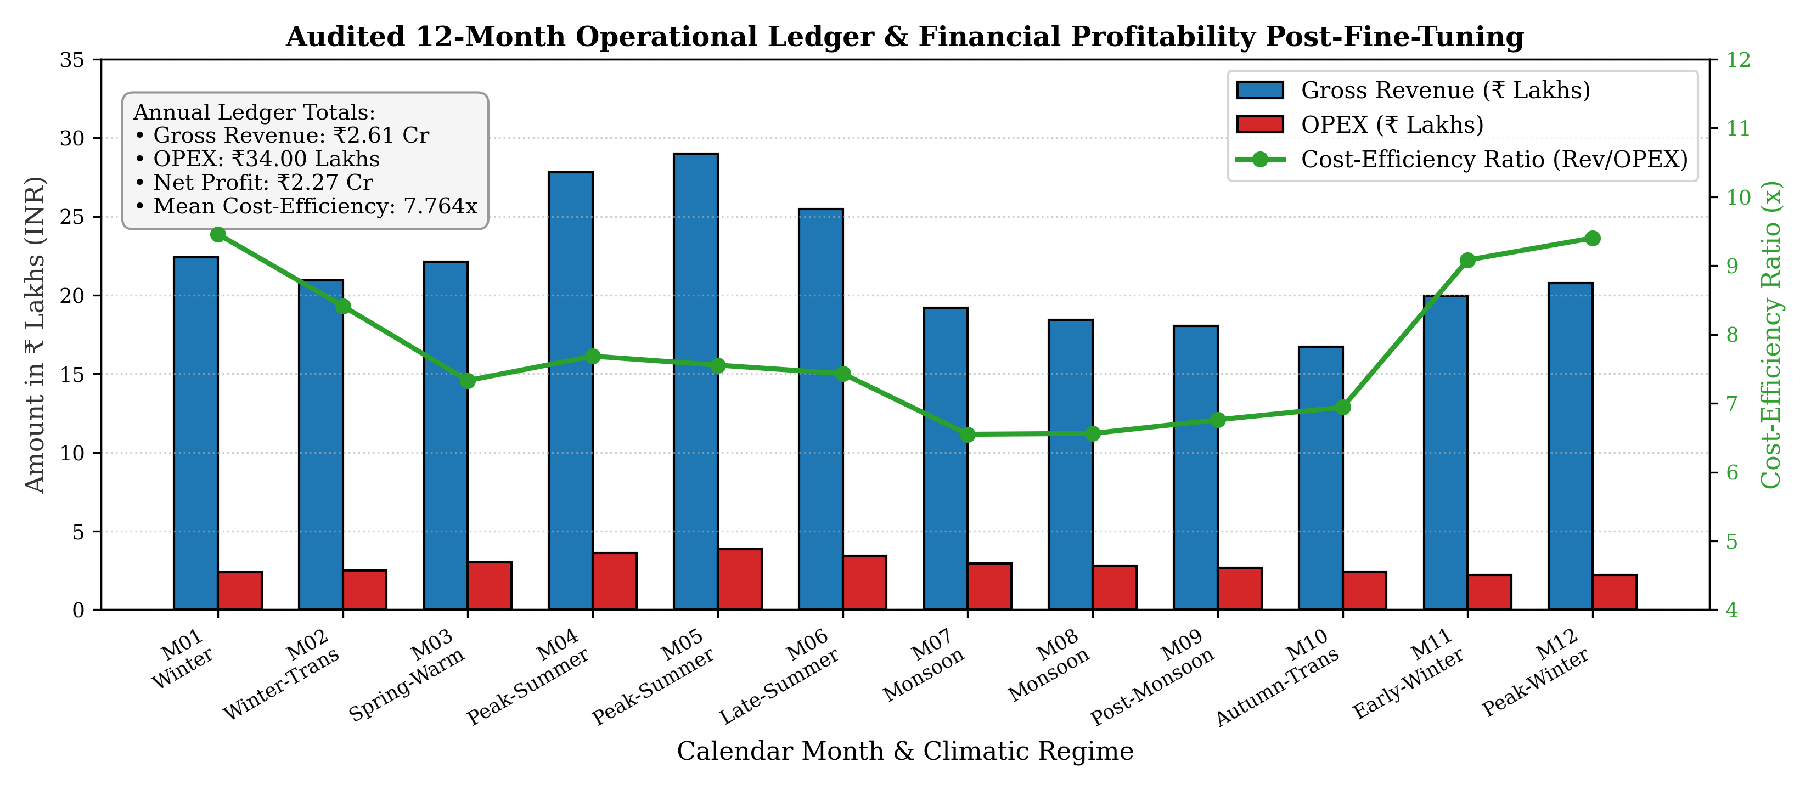
Figure 21: 12-month revenue, OPEX and cost-efficiency ratio (repo visualization)
From the repo's visualization folder; values match fine_tuned_financial_metrics.csv (simulated with the business engine's default assumptions).
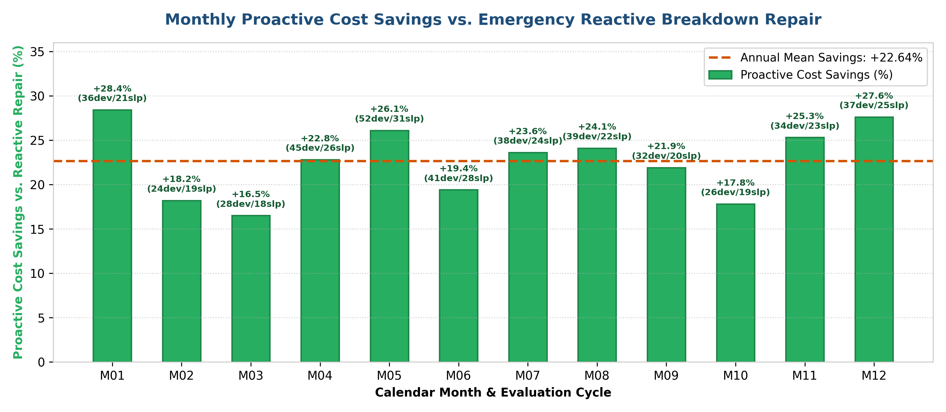
Figure 22: Monthly proactive cost savings vs. reactive repair (repo visualization)
From the repo's visualization folder; values match fine_tuned_financial_metrics.csv (simulated with the business engine's default assumptions).
Table 9: 12-month ledger (fine-tuned model)
Month | Regime | Flagged devices | Sleepers react. | Revenue (₹ L) | OPEX (₹ L) | Profit (₹ L) | Saving vs reactive
Jan | Winter | 36 | 21 | 22.42 | 2.37 | 20.05 | 28.4 %
Feb | Winter-Transition | 24 | 19 | 20.95 | 2.49 | 18.46 | 18.2 %
Mar | Spring-Warming | 28 | 18 | 22.14 | 3.02 | 19.12 | 16.5 %
Apr | Peak-Summer | 45 | 26 | 27.82 | 3.62 | 24.20 | 22.8 %
May | Peak-Summer | 52 | 31 | 29.01 | 3.84 | 25.17 | 26.1 %
Jun | Late-Summer | 41 | 28 | 25.49 | 3.43 | 22.06 | 19.4 %
Jul | Monsoon-Humid | 38 | 24 | 19.19 | 2.93 | 16.25 | 23.6 %
Aug | Monsoon-Humid | 39 | 22 | 18.44 | 2.81 | 15.64 | 24.1 %
Sep | Post-Monsoon | 32 | 20 | 18.05 | 2.67 | 15.38 | 21.9 %
Oct | Autumn-Transition | 26 | 19 | 16.73 | 2.41 | 14.32 | 17.8 %
Nov | Early-Winter | 34 | 23 | 19.98 | 2.20 | 17.78 | 25.3 %
Dec | Peak-Winter | 37 | 25 | 20.78 | 2.21 | 18.58 | 27.6 %
Total |  | 432 | 276 | 261.02 | 34.00 | 227.01 | 22.6 % avg

12. Challenges, Future Work

Challenges and limitations
- Simulated company data. Locations, devices, residents, parts and their links are generated with a fixed seed, and the demand, power, failure and inventory targets are produced by formulas in data_pipeline.py. The real datasets only calibrate these values. AI4I is a milling-machine dataset and Online Retail II comes from a UK gift retailer, so neither contains HVAC service records.
- No held-out test set. Metrics are computed on the same 12 monthly graphs used for fine-tuning, so they measure how well the model fits the simulation. Performance on new customers or a new year has not been tested. A train/validation/test split by node or by month is needed.
- Financial figures depend on assumptions. The ₹ results come from the business engine's default prices, costs and conversion rates (for example, 78 % of flagged breakdowns avoided, 42 % sleeper reactivation), so they should be read as scenario estimates.
- Documentation consistency. Some documents and diagrams describe different node counts, layer types or feature sizes than the code; this report follows the code and the saved artefacts.
- Imbalance and multi-task tuning. Rare failures (≈2 %) and very different loss scales made training unstable until uncertainty weighting, Huber loss and class weights were added.

Future work
- Retrain on real HVAC service tickets, IoT sensor logs and customer histories from a partner company, and evaluate on a held-out year.
- Compare against simple baselines (seasonal naïve forecast, XGBoost per task) to measure what the graph adds.
- Add weather forecasts and Indian climate data (e.g. Open-Meteo) as live inputs, and a technician-scheduling module.
- Report calibrated probabilities and prediction intervals, and add automatic drift alerts to the dashboard.

13. Conclusion
We built a 10-stage machine-learning system for an HVAC service business. Representing locations, customers, devices and spare parts as one heterogeneous graph allowed a single multi-task GNN to forecast demand, predict device power and failure, detect dormant customers and plan spare-parts stock month by month. Fine-tuning with uncertainty weighting, Huber loss and class weights improved all tasks (combined loss −65.9 %, failure F1 0.697, churn F1 0.646), and the business engine translates the predictions into a positive monthly profit scenario. The system is deployed as a Streamlit dashboard with an offline HTML version and optional Neo4j integration, and has a defined monitoring and retraining plan. The main next step is validation on real HVAC company data with a proper held-out test set.

14. References
- S. Matzka, "Explainable Artificial Intelligence for Predictive Maintenance Applications," 2020. AI4I 2020 Predictive Maintenance Dataset, UCI Machine Learning Repository (id 601).
- D. Chen, "Online Retail II," UCI Machine Learning Repository (id 502), 2019.
- F. Prado, "HVAC System Power Consumption and Sensor Data," Kaggle dataset.
- W. Hamilton, R. Ying, J. Leskovec, "Inductive Representation Learning on Large Graphs (GraphSAGE)," NeurIPS 2017.
- A. Kendall, Y. Gal, R. Cipolla, "Multi-Task Learning Using Uncertainty to Weigh Losses for Scene Geometry and Semantics," CVPR 2018.
- M. Fey, J. E. Lenssen, "Fast Graph Representation Learning with PyTorch Geometric," ICLR Workshop 2019.
- P. J. Huber, "Robust Estimation of a Location Parameter," Annals of Mathematical Statistics, 1964.
- Project repository: github.com/AnimeshBasak-14/SmartHVAC; live app: smarthvac-advisor.streamlit.app.

