INDIAN INSTITUTE of TECHNOLOGY
ROORKEE



Department of Computer Science & Engineering

Project Report On
Using ML Improve Business Chain of HVAC System

Course- Machine Learning (CSC-505)
Group 1

Group Members:
Kriti Vajpayee (25931008)
Dhruv Aggarwal (26911004)
Ankit Kumar (26911002)
Animesh Basak (26911001)
Saurav Kumar Boro (26535026)

Under The Guidance of:
Dr. Durga Toshniwal
Professor, CSE, IIT Roorkee

Table of Contents:
S.No. | Section | Page No.
1 | Members' Contribution | 3
2 | Abstract | 4
3 | List of Figures | 5
4 | List of Tables | 6
5 | Chapter 1. Problem definition | 7
6 | Chapter 2. Data collection | 12
7 | Chapter 3. Data cleaning and preprocessing | 15
8 | Chapter 4. Exploratory data analysis | 19
9 | Chapter 5. Feature engineering | 22
10 | Chapter 6. Model selection | 27
11 | Chapter 7. Model training | 31
12 | Chapter 8. Model evaluation and tuning | 34
13 | Chapter 9. Model deployment | 40
14 | Chapter 10. Monitoring and maintenance | 44
15 | Chapter 11. Results and discussion | 48
16 | Chapter 12. Conclusion and recommendation | 50
17 | Chapter 13. Limitations and future work | 52
18 | References and data sources | 54

Members contribution:

S NO | Name | Enrollment No | Page No | Description of work
1 | Kriti Vajpayee | 25931008 | 7-14 | 1. Problem definition; 2. Data collection. Framed the problem and the product (stage 1). Searched for, downloaded and documented the three datasets and their sources (stage 2).
2 | Dhruv Aggarwal | 26911004 | 15-21 | 3. Data cleaning and preprocessing; 4. Exploratory data analysis. Cleaned the data, built the churn table, designed the train and test splits and the leakage tests (stage 3). Explored the data and drew the plots that guided the features (stage 4).
3 | Ankit Kumar | 26911002 | 22-30 | 5. Feature engineering; 6. Model selection. Designed and tested the engineered features (stage 5). Chose the candidate models and the selection rule, and ran the model contest (stage 6).
4 | Animesh Basak | 26911001 | 31-39 | 7. Model training; 8. Model evaluation and tuning. Trained all models under one protocol and measured learning curves and sensitivity (stage 7). Ran the held-out evaluation, error analysis and calibration checks (stage 8).
5 | Saurav Kumar Boro | 26535026 | 40-47 | 9. Model deployment; 10. Monitoring and maintenance. Built and tested the dashboard and the heatwave safeguard (stage 9). Wrote the monitoring checks, alert rules and maintenance plan (stage 10).

All five members also took part in choosing the topic and the product, in reviewing each other's chapters, and in preparing the presentation. The report chapters 11 to 13 (results, conclusion and recommendation, limitations and future work) were written jointly.

Abstract
HVAC service providers such as Aire Serv make three kinds of decisions every week: how many technicians and how much stock a hot or cold spell will need, which customer machines to inspect before they fail, and which customers to phone before they stop buying. We developed a machine learning-based solution to improve the HVAC business chain by converting predictive insights into actionable decisions, including hourly power demand forecasting, prioritized machine inspections, and customer retention planning.
We had no data from a real HVAC company, so each prediction is trained on a public stand-in dataset: a year of hourly HVAC power readings (8,760 rows), the AI4I 2020 machine failure data (10,000 machines, 3.4% failures) and the Online Retail II purchase history (5,939 customers). We compare two models of our choice, Ridge regression and XGBoost, with ordinary linear or logistic regression, a Random Forest and a rule of thumb that a company could use today. Every score comes from data the model did not see: random hours, unseen months, a forecast of the last three months, a heatwave at or above 40 °C, unseen machines and unseen customers in a later period. Each experiment is repeated with five random seeds.
The main results are as follows. For demand, XGBoost misses by 0.065 kW on average, against 0.93 kW for the rule of thumb, but in the heatwave test its error grows to 0.34 kW, because tree models cannot predict beyond the temperatures they were trained on. Ridge regression extends the trend and misses by 0.08 kW there, so the dashboard uses Ridge for hours above 40 °C. For failure, XGBoost and Random Forest find 94% of failures in the 10% of machines they rank highest, against 36% for inspecting the most worn tools first. For churn, every model reaches about 0.78 ROC-AUC and finds 20% of lapsing customers in the top 10% of the list, twice as many as random contact and four points more than the recency rule. That gain is real but modest.
We recommend piloting the Demand Planner with the heatwave safeguard and the Failure Radar on real company data, and treating the Retention List as a low-cost aid until richer customer data are available. The report follows the ten stages of the machine learning lifecycle, from problem definition to monitoring, and each stage was written by one member of the group.
Keywords: HVAC, demand forecasting, predictive maintenance, customer churn, Ridge regression, XGBoost, held-out evaluation, model monitoring.
List of Figures
1.1 The ten lifecycle stages and who wrote each one
1.2 HVAC Service Planner, from data to decision
1.3 The bar to beat: rule of thumb against our models on unseen data
2.1 One year of hourly readings, shown by day
3.1 From 1.07 million original lines to 44,870 invoices
3.2 How one row of the churn table is built
3.3 How each pillar is split into training and test data
4.1 Average HVAC power by hour and month
4.2 Sensor readings of failing and healthy machines
4.3 Lapse rate by number of orders, recent orders and order rhythm
5.1 Power against temperature, and against the absolute gap
5.2 Failure rate by decile of each engineered feature
5.3 Test score with basic and with engineered inputs
5.4 Feature importance for failure (XGBoost on the left, Ridge on the right)
5.5 Feature importance for churn
6.2 Why trees stop rising outside the training range
6.3 How the tie rule picks a model for failure and churn
7.1 What happens in one run of the experiment
7.2 Learning curves: test score against the amount of training data
8.1 Residuals of Ridge and XGBoost in the forecast months and in the heatwave
8.2 ROC curves, and the trade-off at different thresholds
8.3 Failures found as the inspection list grows
8.4 Where XGBoost helps and where it does not
9.1 System architecture
9.2 Demand Planner output for a normal July day and for a heatwave day
9.4 How the safeguard chooses the model for each hour
10.1 The monitoring loop
10.3 Input drift in three comparisons

List of Tables
2.1 Columns of the hourly HVAC power file
6.1 The model families we compare
8.1 Mean absolute error (kW) of every demand model on every test
8.2 Failure prediction scores on 2,000 held-out machines (mean ± standard deviation over five seeds)
8.3 Churn prediction scores on unseen customers in the later period
9.3 Failure Radar: the riskiest machines in a sample of 500
10.2 Alert rules

Chapter 1
Problem Definition
Written by Kriti Vajpayee (25931008).

1.1 Why this stage comes first
A vague statement such as "use machine learning for HVAC companies" cannot be tested. We therefore spent the first days writing down who would use the result, what they would decide with it, and what number would tell us the model is good enough. This document records that reasoning. The other nine stage documents refer back to it.
The lifecycle we follow has ten stages. Figure 1.1 shows them in order, with the group member who wrote each one. The arrow that returns from stage 5 to stage 6 only marks the line break in the picture: the work itself ran in order, and we went back to earlier stages whenever a result surprised us (for example, we revisited the churn table in stage 3 after seeing weak results in stage 8).

The ten lifecycle stages and who wrote each one
Stage 1
Problem definition
3 decisions,
3 pillars
Stage 2
Data collection
3 public datasets,
1.7 MB
Stage 3
Data cleaning and preprocessing
invoice table,
churn labels
Stage 4
Exploratory data analysis
what drives power,
failure, lapse
Stage 5
Feature engineering
gap, power and
order-gap features
Stage 6
Model selection
Ridge, XGBoost
+ baselines
Stage 7
Model training
5 seeds, fixed
settings
Stage 8
Model evaluation and tuning
unseen months,
machines, customers
Stage 9
Model deployment
dashboard with
three tools
Stage 10
Monitoring and maintenance
drift and error
checks
Kriti Vajpayee
(25931008): stages 1, 2
Dhruv Aggarwal
(25911019): stages 3, 4
Ankit Kumar
(26911002): stages 5, 6
Animesh Basak
(26911001): stages 7, 8
Saurav Kumar Boro
(26535026): stages 9, 10
Figure 1.1. The ten lifecycle stages and who wrote each one
Figure 1.1 is a map of the report. Stages 1 and 2 (purple) set up the problem and the data. Stages 3 and 4 (blue) clean the data and look at it. Stages 5 and 6 (green) turn the data into model inputs and choose the models. Stages 7 and 8 (orange) train and test them. Stages 9 and 10 (red) put the models into a dashboard and describe how to watch them afterwards. Each stage has one author, whose name and enrollment number sit under its box.

1.2 The business we are helping
Our topic is "using machine learning for HVAC system providers such as Aire Serv". Aire Serv is a franchise that installs, repairs and maintains heating, ventilation and air-conditioning equipment. A franchise manager makes the same kinds of decisions every week, and most of them are made today with experience and spreadsheets:
1. How many technicians and how much stock do we need for the coming days? Demand for repairs follows the weather, because systems work hardest on the hottest and coldest days. A heatwave brings a rush of calls and a high electricity load.
2. Which customer machines should we visit before they break? A planned inspection costs far less than an emergency call-out, but nobody can inspect every machine.
3. Which customers are drifting away? Winning back a customer who is about to go quiet is cheaper than finding a new one, but the sales team can only phone so many people.
These are three separate decisions with three different kinds of data. We decided to build one product that handles all three, so that the group could show breadth, and to keep each part simple enough that every member can explain it.

1.3 The product: HVAC Service Planner
HVAC Service Planner is a small dashboard with three tools. Each tool takes one prediction and turns it into a short list that a manager can act on. Figure 1.2 shows the path from data to decision for each tool.

HVAC Service Planner: from data to a decision
Data
Model
Tool in the dashboard
Decision it supports
Pillar 1: demand
Kaggle HVAC power
8,760 hourly rows
weather, setpoint, calendar
XGBoost for normal weather,
Ridge above 40 °C
target: power in kW
Demand Planner
hourly demand curve, peak hour, daily energy
Staffing, stock and grid load for tomorrow
Pillar 2: failure
UCI AI4I 2020
10,000 machines
3.4% fail
XGBoost or Random Forest
target: failure yes or no
(risk score 0 to 1)
Failure Radar
risk score and ranked inspection list
Which machines to inspect first
Pillar 3: retention
UCI Online Retail II
5,939 customers
44,870 invoices
Ridge (penalised logistic)
target: buys nothing in the next 90 days
Retention List
ranked call list of active customers
Which customers to call
Figure 1.2. HVAC Service Planner, from data to decision
Figure 1.2 reads from left to right. The first column names the dataset behind each tool. The second column names the model and the quantity it predicts. The third column is the tool the manager sees in the dashboard, and the last column is the decision that the tool supports. Pillar 1 predicts a number (power in kilowatts), while Pillars 2 and 3 predict a yes or no outcome and return a risk score between 0 and 1. The model names in the middle column are the result of stages 6 to 8; at the time we wrote the problem statement we only knew that we would compare a few simple models.
Tool | Manager's question | What the tool returns | Who uses it
Demand Planner (Pillar 1) | How much power will the HVAC systems draw tomorrow, and when is the peak? | Hourly demand curve, peak hour, energy for the day | Dispatch and stock planning
Failure Radar (Pillar 2) | Which machines should we inspect first? | Risk score per machine and a ranked inspection list | Maintenance lead
Retention List (Pillar 3) | Which active customers are about to go quiet? | Ranked call list with each customer's risk | Customer success and marketing

1.4 Turning each question into a machine learning task
A business question becomes a machine learning problem only when we can say what goes in, what comes out, how far ahead we look and how we score the answer. The table below fixes these four things for each pillar. We wrote it before touching any data, and we have not changed it since.
 | Pillar 1: demand | Pillar 2: failure | Pillar 3: retention
Task type | Regression (predict a number) | Binary classification, rare event | Binary classification
Unit of prediction | One building-hour | One machine | One active customer at a cutoff date
Inputs | Outdoor and indoor temperature, humidity, hour, month, HVAC mode | Air and process temperature, rotational speed, torque, tool wear, machine type | Purchase history before the cutoff
Output | Power in kW | Failure yes or no, with a risk score | Lapses yes or no, with a risk score
Looking ahead | None: power in an hour is predicted from that hour's weather (a forecast, in use) | The recorded failure label | 90 days after the cutoff
Main metric | Mean absolute error in kW | PR-AUC and share of failures in the top 10% | ROC-AUC and share of lapsers in the top 10%
Why this metric | Mean absolute error: the average size of a miss in kW, the same unit as the load | Failures are 3.4% of machines, so accuracy is meaningless | The team can call only a few customers, so the top of the list matters

Three decisions in this table deserve a note.
For Pillar 1, we report the mean absolute error (MAE): the average of |actual power − predicted power| over the test hours, in kW. It is in the same unit as the load, so a planner can read it directly, and a few very large misses do not dominate it as they would a squared error. An MAE of 0.07 kW on an average load of about 2 kW means a typical hour is off by about 3.5%.
For Pillar 2, a model that always predicts "no failure" is correct for 96.6% of machines and finds none of the failures. Accuracy would reward it. We therefore report PR-AUC, which stays low unless the model finds the rare failures with few false alarms, and the share of all failures that fall inside the 10% of machines with the highest risk. A manager understands the second number directly: "if we inspect one machine in ten, we catch this share of the failures".
For Pillar 3, the Online Retail II data has no column that says whether a customer left. An earlier version of our project used the flag "no purchase in 90 days" as the target while also using the days since the last purchase as an input. That is circular, since the input already contains the answer. We now define the target in the future: take a cutoff date, describe each customer using only what happened before it, and ask whether the customer buys nothing in the next 90 days. Stage 3 explains how the table is built.

1.5 What counts as success
We need a bar for "good enough", otherwise any score can be called a success. We set two kinds of bars.
First, the model must beat a rule of thumb that a company could apply today without any machine learning. For each pillar we picked the simplest sensible rule:
• Demand: predict the average load for that hour of the day.
• Failure: inspect the machines with the most tool wear first.
• Retention: call the customers who have not bought for the longest time.
Second, the model must beat two standard baselines from statistics and classic machine learning, so that a more complicated model is justified only if it earns its place. The baselines are ordinary linear or logistic regression (statistics) and a Random Forest (classic machine learning).
Figure 1.3 shows what the rules of thumb achieve on data they have not seen, next to our two models. This is the bar we set for ourselves, and it is also a preview of the result, since we computed it after the work was done.
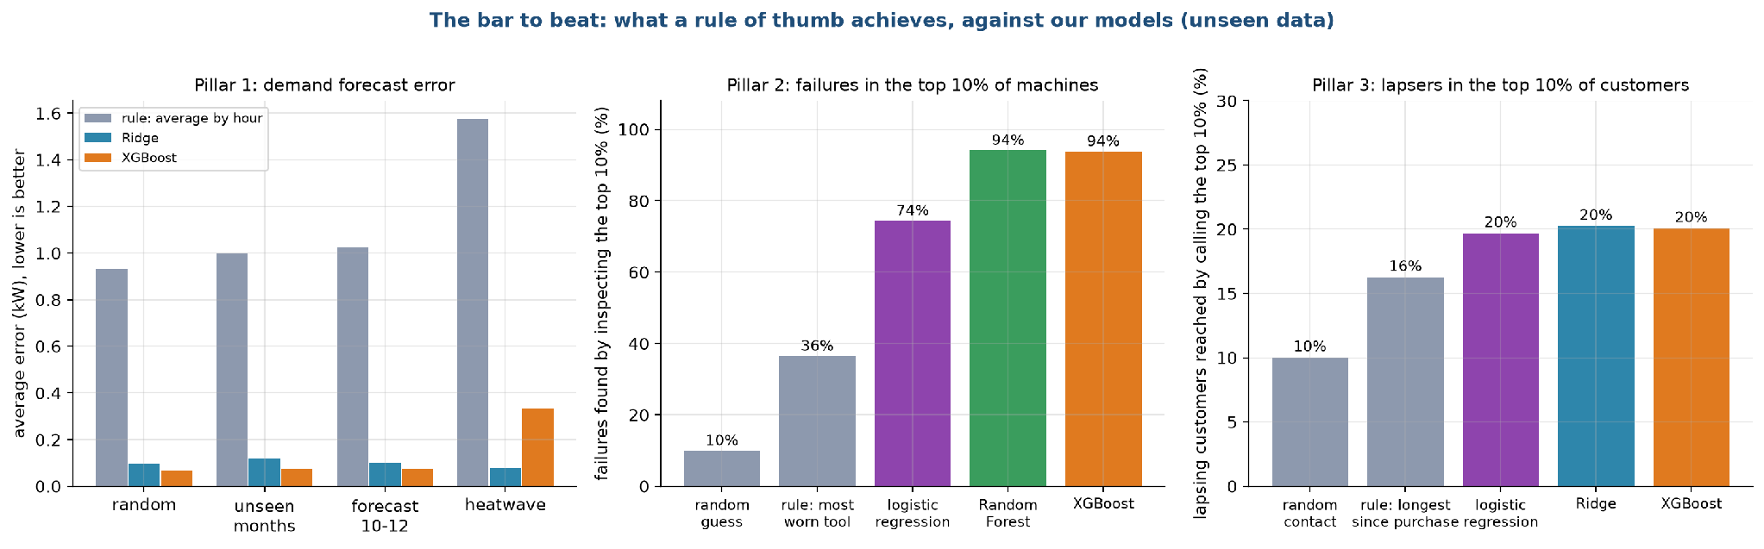
Figure 1.3. The bar to beat: rule of thumb against our models on unseen data
In the left panel the grey bars are the error of the "average by hour" rule for demand. It misses by about 0.9 to 1.6 kW depending on the test, while Ridge and XGBoost miss by 0.12 kW or less except in the heatwave test, where XGBoost reaches 0.34 kW. We return to that exception in stage 8. In the middle panel, inspecting the most worn tools first finds 36% of failures in the top 10% of machines, against 10% for a random list, 74% for logistic regression and 94% for Random Forest and XGBoost. In the right panel the recency rule reaches 16% of the customers who lapse in the top 10%, against 10% for random contact and 20% for our models. The three model bars on the right are equal because all three models reach the same ROC-AUC of about 0.78 and put almost the same customers at the top. The top 10% is about 36 of the 360 test customers, and the models differ there by less than one lapsing customer on average. The best possible value is about 30%, because only 36 of the 118 customers who lapse can fit in the top 10%. Random Forest and XGBoost tie at 94% in the middle panel for the same kind of reason: of the 68 failures among the 2,000 test machines, both find about 64, and the gap between them is a fraction of one machine. The retention gain is small, and we say so plainly in the conclusion.

Chapter 2
Data Collection
Written by Kriti Vajpayee (25931008).

2.1 What we needed and what we could get
A real HVAC service provider holds three kinds of records: hourly energy readings from its buildings, sensor logs from the machines it maintains, and a history of what each customer bought. We had no access to such a company, so we looked for public datasets that match each record type and are small enough to share with the report. We set four rules for the search:
1. The data must be public and free to use for coursework, with a source link we can cite.
2. Each dataset must support one of the three predictions in stage 1 without anything invented by us.
3. The total size must stay small, so the project runs on a laptop and can be handed in as a zip file.
4. We would rather use a dataset clearly labelled as a stand-in than build artificial data that looks real.
Three datasets passed.

2.2 Dataset 1: hourly HVAC power (Pillar 1)
The file has one row for every hour of 2025, 8,760 rows in all, with no missing values. Table 2.1 lists the columns.
Table 2.1. Columns of the hourly HVAC power file
Column | Meaning | Type | Range or values
timestamp | Date and hour | datetime | 1 Jan 2025 00:00 to 31 Dec 2025 23:00
Month | Month number | integer | 1 to 12
Hour | Hour of day | integer | 0 to 23
Ambient_Temp | Outdoor temperature in °C | number | 6.06 to 50.38, mean 28.1
Indoor_Temp | Indoor temperature in °C | number | 19.07 to 25.81, mean 22.8
Humidity_pct | Relative humidity in % | number | 15 to 98, mean 54.6
HVAC_Mode | Cooling, Heating or Idle | category | 4,886 cooling, 1,637 heating, 2,237 idle hours
Power_kW | HVAC power draw in kW (our target) | number | 0.10 to 4.01, mean 1.92

Figure 2.1 shows the year as daily values. The top panel is the daily mean outdoor temperature with the 19 °C, 27 °C and 40 °C lines that matter later. The bottom panel is the daily mean and peak power.
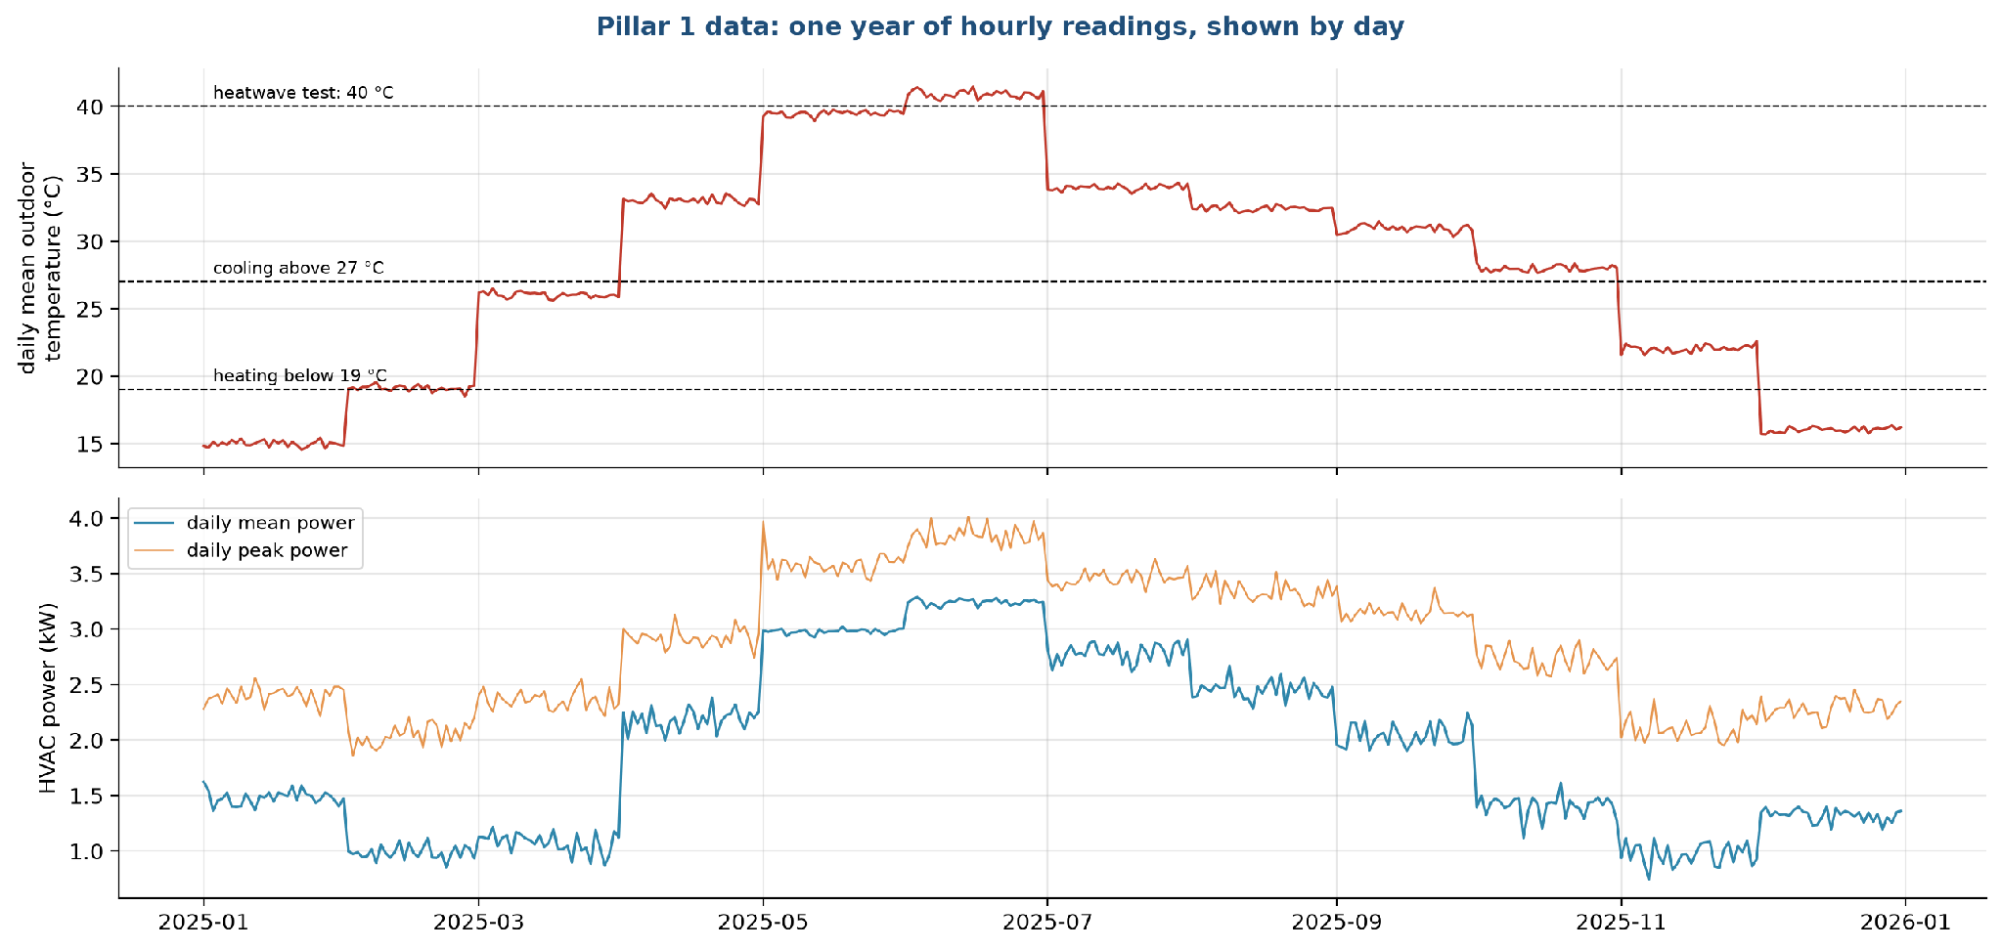
Figure 2.1. One year of hourly readings, shown by day
The temperature does not move smoothly through the year. It steps up or down on the first day of almost every month and then stays flat, and the same shape appears in the power curve. Real weather does not behave this way, and the Kaggle page does not say where the readings come from, so we treat the file as simulated data. It also tells us something useful: the month is almost a proxy for the temperature level, and a model that sees an unfamiliar month has to rely on the temperature itself. The monthly average is above 39 °C in May and June, and 824 hours between April and September reach 40 °C or more, which is what our heatwave test uses.

2.3 Dataset 2: machine failures, AI4I 2020 (Pillar 2)
The file holds 10,000 simulated machine records. The UCI page describes it as synthetic data built to resemble real industrial maintenance logs. It describes machine tools, and we use it as a stand-in for "sensor readings that precede a breakdown".
Column | Meaning | Values
UDI, Product ID | Row number and product code | identifiers, not used as inputs
Type | Product quality class | L 6,000, M 2,997, H 1,003
Air temperature [K] | Surrounding air temperature | 295.3 to 304.5, mean 300.0
Process temperature [K] | Temperature of the process | 305.7 to 313.8, mean 310.0
Rotational speed [rpm] | Spindle speed | 1,168 to 2,886, mean 1,539
Torque [Nm] | Twisting force | 3.8 to 76.6, mean 40.0
Tool wear [min] | Minutes the tool has been in use | 0 to 253
Machine failure | 1 if the machine failed (our target) | 339 ones, 3.39%
TWF, HDF, PWF, OSF, RNF | Which failure type occurred | 46, 115, 95, 98 and 19 cases

The five failure-type columns describe how a failure happened, so they are the answer in disguise. We do not use them as inputs, and a unit test checks that they stay out.

2.4 Dataset 3: customer purchases, Online Retail II (Pillar 3)
Online Retail II is a real transaction log from a UK online gift shop, from 1 December 2009 to 9 December 2011. The original workbook has 1,067,371 lines and is about 45 MB. A line is one product on one invoice. We do not need the product level for the churn task, so we collapse it to one row per invoice.
Column in our invoice table | Meaning
customer | Customer id (anonymised number)
invoice | Invoice number; numbers starting with C are returns
date | Date and time of the invoice
value | Money value of the invoice (quantity times price, summed)
items | Total number of units
products | Number of different products
country | Customer's country
is_return | True for a return or cancellation

After this step the table has 44,870 invoices from 5,939 customers: 36,969 purchases and 7,901 returns. The UK accounts for 90% of invoices, and 41 countries appear in total. The file shrinks from 45 MB to 0.76 MB.

Chapter 3
Data Cleaning and Preprocessing
Written by Dhruv Aggarwal (26911004).

3.1 Cleaning the retail transactions

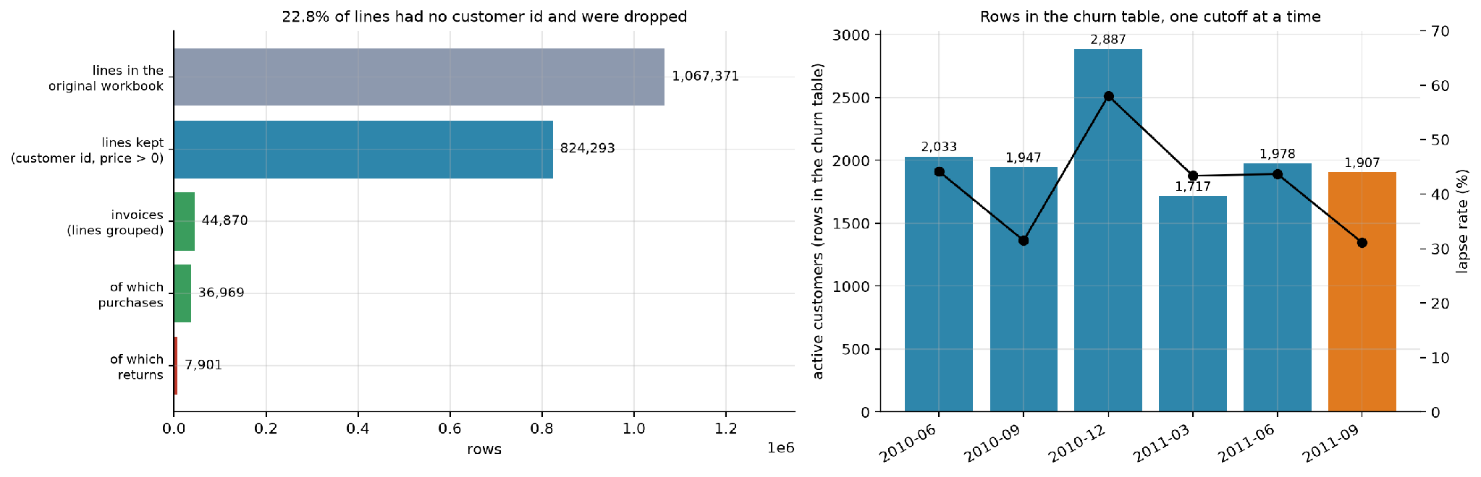
Figure 3.1. From 1.07 million original lines to 44,870 invoices
The top bar is the original workbook, 1,067,371 lines. The second bar is what remains after we drop lines without a customer id and lines with a price of zero or less, 824,293 lines, which means 22.8% of the original lines were removed. Grouping the remaining lines by invoice gives 44,870 invoices (third bar). Of these, 36,969 are purchases and 7,901 are returns. The right panel of the same figure shows how many rows each churn snapshot gets, with the lapse rate as a line, which section 3.2 explains. The invoice table is only 0.76 MB, against 45 MB for the original workbook.
The steps, in the order we applied them:
1. Joined the two sheets of the workbook (the data comes in two yearly sheets).
2. Dropped lines with no customer id. Without an id we cannot follow a buyer over time, so such lines are useless for churn. This removed about 243,000 lines.
3. Dropped lines with a price of zero or less. These are stock adjustments and write-offs, not sales. Almost all of them were already in the group above.
4. Marked invoices whose number starts with "C" as returns. We keep them in a separate flag and use them only to compute each customer's return share. A return never counts as a purchase, so it cannot make a lapsing customer look active.
5. Computed the value of each line as quantity times price, and grouped lines by customer and invoice, so that each invoice becomes one row with its date, total value, units, number of distinct products and country.
6. Kept only positive quantities for purchases.

3.2 Building the churn table
The retail file has no column that says a customer has left, so we build the target. This is the most delicate step in the project, because a careless version leaks the answer into the inputs. Figure 3.2 shows how each row of the table is built.
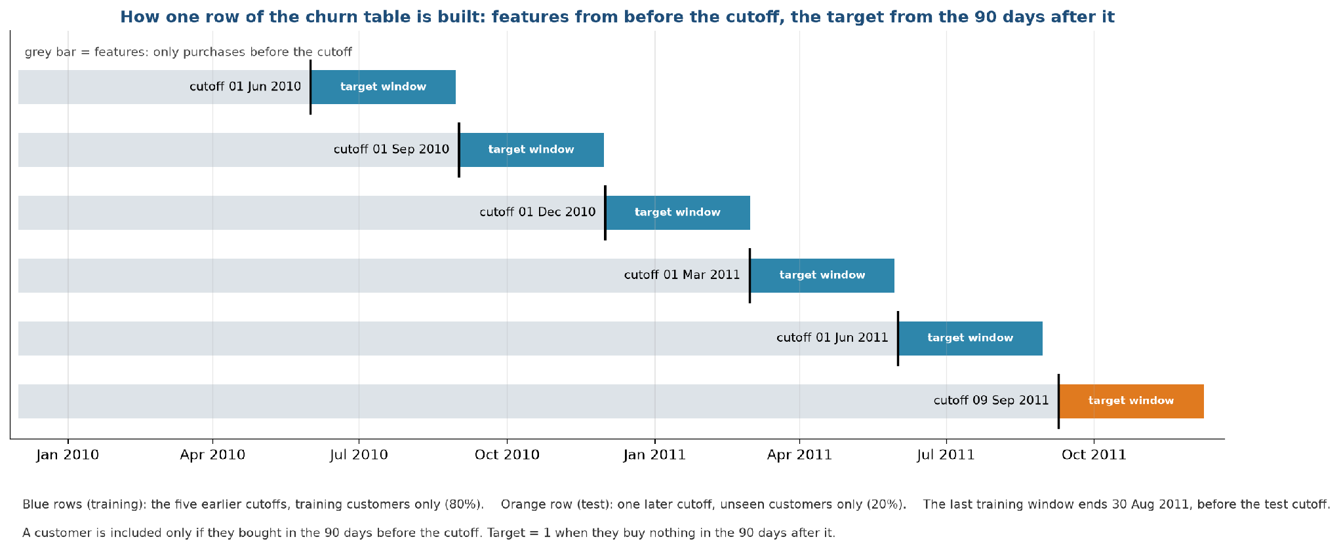
Figure 3.2. How one row of the churn table is built
Each horizontal line is one snapshot of the customer base, taken on a cutoff date (the black tick). Each snapshot has two windows. The history window (grey bar) is everything before the cutoff, and every feature is computed from it. The target window (coloured bar) is the 90 days after the cutoff, and it is used only to set the label: the label is 1 (lapsed) if the customer buys nothing in those 90 days and 0 if they buy at least once. Only customers who bought in the 90 days before the cutoff are included, so each snapshot asks: of the customers who are active now, who will go quiet? For example, for the cutoff 1 June 2010 the features use purchases up to 31 May 2010, and a customer who bought in April 2010 but not between 1 June and 30 August 2010 gets the label 1.
We take five training snapshots (1 June 2010, 1 September 2010, 1 December 2010, 1 March 2011 and 1 June 2011, blue bars) and one later test snapshot (9 September 2011, orange bar). The last training window ends on 30 August 2011, before the test cutoff, so no training label looks into the test period. The test window ends on 8 December 2011, the last full day in the data.

The December 2010 snapshot has the highest lapse rate, because the 90 days after 1 December include the quiet holiday weeks, and the September snapshots have the lowest, because their window covers the pre-Christmas buying season. The same customer can appear in several snapshots, once for each cutoff at which they were active. A customer is a different row at each cutoff, with different features and a different outcome.

3.3 Splitting the data
We decided how to split before looking at any model score. Figure 3.3 shows the designs.
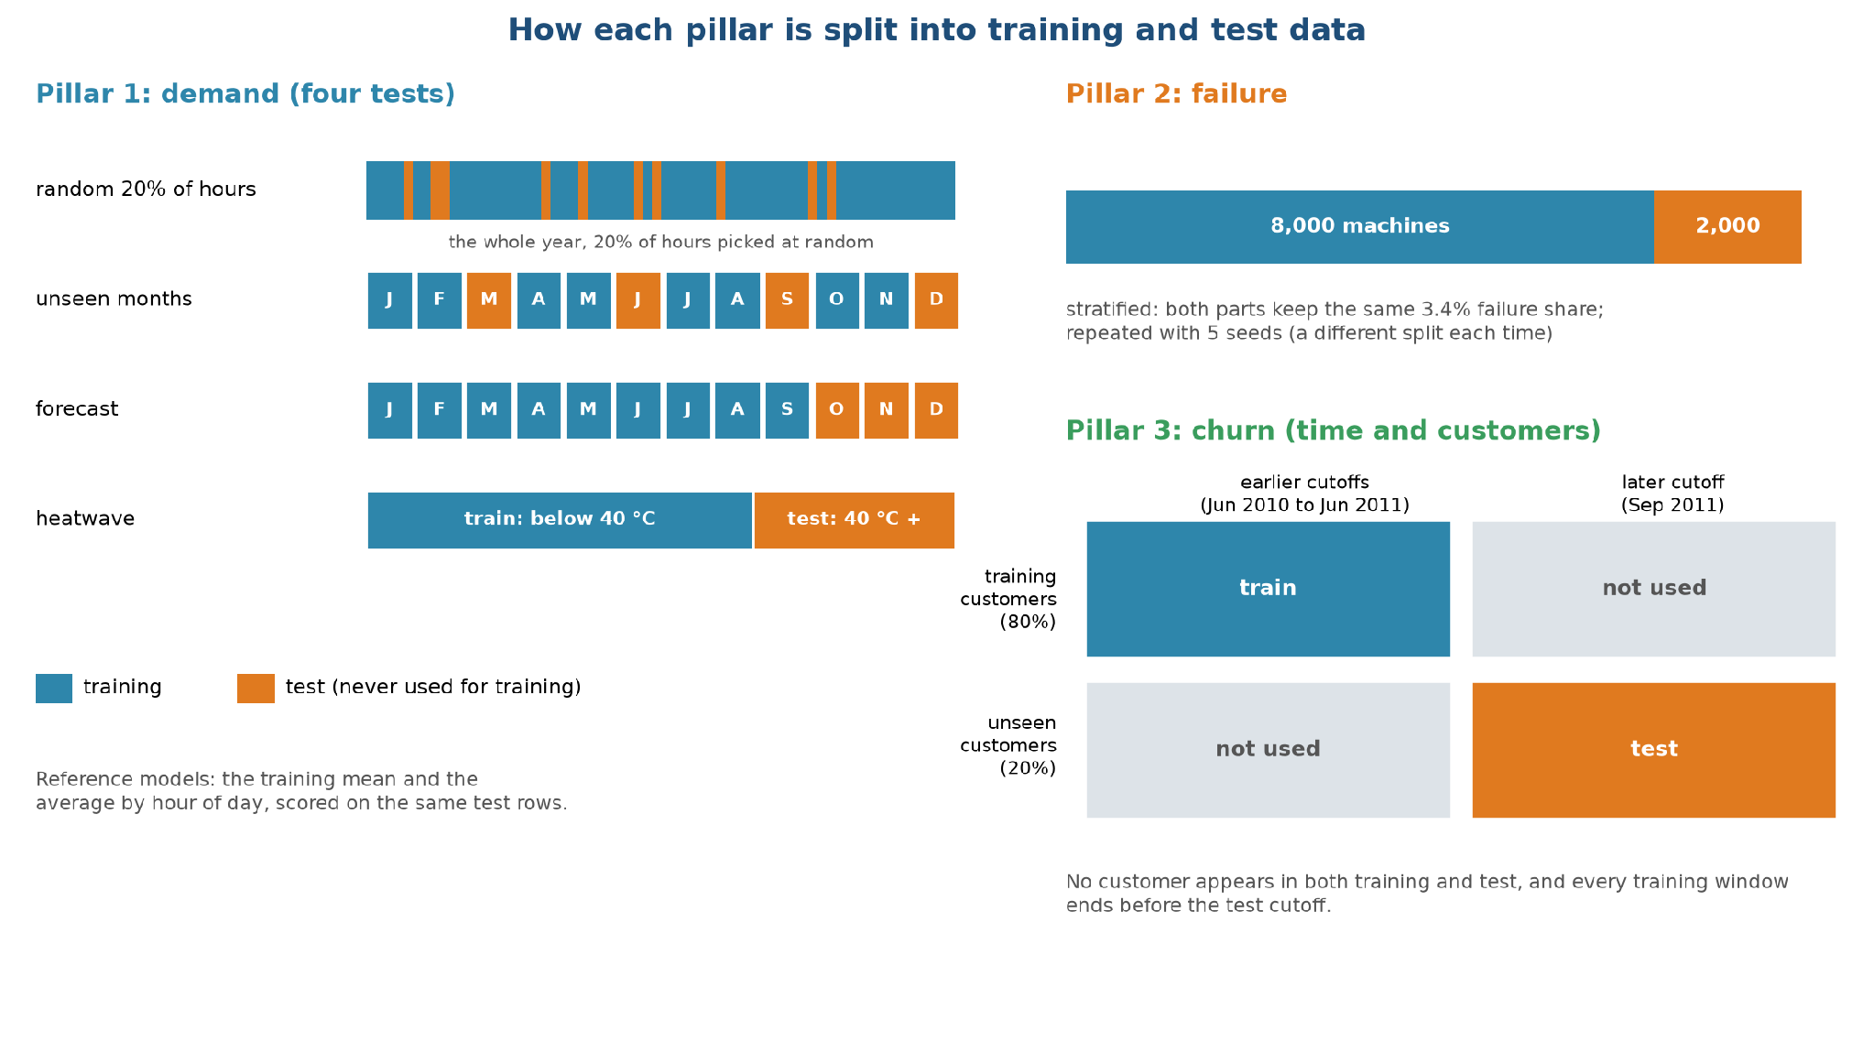
Figure 3.3. How each pillar is split into training and test data
Pillar 1 has four tests, each harder than the last. The first holds out a random 20% of hours. It is the easy case, since the neighbours of every test hour are in training, so we treat it as an optimistic reference. The second holds out whole months (March, June, September and December), so the model must predict months it never saw. The third trains on January to September and predicts October to December, which imitates a real forecast. The fourth trains on hours below 40 °C and tests on hours at or above 40 °C, which imitates a heatwave. The number of hours in training and test is 7,008 and 1,752 for the random split, 5,832 and 2,928 for unseen months, 6,552 and 2,208 for the forecast, and 7,936 and 824 for the heatwave. Each Pillar 1 model is therefore trained four separate times, once per test, and each fit sees only the training hours of its own test; every fit is repeated with the five seeds. The scores are reported per test and never averaged across tests. The model in the dashboard is a separate final fit on all 8,760 hours (stage 7).
Pillar 2 uses a stratified 80/20 split, with 8,000 machines for training and 2,000 for testing. Stratified means both parts hold the same 3.4% share of failures, so the test set has 68 failures. We repeat the split with five different seeds.
Pillar 3 splits customers and time at once. First, 20% of customers are picked at random and set aside. Training rows come from the earlier cutoffs and the 80% of customers. Test rows come from the later cutoff and the 20% of customers set aside. No customer appears on both sides, and no training window overlaps the test period. This leaves about 8,450 training rows and about 360 test rows, 118 of which are customers who lapse. The test set is small, so the scores vary from seed to seed, and we report that spread in stage 8.

3.4 Guards against leakage
Leakage means that information from the answer or the test period reaches the model during training. It produces scores that look excellent and fail in real use. Seven checks protect us, and six of them are automated tests that run before every release.
Risk | What we did | Test
Features that use the future (churn) | Features only look at invoices before the cutoff; the test deletes all later invoices and checks that no feature changes | features use only the past
Target built from the past (churn) | The target only looks at invoices after the cutoff | label comes from the future
Same customer on both sides | Customers are split before rows are built | test customers never appear in training
Overlapping windows | The last training window ends before the test cutoff | training cutoffs end before the test cutoff
Answer hidden in the inputs (failure) | The five failure-type columns are never inputs | failure features
Test statistics in the pipeline | Imputing and scaling are inside the model pipeline | by design
Choosing a threshold on test data | The alert threshold comes from out-of-fold training scores | by design

Chapter 4
Exploratory Data Analysis
Written by Dhruv Aggarwal (26911004).

4.1 Pillar 1: what drives HVAC power

Power by hour and month
Figure 4.1 is a heat map of average power for each month (columns) and hour of the day (rows).
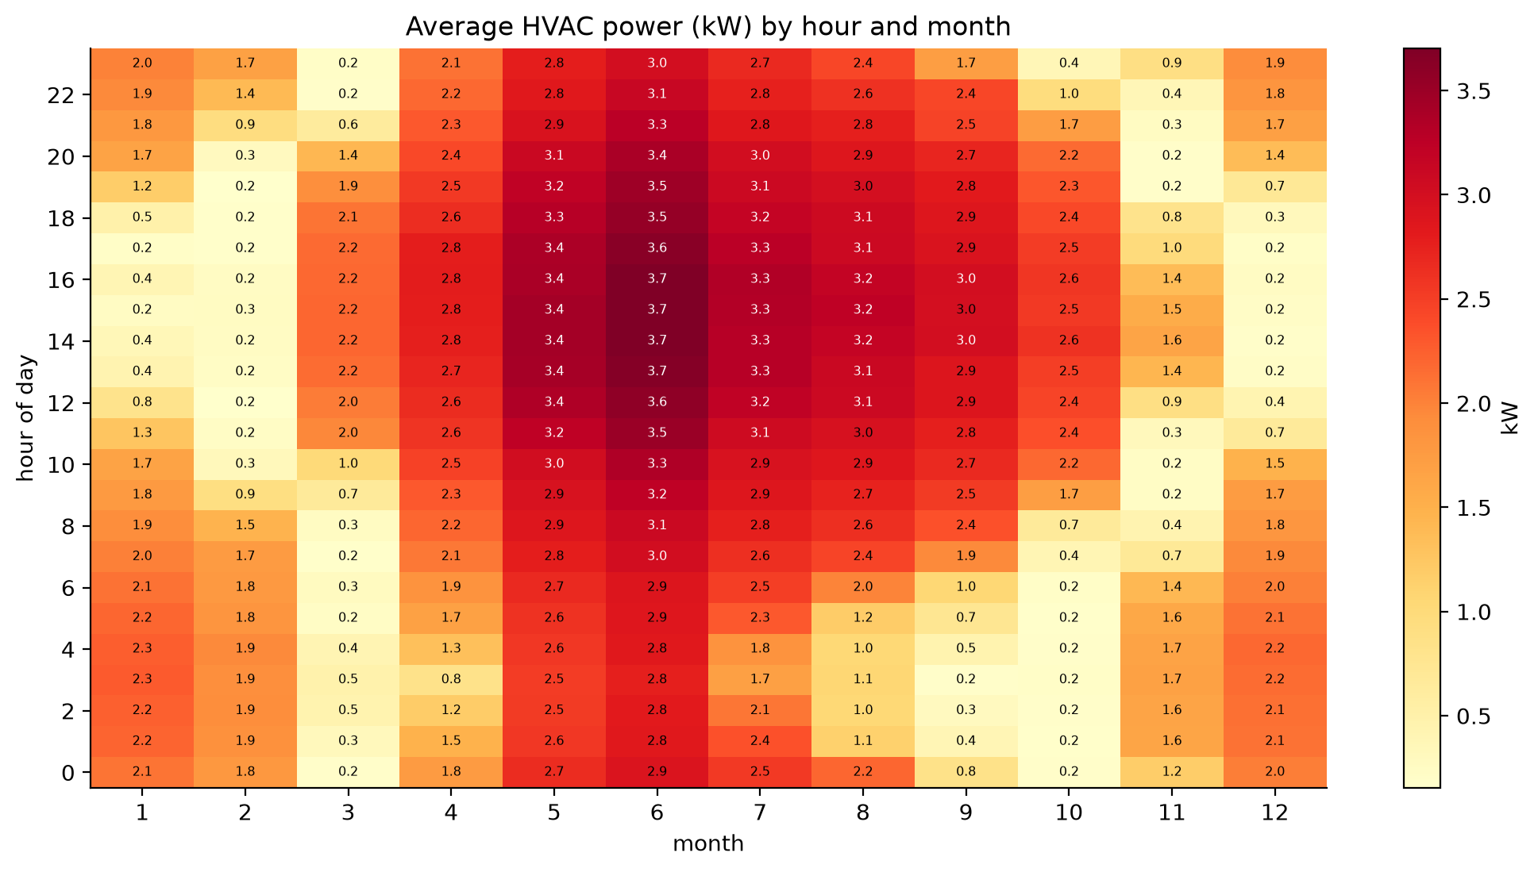
Figure 4.1. Average HVAC power by hour and month
Dark red cells are high power and pale yellow cells are close to zero. The map is dominated by the months: May to August are dark red all day, with a peak of 3.7 kW between 12:00 and 17:00 in June. January and December are medium, around 2 kW. February, March, October and November are mostly pale, which means the system sits in idle mode for most hours, with bursts of heating in the cold nights and mornings. Inside a month, the hour matters less than the month, because the daily range of temperature in this data is modest compared with the jump from one month to the next. This is a direct result of the monthly steps we saw in stage 2. It tells us that a month alone would explain a good part of the power, and that a model trained without some months has to take its knowledge from the temperature itself.

4.2 Pillar 2: what separates failing machines

Sensor distributions
Figure 4.2 compares every sensor reading for machines that failed (red) and machines that did not (blue).
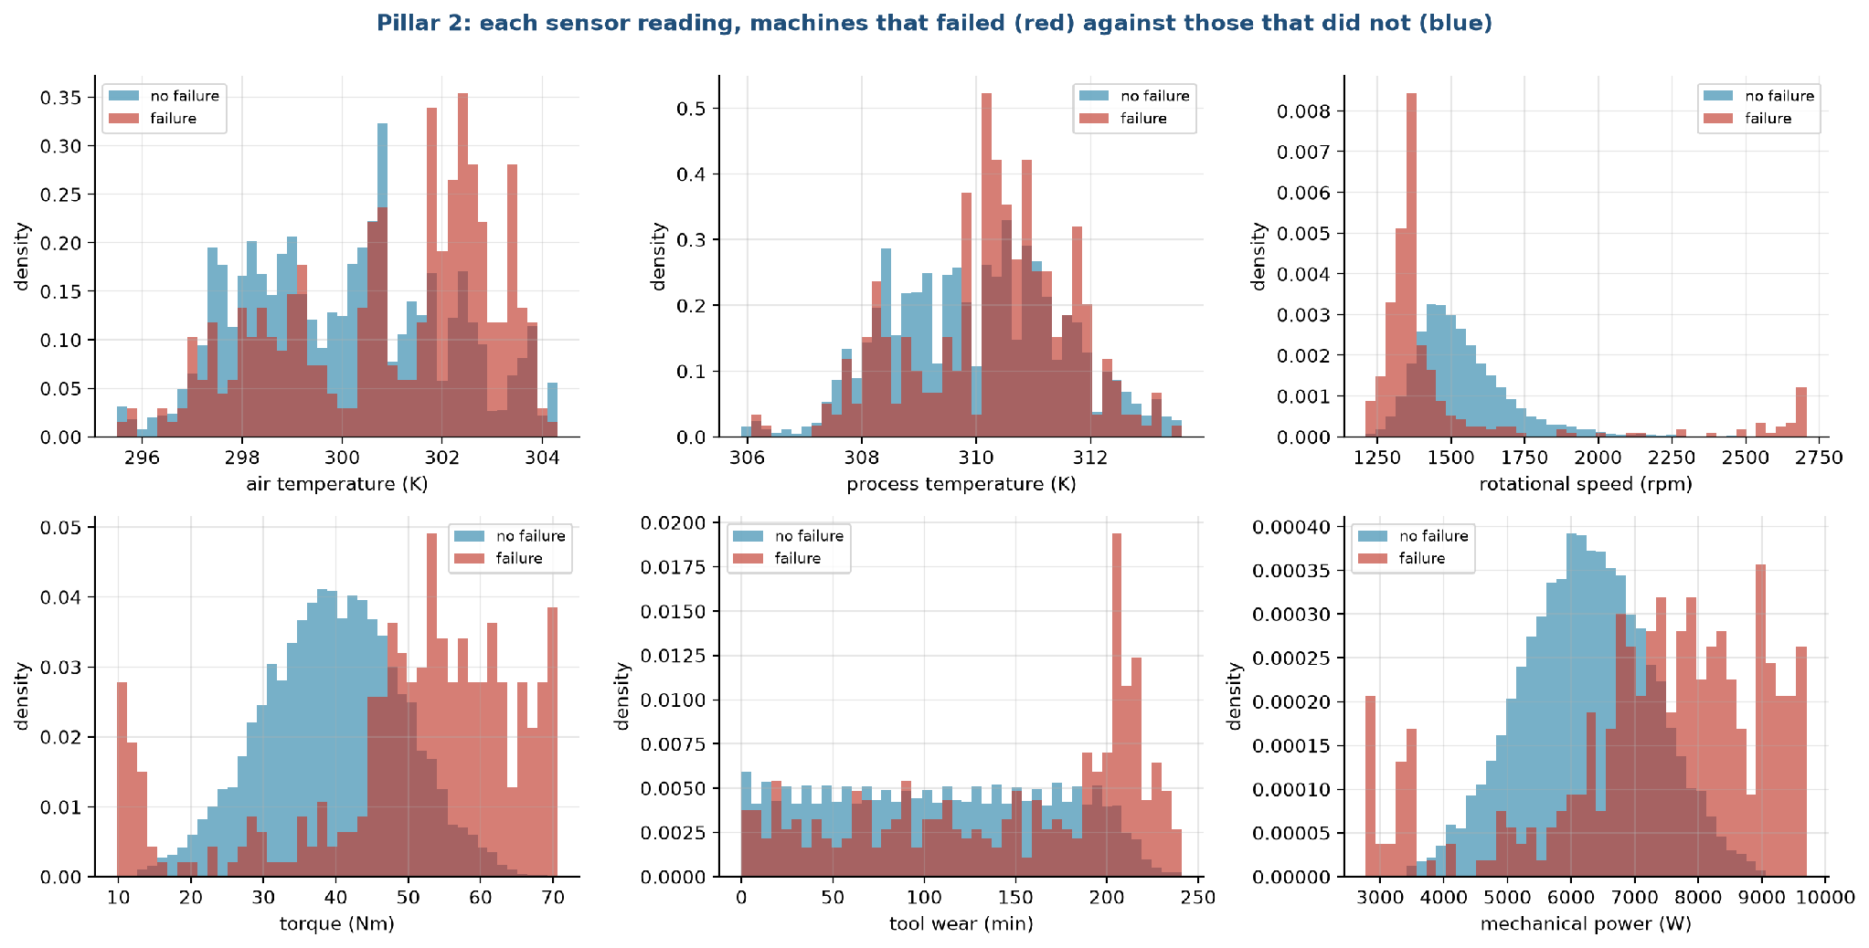
Figure 4.2. Sensor readings of failing and healthy machines
The panels are density histograms. Each colour is scaled so that its bars cover a total area of 1, so the height of a bar is the share of that group's machines in the bin divided by the bin width. Raw counts would hide the failures, since there are about 28 healthy machines for each failure; with densities the two shapes can be compared directly. Where the red bars sit apart from the blue ones, that reading carries information.
• Torque: healthy machines centre around 40 Nm, while failures spread to both ends, with a cluster below 20 Nm and a large share above 50 Nm. Failure rates are 18.2% in the top decile of torque.
• Rotational speed: failures concentrate at low speed, near 1,300 rpm, and there is a small second group above 2,600 rpm. The lowest speed decile has a 16.7% failure rate.
• Tool wear: the two distributions look alike up to about 200 minutes, then failures pile up in the last stretch. The top decile has a 12.6% failure rate.
• Mechanical power, torque times speed, which we added as a derived column: failures sit at both extremes, below 4,000 W and above 8,000 W. The top decile has a 16.9% failure rate.
• Air and process temperature: failures lean toward higher temperatures, and the overlap is large.
The torque and power panels show a "U" shape: failure is more likely at both low and high values. A linear model draws one straight line, so it cannot capture a U. Tree models can. This foretells the large gap between logistic regression and the tree models that we see in stage 8.

4.3 Pillar 3: how customers behave

Who lapses
Figure 4.3 splits the lapse rate by three customer features, using all six snapshots together.
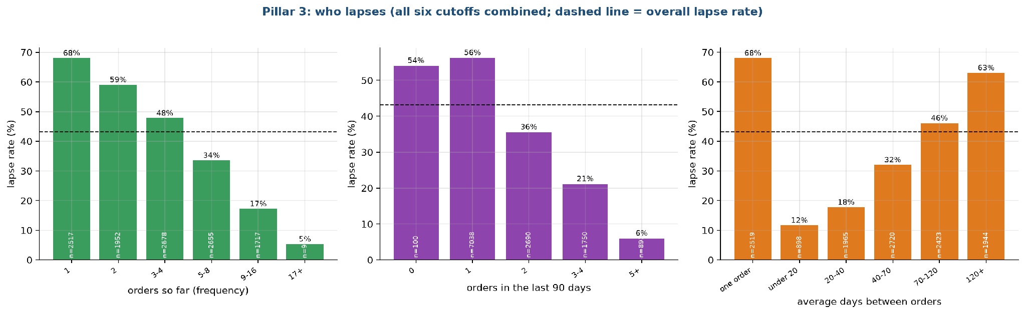
Figure 4.3. Lapse rate by number of orders, recent orders and order rhythm
The dashed line is the overall lapse rate of about 43%. The numbers inside the bars show how many customers fall in each group, and small groups are less reliable.
• By number of orders so far (left): a customer with one order lapses 68% of the time, with two orders 59%, with three or four 48%, and those with 17 or more lapse 5% of the time. Loyalty builds with each order.
• By orders in the last 90 days (middle): customers with no recent order (a boundary case of only 100 rows) or one order lapse 54% to 56%, those with two lapse 36%, three or four 21% and five or more 6%.
• By average days between orders (right): customers with one order only lapse 68%, those who reorder in under 20 days lapse 12%, and those who reorder every 120 days or more lapse 63%. A shorter rhythm predicts staying.
The effect is large in each panel, so a model has useful signal to find. What the panels do not show is how these features interact, or whether the signal in one overlaps the others.

4.4 Summary of findings
Pillar | Main finding | Number | Consequence
1 | Power is driven by the gap between outdoor and indoor temperature | correlation 0.85 | Add the absolute gap; a linear model on it can extrapolate
1 | Idle hours draw 0.19 kW, cooling 2.73 kW | by mode | Keep mode as an input
1 | 824 hours reach 40 °C or more, all in cooling mode | 9.4% of hours | Use them as the heatwave test
2 | Failure is U-shaped in torque, speed and power | top-decile failure rate 17% to 18% against 3.4% overall | Trees should beat linear models
2 | No single input has a high correlation with failure | at most 0.19 | Combine inputs; use PR-AUC
3 | Lapse falls from 68% to 5% as order count rises | frequency | The signal is in order history
3 | Recency is the weakest of the main signals | correlation 0.16 | The recency rule should be a weak baseline
3 | Money columns are very skewed | top 1% hold 32% of spend | Use log versions

Chapter 5
Feature Engineering
Written by Ankit Kumar (26911002).

5.1 Pillar 1: demand features

Basic inputs (10)
Input | How it is built | Why
Outdoor temperature | as is | the main driver of load
Indoor temperature | as is | the setpoint the system works toward
Humidity | as is | affects cooling effort
Hour, as sine and cosine | sin and cos of 2 x pi x hour / 24 | so that 23:00 sits next to 00:00
Month, as sine and cosine | sin and cos of 2 x pi x (month - 1) / 12 | so that December sits next to January
Mode (cooling, heating, idle) | three 0 or 1 columns | the system is in one of three states

Engineered inputs (3 more, 13 in all)
Input | How it is built | Why
Absolute gap | the absolute value of outdoor minus indoor temperature | the exploration in stage 4 showed a correlation of 0.85 with power
Gap while cooling | absolute gap times the cooling indicator | the cost per degree of gap differs between cooling and heating
Gap while heating | absolute gap times the heating indicator | same reason

Figure 5.1 shows why the absolute gap is useful.
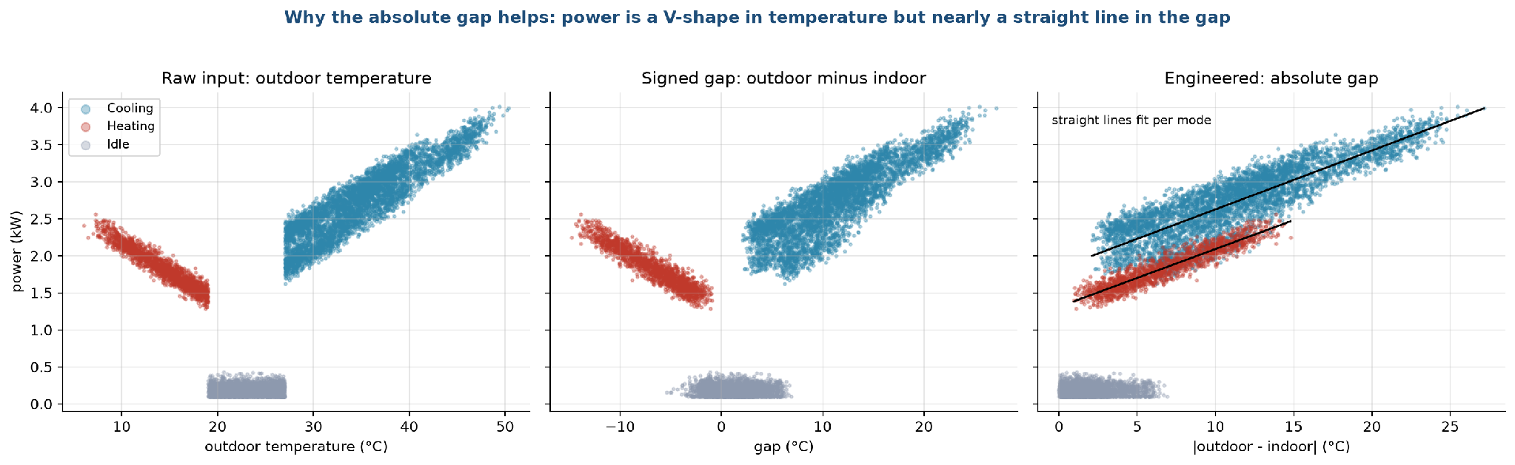
Figure 5.1. Power against temperature, and against the absolute gap
The left panel plots power against outdoor temperature. The points form a V: power is high when it is very cold, drops to near zero in the comfortable middle, and climbs again when it is hot. A straight line fitted to such a V is a poor description, because it would have to slope one way for the cold half and the other way for the hot half. The right panel plots power against the absolute gap. The V has folded into a single rising band, which a straight line follows well. The cooling and heating features then let the line have a different slope on each side. We did not add the mode thresholds (19 and 27 °C) as separate features, because the mode column already carries them.

5.2 Pillar 2: failure features

Basic inputs (8)
The five sensor readings (air temperature, process temperature, rotational speed, torque and tool wear) and the machine type as three 0 or 1 columns.

Engineered inputs (3 more, 11 in all)
Input | How it is built | Physical meaning
Temperature gap | process temperature minus air temperature | how much heat the process produces; a small gap means heat is not leaving
Mechanical power | torque times rotational speed times 2 pi / 60, in watts | the work done; very low and very high power both strain the machine
Wear times torque | tool wear in minutes times torque | overstrain: a worn tool under heavy load

We chose these because they are the physical quantities named in the dataset's own description of the failure modes (heat dissipation, power failure, overstrain). We did not add the failure thresholds themselves, because that would put the generator's rules directly into the table and make the problem trivial. Figure 5.2 shows how the failure rate changes across the range of each new feature.
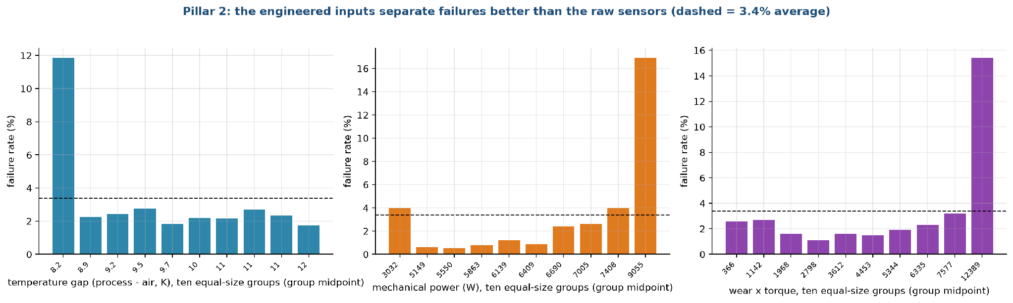
Figure 5.2. Failure rate by decile of each engineered feature
Each bar is one tenth of the machines, ordered from the lowest value to the highest, and its height is the share of those machines that failed. The overall rate is 3.4%. For the temperature gap, the lowest tenth (gaps near 8.2 K) has a failure rate of about 12%, more than three times the average, while the other nine tenths sit near 2%. For mechanical power, the failure rate is under 1% in the middle of the range, about 4% in the lowest tenth and about 17% in the highest, which is the U shape we saw in stage 4. For wear times torque, the rate stays between 1% and 3% for nine tenths of the machines and then jumps to about 15% in the highest tenth. These are the effects we hoped to expose. They are threshold-shaped or U-shaped, so a tree can use them more easily than a straight line, and a straight line gets only part of the benefit.

5.3 Pillar 3: customer features

Basic inputs (3)
The classic customer summary: recency (days since the last purchase), frequency (number of purchase invoices before the cutoff) and monetary value (total spend).

Engineered inputs (13 more, 16 in all)
Input | How it is built | Why
Tenure | days from first purchase to the cutoff | long-standing customers are steadier
Average order value | total spend divided by number of invoices | size of the typical order
Average gap between orders | tenure divided by (invoices - 1); empty for one-time buyers | the customer's own rhythm; the strongest correlation with lapsing (0.33)
Average items and average products per invoice | means over invoices | how big and varied the baskets are
Orders in the last 90 days | count of invoices in the 90 days before the cutoff | recent activity
Orders in the 90 days before that | count in the window 90 to 180 days before | earlier activity to compare with
Order trend | last 90 days minus previous 90 days | whether activity is rising or falling
Return share | returns divided by (returns + purchases) | how often the customer sends goods back
UK flag | 1 if the customer is in the United Kingdom | the shop sells mostly to the UK
Log spend, log frequency, log order value | natural log of one plus the value | spend is very skewed (stage 3)

All of these use only invoices dated before the cutoff, and a unit test deletes every invoice after the cutoff and checks that no feature changes.

5.4 Does feature engineering help?
For every pillar and model we ran the same test with basic and with engineered inputs. Figure 5.3 compares the two.
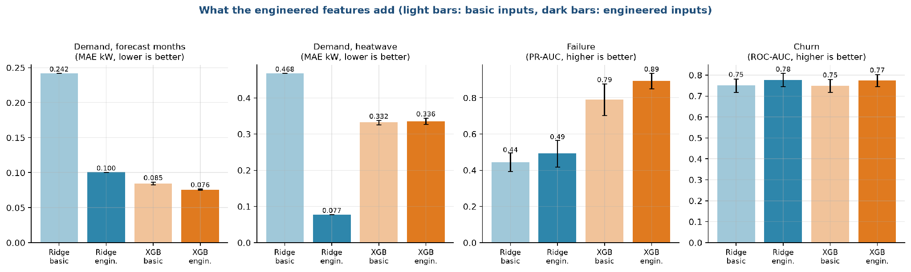
Figure 5.3. Test score with basic and with engineered inputs
The clearest result is the first group of bars. For demand, Ridge regression with basic inputs misses by 0.18 to 0.24 kW on the first three tests, and engineered inputs cut that error to 0.10 to 0.12 kW, about half. In the heatwave test the error falls from 0.47 to 0.08 kW. A linear model cannot build the absolute gap from its parts, so it needs it handed over. XGBoost gains almost nothing for demand, with 0.065 kW on the random test whether or not the gap is included, because trees can build such a shape themselves by splitting. For failure, the PR-AUC rises from 0.45 to 0.49 for Ridge and from 0.79 to 0.89 for XGBoost. For churn the ROC-AUC rises from 0.75 to 0.78 for both models.

5.5 Which features the models rely on
After training, we looked at which inputs each model uses most. Figure 5.4 shows this for Pillar 2 and Figure 5.5 for Pillar 3.
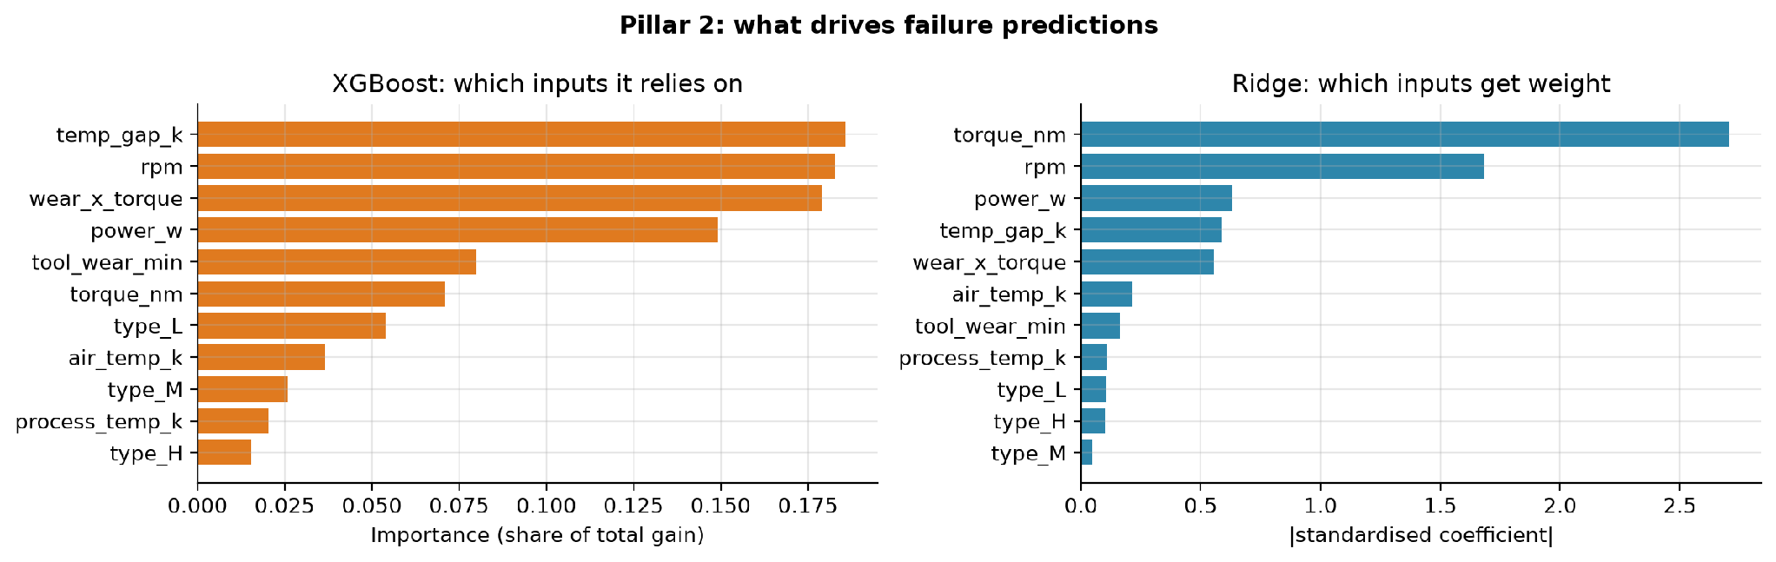
Figure 5.4. Feature importance for failure (XGBoost on the left, Ridge on the right)
For failure, XGBoost spreads its reliance over the temperature gap, rotational speed, wear times torque and mechanical power, three of which are our engineered features. Ridge puts the largest weights on torque and speed and little on the others. The orange bars measure the share of the total improvement in the fit that each input provides, and the blue bars show the size of the standardised coefficient.
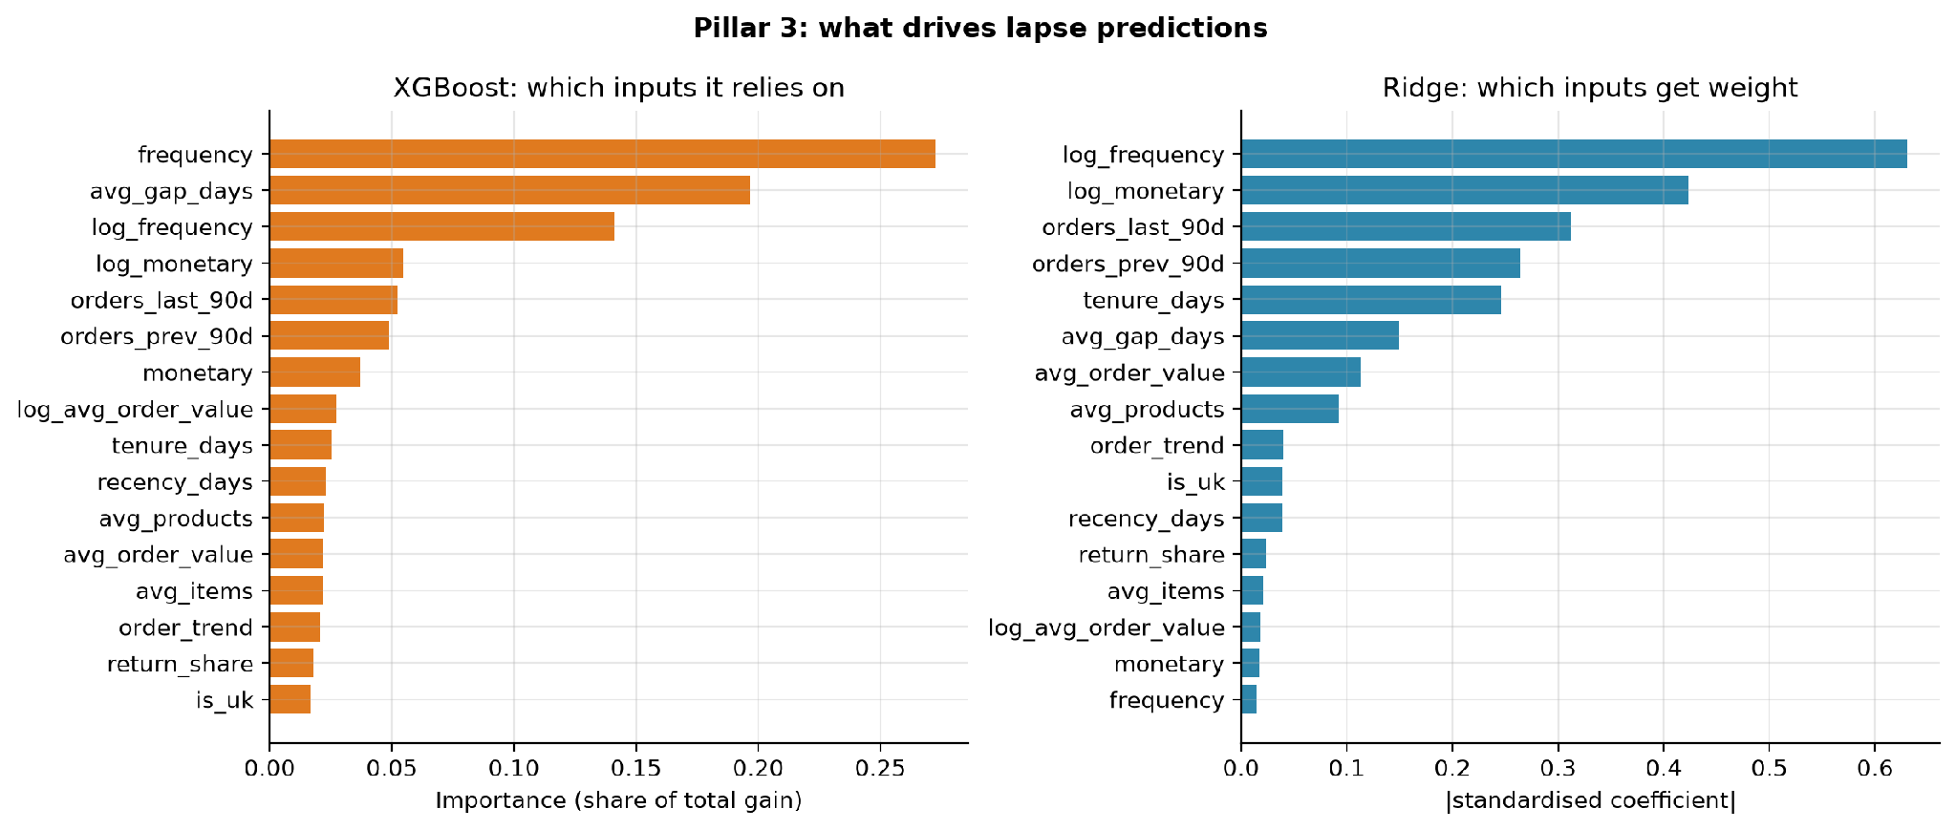
Figure 5.5. Feature importance for churn
For churn, both models rely most on how often the customer has ordered (frequency or its log) and, for XGBoost, the average gap between orders. Recency, the basis of the usual rule of thumb, ranks only tenth for XGBoost and eleventh for Ridge.

Chapter 6
Model Selection
Written by Ankit Kumar (26911002).

6.1 The candidates
We use five kinds of predictors for each pillar. Table 6.1 sums up their roles.

Table 6.1. The model families we compare
Model | Role in this project | How it fits | Beyond the training range? | Main point
Rule of thumb | no learning | average by hour; most worn tool first; longest since last purchase | n/a | what a company does today
Linear / logistic regression | statistical baseline | one weight per input, no penalty | yes (straight line) | explainable; cannot bend
Ridge | our model 1 | same, with an L2 penalty chosen by cross-validation | yes (straight line) | stable with many inputs
Random Forest | classic ML baseline | 300 trees on random subsets; averaged | no (flat beyond training range) | few settings; handles thresholds
XGBoost | our model 2 | 400 or 300 small trees, each fixing the errors of the previous ones | no (flat beyond training range) | most accurate on tables

The table in Table 6.1 lists the rule of thumb, linear and logistic regression, Ridge, Random Forest and XGBoost. For each it gives its role in this project, how it fits, whether it can predict beyond the range of values it saw in training, and the main point to remember. The column about the training range turns out to matter a great deal for the heatwave test (section 6.2).

6.2 The trees-and-extrapolation problem
One property of tree models decides the outcome of the heatwave test. Figure 6.2 shows a toy example that has nothing to do with HVAC.
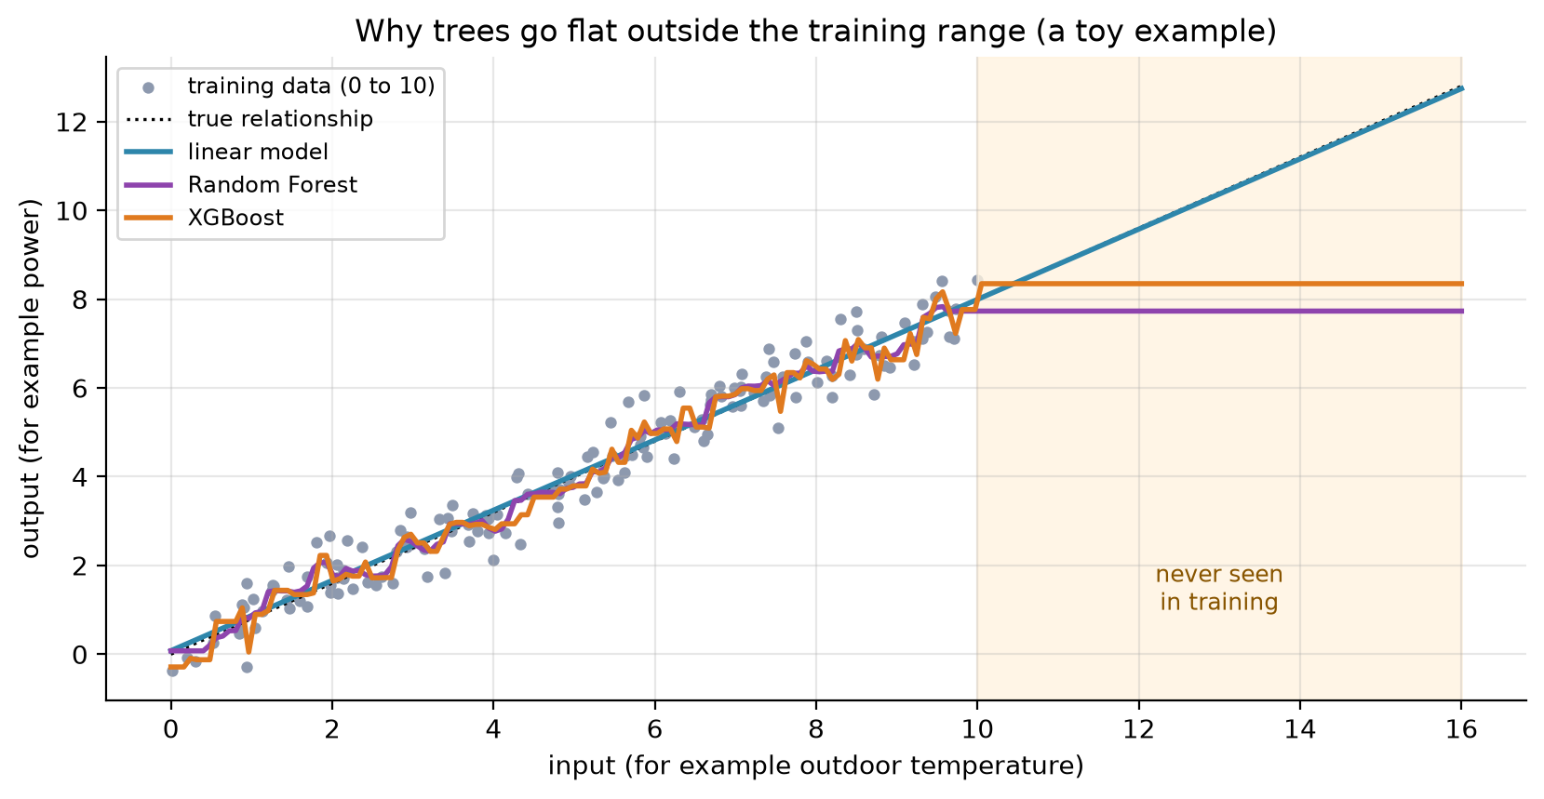
Figure 6.2. Why trees stop rising outside the training range
The grey dots are training points between 0 and 10, from a relationship that rises in a straight line. The dotted black line is the true relationship, which continues past 10. All three models fit the training range well. Beyond 10, in the shaded area, the linear model (blue) continues along the straight line and stays close to the truth. The Random Forest (purple) and XGBoost (orange) stay flat at the last value they saw. A tree can only output averages of training values, so it cannot predict anything higher than the highest values it was trained on. In our data, power grows in proportion to the gap between outdoor and indoor temperature, and the heatwave hours have larger gaps than any hour in training. We therefore expected linear models to win the heatwave test and trees to lose it, and chose to make the heatwave test a part of the contest.

6.3 The selection rule
We wrote the rule before running the contest.
1. Run every candidate on every test, five times, with seeds 42 to 46.
2. For each test, take the mean score of each model over the five seeds. The model with the best mean is the leader.
3. Every model whose mean lies within one standard deviation of the leader is declared tied with it. The standard deviation is the leader's spread over the five seeds.
4. Among tied models, the simplest one wins. Simplest first: linear or logistic regression, Ridge, Random Forest, XGBoost.
The idea is to avoid choosing a complicated model for a difference that is just noise. Figure 6.3 shows the rule in action for the two classification pillars.
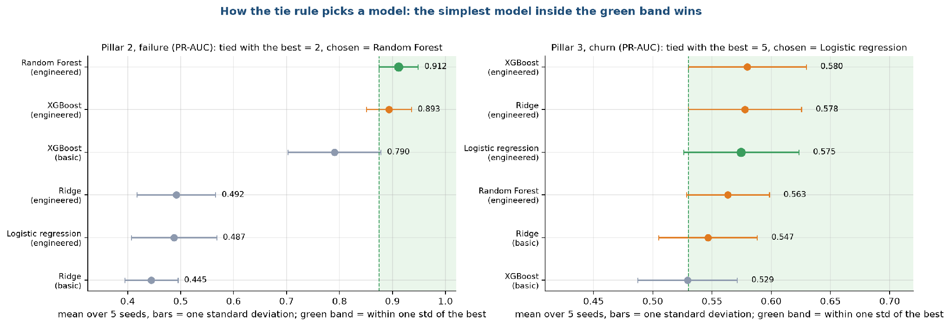
Figure 6.3. How the tie rule picks a model for failure and churn
Each dot is the mean over five seeds with a bar of one standard deviation. The green band is the leader's mean minus one standard deviation, up to the top. In the failure panel (left), the leader is Random Forest at 0.912 PR-AUC, and only XGBoost (0.893) falls inside the band, so the two are tied and Random Forest is the simpler. Logistic regression and Ridge sit at about 0.49 and are far outside the band. In the churn panel (right), the leader is XGBoost with a PR-AUC of 0.580, but five models fall in the band, from logistic regression at 0.575 to Ridge with basic inputs at 0.547. The simplest is logistic regression, so it wins. The spread is wide because the churn test set has only about 360 customers.

6.4 What the rule selects
Test | Leader (mean) | Models tied with the leader | Pick by the rule | What the product uses
Demand, random split | XGBoost, basic inputs (0.065 kW) | XGBoost, engineered inputs | XGBoost | XGBoost
Demand, unseen months | XGBoost, basic inputs (0.070 kW) | none | XGBoost | XGBoost
Demand, forecast | XGBoost, engineered inputs (0.076 kW) | none | XGBoost | XGBoost
Demand, heatwave | Linear regression and Ridge (0.077 kW) | none | Linear regression (Ridge gives the same score) | Ridge
Failure | Random Forest (0.912 PR-AUC) | XGBoost | Random Forest | XGBoost
Churn | XGBoost (0.580 PR-AUC) | four more, see Figure 3 | Logistic regression | Ridge

For demand the answer is a pair: XGBoost for ordinary weather and Ridge for heat beyond 40 °C or outside the temperature range of the training data. We call this the heatwave safeguard, and stage 9 describes how it works in the dashboard.
For failure, the rule alone picks Random Forest. The product uses XGBoost, which finished inside the same band (0.893 against 0.912), because it is one of the two models the group set out to compare and the gap is smaller than one standard deviation. Either would be a sound choice. A reader who prefers the strict rule would add Random Forest to the saved models, which is a small change because every model has the same interface.
For churn, the rule picks logistic regression. The dashboard uses the Ridge version of it, which scores 0.777 ROC-AUC against 0.775 for plain logistic regression. The two are the same method with a different penalty, and we kept Ridge because it is slightly more stable when the inputs are strongly correlated.

Chapter 7
Model Training
Written by Animesh Basak (26911001).

7.1 The training protocol
Every experiment follows the same six steps, shown in Figure 7.1.

What happens in one run of the experiment (repeated for seeds 42 to 46)
1. Split
hold out the test data (by month, temperature, machine or customer)
2. Features
build the basic and engineered inputs from the training rows
3. Tune penalty
Ridge alpha or logistic C chosen by 5-fold cross-validation on training data only
4. Fit
fit each model once on all training rows (settings fixed in config.py)
5. Threshold
F1-best alert threshold from out-of-fold training scores (yes/no tasks)
6. Test
one pass over the test rows: MAE, PR-AUC, ROC-AUC, top 10%
After the six steps the seed is changed and everything is repeated. We report the mean and the standard deviation over the five seeds.
The test rows are used once, at step 6. Nothing is tuned on them.
Figure 7.1. What happens in one run of the experiment
The six boxes read from left to right.
1. Split. The test data is set aside first (by month, by temperature, or by machine and customer), as described in stage 3.
2. Features. The basic and engineered inputs are built from the training rows.
3. Tune the penalty. Ridge picks its penalty (alpha for numbers, C for yes or no) by five-fold cross-validation on the training rows. That means the training rows are split into five parts, the model is fitted on four and scored on the fifth, and this is repeated five times. No test row is involved.
4. Fit. Each model is fitted once on all training rows. The tree settings are fixed in one configuration file and are not tuned.
5. Threshold. For the yes or no tasks, a model returns a risk score from 0 to 1. To raise an alert we need a cut-off. We choose the cut-off that gives the best F1 score on out-of-fold training scores, meaning scores that the model produced for rows it had not been trained on within the cross-validation. This keeps the test rows out of the choice.
6. Test. The fitted model scores the test rows once. We record the error for demand, and PR-AUC, ROC-AUC, F1, precision, recall and the top-10% capture for failure and churn.
After the six steps, the seed is changed and everything is repeated. We use five seeds, 42 to 46, and report the mean and the standard deviation. A seed changes the random 20% of hours, the stratified split of machines, the 20% of customers set aside, and the random choices inside the tree models. The tests by month and by temperature do not depend on the seed, so only the model's own randomness varies there, and Ridge gives the same answer every time (a standard deviation of zero).

7.2 Settings
Setting | Value | Where it applies
Seeds | 42, 43, 44, 45, 46 | all experiments
Share of data held out | 20% (rows for AI4I, customers for retail, hours for the random demand split) | all pillars
Held-out months | 3, 6, 9, 12 | demand, unseen months
Forecast months | 10, 11, 12 (train on 1 to 9) | demand, forecast
Heatwave threshold | 40 °C | demand, heatwave
Training cutoffs | 1 Jun, 1 Sep, 1 Dec 2010; 1 Mar, 1 Jun 2011 | churn
Test cutoff | 9 Sep 2011 | churn
Prediction window | 90 days | churn
Ridge penalty candidates | 0.001, 0.01, 0.1, 1, 10, 100, 1000 | demand, 5-fold cross-validation
Logistic penalty candidates (C) | 0.01, 0.1, 1, 10, 100 | failure and churn, 5-fold cross-validation, scored by average precision
XGBoost for demand | 400 trees, depth 4, learning rate 0.05, 80% of rows and of columns per tree
XGBoost for failure and churn | 300 trees, depth 3, learning rate 0.05, 80% of rows and of columns per tree
Random Forest | 300 trees, at least 5 rows per leaf
Linear and logistic regression | no penalty (C = 1,000,000 for logistic) | statistical baseline

For the final models in the dashboard, cross-validation chose an alpha of 0.1 for the demand Ridge and a C of 0.1 for the failure and churn Ridge. The alert thresholds learned on training data are 0.44 for XGBoost on failure (0.26 for Ridge) and 0.34 for XGBoost on churn (0.35 for Ridge).

7.3 How much data does each model need?
A learning curve shows the test score as the training set grows. If the curve is still rising at the right-hand end, more data would help. If it is flat, the model has learned what it can. Figure 7.2 shows the curves for the three pillars.
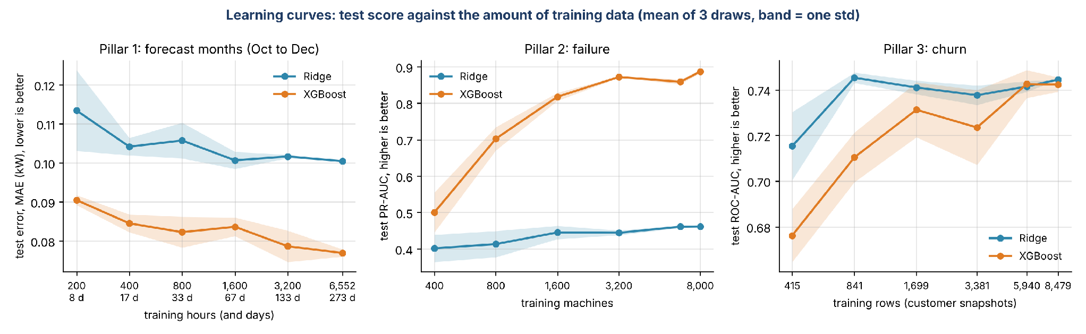
Figure 7.2. Learning curves: test score against the amount of training data
Each point is the mean of three random draws of the training rows, and the shaded band is one standard deviation. The axis for the training size is logarithmic, and each tick is labelled with its value; for demand the tick also gives the training period in days (24 hours = 1 day).
• Demand, forecast months (left): the error of Ridge stays near 0.10 kW from about 400 hours (17 days) up, so it has learned its straight line early. XGBoost starts at 0.09 kW with 200 hours (8 days), gets down to about 0.077 kW with all 6,552 hours (273 days), and keeps improving slowly. It is ahead of Ridge at every size.
• Failure (middle): Ridge gains little, from 0.40 to 0.46 PR-AUC, because its limit is the straight-line form and not the data. XGBoost climbs from 0.50 with 400 machines to 0.89 with 8,000. The curve flattens at the right but has not fully levelled, so more machines would probably help a little.
• Churn (right): Ridge is flat near 0.74 ROC-AUC from about 800 rows. XGBoost starts at 0.68 and reaches the same 0.74 only with about 6,000 rows or more. It never clearly passes Ridge.
The learning curves explain much of what we see in stage 8. The tree models need data to build their splits, and they have enough for failure, where the signal is strong and shaped like thresholds. For churn there is no extra signal beyond what a straight line captures.

7.4 Training the final models
The experiments above fit models on training rows and score them on test rows. The dashboard needs models that have seen all the data, so after the experiments we refit the Ridge and XGBoost models for each pillar on every row and save them in one file. The thresholds for the alerts are taken from the training scores. These models are only used for demonstration in the dashboard. Their scores come from the experiments. Scoring the final refit would be unfair because the model has seen the rows (the retention table in stage 9 says so).

Chapter 8
Model Evaluation and Tuning
Written by Animesh Basak (26911001).

8.1 How we evaluate
Every score in this document comes from data the model did not see during training, and every score is the mean over five seeds with its standard deviation. We do not tune anything on the test data. The tests are described in stage 3 and the training protocol in stage 7. Here we explain the metrics, report the results pillar by pillar, look at the errors, and say what the results mean for the product.

8.2 Pillar 1: demand
Table 8.1 gives the mean absolute error in kW for every model on every test. The reference rules never see the weather, and the other models use the engineered inputs unless noted.
Table 8.1. Mean absolute error (kW) of every demand model on every test
Test | Training mean (rule) | Average by hour (rule) | Linear regression | Ridge, basic | Ridge | Random Forest | XGBoost, basic | XGBoost
Random 20% of hours | 0.942 | 0.934 | 0.096 | 0.182 | 0.096 | 0.066 | 0.065 | 0.065
Unseen months 3, 6, 9, 12 | 1.017 | 0.995 | 0.118 | 0.224 | 0.118 | 0.077 | 0.070 | 0.072
Forecast, months 10 to 12 | 1.012 | 1.024 | 0.101 | 0.242 | 0.100 | 0.083 | 0.085 | 0.076
Heatwave, 40 °C and above | 1.648 | 1.574 | 0.077 | 0.468 | 0.077 | 0.365 | 0.332 | 0.336

The standard deviation over the five seeds is 0.001 to 0.002 kW on the random test, 0.009 or less in the heatwave for XGBoost, and exactly zero for the linear models on the three tests that do not depend on the seed.

Three findings stand out.
First, any model that sees the weather beats the rules of thumb by a factor of ten or more. The average mean power is 1.92 kW, so an error of 0.065 kW is 3.4% of the load, while the rule of thumb is wrong by about half of the load.
Second, trees are better than a straight line in ordinary conditions. XGBoost beats Ridge by 32%, 39% and 24% in the first three tests (Figure 8.4 below). The straight line cannot capture how the relationship bends at the mode switches. The model with basic inputs and Ridge is the weakest, which again shows that the engineered gap is worth having for linear models.
Third, in the heatwave the order reverses. XGBoost is wrong by 0.336 kW and has a negative R squared of -2.28, which is worse than predicting the average of the heatwave hours. Ridge is wrong by 0.077 kW with an R squared of 0.80. Random Forest behaves like XGBoost (0.365 kW).

Where the errors are
Figure 8.1 looks at the heatwave and forecast residuals, meaning actual power minus predicted power.
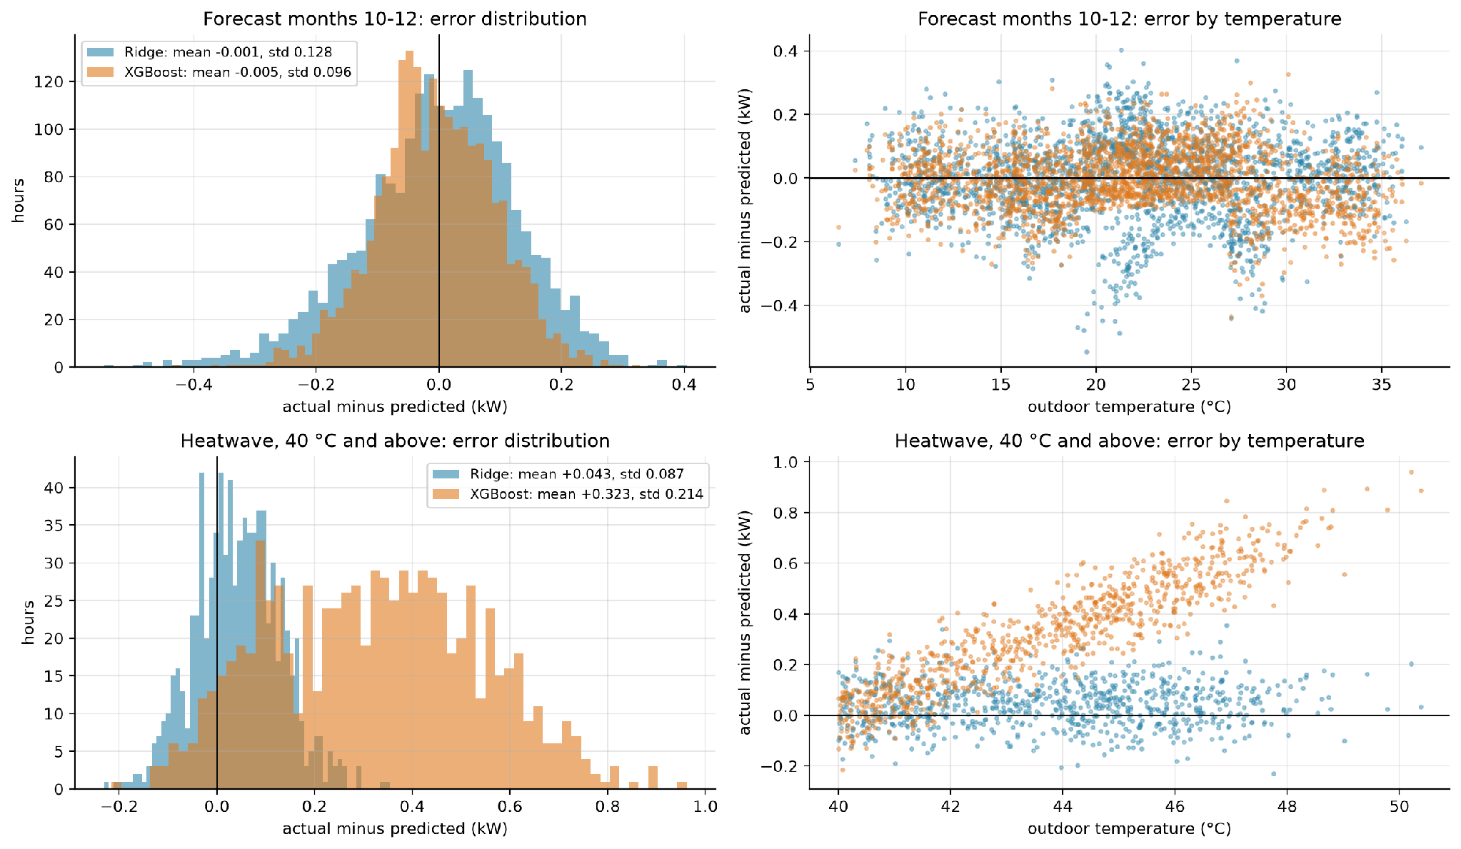
Figure 8.1. Residuals of Ridge and XGBoost in the forecast months and in the heatwave
The top row is the forecast test, months 10 to 12. The left panel is a histogram of the residuals. Both models are centred on zero (mean -0.001 kW for Ridge and -0.005 kW for XGBoost), and XGBoost is narrower, with a standard deviation of 0.096 kW against 0.128 kW. The right panel plots the residual against the outdoor temperature. Ridge shows a slight pattern, with larger negative misses near 20 °C and near 28 °C, which are close to the places where the mode changes. XGBoost has no pattern.
The bottom row is the heatwave test. The residual of XGBoost (orange) has an average of +0.32 kW, so it underestimates the power. The right panel shows why: the residual rises with temperature, from close to zero at 40 °C to 0.8 kW and more near 50 °C. The model stays flat at the highest power it saw in training while the real power keeps rising. Ridge (blue) is centred near zero with a small average of +0.04 kW at every temperature, because it extends the straight line.

8.3 Pillar 2: failure
Table 8.2 gives the mean and standard deviation over five seeds on the 2,000 held-out machines.
Table 8.2. Failure prediction scores on 2,000 held-out machines (mean ± standard deviation over five seeds)
Model | ROC-AUC | PR-AUC | F1 | Precision | Recall | Failures in top 10%
Rule: most worn tool first | 0.655 ± 0.027 | 0.123 ± 0.013 | 0.197 ± 0.011 | 0.158 ± 0.013 | 0.262 ± 0.012 | 0.365 ± 0.024
Logistic regression | 0.930 ± 0.021 | 0.487 ± 0.080 | 0.480 ± 0.059 | 0.457 ± 0.065 | 0.512 ± 0.075 | 0.744 ± 0.069
Ridge, basic inputs | 0.898 ± 0.022 | 0.445 ± 0.050 | 0.470 ± 0.048 | 0.456 ± 0.060 | 0.497 ± 0.085 | 0.662 ± 0.067
Ridge | 0.925 ± 0.021 | 0.492 ± 0.074 | 0.489 ± 0.059 | 0.514 ± 0.088 | 0.471 ± 0.045 | 0.732 ± 0.069
Random Forest | 0.988 ± 0.007 | 0.912 ± 0.037 | 0.887 ± 0.041 | 0.927 ± 0.046 | 0.850 ± 0.041 | 0.941 ± 0.040
XGBoost, basic inputs | 0.980 ± 0.009 | 0.790 ± 0.088 | 0.727 ± 0.094 | 0.726 ± 0.138 | 0.738 ± 0.070 | 0.912 ± 0.039
XGBoost | 0.987 ± 0.007 | 0.893 ± 0.042 | 0.851 ± 0.045 | 0.901 ± 0.039 | 0.806 ± 0.052 | 0.938 ± 0.035

The base rate is 3.4%, so a random guess has a PR-AUC of 0.034. XGBoost reaches 0.89 and Random Forest 0.91. The linear models reach 0.49, which is still ten times better than random but half of what the trees achieve. In the top 10% of machines, XGBoost holds 94% of all failures, against 73% for Ridge, 74% for logistic regression and 36% for the rule of thumb.

Ranking quality
Figure 8.2 shows the ROC curves and the effect of the alert threshold.
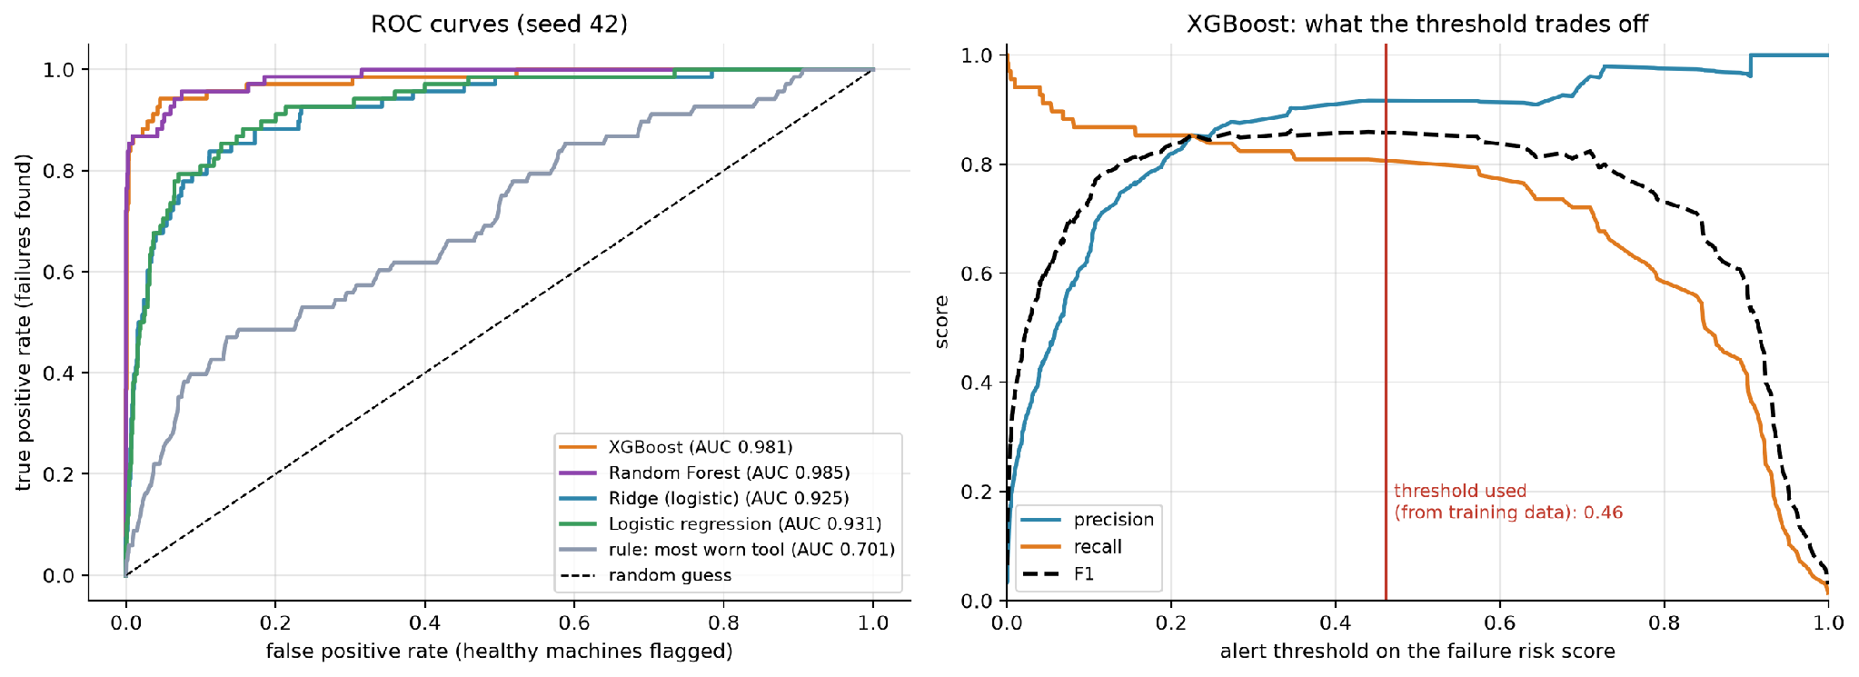
Figure 8.2. ROC curves, and the trade-off at different thresholds
The left panel plots the share of failures found against the share of healthy machines flagged, for every possible threshold. A curve that hugs the top-left corner is better. Random Forest (AUC 0.985) and XGBoost (0.981) rise almost vertically: they find about 85% of the failures before they flag any noticeable number of healthy machines. Ridge (0.925) and logistic regression (0.931) rise more slowly. The rule that sorts by tool wear (0.701) is far from the corner and not much above the diagonal, which stands for random guessing. The right panel follows one model, XGBoost, as the threshold on its risk score moves from 0 to 1. At low thresholds the recall (orange) is high and the precision (blue) is low, since almost every machine is flagged. At high thresholds the opposite happens. The F1 score (dashed) is flat and high between about 0.2 and 0.6, so the result does not depend on a precise threshold. The red line marks 0.46, the value chosen from training data for this seed.

Inspection effort
Figure 8.3 turns the ranking into a statement a manager can use.
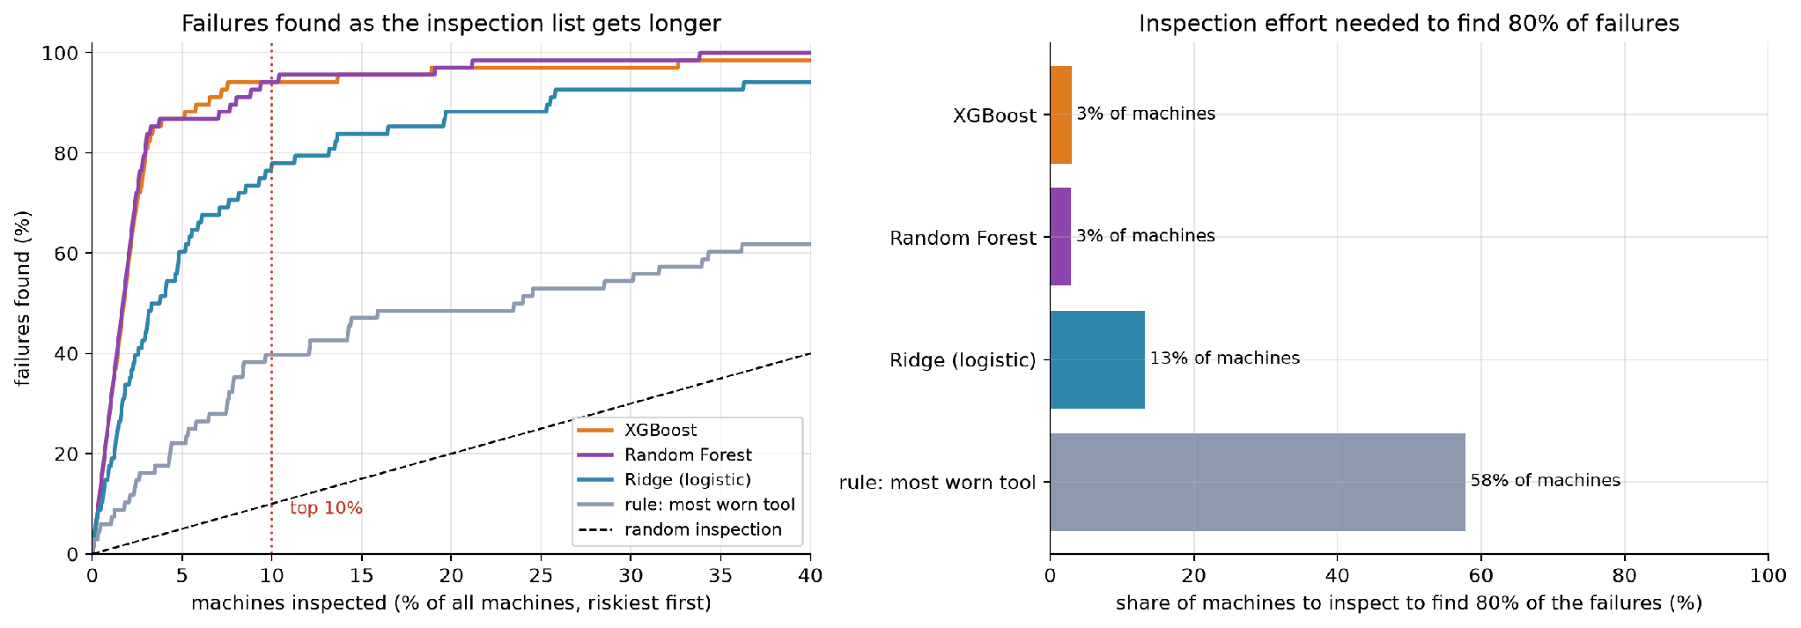
Figure 8.3. Failures found as the inspection list grows
The left panel plots the share of failures found (vertical) against the share of machines inspected (horizontal), riskiest first. The dotted line at 10% shows the top-10% capture that we quote: XGBoost and Random Forest are at about 94% there. The dashed diagonal is a random inspection order. The right panel counts how many machines must be inspected to find 80% of the failures: about 3% of machines with XGBoost or Random Forest, 13% with Ridge and 58% with the most-worn-tool-first rule. The rule needs about 19 times as many inspections as XGBoost to catch the same share of failures.

8.4 Pillar 3: churn
Table 8.3 gives the results on unseen customers in the later period. The test set holds about 360 customers, of whom about 32% lapse.
Table 8.3. Churn prediction scores on unseen customers in the later period
Model | ROC-AUC | PR-AUC | F1 | Precision | Recall | Lapsers in top 10% | Lift
Rule: longest since purchase | 0.607 ± 0.041 | 0.417 ± 0.019 | 0.478 ± 0.022 | 0.318 ± 0.020 | 0.964 ± 0.019 | 0.162 ± 0.017 | 1.63 ± 0.17
Logistic regression | 0.775 ± 0.033 | 0.575 ± 0.049 | 0.608 ± 0.024 | 0.459 ± 0.024 | 0.903 ± 0.019 | 0.197 ± 0.021 | 1.97 ± 0.21
Random Forest | 0.772 ± 0.022 | 0.563 ± 0.035 | 0.595 ± 0.017 | 0.445 ± 0.018 | 0.901 ± 0.030 | 0.201 ± 0.025 | 2.01 ± 0.25
Ridge, basic inputs | 0.750 | 0.547 | 0.593 | 0.476 | 0.788 | 0.187
Ridge | 0.777 | 0.578 | 0.609 | 0.465 | 0.885 | 0.202 | 2.0
XGBoost, basic inputs | 0.749 | 0.529 | 0.590 | 0.491 | 0.741 | 0.178
XGBoost | 0.775 | 0.580 | 0.609 | 0.462 | 0.895 | 0.200 | 2.0

The result is plainer than for failure. Every model with the engineered inputs lands between 0.77 and 0.78 ROC-AUC, and the differences are far smaller than the standard deviation of 0.02 to 0.03. The rule of thumb reaches 0.61. So the model beats the rule clearly (0.78 against 0.61), and complexity buys nothing: logistic regression ties with XGBoost.
In terms of the call list, contacting the 10% of customers with the highest risk reaches 20% of those who lapse, twice as many as a random list (10%) and about 4 points more than the recency rule (16%). This is the weakest of the three results, and we say so in the conclusion.
At its threshold of about 0.35, Ridge flags 211 of 360 customers. It catches 101 of the 118 who lapse (recall 86%) and wrongly flags 110 of 242 who stay (precision 48%). XGBoost catches 105 of 118 (89%) at the cost of 129 false alarms. The thresholds are set by F1 on the training data, which favours recall when lapsing is common, so the lists are long. For a small call budget, the manager should follow the ranking from the top instead of using the threshold, as the Retention List does.

8.5 Tuning
We tuned very little, and on purpose.
What | How it was chosen | On which data
Ridge penalty (alpha, C) | Five-fold cross-validation | Training rows only
Alert threshold | Best F1 on out-of-fold scores | Training rows only
XGBoost settings | Fixed in advance (stage 7) | None
Random Forest settings | Fixed in advance | None
Feature set | Compared basic and engineered | Test scores reported for both
Model per pillar | Tie rule on mean and standard deviation (stage 6) | Test scores of the five seeds

Two caveats apply. First, the choice of model by the tie rule uses the test scores of the five seeds, so a small amount of selection pressure remains. With six candidates and one clear winner in each demand test, we think the effect is small. Second, we did not run a separate validation set, since the data is too small to hold out a third part. An independent check would need data from a real service company.
Stage 7 showed that a wide range of settings gives nearly the same score, so heavy tuning would not change the picture. The one place where more tuning is pointless is the heatwave: more trees, deeper trees or a lower learning rate cannot make a tree predict above its training range.

8.6 Summary of the evaluation
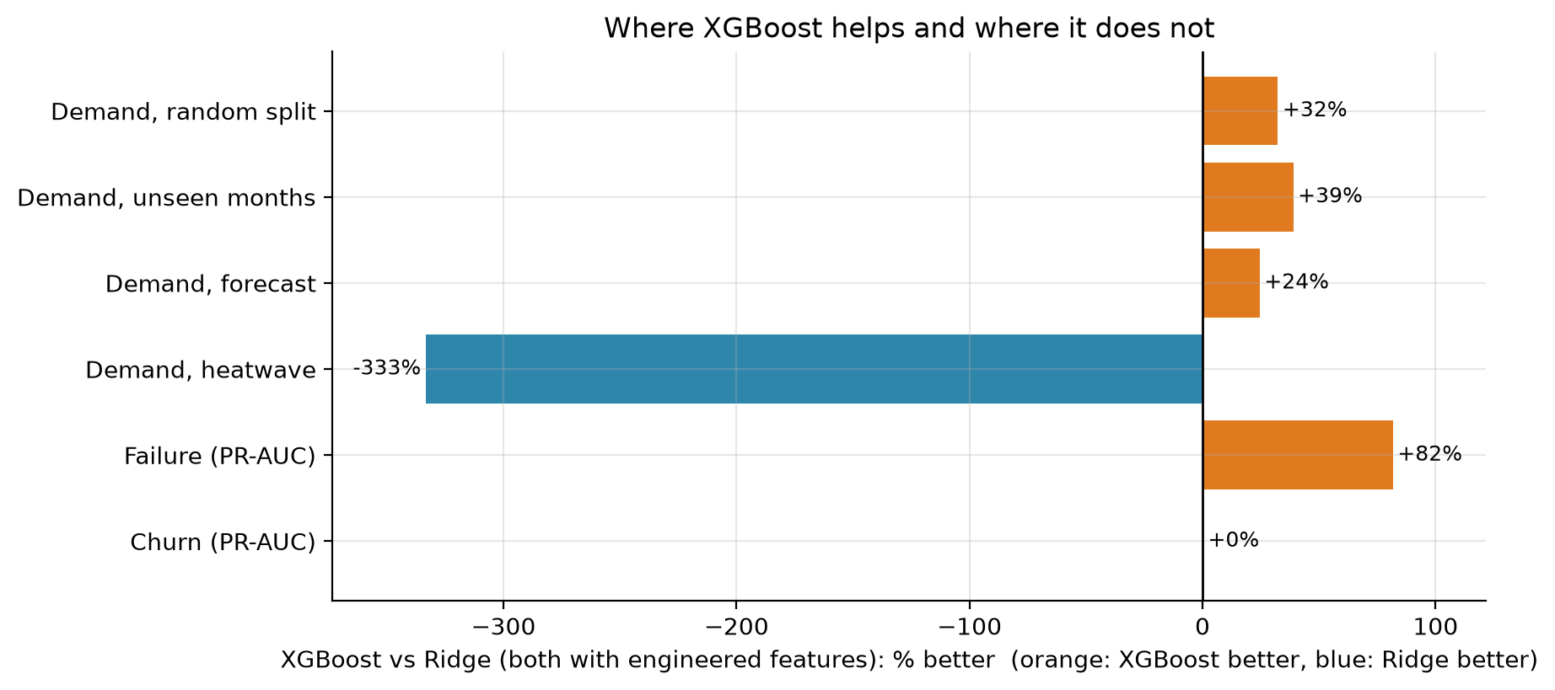
Figure 8.4. Where XGBoost helps and where it does not
Figure 8.4 compares XGBoost with Ridge, both with engineered inputs, as a percentage improvement. XGBoost is better by 32%, 39% and 24% on the first three demand tests and by 82% on failure (PR-AUC). It is 333% worse in the heatwave, where its error is more than four times that of Ridge, and it is the same for churn.
Pillar | Best result on unseen data | Compared with the rule of thumb | Verdict
Demand | MAE 0.065 kW (XGBoost), 0.077 kW in a heatwave (Ridge) | Rule: 0.93 kW and 1.57 kW | Strong, with the heatwave safeguard
Failure | PR-AUC 0.89 to 0.91; 94% of failures in the top 10% | Rule: PR-AUC 0.12 and 36% | Strong
Churn | ROC-AUC 0.78; 20% of lapsers in the top 10% | Rule: ROC-AUC 0.61 and 16% | Real but modest

Chapter 9
Model Deployment
Written by Saurav Kumar Boro (26535026).

9.1 System architecture
Figure 9.1 shows the whole system, from data files to the people who use the results.

System architecture
Data (hvac_ml/data/, 1.7 MB)
hvac_power_consumption.csv
ai4i2020.csv
retail_invoices.csv.gz
Pipeline (python run_all.py, about 10 minutes)
data.py
load and clean
pillar1/2/3 .py
features, models, tests
common.py
models and metrics
plots.py
figures
Saved artifacts (hvac_ml/outputs/)
models/hvac_models.joblib
1.38 MB
results/*.csv and
RESULTS_SUMMARY.md
figures/*.png
run_log.txt
Application and checks
app.py (Streamlit)
Demand Planner
Failure Radar, Retention List
monitoring.py
drift and error checks
tests/ (17 checks)
run with pytest
read by
writes
loaded by
users: dispatch manager, maintenance lead, customer-success team
Figure 9.1. System architecture
The picture has four layers, read from top to bottom. The grey boxes are the three data files, 1.7 MB in all. The blue boxes are the pipeline, the programs that clean the data, build features, train and test the models, and draw the figures. A full run takes about ten minutes. The green boxes are what the pipeline writes: the saved models in a single file of 1.38 MB, the result tables, the figures and a log. The orange boxes are the programs that use these results: the dashboard, the monitoring checks (stage 10) and the automated tests. The users at the bottom are a dispatch manager, a maintenance lead and a customer-success team.
The design keeps training and serving apart. The pipeline can be run again at any time and produces a fresh models file. The dashboard only reads that file and the data. It never trains anything while a user waits, so every click is answered in a few milliseconds (1.4 to 2.4 ms per single prediction).

9.2 The three tools

Tool 1: Demand Planner
The manager sets the month, the indoor setpoint, the humidity and the lowest and highest outdoor temperature of the day. The program builds a smooth temperature curve for the 24 hours, with the coolest hour at 05:00 and the hottest at 15:00, and works out the HVAC mode for each hour. It builds the model inputs for each hour and asks both models for a prediction. The tool shows the planned demand curve, the peak demand and the hour at which it occurs, the total energy for the day, and the number of hours that used the heatwave safeguard. The safeguard is explained in section 9.3.
Figure 9.2 shows the output for two days.
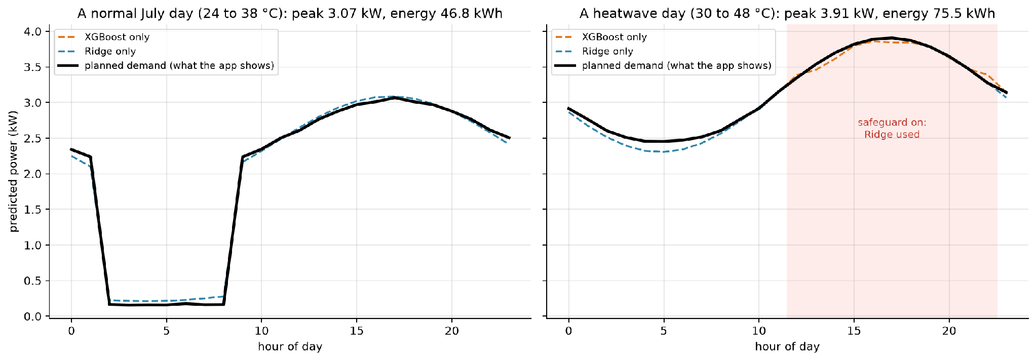
Figure 9.2. Demand Planner output for a normal July day and for a heatwave day
The left panel is a normal July day with temperatures from 24 to 38 °C. The black line is the planned demand: it falls to about 0.2 kW in the early hours, when the outdoor temperature is in the idle band, and rises to a peak of 3.07 kW in the late afternoon. The dashed orange and blue lines are the XGBoost and Ridge predictions alone, and they agree closely. The day's energy is 46.8 kWh. The right panel is a heatwave day from 30 to 48 °C. From about 11:00 to 22:00 the temperature is above 40 °C, which the pink band marks, and the planner uses the Ridge model there. The peak is 3.91 kW and the daily energy is 75.5 kWh. On this day the two models still agree closely, because the temperatures stay inside the range seen in training, but they would drift apart for temperatures above 50 °C, which is why the safeguard uses the range as well as the 40 °C line.

Tool 2: Failure Radar
The maintenance lead enters one machine's readings (type, air and process temperature, speed, torque and tool wear) and sees its risk of failure as a percentage, whether it is above the alert threshold (44% for XGBoost), and how it compares with the 10,000 machines in the dataset. A table lists the riskiest machines in a random sample of 500, and a caption says how many of the actual failures in the sample the top 10% would catch. Table 9.3 shows that table.

Table 9.3. Failure Radar: the riskiest machines in a sample of 500
Product ID | Type | Torque (Nm) | Speed (rpm) | Tool wear (min) | Risk (%) | Alert | Actually failed
L51822 | L | 54.6 | 1238 | 226 | 99.6 | inspect | yes
L49778 | L | 67.5 | 1320 | 20 | 96.4 | inspect | yes
M20475 | M | 71.3 | 1257 | 122 | 96.0 | inspect | yes
L53705 | L | 73.6 | 1312 | 49 | 95.2 | inspect | yes
L51800 | L | 52.6 | 1336 | 172 | 94.6 | inspect | yes
M19287 | M | 48.9 | 1379 | 107 | 94.1 | inspect | yes
L51801 | L | 51.0 | 1341 | 174 | 94.1 | inspect | yes
M23874 | M | 61.3 | 1340 | 207 | 93.6 | inspect | yes
M21659 | M | 12.2 | 2636 | 100 | 93.0 | inspect | yes
L51724 | L | 55.1 | 1349 | 187 | 92.7 | inspect | yes
L48763 | L | 61.0 | 1310 | 189 | 89.7 | inspect | yes
L54939 | L | 59.2 | 1272 | 198 | 89.4 | inspect | yes

Each row is a machine, with its identifier, type, torque, speed and tool wear, the risk the model gives it, whether it passes the alert threshold, and, for illustration, whether it did fail. All twelve machines shown have risks from 89% to 100% and all did fail. The model was trained on all 10,000 machines, so this list demonstrates the tool. The held-out scores are in stage 8.

Tool 3: Retention List
The customer-success team chooses how many customers they can contact, from 10 to 200. The tool lists the active customers with the highest risk of buying nothing in the next 90 days, with each customer's risk, days since the last order, number of orders, spend and recent orders. A caption says what share of the customers who really lapsed this list would reach, and compares it with random contact.

9.3 The heatwave safeguard
The Demand Planner does not trust XGBoost everywhere. Figure 9.4 shows the rule.

Demand Planner: how the heatwave safeguard picks the model for each hour
Weather forecast
for the day
(24 hourly temperatures)
Build the model
inputs for each hour
outdoor temperature
>= 40 °C, or outside
6.1 to 50.4 °C?
Ridge model
(extends the trend)
XGBoost model
(most accurate in normal weather)
yes
no

Figure 9.4. How the safeguard chooses the model for each hour
For each hour the program checks the outdoor temperature. If it is at or above 40 °C, or outside the range of temperatures seen in the training data (6.1 to 50.4 °C), the hour is predicted by Ridge. Otherwise it is predicted by XGBoost. The reason is the result in stage 8: on the heatwave test Ridge is off by 0.08 kW on average and XGBoost by 0.34 kW, because trees stay flat beyond the temperatures they were trained on. The planner shows both curves and says how many hours used the safeguard, so the manager can see that the switch happened. A warning text appears whenever it is used.
The switch has a visible cost: at the boundary, the two models may predict a little differently, and the curve can have a small step. We accepted this because a visible step is better than a hidden error of 0.3 kW or more.

Chapter 10
Monitoring and Maintenance
Written by Saurav Kumar Boro (26535026).

10.1 The monitoring loop
Figure 10.1 shows the routine as a cycle.

The monitoring loop
1. New data arrives
(weather, readings, invoices)
2. Input drift check
PSI and KS test per input
3. Score and log predictions
4. Outcomes arrive
(real power, failures, purchases)
5. Error and rate check
MAE, calibration
6. Decide:
ok, warning, alert
warning: look at the cause
alert: retrain or switch to the safe model
Figure 10.1. The monitoring loop
The loop has six steps. New data arrives (1), whether weather, sensor readings or invoices. An input drift check compares it with the training data (2). The model scores it and the prediction is logged (3). Later the real outcome arrives, such as the measured power, the failure record or the purchases of the next 90 days (4). An error and rate check compares the predictions with the outcomes (5). The last step is a decision (6): everything is fine, or a warning says to look at the cause, or an alert says to retrain or switch to the safe model. The cycle then starts again with the next batch of data.
Checks 2 and 5 are separate on purpose. The input check needs no outcome, so it can be run the moment new data arrives, and it warns early. The error check needs the real outcome, so it comes later, and it is the final proof of whether the model works.

10.2 The checks we built

Check 1: input drift with PSI and the KS test
The Population Stability Index (PSI) compares the distribution of one input in new data with its distribution in the training data. We cut the training values into ten bins of equal size and count what share of the new data falls in each bin. If the shares match, the PSI is near zero. If new data piles up in a few bins, it grows. The usual reading is below 0.10 for a stable input, 0.10 to 0.25 for a moderate shift and above 0.25 for a large shift. We use those thresholds. The Kolmogorov-Smirnov (KS) test is a second view: it gives the largest gap between the two cumulative distributions and a p-value. We also report how far the mean has moved, in units of the training standard deviation.

Check 2: error against the tested error
For demand, we compute the mean absolute error of each new month and divide it by the error measured in testing, 0.065 kW. A ratio of 1.5 or more is a warning, and 2.0 or more is an alert.

Check 3: rate against the observed rate
For failure and churn, we compare the share of cases the model flags, and its average predicted probability, with the share that really turned out positive. A gap of 0.10 is a warning and a gap of 0.20 is an alert.
Checks 1 and 2 are implemented as functions, and tested by three automated tests, which check that the PSI is small for the same distribution and large for a shifted one, that the drift table flags the column that moved, and that the error ratio maps to the right status. Check 3 is implemented as a function that returns the numbers. The 0.10 and 0.20 thresholds for it are applied by hand for now.

10.3 Alert rules
Table 10.2 lists the rules and the action that follows.

Table 10.2. Alert rules
Check | What is measured | Warning at | Alert at | Action
Input drift | PSI of each model input | >= 0.10 | >= 0.25 | check the data source; refit if it persists
Demand error | monthly MAE vs 0.07 kW tested | >= 1.5x | >= 2.0x | refit on the newest months; check sensors
Heatwave safeguard | hours above 40 °C using Ridge | any | error >= 2x 0.08 kW | extend the Ridge range; review features
Failure ranking | failures found in top 10% (tested 94%) | < 85% | < 70% | refit with the new failures; review sensors
Churn calibration | predicted vs actual lapse rate | gap > 0.10 | gap > 0.20 | refit on the latest cutoff; re-set the threshold

Each row is one check. The columns give what is measured, the level that triggers a warning, the level that triggers an alert and what we do. The five checks are input drift, demand error, the heatwave safeguard, the failure ranking and the churn calibration. The failure ranking check uses the 94% top-10% capture found in testing: a fall below 85% warns and a fall below 70% is an alert. The heatwave safeguard check watches the hours above 40 °C that used Ridge: any use is noted, and an error of 0.16 kW or more on those hours (twice the tested 0.08 kW) is an alert that the Ridge range needs extending.

10.4 How the checks behave on our data
We ran the checks on the project data, as a rehearsal of what they would do on live data.

Input drift
Figure 10.3 shows the PSI of the main inputs in three comparisons.
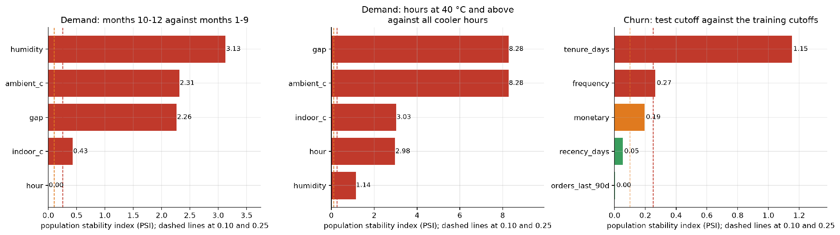
Figure 10.3. Input drift in three comparisons
Each bar is one input and its colour shows the status: green is stable, orange is a warning and red is an alert. The two dashed lines are the 0.10 and 0.25 thresholds.
• Demand, months 10 to 12 against months 1 to 9 (left): humidity (PSI 3.13), outdoor temperature (2.31), the temperature gap (2.26) and indoor temperature (0.43) all alert. Only the hour of day is stable. The reason is the season: autumn weather is not like the average of the first nine months. This is a useful lesson. A drift check that compares a new month with the whole of the training period will fire every season. In production the comparison should be with the same season in the previous year, or with the training data from the same months.
• Demand, heatwave hours against cooler hours (middle): the PSI of the outdoor temperature is 8.3 and that of the gap is 8.3. This is the drift we expected, since the heatwave hours were defined by the temperature. The check would have flagged the heatwave before the model failed, which is the purpose of an input check. The alert on these inputs is the reason for the safeguard.
• Churn, test cutoff against the training cutoffs (right): tenure drifts strongly (PSI 1.15), because customers are a year older at the later cutoff. Frequency alerts (0.27), spend gives a warning (0.19), and recency (0.05) and recent orders (0.003) are stable. A growing customer base is expected to look older, and the alert means that tenure needs a new training window; it does not mean the model is wrong. The churn scores in stage 8 were nevertheless steady.
The lesson is that PSI tells us when the inputs have moved. It does not say whether the model is hurt. That is the job of the error check.

Chapter 11
Results and Discussion

11.1 The results on one page
The table below collects the headline result of each pillar, next to the rule of thumb that a company could apply today. All numbers come from data the models did not see and are means over five seeds.
Pillar | Measure | Rule of thumb | Statistical baseline | Ridge | XGBoost | Best result
Demand, ordinary weather (forecast test) | Error in kW, lower is better | 1.02 | 0.101 | 0.100 | 0.076 | XGBoost
Demand, heatwave | Error in kW, lower is better | 1.57 | 0.077 | 0.077 | 0.336 | Linear models
Failure | PR-AUC, higher is better | 0.123 | 0.487 | 0.492 | 0.893 | Random Forest 0.912, XGBoost close
Failure | Failures found in the top 10% | 36% | 74% | 73% | 94% | Random Forest and XGBoost
Churn | ROC-AUC, higher is better | 0.607 | 0.775 | 0.777 | 0.775 | All four models tie
Churn | Lapsers found in the top 10% | 16% | 20% | 20% | 20% | All four models tie

The statistical baseline is ordinary linear regression for demand and logistic regression for failure and churn. The rule of thumb is the average by hour of day for demand, the most worn tool first for failure and the longest time since the last purchase for churn.

11.2 What the results tell us
- Using the weather beats ignoring it by a wide margin. For demand, every model that sees the temperature has an error around 0.1 kW or less, while the rule that ignores it is wrong by about 1 kW, which is half of the average load. The same is true for failure: a ranking built from the sensor readings finds more than twice as many failures as the most-worn-tool rule.
- the best model depends on the question. XGBoost is the best choice in ordinary weather and for failure. A linear model is the only safe choice beyond the training range, as the heatwave test showed. In churn, the simplest model is as good as any. A group that had chosen XGBoost for everything would have a good dashboard on most days and a wrong forecast on the hottest days, which are the days that matter. A group that had chosen Ridge for everything would have had a failure PR-AUC of 0.49 instead of 0.89.
- Third, engineered inputs matter most for the simple models. The absolute temperature gap halves the error of Ridge in demand and removes almost all of its heatwave error. Trees find the same shape on their own. A feature that is based on the physics of the problem is therefore cheaper than a more complex model.
- the metric decides what looks good. If we had scored the failure model by accuracy, a model that never raises an alarm would have scored 96.6%. By PR-AUC and top-10% capture, it scores almost nothing, as it should.
- small test sets give wide error bars. The churn test holds about 360 customers and the failure test 68 failures, and the five seeds disagree by several points on them. The tie rule, which treats gaps below one standard deviation as equal, kept us from reading too much into those differences.

Chapter 12
Conclusion and Recommendation

12.1 Conclusion
We set out to show how machine learning could help an HVAC service provider such as Aire Serv with three weekly decisions: planning for demand, choosing which machines to inspect and choosing which customers to call. We built a dashboard with one tool for each decision and tested the models behind them on data they had never seen.
The work answered the question for our three public stand-in datasets. Predicting hourly power from the weather is easy for a model that sees the weather, and the question is only how far the model can be trusted when the weather leaves the range of the training data. Ranking machines by failure risk is where machine learning adds the most: the best models find 94% of failures in the 10% of machines they rank highest. Predicting which customers will go quiet is the hardest of the three, and a simple model is as good as a complex one.
We also learned some things about the process. A test that matches the real use, such as forecasting the last three months or predicting a heatwave, tells us more than a random split. A baseline from statistics and a rule of thumb keep the comparison fair. The best model changes in accordance with the scenario and it’s our decision where a simpler model beats a more complex model.

12.2 Recommendation
We recommend that an HVAC service provider adopt the three tools in this order and under these conditions.
1. Start with the Failure Radar. Use XGBoost (Random Forest is equally good in our tests) to rank machines by failure risk, and inspect from the top of the list down to the capacity of the team, without relying on a single alert threshold. In testing, inspecting the top 10% finds 94% of failures against 36% for the most-worn-tool rule. Before relying on it, retrain on the company's own sensor and failure records, since our data describe machine tools.
2. Then use the Demand Planner, always with the heatwave safeguard. Use XGBoost in ordinary weather and switch to Ridge regression for hours at or above 40 °C and for temperatures outside the range seen in training. Never use XGBoost alone for planning peak load. Retrain before each cooling season on data from the company's own buildings.
3. Treat the Retention List as a low-cost aid. Use a simple penalised logistic regression (Ridge) to rank active customers, and expect about twice the hit rate of random calling. Do not spend on a more complex model until richer data, such as product categories or service contracts, are available.
4. Run the monitoring routine from the first day. Check input drift each month, compare the demand error with the tested 0.065 kW each month, and compare predicted and actual churn each quarter. Refit the demand model before and after the cooling season, the churn model each quarter and the failure model after 100 new logged failures.
This recommendation depends on the pilot. The scores in this report are from public stand-in data, and a service provider should confirm the gains on its own records before changing how it works. A reasonable pilot is a four-week side-by-side run, in which the tools produce lists and the current process continues, and the two are compared at the end.

Chapter 13
Limitations and Future Work

13.1 Limitations
• None of the three datasets comes from an HVAC service company. The demand file looks simulated, the failure file is synthetic and describes machine tools, and the purchase file is from an online gift shop. The method transfers; the scores may not.
• The demand data covers one building for one year. We cannot say how the models behave in another climate, and the heatwave test is one kind of extrapolation.
• The churn definition (no purchase in 90 days) suits a shop. A service company would define churn from contract renewals or missed visits.
• The churn test set is small, about 360 customers, so its scores have wide error bars.
• The models choose among six candidates using the same test scores that we report, so a small optimistic bias remains.
• The monitoring checks ran on stored data. We have no live system that logs predictions and outcomes.

13.2 Future work
Six directions follow from the limits above.
• Real company data. Retrain and re-test all three pillars on an HVAC provider's own records: building meter readings for demand, unit sensor logs and service tickets for failure, and contract renewals for churn. The four-week side-by-side pilot in chapter 12 is the first step.
• Forecast weather as input. The demand tests use the measured temperature, while in use the planner receives a forecast. The next test should feed the model forecast temperatures and measure how much the forecast error adds to the 0.065 kW.
• A smoother safeguard beyond the training range. The planner now switches to Ridge at 40 °C. A residual hybrid, in which Ridge captures the trend and XGBoost learns only Ridge's errors, avoids the switch; in an early test it reached 0.069 kW in the heatwave, against 0.077 kW for Ridge and 0.336 kW for XGBoost.
• Richer churn signals. Every churn model stops at about 0.78 ROC-AUC, which points to missing information in the data. Product categories, service visits, complaints and contract dates would add it, and a survival model could also predict when a customer is likely to lapse.
• Cost-based alert thresholds. The failure and churn thresholds now maximise F1. A company could set them from the cost of an inspection or a call against the cost of a missed failure or a lost customer.
• A live system. Log every prediction and outcome, run the drift and error checks automatically each month, retrain on a schedule, and add a login and a live data feed to the dashboard.

References and Data Sources

Data sources
1. felixpradoh (Kaggle user). HVAC Power Consumption (hourly, 2025). Kaggle. https://www.kaggle.com/datasets/felixpradoh/hvac-power-consumption
2. Matzka, S. (2020). AI4I 2020 Predictive Maintenance Dataset. UCI Machine Learning Repository, dataset 601. https://archive.ics.uci.edu/dataset/601/ai4i+2020+predictive+maintenance+dataset
3. Chen, D. (2019). Online Retail II. UCI Machine Learning Repository, dataset 502. https://archive.ics.uci.edu/dataset/502/online+retail+ii

Methods and software
4. Hoerl, A. E., and Kennard, R. W. (1970). Ridge regression: biased estimation for nonorthogonal problems. Technometrics, 12(1), 55-67.
5. Breiman, L. (2001). Random forests. Machine Learning, 45(1), 5-32.
6. Chen, T., and Guestrin, C. (2016). XGBoost: a scalable tree boosting system. Proceedings of the 22nd ACM SIGKDD International Conference on Knowledge Discovery and Data Mining, 785-794.
7. Pedregosa, F., et al. (2011). Scikit-learn: machine learning in Python. Journal of Machine Learning Research, 12, 2825-2830.
8. Saito, T., and Rehmsmeier, M. (2015). The precision-recall plot is more informative than the ROC plot when evaluating binary classifiers on imbalanced datasets. PLOS ONE, 10(3), e0118432.
9. Siddiqi, N. (2006). Credit Risk Scorecards: Developing and Implementing Intelligent Credit Scoring. Wiley. (Population Stability Index and its usual thresholds.)
10. Streamlit documentation. https://docs.streamlit.io
11. Matplotlib, pandas, NumPy and SciPy documentation, used for figures, tables and the Kolmogorov-Smirnov test.

Course material
12. CSC-505 Machine Learning, Department of Computer Science and Engineering, IIT Roorkee. Lecture notes and project guidelines.

