Name- Apoorv Bhadoriya

Course- M.Tech (Mechatronics)

Batch- 2015-17

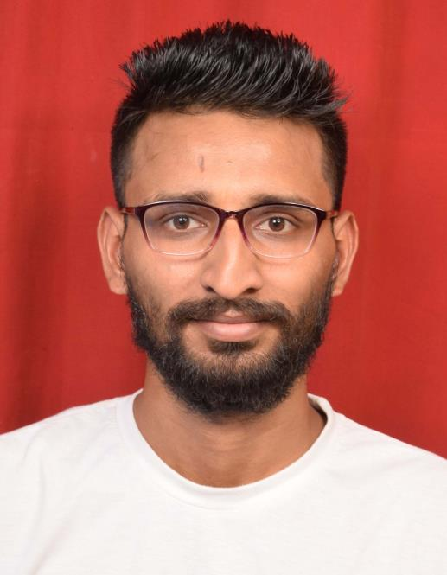

Name: Navinder Singh Bhamra

Masters in Mechatronics (2015-2017)

Roll no. 1510508

PDPM IIITDM Jabalpur, MP.

Currently (from July 2017):

Research Scholar (Ph.D.)

Dept. Of Ocean Engineering and Naval Architecture,

IIT Kharagpur, W.B.



JICA Scholarship: INNOVATIVE INDIA

BATCH2013 IIIT DM

Rohit Bhardwaj : MS, Mechanical Engineering, Toyohashi Uni. of Technology.



JICA Scholarship: INNOVATIVE INDIA

BATCH2013 IIIT DM

Gaurav Pandey: MS, Mechanical Engineering, Toyohashi University of

Technology,

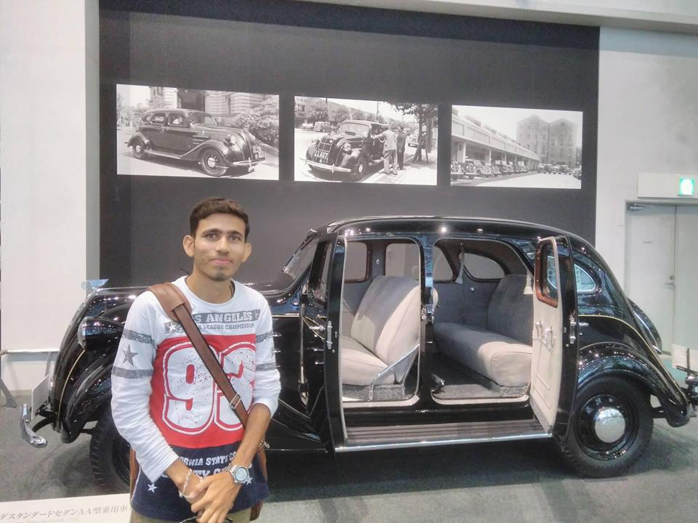

Sudhir vishal

Batch mtech 2015 mechanical (cad/cam)

Current details : PhD from IIT KHARAGPUR

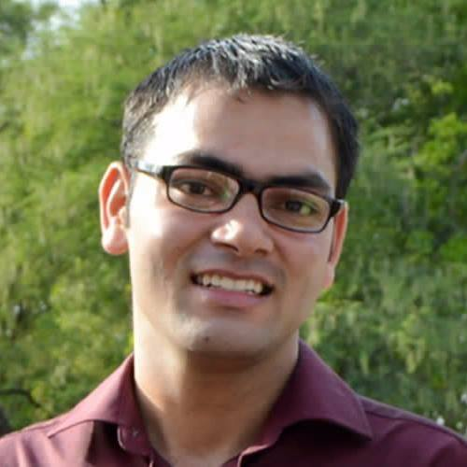

Org: Dell EMC

Current Pos: Software Engineer 2

Batch: 2012

Branch : CSE

