**TABLE OF CONTENTS**

Background 2

Objectives 3

Requirements: 4

System Features: 4

Background Information: 4

Response Sequences: 5

* 1. Register: 5
  2. Login: 6

Workspace Management: 7

Action/Filters on item/s: 8

Non Functional Requirements 10

Fig: Use Case Diagram 11

Analysis Model: 12

Context Model 12

Data Flow Diagram(DFD) 13

Entity Relationship Diagram(ERD) 14

Interface Design: 15

Prototypes: 15

Dashboard: 15

Add: 16

Search: 17

Sequence Diagram: 18

# Background

This software project is intended to be used as an inventory management software for laboratories present in the Electronics and Computer Department section as well as the ICT building in Pulchowk Campus, Lalitpur. This project is developed with the sole focus of proper management of the products, devices and other inventories present in the department for efficient lab operations. This project will ensure proper labeling of products, populating the system, defining storage space and locations and characterizing each collection with its present working status. All the lab inventories are classified according to their location as buildings, floors and rooms and are divided according to their types and model numbers. This software is useful for product categorization, product measurement, recording product history, product cost, inventory tracking by serial numbers, model number and other important IDs as well as reviewing the status of products. This software is in the form of web app containing a proper database management structure with the ability to create, read, update, and delete records with secure authorization system.

# Objectives

* Categorizing products according to their location on the basis of building, floors and rooms.
* Labeling of products with serial numbers and model numbers.
* Keeping records of number of products, their cost and date of acquirement.
* Reviewing the status of products and their current working condition
* Alerting the software admin if there is a shortage of any product or is out of order and providing a separate field for enlisting such products that require immediate order or replacement as per need.

# Requirements:

## System Features:

In this subsection, we will examine the features of the system in detail by categorizing them according to their functionality. For each feature we will give introduction, purpose, diagram and response sequence. Introduction part will give basic background about this feature. After that we will show a diagram for the feature representing the flow of events.

User Authentication:

## Background Information:

Product will be used via workspace. There will two types of user: Department and Ictc. Each user will have his own workspace and must be logged in server to access to his workspace. Hence, first time users must complete the registration process. To be registered into the system user must specify some information asked during the registration. After validation, registration is completed, and user is notified.

There will be login page so that user can type into his login information, and login to the system. Login information will be username and password specified during the registration process. Server let through the user if the given username and password are matched with the ones in the database saved in registration. If specified information is not matched, an error dialog will be shown. Otherwise, user will be redirected to his personal workspace.

When user forgets his password, he can request new one from the system by specifying his username.

## Response Sequences:

## 

### Register:

Description

|  |  |
| --- | --- |
| Primary Actor | User: Department or Ictc |
| Goal in context | Purpose of this feature is to register user into the system. |
| Trigger | User wants to register to the system. |

Normal Flow of Events

1. User opens the registration page on selecting the type of user (Department Or ICTC).
2. User specifies his information.
3. System validate the specified information.
4. User is registered to the system.

Alternative Event Flow 1

1. User cannot be registered into the system due to inappropriate information.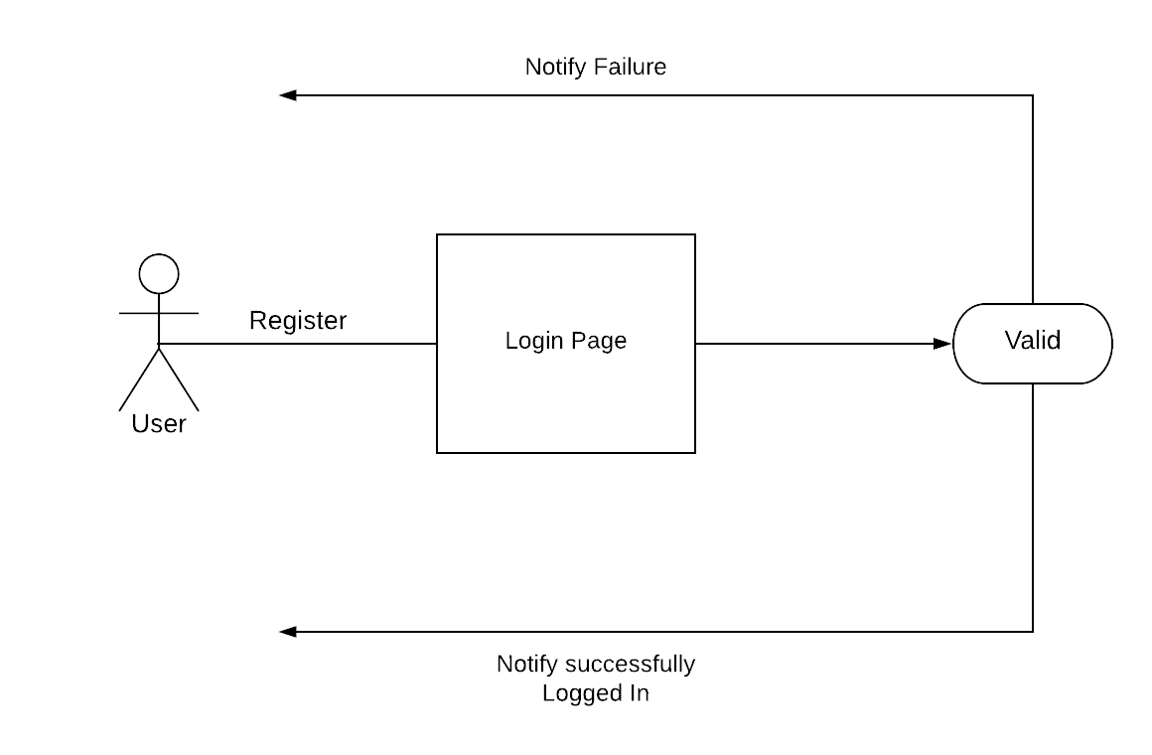

### Login:

Description:

|  |  |
| --- | --- |
| Primary Actor | User |
| Goal in context | Purpose of this feature is to login to the system with user credentials in order to use the system. |
| Trigger | User wants to login to the system. |

Normal Flow of Events

* 1. User opens the login page.
  2. User tries to login to the system with his credentials
  3. System validate the specified information
  4. User is logged into the system

Alternative Event Flow 1

* 1. User cannot log into the system due to incorrect credentials

### Workspace Management:

Background Information:

A workspace is a logical collection of projects. User can manage his projects within his workspace. User can add new item, remove existing items and can also see total products, out of order products and in maintenance products.

There may be different kinds of items, and depending upon the need of information of certain kind of item a add form will be displayed. User must fill up the necessary information I.e he/she must fill up the information fields of that item to fully add the item into the database.

After registration of users, a private workspace will be available for him. Workspace will be accessed by workspace owner with full access.

Response Reaction:

Diagram

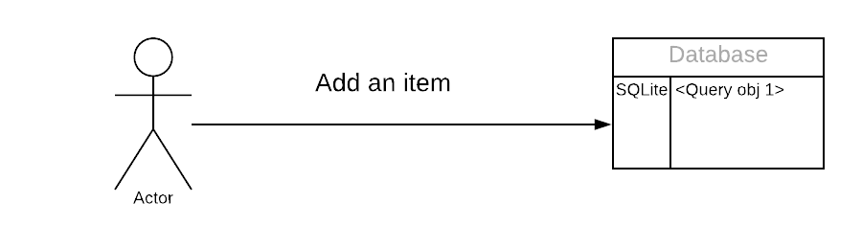

Description:

|  |  |
| --- | --- |
| Primary Actor | User |
| Goal in context | Purpose is to add new item/s into database |
| Preconditional | User must be logged into the system |
| Trigger | User wants to add item/s |

Normal Flow of Events:

* 1. User logins to the system.
  2. User opens his workspace.
  3. User adds and saves item/s into database.

## Action/Filters on item/s:

Background Information:

Authenticated user can view the items according to the filters provided on the page. Filters are on the basis of room, floor, or type of item. User can view the item/s information of the specific room of specific floor by setting the required filters. Example: User wants to know number of computers in room 5 of second floor. S/he just have to select second floor followed by room 5 (filter options are provided in the left side of the page). Then select the required item; in our case it is to see computer’s information.

Further actions like edit/delete on item/s is also one of the functions provided by this software. User can apply this functionality by selecting the specific item. Here, if user wants to edit the information of item printer. S/he must select item printer first, then select the edit option. A form of that item will be rendered provided that previous information will be displayed there and user can edit the latest or required information.

Response Reaction:

Diagram: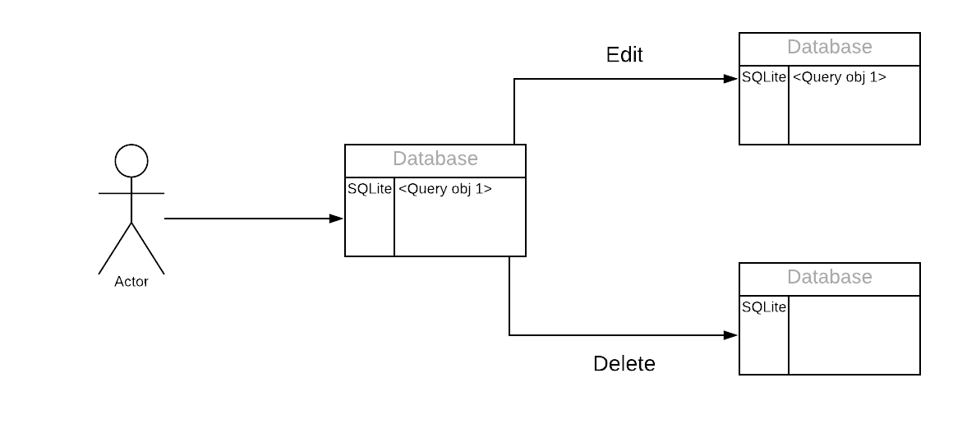

Description:

|  |  |
| --- | --- |
| Primary Actor | User |
| Goal in context | User wants to edit/delete item/s |
| Precondition | User must be logged into the system |
| Trigger | User sets item/s information as his requires. |

Normal Flow of Events:

1. User logs into the system.
2. User selects the required item, setting up the filters.
3. User performs the actions: edit or delete on item/s as per need.
4. User saves the new (if new) into the database.

Functional Requirements:

1. The system shall have registration page.
2. The system shall have login page.
3. The system shall support adding new item/s feature.
4. The system shall support edit or delete functionality on past saved items.

## 

## Non Functional Requirements

A non-functional requirement refers to the requirements used to judge the system operation rather than its specific behaviours. The non-functional requirements of the Lab Inventory System are as follows:

• Data Integrity and Retention: The software must preserve the data and maintain its integrity over its entire life cycle.

• Efficiency: The software must be efficient in its operation.

• Maintainability: The software must be easy to maintain with minimal technical knowledge.

• Modifiability: The software functions must be easy to modify as per the needs.

• Operability: The software must be easy to be kept safe and working for its entire life cycle.

• Quality: The software must be qualitative and aesthetically pleasing for the user. All bugs and kinks in the program must be removed.

• Reliability: The software must be reliable and not break down at any time.

• Response time: The software must react immediately upon any given input.

• Upgradability: The software must be easy to upgrade if the needs of the software expand.

• Usability: The software must be easy to use. Maintenance of the software must be easily learned by the user.

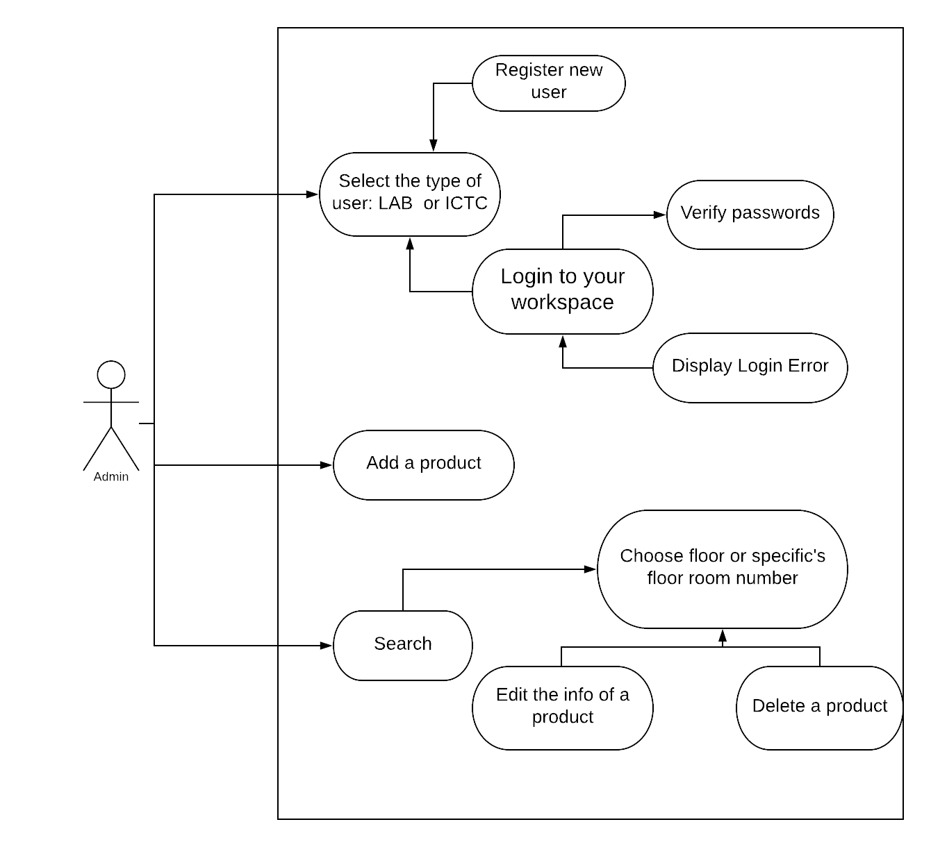

## Fig: Use Case Diagram

## 

# Analysis Model:

## Context Model

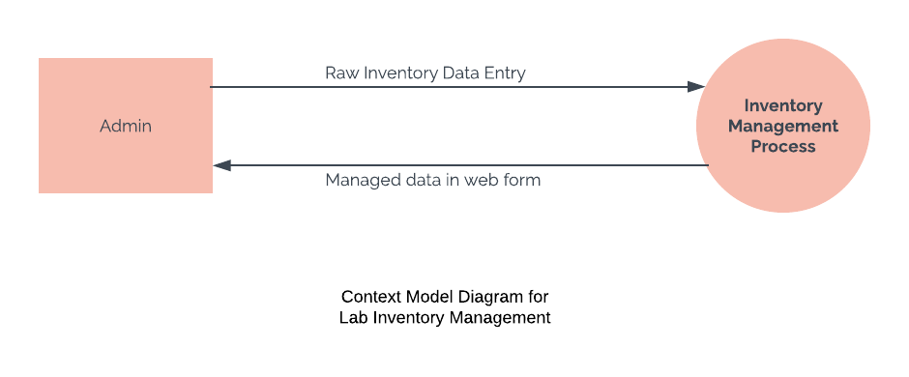

## Data Flow Diagram(DFD)

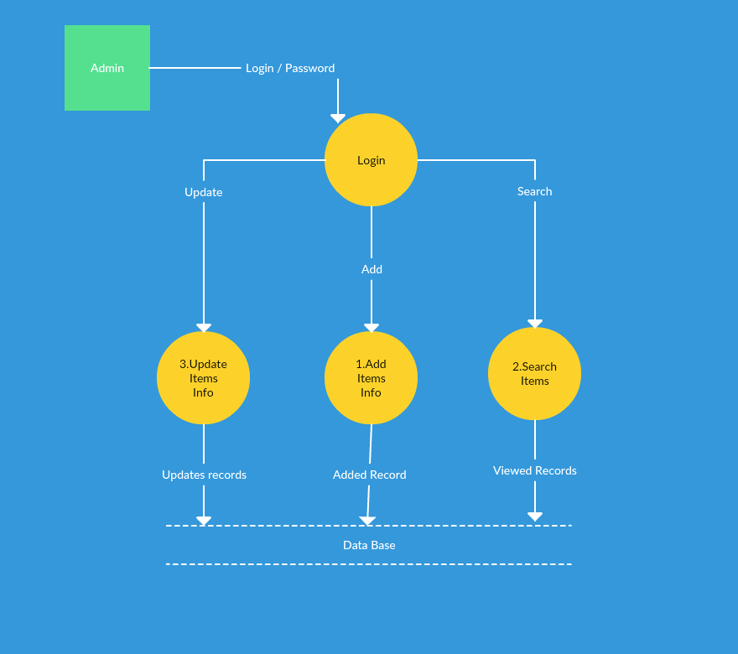

## Entity Relationship Diagram(ERD)

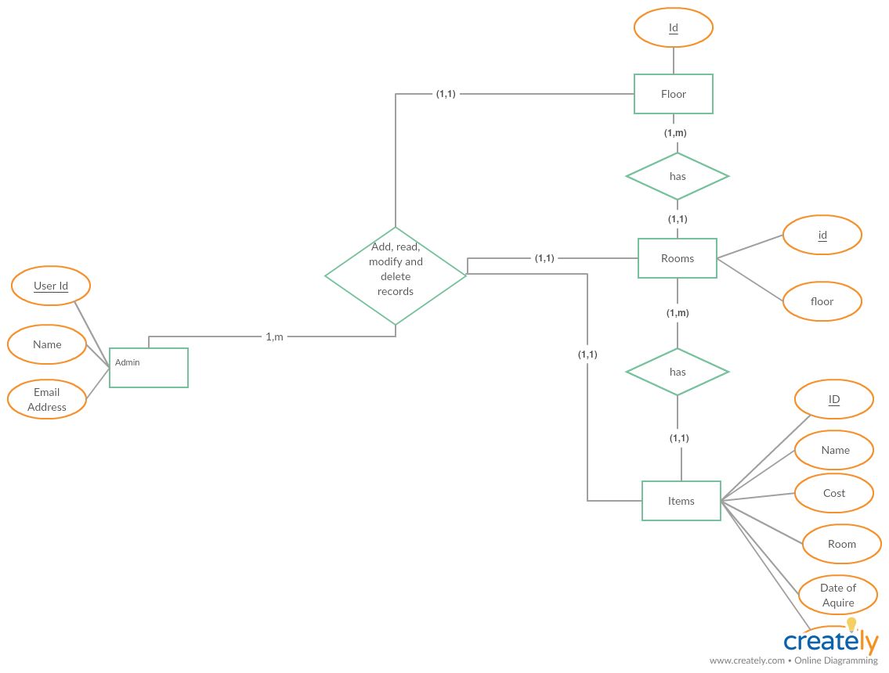

# Interface Design:

## Prototypes:

### Dashboard:

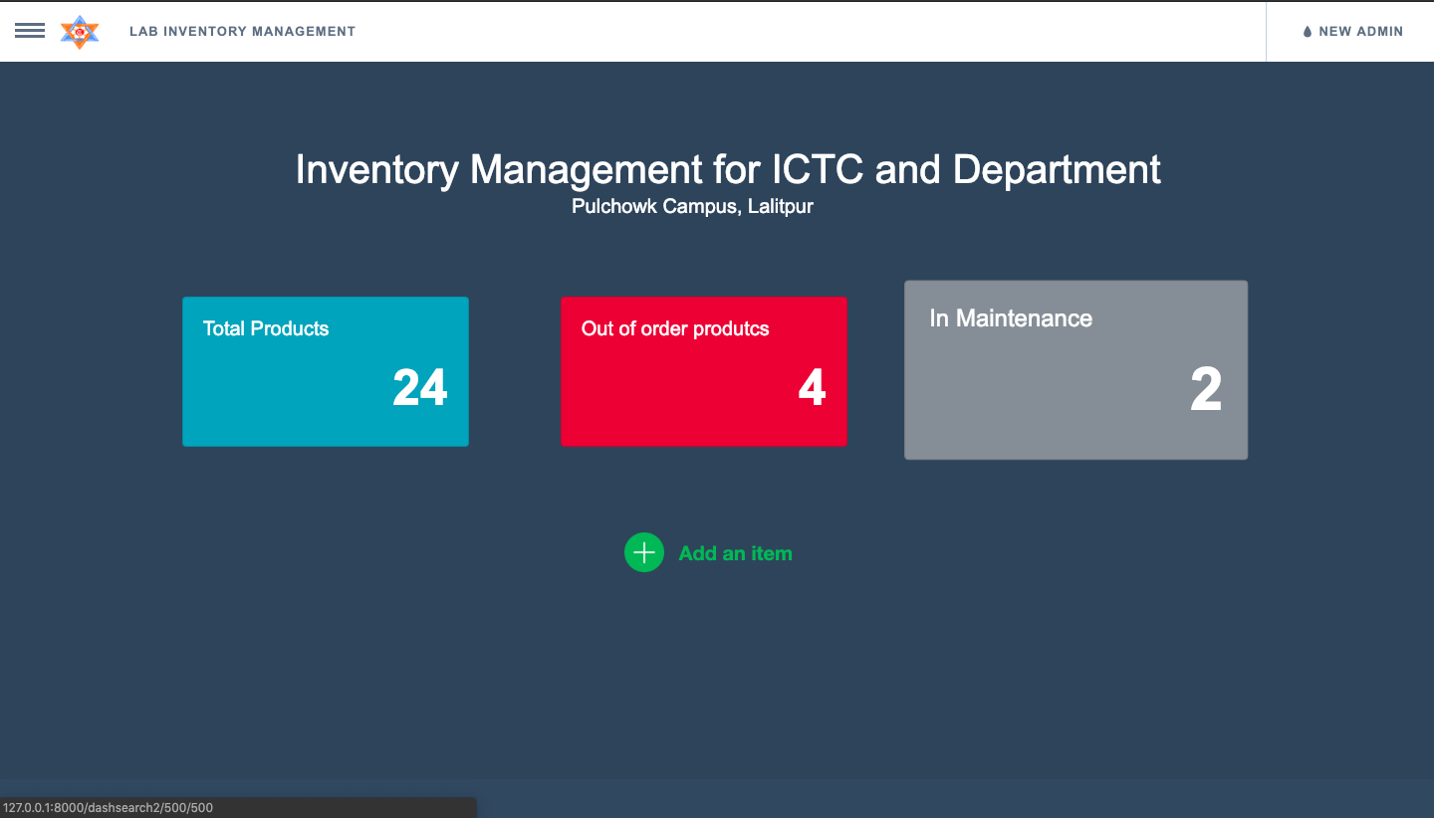

### Add:

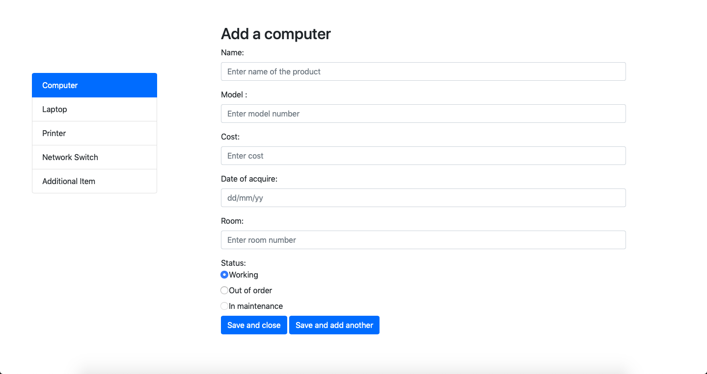

### Search:

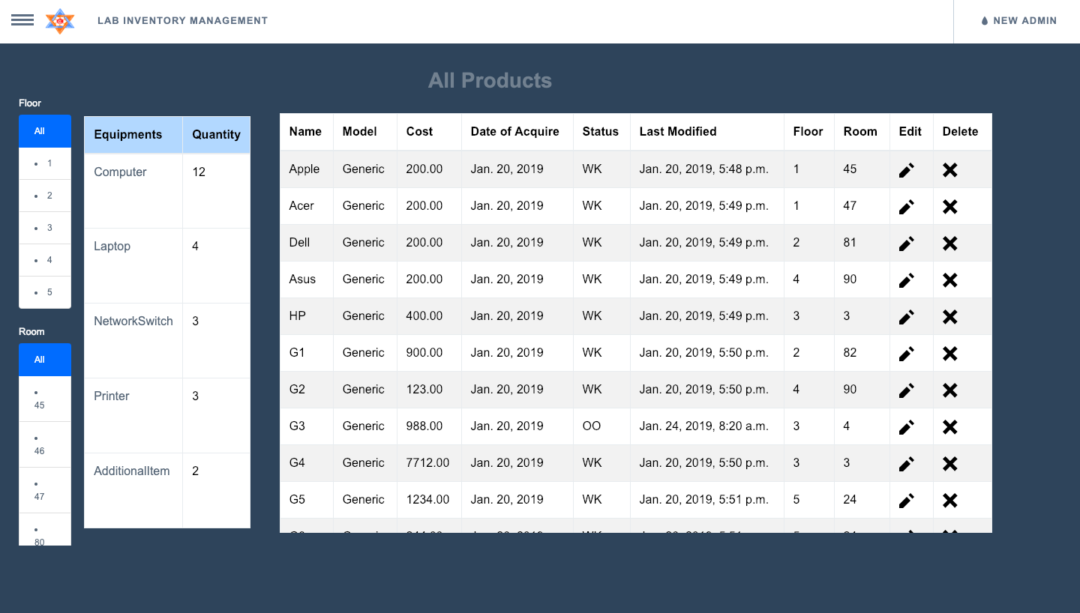

# Sequence Diagram:

**Entity Relationship Diagram(ERD)**