TASK 1 / WEB APPLICATION QA

QA & Debug Report
RealWorld - Conduit blogging application
TESTER  Animesh Khare | TEST DATE  8 November 2026 | APPLICATION  demo.realworld.show | TEST TYPE  Manual exploratory QA

1. Executive summary
The Conduit application was tested through registration, login, article creation/editing/deletion, comments, profiles, logout, and selected edge cases. Five issues are documented below. The strongest observations concern duplicate registration identifiers, acceptance of whitespace-only usernames, and horizontal layout overflow caused by long unbroken comments.

2. Scope and test environment
Application: https://demo.realworld.show/ (Conduit, a Medium-style blogging application). Method: manual black-box browser testing; no source-code or database access. Test data: disposable accounts labelled Account A and Account B; credentials are omitted. Coverage: registration, login, article CRUD, comments, validation, profiles, logout/session access and edge-case input.

3. Tests that behaved as expected
TEST | OBSERVED RESULT
Login / logout | Valid login works; after logout, protected functionality requires login again.
Article CRUD | Article creation, editing and deletion worked in the tested account.
Required article fields | Empty title, description and body were rejected with field-specific messages.
Blank comment | Submission was rejected with the message: “Body post can’t be blank.”
Malformed email | The clearly malformed value “not-an-email” was rejected as invalid.
XSS smoke test | The submitted <script>alert('XSS')</script> payload was displayed as text and did not execute after refresh. This is one payload test, not a full security audit.

4. Bug report table
Severity uses the assessment categories Critical, High, Medium and Low. Suspected causes are hypotheses based on black-box behaviour; they have not been verified against source code.
# | Title / Summary | Steps to reproduce | Expected vs actual | Severity | Suspected cause
1 | Duplicate email accepted | 1. Register Account A.  2. Log out.  3. Register Account B using Account A’s email and a different username.  4. Confirm Account A can still log in. | Expected: reject registration using an email already in use.  Actual: second registration succeeds; Account A remains able to log in. Account B's independent login outcome was not recorded. | Medium | Email uniqueness may not be enforced by server-side validation or a database unique constraint. Inspect the registration API response and persistence layer to confirm.
2 | Duplicate username accepted | 1. Register Account A.  2. Register Account B with the same username but a different email.  3. Open the profile URL for that username. | Expected: reject a duplicate username so each profile identifier maps to one account.  Actual: registration succeeds; in the normal signed-in tab, the profile URL displayed Account A rather than a distinct profile for Account B. The anonymous tab showed a blank page, subject to the demo's visibility limits. | Medium | Username uniqueness may be missing at registration or persistence level. Since profile retrieval uses a username path parameter, collisions make profile identity ambiguous.
3 | Whitespace-only username accepted | 1. Open registration.  2. Enter spaces only in the username field.  3. Complete the remaining valid fields and submit.  4. Open the new profile. | Expected: trim input and reject a username that is empty after trimming.  Actual: registration succeeds; opening the profile produces a blank page. | Medium | Input validation may check only raw field length and omit trimming/normalization. The profile view may also lack a useful error state for this invalid identity.
4 | Long unbroken comment overflows layout | 1. Open an article.  2. Post a comment of about 2,000 characters with no spaces.  3. Inspect the comment card and page width. | Expected: long text wraps inside the comment card; the page stays within the viewport.  Actual: text extends outside the card and horizontal scrolling appears. | Medium | The comment body or an ancestor container likely lacks robust wrapping rules (for example, overflow-wrap:anywhere); a flex/grid child may also need min-width:0.
5 | Blank page for unavailable article content | 1. Sign in as Account A and publish an article.  2. Copy its URL.  3. Sign in as Account B and open that URL.  4. Observe the content area. | Expected: when the API returns no visible article, show a clear unavailable/not-found message or safe navigation.  Actual: the site chrome remains, but the main content area is blank. | Low | The frontend may not handle an empty/filtered article response and may render neither an error state nor a fallback. The demo API’s cross-account visibility restriction is intentional; the blank UI is the reported issue.
Interpretation note: The two duplicate-identifier findings are based on the successful registration behaviour observed. The username collision was associated with the profile route displaying Account A in the normal signed-in tab. A dedicated screenshot of the registration responses was not captured; these observations were recorded manually.

5. Root cause analysis
Selected issue: Long unbroken comments cause horizontal overflow
The comment is saved and displayed, but a long string without spaces extends beyond the comment card and the viewport. This behaviour suggests that the comment body is being laid out as one unbreakable text run. The most likely cause is a missing or ineffective CSS wrapping rule on the comment body or one of its parent containers. A parent flex or grid item may also be retaining its intrinsic minimum width, preventing the text container from shrinking. I would first inspect the comment-body element and its ancestors in browser developer tools, then apply a rule such as overflow-wrap: anywhere and verify that the container has an appropriate max-width. Where the layout uses flexbox or grid, I would also check whether min-width: 0 is needed on the relevant child. Finally, I would retest with long unbroken strings, long URLs, ordinary prose, and narrow viewport widths to confirm that the card wraps without introducing horizontal page scrolling.
AREA | RECOMMENDED ACTION
Registration | Normalize/trim username input; enforce unique email and username server-side and at the persistence layer; return field-specific validation errors.
Profile routes | Handle missing, filtered or malformed profile responses with a visible not-found/unavailable state instead of an empty page.
Comment layout | Allow long tokens to wrap; constrain content width; test desktop and narrow viewport layouts.
Article fallback | When the API returns no article, show a clear message and a way back to the feed. Do not expose a blank content area.

6. Important limitations and assumptions
- This was black-box testing. Suspected causes are not confirmed without source-code, server-log or database inspection.
- The hosted RealWorld demo intentionally limits content visibility: logged-out visitors see demo-account content only; logged-in users see their own content and demo-account content. Cross-account article invisibility itself is therefore not reported as a defect.
- The blank unavailable-content state is reported as a front-end usability/error-handling issue, not as a failure of the demo API visibility policy.
- The XSS check covered one script-tag payload only. It is not evidence of complete XSS immunity or a full security assessment.
- The long-comment defect was observed with approximately 2,000 characters without spaces. No arbitrary maximum comment length is assumed.

7. Reference documentation
RealWorld - Frontend API / Demo API limitations: https://docs.realworld.show/specifications/frontend/api/
RealWorld - Backend API endpoints: https://docs.realworld.show/specifications/backend/endpoints/

8. Screenshot evidence
Screenshots below were provided during the manual test session. They support the observed UI behaviour; they do not independently prove backend implementation details.
Evidence 1 - Long comment overflow  A long unbroken comment extends outside its card and produces horizontal page scrolling.  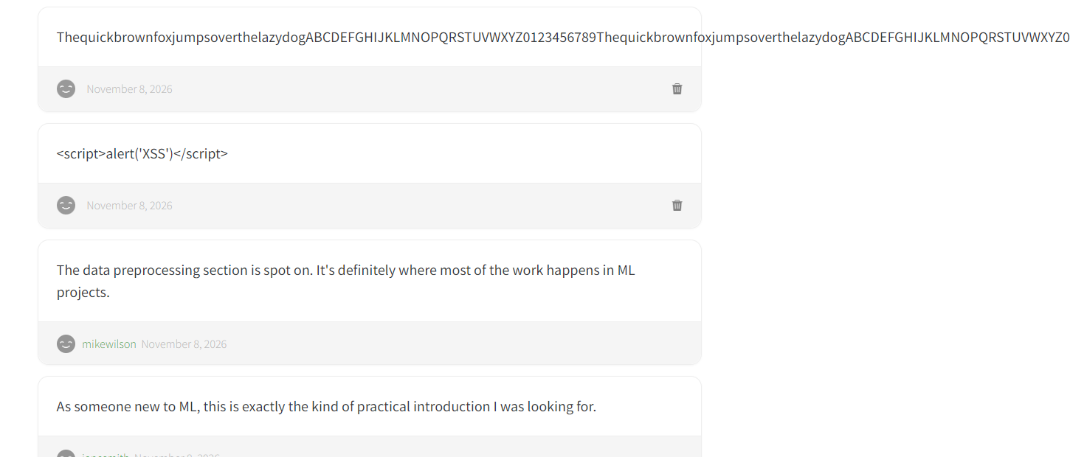 | Evidence 2 - Blank unavailable-content state  The application shell is visible, but the main content area is blank after navigating to content that is not available to the current account under the hosted demo rules.  

