OBJECTIVE QUESTIONS

Question 1: What is the total no. of tables present in the data?
Solution:
Total Number of Tables: 2
Table 1: Raw Data(Sheet name: "Raw Data" )
Table 2: Country Description(Sheet name: "country description")

Question 2: What is the total no. of attributes present in the data?
Solution:

The total number of attributes present in the Data which refers to the
The number of columns is 21.

Question 3: How many categorical columns are there in the data? [Search about categorical and continuous data, and try to answer this question]
Solution:

There are 13 categorical columns namely ( Country Code, City, Locality,
Country_Name, RestaurantID, RestaurantName, Cuisines, Year,
Currency, Has_Table_Booking, Has_Online_Delivery, Is_Delivering_now and Price_range ) present in the Data.

There are 5 Continuous Columns are as follows:
Longitude, Latitude, Votes, Average_Cost_for_two_INR, Rating,

Question 4: The data consists of some inconsistent and missing values so ensure that the data used for further analysis is cleaned.
Solution:
.Data Cleaning Steps:

1. We removed duplicates by selecting raw data and clicking on remove duplicate option.
Select raw data> go to Data tab> go to Data tool> Remove Duplicates.

2. Removed unnecessary columns like Address, Locality Verbrose, Switch_to_
Order_menu .

3. There are some blank cells in cuisines column which we replace by mode
of cuisines.

Question 5: Using the LookUp functions, fill up the countries in the original data using the country code.
Solution:
. To retrieve country data from country description table to original data table,
We use the V-lookup function. It is the ‘D’ column.

=VLOOKUP(C2,'country description'!$A$1:$B$16,2,0)

Question 6: Create a table to represent the number of restaurants opened in each country.
Solution:
The table for the country wise number of restaurants is shown below.

Approach:
The pivot table is inserted to the sheet and the country name is inserted to rows and the restaurant id is inserted to values, finally getting the grand total. Based on the pivot table we have created, the column chart has been plotted.

Charts & Tables:

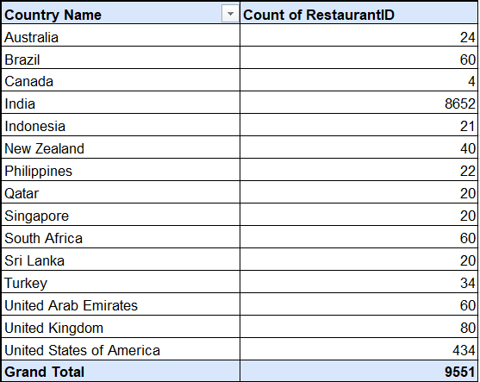

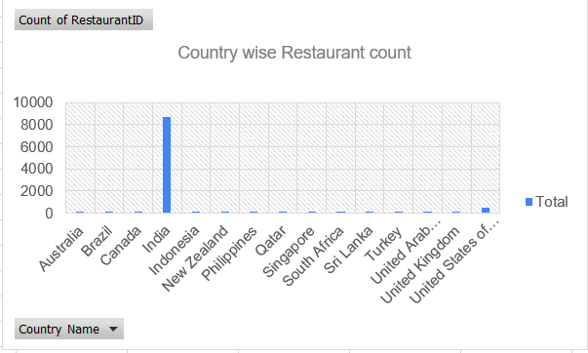

Description:
The chart represents the total number of restaurants that are present in each country.

Question 7: Also, the management wants to look at the number of restaurants opened each year, so provide them with something here.
Solution: The number of restaurants opened per year is given below :
Final Answer :
The total number of restaurants opened is 9551. The year 2018 records the most number of restaurant openings(1102 restaurants).

Approach :
Applying the concept of pivot to create the table for displaying the data to see the year and the number of restaurants opened in that particular year.

Charts & Tables:

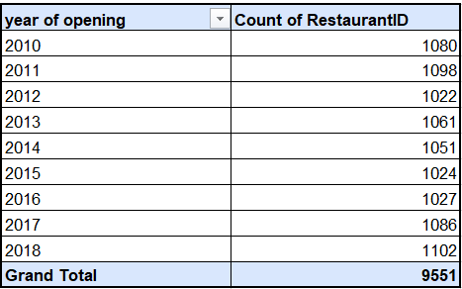

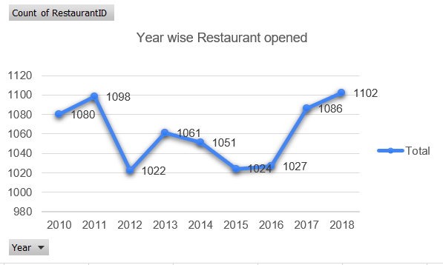

COUNT OF RESTAURANTS OPENED PER YEAR

Description:
The above chart represents the number of restaurants opened in each year.

Insights:
The above chart clearly shows the number of restaurants opened between
2010 and 2018 were highest in 2018 with count of 1102 and lowest in the
year 2012 with count of 1022.

Question 8: What is the total number of restaurants in India in the price range of 4?
Solution: .
In the price range of 4, the total number of restaurants in India is given
by COUNTIFS aggregate function.

=COUNTIFS('Raw Data'!D:D,"India",'Raw Data'!N:N,4)

Charts & Tables: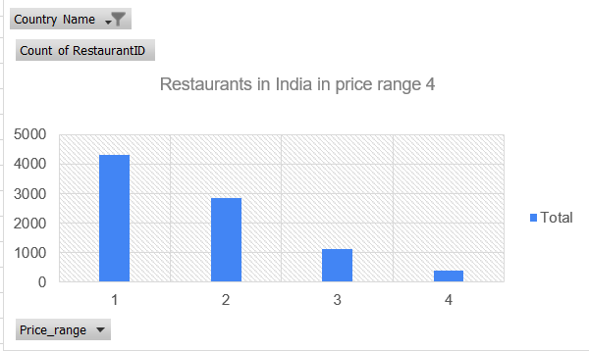
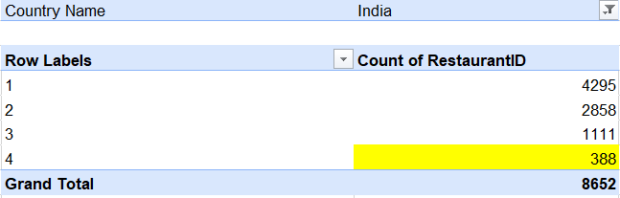

Observations:

• Price Range 1 (4295 restaurants) – A majority of restaurants fall under this price
range and this clearly indicates a high demand for budget-friendly options.

• Price Range 2 (2858 restaurants) – A significant number of restaurants fall under
this category indicating a small majority of people are looking for balance between
affordability and premium services.

• Price Range 3 (1111 restaurants) – Fewer restaurants exist in this category which
means that the premium category is less common in number.

• Price Range 4 (388 restaurants) – The least number of restaurants fall in this
category meaning the luxury dining options are rare in number.

Question 9: What is the average number of voters for the restaurants in each country according to the data?
Solution:
The average number of voters for the restaurants in each country is given
below.
Final Answer:
The grand total of the average of votes is 156.909747. In the below table the detailed information is mentioned.

Approach:
Applying the concept of pivot to create the table for displaying the data to see the country name and the average of votes that each country has got.

Charts & Tables:
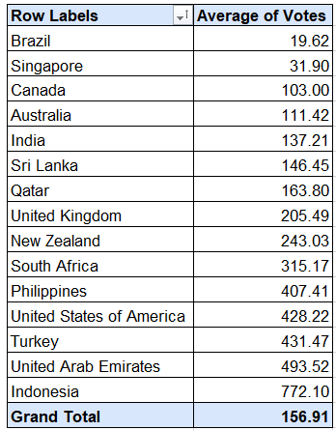
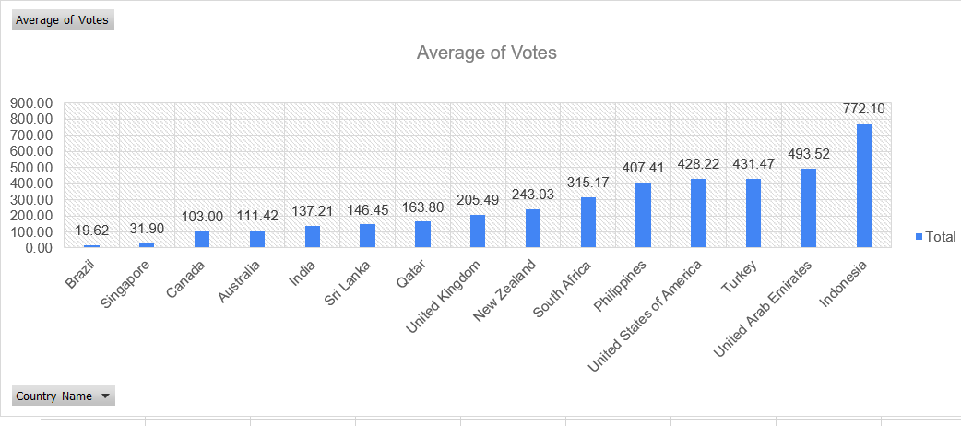
Insights:

· Indonesia and the United Arab Emirates have the highest average number of votes per restaurant (772.10 and 493.52, respectively), indicating higher engagement or a more active voting population.

· Countries like Brazil, Singapore, show relatively lower averages (around 19.62 to
31.90 votes), which may suggest less customer engagement or fewer restaurants
per country.

· South Africa, Philippines, United States of America and Turkey have moderate averages (315.17 , 407.41 , 428.22 and 431.47), indicating a balanced level of voter participation.

Recommendation:

· Focus on increasing customer engagement in countries with lower averages, such as Brazil and Singapore, by implementing targeted marketing strategies or loyalty programs.
· Search and investigate the reasons for higher customer engagement in countries
like U.A.E , Indonesia and Turkey and implement the same model in other countries where engagement is low.

Question 10: Calculate the average rating for all the restaurants that have price_range < 4 and provide online delivery. Use only the “IF” function, Logical Operators, and Aggregation functions to solve this problem. [Note: Don’t use Conditional aggregation in this question.]
Solution: The average rating for all the restaurants whose have price_range <4
Is given by:

{=AVERAGEIFS('Raw Data'!S:S,'Raw Data'!N:N,"<4",'Raw Data'!L:L, "Yes")}

Here we have used an array formula denoted by {} which gives ans. 3.273812.

Question 11: Using Conditional formatting highlights the rows of restaurants that are located in the countries or cities that you’ve suggested to the management for opening new restaurants.
Solution:
. I applied Conditional formatting to highlight the rows of restaurants located in the countries or cities I recommended to management for potential new restaurant locations. Specifically, I used the “Text Contains” rule to highlight rows that include the following locations: Canada, Indonesia, Qatar, Singapore, and Sri Lanka.
Question 12: Create a new customized price column that consists of the abbreviation/symbol of the currency along with the Average_cost_for_two value. [Use string operations to do this task]
Solution:
Answer = We use a concatenate string function to get a new 'customized price' column.
=CONCATENATE(MID(J2,FIND("(",J2)+1,FIND(")",J2)-FIND("(",J2) -1),Q2)
=IF(J2="Indian Rupees(Rs.)", Q2, (VLOOKUP(J2,'country description'!$E$1:$F$12, 2, 0)*Q2))

Question 13: How can you create an array formula in Excel or Google Sheets to count the number of restaurants listed that do not offer online delivery, are in the lowest price range, and have an average cost for two people less than or equal to 250 Indian Rupees?
Solution:
. A total number of 1694 restaurants are there that do not offer online delivery
, are in the lowest price range, and have an average cost for two people of
less than equal to 250 Indian Rupees. The array formula will be :

{=SUM(IF( ('Raw Data'!L:L="No")*('Raw Data'!N:N=1)*('Raw Data'!R:R<=250),1,0))}

Ans: 1694.

Here this bracket {} indicates array formula by pressing ctrl + shift + enter.

SUBJECTIVE QUESTIONS
Question 1: Suggest a few countries where the team can open newer restaurants with lesser competition. Which visualization/technique will you use here to justify the suggestions?
Solution:
To open restaurants in countries will depend upon factors like count of restaurants,
Average ratings and Average of Price range.

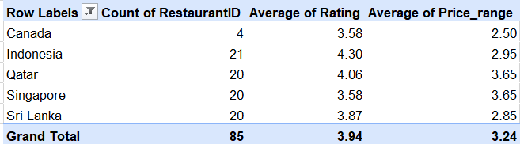

Insights:

1. Countries recommended on the basis of fewer restaurant count are:
· Canada (4)
· Indonesia (21)
· Qatar (20)
· Singapore (20)
· Sri Lanka (20)

2. The less count of restaurants in above countries indicate less competition and more potential of expansion.

3. In countries like Indonesia and Qatar, average ratings are (4.3) and (4.06)
while in countries like Canada, Singapore and Sri Lanka, ratings vary
from (3.5) to (3.89).

4. In countries like Canada, Indonesia and Sri Lanka, lower price range varies
from (2.5) to (3.0) whereas in countries like Qatar and Singapore, there is a
moderate price of (3.7) .

Recommendation:

1. The following countries already have less number of restaurant count which
means low competition and a potential location in restaurant expansion.

-Canada
-Indonesia
-Qatar
-Singapore
-Sri Lanka

2. Countries like Qatar and Indonesia should continue giving premium and quality food services to their customers and focus more on customer engagement that can aid in improving ratings.

3. Whereas countries like Canada, Singapore and Sri Lanka should focus more on
Improving food quality and services to further improve ratings.

4. In countries like Canada, Indonesia and Sri Lanka, there is low price range meaning we can target a medium and moderate income group of people that
can afford easily in this price range.

Question 2: Come up with the names of States and cities in the suggested countries suitable for opening restaurants.
Solution:
The cities suitable for opening new restaurants country wise will depend upon Restaurant count, Avg of Rating, Average of Average cost for two.

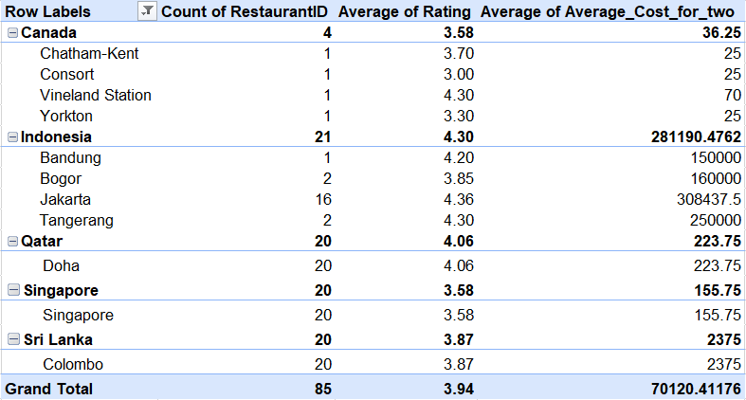

1. Cities like (Chatham – Kent, Vineland Station, Bandung, Bogor, Jakarta, Tangerang, Doha, Singapore and Colombo) have moderate to high
Average rating which is above 3.5 and it means that people in these cities are satisfied with the services and quality of food served but it still needs some improvement.

2. The average cost for two is highest in countries like Indonesia (281190.47)
and Sri Lanka(2375) which means here market point towards more luxuries options whereas in cities of countries like Canada, Qatar and Singapore here
market points to more affordable and budget friendly options.
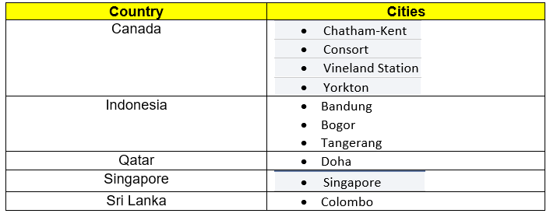

Question 3: According to the countries you suggested, what is the current quality regarding ratings for restaurants that are open there?
Solution:
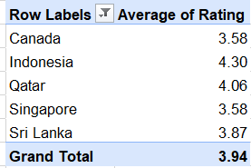
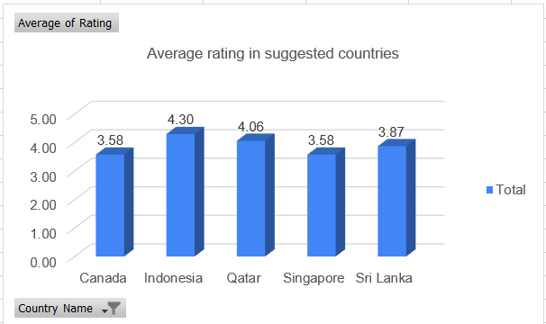

Insights:

1. Countries like ‘Canada’, ‘Singapore’ and ‘Sri Lanka’ have average rating
Between 3.5 to 3.85. It means that here restaurants meet customers
expectations but still they needs improvement in quality and services they
offer to customers so that they can perform well.

2. Whereas countries like ‘Indonesia’ and ‘Qatar’ have ratings above 4.0
Which means that restaurants are performing extremely well in terms
of good service and quality food.

Recommendation:

1. ‘Canada’, ‘Singapore’, and ‘Sri Lanka’ should give priority to food quality,
food services to further improve their ratings.

2. Countries like ‘Indonesia’ and ‘Qatar’ should continue to offer premium and
Luxury services to customers but with that also maintain their ratings by
continuous customer engagement.

Question 4: Also, what is the current expenditure on food in the suggested countries, so we can keep our financial expenditure in control?
Solution:
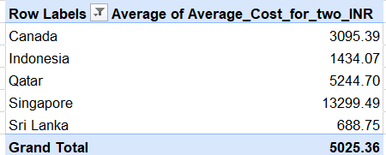

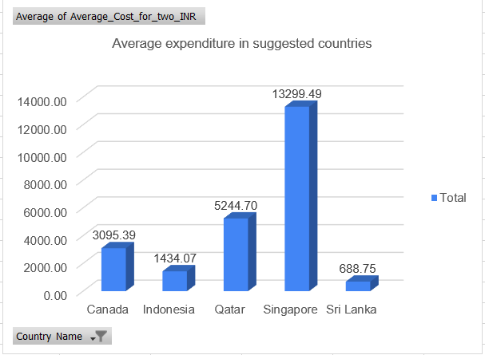

Insights:

1. Countries like ‘Singapore’ , ‘Canada’ and ‘Qatar’ offer moderate
to high costs premium and luxury services. Whereas countries like
‘Indonesia’ and ‘Sri Lanka’ offer budget friendly services.

2. There is a diverse spending observation with ‘Singapore’, ‘Canada’
and ‘Qatar’ leading in higher expenditure while countries like
‘Indonesia’ and ‘Sri Lanka’ have lower to medium expenditures.

Recommendation:

1. We need to continue offering premium pricing in countries like ‘Singapore’,
‘Canada’ and ‘Qatar’ while introduce lower to medium price options
for a large customer base.

2 Countries like ‘Indonesia’ and ‘Sri Lanka’ shall introduce premium dining
options to target a group of rich and high spending people while maintaining
their budget friendly options.

Question 5: Come up with the names of restaurants from the recommended states that are our biggest competitors and also those that are rated in the lower brackets, i.e. 1-2 or 2-3.
Solution:
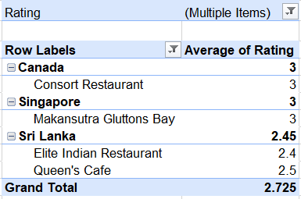

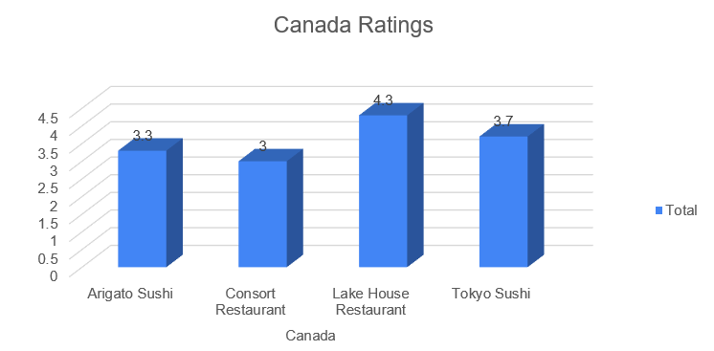
Insights:

1. Canada: Lake House Restaurant with (4.3) rating stands out of the competitors list whereas Consort Restaurant with (3.0) rating is a
good competitor due to its low rating.

2. Qatar: Mainland China Restaurant with (4.9) rating and Gymkhana with
(4.7) rating stands out of competition as they are highly rated whereas
7st by Mumbai Spices with (3.4) rating and Indian Coffee House with
(3.4) rating can be good competitors with low ratings.

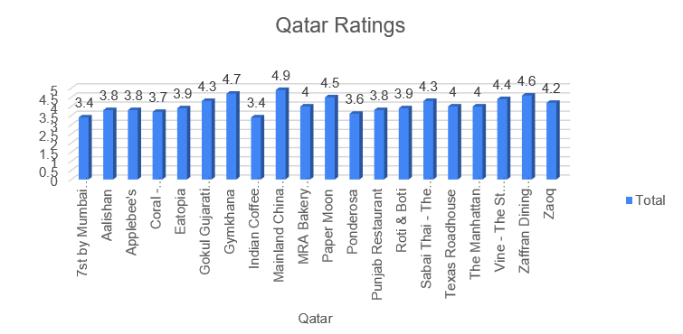

3. Singapore: Al’Frank Cookies with (4.2) rating and Fratini La Trattoria
With rating (4.1) are strong competitors. However restaurant like
Makansutra Gluttons Bay with rating (3) is capable and have potential
to be a good competitor in the future as it has a low rating.

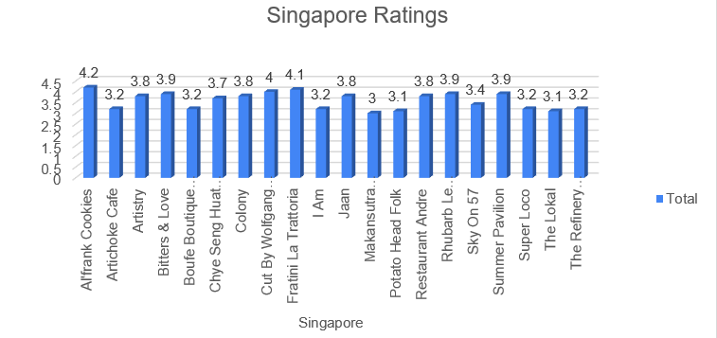
4. Sri Lanka: Ministry of Crab of rating(4.9) and Simply Strawberries By Jagro of rating (4.5) are strong competitors. However, Elite Indian Restaurant of rating (2.4) and Queen's Cafe of rating (2.5) are rated poorly and are struggling against higher-rated competitors.

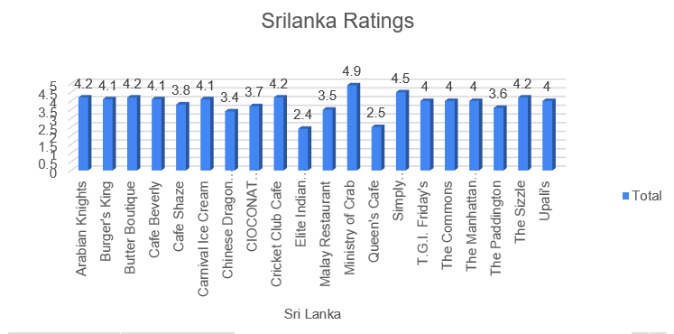
Recommendation:

1. The Elite Indian Restaurant (Sri Lanka), Queen's Cafe (Sri Lanka), Makansutra Gluttons Bay (Singapore), and Consort Restaurant (Canada) have low ratings. Opening a new restaurant with a focus on good quality food and service could directly address the shortcoming in these regions.

2. We can attract those customers looking for some new dishes and taste by Introducing new and local cuisines which are in high demand all time and
mostly liked or admired by the people.

Question 6: Which cuisines should we focus on in the newer restaurants to get better feedback? Does the choice of cuisines affect the restaurant ratings?
Solution: Insights:

· Canada- Italian, Mediterranean, Pizza ( have ratings >= 4) whereas
Japanese, Sushi, Asian, Chinese, Canadian (have ratings >= 3)

· Indonesia- Sunda, Indonesian, Sushi, Japanese (have ratings > 4)

· Qatar- Chinese, Italian, Thai, Indian, International, Pakistani, Steak, AmericanSeafood, Kerala, Indian, Chinese, Bakery (have ratings >=4)

· Singapore- Bakery, Italian, American, Steak( have ratings >= 4)
whereas Café, Singaporean, Chinese, Seafood, Malay and Indian (have
ratings >= 3)

· Sri Lanka- Seafood, Juices, Italian, Desserts, Middle Eastern,
American and Steak ( have rating >=4)

· Yes, the choice of Cuisines affect the restaurant ratings with highest ratings
Cuisines are more prioritized.

Recommendation:

1. High-end restaurants in Canada, Indonesia, Qatar, Singapore, and Sri Lanka that specialize in Italian, Mediterranean, Seafood, American and Steak should focus on quality and service to maintain the high ratings (>=4).

2. Countries like Indonesia, Qatar and Sri Lanka should promote International cuisines like Sushi, Japanese, Chinese, Indian, Pakistani, Kerala, Indian, American and Steak.

3. Put a diverse range of cuisines options in front of customers ranging from Asian and Mediterranean in Qatar and Sri Lanka.

Question 7: According to our current data, should we go for online delivery and table booking? Does that affect the customer’s ratings?
Solution:
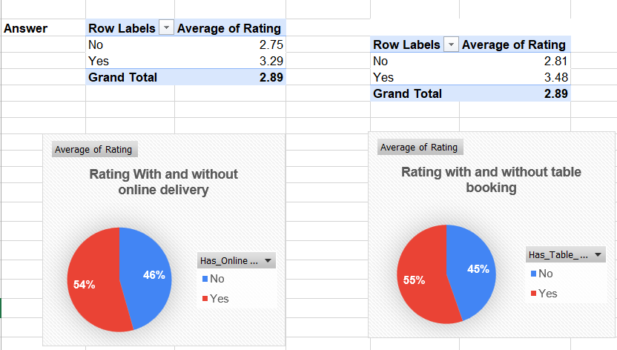

Insights:
1. From the above pie charts we can conclude that ratings with online delivery
(3.29) is higher than (2.75) without online delivery whereas ratings with table
booking (3.48) is higher than (2.81) without table booking.

Recommendation:

It is advisable to Implement table booking and online delivery type services which will enhance customer Satisfaction and further improve ratings.

Question 8: Should the team keep the rate of cuisines higher? Will that affect the feedback? According to our data are the rates of cuisines and ratings, correlated?
Solution:
Formula = CORREL('Raw Data'!R:R, 'Raw Data'!S:S)

Insights:

1. With a correlation of 0.307 there is no strong relation between cost of cuisine and
ratings.

2. It means that ratings are not affected by changes in cuisine prices.

Recommendation :

The team should not focus on raising prices to improve ratings but instead enhance food quality and service.

Question 9: What is the distribution of the number of restaurants of different price ranges in all the countries?
Solution:
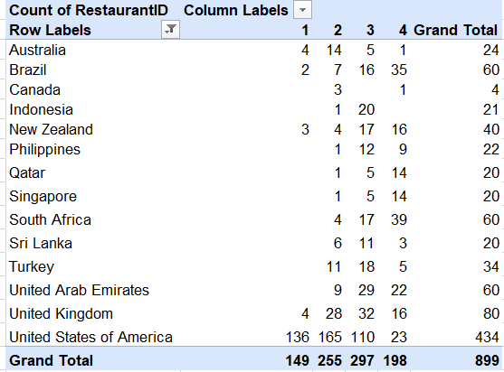
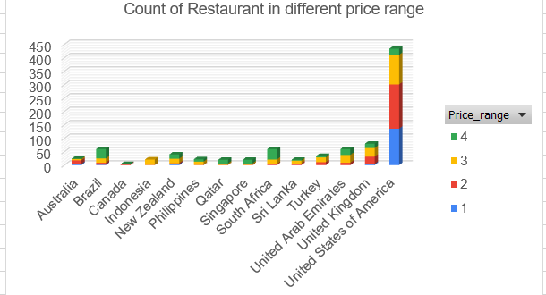

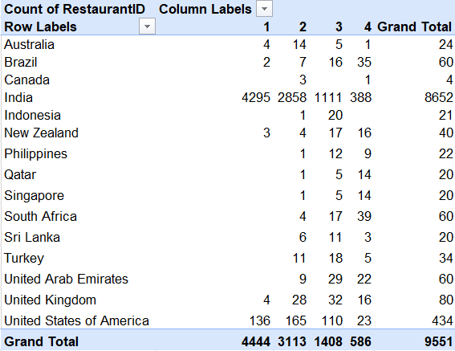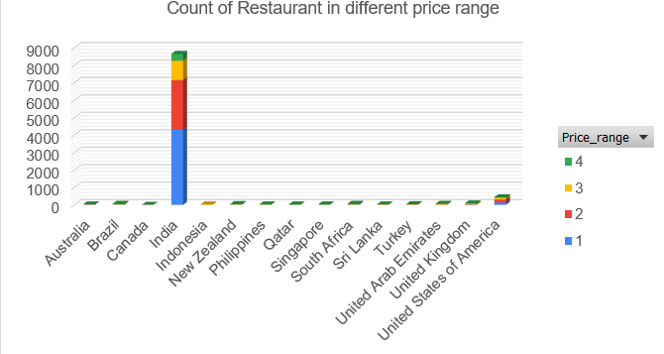
Insights:
1. India has majority of restaurants falling under price 1 which means
Here preference is given to the lower price range ( 1 – 2).

2. Countries like Brazil, South Africa, Qatar and Singapore prefer
premium restaurants in the price range of 4.

Recommendation:

1. Focus on expanding business in India by opening budget – friendly
restaurants to cover a large customer base.

2. Whereas focus on opening luxury premium dining in countries like Brazil, South Africa, Qatar and Singapore. The reason is because of strong support for high- price dining.

Question 10: Explain your approach in brief for suggesting countries/cities in order to open new restaurants, if the objective and subjective questions would have not been given to assist you. [you have to give bullet pointers in order to answer this question]
Approach for opening new Restaurants

Cities with High Ratings:
· Identifying cities with high ratings ( above 4) because it means
customer satisfaction and demand for quality restaurants and
also tell us about the high spending potential of customers so
We can target an elite group who prefers premium options.

Affordable price range (1 – 3):
. Target cities with affordable price range between (1 – 3) as it
will cover large customer base with middle and upper middle class
with no compromise in food quality and service.

Online Delivery option:
· Provide customers with option of online delivery as in this era of digital
revolution we can connect with a large customer base digitally and expand business online.

Restaurants count:
· Choosing the cities with low restaurant density where competition is less
and introduce cuisines according to the taste and what customers like
in that city or region.

Using Technology:
· Make use of google maps and see public reviews of restaurants and on
the basis of their feedback making improvements in services, food quality and cuisine which can benefit more customers and business can make
more profits.

--------------------------------------------------------------------------------------------------------
The dashboard must consist of Year-wise and country slicers.

