Training

[Email address]

Abstract

SYNOPSIS AS ON 26/4/2018

BRAIN MENTOR

ONLINE TEST SYSTEM

**INTRODUCTION**

Brain Mentors is an Online Quiz web application for candidate to appear for an online test in an effective way and there is no loss of time to check the paper. The chief aim of Online Quiz is to effectively estimate the candidate completely via a totally automated system which besides preserving time, offers swifter outcomes. Generally, pupil are provided with paper, pen etc. for taking the test but the Online Quiz doesn’t require all these.

This application is fundamentally developed in Java, which is a web application software that can be employed to develop a test system. The advantage of this software is that it is free as well as costless.

**Scope:**

This project has a wide scope as it is better than the manual tests. Following are some of its advantages:

* Both educational organizations and corporate companies can employ this Quiz.
* It, being an application based on web may be taken at any place or any time as the location is not considered.
* The presence of the examiner is not required while the candidate is appearing for the test.

**Benefits:**

For web surfers, Online Quiz acts as a popular way of recreation. It is free of cost and meant for entertainment and they also give prizes. Online Quiz is organized to examine the wisdom or identify a person’s characteristics. Most of the companies employ online quiz as an effective manner of examining a prospective employee’s wisdom without that person’s personal presence.

**DESIGN OF THE SYSTEM**

* **E R Diagram**

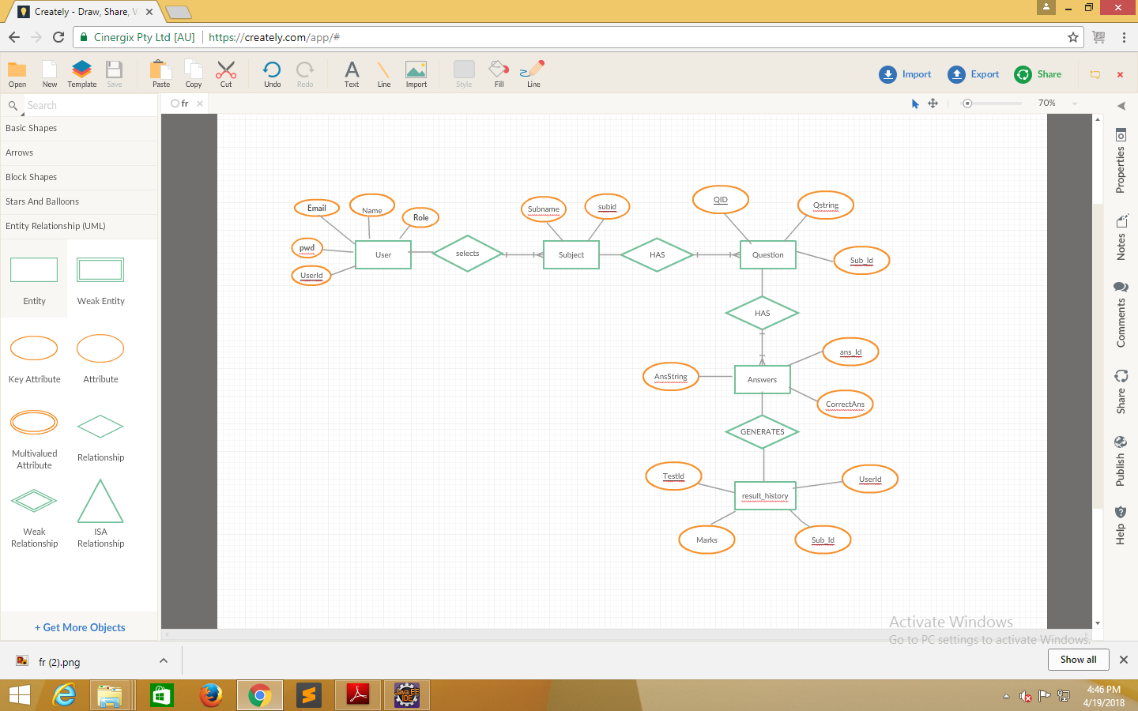

* **Data Flow Diagram**
* **DFD LEVEL 1**

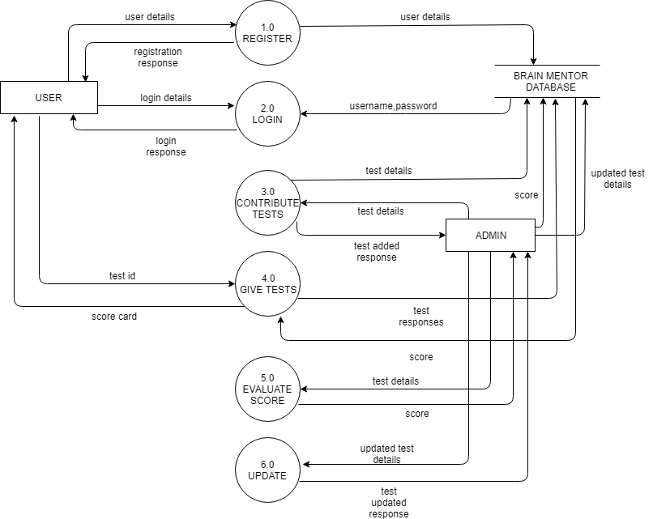

* **Use Case Diagram**

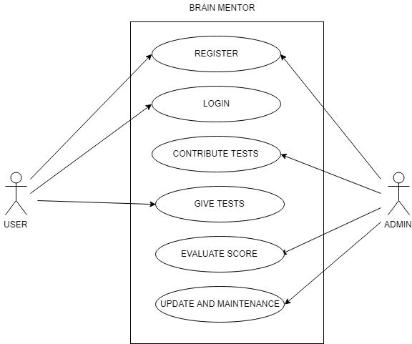

* **Class Diagram**

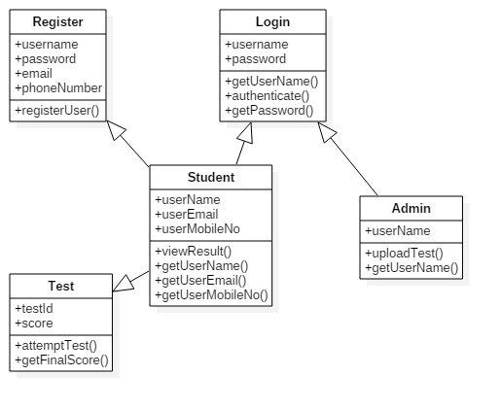

* 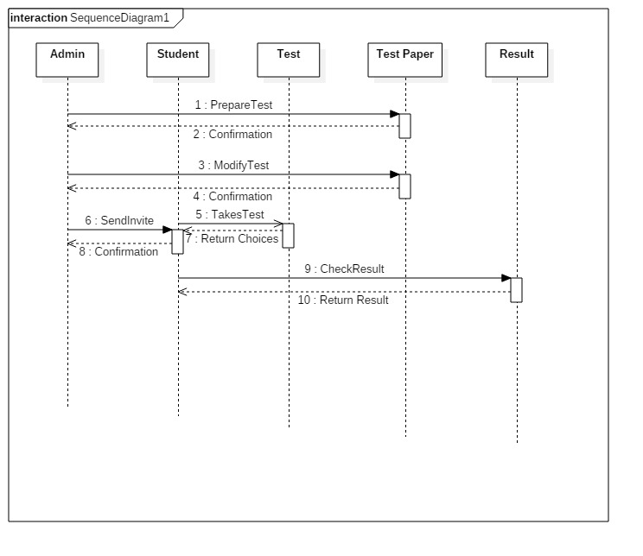**SEQUENCE DIAGRAM**