SURVEY

There are many topics for which we needed real-time feedback to understand more about the stakeholders’ opinions on various sections of our project. We created a google survey for our project. Link for our survey is <https://forms.gle/DQmQbG66wmDbdgYE9> , we kept it open for people who might still want to provide feedback (link is also provided in the reference section). Questions given in the feedback are listed below with a small screen capture containing few initial responses.

Q1. What are the added feature you would like us to integrate apart from in built features (call, navigation, group sync and music)?

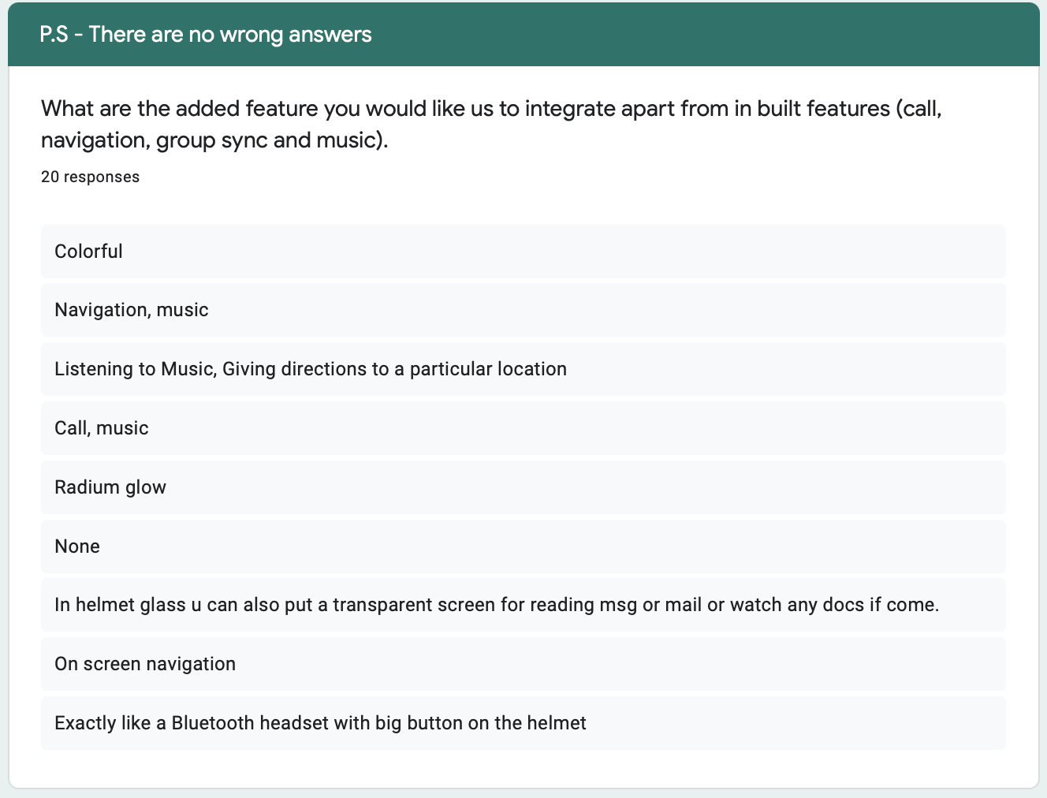

Q2. Please provide us some risk factors which you think can affect our business model ? (Pandemics, disasters)

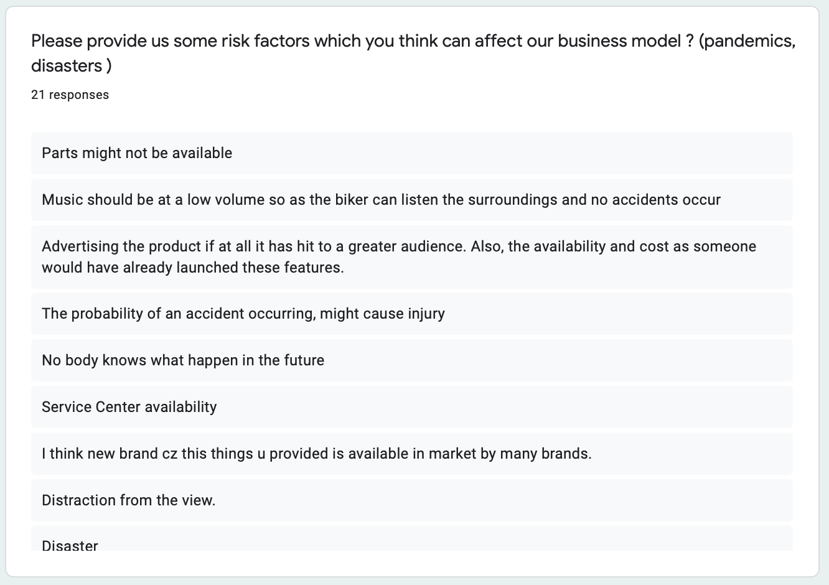

Q3. What should be the cost of the product (USD)?

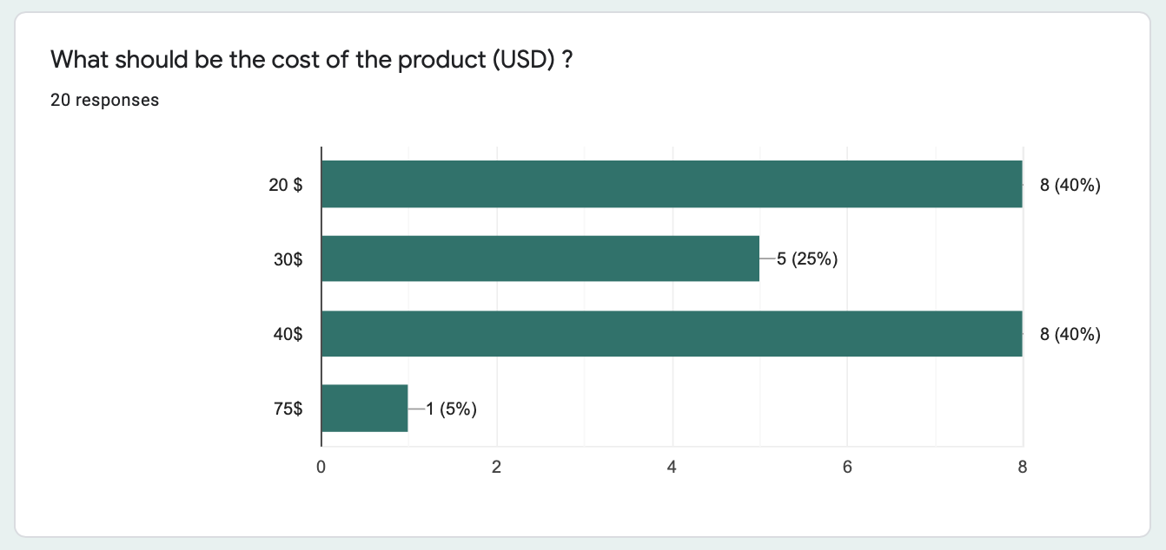

Q4. Suggestions for improvement.

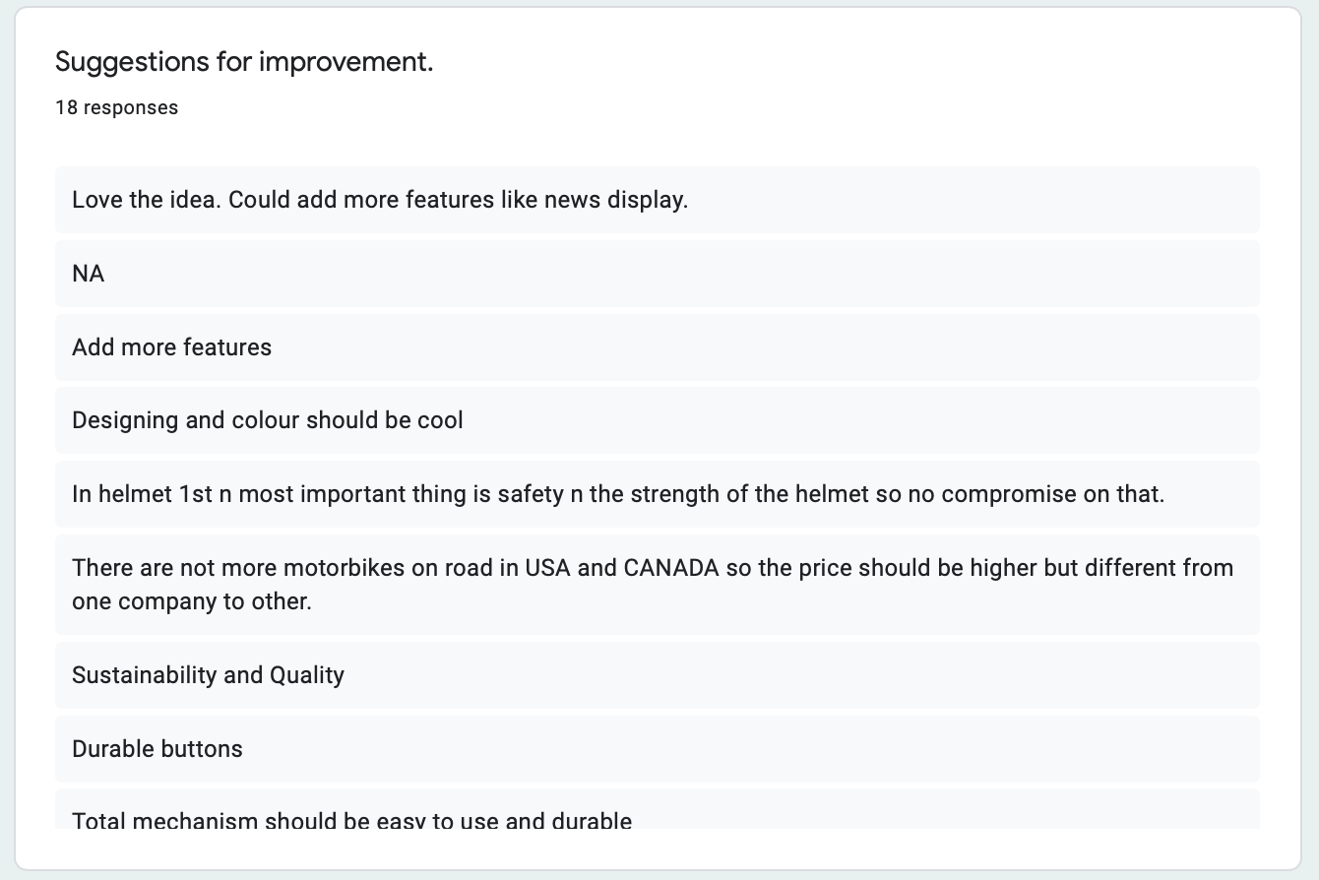

Q5. Overall Feedback

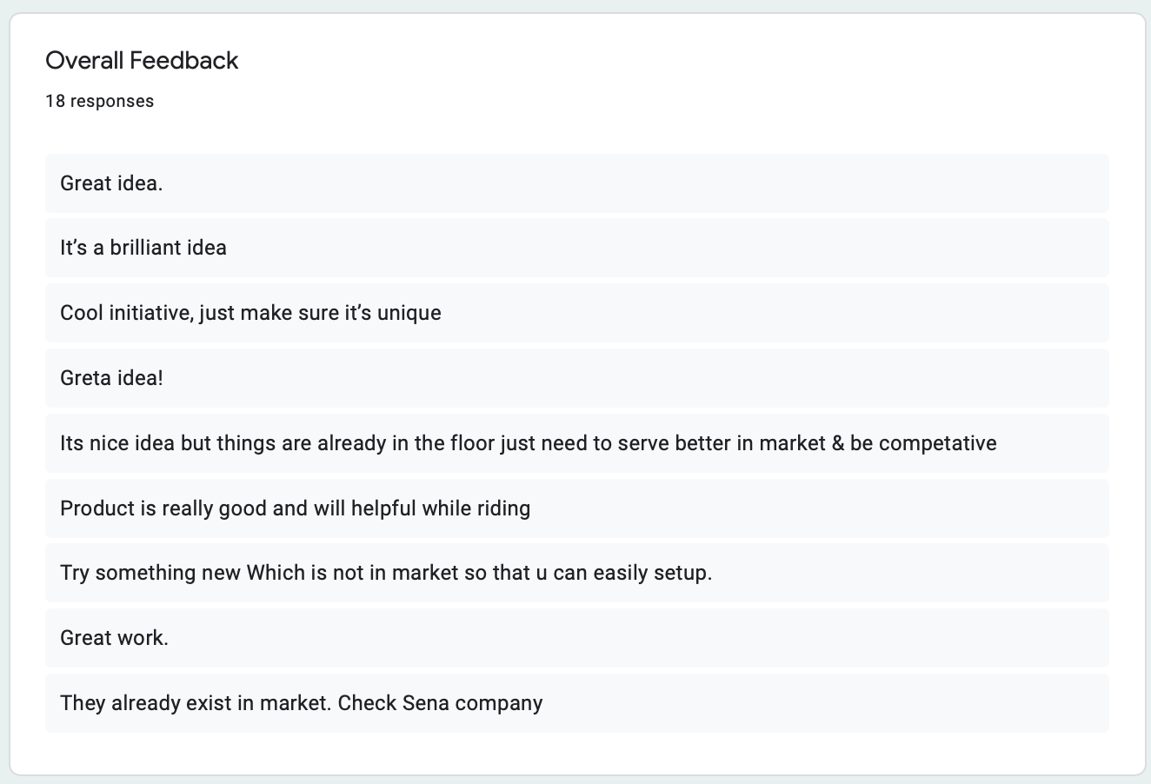

There were five questions provided in the survey. We got an approximate of total 20 responses. Main objective of our survey is to figure out what the client wants and needs. We have consolidated the client requirements from survey into a table shown below.

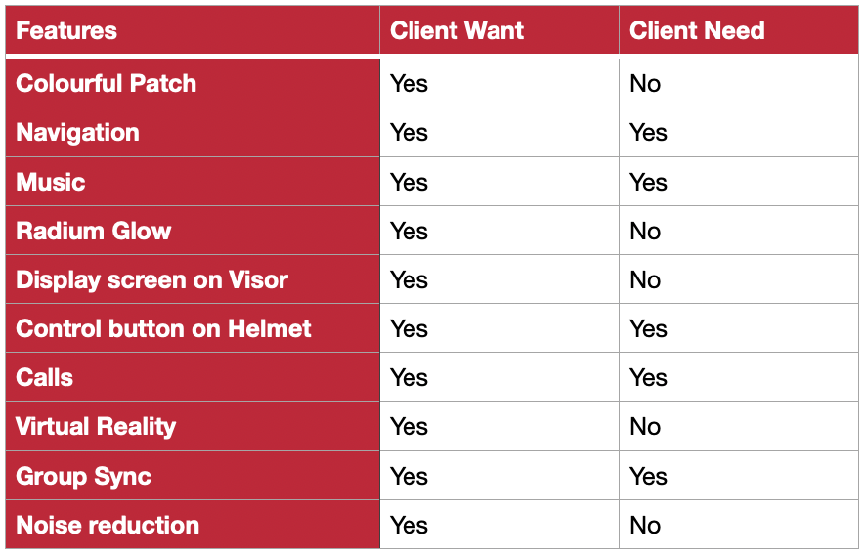

Four features that are repeated most number of times are calls, navigation, music and group synchronization which are the basic built in features for our product. Few other features which are in demand are display screen on visor which is a good option but it’s a costly technology and it will increase the cost of the product defeating the main aim of creating a cheaper solution to smart helmets. Another important feature in the wants field was adding color to our product design which is not yet implemented but a very easy alternative and won’t cost much as we just need to buy the colorful fabric for outer layer and it also gave us motivation to add stickers to patches related to sports, fashion which are in popular demand and can be used to advertise easily as a fashion accessory.