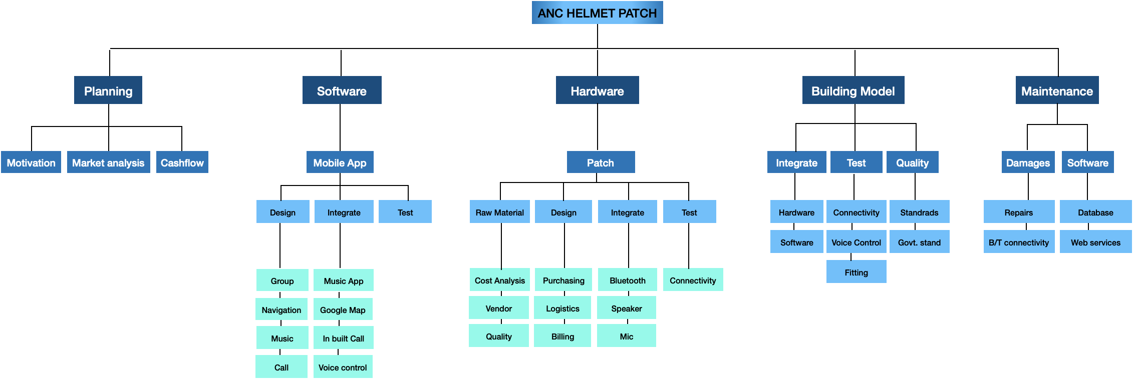

RISK IDENTIFICATION MATRIX

|  |  |  |  |  |  |  |  |
| --- | --- | --- | --- | --- | --- | --- | --- |
| **Risk Category** | **Scope Triangle** | **Event#** | **Event** | **Y/N** | **Probability** | **Priority(H/L/M)** | **Mitigate(Y/M/N)** |
|  |  |  |  |  |  |  |  |
| **Technology** | Scope | TS1 | Hardware might not connect with future devices | Y | 30% | M | Y |
|  |  | TS2 | Present web services might stop its services | Y | 5% | H | Y |
|  |  | TS3 | Device not syncing with group of mobiles(BT capacity is 7 peoples) | Y | 50% | M | Y |
|  |  | TS4 | Hardware availability or change of vendor | Y | 60% | H | M |
|  |  |  |  |  |  |  |  |
|  | Cost | TC1 | Unexpected need to acquire hardware | Y | 20% | H | M |
|  |  | TC2 | Unexpected need to acquire software | Y | 10% | H | M |
|  |  | TC3 | Cost of Web services might increase | Y | 90% | L | Y |
|  |  |  |  |  |  |  |  |
|  | Time | TT1 | Service disruptions by vendors | Y | 15% | H | N |
|  |  | TT2 | Software integrated API’s updates might cause delay | Y | 20% | L | N |
|  |  |  |  |  |  |  |  |
|  | Quality | TQ1 | Cotton patch might come off | Y | 10% | H | Y |
|  |  | TQ2 | Patch might not be properly stitch | Y | 10% | M | Y |
|  |  |  |  |  |  |  |  |
|  |  |  |  |  |  |  |  |
| **Project Management** | Quality | PQ1 | Incase of accidents the device might break and cause injury | Y | 2% | H | N |
|  |  | PQ2 | Inaccurate budget assumptions | Y | 30% | M | Y |
|  |  |  |  |  |  |  |  |
|  |  |  |  |  |  |  |  |
|  | Scope | PS1 | Existing market coming up with better solutions | Y | 28% | M | N |
|  |  | PS2 | Unavailibilty of internet | Y | 15% | L | N |
|  |  |  |  |  |  |  |  |
|  | Resource | PR1 | Delivery of raw material | Y | 10% | M | N |
|  |  | PR2 | Return/replace damaged materials | Y | 15% | M | M |
|  |  |  |  |  |  |  |  |
|  | Time | PT1 | Task duration estimate too optimistic | Y | 15% | L | Y |
|  |  | PT2 | Difficulty scheduling meeting | Y | 5% | L | Y |
|  |  |  |  |  |  |  |  |
|  | Cost | PC1 | Less demand but high production | Y | 20% | L | Y |
|  |  |  |  |  |  |  |  |
| **Organizational** | Cost | OC1 | Deliverable rejected at last minute | Y | 5% | H | M |
|  |  | OC2 | Unable to payoff the loan amount | Y | 25% | H | Y |
|  |  |  |  |  |  |  |  |
|  | Scope | OS1 | Hired employee left before completing the task | Y | 30% | M | Y |
|  |  |  |  |  |  |  |  |
|  | Time | OT1 | Slow knowledge transfer | Y | 5% | L | Y |
|  |  | OT2 | Excessive amount of leaves | Y | 5% | L | Y |
|  |  |  |  |  |  |  |  |
| **External** | Resources | ER1 | Unavailability of hardware raw material (pandemic/disaster) | Y | 4% | H | N |
|  |  |  |  |  |  |  |  |
|  | Cost | EC1 | Inflation due to pandemic | Y | 4% | M | N |
|  |  |  |  |  |  |  |  |
|  | Time | ET1 | Employee availability due to pandemics/disasters | Y | 20% | H | N |
|  |  | ET2 | Natural disasters might delay the production and sales | Y | 10% | M | N |
|  |  |  |  |  |  |  |  |
|  | Scope | ES1 | Pandemic might reduce the product usage | Y | 5% | H | N |
|  |  |  |  |  |  |  |  |
|  | Quality | EQ1 | Weather conditions might affect the internet connectivity | Y | 15% | M | N |
|  |  |  |  |  |  |  |  |
|  |  |  |  |  |  |  |  |
|  |  |  |  |  |  |  |  |

COST ANALYSIS

|  |  |  |  |
| --- | --- | --- | --- |
| **Raw materials** | **Per Piece cost (dollars)** | **Yearly cost (dollars)** | **Cost estimate(500 pieces)** |
| **App store IOS** |  | 99 | 99 |
| **App store Android** |  | 25 | 25 |
| **Advertise - FB** | 10/month | 120 | 120 |
|  |  |  |  |
| **Cloud service** | 189 | 2268 | 2268 |
|  |  |  |  |
| **Mic** | 1.7 |  |  |
| **Bluetooth chip** | 3.2 |  |  |
| **headset** | 6.2 |  |  |
|  |  |  |  |
| **cotton** | 0.5 gm |  |  |
|  | 1 kg - 1.5 $ |  |  |
|  |  |  |  |
| **Cotton fabric** | 25 patches from 1 meter fabric | 1 mar - 0.5$ |  |
| **Velcro** | 2cm X 25mtr (l x w) = 2.5 $ |  |  |
|  | 2 cents per piece |  |  |
|  |  | Price per piece | 11.15 |
|  |  |  |  |
|  |  |  |  |
| **Labour after 3 years** |  | *need to hire only for 1 month | 3000 (Stitching and assembling) |
|  |  |  |  |

BENEFIT COST RATIO

|  |  |  |  |  |  |  |  |
| --- | --- | --- | --- | --- | --- | --- | --- |
|  | **Products** | **Cost** | **Extra cost** | **Per product cost** | **Input** | **Return** | **Profit** |
|  |  |  |  |  |  |  |  |
| **1st Year** | 200 | 11.15 | 2512 | 30 | 4742 | 6000 | 1258 |
| **2nd Year** | 250 | 11.15 | 2512 | 30 | 5299 | 7500 | 2201 |
| **3rd Year** | 250 | 11.15 | 2512 | 30 | 5299 | 7500 | 2201 |
| **Money** |  |  |  |  |  |  |  |
| **4th Year** | 500 | 11.15 | 2512 + 1500 | 30 | 9587 | 15000 | 5413 |
| **5th Year** | 500 | 11.15 | 2512 + 1500 | 30 | 9587 | 15000 | 5413 |
|  |  |  |  |  |  |  |  |
| **Benefit** | 15280 |  |  |  |  |  |  |
| **Cost** | 5976 |  |  |  |  |  |  |
| **BC ratio** | 2.55 |  |  |  |  |  |  |

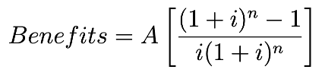



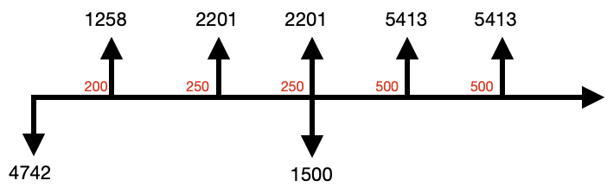

|  |  |  |  |  |  |  |  |
| --- | --- | --- | --- | --- | --- | --- | --- |
| **Benefit** | 15280 |  |  |  |  |  |  |
| **Cost** | 5976 |  |  |  |  |  |  |
| **BC ratio** | 2.55 |  |  |  |  |  |  |
| **1** |  |  |  |  |  |  |  |
| **Benefit** | 15280 | 15280*0.85 | 12988 | Ratio = 2.415 |  |  |  |
|  | 5976 | 5976*0.90 | 5378 |  |  |  |  |
| **2** |  |  |  |  |  |  |  |
| **Benefit** | 15280 | 15280*0.60 | 9168 | Ratio = 1.534 |  |  |  |
|  | 5976 | 5976*1.00 | 5976 |  |  |  |  |

**Best case scenario** : 1. If we do not receive any defective goods and that would save us on return cost.

2. If demand of our product goes up, it will increase the overall benefit cost.

**Worst case scenario** : 1. Due to pandemic, there is no use of bikes and there will be no use of helmets.

2. Competitors came out with better features in helmets.

3. Labour prices increased and raw material became expensive. (Cost 3000 - 1.7 bc)

4. Server crashed and data got lost/leaked.

CLIENT WANTS AND NEEDS

|  |  |  |
| --- | --- | --- |
| **Features** | **Client Want** | **Client Need** |
|  |  |  |
| **Colourful Patch** | Y | N |
| **Navigation** | Y | Y |
| **Music** | Y | Y |
| **Radium Glow** | Y | N |
| **Display screen on Visor** | Y | N |
| **Control button on Helmet** | Y | Y |
| **Calls** | Y | Y |
| **Virtual Reality** | Y | N |
| **Group Sync** | Y | Y |
| **Noise reduction** | Y | N |
|  |  |  |

<https://forms.gle/DQmQbG66wmDbdgYE9>

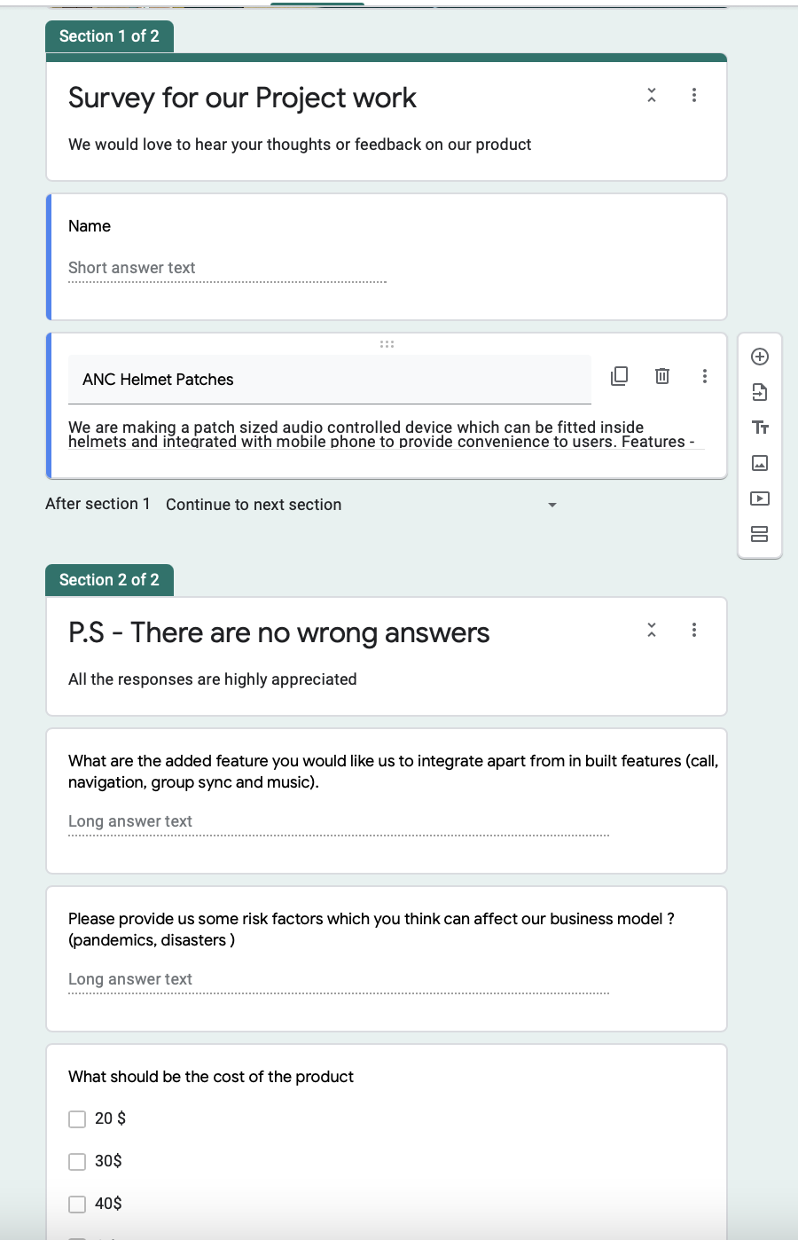

CRITICAL PATH

|  |  |  |  |
| --- | --- | --- | --- |
| **Activities** | **activities** | **Immediate Predecessor** | **Duration (Days)** |
| **Project Proposal** | A | - | 5 |
| **Requirement and Feasibility** | B | A | 11 |
| **Market analysis** | C | B | 9 |
| **Budget cost ratio** | D | C | 6 |
| **Design /sw** | E | B | 14 |
| **Design / hw** | F | B | 5 |
| **Order material** | G | F | 10 |
| **Code / prototype** | H | E | 12 |
| **Hardware / prototype** | I | G | 8 |
| **Integrate device with app** | J | H,I | 5 |
| **Testing prototype** | K | J | 3 |
| **Documenting** | L | D,K | 3 |
| **Presentation** | M | L | 6 |
| **Project completion and submission** | N | M | 1 |

|  |  |  |  |
| --- | --- | --- | --- |
|  | **Duration**  **(*tij*)**  **(2)** | **Total Float**  **(*Lj*-*tij*)-*Ei***  **(9)=(8)-(3)** | **Free Float**  **(*Ej*-*Ei*)-*tij***  **(10)=((4)-(3))-(2)** |
| 2-7 | 9 | 19 | 0 |
| 2-5 | 5 | 3 | 0 |
| 7-10 | 6 | 19 | 19 |
| 5-6 | 10 | 3 | 0 |
| 6-8 | 8 | 3 | 3 |

CRITICAL PATH : 0-1-2-4-8-9-10-11-12-13