ENSC820: Project Proposal Team: ANC

Team Members: Animesh, Nikita and Charley

## INTRODUCTION:

Bikes and cycles have always been associated with helmets since it is a means of safety. Helmet is the most common motor vehicle equipment in the most populous countries. Paper [1] said the enforcement of road safety regulations to drive the motorcycle helmets market to US$ 3,516.5 Million by 2027. Paper [1] also said that smart helmet will play an important role in the future. At present the helmet market are not able to fulfil the needs of riders, most of the helmets available in market are just a shell to protect user in case of an accident and helmets with advance features are too expensive to buy, some of the smart helmets cost more than half the price of motorbike. People are still searching for helmets which are smart, simple to operate and fits in their budget. Our proposed ANC device is built to fulfil those needs.

On the other hand, cars are equipped with endless features. Our agenda is to bring some features to the bike world and make their lives a bit easier. Our idea is to invent a small device that works as a patch with an in-built Bluetooth speakers and microphone that could be fitted inside helmets. This device will connect with a mobile application with features that would make sure their every ride is pleasant, safe, efficient and joyful. Our main motto is to make riding experience advance yet simple.

We will further discuss about the various aspects of the projects in the later sections. The report contains the motivation of the project, a brief introduction of the overall working of the project under project summary and details of all the technical aspects of the project under project details.

## MOTIVATION:

With growing population, the traffic on roads is increasing rapidly and people are leaning towards using two wheelers for daily commute, there are other benefits to it like they are cheaper than cars, do not take much parking space and reaching to places of work takes less than half the time as compared to four wheelers specially in crowded cities and peak office hours, which is an issue in most parts of the world now. One issues with bikes is that you cannot multitask, using maps for navigation needs you to stop the bike open your phone and then remember the route for your destination unlike people with cars who can see as well as listen to navigations, but what if we make it easier just say a command and you can hear navigation till you reaches to your destination from your helmet, no need to check your mobile multiple times and remember the route.

In case your home is far away from your office and it takes you an hour ride to home, now being a productive individual, you would like to listen to podcasts or audio books while you

ride, or maybe you had a bad day in office and you want to uplift your mood before getting home to your family in that case what’s better than listening to Beatle’s on your way back home? But wait you are still stuck with your boring helmet which do not facilitates any of these features. Now you are searching for another helmet which gives you this feature but they are not for all people, they have quite a lot of unnecessary features which you don’t need and they are very expensive, smart helmets are almost half the price of the motor bikes, so you cannot afford it.

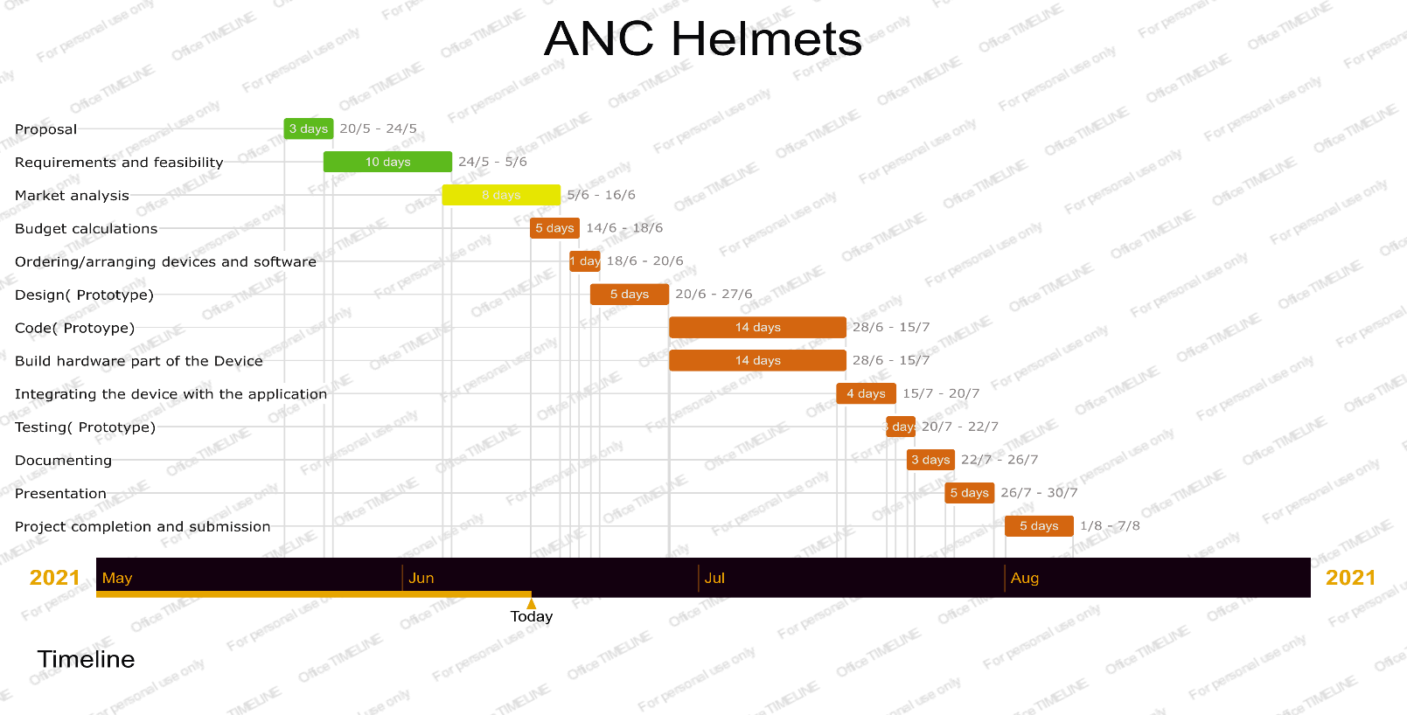

8 days

According to the National Highway Safety Transportation Administration (NHTSA), distracted driving motor accident crashes killed 2,841 people in 2018. And the top 5 reasons are:

1, Using a cellphone for calls, emails, texts, and other phone-related activities. 2, Adjusting a radio station or entertainment system.

3, Looking at electronic devices, such as Global Positioning System (GPS).

We urgently need a plan to release our hands and let us focus more on the road and safe more lives, not only rider but also the pedestrian.

One may ask why not use airpods or other Bluetooth earplug-ins? Firstly, airpods and other Bluetooth earphones costs a lot and in-case of an accident these may break inside the ear and cause harm to the user. Our usage of a patch makes the device much safer and is a cheaper option as compared to those devices. One more disadvantage of having cameras on helmet is that you are carrying it every time you go out so they get scratches and dirt filled in small opening and with the complicated design you cannot just wash it with water and why carry the extra weight when you do not require it? Smart helmet became a complicated device and our main motto for making helmets advance, simple and cheaper.

These helmets can also be modified to be used by construction site workers or people working in tunnels or mines, we can install an additional flashlight maybe in future. Communication with the help of helmets can be lifesaving in these risky jobs, it can be used for efficiently communicating with other to increase the work efficiency as well.

# Timeline

*Figure 1 Gantt Chart*

## PROJECT SUMMARY

Mobiles are very efficient and portable. Since they are carried everywhere, why not use it for bikes? Using this basic idea, we thought of making a device that could be fitted in all kinds of helmets and directly connect it to the mobile with an application. ANC gadget makes a normal helmet an advance one with all the necessary features like calling, listening to songs or podcasts, making groups for multiple helmet synchronization and much more which can be controlled with a mobile application. All the equipment’s for communication like speaker and mic is installed with safe padding within the patch to protect any injuries to rider in case of any unwanted event and it will not reduce the helmets safety measures.

## PROJECT DETAILS

The project is a combination of 2 elements:

1. Helmet Patch ( Hardware element ): It includes a mic, speaker circuit with a computer chip with Bluetooth connectivity.
2. Mobile application ( Software element ) : An IOS application that would perform as an interface to connect to various application like google maps, podcast, weather application and a group navigation app.

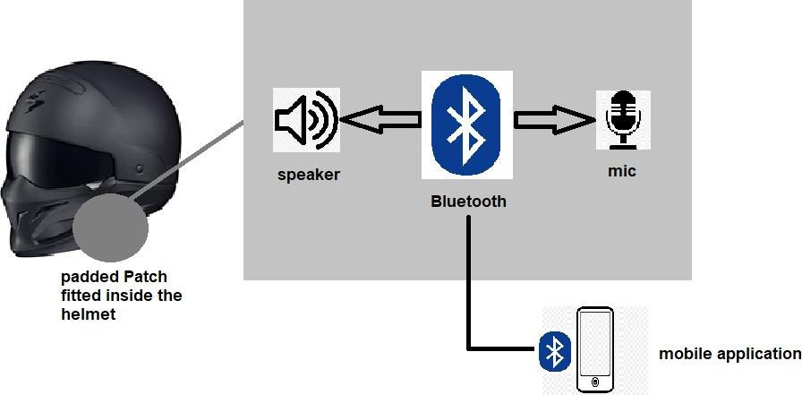

*Figure 2 Architecture*

For the software development: Xcode for the IOS apps, rev.ai for Speech-to-Text API/SDK( rev.ai is an API that translates human voice to the command parameter further send requests to the mobile phones)

For the local service (Virtual machine): Docker (Container), Kubernetes (Container and network control), Python (Port Listening, Response for the user order like group navigation), PostgreSQL (Storage for user profile, user location, user voice record)

For hardware: since we will be making a prototype, we will be using Arduino /raspberry pi paired with Bluetooth module, speaker, mic and a button.

*Features:*

### group navigation

First, add everyone as a group with the unique user ID. Every second the smart helmet sends its ID and coordinates to a database from the cloud. Then the database receives and distributes group information to each of the smart helmets. We could check the location of our friend through our phone app.

### phone call

With the help of the mobile application the user will be prompted whenever there is a call and if he wishes to receive it. A hand-free system of making and receiving calls with simple speech/voice recognition gives a comfortable option to the user.

### GPS

By integrating google maps into the IOS application, the user will be able to navigate easily with the help of speech and listen to the direction without looking at the phone. This would remove the dangers of physically using mobile GPS systems.

* 1. Other features like weather forecast and music will also be available for the user.

# Contribution

* Animesh: Market Research and budget calculation
* Nikita: Application Design (User Interface) and Documentation
* Charley: Device assembling and mobile app development

# References

1. https://[www.researchandmarkets.com/reports/5136523/helmet-market-global-](http://www.researchandmarkets.com/reports/5136523/helmet-market-global-) industry-analysis- size?utm_source=GNOM&utm_medium=PressRelease&utm_code=8xvv63&utm_ca mpaign=1430527+-+Global+Helmet+Market+(2020+to+2030)+-

+Industry+Analysis%2c+Size%2c+Share%2c+Growth%2c+Trends%2c+and+For ecast&utm_exec=jamu273prd

1. https://online.officetimeline.com/
2. D. Audino, F. Baronti, R. Roncella and R. Saletti, "Wireless Audio Communication Network for In-Vehicle Access of Infotainment Services in Motorcycles," *2006 IEEE 17th International Symposium on Personal, Indoor and Mobile Radio Communications*, 2006, pp. 1-5, doi: 10.1109/PIMRC.2006.254000.
3. https://[www.globenewswire.com/en/news-](http://www.globenewswire.com/en/news-) release/2020/08/26/2083877/28124/en/Global-Helmet-Market-2020-to- 2030- Industry-Analysis-Size-Share-Growth-Trends-and-Forecast.html

Future work

Gantt chart

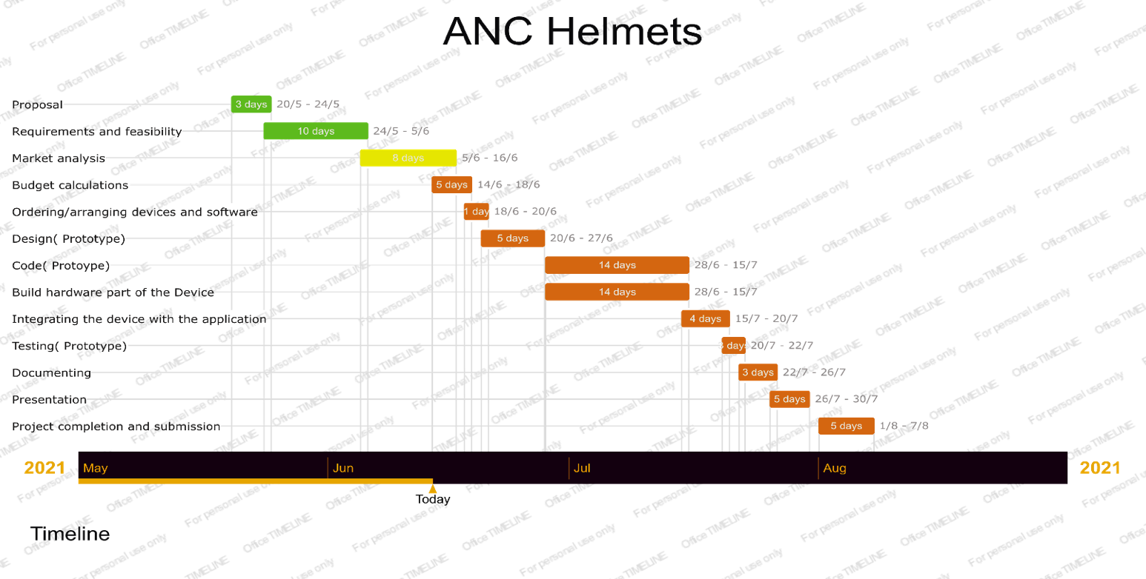

8 days