RISK MANAGEMENT

Delivering a project’s defined scope on time and under estimated budget are characteristics of a successful project. Unfortunately, these factors are extremely hard to achieve, there are external as well as internal requirements associated with the project estimate which can change significantly over time. Risk management deals with such scenarios which may cause delay in project completion. As murphy law state “anything that can go wrong will go wrong”, so while doing initial project planning risk management is extremely helpful to deal with uninvited delay elements, keeping track of all the potential risk elements and preparing a backup plan for at least those which have more than half the probability of occurring is a good approach.

Risk management is often not considered as a core component of a project development phase rather it is taken as “nice to have” strategy but I believe it is a core component because analyzing risk and being prepared for it beforehand is an effective way to deal with any future risk than to prepare a strategy after it happened and wasting time to figuring out what to do while its continuing to damage the business. Main objective of risk management planning is to understand project and program level risks and trying to minimize the likelihood of negative events and maximize the chances of positive events which may be helpful for a business, having risk which can positively affect the business is not definite and it depends on business and its usage.

Project risk management is divided into four major process groups which are risk identification, risk assessment, risk mitigation and risk monitoring and control. Let us look into all of these one by one, risk identification is the first step in which we try to identify all the types of risks that can happen in a project. Risk identification is subdivided into four categories which are technical risks, project management risks, organizational risks and external risks. Second step is to assess the risks identified which is called as risk assessment. We analyze all the risks listed and try to assign a probability of occurrences to each of them, also we figure out the probability of loss that result from them, how much will be the cost of that loss and few worst-case scenarios associated with some of the risks as well. Next step is to find the possible ways of preventing the risk and named as risk mitigation, in this step we try to find out ways to avoid risks, make contingency plans and trying to find alternative if the risk is worth too much and again figuring out if the alternative is not doing much damage otherwise it will be of now use. Last part is to monitor and control the risks, we create a database which logs all the risks occurrences along with a risk ID number, description, who worked on it and what are the steps taken to prevent the risk with all the other details which will help in future to avoid any similar type of risk.

To efficiently manage the risk the best practice is to create a risk identification matrix which will help in categorizing the type of risks and also gives an overview of the risk category, occurrence probability, priority of the risk along with mitigations options. In risk identification matrix we categories the risk within four categories mentioned in the risk identification part. We subdivide the risks into five main types which affect the scope triangle of the project which are scope, time, cost, quality and resource. Risks are assigned to a risk category and then subdivided into scope triangle along with probability and mitigation options. Risk identification matrix associated with our project is shown in figures [].

It is observed that our project has the greatest number of risk events in technology category, there are multiple risk involved with various scope triangle features. We have TS1 – TS4 defining events under the category of technology and which comes under scope part, TS1 is related to hardware issues which may cause by upgraded devices launching in near future, probability associated with event TS1 is 30% which is not much likely but this is not a high priority risk as increase in technology over time will also make our product to upgrade and we will try to make them connect easily with multiple future devices. Event TS2 is related to vendors providing web services for our application which is very less so we assigned a chance of 5% to it as there are always alternative to this option. Device not syncing with cellular phone of new generation as there are many new phone companies emerging every year but all of these are very flexible and they are making phones which are easily connectable with any Bluetooth devices so we don’t have a high probability for this event. Hardware availability might be an issue especially when we have high demands, that is the reason for making this a high priority task and its probability of occurrence is 60%. Cost part of technology category is concerned about the money aspect, event TC1 is directly pointing out to a risk which may cause us to acquire an unexpected hardware maybe in the case of some bulk orders coming in and we might need a device to automate some of our work, money investment for that period of time will work as a negative but the upside of this event is that we will get back a higher revenue with bulk orders which might compensate the issue later, so probability assigned to this event is 20% which priority is high. One same type of event is a parallel event of previous one but this time it’s for software department. One most likely event is TC3 “cost of web services might go up” which is easy to mitigate and hence have a low priority. In time category for the matrix, we have two main events which are service disruption by vendors and software integration API update delays both of these events are not highly probable and unfortunately cannot be mitigated at the time of occurrence, we might plan for a backup but during initial phase of the business model it can be costly. Quality of the product is a very critical component in our scope triangle so we have assigned quality related risks a low priority 10% each for TQ1 and TQ2 and it is very easy to mitigate as well.

Project management category also have some significant events associated with it, there are two events in quality part of project management which deals with accidents of biker riders and inaccuracy in budget planning. Event PQ1 is related to accidents and it’s not something which we can control so no mitigation plan but there is mitigation available for budget accuracies in form of extra funds or savings in case we go out of budget in between project or in any future stage. There are other risks such as better or cheaper product in market and internet unavailability, looking into current business market these are not very likely events and hence assigned a probability of 28% and 15% respectively. Another scope triangle component affected by project management risk is resource which we have introduced in project management category. PR1 is delivery of raw material and PR2 is return of damaged goods, both are very less probable and assigned a probability of medium. PT1 and PT2 is under time category and states risk associated with time duration estimate and problems with meeting schedules both of these are easy to mitigate and unlikely to happen. One last scope triangle feature is related to cost which is having a less demand of product but higher production, this also have another name which is creating more products than the order but this is a necessary step and can be easily controlled under good supervision and quality client management.

STATIC RISK ASSESSMENT MATRIX

Static risk assessment matrix is defined under risk assessment part of risk management, it deals with categorizing events which should be ignored or worked upon or required instant action. It can be created with two main features which are probability of occurrence of an event and loss associated with it.

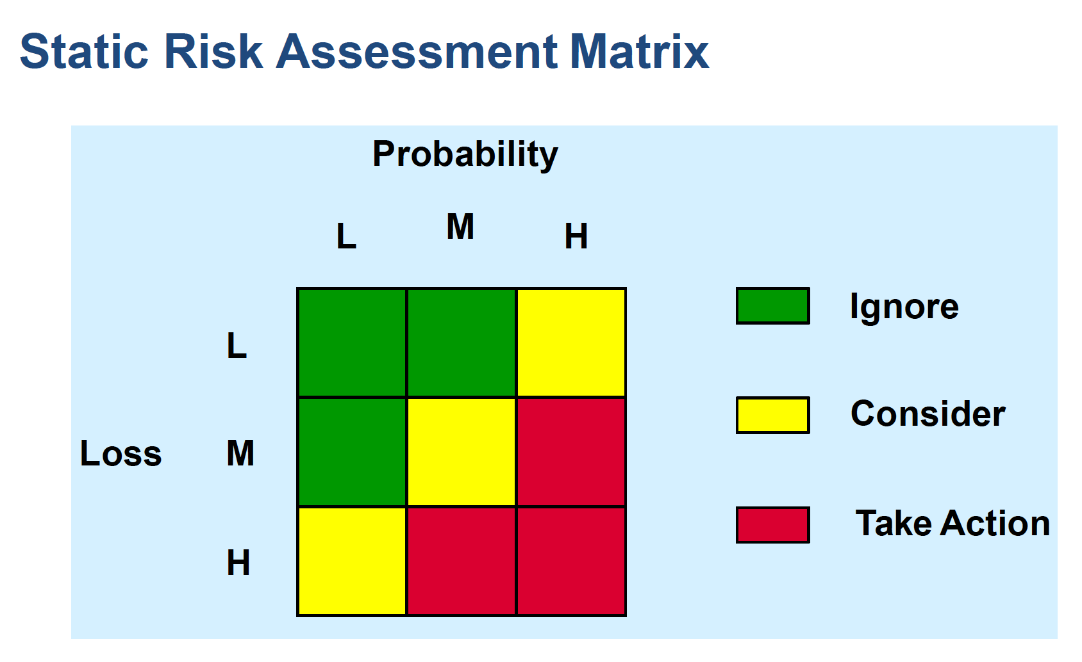

All the events in green region are less probable and do not incur high loss and hence can be ignore, yellow events are the one which do not require instant response but management should consider these as potential risks and make plans to fix them in future. Red region is the dangerous one, all the events falling under red are highly probable and have high loss component attached to them. In our case TS4 in technology category is an event which is highly probable with 60% chances of occurrence and have high losses associated with it, hence this event can be categorized as take actions event.

BENEFIT COST RATIO

Benefit cost ratio is a project profitability indicator used in cost benefit analysis to determine the viability of cash flow in a project. It is the ratio between the present worth benefit generated from the model with the present worth cost involved in it. A benefit cost ratio value higher than 1 indicates that the project is expected to generate a profitable income while a value less than 1 is a loss scenario. Mathematically benefit cost ratio is given as below.

Present worth benefits and cost is given by the equation below.

Where,

Benefit cost ratio values interpretation,

: Business is projected to make profit

: Breakeven situation, money invested = money earned

: Business is projected to make loss

In term of our project, to calculate the benefit cost ratio we need to first figure out the total cost and estimated benefit of our project. Let’s look into the cost analysis for our prototype in below table with an overview of manufacturing and operations cost for products in the figure. Manufacturing cost of products comprises of the cost of various raw materials used in manufacturing such as Mic, Bluetooth and other materials while on the right hand side of the figure ratio of operating costs which is required to smooth functioning of our project is given, it is clear that cloud services is taking a big chunk of pie out of operating cost which can be reduced using cheaper alternatives in future.

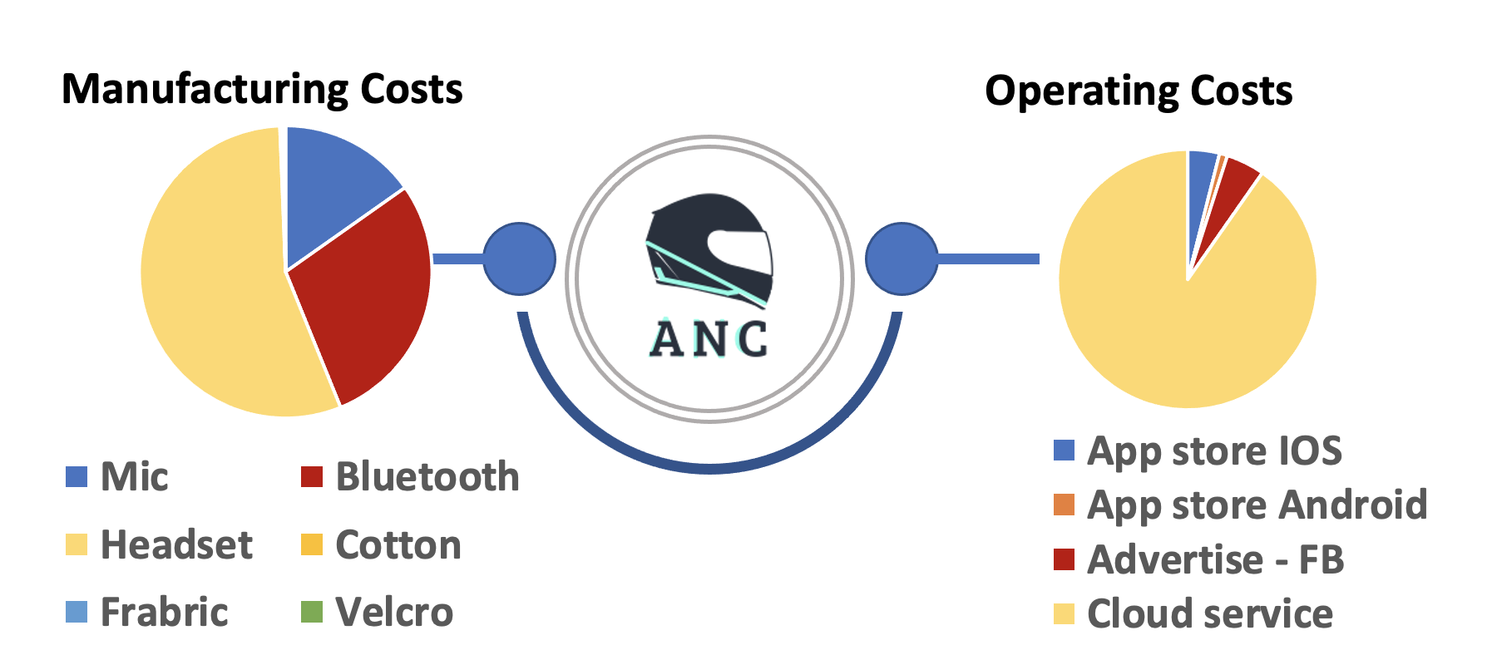

We need to list out the cost involved for each individual raw material per product to find out the total cost involved in overall project; table below shows the cost breakdown of manufacturing as well as operational requirements. Internal assemble of microphone, bluetooth and headset costs 1.7, 3.2 and 6.2 dollars respectively while outer padding consist of cotton, fabric and Velcro which costs a total of 0.07 dollars per piece. There are no raw material involved for software as we can use our normal laptop for programming and maintenance but we do need to list out our application in IOS and android store which can cost a total of 124 dollars. We are involving a very basic Facebook advertising scheme involving investment of 10$ per month which makes it 120 dollars annually. Cloud services for hosting out environment and supporting database and other application required services will cost around 2268 dollar. Total 2512 dollars are invested in operations costs annually.

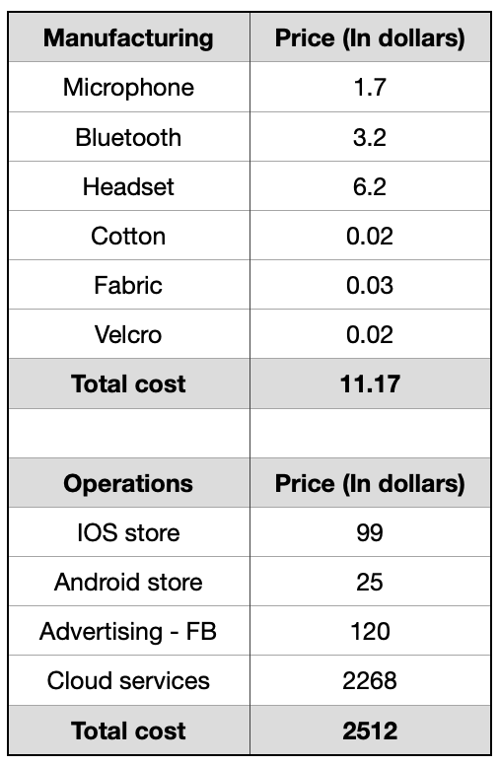

Sales estimate is the main part for deciding the benefit cost ratio over the upcoming years so table below shows the items manufacturing estimate along with the cost involved and cost price as well as the return amount on the overall investment with profit figure separate. We will start the project with manufacturing 200 product for the first year which will require a manufacturing cost of 2234 dollars with 11.17 dollars per piece. Extra cost evaluated for first year which will be our operational cost will be 2512 dollars annually. So total input from our end by the end of first year will be 4742 dollars. Now let’s look into the selling aspect, considering margin to enough for sustaining our business model and generating money for our risk mitigation as well as research part we kept the selling price for each product as 30 dollars which is still way less than any smart helmets available in market as of now. If we manage to sell all 200 products by the end of the year, we will have a profit of 1258 dollar in our first year which is a good figure.

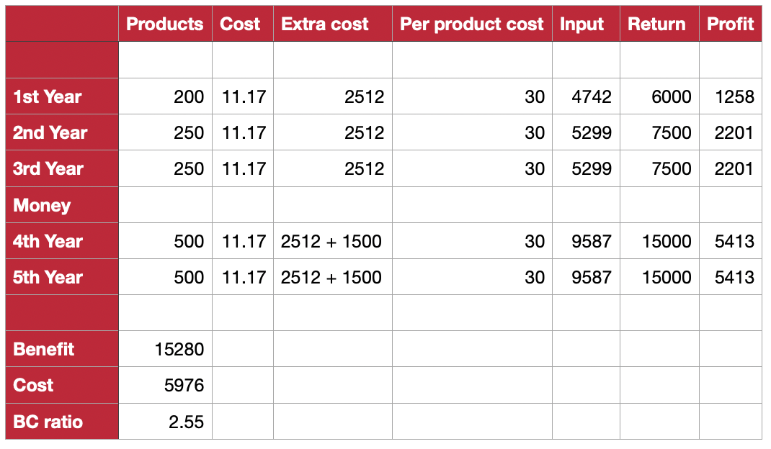

Looking into the second and third year, with the profit gained in first year we will be increasing our manufacturing quantity to 250 products for these years. With the same logistics in place, we will be projecting for a profit of 2201 during these years. After third year we are planning to go for a business loan at the standard rate of 4.5%. Loan amount will be of 1500 dollars and we will be using this money to invest in doing our assembly and stitching work, we are planning to increase our production from 250 to 500, it is required to have some assistance for making these products and since this can be done within a month, we do not need a full-time person or employee rather we can outsource it to vendor or maybe as a part time job for a month costing us 1500 for fourth and fifth year. With the loan in the model, we still are having a profit of 5413 with which we can easily clear up the loan amount in a year. A benefit cost ration chart shown below will be easy to visualize the projection of our project.

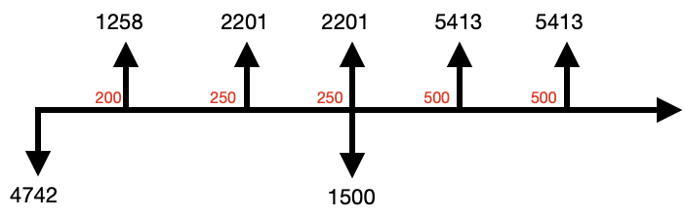

Downward arrows showing money invested into the business while upward arrows showing profit generated each year. 4742 is the initial investment and 1258 is the profit after completing first year. 1500 downward shows the loan taken and arrow just after the loan shows that consecutive year the projection for profit will be 5413 dollars.

With all the cost details are analyzed and final projection is also decided, next step is to calculate the benefit cost ratio using the formula before.

Above calculation shows that we have a benefit cost ratio after five years projection of input and sales will be 2.55, which means that for each dollar invested into the project we will receive a benefit of 2.55 dollars. It is easy to interpret now that the higher the ratio goes the more profitable business it became. Incorrect cashflow prediction may lead to a flawed benefit cost ratio and it can lead to a very bad situation. Therefor benefit cost ratio is a useful measure to determine the project feasibility and check if the project will generate profit over the upcoming years or not. One of the main advantages of benefit cost ratio is that it is very easy to calculate, it does not involve any complex mathematical calculations for which one need a computer or MATLAB skills. Anyone can do the BCR projection with the help of a simple calculator.

BEST AND WORST CASE SCENARIO

A very important point to be considered while creating a benefit cost ratio is that it is based on assumptions and we cannot rely completely on the estimates by our projection, there are scenarios which can affect these estimations and which can change the benefit cost ratio for the project. For example, in case other companies launched a product which is cheaper or equal price as our product then it may reduce the sales projection and we may not be able to sell all our products which can affect the BCR ratio. Another example will be a software related issue maybe transaction or payment gateway not working or server crashed which may cause us to lose revenue. We tackle these unwanted situations with adding probability in benefit cost ratio. We multiple the benefit generated with the probability of getting the benefit value as expected and we do the same with the denominator. Overall formula changes a little bit as shown below.

In our project we have taken two scenarios to get a benefit cost ratio with probability in both the cases, first case is an optimistic approach where we are considering a 85% probability of getting the same benefit as expected and 90% probability that the cost of project will be the same as expected. After calculations as shown in table below, we got a benefit cost ratio of 2.415 which is almost same as our initial projection which was 2.55. Let us now take the worst-case situation where we have taken a benefit likeliness of 60% whereas the cost will remain the same, this gave us a benefit cost ratio of 1.53 approximately which is a dollar less than our initial projection and it’s not a good scenario but risks are inevitable part of any business and we must consider the worst-case scenarios to be on the safer side. One good point about both the worst and the best case is we were able to make profit in both the situations, even though we reduced our benefit from 100-60 percent we are still on the positive end of the benefit cost ratio, which implies that this project is a good choice and it will be able to sustain even the high risks associated with it.

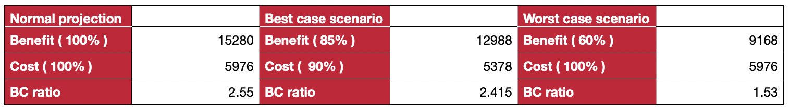

SURVEY

There are many topics for which we needed real-time feedback to understand more about the stakeholders’ opinions on various sections of our project. We created a google survey for our project. Link for our survey is <https://forms.gle/DQmQbG66wmDbdgYE9> , we kept it open for people who might still want to provide feedback (link is also provided in the reference section). Questions given in the feedback are listed below with a small screen capture containing few initial responses.

Q1. What are the added feature you would like us to integrate apart from in built features (call, navigation, group sync and music)?

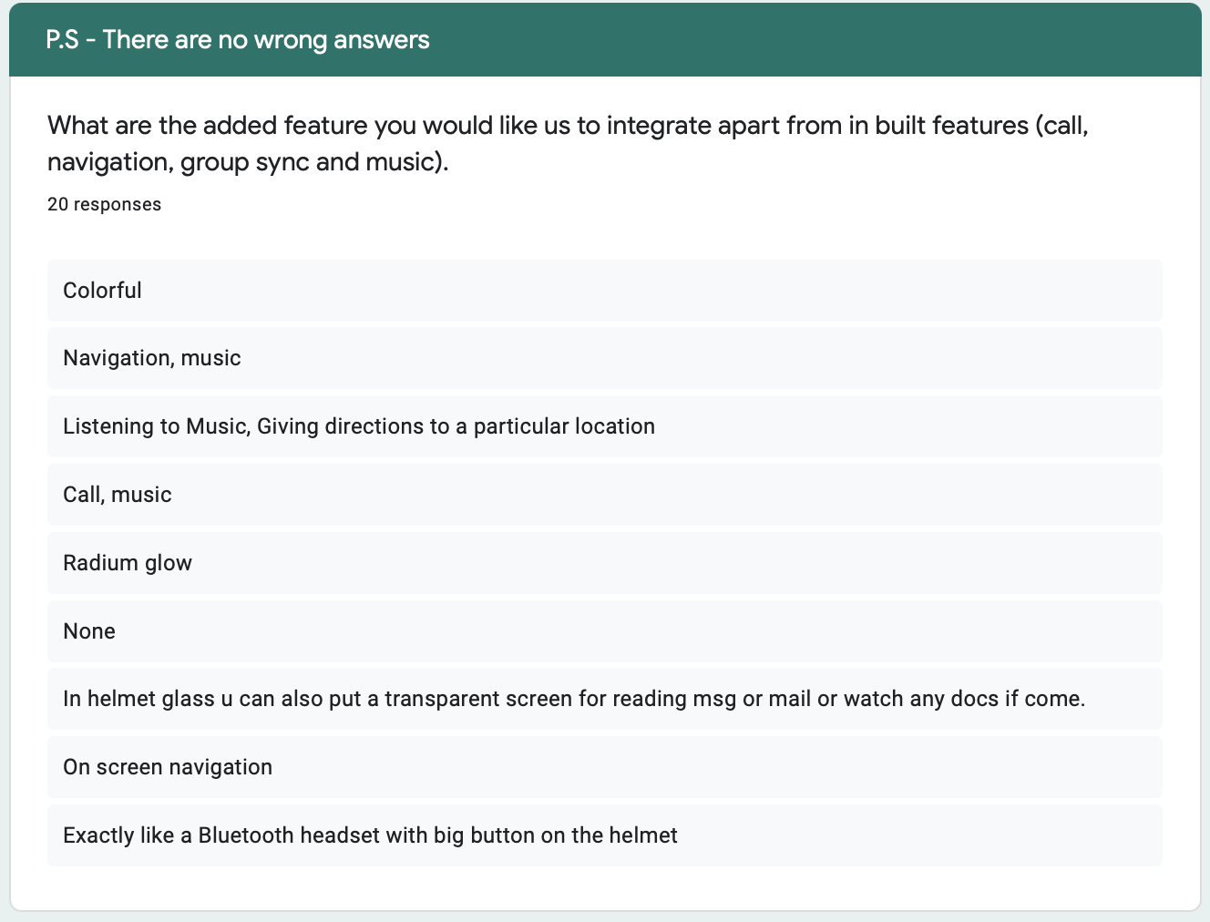

Q2. Please provide us some risk factors which you think can affect our business model ? (Pandemics, disasters)

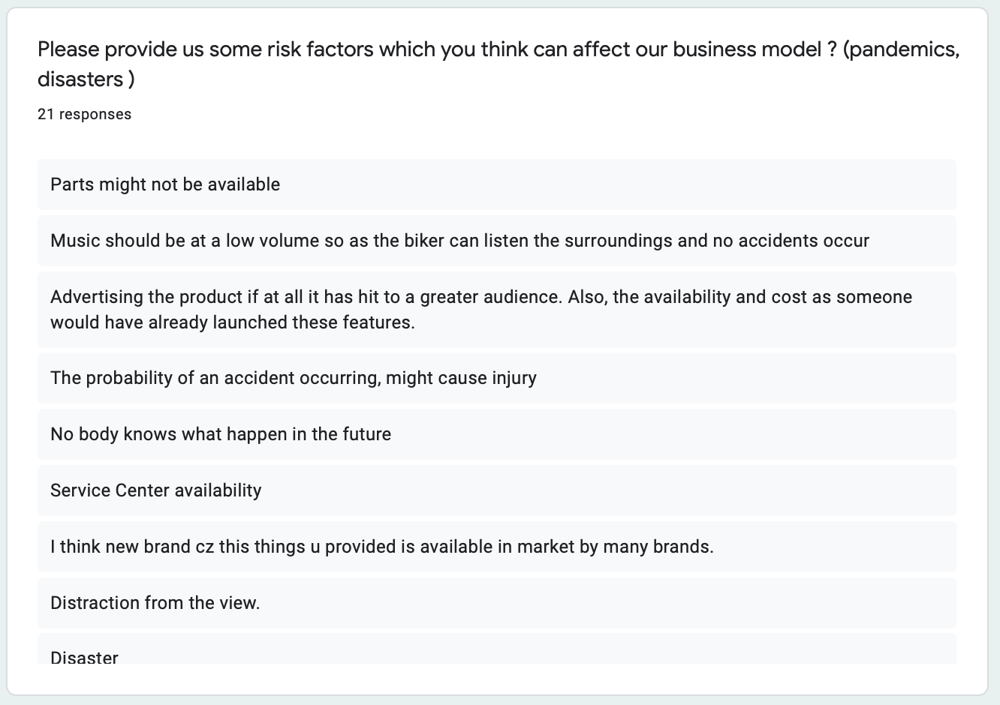

Q3. What should be the cost of the product (USD)?

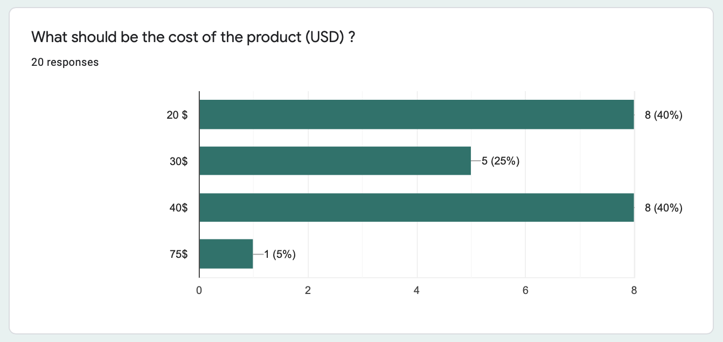

Q4. Suggestions for improvement.

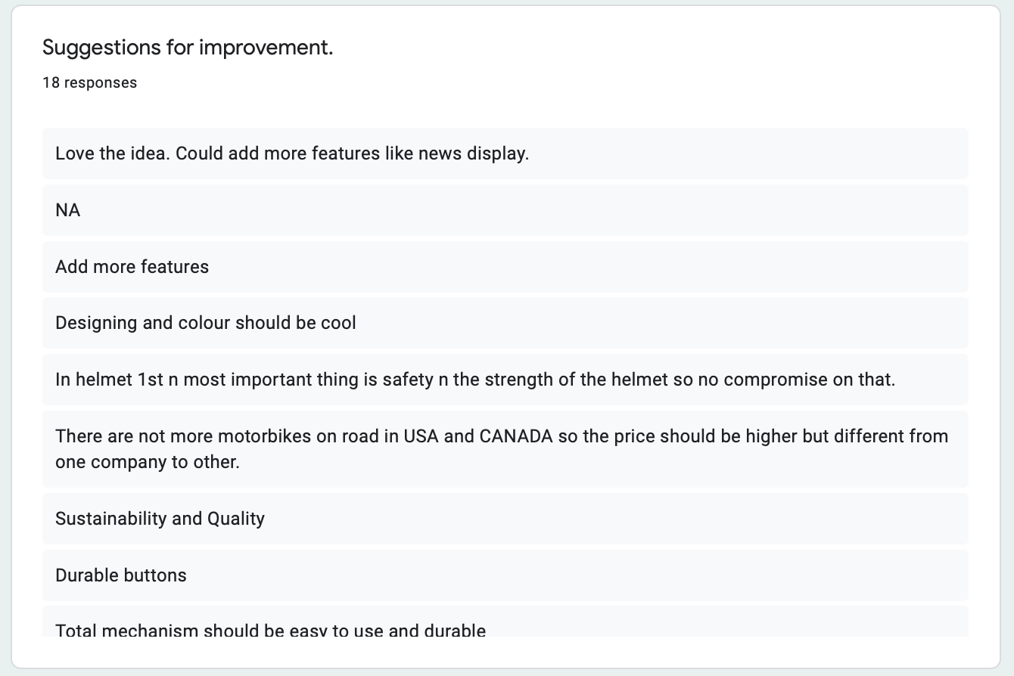

Q5. Overall Feedback

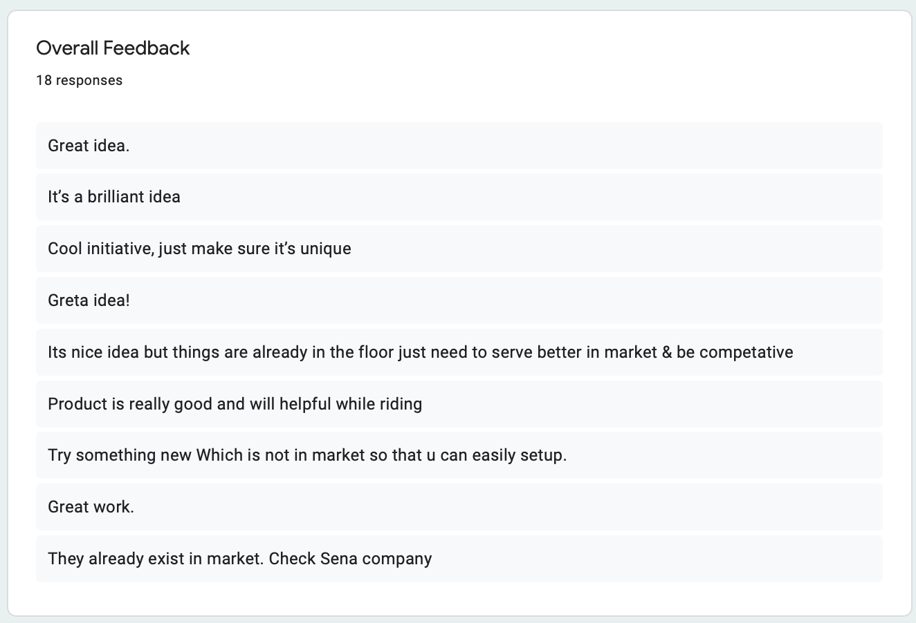

There were five questions provided in the survey. We got an approximate of total 20 responses. Main objective of our survey is to figure out what the client wants and needs. We have consolidated the client requirements from survey into a table shown below.

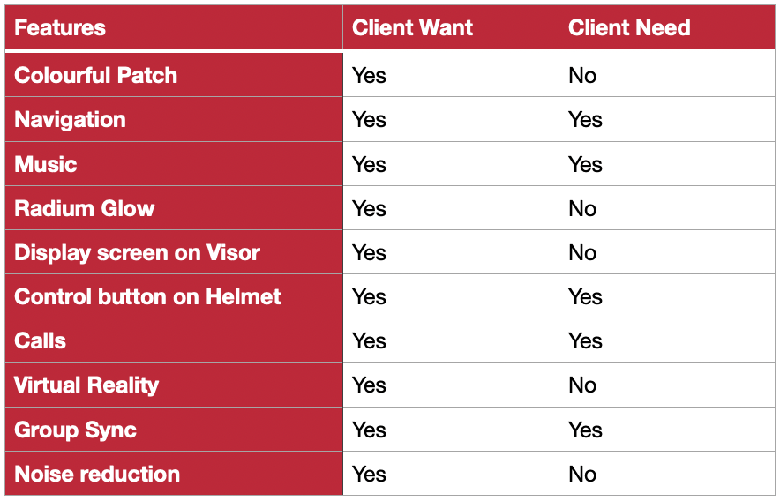

Four features that are repeated most number of times are calls, navigation, music and group synchronization which are the basic built in features for our product. Few other features which are in demand are display screen on visor which is a good option but it’s a costly technology and it will increase the cost of the product defeating the main aim of creating a cheaper solution to smart helmets. Another important feature in the wants field was adding color to our product design which is not yet implemented but a very easy alternative and won’t cost much as we just need to buy the colorful fabric for outer layer and it also gave us motivation to add stickers to patches related to sports, fashion which are in popular demand and can be used to advertise easily as a fashion accessory.

FUTURE WORK

Our product is an alternative to a product which is not very famous because of its price factor. There are smart helmets available in the market which is expensive and people are not very much interested in those helmets because comparing the technology factor of those helmets with normal helmets doesn’t justify the use and people are better off with a simple helmet. No one wants to listen to music on their helmet by paying an additional sum of 500 dollar, but this does not mean that there is no market for this type of product. Making commute simple yet efficient is a major advantage of our patches. These patches are easy to install and can be used with any type of helmets. Our survey showed that all participants who took part in survey are in favor of our product and the price range is also very less which makes it a suitable product. People don’t need a new helmet rather they can just stick up our patch inside their existing helmet and it will work completely fine. Adding color and stickers for our patch is a future aspect which can be very beneficial, as people showed interest in colorful patches in our survey. One important future work is a survey on a bigger scale. We need to do a survey including at least more than 1000 people who are bike riders having driving license and it will increase the quality of survey and we can get some serious feedbacks.

Patches which are detachable have a very big market in the field of construction workers who wear helmets while working. They use a walkie talkie to communicate which has a disadvantage of short range and distortion in signals, people need to stop working while talking on walkie but with our patches all these issues can be resolved, in fact we can use this in any facility where a group of people works together like zoo, museum or laboratories. Another important future modification work for these patches will be making it flexible to install on hospital beds where patients can use these to send a distress signal to hospital authorities in case of emergencies, it need many modifications but we can make it work. Another important usage of this patch is that we can add a larger speaker with all other features and it can be used in cars as hanging accessory, there are many advance cars which comes equipped with all these functions but again the price plays an important role, everyone cannot afford those cars or maybe most of the people loves their old car and don’t want to change it, our patch can help making the old or vintage car equipped with some latest accessories with a very small amount of money and its detachable feature wont hinder the appearance after the drive you do not have to keep it hanging in the car, take it with you in garden and have a musical barbeque.

Military

Construction

Permanent go pro