SEM VI

T.Y. B.C.A.

2021-2022

INTERNET OF THINGS

PRACTICAL LAB

ISA-2

Home Automation System

Class: TY BCA

Group:

**Name** **Admission No.**

Dwijesh Talaulikar 192004

Animish Shrivant 192019

Rutik Bhatt 192021

Aniruddh Borkar 192026

**INTRODUCTION**

Home automation is the automatic control of electronic devices in your home. These devices are connected to the Internet, which allows them to be controlled remotely. With home automation, devices can trigger one another so you don’t have to control manually via an app or voice assistant.

Sensors used in our project:

1.PIR Sensor (Passive Infrared)

2.Ultrasonic Distance Sensor

3.Photoresistor/LDR Sensor (Light-Dependent Sensor)

4.Gas Sensor

1. PIR Sensor – (Passive Infrared sensor) a device used to detect motion by receiving infrared radiation. When a person walks past the sensor, it detects a rapid change of infrared energy and sends a signal.

Uses: PIR sensors are used for applications such as automatically turning on lights when someone enters a room or causing a video camera to begin operating.

2. Ultrasonic Distance Sensor - An ultrasonic sensor is an electronic device that measures the distance of a target object by emitting ultrasonic sound waves and converts the reflected sound into an electrical signal.

Uses: It is used in Submarine using Sonar waves which stands for Sound for navigation and ranging.

3. Photoresistor/LDR Sensor - LDR (Light Dependent Resistor) as the name states it is a special type of resistor that works on the photoconductivity principle means that resistance changes according to the intensity of light. Its resistance decreases with an increase in the intensity of light.

Uses: It is often used as light sensor, light meter, [Automatic Street lights](https://www.electronicsforu.com/electronics-projects/street-light-controller) and in area where we need to have light sensitivity.

4. Gas Sensor - A gas sensor is a device that senses the atmosphere's presence or concentration of gases.

Uses: Gas sensors are used in Agriculture industries, transportation industries, fire suspension testing, aerospace industries, and medical and life-science industries.

**DIAGRAM**

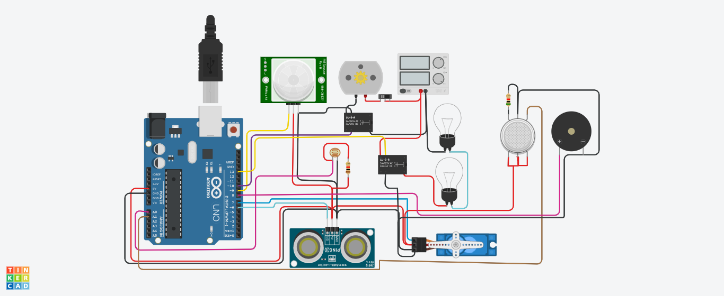

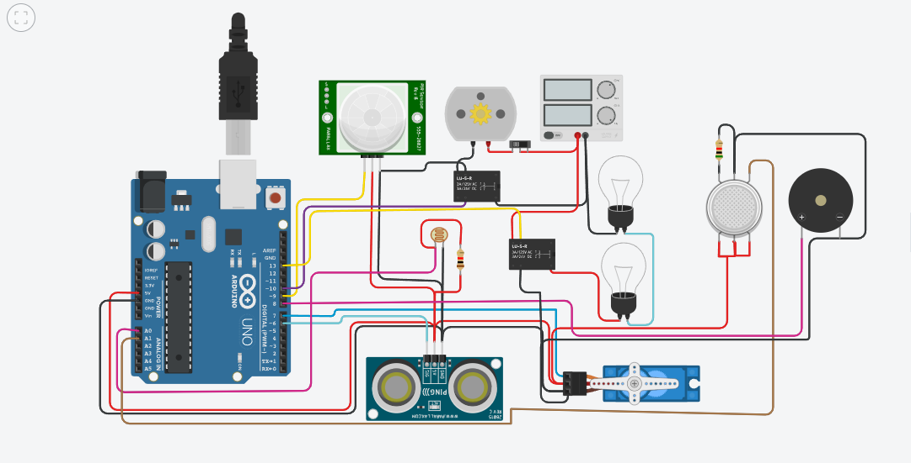

**CODE**

