Assignment Solution

Short version

The solution includes 3 databases:



The source database:

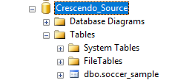

Staging database:

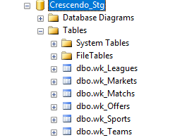

Target database:

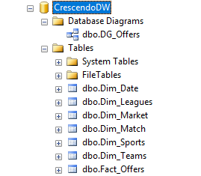

Datawarehouse schema:

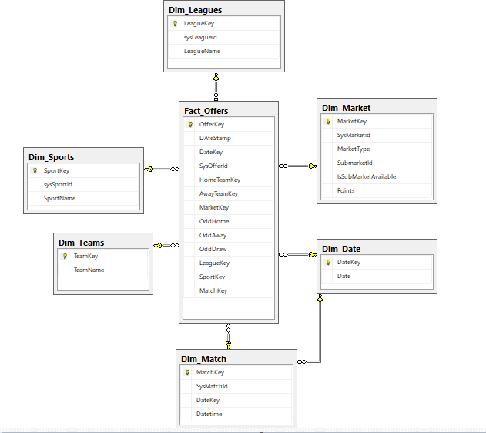

2. Script for generated extract & transform stored procedures:

**scCodeGenerator-wk-Tables_Procs.sql**

3.Script for running Extract&Transform code:

**Extract&Transform_Script.sql**

**Todo:**

Stored procedures for Load data in target database.