**NAME OF THE EXPERIMENT:** Fiber Optic Communication using Fiber Optic Communication Kit

**OBJECTIVES**:

1. To study the principles and working mechanisms of fiber optic communication
2. To demonstrate the transmission and reception of optical signals through fiber optic cables laser as light sources.
3. To analyze the efficiency of data transmission.
4. To provide practical exposure to the components involved in fiber optic communication systems, such as optical transmitters, receivers, couplers, and connectors

**FUNDAMENTAL CONCEPT**

Fiber optic communication involves transmitting data using light signals through a fiber made of glass or plastic. The optical fiber is a medium that guides the light pulses generated by an optical transmitter, which are then detected by an optical receiver at the other end. The process relies on the principle of total internal reflection, which keeps the light contained within the core of the fiber. The propagation of light inside an optical fiber is governed by the phenomenon of total internal reflection. The light signal travels through the fiber core, reflecting off the core-cladding interface, which keeps the signal confined within the fiber. This ensures minimal signal loss over long distances.

The basic components used in for optical communication is mentioned below:

* **Transmitter (Light Source):** Usually a Light Emitting Diode (LED) or a laser diode that generates the light signal. The light is modulated by the electrical data signal before entering the fiber.
* **Optical Fiber:** A thin, flexible strand of high-purity glass or plastic that transmits the light signal. Optical fibers are classified into two types:
* **Single-mode fibers**: Used for long-distance communication as they allow only one mode of light to propagate, reducing dispersion and signal loss.
* **Multi-mode fibers**: Used for short-distance communication, where multiple light modes propagate through the fiber, leading to higher dispersion.
* **Optical Detector (Receiver):** Converts the optical signal back into an electrical signal. Common detectors are photodiodes (PIN or avalanche photodiodes).
* **Regenerators or Amplifiers:** These are used in long-distance fiber optic systems to boost the signal strength.

**REQUIRED EQUIPMENT**

* + - 1. Module KL-95001
      2. 3-meter optical fiber
      3. AC- to- DC Power Adapter
      4. Microphone-Earphone set
      5. 10-mm jumper
      6. Connecting lead

**EXPERIMENTAL SETUP**

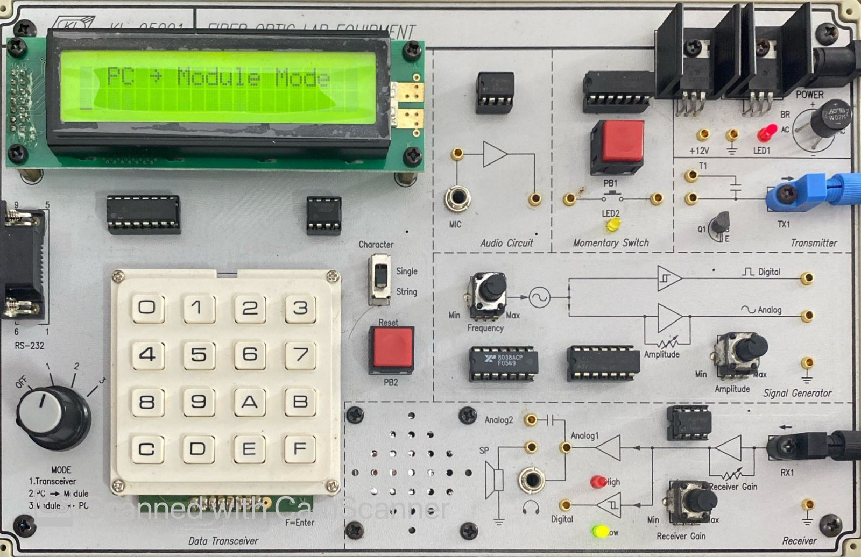

Fig 1: Setup of the Module KL-95001 used as a Transmitter for different purpose like voice, text, etc.

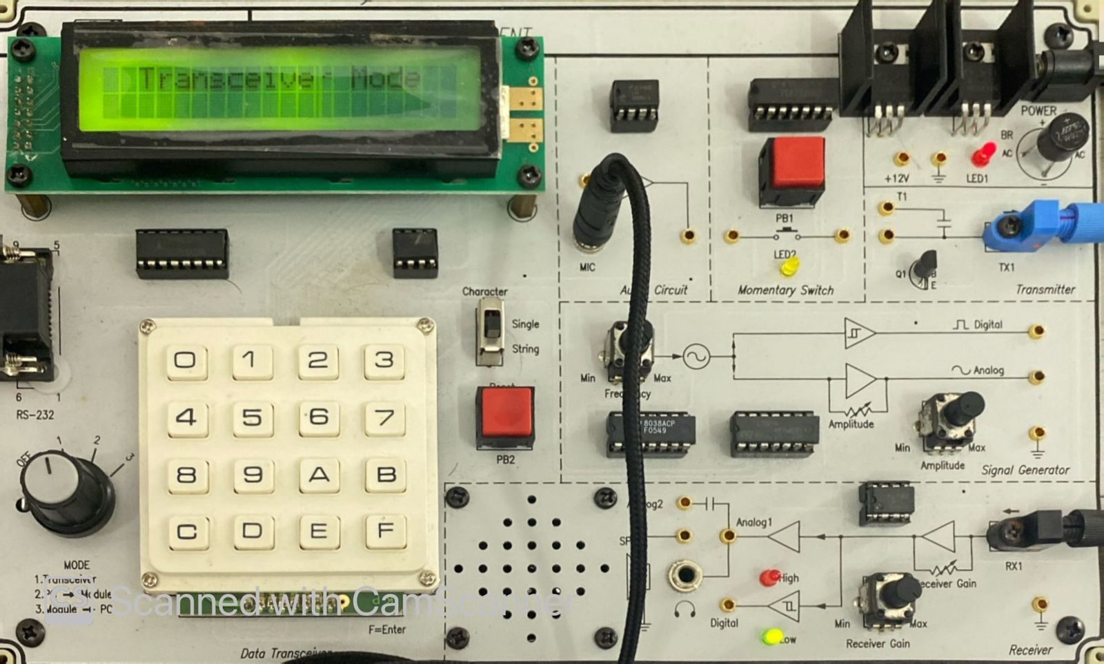

Fig 2: Setup of the Module KL-95001 used as a receiver for different purpose like voice, text, etc.

**EXPERIMENTAL PROCEDURE**

1. Modules were positioned 4 to 4.5 meters apart to avoid interference.

2. Verified the MODE selector on the transceiver was in the off position.

3. Connected the audio circuit output to the transmitter input with a lead.

4. Connected the receiver’s analog output to a speaker.

5. Inserted one end of the fiber into a 5-meter duplex cable and connected it to the transmitter.

6. Plugged in the AC-to-DC adapter into the transmitter’s power jack.

7. Identified the loose end of the fiber by the red light.

8. Connected the fiber to the receiver's Rx1 port until contact was made.

9. Tested the modules by tapping the microphone.

10. Verified voice transmission through the fiber optic system by having a team member speak into the microphone.

**RESULTS**

After setting up the module for the experiment, an analog signal was transmitted, and it was detected at the end of the fiber optic cable, with a steady light being observed, as depicted in Fig 3. Subsequently, digital data transmission was performed, and a blinking light was noted at the end of the fiber optic cable, as shown in (Fig 4), representing the pattern "101010" and thereby confirming successful digital data transfer.

Following this, the transmission of audio signals from the transmitter to the receiver was successfully accomplished. The audio transmitted through the optical fiber was clear, with very low noise interference. When a member of the group spoke into the microphone at the transmitting end, the voice was distinctly audible through the earphones at the receiving end, demonstrating successful signal transmission (Fig 5). The red light observed at the fiber's output confirmed the ongoing transmission of light from the transmitter to the receiver.

Throughout the process, there was no significant degradation or loss of signal, and the system remained responsive to the microphone's input. The KL-900D modules operated efficiently in both transmitting and receiving modes, ensuring smooth data flow through the optical fiber network.

Fig 3: Transmission of Analog data using fiber optic

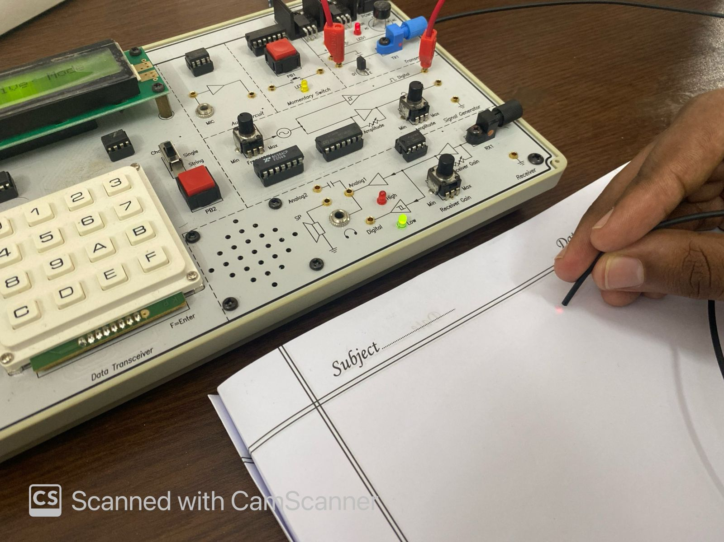

Fig 4: Transmission of Digital data using fiber optic

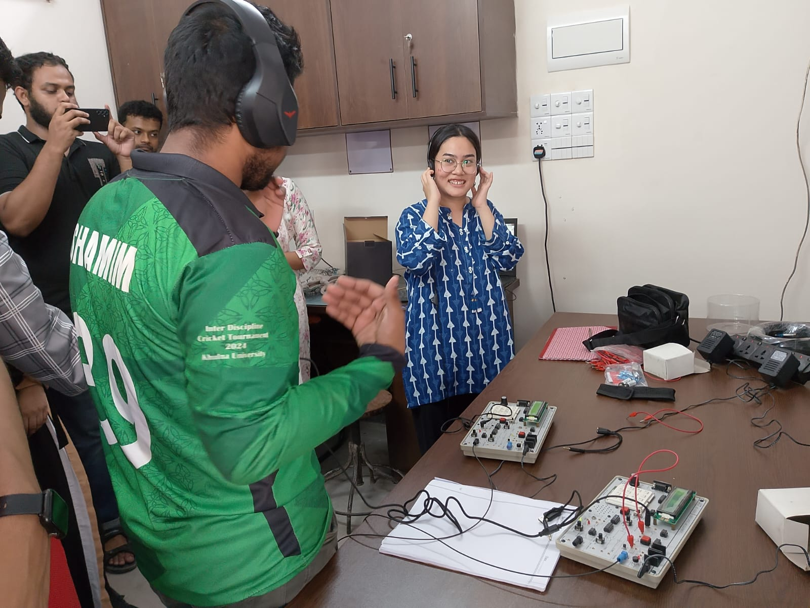

Fig 5 :Transmission of voice signal through fiber optic cable using microphone and speaker

**DISCUSSION**

The experiment demonstrated fiber optic communication principles, where light transmits data effectively. The KL-900D kit converted electrical signals to optical signals at the transmitter and back to electrical at the receiver. The clear audio transmission confirmed optical fibers' efficiency and reliability with minimal noise and distortion. Both analog and digital signals showed minimal signal degradation, highlighting the importance of proper alignment. The experiment demonstrated the advantages of optical fibers, including high data rates, long-distance transmission, and resistance to electromagnetic interference, showcasing their superiority over copper-based systems for reliable data transfer.

**CONCLUSION**

In conclusion, the fiber optic communication experiment successfully demonstrated reliable transmission of audio, analog, and digital signals with minimal interference. Proper fiber alignment ensured signal quality, and real-time voice/data transmission was achieved without noticeable noise. This experiment highlighted fiber optics' benefits—high bandwidth, low signal loss, and immunity to electromagnetic interference—proving its efficiency for clear data transmission.