**Implementation of Claims Web-Service (in Java) that performs CRUD operations**

1. Technologies used
2. Database Design
3. Architecture
4. Sample test data
5. Test Cases

Technologies used:

Programming language: Java 1.8.0_25

Database Server: MySQL 5.5

Application Server: Apache Tomcat 7.0

Web service: REST

Project Management tool: Maven

External jars: mysql-connector-java and jersey libraries

IDE: Eclipse Luna

REST Client: Postman

Database Design:

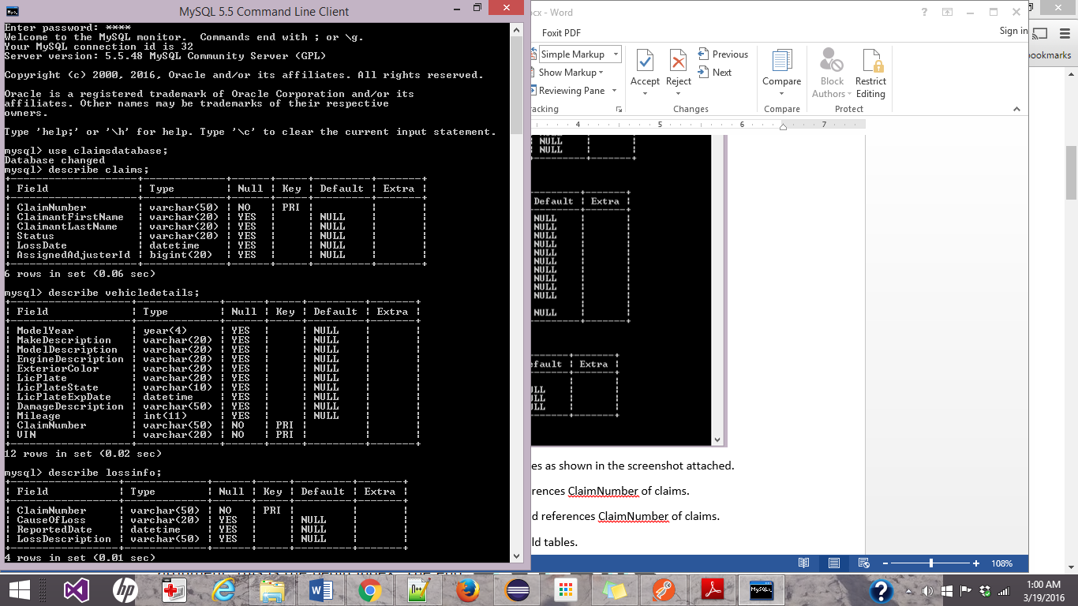

Database name is claimsdatabase, which has three tables as shown in the screenshot attached.

*ClaimNumber* column in lossinfo is foreign key and references *ClaimNumber* of claims.

*ClaimNumber* column in vehicledetails is foreign key and references *ClaimNumber* of claims.

Deleting a claim in the parent table, cascades to the child tables.

Architecture used: MVC

Controller: Controller classes are implemented in the package WebService.Claims.Controller

Model: Model classes are implemented in the package WebService.Claims.Beans

View: In this application, Postman client is used to accesses the web service.

Apart from the above mentioned packages, there are the following two packages:

WebService.Claims.Business: provided for implementation of any business logic.

WebService.Claims.DAL: takes care of database connectivity and CRUD operations.

Sample test data:

Following is a screenshot of some of the sample data that was used for testing purposes.

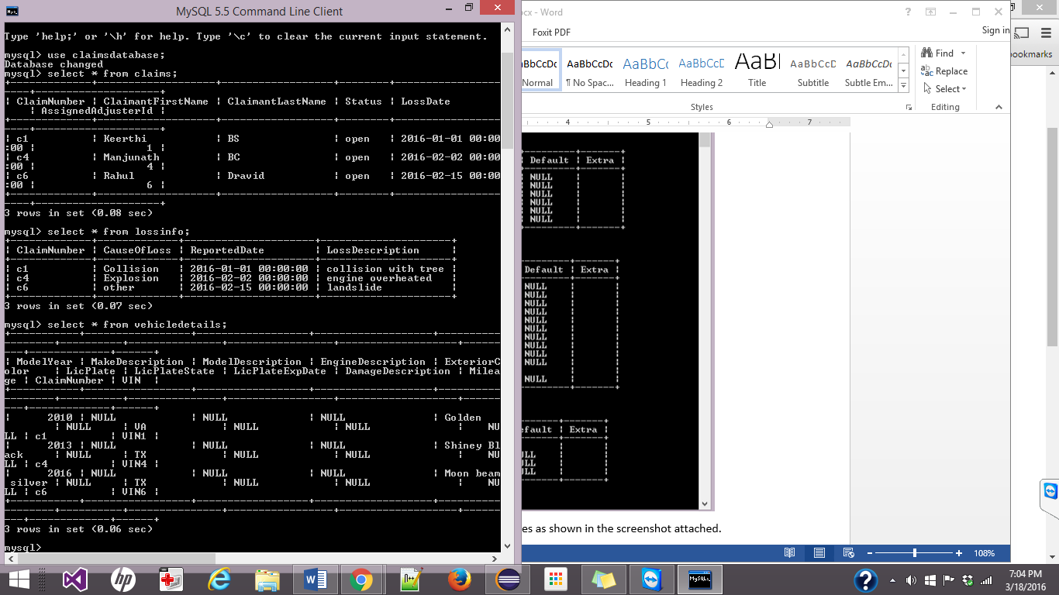

Test Cases: These also serve as instructions on how to access the web service from the client.

1. Read a claim from the backing store.

Request:

Uri: <http://localhost:8080/Claims/webapi/readclaim>

Method: POST

Body:

<inputclaimnumber>

<claimnumber>c6</claimnumber>

</inputclaimnumber>

2. Find a list of claims in the backing store by date range of the LossDate.

Request:

Uri: [http://localhost:8080/Claims/webapi/findclaimsgivendaterange](http://localhost:8080/Claims/webapi/readvehiclefromclaim)

Method: POST

Body:

<inputlossdates>

<fromdate>2016-01-01</fromdate>

<todate>2016-02-02</todate>

</inputlossdates>

3. Read a specific vehicle from a specific claim.

Request:

Uri: <http://localhost:8080/Claims/webapi/readvehiclefromclaim>

Method: POST

Body:

<inputclaimnumberandvin>

<claimnumber>c6</claimnumber>

<vin>VIN6</vin>

</inputclaimnumberandvin>

4. Delete a claim from the backing store.

Request:

Uri: [http://localhost:8080/Claims/webapi/deleteclaim](http://localhost:8080/Claims/webapi/readclaim)

Method: POST

Body:

<inputclaimnumber>

<claimnumber>c6</claimnumber>

</inputclaimnumber>

5. Create a claim and persist it to the backing store.

Request:

Uri: <http://localhost:8080/Claims/webapi/createclaim>

Method: POST

Body:

<?xml version="1.0" encoding="utf-8"?>

<mitchellclaim xmlns:cla="http://www.mitchell.com/examples/claim">

<claimnumber>c299</claimnumber>

<claimantfirstname>george</claimantfirstname>

<claimantlastname>washington</claimantlastname>

<status>open</status>

<lossdate>2014-07-09t17:19:13.631-07:00</lossdate>

<lossinfo>

<causeofloss>collision</causeofloss>

<reporteddate>2014-07-10t17:19:13.676-07:00</reporteddate>

<lossdescription>crashed into an apple tree.</lossdescription>

</lossinfo>

<assignedadjusterid>12345</assignedadjusterid>

<vehicles>

<vin>2788</vin>

<modelyear>2015</modelyear>

<makedescription>ford</makedescription>

<modeldescription>mustang</modeldescription>

<enginedescription>ecoboost</enginedescription>

<exteriorcolor>deep impact blue</exteriorcolor>

<licplate>no1pres</licplate>

<licplatestate>va</licplatestate>

<licplateexpdate>2015-03-10-07:00</licplateexpdate>

<damagedescription>front end smashed in. apple dents in roof.</damagedescription>

<mileage>1776</mileage>

</vehicles>

<vehicles>

<vin>p042788</vin>

<modelyear>2015</modelyear>

<makedescription>ford</makedescription>

<modeldescription>mustang</modeldescription>

<enginedescription>ecoboost</enginedescription>

<exteriorcolor>deep impact blue</exteriorcolor>

<licplate>no1pres</licplate>

<licplatestate>va</licplatestate>

<licplateexpdate>2015-03-10-07:00</licplateexpdate>

<damagedescription>front end smashed in. apple dents in roof.</damagedescription>

<mileage>1776</mileage>

</vehicles>

</mitchellclaim>