Methods
2.1 Design Philosophy
A Star schema-based data warehouse was designed to facilitate data-driven decision making within the supply chain domain. This architecture enables efficient multidimensional analysis and supports both descriptive and predictive analytics. The design phase focused on establishing a robust logical model prior to ETL and data population.
2.2 Platform and Tools
All schema design and database creation were conducted using Microsoft SQL Server Express 2022. SQL Server Management Studio (SSMS) was employed as the primary interface for schema creation and verification. Entity-Relationship Diagram (ERD) were generated using dbdiagram.io to ensure schema integrity and facilitate communication of database design.
2.3 Schema Construction

2.3.1 Entity Model
The database schema adheres to the canonical star schema, comprising one fact table (FactOrderItem) and six dimension tables (DimProduct, DimCustomer, DimLocation, DimShipping, DimOrderStatus, DimDate). The fact table is defined at the order item level, capturing relevant transactional measures, while dimensions encode contextual and descriptive attributes.
A summary of the tables and their principal attributes is provided below:
Table | Key Columns (Examples) | Description
DimProduct | ProductId, ProductName, Category, Price | Products and categories (master data)
DimCustomer | CustomerId, Name, Email, Segment, Location | Customers (master/demographics)
DimLocation | LocationId, DepartmentId, Market, Region | Store/department/market context
DimShipping | ShippingId, ShippingMode, ShippingDays | Modes and timing of shipping
DimOrderStatus | OrderStatusId, OrderStatus | Possible order states (completed, etc.)
DimDate | DateId, Year, Month, Day | Date for flexible time-based analysis
FactOrderItem | (all FK Ids above), Quantity, Sales, Discount | Granular order-item-level transactions

2.3.2. Table Definitions
All tables were created via explicit Data Definition Language (DDL) statements, ensuring type safety and referential integrity through primary and foreign key constraints. Monetary and quantitative columns employ the DECIMAL(18,2) type to prevent rounding errors.
Below is an example of the SQL definition for one dimension and the fact table:

-- Example: Product Dimension Table
CREATE TABLE dbo.DimProduct (
ProductId NVARCHAR(50) PRIMARY KEY,
ProductName NVARCHAR(100),
ProductCategoryId NVARCHAR(50),
ProductCategoryName NVARCHAR(100),
ProductPrice DECIMAL(18,2),
ProductStatus BIT,
ProductDescription NVARCHAR(255),
ProductImage NVARCHAR(255)
);

-- Example: Fact Table
CREATE TABLE dbo.FactOrderItem (
FactOrderItemId INT IDENTITY(1,1) PRIMARY KEY,
OrderId NVARCHAR(50),
OrderItemSourceId NVARCHAR(50),
ProductId NVARCHAR(50) NOT NULL,
CustomerId INT NOT NULL,
LocationId INT NOT NULL,
ShippingId INT NOT NULL,
OrderStatusId INT NOT NULL,
OrderDateId DATE NOT NULL,
ShippingDateId DATE NOT NULL,
Quantity INT NOT NULL,
Sales DECIMAL(18,2),
BenefitPerOrder DECIMAL(18,2),
OrderItemTotal DECIMAL(18,2),
OrderItemDiscount DECIMAL(18,2),
OrderItemDiscountRate DECIMAL(5,4),
ProfitPerOrder DECIMAL(18,2),
LateDeliveryRisk BIT,
DeliveryStatus NVARCHAR(50),
FOREIGN KEY (ProductId) REFERENCES dbo.DimProduct(ProductId),
FOREIGN KEY (CustomerId) REFERENCES dbo.DimCustomer(CustomerId),
FOREIGN KEY (LocationId) REFERENCES dbo.DimLocation(LocationId),
FOREIGN KEY (ShippingId) REFERENCES dbo.DimShipping(ShippingId),
FOREIGN KEY (OrderStatusId) REFERENCES dbo.DimOrderStatus(OrderStatusId),
FOREIGN KEY (OrderDateId) REFERENCES dbo.DimDate(DateId),
FOREIGN KEY (ShippingDateId) REFERENCES dbo.DimDate(DateId)
);

The full schema is included in the project repository and the appendix.

2.3.3. Entity-Relationship Diagram
Schema validation and visual documentation were performed using dbdiagram.io. The diagram exhibits canonical one-to-many relationships between dimension and fact tables. See Figure 1 for the ERD.
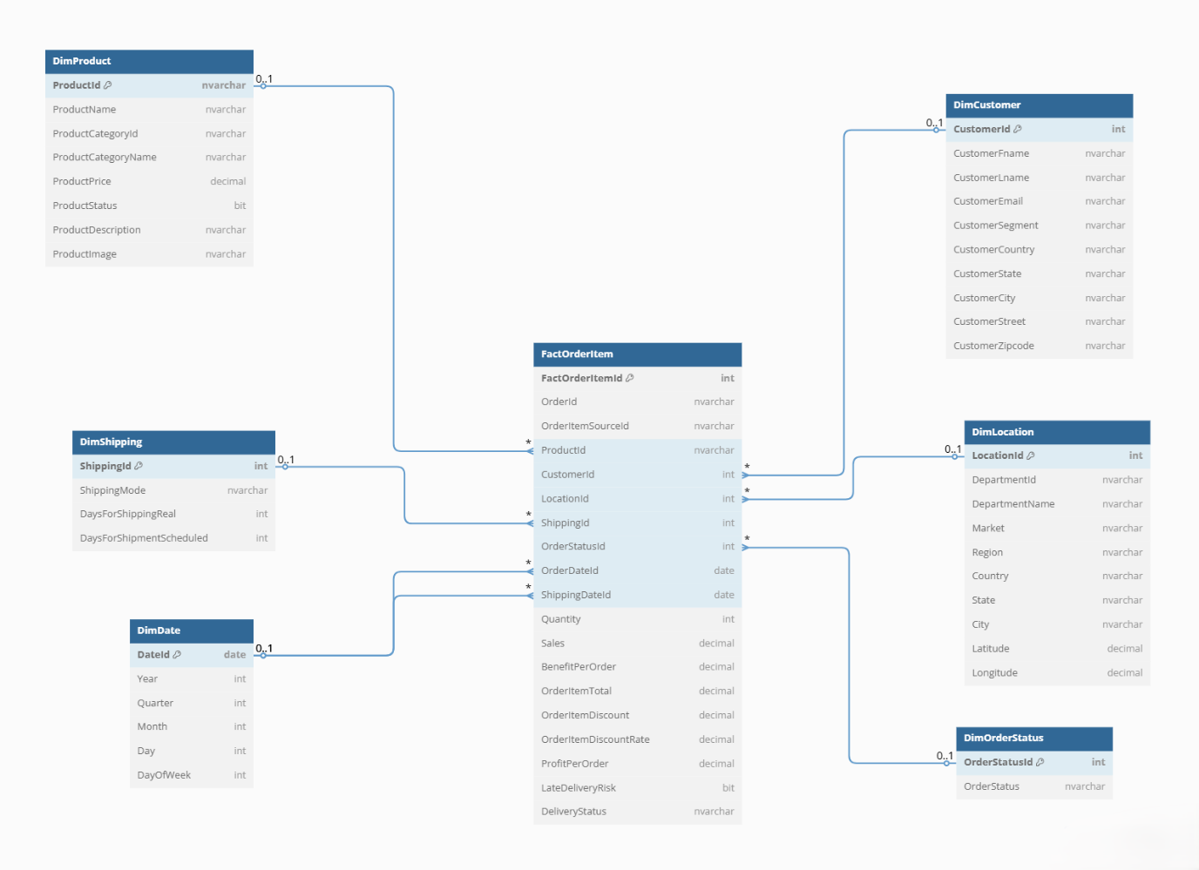
Figure 1 ER DIAGRAM

Results (To This Point)
- The normalized database schema has been instantiated in SQL Server Express.
- Keys and constraints were verified in SSMS and tested structurally via ER diagramming.
- The current state supports future ETL processes and analytic querying.

