Freight Rate Prediction — Model and Validation Report
Spotter AI ML assessment · Anindya Kundu · October 2026

1. Summary
The task is to predict posted_rate for 12,000 loads in November–December 2025, using 48,000 labelled loads from January–October 2025. That makes it a forecast one to two months ahead, and the validation is built around that.
- Model: a linear model on log price (distance, weight, equipment, market_index, smooth geography, a linear time trend and an equipment-specific quarter-end ramp), followed by LightGBM on its residuals. The residual model has no trend features, so it cannot flatten the forward projection.
- Results: fold-average MAE $85.2 on raw labels, against $113.7 for an XGBoost/LightGBM blend (an earlier candidate solution); $88.5 on the two-months-ahead block (train Jan–Aug, test Sep–Oct). On labels with the corrupted rows removed, the error is 1.33% MAPE.
- Key data issue: 677 training labels (1.4%) are corrupted by a multiplicative factor (about ×3.3 or ×0.29). They are detected and dropped from training. The same corruption presumably exists in the validation labels and sets a floor on any model's raw error.
- December chart: $839 on 1 December rising to $881 on the 31st, with a weekly cycle (Thursday peaks) on top of the quarter-end ramp.
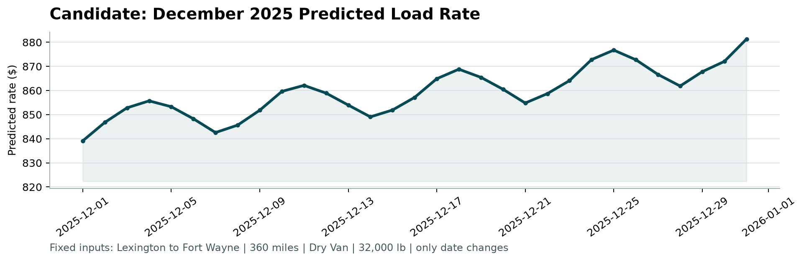
Figure 1. December 2025 chart produced by score.py from the submitted predictions.

2. Data and key findings
- Distance and equipment. Distance explains most of the price: the correlation is 0.989 once the corrupted labels are removed (0.909 with them). Median rate per mile is $2.05 for Dry Van, $2.22 for Flatbed and $2.31 for Reefer. Price grows less than proportionally with distance (log-log slope 0.87).
- A daily market signal. market_index varies far more between days than within a day. Its weekly cycle bottoms on Sunday/Monday and peaks on Thursday. It averages 1.08 in training and 0.93 in validation, so it is a genuine input for Nov–Dec. Its price elasticity is 0.15.
- Time structure that market_index does not explain. Once market_index is controlled for, prices still drift up about 6% from January to October. They also climb through every quarter-end month (March, June, September) and reset on the 1st: Flatbed +8.1%, Reefer +5.1%, Dry Van +2.5% from the first day of the month to the last (Figure 2; fitted values from the final model). December is a quarter-end month.
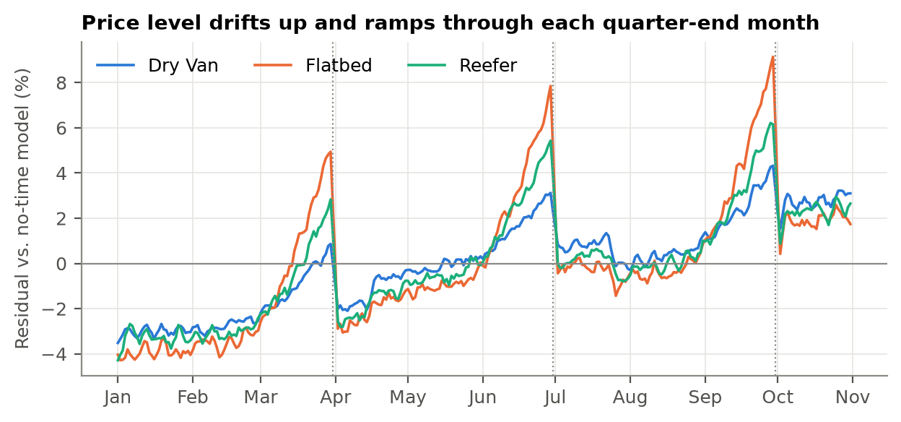
Figure 2. Daily mean residual by equipment from a model with no time terms (3-day mean). Dotted lines mark quarter ends.
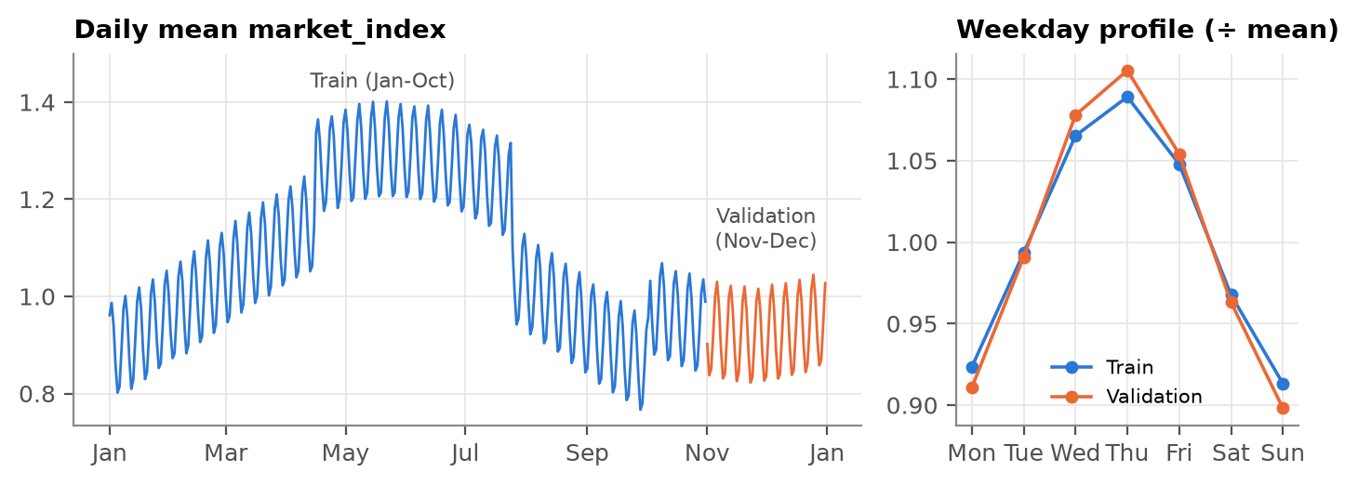
Figure 3. market_index: lower in Nov–Dec, with the same weekly cycle.
- Unseen cities. 8 validation cities never appear in training (1,447 rows, 12%). In training, city effects are small (−3.7% to +2.7%), almost identical whether the city is the pickup or the delivery (r = 0.99), and track latitude (r = −0.86, Figure 4). A smooth function of the coordinates therefore carries over to unseen cities. The coordinates are shifted from the real cities but are consistent for each city, so they are used as given.
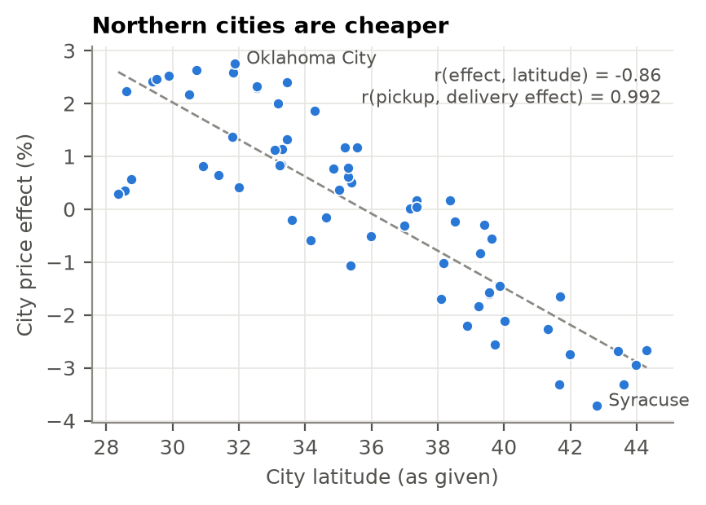
Figure 4. City price effect against latitude.
- quote_signal is noise. Within lane × equipment groups, after weight, market_index and time terms, adding quote_signal leaves the residual SD unchanged (0.0226 vs 0.0226). Its apparent signal comes from the equipment mix. Adding it to the hybrid worsens the fold-average MAE ($86.7 vs $85.2), and removing it improves Codex's LightGBM ($113.8 → $102.9). It is dropped.

3. Data-quality issues and fixes
Issue | Train | Validation | Handling
Weight missing | 300 | 165 | Fill with training median |weight|; w_miss flag
Weight negative (sign flip) | 292 | 145 | Absolute value; w_neg flag
Weight at cap |w| = 47,500 | 1,204 | 301 | Keep (censored); w_cap flag
of which -47,500 | 13 | 4 | Absolute value
Weight at floor |w| = 5,000 | 32 | 7 | Keep; w_floor flag
market_index missing | 374 | 249 | Fill with that date's mean
Distance at 70 mi floor | 48 | 21 | Keep (clipped, not an error)
Corrupted label (|log resid| >= 0.25) | 677 | — | Dropped from training only (detector refitted inside each fold)
high cluster (median x3.33, range x2.21-5.26) | 340 | —
low cluster (median x0.29, range x0.17-0.45) | 337 | —

Corrupted labels are found with a two-pass robust fit. The first pass fits the structural model on log price with least squares. The second refits it on rows with |residual| < 0.30. Rows with |residual| ≥ 0.25 are then flagged. The clusters are far from the clean rows: no residual falls between 0.12 and 0.79 (Figure 5), so cut-offs of 0.20, 0.25 and 0.30 flag the same rows. The detector is refitted inside every fold, and flagged rows are removed from training only; every validation row is predicted. The other repairs touch inputs only: missing values get flags, so the model can learn whatever their absence means.
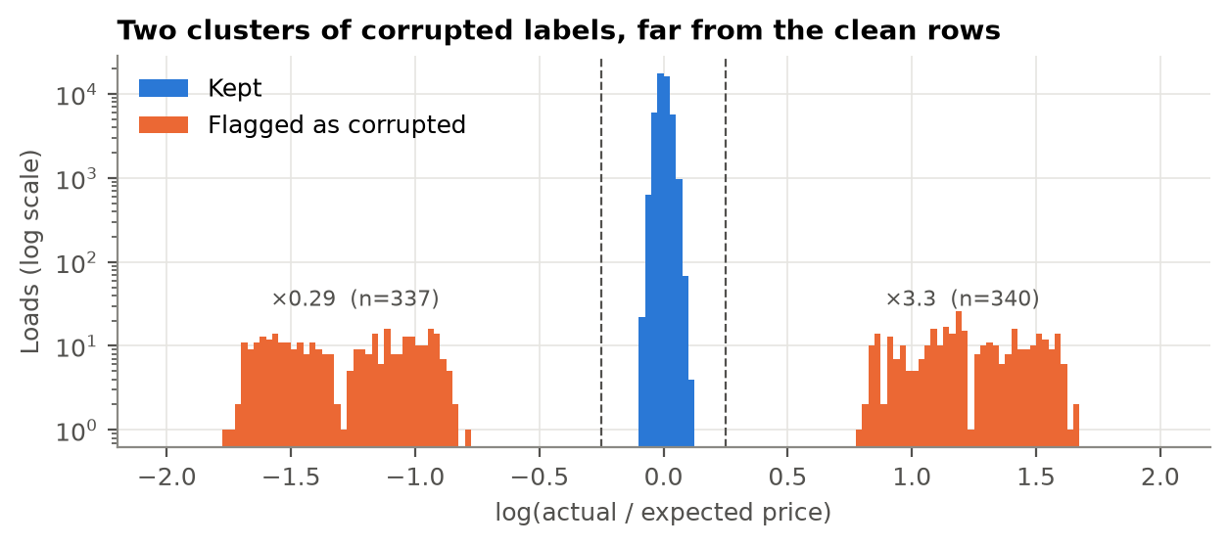
Figure 5. log(actual / expected) on the full training set (log count scale).

4. Split and validation approach
The validation set is the two months after the training data, so every split looks forward in time. Three expanding folds test August, September and October with all earlier data. A fourth block, h2, trains through August and tests September–October: like Nov–Dec, it is one to two months past the end of training, and it spans a quarter-end. Everything was refitted from scratch in each fold, including the label cleaning and the weight imputation.
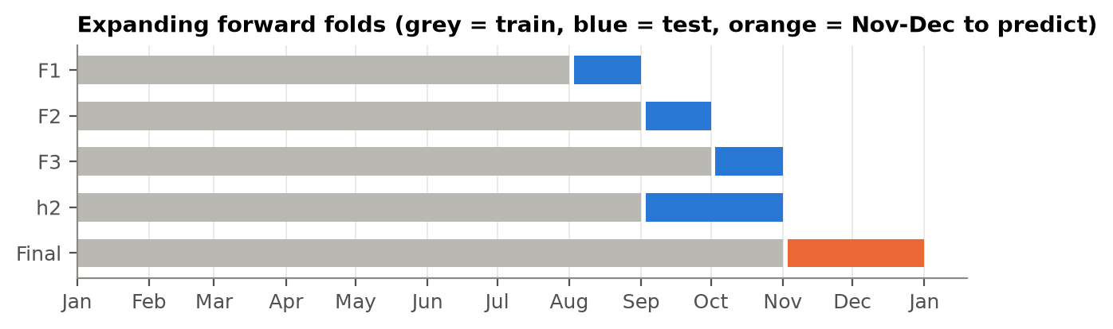
Figure 6. Folds. The final model trains on all of Jan–Oct.
Model selection used raw MAE averaged over F1–F3, with h2 MAE as the tie-break. Raw labels include corruption, as Spotter's labels presumably do. MAE is robust to it. RMSE is not: every model lands between $623.1 and $639.7, because the corrupted rows dominate the squared error. Clean-label MAPE (corrupted rows removed, for reporting only) shows the accuracy on legitimate prices.
Split (MAE) | Hybrid | Codex LightGBM
Random 10% holdout (all months) | $91.5 | $95.3
Forward: train Jan–Sep, test Oct | $95.4 | $110.6
Unseen cities: 8 withheld, test Sep–Oct | $88.2 | $110.6

A random split makes the two models look about equal ($91.5 vs $95.3). Going forward in time, the tree model loses ground ($95.4 vs $110.6). A random split would therefore have picked the wrong model. The unseen-city simulation withholds 8 training cities from training and tests on the Sep–Oct loads that touch them. The hybrid holds up ($88.2); the tree model, which relies on city identities, does not ($110.6).

5. Model
Stage 1 is ordinary least squares on log(posted_rate), fitted on the cleaned rows. Its inputs are log distance, log weight with a hinge term for loads under 12,000 lb, a missing-weight flag, log market_index, equipment dummies, a quadratic surface in pickup and delivery coordinates, a linear trend in months, and a quarter-end ramp per equipment (0 on the first day of March, June, September or December, rising to 1 on its last day; 0 otherwise). Stage 2 is LightGBM on the stage-1 residuals. It uses distance, weight, market_index, equipment, coordinates, weekday and position within the month, plus pickup and delivery city as categorical features. It has no trend input, so it cannot undo the trend. Rows that touch a city absent from training use a second stage-2 model without the city features. Prediction = exp(stage 1 + stage 2).
Why not boosted trees alone: a tree predicts a constant beyond the last date it saw, so it cannot carry the drift or a quarter-end ramp into the future. In the h2 backtest its error moves downward through the September ramp (Figure 7), and it never learns that December will ramp. The linear stage carries time forward; the trees handle the non-linear parts that do not depend on the date.
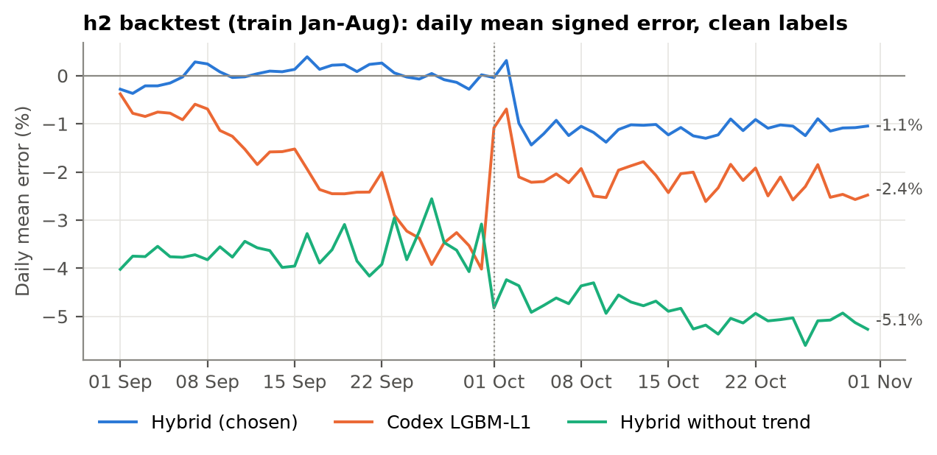
Figure 7. h2 backtest: daily mean signed error on clean labels (labels show the last-5-day mean).
Model | Aug | Sep | Oct | h2 | Fold avg MAE | MAPE | Clean MAPE
Hybrid (chosen) | $79.9 | $80.4 | $95.4 | $88.5 | $85.2 | 3.83% | 1.33%
Hybrid, no city categoricals | $81.4 | $81.9 | $96.6 | $89.9 | $86.6 | 3.89% | 1.39%
Hybrid + quote_signal | $85.4 | $79.9 | $94.9 | $87.9 | $86.7 | 3.90% | 1.40%
Hybrid, untuned defaults | $81.9 | $82.4 | $97.1 | $90.3 | $87.1 | 3.91% | 1.42%
Hybrid 50/50 with Codex XGB | $94.2 | $92.2 | $97.3 | $100.4 | $94.6 | 4.27% | 1.78%
Hybrid without quarter-end ramp | $94.4 | $107.3 | $90.5 | $102.5 | $97.4 | 4.33% | 1.83%
Structural only (stage 1) | $92.8 | $95.1 | $106.2 | $101.3 | $98.0 | 4.42% | 1.93%
Codex LGBM-L1 without quote_signal | $85.3 | $116.2 | $107.2 | $117.6 | $102.9 | 4.64% | 2.16%
Codex blend 0.75 XGB / 0.25 LGBM | $118.2 | $115.6 | $107.2 | $118.9 | $113.7 | 5.09% | 2.63%
Codex LGBM-L1 | $119.5 | $111.4 | $110.6 | $114.8 | $113.8 | 5.08% | 2.62%
Codex XGB-L1 | $121.7 | $119.5 | $109.4 | $122.3 | $116.9 | 5.26% | 2.80%
Linear, city indicators, no time terms | $110.1 | $174.9 | $133.0 | $165.7 | $139.3 | 5.95% | 3.56%
Hybrid without trend | $120.8 | $136.1 | $163.7 | $154.2 | $140.2 | 6.05% | 3.68%
Hybrid without trend or ramp | $109.0 | $174.6 | $160.8 | $173.2 | $148.1 | 6.38% | 4.01%
Hybrid without market_index | $197.3 | $205.8 | $101.1 | $169.2 | $168.1 | 7.41% | 4.85%

MAE in dollars on raw labels; MAPE and clean MAPE averaged over F1–F3. The Codex rows reproduce an earlier candidate solution (tree models on raw dollars with every feature, including quote_signal and calendar features). Removing the trend or market_index roughly doubles the error: handling time is the main problem.
Tuning. Before any tuning run, a small grid was committed to the repository, along with the selection rule. The search went one setting at a time. It picked a linear trend over a step per quarter or a damped trend, 1,000 trees with 31 leaves, L2 loss, and city categoricals, improving the fold-average MAE from $87.1 to $85.2. One change was made after tuning. The folds contain no unseen cities, and in the unseen-city simulation the city categoricals cost money ($89.6 vs $88.2 with routing), so rows touching an unseen city use the model without them. This leaves every fold score unchanged. Results are stable across seeds (h2 MAE $88.5 / $88.5 / $88.5).

6. December prediction
The chart inputs contain no market_index. Each December day gets the mean market_index of that day's loads in validation.csv. This is an input feature Spotter supplied for the same dates, not a label, and it is how the model is applied to the validation loads too. Dropping it (weekday dummies in its place) raises the h2 clean MAPE from 1.37% to 4.76%. The resulting chart reflects four things: lower market_index in December, the weekly cycle, the continuing drift, and the Dry Van quarter-end ramp. It runs from $839 to $881 (mean $859). A Codex-style LightGBM trained without market_index draws an almost flat line ($835–$847, Figure 8), because a tree has no way to extend time effects beyond October.
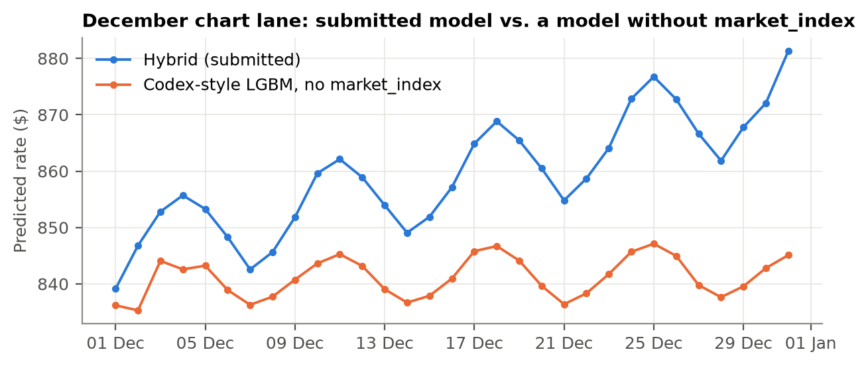
Figure 8. December chart lane: submitted hybrid vs. a tree model without market_index.
Sanity checks on the 12,000 validation predictions: no missing or non-positive values; median rate per mile Dry Van $2.07 (training $2.05), Flatbed $2.26 (training $2.22), Reefer $2.35 (training $2.31); unseen-city rows average $2.23/mi vs $2.22/mi for the rest.

7. Limitations and next steps
- Extrapolation: the linear trend and the December ramp are projected two months beyond the data. The ramp held in 3 of 3 quarters but cannot be checked for December. In the backtests, the model under-predicted October by 1.0% (the month after a quarter end).
- Holidays: holiday effects in late December cannot be learned from Jan–Oct data.
- Label corruption: if the validation labels contain the same ~1.4% corruption, raw MAE and especially RMSE will carry an error floor that no model can remove.
- Next steps: quantile models for prediction intervals; drift monitoring on market_index and the residual level; refitting monthly as new labels arrive; checking the corruption mechanism with the data owner.

Appendix: how to reproduce
python -m pip install -r requirements.txt
python -m src.run_all # full pipeline, about 10 minutes on 16 cores
python -m src.tune # optional: rerun the pre-registered tuning grid
python score.py --predictions validation_predictions.csv --december-predictions data/december_chart_inputs.csv

src/clean.py: input repairs and the corrupted-label detector · src/features.py: feature builders · src/models.py: HybridModel and the baselines · src/validate.py: folds, metrics, contrasts · src/tune.py: tuning grid · src/train.py, src/predict.py: final fit and outputs · src/figures.py, src/report.py: this report.
Python 3.12 · pandas 2.3.3 · numpy 2.5.3 · scikit-learn 1.9.1 · LightGBM 4.7.0 · seeds fixed at 0.

