YEAR 12 METHODS PROBABILITY SAC

SKILLS LIST

**PART 1**

**Binomial:**

* Finding probability from a data.
* Calculating mean and standard deviation
* Writing in the form X~ Bi (n,p) and substituting relevant values.
* Using CAS to find the probability of selecting x outcomes from n and then sketching a probability graph – refer to notes on OneNote (Binomial – Notes Part 2)
* Related probability questions.
* Conditional probability

**Discrete probability:**

* Finding expected value
* Mean(Expected value) and Variance.
* Using the rules to prove that it is a discrete distribution.
* Finding unknown in a discrete distribution using the general theory.
* Related probability questions.
* Conditional probability
* Independent events.

**Sampling:**

* Finding sample proportion.
* Finding 95% confidence interval – need to show working.

* Finding minimum sample size

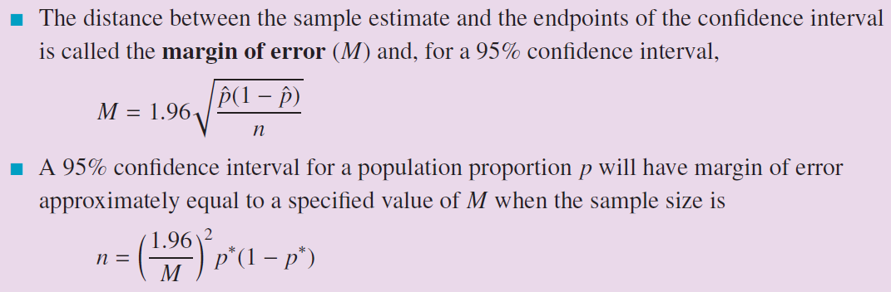

* Related questions from the chapter