**Year 12 Mathematical Methods**

**Probability SAC : Part 2**

**Marks: 40 Time allowed : 75**

**Key skills**

1. **Continuous data**

* Proving the conditions for the continuous data.
* Take note: If the domain includes 2 values – use them in calculations being the lower and upper limits of the Integral.
* However, if $x>2$ for example, then lower limit is 2 and upper limit of the integral is $∞$.
* Mean
* Median
* Inter quartile range
* Calculating Probability.
* Conditional probability.
* Related questions

1. **Normal Distribution**

* Finding Mean and standard deviation in one question.

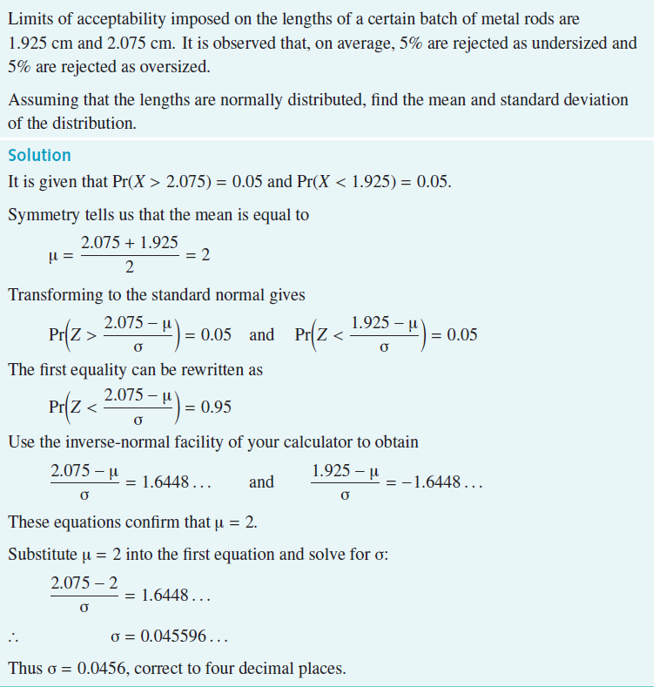

* Calculating probabilities.
* Conditional probability

1. **Discrete Probability**

* Completing the discrete distribution table.
* Finding mean

**d. Binomial Distribution**

* Calculating Probability using CAS.