**RESULTS:**

The whole project is carried out in jupyter lab. There are many outputs found. These are:

First output where the users will listen song of there choice

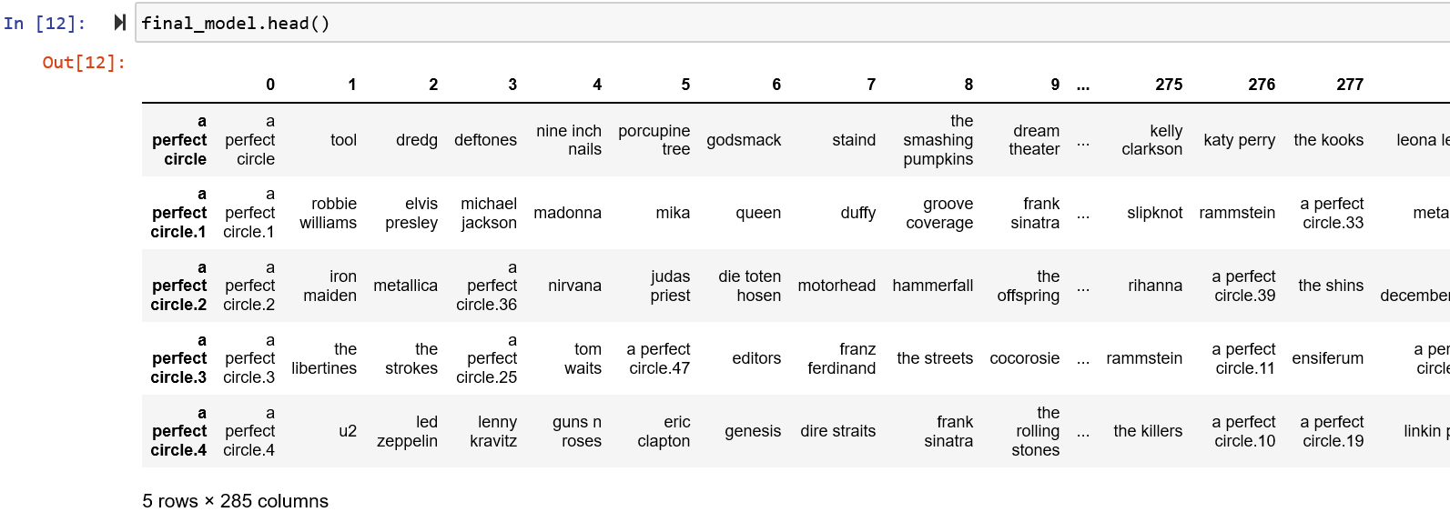

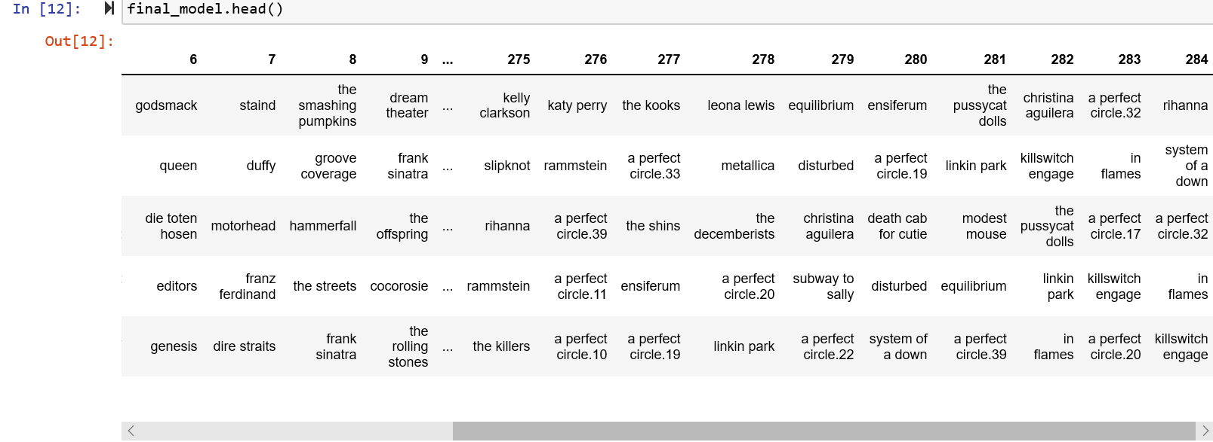

After that recommendation will be done based on the interest of the users:

