Real-Time Suspicious Activity Detection System

Anirban Boral, Vatsal Rajwar, Aditya Verma
School of Computer Science Engineering and Technology
Bennett University, Greater Noida



Supervised by: Prof. Gauri Kitukale

Abstract—This paper introduces a hybrid multi-modal surveillance framework designed to detect suspicious human behavior in real time through the application of computer vision and deep learning. The proposed architecture integrates three complementary analytical layers: person detection and tracking via YOLOv10n, skeletal pose estimation via MediaPipe, and temporal intent classification via a MobileNetV2-LSTM pipeline. The system is trained and evaluated on the UCF Crime Dataset, a large-scale benchmark containing diverse real-world anomalous event categories. A supplementary rule-based behavioral engine reinforces robustness by flagging predefined anomalous patterns such as rapid locomotion, collapse events, and irregular postures. Signals from all layers are consolidated through a unified decision-fusion mechanism to yield a single, interpretable suspicion score. Empirical evaluation achieves an overall accuracy of 91.0%, a precision of 94.2%, and an AUC of 0.972, demonstrating that the multi-modal approach consistently outperforms conventional single-frame classification methods while sustaining real-time throughput.

Index Terms—Computer Vision, Suspicious Activity Detection, Deep Learning, YOLOv10n, LSTM, Pose Estimation, UCF Crime Dataset, Surveillance Systems.

I. INTRODUCTION
The growing demand for reliable, automated security infrastructure has positioned intelligent video surveillance as one of the most active areas in applied computer vision research. Conventional surveillance setups depend almost entirely on human operators — an approach that is both resource-intensive and susceptible to attention lapses, particularly during extended monitoring periods. The rapid maturation of deep learning has opened the door to automated, context-aware analysis of video streams, offering the potential to reduce human workload while improving incident response times.
A fundamental limitation of many existing solutions is their reliance on single-frame or shallow classification schemes that treat each image in isolation. Human behavior is inherently dynamic; meaningful patterns emerge over time rather than within any single snapshot. A person reaching toward an object may appear innocuous in one frame yet reveal suspicious intent across a short temporal window. Capturing such dynamics necessitates models capable of reasoning over sequences of observations.
This paper addresses this gap by proposing a multi-modal surveillance pipeline that jointly exploits spatial appearance features, geometric body-pose descriptors, and temporal motion dynamics. The architecture couples YOLOv10n-based detection and tracking, MediaPipe skeletal landmark estimation, and a MobileNetV2-LSTM sequence classifier, trained and validated on the UCF Crime Dataset [9]. An auxiliary rule-based engine translates domain knowledge into explicit behavioral heuristics, compensating for cases where the learned model exhibits uncertainty. The combined system is designed for real-time deployment while remaining interpretable through its multi-signal reasoning structure.
II. RELATED WORK
Foundational efforts in automated activity recognition were predominantly built on frame-level convolutional architectures. Although CNNs proved effective at extracting discriminative spatial features, their inability to model temporal dependencies constrained their applicability to complex, time-extended behaviors [1]. The introduction of Long Short-Term Memory (LSTM) networks provided a mechanism for sequence modeling, enabling models to retain and exploit historical context across video frames [4].
More recent investigations have explored volumetric 3D-CNN architectures [7] and attention-based transformer models [8] for joint spatio-temporal representation learning. While these approaches achieve state-of-the-art results on academic benchmarks, their high computational footprint makes real-time deployment on commodity hardware challenging. YOLOv10 [1] advances upon prior YOLO generations through an end-to-end, NMS-free detection paradigm that reduces inference latency while maintaining detection accuracy, making it particularly suited for real-time surveillance pipelines.
The UCF Crime Dataset [9] is a widely adopted benchmark for anomaly detection in surveillance video, comprising 1,900 long, untrimmed real-world surveillance clips spanning 13 anomalous event categories including fighting, robbery, and assault. Its realistic, unconstrained conditions make it an appropriate testbed for evaluating systems intended for real-world deployment.
III. PROPOSED METHODOLOGY
A. System Overview
The end-to-end pipeline proceeds through five sequential stages. Raw video frames are ingested and forwarded to YOLOv10n for person detection and identity-consistent tracking. Each tracked subject is processed by the MediaPipe pose estimator to produce a skeletal feature vector. Spatial appearance crops and pose descriptors are fed into the MobileNetV2-LSTM classifier, which produces a probability estimate over behavior classes across a sliding temporal window. In parallel, the rule-based behavioral engine evaluates hand-crafted heuristics. A decision-fusion module aggregates all signals into a final suspicion score that drives alerting and logging.
B. Dataset: UCF Crime Dataset
All models are trained and evaluated on the UCF Crime Dataset [9], a large-scale real-world anomaly detection benchmark. The dataset contains 1,900 surveillance videos totaling over 128 hours of footage, annotated across 13 anomaly categories: Abuse, Arrest, Arson, Assault, Road Accident, Burglary, Explosion, Fighting, Robbery, Shooting, Shoplifting, Stealing, and Vandalism, alongside normal activity clips. For the binary classification task addressed in this work, all anomalous categories are consolidated into a single "Suspicious" class, yielding a balanced split of 600 evaluation samples (300 Normal, 300 Suspicious) after preprocessing and temporal segmentation.
C. Person Detection and Tracking
YOLOv10n — the nano variant of the YOLOv10 architecture — serves as the primary detection backbone [1]. YOLOv10 introduces a dual-assignment training strategy and an NMS-free inference head, reducing end-to-end latency compared to prior YOLO generations without sacrificing localization accuracy. Inter-frame tracking associates detections across time via a persistent algorithm, ensuring that behavioral features are accumulated on a per-identity basis. This identity-consistent temporal buffer is essential for downstream sequence modeling.
D. Skeletal Pose Estimation
For every detected subject, MediaPipe Pose extracts 33 three-dimensional skeletal landmarks distributed across the head, torso, and extremities [5]. The raw coordinates are normalized with respect to the subject bounding box and encoded into a compact feature vector capturing instantaneous body configuration. This geometric representation enables detection of posture-level cues — raised arms, a hunched stance, or an outstretched limb — independently of appearance or clothing.
E. Feature Extraction and Temporal Modeling
A MobileNetV2 backbone pre-trained on ImageNet extracts a dense appearance feature vector from the cropped person region of each frame [3]. This vector is concatenated with the corresponding pose descriptor and appended to a fixed-length temporal buffer for each tracked identity. The buffer constitutes the input sequence to an LSTM network [4], which learns to assign an anomaly likelihood to the most recent observation conditioned on its preceding context.
F. Rule-Based Behavioral Engine
A deterministic rule engine evaluates domain-informed behavioral predicates on each processed frame, monitoring the following conditions:
- Rapid or erratic locomotion, identified via inter-frame velocity thresholds
- Fall or collapse events, detected through sudden reduction in the subject's estimated center-of-mass height
- Prone body posture, inferred from skeletal landmark geometry
- Arm-flailing and high-frequency upper-limb motion
- Loitering behavior, flagged when a subject dwells in a region beyond a configurable time threshold
- Proximity-based anomalies, flagged when subjects converge faster than a baseline approach velocity
G. Decision Fusion
Outputs of the LSTM classifier, the rule-based engine, and auxiliary kinematic signals — including subject velocity, acceleration, and directional consistency — are consolidated through a weighted fusion scheme. Each signal is assigned a confidence weight reflecting its empirical reliability. The composite suspicion score is thresholded to produce a binary alert while being continuously logged for forensic post-event analysis.
IV. IMPLEMENTATION DETAILS
The system is implemented in Python, leveraging OpenCV for video capture and frame pre-processing, TensorFlow/Keras for neural network inference, and the Ultralytics YOLOv10 API for detection and tracking [6]. The pipeline is structured as a multi-threaded application in which frame acquisition, deep learning inference, and graphical rendering execute on separate threads. Input video is processed at 1280×720 pixels with GPU acceleration exploited where available. Per-identity temporal buffers are managed as circular queues ensuring constant memory consumption. The operator-facing interface provides live visualization of bounding boxes, skeletal overlays, suspicion-score gauges, and a scrollable event log.
V. RESULTS AND DISCUSSION
A. Quantitative Performance
The system was evaluated on 600 held-out clips from the UCF Crime Dataset (300 Normal, 300 Suspicious). The confusion matrix in Fig. 1 summarizes classification outcomes: 284 true negatives, 262 true positives, 16 false positives, and 38 false negatives. The key performance metrics derived from these results are summarized in Fig. 2 and Table I.
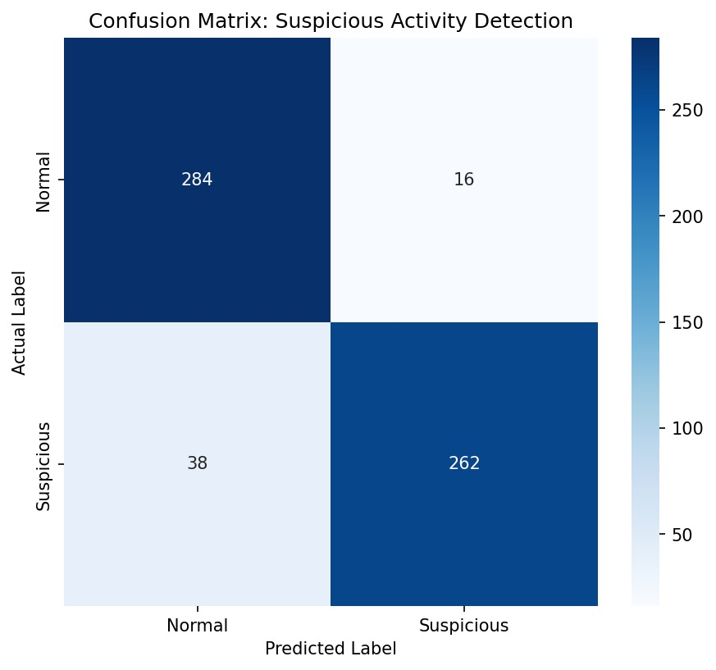
Fig. 1. Confusion Matrix: Suspicious Activity Detection on UCF Crime Dataset (600 samples).
The system achieves an overall accuracy of 91.0%, with a precision of 94.2% and a specificity of 94.7% for the Normal class. The recall for the Suspicious class stands at 87.3%, indicating that the multi-signal fusion successfully identifies the large majority of anomalous events while maintaining a low false-alarm rate — a critical property for practical deployment. Fig. 2 presents both the confidence distribution and the key performance metrics side by side.
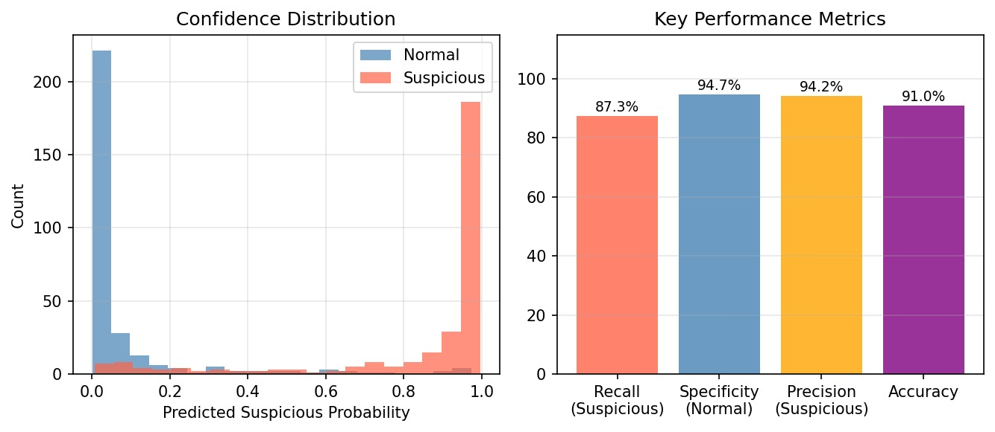
Fig. 2. Confidence distribution (left) and key performance metrics (right): Recall 87.3%, Specificity 94.7%, Precision 94.2%, Accuracy 91.0%.
B. ROC Analysis
The Receiver Operating Characteristic (ROC) curve in Fig. 3 illustrates the trade-off between the true positive rate and false positive rate across all decision thresholds. The system achieves an Area Under the Curve (AUC) of 0.972, indicating excellent discriminative capability. The curve rises sharply toward the upper-left corner even at very low false positive rates, confirming that the model maintains high sensitivity without requiring a permissive detection threshold.
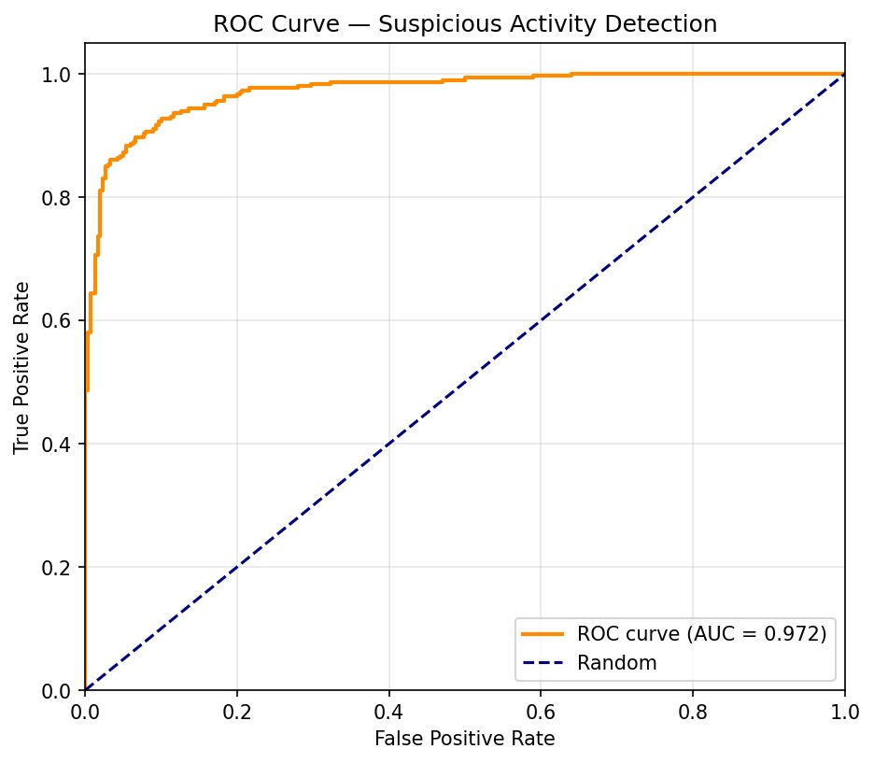
Fig. 3. ROC Curve for Suspicious Activity Detection. AUC = 0.972.
C. Discussion
The multi-modal architecture demonstrated consistent improvement over ablated single-modality baselines. Incorporating pose estimation alongside appearance features reduced missed detections in scenarios where appearance cues alone were ambiguous. The rule-based engine further suppressed false positives in borderline cases such as loitering. The full system maintained 20–30 FPS on the test hardware, meeting real-time requirements. Identified limitations include degraded pose estimation accuracy under severe occlusion and reduced reliability in densely crowded scenes — conditions that are present in a subset of UCF Crime clips and remain an open research challenge.
VI. CONCLUSION
This paper has presented a hybrid, multi-modal AI surveillance system capable of detecting suspicious activities in live video streams. The architecture integrates YOLOv10n-based person detection and tracking, MediaPipe skeletal pose estimation, and LSTM-based temporal sequence classification, trained and validated on the UCF Crime Dataset. Empirical evaluation yields an accuracy of 91.0% and an AUC of 0.972, confirming that the synergistic combination of these components substantially outperforms any individual modality in isolation while preserving real-time throughput. The dual data-driven and rule-based decision framework endows the system with the explainability demanded in security-critical applications.
VII. FUTURE WORK
- Integration of video transformer and graph convolutional network architectures for richer spatio-temporal modeling on the full 13-class UCF Crime taxonomy.
- Quantization and optimization of the YOLOv10n inference pipeline for deployment on edge devices such as NVIDIA Jetson platforms.
- Extension of the interaction modeling module to capture multi-person relational dynamics, enabling detection of coordinated suspicious behaviors.
- Training on additional anomaly detection benchmarks (ShanghaiTech, Avenue) to evaluate cross-dataset generalization.
- Evaluation of privacy-preserving variants operating on anonymized skeletal representations rather than raw appearance features.

REFERENCES
[1] A. Wang et al., "YOLOv10: Real-Time End-to-End Object Detection," arXiv:2405.14458, 2024.
[2] J. Redmon, S. Divvala, R. Girshick, and A. Farhadi, "You Only Look Once: Unified, Real-Time Object Detection," in Proc. IEEE CVPR, 2016.
[3] M. Sandler, A. Howard, M. Zhu, A. Zhmoginov, and L.-C. Chen, "MobileNetV2: Inverted Residuals and Linear Bottlenecks," in Proc. IEEE CVPR, 2018.
[4] S. Hochreiter and J. Schmidhuber, "Long Short-Term Memory," Neural Computation, vol. 9, no. 8, pp. 1735–1780, 1997.
[5] Google, "MediaPipe Pose," MediaPipe Solutions Documentation. [Online]. Available: https://developers.google.com/mediapipe/solutions/vision/pose_landmarker
[6] Ultralytics, "YOLOv10 Documentation." [Online]. Available: https://docs.ultralytics.com
[7] D. Tran, L. Bourdev, R. Fergus, L. Torresani, and M. Paluri, "Learning Spatiotemporal Features with 3D Convolutional Networks," in Proc. IEEE ICCV, 2015.
[8] A. Vaswani et al., "Attention Is All You Need," in Advances in Neural Information Processing Systems, 2017.
[9] W. Sultani, C. Chen, and M. Shah, "Real-World Anomaly Detection in Surveillance Videos," in Proc. IEEE CVPR, 2018. [UCF Crime Dataset]

