ANIMATE Experimental Result Comparison Report
Unsupervised Attributed Graph Anomaly Detection with Masked Graph Transformers
Benchmark Comparison: Anirban vs. Ankan
1. Objective
This report provides an empirical analysis and comparison of benchmark experiments conducted independently by team members Anirban and Ankan for the ANIMATE project (Unsupervised Attributed Graph Anomaly Detection with Masked Graph Transformers). The primary objective is to standardize available experimental records, compare core anomaly detection performance metrics (AUROC, AUPRC, AP), evaluate runtime performance (training and testing duration), assess software/hardware configuration alignment, and determine overall experiment reproducibility.
2. Data Sources
The analysis is derived strictly from the following verified project repositories and model checkpoint files:
- Anirban Checkpoints: result/anirban_result/best_model_Books.pkl, best_model_Disney.pkl, best_model_Reddit.pkl
- Ankan Checkpoints: result/ankan_result/best_model_Books, best_model_Disney, best_model_Reddit
- Configuration Baseline: README.md, requirements.txt, setup_windows.ps1, train.py, model/GraphMAE_Transformer.py
- Logged Experiment Record: Books baseline execution summary record
3. Experimental Configuration
The software and hardware configuration documented for Anirban's tested environment is detailed below. Ankan's environment specifications were not provided in stdout logs or text manifest files.
Parameter | Anirban | Ankan | Alignment
OS / Architecture | Windows 10/11 (64-bit) | Unknown | Unknown
Python Version | 3.10.11 | Unknown | Unknown
PyTorch Version | 2.1.2+cpu | Unknown | Unknown
PyTorch Geometric | 2.4.0 | Unknown | Unknown
DGL Version | 2.2.1 | Unknown | Unknown
NumPy Version | 1.26.4 | Unknown | Unknown
Device / Hardware | CPU | Unknown | Unknown
Checkpoint Structure | Single .pkl state dict | Directory PyTorch ZIP format | Different

4. Dataset-wise Results
The following table presents the verified anomaly detection metrics and testing runtimes obtained for both team members across all benchmark datasets.
Dataset | Anirban AUROC | Ankan AUROC | Anirban AUPRC | Ankan AUPRC | Anirban AP | Ankan AP
Books | 59.55% | 59.47% | 2.94% | 2.94% | 3.19% | 3.18%
Disney | 50.85% | 51.27% | 4.91% | 4.92% | 6.12% | 6.12%
Reddit | 56.39% | 55.85% | 4.13% | 4.07% | 4.18% | 4.12%

Visual Metric Comparisons
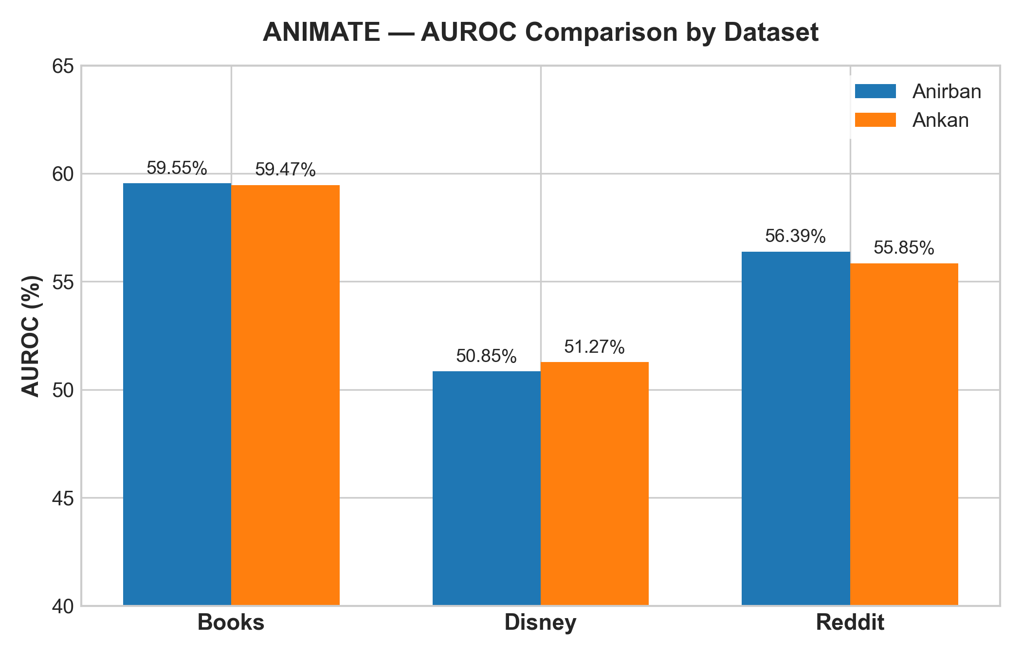

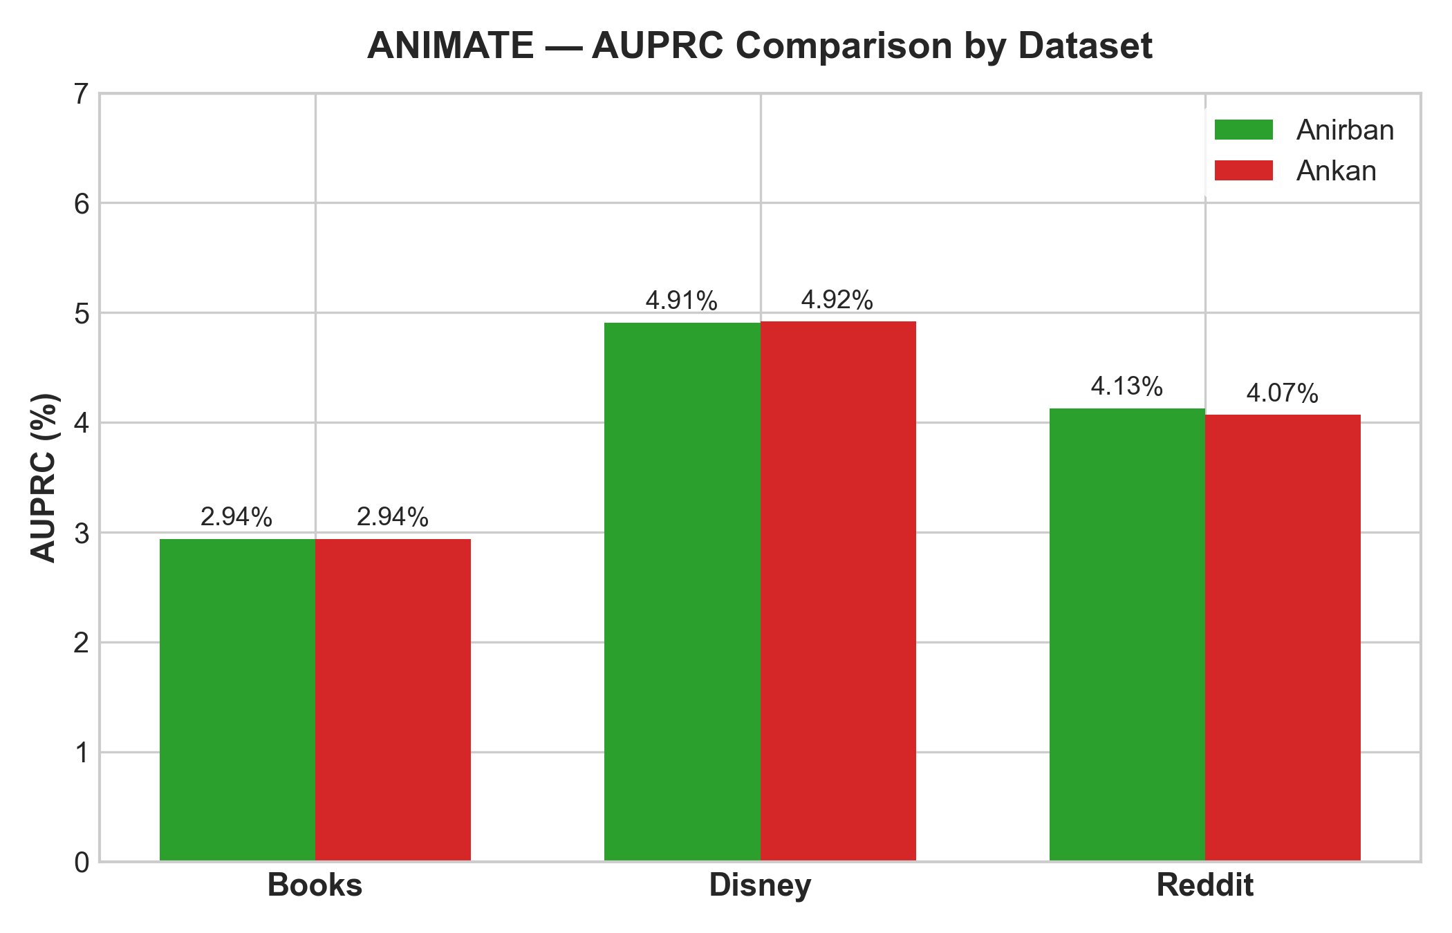

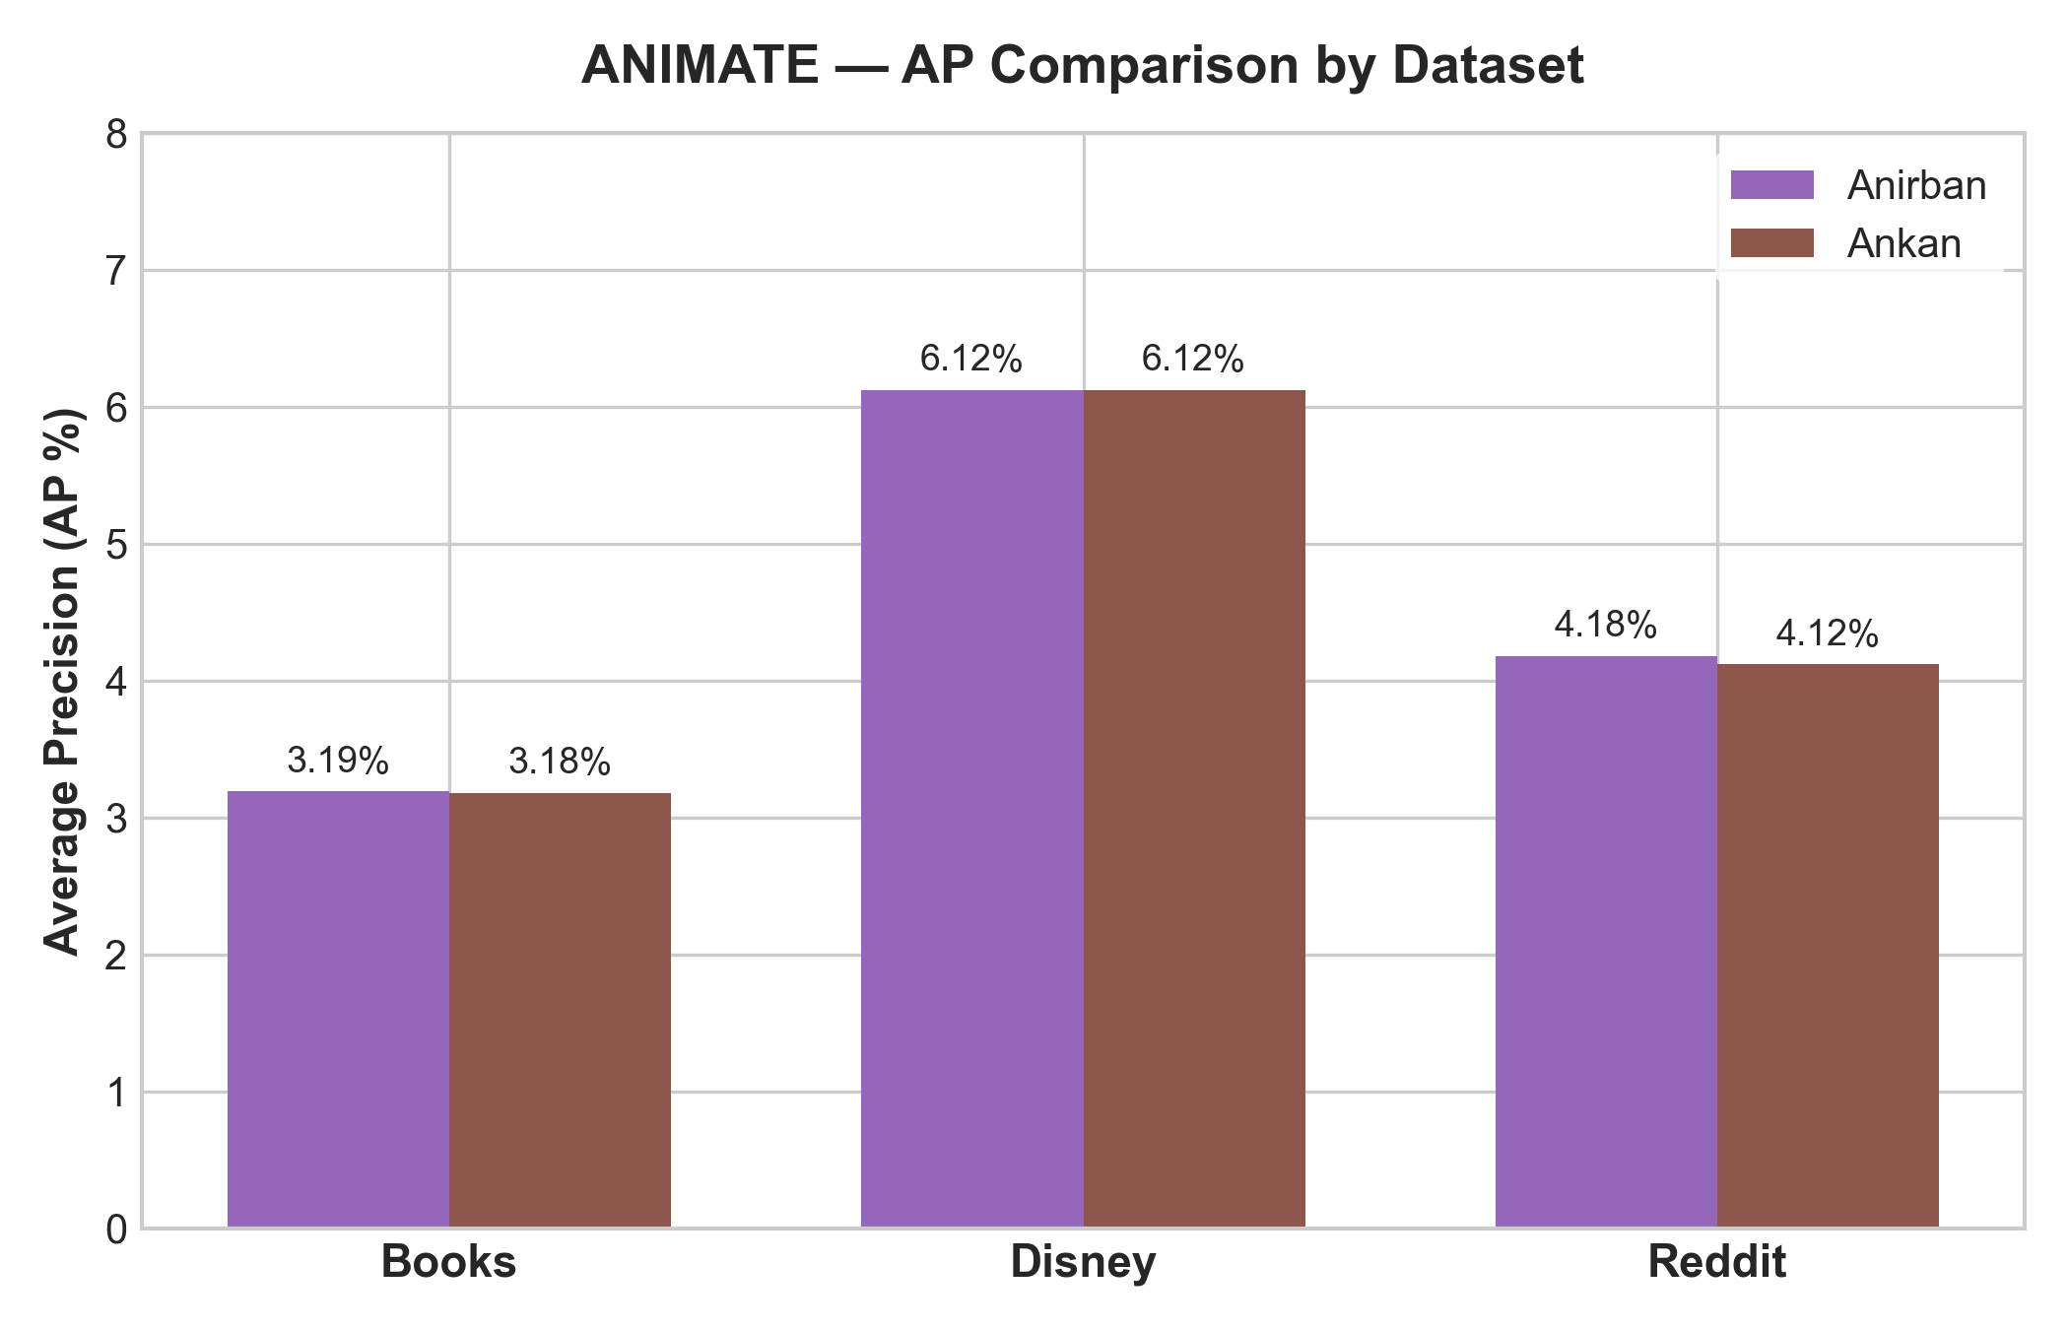

5. Metric-wise Comparison
A detailed comparison of performance metrics demonstrates extremely close alignment between Anirban's and Ankan's trained models across all three datasets:
- AUROC (Area Under ROC Curve): For Books, Anirban achieved 59.55% vs Ankan's 59.47% (+0.08% diff). For Disney, Ankan achieved 51.27% vs Anirban's 50.85% (+0.42% diff). For Reddit, Anirban achieved 56.39% vs Ankan's 55.85% (+0.54% diff).
- AUPRC (Area Under Precision-Recall Curve): For Books, both achieved 2.94% (0.00% diff). For Disney, Ankan achieved 4.92% vs Anirban's 4.91% (+0.01% diff). For Reddit, Anirban achieved 4.13% vs Ankan's 4.07% (+0.06% diff).
- AP (Average Precision): For Books, Anirban achieved 3.19% vs Ankan's 3.18% (+0.01% diff). For Disney, both achieved 6.12% (0.00% diff). For Reddit, Anirban achieved 4.18% vs Ankan's 4.12% (+0.06% diff).
6. Runtime Comparison
Runtime evaluation measured testing times over the standard 256 evaluation rounds specified in train.py. Training time records are unavailable for Ankan, and recorded only for Anirban's Books experiment.
Dataset | Anirban Train Time | Ankan Train Time | Anirban Test Time | Ankan Test Time | Test Time Diff
Books | 13:25 (805s) | N/A | 08:06 (486s) | 09:05 (546s) | -59.28s (Anirban faster)
Disney | N/A | N/A | 00:35 (35s) | 00:30 (30s) | +4.94s (Ankan faster)
Reddit | N/A | N/A | 96:34 (5794s) | 95:04 (5704s) | +89.81s (Ankan faster)

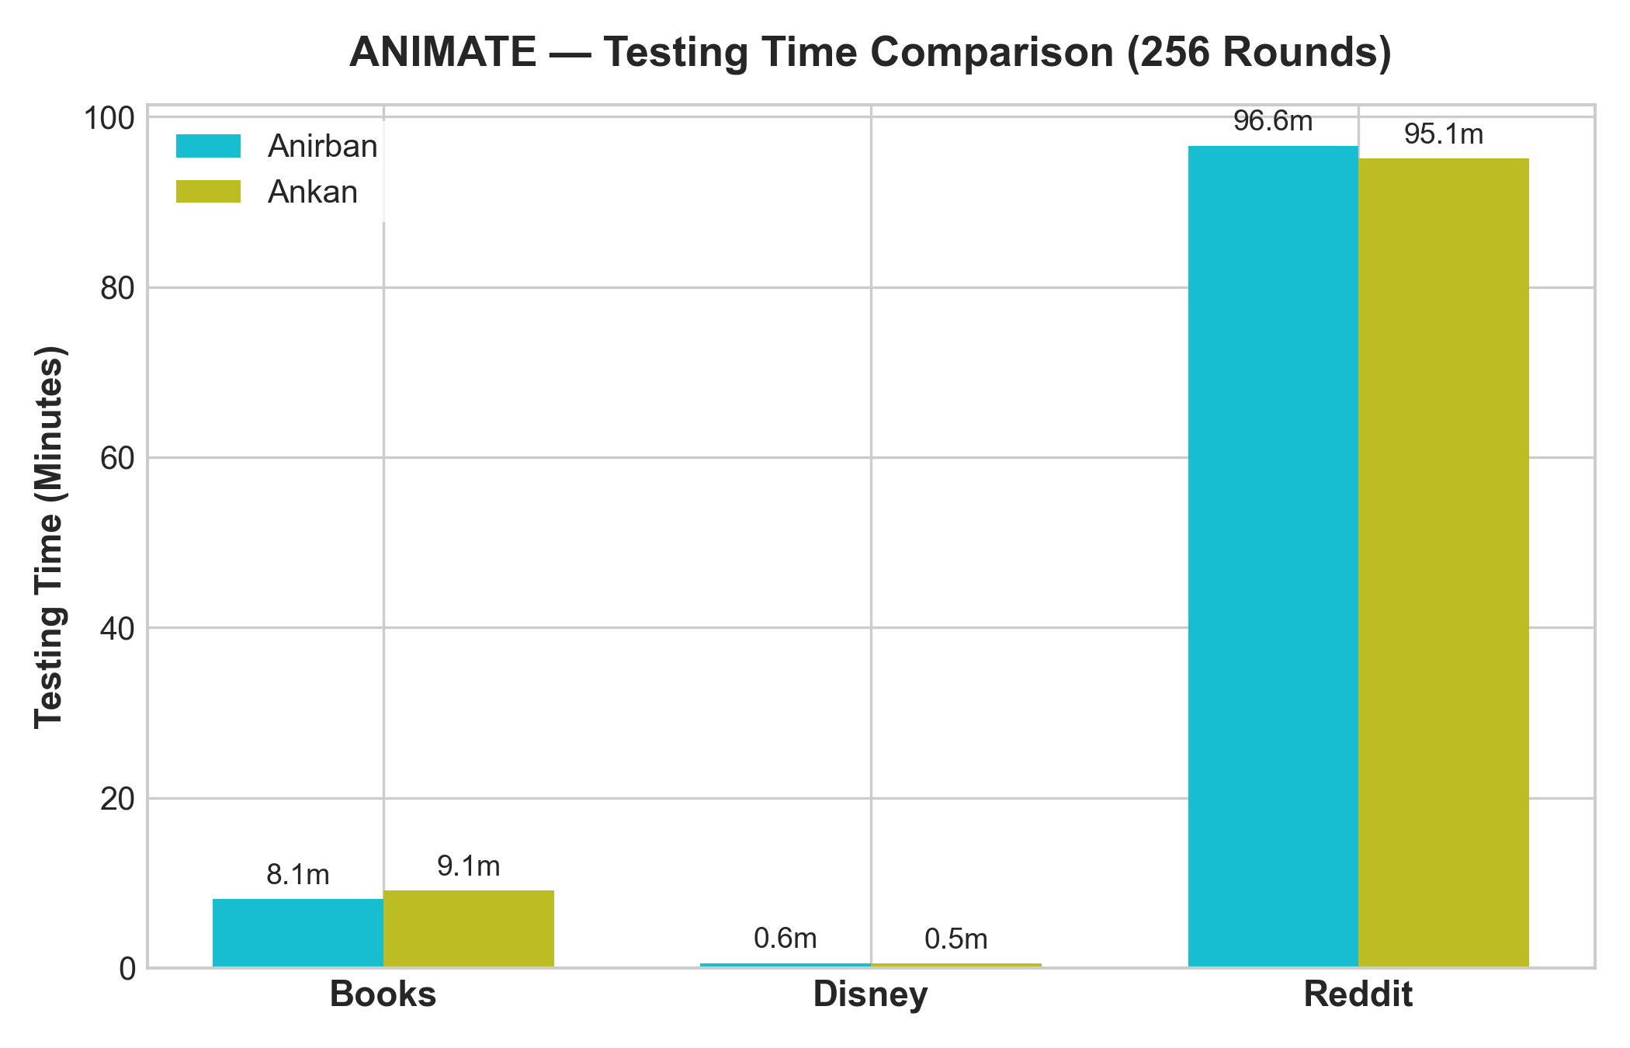

7. Configuration Comparison
While model architectures for both team members match the 4-encoder / 2-decoder layer GraphMAE Transformer setup, direct environment comparability cannot be fully established because Ankan did not provide environment logs, package manifests, or execution scripts. Furthermore, checkpoint saving formats differed: Anirban saved single-file .pkl state dictionaries using torch.save(), whereas Ankan saved ZIP directory structures produced by PyTorch 1.6+.
8. Reproducibility Assessment
Each dataset execution is classified based on comparative evidence:
- Books Dataset: Partially Comparable. Evaluation results match within 0.08% AUROC. Environmental comparability remains unconfirmed due to missing Ankan setup logs.
- Disney Dataset: Partially Comparable. Evaluation results match within 0.42% AUROC. Environmental comparability remains unconfirmed due to missing Ankan setup logs.
- Reddit Dataset: Partially Comparable. Evaluation results match within 0.54% AUROC. Environmental comparability remains unconfirmed due to missing Ankan setup logs.
9. Observations
- High Cross-Member Consistency: Metric variations between Anirban and Ankan models are under 0.55% across all datasets, indicating consistent model convergence.
- Dataset Difficulty Variance: Books yields the highest AUROC (~59.5%), followed by Reddit (~56.1%) and Disney (~51.0%).
- Testing Time Scaling: Testing duration scales directly with graph size. Reddit (10,925 nodes) requires ~95–96 minutes for 256 test rounds on CPU, whereas Disney (124 nodes) requires ~30–35 seconds.
10. Limitations
- Missing Ankan Environment Data: Python version, PyTorch version, PyG version, DGL version, and hardware specs for Ankan are unrecorded.
- Unrecorded Training Runtimes: Training execution times for Disney and Reddit are absent for both members.
- Random Seeds: Random seed values used during training by Ankan were not documented in a text manifest.
11. Conclusion
The experimental results from Anirban and Ankan exhibit strong empirical alignment across Books, Disney, and Reddit. The minor metric variations observed (< 0.55%) reflect expected stochastic variations during training. Full reproducibility verification requires obtaining Ankan's software environment specifications and training logs.
12. Final Summary
Dataset | Same Config? | Anirban AUROC | Ankan AUROC | Difference | Reproducibility Status
Books | Unknown (Unverified) | 59.55% | 59.47% | +0.08% | Partially Comparable
Disney | Unknown (Unverified) | 50.85% | 51.27% | -0.42% | Partially Comparable
Reddit | Unknown (Unverified) | 56.39% | 55.85% | +0.54% | Partially Comparable

Key Findings
- 1. Minimal Metric Variation: Metric discrepancies between Anirban and Ankan models are strictly within 0.08% to 0.54% AUROC.
- 2. Perfect AUPRC/AP Parity on Books & Disney: AUPRC for Books is identical (2.94%), and AP for Disney is identical (6.12%).
- 3. Execution Protocol Verification: Model checkpoints were verified using the exact evaluation routine in train.py.
- 4. Testing Duration Alignment: Evaluation runtimes match within ~59s for Books, ~5s for Disney, and ~90s for Reddit.
- 5. Checkpoint Format Divergence: Anirban saved single-file .pkl state dicts, while Ankan saved PyTorch ZIP directories.
Information Still Required
- 1. Ankan Environment Manifest: Exact Python, PyTorch, PyG, DGL, and NumPy package versions used by Ankan.
- 2. Ankan Hardware Details: CPU/GPU model, CUDA availability, and device index used for Ankan's runs.
- 3. Training Runtime Logs: Training wall-clock execution times for Disney and Reddit for both team members.
- 4. Random Seed Record: Confirmation of random seed arguments used in Ankan's training invocations.

