Student ID Number: A0108517H

(Fill in your NUS Student ID here)

Institute of Systems Science
National University of Singapore

MASTER OF TECHNOLOGY IN
INTELLIGENT SYSTEMS

Graduate Certificate Online Examination
Semester I 2020/2021

Subject: Pattern Recognition Systems

ANSWER BOOKLET
SECTION A

Question | Marks
1 | /20
2 | /20
TOTAL | /40

Write your answers here:

1a)

Data has 20 variables and 41,188 data points. 8 are numeric variables while 12 are categorical variables. Only 12% of the records are related to the customers who have subscribed to a term deposit. The problem is that this decision tree is that it is only using duration for the classification predictions.
An ID3 or CART decision tree algorithm that looks at multiple variables instead of one to make predictions and also identifies importance of variables input variables. Then apply the algo for the child nodes recursively and include all the variables V2-V19 as the predictor variables. Using a single predictor variable will produce less accurate predictions.
Information gain, a popular statistical criterion is leveraged upon by these decision tree algorithms. It increases with average data subset/partitions a variable produces while the tree makes a split. This algorithm chooses variables with highest information gain for splitting.
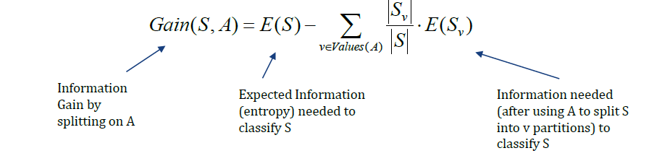
Important attributes have high/maximum information gain.
1b)
Accuracy = (TP+TN)/(TP+FP+FN+TN)
Model B looks better option as there is a smaller cross validation score difference between training and test dataset.
From business context, model B is more reliable as it has lesser tendency to overfit due to smaller difference in train and test score. Customer predictions on unseen and new data are reliable. This is helpful for planning and allocating marketing budget efficiently due to lesser uncertainty in model results interpretability.
Even if model A fares better on training/known dataset, it will fare poorly on unseen data.

1c)
Create a hybrid machine learning system, also known as a voting classifier, consisting of decision tree, support vector machine and KNN classifier and rule-based classifier. Motivation is different models are experts in different fields of learning, owing to variations in budget for different campaigns. The predictive power of different classifiers can be averaged to get overall response.

Yes, it is possible to predict optimal number but we need regression model for that since we will be predicting a numeric value. The independent variables given here impact customers who respond to a campaign and that’s indicated by high information gain of variables determining customer response. A valuable variable shall be V13, number of contacts performed for a customer during a campaign.

1d) Dataset is skewed in favour of ‘no’ class. ‘yes’ class is a minority. This explains why random forest model is biased in favour of ‘no’ class as seen by high error rates for ‘no’ class. Increase weight importance of ‘yes’ class. There is a hyperparameter is sklearn API for machine learning models to do so. Large difference between ‘yes’ class and OOB score as well. OOB scoring does not seem to improve random forest predictive performance too.

1e)
For discrete variables, mean imputation
In case of discrete variable, we cannot replace the values with the means.
Mode is a better statistical missing value imputation to handle missing data for discrete values while mean is good for continuous.

Another observation is different ranges of the numeric variables as seen from mean and standard deviation significant differences. Clustering models that are sensitive to distances in space their ability to measure similarity of datapoints will be impacted adversely. Standard scaling to mean 0 and variance 1 for numeric values chosen for clustering will solve issue.

1f) Yes, 5 is optimal number of cluster. Based on the elbow plot, sum of squared errors do not significantly decrease beyond 5 clusters. According to silhouette plot, beyond 5 clusters silhouette score is pretty steady without further significant increase.

2a) Large numbers of neurons result in possible overfit is a possibility. The intermediate hidden layers are assumed to do an identity mapping but don’t do so thus resulting in significant training error generated by those hidden layers that do not perform identity mapping.

Dropout is one good option where a certain fraction of randomly selected hidden layer neurons are ignored during training to avoid overfitting.
Add residual layers to perform identity mapping to avoid performance degradation of deeper neural networks. Random initialisation of weights, ensuring they are not close to 0 to avoid vanishing gradient problem and not too high to avoid instability in learning that may prevent convergence to global minimum in loss function is very important too.

Layer Type | Activation | Kernel Size | Output Shape
Input | - | - | (256, 256, 3)
Conv2d | Relu | (12,12) | (245, 245, 16)
Identity Block | - | - | (245, 245, 16)
Maxpooling2d | - | (2,2) | (122,122,16)
Dropout(0.3) | - | -
Conv2d | Relu | (6,6) | (117,117,32)
Identity Block | - | - | (117,117,32)
Maxpooling2d | - | (4,4) | (29,29,32)
Dropout(0.3) | - | -
Flatten | - | - | 26912
Dense | Relu | - | 128
Dense | Softmax | - | 6

2b) Data augmentation in data analysis are techniques used to increase the amount of data by adding slightly modified copies of already existing data or newly created synthetic data from existing data. It helps reduce overfitting when training a machine/deep learning model.

Examples of data augmentation are jittering (addition of random noise to images) and standardization rescaling of images to consider variations of image quality in different countries will help.

2c) Both models can be combined via loosely coupled sensor data fusion/restricted recognition where recognition search space of second recognition pipeline is restricted based on results of first recognition pipeline.

In this approach, predictions from 1st CNN model that limits the search boundary for predictions for the 2nd CNN model that is required to classify categories of the image signs. The second model need only perform recognition within the established context boundaries, leading to reduced computation memory space and time.

The image below, taken from PRS note, depicts schematic architecture of combination of both models. Data source can be common for both models.

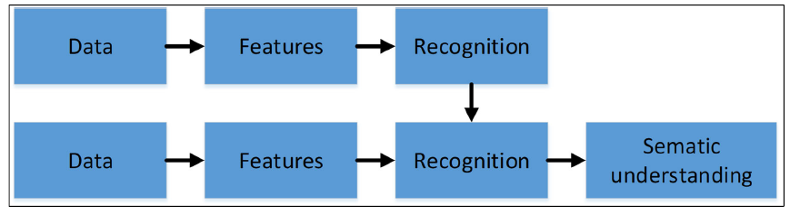

2d)

Loosely coupled ‘early’ more suited for this task.
In the early fusion strategy, all local features (shape and color) are extracted from the same patches and are locally concatenated before encoding whereas in the late fusion the features representations are computed separately for each feature and concatenated thereafter.

Time and freq domain are inverse domain but not independent and can be derived from each other thus ‘Early’ fusion more appropriate. ‘Late’ fusion obtained wavelet features are assumed to be independent but may not be so actually. The statistical features obtained may not be constant too over time.

2e) Utilise Naïve Bayes classifier.

Compute prior probabilities of classes first.
P(comfortable) = 4/8 = ½
P(need to be improved) = 4/8 = ½

Decision based on driving profile
Driving | comfortable | Need to be improved
Fast | 2/4 | 1/4
Medium | 1/4 | 2/4
slow | 1/4 | 1/4

Driving | comfortable | Need to be improved
Small | 3/4 | 1/4
large | 1/4 | 3/4

Look at likelihoods of different evidences:
A: X(driving profile = Fast| traffic Sign=small)
P(X|Comfortable) = 2/4 x 3/4 x 1/2 = 3/16= 0.1875
P(X|Need to improve) = 1/4 x 1/4 x 1/2 = 1/32 = 0.031

B: X(driving profile = Fast| traffic Sign=large)
P(X|Comfortable) = 2/4 x 1/4 x 1/2 = 1/16 =0.0625
P(X|Need to improve) = 1/4 x 3/4 x 1/2 = 3/32 =0.09375

C: X(driving profile = Medium| traffic Sign=small)
P(X|Comfortable) = 1/4 x 3/4 x 1/2 = 1/32 = 0.031
P(X|Need to improve) = 2/4 x 1/4 x 1/2 = 2/32 = 0.0625

D: X(driving profile = Medium| traffic Sign=Large)
P(X|Comfortable) = 1/4 x 1/4 x 1/2 = 1/32 =0.031
P(X|Need to improve) = 3/4 x 2/4 x 1/2 = 6/32 = 0.1875

E: X(driving profile = Slow| traffic Sign=small)
P(X|Comfortable) = 1/4 x 3/4 x 1/2 = 3/32 = 0.093
P(X|Need to improve) = 1/4 x 1/4 x 1/2 = 1/32 = 0.031

F: X(driving profile = Slow| traffic Sign=large)
P(X|Comfortable) = 1/4 x 1/4 x 1/2 = 1/32 = 0.031
P(X|Need to improve) = 1/4 x 3/4 x 1/2 = 3/32 = 0.09375

If
driving profile | traffic sign
then
driving profile | traffic sign | THEN = prediction
Fast | Small | Comfortable
Fast | Large | Need to improve
Medium | Small | Comfortable
Medium | Large | Need to improve
slow | Small | Comfortable
Slow | Large | Need to improve

