Name: Anireetha M EX NO: 2
Roll No: 25BAD009 Date: 24/07/26
Slot: A 10
Squaring a Sorted Array (Two-Pointer)
AIM:
To write a C program to square each element of a sorted array and return the squared values in sorted order using the Two-Pointer Technique with O(N) time complexity
PSEUDO CODE:
1. Start
2. Read N
3. Read the sorted array arr
4. Create result array of size N
5. Set left = 0
6. Set right = N - 1
7. Set index = N - 1
8. While left <= right
9. If |arr[left]| > |arr[right]|
10. result[index] = arr[left] * arr[left]
11. left = left + 1
12. Else
13. result[index] = arr[right] * arr[right]
14. right = right - 1
15. End If
16. index = index - 1
17. End While
18. Print the result array
19. Stop
CODE:
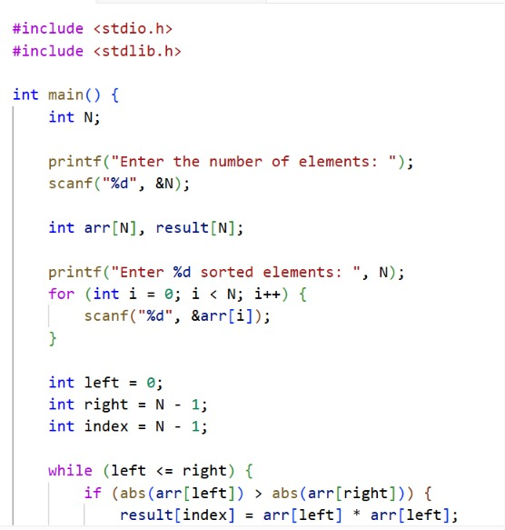
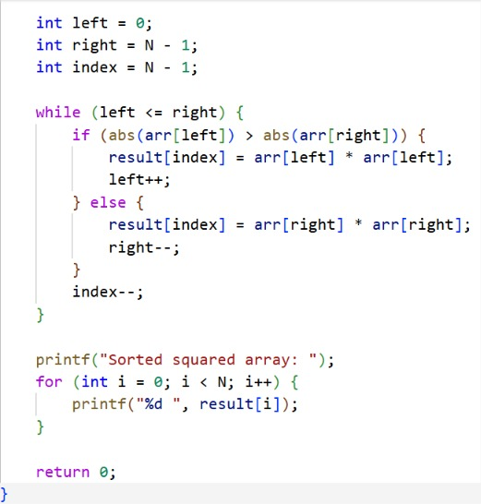

OUTPUT:

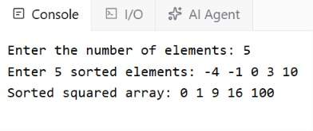

RESULT:
Thus, the C program to square the elements of a sorted array and return the squared values in sorted order using the Two-Pointer Technique was implemented and executed successfully.
LINK: https://github.com/Anireetha/24CSI024-25BAD009/blob/ae8e51cc2e62ad5ea42bcf63f5fa89704c3990e3/Squaring%20a%20sorted%20array(Two-pointer).c

Cumulative Resource Consumption (Prefix Sum)
Aim
To write a C program to compute the Prefix Sum (Cumulative Running Sum) of an array.
PSEUDO CODE:
1. Start.
2. Read the number of elements N.
3. Read the array elements.
4. Create a prefix sum array of size N.
5. Assign prefix[0] = arr[0].
6. Repeat from i = 1 to N - 1: prefix[i] = prefix[i - 1] + arr[i].
7. Print the prefix sum array.
8. Stop.

CODE:

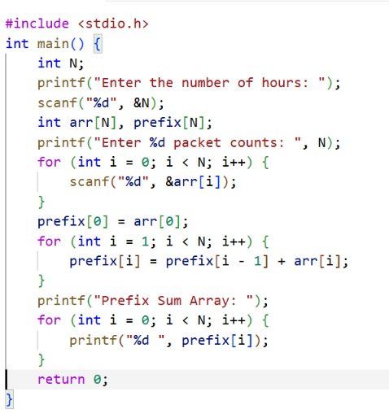

OUTPUT:
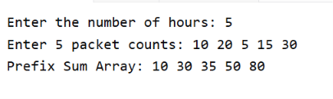
RESULT:
Thus, the program to find the prefix sum (cumulative running sum) of an array was successfully implemented and the correct output was obtained.
LINK: https://github.com/Anireetha/24CSI024-25BAD009/blob/ae3d0c3d5b26099adadc453562c3be2ed14bcd25/Cumulative%20Resource%20Consumption.c

Grouping Active Sectors (Fixed-Size Sliding Window)
AIM:
To write a C program to find the minimum number of swaps required to bring all active sectors (1s) together in a binary array using the Fixed-Size Sliding Window Technique.
PSEUDO CODE:
1.Start.
2.Read N.
3.Read the binary array arr.
4.Count the total number of 1s and store it in countOnes.
5.If countOnes <= 1, print Min Swaps: 0 and stop.
6.Count the number of 1s in the first window of size countOnes.
7.Store this value in currentOnes and maxOnes.
8.Slide the window from left to right:
9.Update currentOnes by adding the new element and removing the outgoing element.
10.Update maxOnes if currentOnes is greater.
11.Compute minSwaps = countOnes - maxOnes.
12.Print Min Swaps: minSwaps.
13.Stop.

CODE:

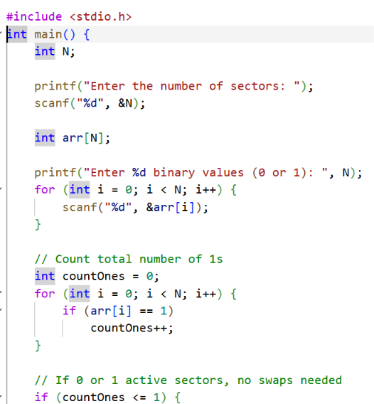
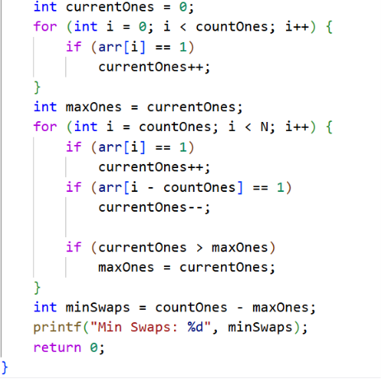
OUTPUT:
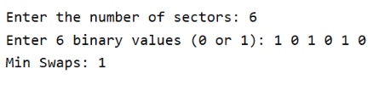
RESULT:
Thus, the C program to find the minimum number of swaps required to group all active sectors (1s) together using the Fixed-Size Sliding Window Technique was implemented and executed successfully.
LINK: https://github.com/Anireetha/24CSI024-25BAD009/blob/a5912719b3ae82184012c997cdcbcdd8522beb0a/Grouping%20Active%20Sectors.c

Maximum Task Window Within Budget (Variable-Size Sliding Window)
AIM:
To implement the Variable Size Sliding Window technique in C to find the maximum number of consecutive tasks whose total energy cost does not exceed the given budget.
PSEUDO CODE:
1.Start
2.Read N and P
3.Read the array elements
4.Initialize start = 0, sum = 0, maxLen = 0
5.For end = 0 to N-1
Add arr[end] to sum
While sum > P
Subtract arr[start] from sum
Increment start
End While
Update maxLen = maximum(maxLen, end - start + 1)
6.End For
7.Print maxLen
8.Stop

CODE:
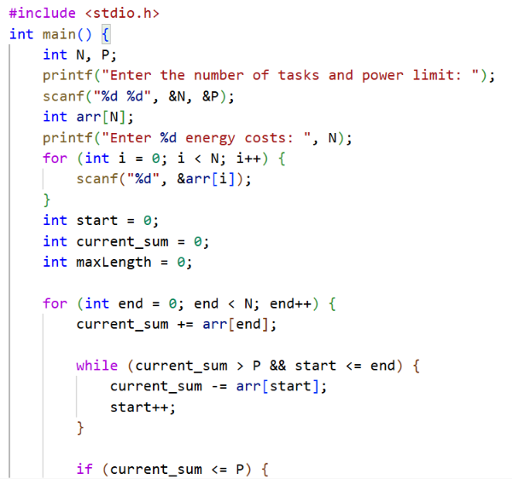

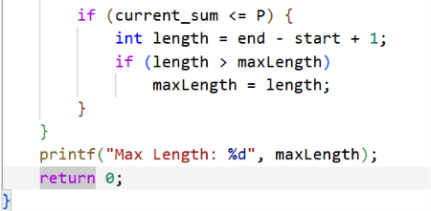
OUTPUT:
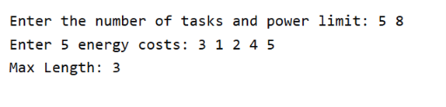
RESULT:
The program was executed successfully and the maximum number of consecutive tasks that can be performed without exceeding the given budget was found using the Variable Size Sliding Window technique.
LINK: : https://github.com/Anireetha/24CSI024-25BAD009/blob/298db7100f61cc943340baeb6efdf68fbda45104/Maximum%20Task%20Window%20Within%20Budget.c

Sliding Window Maximum Peak (Monotonic Window Queue)
AIM:
To write a C program to find the maximum element in every sliding window of size K using a Monotonic Deque with O(N) time complexity.
PSEUDO CODE:
1. Start.
2. Read N and K.
3. Read the array elements.
4. Create a deque using an array with front and rear.
5. For each element from 0 to N-1:
Remove indices from the front if they are outside the current window.
Remove indices from the rear while the current element is greater than or equal to the elements at those indices.
Insert the current index at the rear.

If the window is formed (i >= K-1), print the element at the front of the deque.
6. Stop.
CODE:
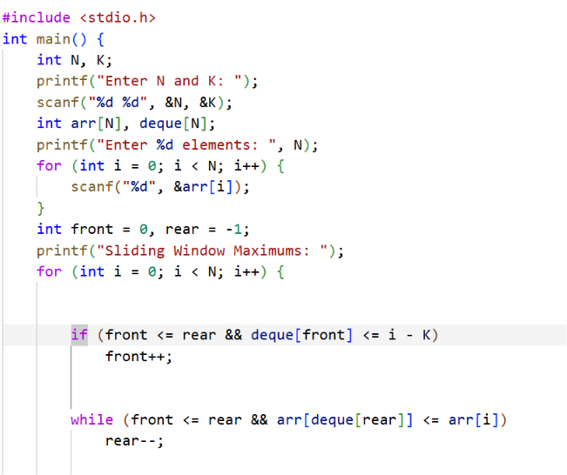

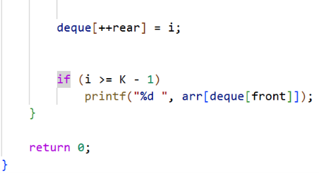

OUTPUT:

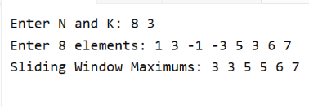
RESULT:
Thus, the C program to find the maximum element in every sliding window of size K using a Monotonic Deque was implemented and executed successfully
LINK: https://github.com/Anireetha/24CSI024-25BAD009/blob/eca57570d07cda8cd15135abc54977a0c8e19577/Sliding%20Window%20Maximum%20Peak.c

