Name: Anireetha M EX NO: 2
Roll No: 25BAD009 Date: 17/07/26
Slot: A 10
Experiment: Implementation of List ADT and Linear Search
AIM:
To implement the List Abstract Data Type (ADT) and perform Linear Search to find a given element in the list.
PSEUDO CODE:
START
1. Define a List ADT with:
- Array of size MAX
- Variable size
2. Read the number of elements (n).
3. Create the list:
a. Store n in size.
b. Read n elements into the array.
4. Read the element to be searched (key).
5. Perform Linear Search:
a. Start from the first element.
b. Compare each element with key.
c. If a match is found, return its index.
d. If no match is found after checking all elements,
return -1.
6. If index ≠ -1
Display "Element found at index".
Else
Display "Element not found".
STOP

CODE:
#include <stdio.h>
#define MAX 100
typedef struct {
int arr[MAX];
int size;
} List;
void createList(List *l, int n) {
l->size = n;
printf("Enter %d elements: ", n);
for (int i = 0; i < n; i++) {
scanf("%d", &l->arr[i]);
}
}
int linearSearch(List l, int key) {
for (int i = 0; i < l.size; i++) {
if (l.arr[i] == key)
return i;
}
return -1;
}
int main() {
List l;
int n, key, pos;
printf("Enter the number of elements: ");
scanf("%d", &n);
createList(&l, n);
printf("Enter the element to search: ");
scanf("%d", &key);
pos = linearSearch(l, key);

if (pos != -1)
printf("Element found at index %d", pos);
else
printf("Element not found");
return 0;
}
OUTPUT:
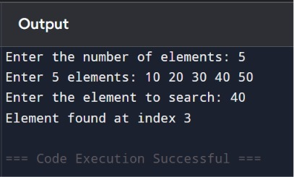
RESULT:
The List ADT was successfully implemented using an array, and the Linear Search operation was performed. The program correctly displayed the index of the searched element if it was present; otherwise, it displayed "Element not found."

