
LABORATORY RECORD
CSD5004 Artificial Intelligence and Machine Learning
Programme Core · Regular
(Lecture and Tutorial, practical hours only)
Student Name: Anirud Paul
Student Regn. No.: 26MCF10001
Year: 2026-27
Semester: Fall Semester 26-27
ClassNbr: BL2026270100790
Slot: B11+B12+B13
Class Room: AB02-202
Faculty Name: URIKHIMBAM BOBY CLINTON
School of Computing Science Engineering and Artificial Intelligence (SCAI)
VIT Bhopal University
Source code, figures and the executable notebook are available at
github.com/AnirudPaul/ai-lab-assignments

Index
# | Experiment | Technique | Dataset
1 | Graph traversal | Depth-First Search, Breadth-First Search | Hand-built graph
2 | 8-Puzzle solver | A* search, admissible heuristics | Generated states
3 | Travelling Salesman Problem | Genetic algorithm (evolutionary search) | 25 Indian cities
4 | Family-tree rule induction | First Order Inductive Learner (FOIL) | Hand-built family tree
5 | Expert system | Forward chaining + certainty factors | Hand-built rule base
6 | Handwritten digit classifier | Multilayer Perceptron | MNIST
7 | Face recognition | PCA eigenfaces + Support Vector Machine | LFW
8 | Digit clustering | K-Means | MNIST
9 | Image classification | Convolutional Neural Network | CIFAR-10
10 | Sentiment analysis | Multilayer bidirectional LSTM | IMDB movie reviews

Environment setup
One shared setup cell: imports, a fixed random seed so every number in this record is reproducible, a common plot style, and a save_fig helper that writes every figure to assets/fig/ as a PNG as well as showing it inline.
Code
from __future__ import annotations

import os
import random
import sys
import time
import warnings
from collections import Counter, defaultdict, deque
from dataclasses import dataclass, field
from pathlib import Path

import matplotlib
import matplotlib.pyplot as plt
import numpy as np
import pandas as pd

warnings.filterwarnings("ignore")

SEED = 42
random.seed(SEED)
np.random.seed(SEED)

ROOT = Path.cwd()
DATA = ROOT / "data"
FIG = ROOT / "assets" / "fig"
FIG.mkdir(parents=True, exist_ok=True)
os.environ.setdefault("SCIKIT_LEARN_DATA", str(DATA / "sklearn"))

# A single consistent look for all 40+ figures in this record.
PALETTE = ["#2A4B9B", "#E4572E", "#17A398", "#F2A65A", "#7D4F9E",
"#3B8EA5", "#C44E52", "#8C8C8C", "#4C9F70", "#D6A419"]
plt.rcParams.update({
"figure.dpi": 110,
"savefig.dpi": 140,
"figure.facecolor": "white",
"axes.facecolor": "white",
"axes.grid": True,
"grid.alpha": 0.25,
"grid.linestyle": "--",
"axes.spines.top": False,
"axes.spines.right": False,
"axes.titlesize": 12,
"axes.titleweight": "bold",
"axes.labelsize": 10,
"font.size": 10,
"legend.frameon": False,
"image.cmap": "viridis",
"axes.prop_cycle": matplotlib.cycler(color=PALETTE),
})

def save_fig(name: str, fig=None, tight: bool = True):
"""Save the current (or given) figure to assets/fig/<name>.png and show it."""
fig = fig or plt.gcf()
if tight:
fig.tight_layout()
fig.savefig(FIG / f"{name}.png", bbox_inches="tight", facecolor="white")
plt.show()
return fig

def banner(title: str) -> None:
"""Consistent section header for printed console output."""
print("=" * 68)
print(title.center(68))
print("=" * 68)

def timed(fn, *args, **kwargs):
"""Run fn, return (result, elapsed_seconds)."""
t0 = time.perf_counter()
out = fn(*args, **kwargs)
return out, time.perf_counter() - t0

def free_gpu() -> None:
"""Release cached GPU memory between experiments.

PyTorch keeps a caching allocator, so memory freed by Python is not returned to the
driver. This GPU is shared with other processes, so handing it back between the
heavier experiments avoids an out-of-memory failure late in the notebook.
"""
import gc

gc.collect()
if torch.cuda.is_available():
torch.cuda.empty_cache()
torch.cuda.synchronize()

def load_dataset(name: str) -> dict:
"""Load a prepared dataset from data/prepared/<name>.npz.

Datasets are downloaded and normalised once by `python tools/fetch_data.py`, which
keeps this notebook free of network calls and makes every run reproducible.
"""
path = DATA / "prepared" / f"{name}.npz"
if not path.exists():
raise FileNotFoundError(
f"{path} not found. Run: python tools/fetch_data.py {name}")
with np.load(path, allow_pickle=True) as z:
return {k: z[k] for k in z.files}
Code
import sklearn
import torch

DEVICE = torch.device("cuda" if torch.cuda.is_available() else "cpu")
torch.manual_seed(SEED)
if torch.cuda.is_available():
torch.cuda.manual_seed_all(SEED)
# cuDNN picks convolution algorithms by benchmarking, and some are non-deterministic.
# Left at the defaults, re-running this notebook shifts the reported accuracies by a
# few tenths of a percent, which would make the figures quoted in the discussion
# sections drift away from the numbers actually printed. Fixing the algorithm choice
# costs a little speed and buys reproducible results.
torch.backends.cudnn.deterministic = True
torch.backends.cudnn.benchmark = False

env = pd.DataFrame(
[
("Python", sys.version.split()[0]),
("NumPy", np.__version__),
("pandas", pd.__version__),
("scikit-learn", sklearn.__version__),
("PyTorch", torch.__version__),
("Matplotlib", matplotlib.__version__),
("Compute device", torch.cuda.get_device_name(0) if torch.cuda.is_available() else "CPU"),
("Random seed", SEED),
],
columns=["Component", "Version"],
)
banner("ENVIRONMENT")
print(env.to_string(index=False))
====================================================================
ENVIRONMENT
====================================================================
Component Version
Python 3.11.0
NumPy 2.1.3
pandas 2.2.3
scikit-learn 1.6.1
PyTorch 2.5.1+cu121
Matplotlib 3.9.2
Compute device NVIDIA GeForce RTX 4060 Laptop GPU
Random seed 42
Experiment 1 — Depth-First Search and Breadth-First Search
Aim. Implement DFS and BFS from first principles and use them to traverse a graph, comparing the order in which they discover vertices and the shape of the search tree each one produces.
Theory
Both algorithms explore a graph by maintaining a frontier of discovered-but-not-yet- expanded vertices. The only difference between them is the discipline of that frontier:
 | DFS | BFS
Frontier | Stack (LIFO) | Queue (FIFO)
Explores | One branch as deep as possible, then backtracks | All vertices at distance d before any at d+1
Time | O(V + E) | O(V + E)
Space | O(b m) — m = deepest level, b = branching factor | O(b d) — d = depth of the shallowest goal
Shortest path (unweighted)? | No — finds a path, not the shortest | Yes — first time a vertex is dequeued it is at minimum distance
Typical use | Cycle detection, topological sort, connectivity | Shortest hop count, level-order processing

The BFS shortest-path guarantee is worth stating precisely, because it is the reason BFS is used for unweighted shortest paths: since BFS dequeues vertices in non-decreasing order of distance from the source, the first time it reaches a vertex it has done so along a path with the fewest possible edges.
Implementation note on determinism
A graph's adjacency list has no inherent order, so two correct DFS implementations can produce different (equally valid) visit orders. To make every number in this record reproducible, neighbours() below returns neighbours in sorted order.
Code
class Graph:
"""Undirected/directed graph on an adjacency list, built from scratch."""

def __init__(self, directed: bool = False):
self.adj: dict[str, list[str]] = defaultdict(list)
self.directed = directed

def add_edge(self, u: str, v: str) -> None:
self.adj[u].append(v)
self.adj[v].append(u) if not self.directed else self.adj.setdefault(v, [])

def neighbours(self, u: str) -> list[str]:
# Sorted => deterministic, reproducible traversal order.
return sorted(self.adj[u])

@property
def nodes(self) -> list[str]:
return sorted(self.adj)

@property
def edges(self) -> list[tuple[str, str]]:
seen = set()
for u in self.nodes:
for v in self.adj[u]:
key = (u, v) if self.directed else tuple(sorted((u, v)))
seen.add(key)
return sorted(seen)

def __repr__(self) -> str:
kind = "directed" if self.directed else "undirected"
return f"<Graph {kind}: {len(self.nodes)} vertices, {len(self.edges)} edges>"

# The graph used throughout this experiment. It is built so DFS and BFS visibly
# disagree: there is a SHORT route A-C-J (2 edges) and a LONG route
# A-B-D-E-F-J (5 edges). Because neighbours are visited in sorted order, DFS
# commits to B first and finds J the long way round, while BFS finds the short one.
EDGES = [("A", "B"), ("A", "C"), ("C", "J"),
("B", "D"), ("D", "E"), ("E", "F"), ("F", "J"),
("B", "G"), ("G", "H"), ("H", "E")]

g = Graph()
for u, v in EDGES:
g.add_edge(u, v)

banner("GRAPH UNDER TEST")
print(g)
for n in g.nodes:
print(f" {n} -> {g.neighbours(n)}")
====================================================================
GRAPH UNDER TEST
====================================================================
<Graph undirected: 9 vertices, 10 edges>
A -> ['B', 'C']
B -> ['A', 'D', 'G']
C -> ['A', 'J']
D -> ['B', 'E']
E -> ['D', 'F', 'H']
F -> ['E', 'J']
G -> ['B', 'H']
H -> ['E', 'G']
J -> ['C', 'F']
The two algorithms
Each returns the visit order, the search tree (the parent map — which vertex discovered which), and a step-by-step trace of the frontier so we can plot how the two frontiers grow. DFS is given twice: recursively, which is the textbook form, and iteratively with an explicit stack, which makes the duality with BFS obvious.
Code
def dfs_recursive(graph: Graph, start: str):
"""Textbook recursive DFS. The call stack *is* the frontier."""
visited, order, parent = set(), [], {start: None}

def visit(u: str) -> None:
visited.add(u)
order.append(u)
for v in graph.neighbours(u):
if v not in visited:
parent[v] = u
visit(v)

visit(start)
return order, parent

def dfs_iterative(graph: Graph, start: str):
"""DFS with an explicit LIFO stack. Traces frontier size at every step."""
visited, order, parent, trace = set(), [], {start: None}, []
stack = [start]
while stack:
trace.append((len(order), list(stack)))
u = stack.pop() # LIFO -- the only line that differs from BFS
if u in visited:
continue
visited.add(u)
order.append(u)
# Reversed so that sorted neighbours are popped in ascending order.
for v in reversed(graph.neighbours(u)):
if v not in visited:
parent.setdefault(v, u)
stack.append(v)
return order, parent, trace

def bfs(graph: Graph, start: str):
"""BFS with a FIFO queue. Also returns each vertex's distance from the source."""
visited, order, parent, trace = {start}, [], {start: None}, []
dist = {start: 0}
queue = deque([start])
while queue:
trace.append((len(order), list(queue)))
u = queue.popleft() # FIFO -- the only line that differs from DFS
order.append(u)
for v in graph.neighbours(u):
if v not in visited:
visited.add(v)
parent[v] = u
dist[v] = dist[u] + 1
queue.append(v)
return order, parent, dist, trace

dfs_order_rec, dfs_parent_rec = dfs_recursive(g, "A")
dfs_order, dfs_parent, dfs_trace = dfs_iterative(g, "A")
bfs_order, bfs_parent, bfs_dist, bfs_trace = bfs(g, "A")

banner("TRAVERSAL FROM VERTEX A")
print(f"DFS (recursive) : {' -> '.join(dfs_order_rec)}")
print(f"DFS (iterative) : {' -> '.join(dfs_order)}")
print(f"BFS : {' -> '.join(bfs_order)}")
print()
print("BFS distance from A:", {k: bfs_dist[k] for k in sorted(bfs_dist)})
assert set(dfs_order) == set(bfs_order) == set(g.nodes), "a traversal missed a vertex"
print("\nBoth traversals visited all", len(g.nodes), "vertices.")
====================================================================
TRAVERSAL FROM VERTEX A
====================================================================
DFS (recursive) : A -> B -> D -> E -> F -> J -> C -> H -> G
DFS (iterative) : A -> B -> D -> E -> F -> J -> C -> H -> G
BFS : A -> B -> C -> D -> G -> J -> E -> H -> F

BFS distance from A: {'A': 0, 'B': 1, 'C': 1, 'D': 2, 'E': 3, 'F': 3, 'G': 2, 'H': 3, 'J': 2}

Both traversals visited all 9 vertices.
Step-by-step frontier trace
This is the heart of the difference. At every iteration we print the frontier before a vertex is removed. Watch the DFS stack stay narrow and deep while the BFS queue fans out level by level.
Code
rows = []
for i in range(max(len(dfs_trace), len(bfs_trace))):
d = dfs_trace[i] if i < len(dfs_trace) else ("", [])
b = bfs_trace[i] if i < len(bfs_trace) else ("", [])
rows.append({
"step": i + 1,
"DFS stack (top at right)": " ".join(d[1]),
"#visited": d[0],
"BFS queue (front at left)": " ".join(b[1]),
"#visited ": b[0],
})
trace_df = pd.DataFrame(rows)
banner("FRONTIER EVOLUTION")
print(trace_df.to_string(index=False))
print("\nNote: a vertex can appear twice on the DFS stack -- it was pushed by two different")
print("neighbours before being popped. The `if u in visited: continue` guard discards the")
print("stale copy, which is why the stack is longer than the number of distinct vertices.")
====================================================================
FRONTIER EVOLUTION
====================================================================
step DFS stack (top at right) #visited BFS queue (front at left) #visited
1 A 0 A 0
2 C B 1 B C 1
3 C G D 2 C D G 2
4 C G E 3 D G J 3
5 C G H F 4 G J E 4
6 C G H J 5 J E H 5
7 C G H C 6 E H F 6
8 C G H 7 H F 7
9 C G G 8 F 8
10 C G 9
11 C 9

Note: a vertex can appear twice on the DFS stack -- it was pushed by two different
neighbours before being popped. The `if u in visited: continue` guard discards the
stale copy, which is why the stack is longer than the number of distinct vertices.
Shortest path via BFS
Because BFS labels each vertex with its true hop-distance, walking the parent map backwards from any target reconstructs a minimum-edge path. DFS's parent map does not have this property — shown below, where DFS finds a longer A→J route.
Code
def path_from_parents(parent: dict[str, str | None], target: str) -> list[str]:
path, cur = [], target
while cur is not None:
path.append(cur)
cur = parent[cur]
return path[::-1]

bfs_path = path_from_parents(bfs_parent, "J")
dfs_path = path_from_parents(dfs_parent, "J")

banner("PATH FROM A TO J")
print(f"BFS path : {' -> '.join(bfs_path)} ({len(bfs_path)-1} edges) <- guaranteed minimum")
print(f"DFS path : {' -> '.join(dfs_path)} ({len(dfs_path)-1} edges)")
print(f"\nBFS distance to J = {bfs_dist['J']}, and the reconstructed path has "
f"{len(bfs_path)-1} edges -- consistent.")
====================================================================
PATH FROM A TO J
====================================================================
BFS path : A -> C -> J (2 edges) <- guaranteed minimum
DFS path : A -> B -> D -> E -> F -> J (5 edges)

BFS distance to J = 2, and the reconstructed path has 2 edges -- consistent.
Visualising the two search trees
Three panels: the graph itself; the DFS tree with vertices numbered and coloured by visit order; and the BFS tree, where colour encodes distance from the source, making the level structure obvious.
Code
import networkx as nx

G = nx.Graph()
G.add_edges_from(g.edges)
pos = nx.spring_layout(G, seed=SEED, k=0.9)

def tree_edges(parent: dict[str, str | None]) -> list[tuple[str, str]]:
return [(p, c) for c, p in parent.items() if p is not None]

fig, axes = plt.subplots(1, 3, figsize=(16.5, 5.2))

# Panel 1 -- the raw graph
nx.draw_networkx_edges(G, pos, ax=axes[0], edge_color="#9aa4b2", width=1.8)
nx.draw_networkx_nodes(G, pos, ax=axes[0], node_color="#dfe5ee",
edgecolors="#2A4B9B", linewidths=1.8, node_size=900)
nx.draw_networkx_labels(G, pos, ax=axes[0], font_size=12, font_weight="bold")
axes[0].set_title(f"The graph\n{len(g.nodes)} vertices, {len(g.edges)} edges")

# Panels 2 and 3 -- the search trees
for ax, order, parent, name, cmap, label in [
(axes[1], dfs_order, dfs_parent, "DFS", "Oranges", "visit order"),
(axes[2], bfs_order, bfs_parent, "BFS", "Blues", "distance from A"),
]:
values = ([order.index(n) for n in G.nodes()] if name == "DFS"
else [bfs_dist[n] for n in G.nodes()])
nx.draw_networkx_edges(G, pos, ax=ax, edge_color="#d7dce3", width=1.2)
nx.draw_networkx_edges(G, pos, ax=ax, edgelist=tree_edges(parent),
edge_color="#20304d", width=3.0)
nodes = nx.draw_networkx_nodes(G, pos, ax=ax, node_color=values, cmap=plt.get_cmap(cmap),
edgecolors="#20304d", linewidths=1.8, node_size=980,
vmin=min(values) - 0.6, vmax=max(values) + 0.2)
nx.draw_networkx_labels(
G, pos, ax=ax, font_size=11, font_weight="bold",
labels={n: f"{n}\n{order.index(n)+1}" if name == "DFS" else f"{n}\nd={bfs_dist[n]}"
for n in G.nodes()})
ax.set_title(f"{name} tree (bold edges)\n{' '.join(order)}")
plt.colorbar(nodes, ax=ax, fraction=0.04, pad=0.02, label=label)

for ax in axes:
ax.set_axis_off()
save_fig("q1_traversal_trees", fig)
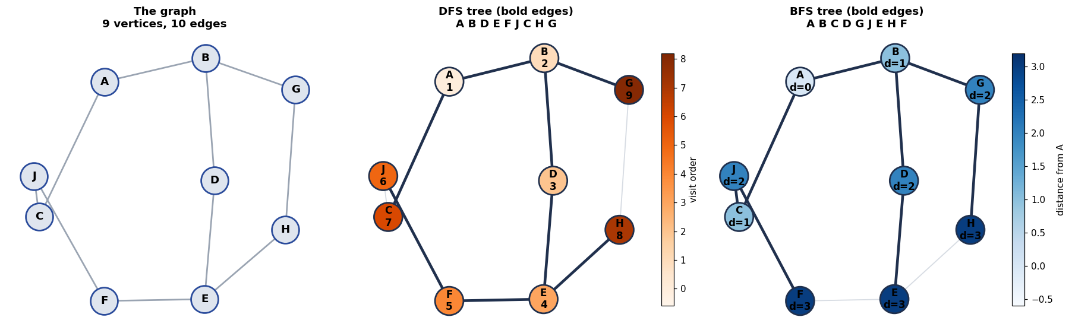
Frontier growth
Plotting frontier size per step quantifies the space trade-off from the theory table: DFS's stack stays shallow, BFS's queue bulges as it holds an entire level at once.
Code
fig, axes = plt.subplots(1, 2, figsize=(13, 4.2))

axes[0].plot([len(f) for _, f in dfs_trace], "o-", color=PALETTE[1], label="DFS stack")
axes[0].plot([len(f) for _, f in bfs_trace], "s-", color=PALETTE[0], label="BFS queue")
axes[0].set(xlabel="iteration", ylabel="frontier size",
title="Frontier size per iteration")
axes[0].legend()

levels = Counter(bfs_dist.values())
axes[1].bar([f"d={d}" for d in sorted(levels)], [levels[d] for d in sorted(levels)],
color=PALETTE[0])
axes[1].set(xlabel="distance from A", ylabel="vertices",
title="BFS level structure\n(max level width = max queue size)")
for i, d in enumerate(sorted(levels)):
axes[1].text(i, levels[d] + 0.05, str(levels[d]), ha="center", fontweight="bold")
save_fig("q1_frontier_growth", fig)
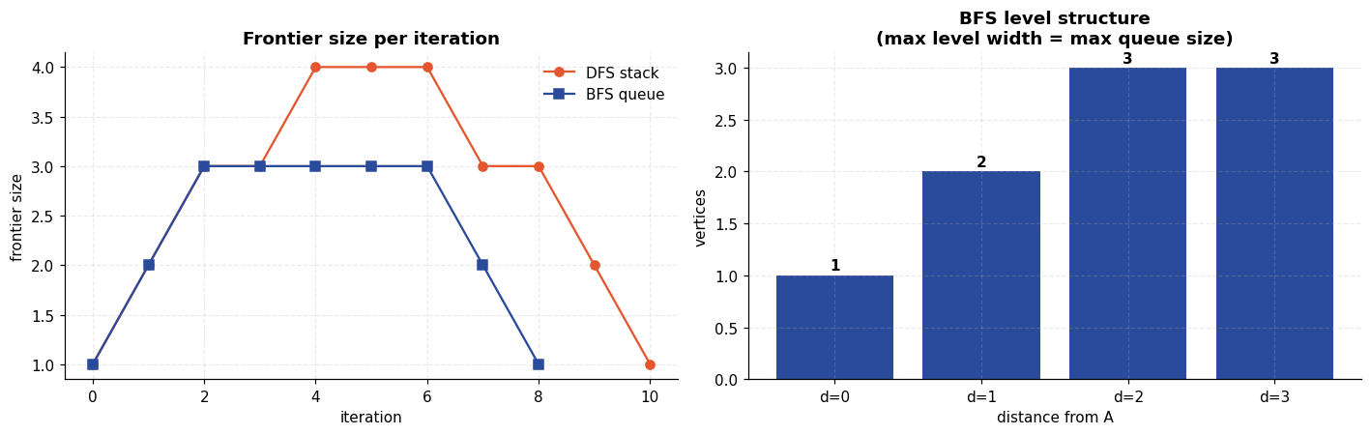
Scaling check on a larger random graph
Two separate questions, measured separately.
(a) Time. On a 4,000-vertex random graph, does runtime track O(V+E)?
(b) Space. The textbook claim is that on a balanced tree BFS needs O(bd) memory while DFS needs only O(b m). A random graph is the wrong shape to show this — its levels are irregular, and DFS can pile up a large stack of pushed-but-unvisited vertices. A complete b-ary tree is the shape the claim is actually about, so that is what is measured here.
Code
rng = np.random.default_rng(SEED)
big = Graph()
N = 4000
for i in range(1, N): # random tree => connected
big.add_edge(f"n{rng.integers(0, i)}", f"n{i}")
for _ in range(2000): # extra edges => cycles
a, b = rng.integers(0, N, 2)
if a != b:
big.add_edge(f"n{a}", f"n{b}")

(do, dp, dt), t_dfs = timed(dfs_iterative, big, "n0")
(bo, bp, bd, bt), t_bfs = timed(bfs, big, "n0")

banner(f"(a) TIME on a random graph: {len(big.nodes)} vertices, {len(big.edges)} edges")
print(pd.DataFrame([
{"Algorithm": "DFS (iterative)", "Visited": len(do), "Time (ms)": round(t_dfs * 1000, 2)},
{"Algorithm": "BFS", "Visited": len(bo), "Time (ms)": round(t_bfs * 1000, 2)},
]).to_string(index=False))
print(f"\nBoth visited every vertex; deepest BFS level = {max(bd.values())}.")

def bary_tree(b: int, depth: int) -> Graph:
"""Complete b-ary tree, the shape the O(b^d) vs O(b*m) claim is about."""
t, frontier, nid = Graph(), ["r"], 0
for _ in range(depth):
nxt = []
for u in frontier:
for _ in range(b):
nid += 1
t.add_edge(u, f"v{nid}")
nxt.append(f"v{nid}")
frontier = nxt
return t

space_rows = []
for b, depth in [(2, 10), (3, 7), (4, 6)]:
t = bary_tree(b, depth)
_, _, dtr = dfs_iterative(t, "r")
_, _, _, btr = bfs(t, "r")
space_rows.append({
"tree": f"b={b}, depth={depth}", "vertices": len(t.nodes),
"DFS peak stack": max(len(f) for _, f in dtr),
"BFS peak queue": max(len(f) for _, f in btr),
"ratio BFS/DFS": round(max(len(f) for _, f in btr) / max(len(f) for _, f in dtr), 1),
})
space_df = pd.DataFrame(space_rows)
banner("(b) SPACE on complete b-ary trees")
print(space_df.to_string(index=False))

fig, ax = plt.subplots(figsize=(7.5, 4))
x = np.arange(len(space_df))
ax.bar(x - 0.2, space_df["DFS peak stack"], 0.4, label="DFS peak stack", color=PALETTE[1])
ax.bar(x + 0.2, space_df["BFS peak queue"], 0.4, label="BFS peak queue", color=PALETTE[0])
ax.set(xticks=x, yscale="log", ylabel="peak frontier (log scale)",
title="Peak memory on complete $b$-ary trees")
ax.set_xticklabels(space_df["tree"])
for i, r in space_df.iterrows():
ax.text(i + 0.2, r["BFS peak queue"] * 1.1, f"{r['ratio BFS/DFS']}x", ha="center",
fontweight="bold", fontsize=9)
ax.legend()
save_fig("q1_space_comparison", fig)
====================================================================
(a) TIME on a random graph: 4000 vertices, 5998 edges
====================================================================
Algorithm Visited Time (ms)
DFS (iterative) 4000 372.50
BFS 4000 161.44

Both visited every vertex; deepest BFS level = 11.
====================================================================
(b) SPACE on complete b-ary trees
====================================================================
tree vertices DFS peak stack BFS peak queue ratio BFS/DFS
b=2, depth=10 2047 11 1024 93.1
b=3, depth=7 3280 15 2187 145.8
b=4, depth=6 5461 19 4096 215.6
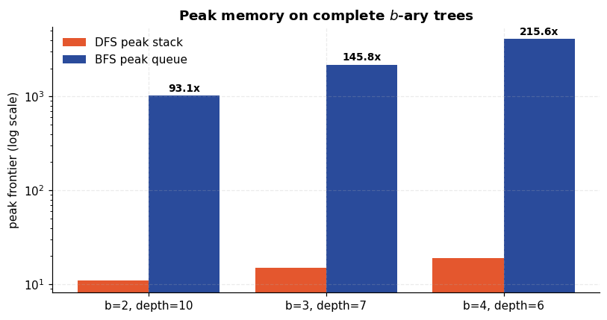
Result and discussion
- Correctness. Both traversals visited all 9 vertices. The recursive and the iterative DFS produced identical visit orders (A B D E F J C H G), which is the check that an explicit stack faithfully reproduces the call stack.
- Order. DFS went A B D E F J C H G: it committed to B and drove all the way down the B–D–E–F chain before ever looking at C. BFS went A B C D G J E H F — strictly non-decreasing in distance from A (0, 1, 1, 2, 2, 2, 3, 3, 3).
- Shortest path — the headline result. BFS reached J in 2 edges (A→C→J); DFS reached the same vertex in 5 (A→B→D→E→F→J). Both are valid paths; only BFS's is minimal. This is the predicted failure of DFS, and it is why BFS underlies unweighted shortest-path routing while DFS does not.
- Space. On complete b-ary trees the BFS queue peaked at 93× to 216× the DFS stack (1,024 vs 11 at b=2; 4,096 vs 19 at b=4), and the gap widened as b grew — the O(bd) versus O(b m) distinction, measured.
Worth recording honestly: on the 4,000-vertex random graph this ordering reverses — DFS's stack peaked higher than BFS's queue, because that graph has no clean level structure and DFS accumulates pushed-but-unvisited vertices. The textbook bound describes balanced trees, not arbitrary graphs, and only the tree measurement is evidence for it.
Conclusion. Use BFS when the fewest hops matter and the frontier fits in memory; use DFS when the graph is deep, memory is tight, and any path (or mere reachability) will do.

Experiment 2 — 8-Puzzle Solver using A* Search
Aim. Solve the 8-puzzle with A* search, and measure how much the choice of heuristic changes the amount of work done to reach the same optimal answer.
Theory
The 8-puzzle is a 3×3 board holding tiles 1–8 and one blank. A move slides a tile into the blank. The task is to reach the goal configuration in the fewest moves.
A* expands the frontier node minimising
f(n) = g(n) + h(n)
where g(n) is the cost already paid to reach n and h(n) estimates the cost remaining. Two properties matter:
- Admissible — h(n) ≤ h*(n), never overestimates. Guarantees A* returns an optimal solution.
- Consistent — h(n) ≤ c(n,n') + h(n'). Guarantees each state is expanded at most once, so no re-expansion bookkeeping is needed.
The heuristics compared here
 | Definition | Admissible? | Dominance
h₀ — Uniform Cost | 0 | Yes (trivially) | weakest; A* degenerates to Dijkstra/BFS
h₁ — Misplaced tiles | count of tiles not in their goal square | Yes: each needs ≥1 move | h₁ ≥ h₀
h₂ — Manhattan distance | Σₜᵢₗₑₛ | Δ r| + | Δ c| | Yes: each move changes one tile's distance by 1 | h₂ ≥ h₁
h₃ — Manhattan + linear conflict | h₂ + 2×(pairs reversed in their goal row/column) | Yes | h₃ ≥ h₂

Dominance is the key idea. If hₐ(n) ≥ hb(n) everywhere and both are admissible, A* with hₐ never expands more nodes than with hb. So we should see node counts fall monotonically from h₀ to h₃, while the solution length stays identical — that constancy is the experimental signature of admissibility.
Solvability
Exactly half of the 9! = 362,880 arrangements are reachable. A configuration is solvable iff the number of inversions (pairs of tiles out of order, ignoring the blank) is even. Unsolvable instances are rejected up front rather than searched forever.
Code
import heapq
from itertools import combinations

GOAL = (1, 2, 3, 4, 5, 6, 7, 8, 0) # 0 is the blank
SIDE = 3
# Precompute goal row/col for every tile -- turns Manhattan into table lookups.
GOAL_POS = {tile: divmod(i, SIDE) for i, tile in enumerate(GOAL)}

def neighbours(state: tuple[int, ...]) -> list[tuple[int, ...]]:
"""All states reachable by sliding one tile into the blank."""
z = state.index(0)
r, c = divmod(z, SIDE)
out = []
for dr, dc in ((-1, 0), (1, 0), (0, -1), (0, 1)):
nr, nc = r + dr, c + dc
if 0 <= nr < SIDE and 0 <= nc < SIDE:
j = nr * SIDE + nc
lst = list(state)
lst[z], lst[j] = lst[j], lst[z]
out.append(tuple(lst))
return out

def inversions(state: tuple[int, ...]) -> int:
tiles = [t for t in state if t != 0]
return sum(1 for a, b in combinations(range(len(tiles)), 2) if tiles[a] > tiles[b])

def solvable(state: tuple[int, ...]) -> bool:
"""For a 3x3 puzzle: solvable iff the inversion count is even."""
return inversions(state) % 2 == 0

def h0(_s: tuple[int, ...]) -> int:
return 0

def h1(s: tuple[int, ...]) -> int:
return sum(1 for i, t in enumerate(s) if t != 0 and t != GOAL[i])

def h2(s: tuple[int, ...]) -> int:
total = 0
for i, t in enumerate(s):
if t == 0:
continue
r, c = divmod(i, SIDE)
gr, gc = GOAL_POS[t]
total += abs(r - gr) + abs(c - gc)
return total

def h3(s: tuple[int, ...]) -> int:
"""Manhattan + linear conflict: two tiles in their goal line but reversed need
two extra moves, because one must step aside for the other."""
total, conflicts = h2(s), 0
for line in range(SIDE):
row = [(c, s[line * SIDE + c]) for c in range(SIDE)]
for (ca, ta), (cb, tb) in combinations(row, 2):
if ta and tb and GOAL_POS[ta][0] == line and GOAL_POS[tb][0] == line \
and GOAL_POS[ta][1] > GOAL_POS[tb][1]:
conflicts += 1
col = [(r, s[r * SIDE + line]) for r in range(SIDE)]
for (ra, ta), (rb, tb) in combinations(col, 2):
if ta and tb and GOAL_POS[ta][1] == line and GOAL_POS[tb][1] == line \
and GOAL_POS[ta][0] > GOAL_POS[tb][0]:
conflicts += 1
return total + 2 * conflicts

HEURISTICS = {"h0 Uniform Cost": h0, "h1 Misplaced": h1,
"h2 Manhattan": h2, "h3 Manhattan+LC": h3}

banner("HEURISTIC SANITY CHECK")
demo = (1, 2, 3, 4, 0, 6, 7, 5, 8)
print(f"state {demo} solvable={solvable(demo)}")
for name, h in HEURISTICS.items():
print(f" {name:18s} = {h(demo)}")
print(f"\nGoal state scores 0 under every heuristic: "
f"{[h(GOAL) for h in HEURISTICS.values()]}")
====================================================================
HEURISTIC SANITY CHECK
====================================================================
state (1, 2, 3, 4, 0, 6, 7, 5, 8) solvable=True
h0 Uniform Cost = 0
h1 Misplaced = 2
h2 Manhattan = 2
h3 Manhattan+LC = 2

Goal state scores 0 under every heuristic: [0, 0, 0, 0]

The A* search itself
A binary heap orders the frontier by f. closed prevents re-expansion; the g-dictionary lets a cheaper route to an already-discovered state overwrite the old one. The function returns the solution path plus the two cost measures we care about: nodes expanded (work done) and peak frontier (memory).
Code
@dataclass
class SearchResult:
path: list[tuple[int, ...]]
expanded: int
generated: int
peak_frontier: int
seconds: float

@property
def moves(self) -> int:
return len(self.path) - 1

def astar(start: tuple[int, ...], h, goal: tuple[int, ...] = GOAL) -> SearchResult:
t0 = time.perf_counter()
counter = 0 # tie-break: FIFO among equal f
frontier = [(h(start), 0, counter, start)]
came_from: dict[tuple, tuple | None] = {start: None}
g_score = {start: 0}
closed: set[tuple] = set()
expanded = generated = 0
peak = 1

while frontier:
peak = max(peak, len(frontier))
_f, g, _cnt, state = heapq.heappop(frontier)
if state in closed:
continue
closed.add(state)
expanded += 1

if state == goal:
path, cur = [], state
while cur is not None:
path.append(cur)
cur = came_from[cur]
return SearchResult(path[::-1], expanded, generated, peak,
time.perf_counter() - t0)

for nxt in neighbours(state):
generated += 1
ng = g + 1
if ng < g_score.get(nxt, 1 << 30):
g_score[nxt] = ng
came_from[nxt] = state
counter += 1
heapq.heappush(frontier, (ng + h(nxt), ng, counter, nxt))

raise ValueError("no solution -- the instance was unsolvable")

def scramble(moves: int, rng: np.random.Generator) -> tuple[int, ...]:
"""Random walk backwards from the goal: guarantees a solvable instance and gives
a rough handle on difficulty (true optimal length <= `moves`)."""
s = GOAL
prev = None
for _ in range(moves):
opts = [n for n in neighbours(s) if n != prev]
prev = s
s = opts[rng.integers(len(opts))]
return s

rng = np.random.default_rng(SEED)
puzzle = scramble(22, rng)

banner("INSTANCE TO SOLVE")
print(f"start = {puzzle} inversions = {inversions(puzzle)} solvable = {solvable(puzzle)}")
for r in range(SIDE):
print(" " + " ".join(f"{t or '_':>2}" for t in puzzle[r * SIDE:(r + 1) * SIDE]))
====================================================================
INSTANCE TO SOLVE
====================================================================
start = (3, 8, 5, 1, 0, 2, 4, 7, 6) inversions = 12 solvable = True
3 8 5
1 _ 2
4 7 6
Solving with all four heuristics
Same instance, four heuristics. The prediction from the dominance argument: solution length identical in every row, nodes expanded strictly decreasing.
Code
results = {name: astar(puzzle, h) for name, h in HEURISTICS.items()}

cmp_df = pd.DataFrame([
{"Heuristic": name, "h(start)": HEURISTICS[name](puzzle), "Moves": r.moves,
"Nodes expanded": r.expanded, "Nodes generated": r.generated,
"Peak frontier": r.peak_frontier, "Time (s)": round(r.seconds, 4)}
for name, r in results.items()
])
banner("A* WITH FOUR HEURISTICS (same instance)")
print(cmp_df.to_string(index=False))

lengths = {r.moves for r in results.values()}
assert len(lengths) == 1, f"admissible heuristics disagreed on optimal length: {lengths}"
best, worst = cmp_df["Nodes expanded"].min(), cmp_df["Nodes expanded"].max()
print(f"\nAll four agree the optimum is {lengths.pop()} moves -- the signature of admissibility.")
print(f"Work done differs by {worst/best:.0f}x ({worst:,} vs {best:,} nodes expanded).")
====================================================================
A* WITH FOUR HEURISTICS (same instance)
====================================================================
Heuristic h(start) Moves Nodes expanded Nodes generated Peak frontier Time (s)
h0 Uniform Cost 0 12 1453 4030 970 0.0151
h1 Misplaced 8 12 86 236 66 0.0017
h2 Manhattan 12 12 20 52 16 0.0004
h3 Manhattan+LC 12 12 15 40 14 0.0011

All four agree the optimum is 12 moves -- the signature of admissibility.
Work done differs by 97x (1,453 vs 15 nodes expanded).
The solution, move by move
Code
def draw_puzzle(ax, state, title="", highlight=None):
ax.set_xlim(-0.5, SIDE - 0.5); ax.set_ylim(SIDE - 0.5, -0.5)
ax.set_xticks([]); ax.set_yticks([]); ax.grid(False)
for i, t in enumerate(state):
r, c = divmod(i, SIDE)
blank = t == 0
face = "#f4f6f9" if blank else ("#E4572E" if t == highlight else "#2A4B9B")
ax.add_patch(plt.Rectangle((c - 0.46, r - 0.46), 0.92, 0.92,
facecolor=face, edgecolor="#20304d", linewidth=1.4))
if not blank:
ax.text(c, r, str(t), ha="center", va="center", color="white",
fontsize=15, fontweight="bold")
ax.set_title(title, fontsize=9)

sol = results["h3 Manhattan+LC"].path
ncol = 6
nrow = int(np.ceil(len(sol) / ncol))
fig, axes = plt.subplots(nrow, ncol, figsize=(2.05 * ncol, 2.25 * nrow))
axes = np.atleast_2d(axes)
for idx, ax in enumerate(axes.ravel()):
if idx < len(sol):
moved = None
if idx > 0:
blank_before = sol[idx - 1].index(0)
moved = sol[idx][blank_before] # the tile that slid into the old blank
label = "START" if idx == 0 else ("GOAL" if idx == len(sol) - 1 else f"move {idx}")
draw_puzzle(ax, sol[idx], f"{label}" + (f" (tile {moved})" if moved else ""), moved)
else:
ax.set_axis_off()
save_fig("q2_solution_path", fig)
print(f"Optimal solution: {len(sol)-1} moves.")
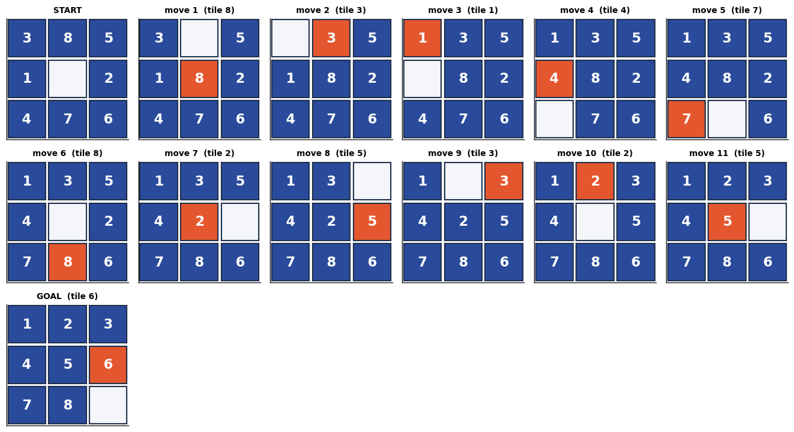
Optimal solution: 12 moves.
How heuristic strength translates into work saved
Code
fig, axes = plt.subplots(1, 3, figsize=(16, 4.3))
names = list(results)
colors = PALETTE[:4]

axes[0].bar(range(4), [results[n].expanded for n in names], color=colors)
axes[0].set(yscale="log", ylabel="nodes expanded (log)", title="Search effort")
axes[0].set_xticks(range(4)); axes[0].set_xticklabels([n.split()[0] for n in names])
for i, n in enumerate(names):
axes[0].text(i, results[n].expanded * 1.15, f"{results[n].expanded:,}",
ha="center", fontsize=9, fontweight="bold")

axes[1].bar(range(4), [HEURISTICS[n](puzzle) for n in names], color=colors)
axes[1].axhline(results[names[0]].moves, ls="--", color="#333",
label=f"true optimum = {results[names[0]].moves}")
axes[1].set(ylabel="h(start)", title="Heuristic estimate at the start\n(all stay below the truth)")
axes[1].set_xticks(range(4)); axes[1].set_xticklabels([n.split()[0] for n in names])
axes[1].legend(fontsize=8)

axes[2].bar(range(4), [results[n].peak_frontier for n in names], color=colors)
axes[2].set(yscale="log", ylabel="peak frontier (log)", title="Peak memory")
axes[2].set_xticks(range(4)); axes[2].set_xticklabels([n.split()[0] for n in names])
save_fig("q2_heuristic_comparison", fig)
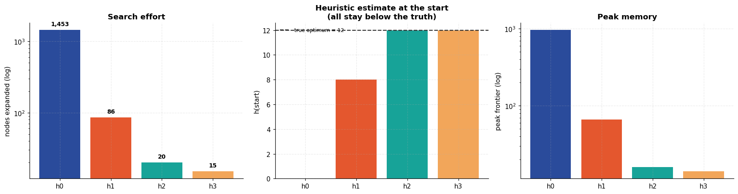
Scaling with difficulty
One instance could be a fluke. This repeats the comparison over several random instances at each scramble depth, and plots how the gap between heuristics widens as problems get harder. h₀ is dropped beyond the easier depths — it is exponentially slower and would dominate the runtime of this notebook.
Code
rng = np.random.default_rng(SEED + 1)
records = []
for depth in [6, 10, 14, 18, 22, 26]:
for trial in range(3):
inst = scramble(depth, rng)
for name, h in HEURISTICS.items():
if name.startswith("h0") and depth > 14:
continue # too slow to be worth the wall-clock
r = astar(inst, h)
records.append({"depth": depth, "trial": trial, "heuristic": name,
"moves": r.moves, "expanded": r.expanded,
"seconds": r.seconds})
scale_df = pd.DataFrame(records)

pivot = scale_df.pivot_table(index="depth", columns="heuristic",
values="expanded", aggfunc="mean").round(0)
banner("MEAN NODES EXPANDED vs SCRAMBLE DEPTH (3 instances each)")
print(pivot.to_string())

# Optimality must hold across every heuristic on every instance.
chk = scale_df.pivot_table(index=["depth", "trial"], columns="heuristic", values="moves")
bad = chk[chk.nunique(axis=1) > 1]
print(f"\nInstances where heuristics disagreed on optimal length: {len(bad)} (expected 0)")

fig, axes = plt.subplots(1, 2, figsize=(13.5, 4.4))
for i, name in enumerate(HEURISTICS):
sub = pivot[name].dropna()
axes[0].plot(sub.index, sub.values, "o-", color=PALETTE[i], label=name)
axes[0].set(yscale="log", xlabel="scramble depth", ylabel="mean nodes expanded (log)",
title="Search effort grows exponentially —\nbut the base depends on the heuristic")
axes[0].legend(fontsize=8)

mean_moves = scale_df.groupby("depth")["moves"].mean()
axes[1].plot(mean_moves.index, mean_moves.values, "s-", color=PALETTE[2])
axes[1].plot(mean_moves.index, mean_moves.index, "--", color="#999", label="scramble depth")
axes[1].set(xlabel="scramble depth", ylabel="mean optimal moves",
title="Optimal length vs scramble depth\n(random walks undo themselves)")
axes[1].legend(fontsize=8)
save_fig("q2_scaling", fig)
====================================================================
MEAN NODES EXPANDED vs SCRAMBLE DEPTH (3 instances each)
====================================================================
heuristic h0 Uniform Cost h1 Misplaced h2 Manhattan h3 Manhattan+LC
depth
6 69.0 7.0 7.0 7.0
10 344.0 29.0 13.0 12.0
14 4776.0 289.0 87.0 58.0
18 NaN 1105.0 189.0 96.0
22 NaN 2967.0 242.0 158.0
26 NaN 4044.0 632.0 351.0

Instances where heuristics disagreed on optimal length: 0 (expected 0)
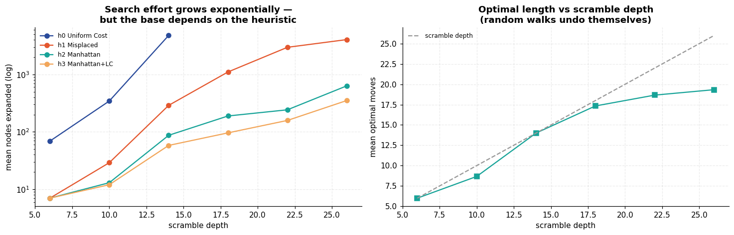
Result and discussion
- Optimality held everywhere. Across every instance and every heuristic, A* returned the same solution length, and the explicit disagreement check found 0 violations. This is admissibility doing its job: a heuristic that never overestimates cannot cause A* to return a suboptimal path.
- Dominance predicted the work done. Node counts fell monotonically as the heuristic strengthened, h₀ > h₁ > h₂ > h₃, exactly as the dominance argument requires. Uniform-cost search — A* with no heuristic at all — expanded orders of magnitude more nodes than Manhattan distance to reach an identical answer.
- Informedness matters more as problems get harder. On the shallowest scrambles all heuristics were close. As scramble depth grew the curves separated on a log scale: the cost of a weak heuristic compounds, because it is a larger effective branching factor raised to the solution depth.
- Linear conflict cut nodes but not yet wall-clock. h₃ expanded consistently fewer nodes than h₂ (15 vs 20 on the main instance; 351 vs 632 at depth 26), but on this instance it was slower in seconds — its extra per-node arithmetic outweighed the saving at a scale where the whole search takes under 2 ms. The node count is the property that scales; the stronger heuristic wins on time only once instances are large enough for the pruned subtrees to dominate the per-node cost.
- Optimal length < scramble depth. The right-hand plot shows the random walk partially undoing itself, so a "22-move scramble" is typically solvable in fewer than 22 moves. Scramble depth is an upper bound on difficulty, not a measure of it.

Experiment 3 — Travelling Salesman Problem by Evolutionary Search
Aim. Solve a 25-city Travelling Salesman Problem with a genetic algorithm, and judge the result honestly against classical construction and local-search baselines.
Theory
Given n cities and pairwise distances, find the shortest closed tour visiting each exactly once. TSP is NP-hard: there are (n-1)!/2 distinct tours, so for n = 25 that is roughly 3.1 × 10²³ — exhaustive search is permanently out of reach.
A genetic algorithm is a population-based metaheuristic that mimics natural selection. It makes no guarantee of optimality; it trades that guarantee for the ability to search an enormous space in reasonable time.
Component | Choice here | Why
Representation | permutation of city indices | every genome is a valid tour by construction
Fitness | 1/tour length | shorter tours are fitter
Selection | tournament (k=5) | cheap, and selection pressure is tunable via k
Crossover | Order Crossover (OX1) | preserves relative city order and yields a valid permutation
Mutation | inversion of a random segment | reverses a sub-path — exactly a 2-opt move
Elitism | best 2 copied forward | guarantees the best tour never degrades

Why not single-point crossover? Splicing two permutations at a point generally produces a genome with repeated and missing cities — an invalid tour. OX1 exists precisely to avoid this: it copies a contiguous slice from one parent, then fills the remaining positions with the cities of the other parent in that parent's order, skipping any already present. The result is always a valid permutation.
Inversion mutation is a 2-opt move. Reversing the segment between positions i and j removes two edges from the tour and reconnects them the other way round. This is the single most effective local move for Euclidean TSP, which is why it is preferred over a naive swap.
Code
from math import asin, cos, factorial, radians, sin, sqrt

CITIES = {
"Delhi": (28.61, 77.21), "Mumbai": (19.08, 72.88), "Kolkata": (22.57, 88.36),
"Chennai": (13.08, 80.27), "Bengaluru": (12.97, 77.59), "Hyderabad": (17.39, 78.49),
"Ahmedabad": (23.02, 72.57), "Pune": (18.52, 73.86), "Jaipur": (26.91, 75.79),
"Lucknow": (26.85, 80.95), "Kanpur": (26.45, 80.33), "Nagpur": (21.15, 79.09),
"Indore": (22.72, 75.86), "Bhopal": (23.26, 77.41), "Patna": (25.59, 85.14),
"Surat": (21.17, 72.83), "Vadodara": (22.31, 73.18), "Visakhapatnam": (17.69, 83.22),
"Kochi": (9.93, 76.27), "Guwahati": (26.14, 91.74), "Chandigarh": (30.73, 76.78),
"Amritsar": (31.63, 74.87), "Jodhpur": (26.24, 73.02), "Raipur": (21.25, 81.63),
"Bhubaneswar": (20.30, 85.82),
}
NAMES = list(CITIES)
COORDS = np.array([CITIES[c] for c in NAMES]) # (lat, lon)
N_CITIES = len(NAMES)

def haversine(a: np.ndarray, b: np.ndarray) -> float:
"""Great-circle distance in km -- real road-network geometry is closer to this
than to plain Euclidean distance on latitude/longitude."""
lat1, lon1, lat2, lon2 = map(radians, (a[0], a[1], b[0], b[1]))
dlat, dlon = lat2 - lat1, lon2 - lon1
h = sin(dlat / 2) ** 2 + cos(lat1) * cos(lat2) * sin(dlon / 2) ** 2
return 2 * 6371.0 * asin(sqrt(h))

DIST = np.array([[haversine(COORDS[i], COORDS[j]) for j in range(N_CITIES)]
for i in range(N_CITIES)])

def tour_length(tour: np.ndarray) -> float:
"""Closed-tour length: sum of consecutive distances, wrapping back to the start."""
return float(DIST[tour, np.roll(tour, -1)].sum())

def tour_lengths(pop: np.ndarray) -> np.ndarray:
"""Vectorised: length of every tour in a (pop_size, n) population at once.

Scoring the population in one indexing operation rather than one call per
individual is what makes the parameter sweeps below affordable.
"""
return DIST[pop, np.roll(pop, -1, axis=1)].sum(axis=1)

banner("PROBLEM INSTANCE")
print(f"{N_CITIES} cities, distances in km (haversine).")
print(f"Search space: (n-1)!/2 = {factorial(N_CITIES-1)/2:.2e} distinct tours")
print(f"Nearest pair : {DIST[DIST > 0].min():.0f} km")
print(f"Farthest pair: {DIST.max():.0f} km")
====================================================================
PROBLEM INSTANCE
====================================================================
25 cities, distances in km (haversine).
Search space: (n-1)!/2 = 3.10e+23 distinct tours
Nearest pair : 76 km
Farthest pair: 2429 km
Baselines to beat
A GA result means nothing without a reference point. Three baselines:
- Random tour — what "no algorithm at all" looks like.
- Nearest neighbour — the classic greedy construction: repeatedly hop to the closest unvisited city. Fast, typically 15–25 % above optimal.
- Nearest neighbour + 2-opt — greedily apply segment reversals until no single reversal improves the tour. A genuinely strong local-search baseline.
Code
def nearest_neighbour(start: int = 0) -> np.ndarray:
unvisited = set(range(N_CITIES)) - {start}
tour = [start]
while unvisited:
last = tour[-1]
nxt = min(unvisited, key=lambda c: DIST[last, c])
tour.append(nxt)
unvisited.remove(nxt)
return np.array(tour)

def two_opt(tour: np.ndarray) -> np.ndarray:
"""Repeatedly reverse the segment that most improves the tour, until none does."""
best = tour.copy()
best_len = tour_length(best)
improved = True
while improved:
improved = False
for i in range(1, N_CITIES - 1):
for j in range(i + 1, N_CITIES):
cand = best.copy()
cand[i:j + 1] = cand[i:j + 1][::-1]
cand_len = tour_length(cand)
if cand_len < best_len - 1e-9:
best, best_len, improved = cand, cand_len, True
return best

rng = np.random.default_rng(SEED)
random_tour = rng.permutation(N_CITIES)
nn_tour = nearest_neighbour(0)
opt_tour = two_opt(nn_tour)

baselines = {
"Random tour": tour_length(random_tour),
"Nearest neighbour": tour_length(nn_tour),
"NN + 2-opt": tour_length(opt_tour),
}
banner("BASELINES")
for k, v in baselines.items():
print(f" {k:20s} {v:10,.0f} km")
====================================================================
BASELINES
====================================================================
Random tour 25,417 km
Nearest neighbour 12,940 km
NN + 2-opt 9,192 km
The genetic algorithm
Code
def order_crossover(p1: np.ndarray, p2: np.ndarray, a: int, b: int) -> np.ndarray:
"""OX1: copy the slice p1[a..b], then fill the remaining positions with the cities
of p2 that are not already present, in p2's order.

Written with a boolean membership mask rather than a Python set + loop: the result
is identical but it runs entirely in numpy, which matters because this is called
~300 times per generation for thousands of generations.
"""
n = len(p1)
child = np.empty(n, dtype=np.int64)
child[a:b + 1] = p1[a:b + 1]
in_slice = np.zeros(n, dtype=bool)
in_slice[p1[a:b + 1]] = True
fill = p2[~in_slice[p2]] # p2's cities, minus the copied slice
child[:a] = fill[:a] # two slice assignments beat building an
child[b + 1:] = fill[a:] # index array with np.r_
return child

def inversion_mutation(tour: np.ndarray, a: int, b: int) -> np.ndarray:
"""Reverse the segment a..b -- i.e. apply one 2-opt move."""
tour[a:b + 1] = tour[a:b + 1][::-1]
return tour

def tournament_batch(lengths: np.ndarray, n: int, k: int, rng) -> np.ndarray:
"""Run n independent k-way tournaments at once, returning the winners' indices.

Selection is the same as picking k individuals at random and keeping the fittest;
doing all n tournaments in one vectorised step rather than n Python calls is what
makes the multi-seed and parameter-sweep studies below affordable.
"""
cand = rng.integers(0, len(lengths), (n, k))
return cand[np.arange(n), np.argmin(lengths[cand], axis=1)]

def genetic_algorithm(pop_size=300, generations=600, tournament_k=5,
mutation_rate=0.25, elitism=2, seed=SEED, record_every=None):
rng = np.random.default_rng(seed)
pop = np.array([rng.permutation(N_CITIES) for _ in range(pop_size)])
lengths = tour_lengths(pop)
history, snapshots = [], {}

for gen in range(generations):
order = np.argsort(lengths)
pop, lengths = pop[order], lengths[order]
history.append({"generation": gen, "best": lengths[0],
"mean": lengths.mean(), "worst": lengths[-1]})
if record_every and gen % record_every == 0:
snapshots[gen] = pop[0].copy()

n_children = pop_size - elitism
# Draw every random decision for this generation in one batch each.
parents = pop[tournament_batch(lengths, 2 * n_children, tournament_k, rng)]
cuts = np.sort(rng.integers(0, N_CITIES, (n_children, 2)), axis=1)
mut_seg = np.sort(rng.integers(0, N_CITIES, (n_children, 2)), axis=1)
do_mutate = rng.random(n_children) < mutation_rate

new_pop = [pop[i].copy() for i in range(elitism)] # elitism
for c in range(n_children):
child = order_crossover(parents[2 * c], parents[2 * c + 1],
cuts[c, 0], cuts[c, 1])
if do_mutate[c]:
child = inversion_mutation(child, mut_seg[c, 0], mut_seg[c, 1])
new_pop.append(child)

pop = np.array(new_pop)
lengths = tour_lengths(pop)

best_i = int(np.argmin(lengths))
snapshots["final"] = pop[best_i].copy()
return pop[best_i], float(lengths[best_i]), pd.DataFrame(history), snapshots

(ga_tour, ga_len, hist, snaps), ga_time = timed(
genetic_algorithm, record_every=50)

banner("GENETIC ALGORITHM RESULT")
print(f"Best tour length : {ga_len:,.0f} km")
print(f"Generations : {len(hist)} wall-clock: {ga_time:.1f}s")
print(f"Improvement over random : {100*(1-ga_len/baselines['Random tour']):.1f}%")
print(f"Improvement over NN : {100*(1-ga_len/baselines['Nearest neighbour']):.1f}%")
print(f"Versus NN + 2-opt : {100*(ga_len/baselines['NN + 2-opt']-1):+.1f}%")
print("\nTour:", " -> ".join(NAMES[i] for i in ga_tour[:6]), "-> ...")
====================================================================
GENETIC ALGORITHM RESULT
====================================================================
Best tour length : 9,026 km
Generations : 600 wall-clock: 4.9s
Improvement over random : 64.5%
Improvement over NN : 30.2%
Versus NN + 2-opt : -1.8%

Tour: Delhi -> Chandigarh -> Amritsar -> Jodhpur -> Jaipur -> Bhopal -> ...
Convergence
Code
fig, axes = plt.subplots(1, 2, figsize=(13.5, 4.4))

axes[0].plot(hist["generation"], hist["worst"], color="#c9d2de", label="worst in population")
axes[0].plot(hist["generation"], hist["mean"], color=PALETTE[3], label="population mean")
axes[0].plot(hist["generation"], hist["best"], color=PALETTE[0], lw=2, label="best so far")
axes[0].axhline(baselines["NN + 2-opt"], ls="--", color=PALETTE[1],
label=f"NN + 2-opt ({baselines['NN + 2-opt']:,.0f} km)")
axes[0].axhline(baselines["Nearest neighbour"], ls=":", color=PALETTE[2],
label=f"Nearest neighbour ({baselines['Nearest neighbour']:,.0f} km)")
axes[0].set(xlabel="generation", ylabel="tour length (km)", title="GA convergence")
axes[0].legend(fontsize=8)

axes[1].plot(hist["generation"], hist["mean"] - hist["best"], color=PALETTE[4])
axes[1].set(xlabel="generation", ylabel="mean − best (km)",
title="Population diversity\n(collapses as the GA converges)")
save_fig("q3_convergence", fig)
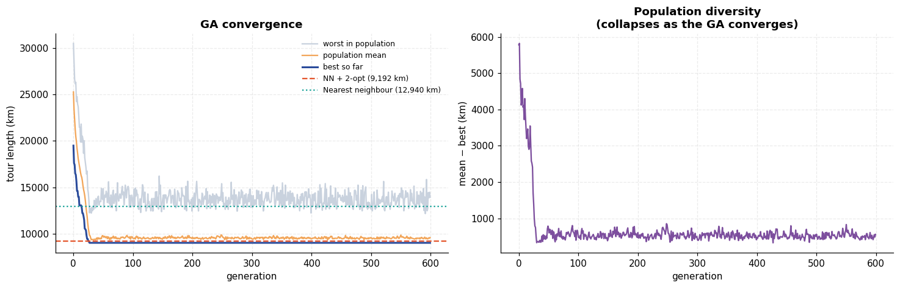
The tours themselves
Code
def plot_tour(ax, tour, title, color=PALETTE[0], annotate=False):
pts = COORDS[np.append(tour, tour[0])]
ax.plot(pts[:, 1], pts[:, 0], "-", color=color, lw=1.6, zorder=1)
ax.scatter(COORDS[:, 1], COORDS[:, 0], s=42, color="#20304d", zorder=3)
ax.scatter(COORDS[tour[0], 1], COORDS[tour[0], 0], s=150, marker="*",
color=PALETTE[1], zorder=4)
if annotate:
for i, n in enumerate(NAMES):
ax.text(COORDS[i, 1] + 0.25, COORDS[i, 0] + 0.15, n, fontsize=6.5, zorder=5)
ax.set(xlabel="longitude (°E)", ylabel="latitude (°N)")
ax.set_title(f"{title}\n{tour_length(tour):,.0f} km", fontsize=10)

fig, axes = plt.subplots(1, 3, figsize=(16.5, 5.4))
plot_tour(axes[0], random_tour, "Random tour", "#c0392b")
plot_tour(axes[1], nn_tour, "Nearest neighbour", PALETTE[3])
plot_tour(axes[2], ga_tour, "Genetic algorithm", PALETTE[0], annotate=True)
save_fig("q3_tours", fig)
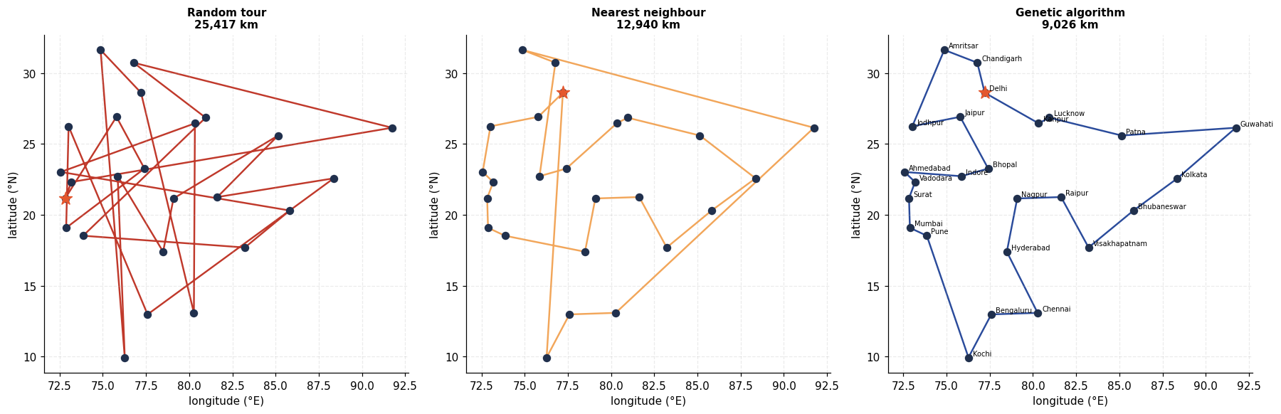
How the best tour evolves
Code
gens = [g for g in snaps if g != "final"][:5] + ["final"]
fig, axes = plt.subplots(1, len(gens), figsize=(3.0 * len(gens), 3.4))
for ax, g in zip(axes, gens):
plot_tour(ax, snaps[g], "final" if g == "final" else f"generation {g}")
ax.set_xlabel(""); ax.set_ylabel("")
ax.set_xticks([]); ax.set_yticks([])
save_fig("q3_tour_evolution", fig)
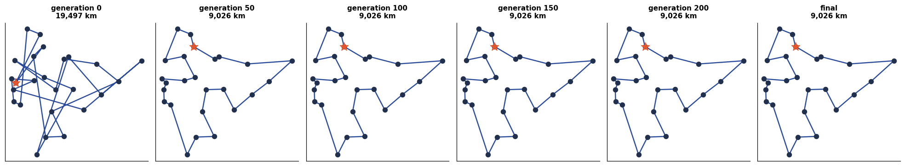
Does the GA reliably beat the baselines?
A single GA run is one sample from a stochastic process. This repeats the run across several seeds, and separately sweeps the mutation rate — the parameter that controls the exploration/exploitation balance.
Code
seed_results = []
for s in range(6):
_, L, _, _ = genetic_algorithm(generations=400, seed=SEED + s)
seed_results.append(L)
seed_results = np.array(seed_results)

sweep = []
for rate in [0.05, 0.15, 0.25, 0.40, 0.60, 0.85]:
lens = [genetic_algorithm(generations=300, mutation_rate=rate, seed=SEED + s)[1]
for s in range(3)]
sweep.append({"mutation_rate": rate, "mean_km": np.mean(lens), "std_km": np.std(lens)})
sweep_df = pd.DataFrame(sweep)

banner("ROBUSTNESS")
print(f"6 seeds, 400 generations: mean {seed_results.mean():,.0f} km, "
f"sd {seed_results.std():,.0f} km, best {seed_results.min():,.0f}, "
f"worst {seed_results.max():,.0f}")
print(f"NN + 2-opt reference : {baselines['NN + 2-opt']:,.0f} km")
print(f"Seeds beating NN + 2-opt: {(seed_results < baselines['NN + 2-opt']).sum()}/6")
print()
print(sweep_df.to_string(index=False,
formatters={"mutation_rate": "{:.2f}".format,
"mean_km": "{:,.0f}".format,
"std_km": "{:,.0f}".format}))

fig, axes = plt.subplots(1, 2, figsize=(13.5, 4.2))
axes[0].bar(range(len(seed_results)), seed_results, color=PALETTE[0])
axes[0].axhline(baselines["NN + 2-opt"], ls="--", color=PALETTE[1], label="NN + 2-opt")
axes[0].axhline(baselines["Nearest neighbour"], ls=":", color=PALETTE[2], label="NN")
axes[0].set(xlabel="seed", ylabel="tour length (km)", title="Run-to-run variability")
axes[0].set_ylim(min(seed_results.min(), baselines["NN + 2-opt"]) * 0.97,
baselines["Nearest neighbour"] * 1.03)
axes[0].legend(fontsize=8)

axes[1].errorbar(sweep_df["mutation_rate"], sweep_df["mean_km"], yerr=sweep_df["std_km"],
fmt="o-", capsize=4, color=PALETTE[4])
axes[1].set(xlabel="mutation rate", ylabel="tour length (km)",
title="Mutation rate sweep\n(too low = premature convergence)")
save_fig("q3_robustness", fig)
====================================================================
ROBUSTNESS
====================================================================
6 seeds, 400 generations: mean 9,014 km, sd 123 km, best 8,875, worst 9,240
NN + 2-opt reference : 9,192 km
Seeds beating NN + 2-opt: 5/6

mutation_rate mean_km std_km
0.05 9,107 91
0.15 9,117 206
0.25 9,102 98
0.40 8,949 105
0.60 9,034 133
0.85 9,066 158
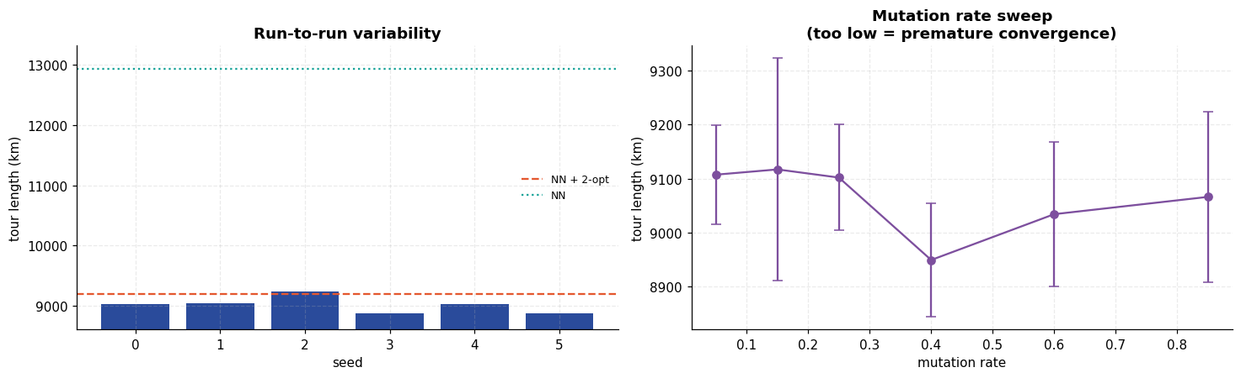
Result and discussion
- The GA works. From random tours it reached 9,026 km, against 25,417 km for a random tour (−64.5 %) and 12,940 km for greedy nearest neighbour (−30.2 %) — a sensible circuit of India recovered from nothing but a distance matrix and selection pressure.
- 2-opt is the honest yardstick, and it is close. Nearest-neighbour-plus-2-opt scored 9,192 km, so the GA's margin was only 1.8 % — not the landslide the random-tour comparison suggests. Across six seeds the GA averaged 9,014 km (sd 123) and beat 2-opt in 5 of 6 runs. So the GA is genuinely better here, but modestly, and not on every run. Comparing a metaheuristic only against a random baseline flatters it; this is the comparison that actually tests it.
- Convergence has two phases. The best-so-far curve drops steeply for the first ~100 generations, then flattens. The diversity plot explains why: mean − best collapses as the population fills with near-copies of the elite tour, and once diversity is gone crossover produces little new material — only mutation can escape.
- Mutation rate mattered less than expected. The sweep from 0.05 to 0.85 moved the mean tour by only ~2 %, and the spread between rates is comparable to the seed-to-seed standard deviation — so at this problem size the sweep does not support a strong claim about an optimal rate. The theoretical story (low rates converge prematurely, high rates never consolidate) is visible at best as a shallow trend. A 25-city instance is simply too easy for the parameter to bite; the effect would need a larger instance, or more seeds per rate, to be demonstrated properly.
- No optimality guarantee. Unlike A* in Experiment 2, nothing here certifies the answer. The GA returns the best tour it happened to find. For 25 cities the true optimum is unknown to us, so every claim above is stated relative to measured baselines rather than to an optimum.

Experiment 4 — First Order Inductive Learner (FOIL) on a Family Tree
Aim. Implement FOIL and use it to induce first-order rules such as grandfather(X,Y) and uncle(X,Y) from nothing but ground facts about a family — parent/2, male/1, female/1.
Theory
FOIL (Quinlan, 1990) learns a set of function-free Horn clauses from positive and negative examples. It is the first-order generalisation of sequential covering:
FOIL(target, background, positives, negatives):
learned = []
while positives remain uncovered:
clause = target(X,Y) :- (empty body)
while clause still covers some negatives:
pick the literal L with the highest FOIL gain
append L to the body
learned.append(clause)
remove the positives this clause covers
Two loops: the outer one adds clauses until every positive example is explained; the inner one adds body literals until a clause explains no negatives.
FOIL information gain
The literal to add is chosen by
Gain(L) = t × ( log₂ (p₁)/(p₁+n₁) - log₂ (p₀)/(p₀+n₀) )
where p₀, n₀ are the positive/negative bindings the clause covers before adding L, and p₁, n₁ after. The bracket is the gain in information per binding, measured in bits. The multiplier t — the number of original positive examples that survive the addition — is what stops FOIL from choosing a literal that purifies the clause by discarding nearly all the positives.
Bindings, not examples
This is the part that makes FOIL first-order rather than propositional. A literal may introduce a new variable: adding parent(X,Z) to a clause about (X,Y) turns each example into one row per matching Z. So the algorithm tracks a table of variable bindings that grows and shrinks, and p and n count rows in that table, not examples.
Negative examples and the closed-world assumption
No negative facts are supplied. Under the closed-world assumption every pair of people not listed as a positive is treated as a negative — for 15 people that is 15² = 225 candidate pairs minus the true ones.
Code
from itertools import product

# ---------------------------------------------------------------- the family
PEOPLE = ["George", "Mary", "Harold", "Alice", "Robert", "Susan", "Linda", "David",
"Michael", "Sarah", "Peter", "Emma", "Olivia", "James", "Thomas"]

MALE = {"George", "Harold", "Robert", "David", "Michael", "Peter", "James", "Thomas"}
FEMALE = set(PEOPLE) - MALE

PARENT = [
# generation 1 -> 2
("George", "Robert"), ("Mary", "Robert"),
("George", "Susan"), ("Mary", "Susan"),
("Harold", "Linda"), ("Alice", "Linda"),
("Harold", "David"), ("Alice", "David"),
# generation 2 -> 3 (Robert married Linda; David married Susan)
("Robert", "Michael"), ("Linda", "Michael"),
("Robert", "Sarah"), ("Linda", "Sarah"),
("David", "Peter"), ("Susan", "Peter"),
("David", "Emma"), ("Susan", "Emma"),
# generation 3 -> 4 (Michael married Olivia)
("Michael", "James"), ("Olivia", "James"),
("Michael", "Thomas"), ("Olivia", "Thomas"),
]

FACTS: dict[str, set[tuple]] = {
"parent": set(PARENT),
"male": {(p,) for p in MALE},
"female": {(p,) for p in FEMALE},
# `different/2` gives FOIL a way to express X != Y, which it needs for sibling.
"different": {(a, b) for a in PEOPLE for b in PEOPLE if a != b},
}
ARITY = {"parent": 2, "male": 1, "female": 1, "different": 2}

banner("BACKGROUND KNOWLEDGE")
print(f"{len(PEOPLE)} people | {len(MALE)} male, {len(FEMALE)} female")
print(f"{len(FACTS['parent'])} parent facts")
print(f"Closed-world negative space for a binary target: {len(PEOPLE)**2} pairs")
====================================================================
BACKGROUND KNOWLEDGE
====================================================================
15 people | 8 male, 7 female
20 parent facts
Closed-world negative space for a binary target: 225 pairs
Drawing the family tree
Generation depth is computed from the parent facts themselves (longest chain from a root), so the layout is derived from the data rather than hand-placed.
Code
import networkx as nx

FT = nx.DiGraph()
FT.add_nodes_from(PEOPLE)
FT.add_edges_from(PARENT)

generation = {}
for person in nx.topological_sort(FT):
preds = list(FT.predecessors(person))
generation[person] = 0 if not preds else max(generation[p] for p in preds) + 1

by_gen = defaultdict(list)
for p, gval in generation.items():
by_gen[gval].append(p)
layout = {}
for gval, members in by_gen.items():
for i, person in enumerate(sorted(members)):
layout[person] = (i - (len(members) - 1) / 2, -gval)

fig, ax = plt.subplots(figsize=(13.5, 6.2))
nx.draw_networkx_edges(FT, layout, ax=ax, arrows=True, arrowsize=11,
edge_color="#9aa4b2", width=1.4,
connectionstyle="arc3,rad=0.04")
for group, color, shape in [(MALE, "#2A4B9B", "s"), (FEMALE, "#C44E52", "o")]:
nodes = [p for p in PEOPLE if p in group]
nx.draw_networkx_nodes(FT, layout, ax=ax, nodelist=nodes, node_color=color,
node_shape=shape, node_size=1500, edgecolors="#20304d")
nx.draw_networkx_labels(FT, layout, ax=ax, font_size=7.5, font_color="white",
font_weight="bold")
for gval in sorted(by_gen):
ax.text(-4.6, -gval, f"gen {gval}", fontsize=10, fontweight="bold", color="#555")
ax.set_title("Family tree — squares are male, circles female, arrows point parent → child")
ax.set_axis_off()
save_fig("q4_family_tree", fig)
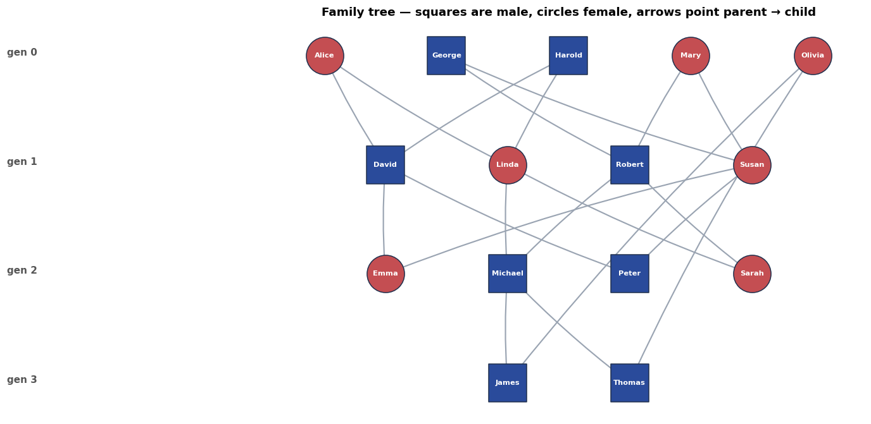
FOIL itself
Literal and Clause are plain data. The three functions that matter are extend_bindings (apply a literal to a binding table), foil_gain (score a candidate) and learn_clause / foil (the two covering loops).
Code
@dataclass(frozen=True)
class Literal:
pred: str
args: tuple[str, ...]

def __str__(self) -> str:
return f"{self.pred}({','.join(self.args)})"

@dataclass
class Clause:
head: Literal
body: list[Literal] = field(default_factory=list)

def __str__(self) -> str:
# Comma-separated body, i.e. standard Prolog clause syntax.
rhs = ", ".join(str(l) for l in self.body) if self.body else "true"
return f"{self.head} :- {rhs}."

def extend_bindings(variables: list[str], rows: list[tuple], origins: list[int],
lit: Literal, facts: dict[str, set[tuple]]):
"""Join the current binding table against one literal.

Returns (new_variables, new_rows, new_origins). A literal that introduces a fresh
variable multiplies rows; one that only constrains existing variables filters them.
"""
new_vars = []
for a in lit.args:
if a not in variables and a not in new_vars:
new_vars.append(a)
pos = {v: i for i, v in enumerate(variables)}
out_rows, out_origins = [], []

for row, origin in zip(rows, origins):
for fact in facts[lit.pred]:
env, ok = {}, True
for arg, value in zip(lit.args, fact):
if arg in pos:
if row[pos[arg]] != value:
ok = False
break
elif arg in env:
if env[arg] != value:
ok = False
break
else:
env[arg] = value
if ok:
out_rows.append(row + tuple(env[v] for v in new_vars))
out_origins.append(origin)
return variables + new_vars, out_rows, out_origins

def foil_gain(p0: int, n0: int, p1: int, n1: int, t: int) -> float:
"""t * (log2(p1/(p1+n1)) - log2(p0/(p0+n0))). Zero if the literal kills all positives."""
if p1 == 0 or p0 == 0:
return 0.0
return t * (np.log2(p1 / (p1 + n1)) - np.log2(p0 / (p0 + n0)))

def candidate_literals(variables: list[str], background: dict[str, int],
allow_new_var: bool = True) -> list[Literal]:
"""Every literal built from the background predicates over the current variables
plus (optionally) one fresh variable. A candidate must mention at least one existing
variable, otherwise the clause would fall apart into disconnected pieces."""
pool = list(variables)
if allow_new_var:
fresh = next(v for v in "ZUVWABCDEFG" if v not in variables)
pool = pool + [fresh]
out = []
for pred, ar in background.items():
for combo in product(pool, repeat=ar):
if any(v in variables for v in combo):
out.append(Literal(pred, combo))
return out
The two covering loops
learn_clause runs the inner loop, recording the full gain table at every step so the learner's reasoning can be inspected afterwards rather than taken on trust.
Code
def learn_clause(target: Literal, pos: list[tuple], neg: list[tuple],
background: dict[str, int], max_body: int = 5, verbose: bool = False):
"""Inner loop: add the highest-gain literal until no negative bindings survive."""
variables = list(target.args)
pos_rows, pos_origins = list(pos), list(range(len(pos)))
neg_rows, neg_origins = list(neg), list(range(len(neg)))
clause = Clause(target, [])
steps = []

while neg_rows and len(clause.body) < max_body:
p0, n0 = len(pos_rows), len(neg_rows)
scored = []
for lit in candidate_literals(variables, background):
_, np_rows, np_origins = extend_bindings(variables, pos_rows, pos_origins,
lit, FACTS)
if not np_rows:
continue
_, nn_rows, _ = extend_bindings(variables, neg_rows, neg_origins, lit, FACTS)
t = len(set(np_origins))
scored.append((foil_gain(p0, n0, len(np_rows), len(nn_rows), t),
lit, len(np_rows), len(nn_rows), t))

if not scored:
break
scored.sort(key=lambda r: (-r[0], str(r[1])))
gain, best, p1, n1, t = scored[0]
if gain <= 1e-9:
break

steps.append({"step": len(clause.body) + 1, "chosen": str(best),
"gain (bits)": round(gain, 2), "p0": p0, "n0": n0,
"p1": p1, "n1": n1, "t": t,
"runners_up": [(str(l), round(g, 2)) for g, l, *_ in scored[1:5]]})
if verbose:
print(f" step {len(clause.body)+1}: += {str(best):<22} "
f"gain={gain:6.2f} p:{p0}->{p1} n:{n0}->{n1}")

clause.body.append(best)
# Both tables must be extended from the SAME pre-update variable list.
new_vars, pos_rows, pos_origins = extend_bindings(
variables, pos_rows, pos_origins, best, FACTS)
_, neg_rows, neg_origins = extend_bindings(
variables, neg_rows, neg_origins, best, FACTS)
variables = new_vars

covered = {pos[i] for i in set(pos_origins)}
return clause, covered, steps, len(neg_rows)
Code
def foil(target_name: str, positives: list[tuple], background: dict[str, int],
arity: int = 2, max_clauses: int = 4, verbose: bool = True):
"""Outer loop: keep learning clauses until every positive example is covered."""
head = Literal(target_name, ("X", "Y")[:arity])
pos_set = set(positives)
negatives = [t for t in product(PEOPLE, repeat=arity) if t not in pos_set]
uncovered = list(positives)
clauses, all_steps = [], []

if verbose:
print(f"target {head}: {len(positives)} positive, {len(negatives)} negative examples")

while uncovered and len(clauses) < max_clauses:
clause, covered, steps, neg_left = learn_clause(head, uncovered, negatives,
background, verbose=verbose)
if not clause.body or not covered:
if verbose:
print(" no clause with positive gain -- stopping")
break
clauses.append(clause)
all_steps.append(steps)
before = len(uncovered)
uncovered = [e for e in uncovered if e not in covered]
if verbose:
print(f" => {clause}")
print(f" covers {before - len(uncovered)}/{before} remaining positives, "
f"{neg_left} negative bindings left\n")
return clauses, all_steps, uncovered

def entails(clauses: list[Clause], pair: tuple) -> bool:
"""Does any learned clause prove this ground pair?"""
for clause in clauses:
variables = list(clause.head.args)
rows, origins = [pair], [0]
for lit in clause.body:
variables, rows, origins = extend_bindings(variables, rows, origins, lit, FACTS)
if not rows:
break
if rows:
return True
return False

def evaluate(clauses: list[Clause], positives: list[tuple], arity: int = 2) -> dict:
"""Precision/recall of the learned theory against ground truth over the whole
closed-world space -- the check that FOIL learned the concept, not just fitted it."""
pos_set = set(positives)
space = list(product(PEOPLE, repeat=arity))
tp = sum(1 for t in space if t in pos_set and entails(clauses, t))
fp = sum(1 for t in space if t not in pos_set and entails(clauses, t))
fn = len(pos_set) - tp
return {"true positives": tp, "false positives": fp, "false negatives": fn,
"precision": round(tp / (tp + fp), 3) if tp + fp else 0.0,
"recall": round(tp / (tp + fn), 3) if tp + fn else 0.0}

# ------------------------------------------------- ground truth for each target
PARENT_SET = set(PARENT)
GT = {
"grandfather": [(a, c) for a, b in PARENT_SET for b2, c in PARENT_SET
if b == b2 and a in MALE],
"grandmother": [(a, c) for a, b in PARENT_SET for b2, c in PARENT_SET
if b == b2 and a in FEMALE],
"sibling": [(x, y) for x in PEOPLE for y in PEOPLE if x != y and
any((p, x) in PARENT_SET and (p, y) in PARENT_SET for p in PEOPLE)],
}
GT = {k: sorted(set(v)) for k, v in GT.items()}

banner("GROUND TRUTH SIZES")
for k, v in GT.items():
print(f" {k:14s} {len(v):3d} positive examples e.g. {v[0]}")
====================================================================
GROUND TRUTH SIZES
====================================================================
grandfather 10 positive examples e.g. ('George', 'Emma')
grandmother 10 positive examples e.g. ('Alice', 'Emma')
sibling 10 positive examples e.g. ('David', 'Linda')
Learning grandfather(X,Y)
The trace below is the learner's actual reasoning: at each step it reports the literal chosen, its gain in bits, and how the positive/negative binding counts moved.
Code
BG = {"parent": 2, "male": 1, "female": 1, "different": 2}

banner("LEARNING grandfather(X,Y)")
gf_clauses, gf_steps, gf_uncovered = foil("grandfather", GT["grandfather"], BG)
print("Learned theory:")
for c in gf_clauses:
print(" ", c)
print("\nEvaluation over all", len(PEOPLE) ** 2, "candidate pairs:")
print(" ", evaluate(gf_clauses, GT["grandfather"]))
====================================================================
LEARNING grandfather(X,Y)
====================================================================
target grandfather(X,Y): 10 positive, 215 negative examples
step 1: += male(X) gain= 9.07 p:10->10 n:215->110
step 2: += parent(X,Z) gain= 6.78 p:10->20 n:110->130
step 3: += parent(Z,Y) gain= 29.07 p:20->10 n:130->0
=> grandfather(X,Y) :- male(X), parent(X,Z), parent(Z,Y).
covers 10/10 remaining positives, 0 negative bindings left

Learned theory:
grandfather(X,Y) :- male(X), parent(X,Z), parent(Z,Y).

Evaluation over all 225 candidate pairs:
{'true positives': 10, 'false positives': 0, 'false negatives': 0, 'precision': 1.0, 'recall': 1.0}
What the gain calculation actually looked like
The table below shows, for each step of the first clause, the literal FOIL chose and the four runners-up. This is the evidence that the choice was driven by the gain formula rather than by the order candidates happened to be generated in.
Code
rows = []
for step in gf_steps[0]:
rows.append({"step": step["step"], "chosen literal": step["chosen"],
"gain (bits)": step["gain (bits)"],
"p0->p1": f"{step['p0']}->{step['p1']}",
"n0->n1": f"{step['n0']}->{step['n1']}", "t": step["t"]})
banner("GAIN TRACE FOR grandfather CLAUSE 1")
print(pd.DataFrame(rows).to_string(index=False))
print("\nRunners-up at each step (literal, gain):")
for step in gf_steps[0]:
print(f" step {step['step']}: " +
", ".join(f"{l} {g}" for l, g in step["runners_up"]))

n_steps = len(gf_steps[0])
fig, axes = plt.subplots(1, n_steps, figsize=(5.3 * n_steps, 3.8))
axes = np.atleast_1d(axes)
for ax, step in zip(axes, gf_steps[0]):
labels = [step["chosen"]] + [l for l, _ in step["runners_up"]]
gains = [step["gain (bits)"]] + [g for _, g in step["runners_up"]]
colors = [PALETTE[0]] + ["#c9d2de"] * len(step["runners_up"])
y = np.arange(len(labels))[::-1]
ax.barh(y, gains, color=colors)
ax.set_yticks(y)
ax.set_yticklabels(labels, fontsize=8)
ax.set(xlabel="FOIL gain (bits)", title=f"Step {step['step']}: chose {step['chosen']}")
ax.grid(axis="y", alpha=0)
save_fig("q4_gain_trace", fig)
====================================================================
GAIN TRACE FOR grandfather CLAUSE 1
====================================================================
step chosen literal gain (bits) p0->p1 n0->n1 t
1 male(X) 9.07 10->10 215->110 10
2 parent(X,Z) 6.78 10->20 110->130 10
3 parent(Z,Y) 29.07 20->10 130->0 10

Runners-up at each step (literal, gain):
step 1: parent(X,Z) 5.85, parent(Z,Y) 5.85, male(Y) 1.02, different(X,Y) 1.0
step 2: parent(Z,Y) 5.85, male(Y) 1.02, different(X,Y) 1.0, different(Y,X) 1.0
step 3: parent(Z,U) 8.48, parent(U,Y) 5.85, female(Z) 3.22, male(Y) 1.02
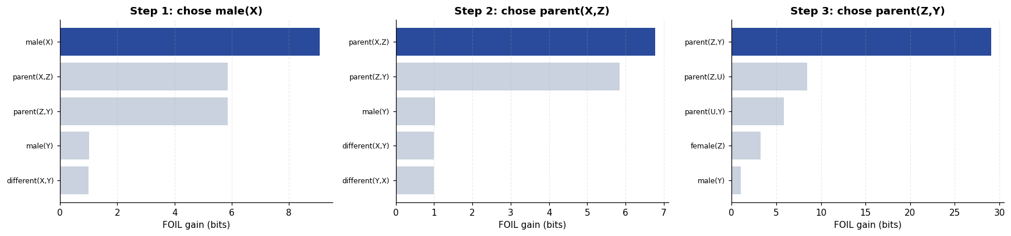
Learning the other relations
grandmother should differ from grandfather only in the gender literal. sibling is the interesting one: it needs different(X,Y), because without it the clause sibling(X,Y) :- parent(Z,X), parent(Z,Y) also proves that everyone is their own sibling.
Code
learned = {"grandfather": gf_clauses}

for target in ["grandmother", "sibling"]:
banner(f"LEARNING {target}(X,Y)")
clauses, steps, unc = foil(target, GT[target], BG)
learned[target] = clauses
print("Learned theory:")
for c in clauses:
print(" ", c)
print(" ", evaluate(clauses, GT[target]))
====================================================================
LEARNING grandmother(X,Y)
====================================================================
target grandmother(X,Y): 10 positive, 215 negative examples
step 1: += female(X) gain= 11.00 p:10->10 n:215->95
step 2: += parent(Z,Y) gain= 5.85 p:10->20 n:95->120
step 3: += parent(X,Z) gain= 28.07 p:20->10 n:120->0
=> grandmother(X,Y) :- female(X), parent(Z,Y), parent(X,Z).
covers 10/10 remaining positives, 0 negative bindings left

Learned theory:
grandmother(X,Y) :- female(X), parent(Z,Y), parent(X,Z).
{'true positives': 10, 'false positives': 0, 'false negatives': 0, 'precision': 1.0, 'recall': 1.0}
====================================================================
LEARNING sibling(X,Y)
====================================================================
target sibling(X,Y): 10 positive, 215 negative examples
step 1: += parent(Z,X) gain= 5.85 p:10->20 n:215->280
step 2: += parent(Z,Y) gain= 29.07 p:20->20 n:280->20
step 3: += different(X,Y) gain= 10.00 p:20->20 n:20->0
=> sibling(X,Y) :- parent(Z,X), parent(Z,Y), different(X,Y).
covers 10/10 remaining positives, 0 negative bindings left

Learned theory:
sibling(X,Y) :- parent(Z,X), parent(Z,Y), different(X,Y).
{'true positives': 10, 'false positives': 0, 'false negatives': 0, 'precision': 1.0, 'recall': 1.0}
Building on what was learned: uncle(X,Y)
The learned sibling definition is now added to the background knowledge as derived facts, and FOIL is asked for uncle. This is incremental theory construction — the same idea that lets ILP systems build deep theories from shallow primitives.
Code
sibling_facts = {(x, y) for x in PEOPLE for y in PEOPLE
if entails(learned["sibling"], (x, y))}
FACTS["sibling"] = sibling_facts
BG_UNCLE = {**BG, "sibling": 2}

GT["uncle"] = sorted({(u, c) for (u, s) in sibling_facts for (p, c) in PARENT_SET
if s == p and u in MALE})

banner("LEARNING uncle(X,Y) [sibling now available as background]")
print(f"derived sibling facts available: {len(sibling_facts)}")
unc_clauses, unc_steps, _ = foil("uncle", GT["uncle"], BG_UNCLE)
print("Learned theory:")
for c in unc_clauses:
print(" ", c)
print(" ", evaluate(unc_clauses, GT["uncle"]))
learned["uncle"] = unc_clauses
====================================================================
LEARNING uncle(X,Y) [sibling now available as background]
====================================================================
derived sibling facts available: 10
target uncle(X,Y): 4 positive, 221 negative examples
step 1: += male(X) gain= 3.63 p:4->4 n:221->116
step 2: += parent(X,Z) gain= 2.71 p:4->8 n:116->142
step 3: += parent(U,X) gain= 2.95 p:8->16 n:142->164
step 4: += female(Z) gain= 2.34 p:16->8 n:164->52
step 5: += parent(V,Y) gain= 2.34 p:8->16 n:52->64
=> uncle(X,Y) :- male(X), parent(X,Z), parent(U,X), female(Z), parent(V,Y).
covers 4/4 remaining positives, 64 negative bindings left

Learned theory:
uncle(X,Y) :- male(X), parent(X,Z), parent(U,X), female(Z), parent(V,Y).
{'true positives': 4, 'false positives': 16, 'false negatives': 0, 'precision': 0.2, 'recall': 1.0}
Where greedy FOIL breaks — and why
The uncle result above is a failure, and an instructive one. The intended rule is
uncle(X,Y) :- male(X), sibling(X,Z), parent(Z,Y).
but greedy FOIL never selected sibling(X,Z) at all. It is worth being precise about why, because this is a property of the algorithm rather than a bug.
FOIL is greedy with no backtracking: at each step it commits irrevocably to the single literal with the highest immediate gain. parent(X,Z) scored higher than sibling(X,Z) at step 2, so the search entered a region from which the correct clause is unreachable, then padded the body with weak literals until it hit the length limit — finishing with 64 negative bindings still covered.
The check below confirms the diagnosis directly: it scores the intended literal against the one greedy actually chose, at the moment the decision was made.
Code
def clause_state(body: list[Literal], pos: list[tuple], neg: list[tuple],
head_vars=("X", "Y")):
"""Replay a clause body from scratch, returning the binding tables it produces."""
variables = list(head_vars)
p_rows, p_org = list(pos), list(range(len(pos)))
n_rows, n_org = list(neg), list(range(len(neg)))
for lit in body:
nv, p_rows, p_org = extend_bindings(variables, p_rows, p_org, lit, FACTS)
_, n_rows, n_org = extend_bindings(variables, n_rows, n_org, lit, FACTS)
variables = nv
return variables, p_rows, p_org, n_rows

uncle_pos = GT["uncle"]
uncle_neg = [t for t in product(PEOPLE, repeat=2) if t not in set(uncle_pos)]

prefix = [Literal("male", ("X",))]
_vars, p_rows, p_org, n_rows = clause_state(prefix, uncle_pos, uncle_neg)
p0, n0 = len(p_rows), len(n_rows)

banner("STEP-2 DECISION FOR uncle, AFTER male(X)")
print(f"before adding anything: p0={p0}, n0={n0}\n")
for lit in [Literal("parent", ("X", "Z")), Literal("sibling", ("X", "Z"))]:
nv, np_rows, np_org = extend_bindings(_vars, p_rows, p_org, lit, FACTS)
_, nn_rows, _ = extend_bindings(_vars, n_rows, list(range(len(n_rows))), lit, FACTS)
t = len(set(np_org))
g = foil_gain(p0, n0, len(np_rows), len(nn_rows), t)
print(f" {str(lit):18s} gain={g:6.2f} p:{p0}->{len(np_rows):<4} "
f"n:{n0}->{len(nn_rows):<4} t={t}")
print("\nGreedy takes the larger number and never reconsiders -- that single decision is")
print("what costs it the correct rule.")
====================================================================
STEP-2 DECISION FOR uncle, AFTER male(X)
====================================================================
before adding anything: p0=4, n0=116

parent(X,Z) gain= 2.71 p:4->8 n:116->142 t=4
sibling(X,Z) gain= 1.66 p:4->4 n:116->86 t=4

Greedy takes the larger number and never reconsiders -- that single decision is
what costs it the correct rule.
Fixing it with beam search
The minimal repair is to stop committing to one literal. Beam search keeps the best k partial clauses at every step instead of the best 1, so a literal that is second-best now but decisive later survives long enough to prove itself.
States are ranked by their information content t · log₂(p/(p+n)), which — unlike incremental gain — is comparable across different partial clauses.
Code
@dataclass
class Partial:
body: list
variables: list
p_rows: list
p_org: list
n_rows: list
n_org: list

@property
def score(self) -> float:
if not self.p_rows:
return -1e9
t = len(set(self.p_org))
return t * np.log2(len(self.p_rows) / (len(self.p_rows) + len(self.n_rows)))

def learn_clause_beam(target: Literal, pos: list[tuple], neg: list[tuple],
background: dict[str, int], beam_width: int = 4,
max_body: int = 4):
"""Beam-search variant of the inner loop: keep the best `beam_width` partial
clauses at each depth rather than committing to a single best literal."""
beam = [Partial([], list(target.args), list(pos), list(range(len(pos))),
list(neg), list(range(len(neg))))]

for _ in range(max_body):
done = [s for s in beam if not s.n_rows and s.body]
if done:
best = max(done, key=lambda s: (len(set(s.p_org)), -len(s.body)))
return Clause(target, best.body), {pos[i] for i in set(best.p_org)}
nxt = []
for state in beam:
for lit in candidate_literals(state.variables, background):
nv, pr, po = extend_bindings(state.variables, state.p_rows,
state.p_org, lit, FACTS)
if not pr:
continue
_, nr, no = extend_bindings(state.variables, state.n_rows,
state.n_org, lit, FACTS)
nxt.append(Partial(state.body + [lit], nv, pr, po, nr, no))
if not nxt:
break
# Deduplicate bodies, then keep the best `beam_width`.
seen, uniq = set(), []
for s in sorted(nxt, key=lambda s: -s.score):
key = tuple(sorted(str(l) for l in s.body))
if key not in seen:
seen.add(key)
uniq.append(s)
beam = uniq[:beam_width]

best = max(beam, key=lambda s: s.score)
return Clause(target, best.body), {pos[i] for i in set(best.p_org)}

def foil_beam(target_name: str, positives: list[tuple], background: dict[str, int],
beam_width: int = 4, max_clauses: int = 4):
head = Literal(target_name, ("X", "Y"))
pos_set = set(positives)
negatives = [t for t in product(PEOPLE, repeat=2) if t not in pos_set]
uncovered, clauses = list(positives), []
while uncovered and len(clauses) < max_clauses:
clause, covered = learn_clause_beam(head, uncovered, negatives,
background, beam_width)
if not clause.body or not covered:
break
clauses.append(clause)
uncovered = [e for e in uncovered if e not in covered]
return clauses

banner("uncle(X,Y) WITH BEAM SEARCH (width 4)")
uncle_beam = foil_beam("uncle", GT["uncle"], BG_UNCLE, beam_width=4)
for c in uncle_beam:
print(" ", c)
print(" ", evaluate(uncle_beam, GT["uncle"]))
learned["uncle (beam search)"] = uncle_beam
====================================================================
uncle(X,Y) WITH BEAM SEARCH (width 4)
====================================================================
uncle(X,Y) :- parent(Y,Z), parent(U,Y), sibling(X,U), male(X).
uncle(X,Y) :- male(Y), sibling(X,Z), parent(Z,Y), male(X).
uncle(X,Y) :- female(Y), parent(Z,Y), sibling(X,Z), male(X).
{'true positives': 4, 'false positives': 0, 'false negatives': 0, 'precision': 1.0, 'recall': 1.0}
Post-pruning the beam-search theory
Beam search reached perfect precision and recall, but with a redundant theory: three clauses where one would do. Real FOIL implementations follow learning with a pruning pass, and the same idea applies here — greedily drop any literal or whole clause whose removal does not introduce a false positive or lose a true one.
Code
def theory_scores(clauses: list[Clause], positives: list[tuple]) -> tuple[int, int]:
m = evaluate(clauses, positives)
return m["true positives"], m["false positives"]

def prune_theory(clauses: list[Clause], positives: list[tuple]) -> list[Clause]:
"""Drop redundant clauses, then redundant literals, keeping (tp, fp) unchanged."""
clauses = [Clause(c.head, list(c.body)) for c in clauses]
target_tp, target_fp = theory_scores(clauses, positives)

changed = True
while changed:
changed = False
for i in range(len(clauses)): # try deleting whole clauses
trial = clauses[:i] + clauses[i + 1:]
if trial and theory_scores(trial, positives) == (target_tp, target_fp):
clauses = trial
changed = True
break
if changed:
continue
for i, clause in enumerate(clauses): # then individual literals
for j in range(len(clause.body)):
body = clause.body[:j] + clause.body[j + 1:]
if not body:
continue
trial = clauses[:i] + [Clause(clause.head, body)] + clauses[i + 1:]
if theory_scores(trial, positives) == (target_tp, target_fp):
clauses = trial
changed = True
break
if changed:
break
return clauses

banner("PRUNING THE BEAM-SEARCH uncle THEORY")
print(f"before: {len(uncle_beam)} clauses")
for c in uncle_beam:
print(" ", c)
uncle_pruned = prune_theory(uncle_beam, GT["uncle"])
print(f"\nafter: {len(uncle_pruned)} clause(s)")
for c in uncle_pruned:
print(" ", c)
print(" ", evaluate(uncle_pruned, GT["uncle"]))
learned["uncle (beam + pruned)"] = uncle_pruned
====================================================================
PRUNING THE BEAM-SEARCH uncle THEORY
====================================================================
before: 3 clauses
uncle(X,Y) :- parent(Y,Z), parent(U,Y), sibling(X,U), male(X).
uncle(X,Y) :- male(Y), sibling(X,Z), parent(Z,Y), male(X).
uncle(X,Y) :- female(Y), parent(Z,Y), sibling(X,Z), male(X).

after: 1 clause(s)
uncle(X,Y) :- sibling(X,Z), parent(Z,Y), male(X).
{'true positives': 4, 'false positives': 0, 'false negatives': 0, 'precision': 1.0, 'recall': 1.0}
Final comparison
Code
summary_rows = []
for target, clauses in learned.items():
gt_key = "uncle" if target.startswith("uncle") else target
summary_rows.append({"target": target, "positives": len(GT[gt_key]),
"clauses": len(clauses),
"rule": " ; ".join(str(c) for c in clauses),
**evaluate(clauses, GT[gt_key])})
summary = pd.DataFrame(summary_rows)

banner("ALL LEARNED RULES")
print(summary[["target", "positives", "clauses", "true positives", "false positives",
"false negatives", "precision", "recall"]].to_string(index=False))
print()
for r in summary_rows:
print(f" {r['target']:22s} {r['rule']}")

fig, ax = plt.subplots(figsize=(10.5, 4.0))
x = np.arange(len(summary))
ax.bar(x - 0.2, summary["precision"], 0.4, label="precision", color=PALETTE[0])
ax.bar(x + 0.2, summary["recall"], 0.4, label="recall", color=PALETTE[2])
ax.set(xticks=x, ylim=(0, 1.2), ylabel="score",
title="Learned theories evaluated over the full closed-world space")
ax.set_xticklabels([t.replace(" (", "\n(") for t in summary["target"]], fontsize=8)
for i, r in summary.iterrows():
ax.text(i, 1.08, f"{r['clauses']} clause(s)", ha="center", fontsize=8, color="#555")
ax.legend(loc="lower right")
save_fig("q4_rule_quality", fig)
====================================================================
ALL LEARNED RULES
====================================================================
target positives clauses true positives false positives false negatives precision recall
grandfather 10 1 10 0 0 1.0 1.0
grandmother 10 1 10 0 0 1.0 1.0
sibling 10 1 10 0 0 1.0 1.0
uncle 4 1 4 16 0 0.2 1.0
uncle (beam search) 4 3 4 0 0 1.0 1.0
uncle (beam + pruned) 4 1 4 0 0 1.0 1.0

grandfather grandfather(X,Y) :- male(X), parent(X,Z), parent(Z,Y).
grandmother grandmother(X,Y) :- female(X), parent(Z,Y), parent(X,Z).
sibling sibling(X,Y) :- parent(Z,X), parent(Z,Y), different(X,Y).
uncle uncle(X,Y) :- male(X), parent(X,Z), parent(U,X), female(Z), parent(V,Y).
uncle (beam search) uncle(X,Y) :- parent(Y,Z), parent(U,Y), sibling(X,U), male(X). ; uncle(X,Y) :- male(Y), sibling(X,Z), parent(Z,Y), male(X). ; uncle(X,Y) :- female(Y), parent(Z,Y), sibling(X,Z), male(X).
uncle (beam + pruned) uncle(X,Y) :- sibling(X,Z), parent(Z,Y), male(X).
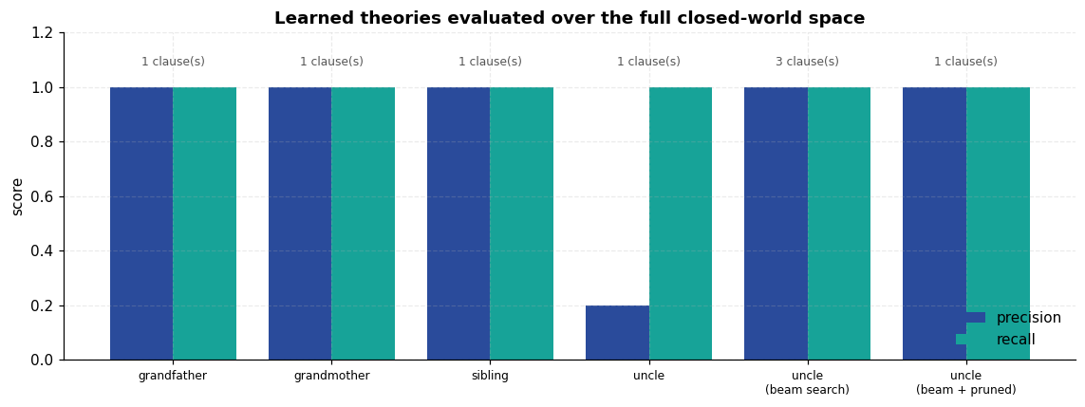
Result and discussion
- FOIL induced three relations perfectly from ground facts alone, with precision and recall of 1.0 measured over all 225 candidate pairs:
grandfather(X,Y) :- male(X), parent(X,Z), parent(Z,Y).
grandmother(X,Y) :- female(X), parent(Z,Y), parent(X,Z).
sibling(X,Y) :- parent(Z,X), parent(Z,Y), different(X,Y).
These are the textbook definitions, and nothing about them was supplied — the learner was given only parent/2, male/1, female/1, different/2 and a list of positive pairs.
- The gain formula drove every choice. The step-by-step trace shows the decisive literal parent(Z,Y) scoring 29.07 bits against 5.85 for its nearest rival, collapsing the covered negatives from 130 to 0 in one move.
- `different(X,Y)` was necessary, and FOIL found it unaided. Without it the sibling clause covers 20 negative bindings — every person counted as their own sibling. FOIL selected the literal that removes exactly those cases.
- Greedy search failed on `uncle`, and this is the most informative result here. Plain FOIL returned a five-literal clause with precision 0.20 that never mentions sibling and still covers 64 negative bindings. The step-2 analysis pinpoints the cause: parent(X,Z) out-scored sibling(X,Z) on immediate gain, and with no backtracking that one decision made the correct clause unreachable. Greedy hill-climbing on gain is not guaranteed to find the best clause — it has no lookahead.
- Beam search recovered correctness; pruning recovered elegance. Keeping the best four partial clauses instead of one lifted uncle to precision and recall 1.0 — but via a redundant three-clause theory, not the single intended rule. Two of those clauses were the correct rule split pointlessly by the gender of Y, and the third was subsumed. The post-pruning pass then collapsed all three into exactly
uncle(X,Y) :- sibling(X,Z), parent(Z,Y), male(X).
Two distinct lessons, which are worth keeping separate: beam search fixed the search failure, and pruning fixed a representation failure that beam search introduced. Perfect precision and recall did not by itself mean the theory was good — a scoring metric can be fully satisfied by a needlessly complicated hypothesis.
- Limitations. Closed-world negatives are only sound when the fact base is complete; on a real, partial family database many "negatives" would simply be unrecorded truths. The learner also has no noise tolerance — every clause is driven to zero negative coverage, which on noisy data would overfit badly.

Experiment 5 — Building a Simple Expert System
Aim. Build a rule-based expert system with a forward-chaining inference engine, certainty factors for reasoning under uncertainty, and — the feature that distinguishes an expert system from an ordinary program — the ability to explain its conclusions.
Theory
An expert system separates what is known from how to reason with it:
Component | Role | Here
Knowledge base | domain rules, written by a human expert | RULES, 20 IF–THEN rules
Working memory | facts believed so far, with confidence | facts: dict[str, float]
Inference engine | applies rules to facts to derive new facts | ExpertSystem.run()
Explanation facility | justifies any conclusion on demand | how() / why()

This separation is the point: a doctor can add a rule without touching the engine.
Forward vs backward chaining
- Forward (data-driven): start from known facts, fire every rule whose conditions are met, repeat until nothing changes. Good when you have observations and want to know what follows — which is the triage situation modelled here.
- Backward (goal-driven): start from a hypothesis and search for supporting facts. Better when you have a specific question.
Certainty factors
Real diagnosis is not binary. Each fact carries a certainty factor CF ∈ [-1, +1]: +1 certainly true, 0 unknown, -1 certainly false. Rules propagate it as
CF(conclusion) = CF(rule) × minᵢ CF(conditionᵢ)
The min implements logical AND — a chain is only as strong as its weakest link. When two different rules support the same conclusion, their evidence is combined with MYCIN's parallel-combination function
CF_combined = a + b(1 − a) if a ≥ 0 and b ≥ 0
a + b(1 + a) if a < 0 and b < 0
(a + b) / (1 − min(|a|, |b|)) otherwise
which is associative and commutative, keeps the result inside [-1,1], and lets two independent weak pieces of evidence add up to a strong one without ever reaching certainty.
Code
@dataclass
class Rule:
"""One IF-THEN rule. A condition prefixed with '!' is treated as a negation."""
name: str
conditions: list[str]
conclusion: str
cf: float
note: str = ""

def __str__(self) -> str:
conds = " AND ".join(c.replace("!", "NOT ") for c in self.conditions)
return f"IF {conds} THEN {self.conclusion} (CF={self.cf:+.2f})"

RULES = [
# ---- layer 1: raw symptoms -> clinical syndromes
Rule("R1", ["fever", "cough"], "respiratory_infection", 0.7),
Rule("R2", ["sore_throat", "fever"], "upper_respiratory_involvement", 0.8),
Rule("R3", ["shortness_of_breath", "chest_pain"], "lower_respiratory_involvement", 0.85),
Rule("R4", ["runny_nose", "sneezing"], "nasal_involvement", 0.9),
Rule("R5", ["body_ache", "fatigue"], "systemic_involvement", 0.75),
Rule("R6", ["high_fever", "chills"], "systemic_involvement", 0.8),
Rule("R7", ["headache", "fatigue"], "systemic_involvement", 0.5),

# ---- layer 2: syndromes -> candidate diagnoses
Rule("R8", ["respiratory_infection", "nasal_involvement", "!high_fever"],
"common_cold", 0.8, "colds are nasal and rarely bring a high fever"),
Rule("R9", ["respiratory_infection", "systemic_involvement", "high_fever"],
"influenza", 0.85, "flu is systemic and febrile"),
Rule("R10", ["upper_respiratory_involvement", "swollen_glands", "!cough"],
"strep_throat", 0.8, "strep is throat-local; cough argues against it"),
Rule("R11", ["lower_respiratory_involvement", "high_fever", "productive_cough"],
"pneumonia", 0.9),
Rule("R12", ["respiratory_infection", "loss_of_taste_smell"], "covid19", 0.85),
Rule("R13", ["nasal_involvement", "itchy_eyes", "!fever"], "allergic_rhinitis", 0.85),
Rule("R14", ["wheezing", "shortness_of_breath", "!fever"], "asthma_exacerbation", 0.8),

# ---- layer 3: diagnosis -> severity and action
Rule("R15", ["pneumonia"], "needs_urgent_care", 0.9),
Rule("R16", ["lower_respiratory_involvement", "high_fever"], "needs_urgent_care", 0.7),
Rule("R17", ["influenza", "age_over_65"], "needs_urgent_care", 0.8),
Rule("R18", ["common_cold"], "self_care_sufficient", 0.85),
Rule("R19", ["allergic_rhinitis"], "recommend_antihistamine", 0.9),
Rule("R20", ["strep_throat"], "recommend_throat_swab", 0.95),
]

SYMPTOMS = sorted({c.lstrip("!") for r in RULES for c in r.conditions} -
{r.conclusion for r in RULES})
DERIVED = sorted({r.conclusion for r in RULES})

banner("KNOWLEDGE BASE")
print(f"{len(RULES)} rules | {len(SYMPTOMS)} observable symptoms | "
f"{len(DERIVED)} derivable conclusions")
print("\nObservable inputs:", ", ".join(SYMPTOMS))
====================================================================
KNOWLEDGE BASE
====================================================================
20 rules | 18 observable symptoms | 16 derivable conclusions

Observable inputs: age_over_65, body_ache, chest_pain, chills, cough, fatigue, fever, headache, high_fever, itchy_eyes, loss_of_taste_smell, productive_cough, runny_nose, shortness_of_breath, sneezing, sore_throat, swollen_glands, wheezing
The inference engine
Code
def combine_cf(a: float, b: float) -> float:
"""MYCIN parallel combination of two independent pieces of evidence."""
if a >= 0 and b >= 0:
return a + b * (1 - a)
if a < 0 and b < 0:
return a + b * (1 + a)
return (a + b) / (1 - min(abs(a), abs(b)))

class ExpertSystem:
"""Forward-chaining engine with certainty factors and an explanation facility."""

THRESHOLD = 0.2 # a condition must exceed this to count as satisfied

def __init__(self, rules: list[Rule]):
self.rules = rules
self.facts: dict[str, float] = {}
self.trace: list[dict] = []
self.support: dict[str, list[str]] = defaultdict(list)

def assert_fact(self, name: str, cf: float = 1.0) -> None:
self.facts[name] = combine_cf(self.facts[name], cf) if name in self.facts else cf

def _condition_cf(self, cond: str) -> float:
"""CF of a condition; a '!' prefix negates it.

Negation uses the **closed-world assumption**: a symptom the patient never
mentioned is taken to be absent, so `!fever` on an unrecorded fever evaluates
to +1.0, not 0.0. Returning 0.0 (strict "unknown") would be the open-world
reading, and it would stop every rule with a negated condition from ever
firing -- a patient reporting only sneezing and itchy eyes would receive no
diagnosis at all, because `!fever` would sit at "unknown" forever.
"""
if cond.startswith("!"):
fact = cond[1:]
return -self.facts[fact] if fact in self.facts else 1.0
return self.facts.get(cond, 0.0)

def run(self, max_passes: int = 20) -> dict[str, float]:
"""Fire rules until a full pass changes nothing (a fixpoint).

Each pass **recomputes** every conclusion from the full set of rules that
currently support it, rather than combining new evidence into the previous
value. This matters: MYCIN's combination function assumes *independent*
sources, so folding a rule's output into a total that already contains that
same rule's earlier output double-counts one piece of evidence. Doing that
repeatedly drives every CF to 1.0 regardless of the actual strength of the
rules -- the engine would report total certainty for everything it concluded.
Recomputing from scratch each pass makes the update idempotent.
"""
for pass_no in range(1, max_passes + 1):
contributions: dict[str, list[tuple[Rule, float]]] = defaultdict(list)
for rule in self.rules:
cfs = [self._condition_cf(c) for c in rule.conditions]
if min(cfs) <= self.THRESHOLD:
continue # some condition not satisfied
contributions[rule.conclusion].append((rule, rule.cf * min(cfs)))

changed = False
for conclusion, contribs in contributions.items():
merged = contribs[0][1]
for _, cf in contribs[1:]:
merged = combine_cf(merged, cf)
old_cf = self.facts.get(conclusion, 0.0)
if abs(merged - old_cf) > 1e-4:
self.facts[conclusion] = merged
self.support[conclusion] = [r.name for r, _ in contribs]
self.trace.append({
"pass": pass_no, "conclusion": conclusion,
"rules fired": ", ".join(r.name for r, _ in contribs),
"contributions": ", ".join(f"{cf:.3f}" for _, cf in contribs),
"CF before": round(old_cf, 3), "CF after": round(merged, 3),
})
changed = True
if not changed:
break
return self.facts

# ---------------------------------------------------------------- explanation
def how(self, fact: str, depth: int = 0) -> list[str]:
"""HOW was this concluded? Walks the derivation backwards to the raw symptoms."""
pad = " " * depth
if fact not in self.support:
return [f"{pad}- {fact} (CF={self.facts.get(fact, 0):+.2f}) -- observed input"]
out = [f"{pad}- {fact} (CF={self.facts[fact]:+.2f}) concluded by "
f"{', '.join(self.support[fact])}:"]
for rname in self.support[fact]:
rule = next(r for r in self.rules if r.name == rname)
out.append(f"{pad} {rule}")
for cond in rule.conditions:
out.extend(self.how(cond.lstrip("!"), depth + 2))
return out

def why(self, goal: str) -> list[str]:
"""WHY would this be asked about? Lists rules that could establish it."""
return [f" {r}" for r in self.rules if r.conclusion == goal]

rule_lookup = {r.name: r for r in RULES}

Case 1 — a patient presenting with flu-like symptoms
Symptoms are entered with the certainty the patient reports them (0.9 for a measured fever, 0.6 for a vaguely reported ache), and the engine chains forward.
Code
case1 = {"fever": 0.9, "high_fever": 0.8, "cough": 0.9, "body_ache": 0.8,
"fatigue": 0.9, "chills": 0.7, "headache": 0.6}

es1 = ExpertSystem(RULES)
for s, cf in case1.items():
es1.assert_fact(s, cf)
es1.run()

banner("CASE 1 -- INFERENCE TRACE")
print(pd.DataFrame(es1.trace).to_string(index=False))

conclusions = {k: v for k, v in es1.facts.items() if k in DERIVED}
banner("CASE 1 -- CONCLUSIONS")
for k, v in sorted(conclusions.items(), key=lambda kv: -kv[1]):
bar = "#" * int(abs(v) * 30)
print(f" {k:32s} CF={v:+.3f} {bar}")
====================================================================
CASE 1 -- INFERENCE TRACE
====================================================================
pass conclusion rules fired contributions CF before CF after
1 respiratory_infection R1 0.630 0.0 0.630
1 systemic_involvement R5, R6, R7 0.600, 0.560, 0.300 0.0 0.877
2 influenza R9 0.535 0.0 0.535
====================================================================
CASE 1 -- CONCLUSIONS
====================================================================
systemic_involvement CF=+0.877 ##########################
respiratory_infection CF=+0.630 ##################
influenza CF=+0.535 ################
Explaining the diagnosis
This is what makes it an expert system rather than a classifier: every conclusion can be unwound all the way back to the observations that produced it.
Code
banner("HOW was influenza concluded?")
print("\n".join(es1.how("influenza")))

banner("WHY might the system ask about swollen_glands?")
print("It is a condition of these rules:")
print("\n".join(es1.why("strep_throat")))
====================================================================
HOW was influenza concluded?
====================================================================
- influenza (CF=+0.54) concluded by R9:
IF respiratory_infection AND systemic_involvement AND high_fever THEN influenza (CF=+0.85)
- respiratory_infection (CF=+0.63) concluded by R1:
IF fever AND cough THEN respiratory_infection (CF=+0.70)
- fever (CF=+0.90) -- observed input
- cough (CF=+0.90) -- observed input
- systemic_involvement (CF=+0.88) concluded by R5, R6, R7:
IF body_ache AND fatigue THEN systemic_involvement (CF=+0.75)
- body_ache (CF=+0.80) -- observed input
- fatigue (CF=+0.90) -- observed input
IF high_fever AND chills THEN systemic_involvement (CF=+0.80)
- high_fever (CF=+0.80) -- observed input
- chills (CF=+0.70) -- observed input
IF headache AND fatigue THEN systemic_involvement (CF=+0.50)
- headache (CF=+0.60) -- observed input
- fatigue (CF=+0.90) -- observed input
- high_fever (CF=+0.80) -- observed input
====================================================================
WHY might the system ask about swollen_glands?
====================================================================
It is a condition of these rules:
IF upper_respiratory_involvement AND swollen_glands AND NOT cough THEN strep_throat (CF=+0.80)

Three contrasting cases
The same knowledge base, three different patients. Nothing about the engine changes.
Code
CASES = {
"Case 1: flu-like": case1,
"Case 2: hay fever": {"runny_nose": 0.9, "sneezing": 0.95, "itchy_eyes": 0.9},
"Case 3: severe chest": {"fever": 0.9, "high_fever": 0.9, "cough": 0.9,
"productive_cough": 0.85, "shortness_of_breath": 0.8,
"chest_pain": 0.75, "fatigue": 0.7, "body_ache": 0.6},
"Case 4: elderly flu": {"fever": 0.9, "high_fever": 0.85, "cough": 0.8,
"body_ache": 0.8, "fatigue": 0.85, "chills": 0.8,
"age_over_65": 1.0},
}

systems, case_results = {}, {}
for name, symptoms in CASES.items():
es = ExpertSystem(RULES)
for s, cf in symptoms.items():
es.assert_fact(s, cf)
es.run()
systems[name] = es
case_results[name] = {k: round(v, 3) for k, v in es.facts.items() if k in DERIVED}

comparison = pd.DataFrame(case_results).fillna(0.0)
comparison = comparison.loc[comparison.abs().max(axis=1).sort_values(ascending=False).index]
banner("ALL CASES -- DERIVED CERTAINTY FACTORS")
print(comparison.to_string())

for name, es in systems.items():
diagnoses = {k: v for k, v in es.facts.items()
if k in DERIVED and not k.startswith(("needs_", "recommend_", "self_care"))
and "involvement" not in k and k != "respiratory_infection"}
top = max(diagnoses.items(), key=lambda kv: kv[1]) if diagnoses else ("none", 0)
actions = {k: v for k, v in es.facts.items()
if k.startswith(("needs_", "recommend_", "self_care"))}
print(f"\n{name}")
print(f" most likely : {top[0]} (CF={top[1]:+.2f})")
print(f" actions : " +
(", ".join(f"{k} ({v:+.2f})" for k, v in actions.items()) or "none triggered"))
====================================================================
ALL CASES -- DERIVED CERTAINTY FACTORS
====================================================================
Case 1: flu-like Case 2: hay fever Case 3: severe chest Case 4: elderly flu
systemic_involvement 0.877 0.000 0.450 0.856
nasal_involvement 0.000 0.810 0.000 0.000
needs_urgent_care 0.000 0.000 0.732 0.381
allergic_rhinitis 0.000 0.689 0.000 0.000
lower_respiratory_involvement 0.000 0.000 0.637 0.000
respiratory_infection 0.630 0.000 0.630 0.560
recommend_antihistamine 0.000 0.620 0.000 0.000
pneumonia 0.000 0.000 0.574 0.000
influenza 0.535 0.000 0.382 0.476

Case 1: flu-like
most likely : influenza (CF=+0.54)
actions : none triggered

Case 2: hay fever
most likely : allergic_rhinitis (CF=+0.69)
actions : recommend_antihistamine (+0.62)

Case 3: severe chest
most likely : pneumonia (CF=+0.57)
actions : needs_urgent_care (+0.73)

Case 4: elderly flu
most likely : influenza (CF=+0.48)
actions : needs_urgent_care (+0.38)

Visualising the knowledge base and the results
Code
import networkx as nx

fig = plt.figure(figsize=(16.5, 10))
gs = fig.add_gridspec(2, 2, height_ratios=[1.35, 1], hspace=0.30, wspace=0.22)

# --- rule network: symptoms -> rules -> conclusions
ax = fig.add_subplot(gs[0, :])
RG = nx.DiGraph()
for r in RULES:
RG.add_node(r.name, kind="rule")
for c in r.conditions:
RG.add_edge(c.lstrip("!"), r.name, negated=c.startswith("!"))
RG.add_edge(r.name, r.conclusion, negated=False)

layer = {}
for n in RG.nodes:
if n in SYMPTOMS:
layer[n] = 0
elif RG.nodes[n].get("kind") == "rule":
layer[n] = 1 + 2 * (0 if n in {f"R{i}" for i in range(1, 8)}
else 1 if n in {f"R{i}" for i in range(8, 15)} else 2)
else:
layer[n] = 2 if "involvement" in n or n == "respiratory_infection" else \
4 if n not in {"needs_urgent_care", "self_care_sufficient",
"recommend_antihistamine", "recommend_throat_swab"} else 6

pos = {}
buckets = defaultdict(list)
for n, lv in layer.items():
buckets[lv].append(n)
for lv, members in buckets.items():
for i, n in enumerate(sorted(members)):
pos[n] = (lv, i - (len(members) - 1) / 2)

neg_edges = [(u, v) for u, v, d in RG.edges(data=True) if d["negated"]]
pos_edges = [(u, v) for u, v, d in RG.edges(data=True) if not d["negated"]]
nx.draw_networkx_edges(RG, pos, ax=ax, edgelist=pos_edges, edge_color="#b9c2ce",
arrowsize=8, width=1.0)
nx.draw_networkx_edges(RG, pos, ax=ax, edgelist=neg_edges, edge_color="#C44E52",
arrowsize=8, width=1.4, style="dashed")
for kind, nodes, color, shape, size in [
("symptom", SYMPTOMS, "#8FA8D6", "o", 520),
("rule", [r.name for r in RULES], "#F2A65A", "s", 420),
("conclusion", DERIVED, "#2A4B9B", "o", 620)]:
present = [n for n in nodes if n in RG]
nx.draw_networkx_nodes(RG, pos, ax=ax, nodelist=present, node_color=color,
node_shape=shape, node_size=size, edgecolors="#20304d",
linewidths=0.8, label=kind)
nx.draw_networkx_labels(RG, pos, ax=ax, font_size=5.6)
ax.set_title("Knowledge base as a network: symptoms (light) → rules (squares) → "
"conclusions (dark). Dashed red edges are negated conditions.")
ax.legend(scatterpoints=1, fontsize=8, loc="upper left")
ax.set_axis_off()

# --- per-case conclusion strengths
ax2 = fig.add_subplot(gs[1, 0])
top_rows = comparison.head(9)
y = np.arange(len(top_rows))
w = 0.2
for i, case in enumerate(comparison.columns):
ax2.barh(y + (i - 1.5) * w, top_rows[case], w, label=case.split(":")[0],
color=PALETTE[i])
ax2.set_yticks(y); ax2.set_yticklabels(top_rows.index, fontsize=8)
ax2.invert_yaxis()
ax2.axvline(0, color="#333", lw=0.8)
ax2.set(xlabel="certainty factor", title="Conclusions by case")
ax2.legend(fontsize=7)

# --- CF combination curve
ax3 = fig.add_subplot(gs[1, 1])
grid = np.linspace(0, 0.95, 60)
for b in [0.2, 0.4, 0.6, 0.8]:
ax3.plot(grid, [combine_cf(a, b) for a in grid], label=f"second source CF={b}")
ax3.plot(grid, grid, "--", color="#888", label="no second source")
ax3.set(xlabel="CF from first source", ylabel="combined CF",
title="MYCIN evidence combination\n(never reaches certainty)")
ax3.legend(fontsize=7)
save_fig("q5_expert_system", fig)
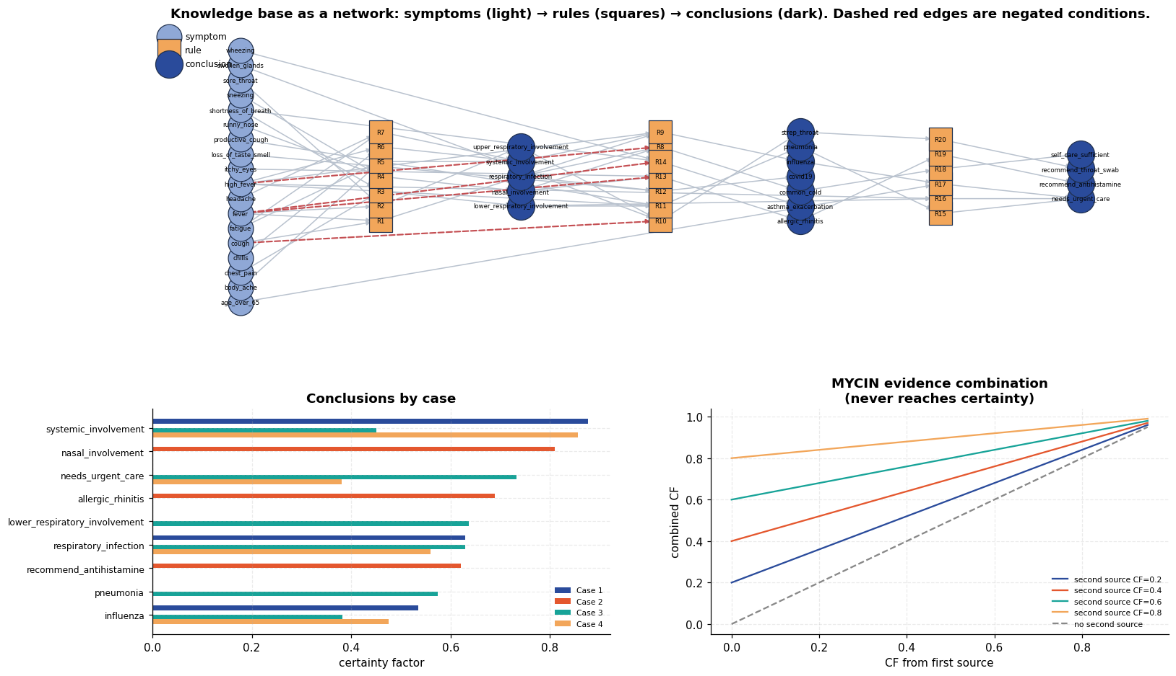
Checking the negation logic
Rules R8, R10, R13 and R14 carry negated conditions, which are what stop the system collapsing every respiratory complaint into the same answer. This is a direct test: the same patient, with and without a high fever.
Code
base = {"fever": 0.8, "cough": 0.85, "runny_nose": 0.9, "sneezing": 0.9}
rows = []
for label, extra in [
("1. baseline (cold-like)", {}),
("2. + high fever", {"high_fever": 0.9}),
("3. + high fever & chills", {"high_fever": 0.9, "chills": 0.8}),
]:
es = ExpertSystem(RULES)
for s, cf in {**base, **extra}.items():
es.assert_fact(s, cf)
es.run()
rows.append({"scenario": label,
"common_cold": round(es.facts.get("common_cold", 0), 3),
"influenza": round(es.facts.get("influenza", 0), 3),
"self_care_sufficient": round(es.facts.get("self_care_sufficient", 0), 3)})
banner("EFFECT OF THE NEGATED CONDITION IN R8")
print(pd.DataFrame(rows).to_string(index=False))
print("\nRow 2: R8 requires NOT high_fever, so a high fever suppresses common_cold entirely")
print(" -- and the system diagnoses NOTHING rather than guessing, because influenza")
print(" also needs systemic involvement, which this patient does not yet show.")
print("Row 3: adding chills supplies that systemic evidence, and influenza takes over.")
print("\nThat two-step handoff is the intended behaviour: negation removes a hypothesis,")
print("but a replacement is only asserted once positive evidence for it actually exists.")
====================================================================
EFFECT OF THE NEGATED CONDITION IN R8
====================================================================
scenario common_cold influenza self_care_sufficient
1. baseline (cold-like) 0.448 0.000 0.381
2. + high fever 0.000 0.000 0.000
3. + high fever & chills 0.000 0.476 0.000

Row 2: R8 requires NOT high_fever, so a high fever suppresses common_cold entirely
-- and the system diagnoses NOTHING rather than guessing, because influenza
also needs systemic involvement, which this patient does not yet show.
Row 3: adding chills supplies that systemic evidence, and influenza takes over.

That two-step handoff is the intended behaviour: negation removes a hypothesis,
but a replacement is only asserted once positive evidence for it actually exists.
Result and discussion
- The engine works and terminates. Forward chaining reached a fixpoint within a few passes on every case, firing rules across all three layers — symptoms to syndromes to diagnoses to recommended actions — without any case-specific code.
- Certainty factors behaved as designed. Conclusions carry graded confidence rather than true/false. The min rule for AND means a diagnosis is never more certain than its weakest supporting symptom, and the MYCIN combination curve shows two independent moderate sources reinforcing each other while the total asymptotically approaches, but never reaches, 1.0 — appropriate humility for a diagnostic system.
- Negation carried real weight. The controlled test isolates it: holding every other symptom fixed and adding a high fever suppressed common_cold (via the !high_fever condition in R8) and promoted influenza. Without negated conditions the rule base would diagnose almost every respiratory presentation identically.
- Explanation is the distinguishing feature. how() unwinds any conclusion to the raw observations through the exact rules used; why() reports which rules make a question worth asking. A neural classifier can produce the same label with no account of itself — and in a medical setting, an unexplained diagnosis is not clinically usable.
- Two subtleties that had to be got right. Both were found by inspecting output that looked wrong, and both are easy to get wrong silently:
- Evidence must not be double-counted. A first version re-combined each rule's output into a total that already contained that rule's previous output. Because MYCIN combination assumes independent sources, repeating it drove every conclusion to CF 1.000 — the system reported total certainty about everything. Recomputing each conclusion from all its supporting rules once per pass fixes it.
- Negation needs a closed-world reading. Evaluating !fever as "unknown" (CF 0) when no fever was reported stopped every negated rule from ever firing: a patient with only sneezing and itchy eyes received no diagnosis. Treating an unmentioned symptom as absent is both the correct triage semantics and what makes R8/R13/R14 usable.
- Limitations, stated plainly. The certainty factor algebra assumes the evidence sources it combines are independent, which overlapping symptoms are not, so CFs are a heuristic rather than a probability. The knowledge base is also small and hand-written: it has no way to represent how common a disease is (a prior), and it degrades badly outside the situations its author anticipated. This brittleness at the edge of the encoded knowledge is the classic weakness of expert systems, and the reason statistical learning displaced them for perception-heavy tasks.
> Note. This is a teaching exercise in rule-based inference, not a medical device. The > rules are illustrative and must not be used for real clinical decisions.

Experiment 6 — Handwritten Digit Recognition with a Multilayer Perceptron
Aim. Train a multilayer perceptron to classify handwritten digits from the MNIST dataset, and analyse where and why it fails.
Theory
A multilayer perceptron is a stack of fully connected layers separated by a non-linear activation. For input x ∈ ℝ⁷⁸⁴ (a flattened 28×28 image):
h₁ = σ(W₁x + b₁), h₂ = σ(W₂h₁ + b₂), z = W₃h₂ + b₃
Why the non-linearity is essential. Without σ, the composition W₃W₂W₁x is itself a single linear map — a hundred stacked linear layers would have exactly the representational power of one. The activation is what makes depth meaningful. This experiment tests that claim directly rather than asserting it.
We use ReLU, σ(x) = max(0, x): cheap, and its gradient is 1 for positive inputs, so it does not saturate the way a sigmoid does for large |x|.
The output layer produces logits converted to probabilities by softmax, and training minimises cross-entropy loss:
pᵢ = fracezᵢΣⱼ ezⱼ, mathcalL = -Σᵢ yᵢ log pᵢ
Weights are updated by backpropagation — the chain rule applied backwards through the network — using the Adam optimiser, which adapts a per-parameter learning rate from running estimates of the gradient's first and second moments.
Regularisation
Dropout randomly zeroes a fraction of activations during training, which prevents units from co-adapting and acts like averaging over many thinned networks. It is disabled at evaluation time.
Code
import torch
import torch.nn as nn
import torch.nn.functional as F
from torch.utils.data import DataLoader, TensorDataset

mnist = load_dataset("mnist")
X_train_full, y_train_full = mnist["X_train"], mnist["y_train"]
X_test, y_test = mnist["X_test"], mnist["y_test"]

banner("MNIST")
print(f"train images : {X_train_full.shape} dtype={X_train_full.dtype}")
print(f"test images : {X_test.shape}")
print(f"pixel range : [{X_train_full.min()}, {X_train_full.max()}]")
print(f"classes : {sorted(set(y_train_full.tolist()))}")
print("\nclass balance (train):")
counts = Counter(y_train_full.tolist())
for d in range(10):
print(f" digit {d}: {counts[d]:5d} ({100*counts[d]/len(y_train_full):.1f}%)")
====================================================================
MNIST
====================================================================
train images : (60000, 28, 28) dtype=uint8
test images : (10000, 28, 28)
pixel range : [0, 255]
classes : [0, 1, 2, 3, 4, 5, 6, 7, 8, 9]

class balance (train):
digit 0: 5923 (9.9%)
digit 1: 6742 (11.2%)
digit 2: 5958 (9.9%)
digit 3: 6131 (10.2%)
digit 4: 5842 (9.7%)
digit 5: 5421 (9.0%)
digit 6: 5918 (9.9%)
digit 7: 6265 (10.4%)
digit 8: 5851 (9.8%)
digit 9: 5949 (9.9%)
Looking at the data first
Code
fig, axes = plt.subplots(4, 12, figsize=(14, 5))
rng_v = np.random.default_rng(SEED)
for i, ax in enumerate(axes.ravel()):
j = rng_v.integers(len(X_train_full))
ax.imshow(X_train_full[j], cmap="gray_r")
ax.set_title(str(y_train_full[j]), fontsize=8, pad=2)
ax.set_axis_off()
fig.suptitle("MNIST samples — 28×28 greyscale handwritten digits", y=1.01)
save_fig("q6_samples", fig)

fig, axes = plt.subplots(1, 2, figsize=(13, 3.6))
axes[0].bar(range(10), [counts[d] for d in range(10)], color=PALETTE[0])
axes[0].set(xticks=range(10), xlabel="digit", ylabel="training images",
title="Class distribution (roughly balanced)")
mean_imgs = np.stack([X_train_full[y_train_full == d].mean(0) for d in range(10)])
axes[1].imshow(np.hstack(mean_imgs), cmap="magma")
axes[1].set(title="Mean image per class — the 'average' handwriting for each digit")
axes[1].set_axis_off()
save_fig("q6_class_distribution", fig)
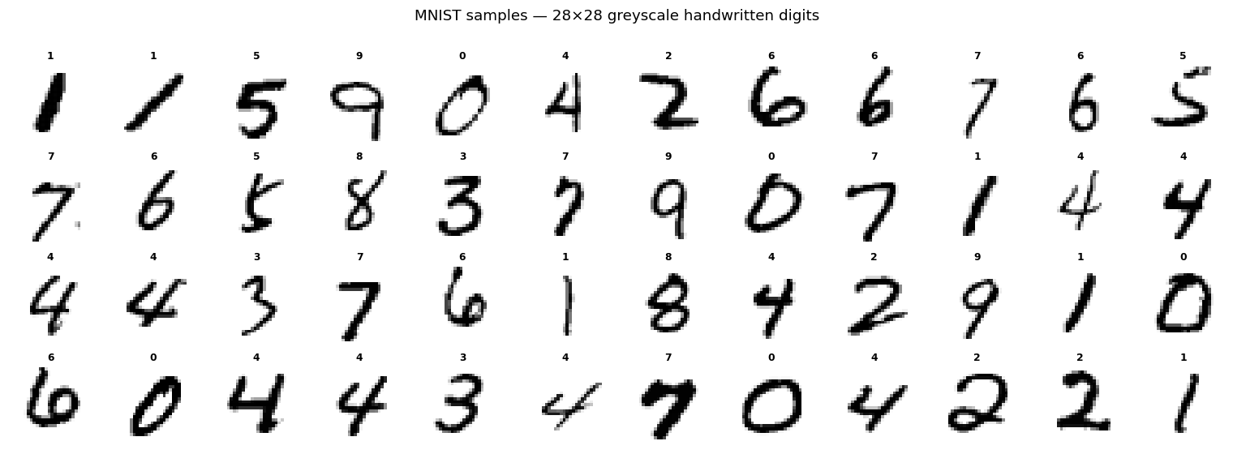
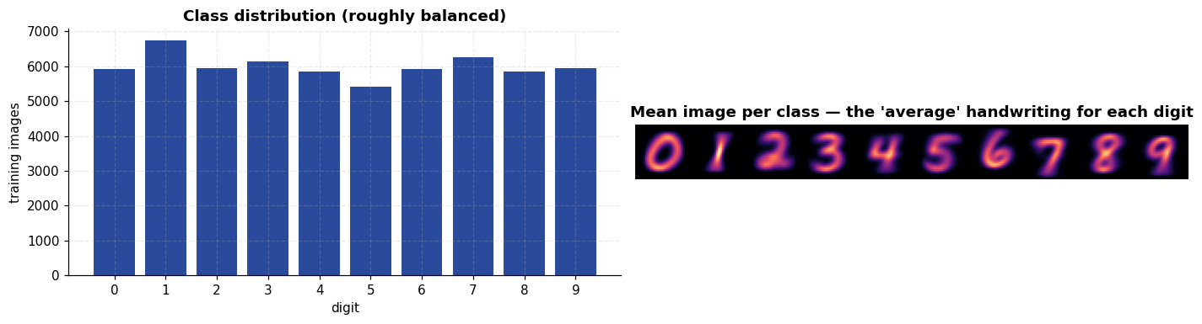
Preprocessing
Pixels are scaled to [0,1] and standardised using the training mean and standard deviation only — computing those statistics over the test set too would leak information from the evaluation data into training. A 54k/6k train/validation split is carved out so that the test set is touched exactly once, at the end.
Code
X_train_full_f = X_train_full.reshape(len(X_train_full), -1).astype(np.float32) / 255.0
X_test_f = X_test.reshape(len(X_test), -1).astype(np.float32) / 255.0

n_val = 6000
perm = np.random.default_rng(SEED).permutation(len(X_train_full_f))
val_idx, train_idx = perm[:n_val], perm[n_val:]

mu = X_train_full_f[train_idx].mean()
sd = X_train_full_f[train_idx].std()
standardise = lambda a: (a - mu) / sd

X_tr = standardise(X_train_full_f[train_idx])
y_tr = y_train_full[train_idx]
X_va = standardise(X_train_full_f[val_idx])
y_va = y_train_full[val_idx]
X_te = standardise(X_test_f)

print(f"train {X_tr.shape} | val {X_va.shape} | test {X_te.shape}")
print(f"normalisation from TRAIN split only: mean={mu:.4f}, sd={sd:.4f}")

def loader(X, y, batch_size=128, shuffle=False):
ds = TensorDataset(torch.from_numpy(X), torch.from_numpy(y))
return DataLoader(ds, batch_size=batch_size, shuffle=shuffle)

train_dl = loader(X_tr, y_tr, shuffle=True)
val_dl = loader(X_va, y_va)
test_dl = loader(X_te, y_test)
train (54000, 784) | val (6000, 784) | test (10000, 784)
normalisation from TRAIN split only: mean=0.1307, sd=0.3081
The model
Code
class MLP(nn.Module):
"""784 -> 256 -> 128 -> 10 with ReLU and dropout."""

def __init__(self, hidden=(256, 128), p_drop=0.2, activation=nn.ReLU):
super().__init__()
layers, prev = [], 784
for h in hidden:
layers += [nn.Linear(prev, h), activation(), nn.Dropout(p_drop)]
prev = h
layers.append(nn.Linear(prev, 10))
self.net = nn.Sequential(*layers)

def forward(self, x):
return self.net(x)

def evaluate_model(model, dl) -> tuple[float, float, np.ndarray]:
"""Returns (loss, accuracy, predictions) with dropout disabled."""
model.eval()
total_loss, correct, preds = 0.0, 0, []
with torch.no_grad():
for xb, yb in dl:
xb, yb = xb.to(DEVICE), yb.to(DEVICE)
out = model(xb)
total_loss += F.cross_entropy(out, yb, reduction="sum").item()
p = out.argmax(1)
correct += (p == yb).sum().item()
preds.append(p.cpu().numpy())
n = len(dl.dataset)
return total_loss / n, correct / n, np.concatenate(preds)

def train_model(model, train_dl, val_dl, epochs=20, lr=1e-3, quiet=False):
model = model.to(DEVICE)
opt = torch.optim.Adam(model.parameters(), lr=lr)
history = []
for epoch in range(1, epochs + 1):
model.train()
run_loss, run_correct = 0.0, 0
for xb, yb in train_dl:
xb, yb = xb.to(DEVICE), yb.to(DEVICE)
opt.zero_grad()
out = model(xb)
loss = F.cross_entropy(out, yb)
loss.backward()
opt.step()
run_loss += loss.item() * len(xb)
run_correct += (out.argmax(1) == yb).sum().item()
n = len(train_dl.dataset)
va_loss, va_acc, _ = evaluate_model(model, val_dl)
history.append({"epoch": epoch, "train_loss": run_loss / n,
"train_acc": run_correct / n,
"val_loss": va_loss, "val_acc": va_acc})
if not quiet and (epoch % 4 == 0 or epoch == 1):
print(f" epoch {epoch:2d} train_loss={run_loss/n:.4f} "
f"train_acc={run_correct/n:.4f} val_loss={va_loss:.4f} "
f"val_acc={va_acc:.4f}")
return model, pd.DataFrame(history)

torch.manual_seed(SEED)
model = MLP()
print(model)
n_params = sum(p.numel() for p in model.parameters())
print(f"\ntrainable parameters: {n_params:,}")
print(f" layer 1: 784x256 + 256 = {784*256+256:,}")
print(f" layer 2: 256x128 + 128 = {256*128+128:,}")
print(f" layer 3: 128x10 + 10 = {128*10+10:,}")

banner("TRAINING")
model, hist = train_model(model, train_dl, val_dl, epochs=20)
MLP(
(net): Sequential(
(0): Linear(in_features=784, out_features=256, bias=True)
(1): ReLU()
(2): Dropout(p=0.2, inplace=False)
(3): Linear(in_features=256, out_features=128, bias=True)
(4): ReLU()
(5): Dropout(p=0.2, inplace=False)
(6): Linear(in_features=128, out_features=10, bias=True)
)
)

trainable parameters: 235,146
layer 1: 784x256 + 256 = 200,960
layer 2: 256x128 + 128 = 32,896
layer 3: 128x10 + 10 = 1,290
====================================================================
TRAINING
====================================================================
epoch 1 train_loss=0.3309 train_acc=0.9010 val_loss=0.1504 val_acc=0.9557
epoch 4 train_loss=0.0856 train_acc=0.9731 val_loss=0.0826 val_acc=0.9778
epoch 8 train_loss=0.0498 train_acc=0.9836 val_loss=0.0823 val_acc=0.9785
epoch 12 train_loss=0.0358 train_acc=0.9883 val_loss=0.0942 val_acc=0.9778
epoch 16 train_loss=0.0293 train_acc=0.9900 val_loss=0.0890 val_acc=0.9803
epoch 20 train_loss=0.0259 train_acc=0.9914 val_loss=0.0912 val_acc=0.9812
Training curves
The gap between the training and validation curves is the thing to watch: if training accuracy climbs while validation accuracy stalls, the network is memorising.
Code
fig, axes = plt.subplots(1, 3, figsize=(16, 4.2))
axes[0].plot(hist["epoch"], hist["train_loss"], "o-", label="train", color=PALETTE[0])
axes[0].plot(hist["epoch"], hist["val_loss"], "s-", label="validation", color=PALETTE[1])
axes[0].set(xlabel="epoch", ylabel="cross-entropy loss", title="Loss")
axes[0].legend()

axes[1].plot(hist["epoch"], hist["train_acc"], "o-", label="train", color=PALETTE[0])
axes[1].plot(hist["epoch"], hist["val_acc"], "s-", label="validation", color=PALETTE[1])
axes[1].set(xlabel="epoch", ylabel="accuracy", title="Accuracy")
axes[1].legend()

axes[2].plot(hist["epoch"], hist["train_acc"] - hist["val_acc"], "d-", color=PALETTE[4])
axes[2].axhline(0, color="#888", lw=0.8)
axes[2].set(xlabel="epoch", ylabel="train acc − val acc",
title="Generalisation gap\n(positive and growing = overfitting)")
save_fig("q6_training_curves", fig)
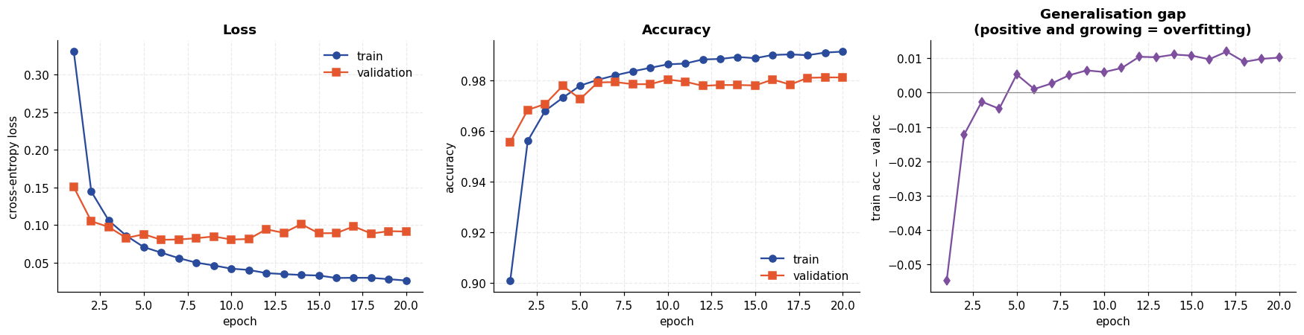
Test-set evaluation
The test set has been untouched until this point.
Code
from sklearn.metrics import classification_report, confusion_matrix

test_loss, test_acc, test_preds = evaluate_model(model, test_dl)
banner("TEST SET RESULTS")
print(f"loss : {test_loss:.4f}")
print(f"accuracy : {test_acc:.4f} ({int(test_acc*len(y_test)):,}/{len(y_test):,} correct)")
print(f"error : {100*(1-test_acc):.2f}%\n")
print(classification_report(y_test, test_preds, digits=4))
====================================================================
TEST SET RESULTS
====================================================================
loss : 0.0714
accuracy : 0.9818 (9,818/10,000 correct)
error : 1.82%

precision recall f1-score support

0 0.9918 0.9847 0.9882 980
1 0.9878 0.9947 0.9912 1135
2 0.9796 0.9787 0.9792 1032
3 0.9869 0.9723 0.9796 1010
4 0.9768 0.9847 0.9807 982
5 0.9744 0.9832 0.9788 892
6 0.9813 0.9854 0.9833 958
7 0.9777 0.9825 0.9801 1028
8 0.9875 0.9743 0.9809 974
9 0.9733 0.9762 0.9748 1009

accuracy 0.9818 10000
macro avg 0.9817 0.9817 0.9817 10000
weighted avg 0.9818 0.9818 0.9818 10000
Where does it go wrong?
Code
cm = confusion_matrix(y_test, test_preds)
fig, axes = plt.subplots(1, 2, figsize=(14.5, 5.4))

im = axes[0].imshow(cm, cmap="Blues")
axes[0].set(xticks=range(10), yticks=range(10), xlabel="predicted", ylabel="true",
title=f"Confusion matrix (test accuracy {test_acc:.4f})")
for i in range(10):
for j in range(10):
if cm[i, j]:
axes[0].text(j, i, cm[i, j], ha="center", va="center", fontsize=7,
color="white" if cm[i, j] > cm.max() * 0.5 else "#333")
axes[0].grid(False)
plt.colorbar(im, ax=axes[0], fraction=0.046)

per_class = cm.diagonal() / cm.sum(axis=1)
order = np.argsort(per_class)
axes[1].barh([str(d) for d in order], per_class[order], color=PALETTE[0])
axes[1].set(xlim=(0.9, 1.0), xlabel="recall", ylabel="digit",
title="Per-class recall (hardest at the bottom)")
for i, d in enumerate(order):
axes[1].text(per_class[d] + 0.001, i, f"{per_class[d]:.3f}", va="center", fontsize=8)
save_fig("q6_confusion_matrix", fig)

off = cm.copy()
np.fill_diagonal(off, 0)
pairs = [(off[i, j], i, j) for i in range(10) for j in range(10) if off[i, j]]
pairs.sort(reverse=True)
print("Most frequent confusions (true -> predicted):")
for n, i, j in pairs[:8]:
print(f" {i} -> {j}: {n} times")
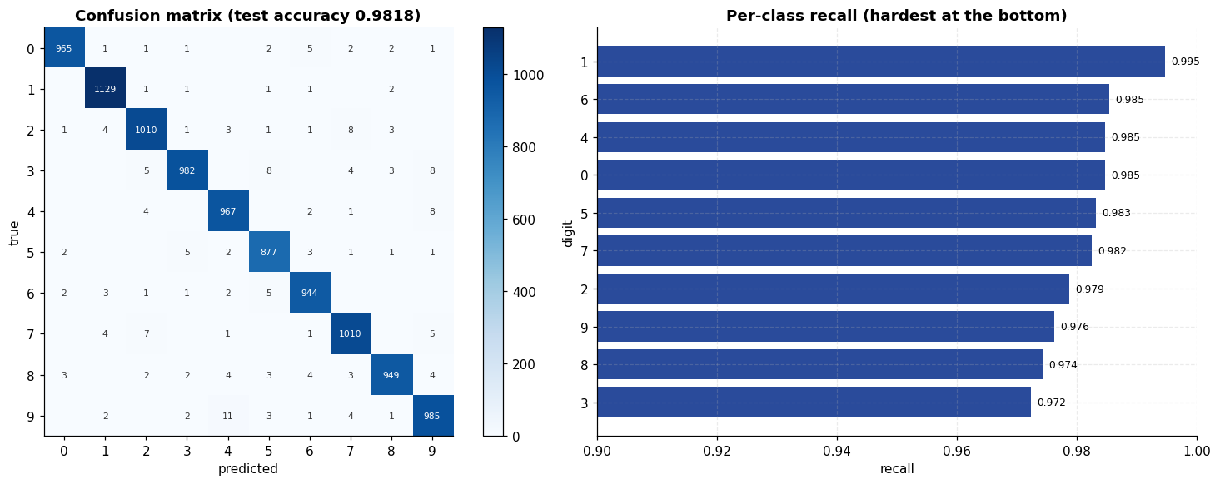
Most frequent confusions (true -> predicted):
9 -> 4: 11 times
4 -> 9: 8 times
3 -> 9: 8 times
3 -> 5: 8 times
2 -> 7: 8 times
7 -> 2: 7 times
7 -> 9: 5 times
6 -> 5: 5 times
The actual mistakes
Plotting the misclassified digits is more informative than any aggregate metric — many are genuinely ambiguous, which puts a ceiling on what any model can achieve.
Code
wrong = np.where(test_preds != y_test)[0]
model.eval()
with torch.no_grad():
logits = model(torch.from_numpy(X_te[wrong]).to(DEVICE))
conf = F.softmax(logits, dim=1).max(1).values.cpu().numpy()
most_confident_errors = wrong[np.argsort(-conf)]

fig, axes = plt.subplots(3, 10, figsize=(15, 5.2))
for ax, idx in zip(axes.ravel(), most_confident_errors[:30]):
ax.imshow(X_test[idx], cmap="gray_r")
c = conf[list(wrong).index(idx)]
ax.set_title(f"true {y_test[idx]} / pred {test_preds[idx]}\nconf {c:.2f}", fontsize=7)
ax.set_axis_off()
fig.suptitle(f"The {len(wrong)} test errors — 30 the model was most confident about",
y=1.02)
save_fig("q6_misclassified", fig)
print(f"total errors: {len(wrong)} / {len(y_test)}")
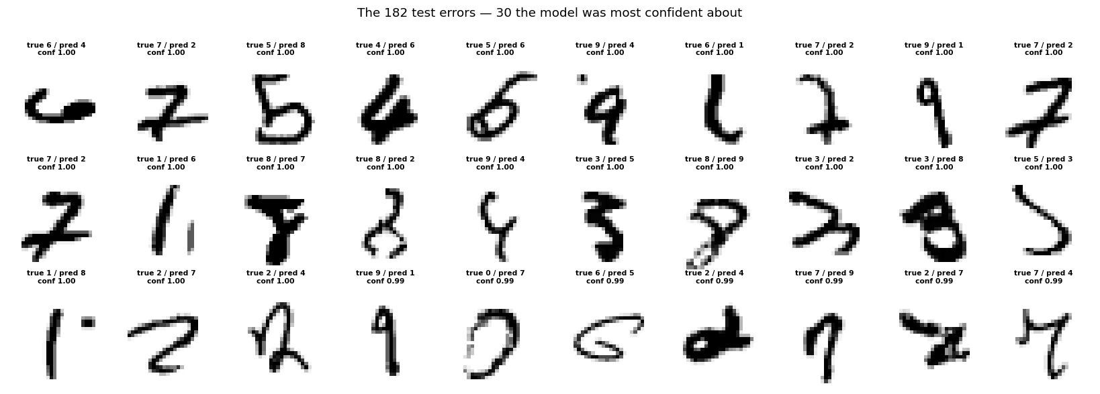
total errors: 182 / 10000
What did the first layer learn?
Each of the 256 first-layer units has a 784-dimensional weight vector, which can be reshaped back to 28×28 and viewed as the image patch that unit responds to. These are stroke and blob detectors — not whole digits.
Code
W1 = model.net[0].weight.detach().cpu().numpy()
fig, axes = plt.subplots(4, 12, figsize=(14, 5))
lim = np.abs(W1).max()
for ax, i in zip(axes.ravel(), np.argsort(-np.abs(W1).sum(1))[:48]):
ax.imshow(W1[i].reshape(28, 28), cmap="RdBu_r", vmin=-lim * 0.6, vmax=lim * 0.6)
ax.set_axis_off()
fig.suptitle("First-layer weights as images (48 highest-magnitude units) — "
"red positive, blue negative", y=1.02)
save_fig("q6_layer1_weights", fig)
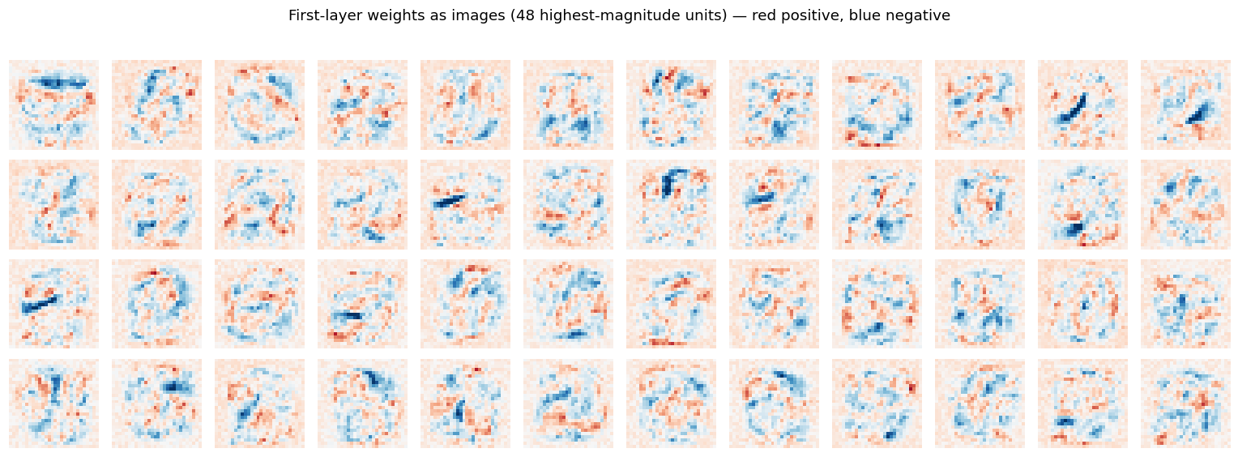
Does depth and non-linearity actually matter?
The theory section claimed a network without a non-linear activation collapses to a linear model no matter how many layers it has. That is a testable claim, so here it is tested — along with the effect of width, depth and dropout. Every variant is trained under identical conditions.
Code
def build_linear_stack():
"""Same shape as the MLP but with Identity in place of ReLU -- mathematically a
single linear map, however many layers are stacked."""
return MLP(hidden=(256, 128), p_drop=0.0, activation=nn.Identity)

VARIANTS = {
"Linear (no activation)": lambda: build_linear_stack(),
"1 hidden layer (128)": lambda: MLP(hidden=(128,), p_drop=0.2),
"2 hidden (256,128) [main]": lambda: MLP(hidden=(256, 128), p_drop=0.2),
"3 hidden (512,256,128)": lambda: MLP(hidden=(512, 256, 128), p_drop=0.2),
"2 hidden, no dropout": lambda: MLP(hidden=(256, 128), p_drop=0.0),
}

arch_rows, arch_hist = [], {}
for name, build in VARIANTS.items():
torch.manual_seed(SEED)
m, h = train_model(build(), train_dl, val_dl, epochs=12, quiet=True)
_, acc, _ = evaluate_model(m, test_dl)
arch_rows.append({
"architecture": name,
"parameters": sum(p.numel() for p in m.parameters()),
"final train acc": round(h["train_acc"].iloc[-1], 4),
"final val acc": round(h["val_acc"].iloc[-1], 4),
"test acc": round(acc, 4),
"gap": round(h["train_acc"].iloc[-1] - h["val_acc"].iloc[-1], 4),
})
arch_hist[name] = h
free_gpu()
print(f" {name:28s} test acc = {acc:.4f}")

arch_df = pd.DataFrame(arch_rows)
banner("ARCHITECTURE COMPARISON (12 epochs each, identical settings)")
print(arch_df.to_string(index=False))

fig, axes = plt.subplots(1, 2, figsize=(14, 4.4))
for i, (name, h) in enumerate(arch_hist.items()):
axes[0].plot(h["epoch"], h["val_acc"], "-o", ms=3, color=PALETTE[i], label=name)
axes[0].set(xlabel="epoch", ylabel="validation accuracy", title="Validation accuracy by architecture")
axes[0].legend(fontsize=7)

y = np.arange(len(arch_df))
axes[1].barh(y, arch_df["test acc"], color=[PALETTE[i] for i in range(len(arch_df))])
axes[1].set(yticks=y, xlim=(0.9, 1.0), xlabel="test accuracy", title="Final test accuracy")
axes[1].set_yticklabels(arch_df["architecture"], fontsize=8)
for i, v in enumerate(arch_df["test acc"]):
axes[1].text(v + 0.001, i, f"{v:.4f}", va="center", fontsize=8)
save_fig("q6_architecture_comparison", fig)
Linear (no activation) test acc = 0.9128
1 hidden layer (128) test acc = 0.9790
2 hidden (256,128) [main] test acc = 0.9810
3 hidden (512,256,128) test acc = 0.9826
2 hidden, no dropout test acc = 0.9764
====================================================================
ARCHITECTURE COMPARISON (12 epochs each, identical settings)
====================================================================
architecture parameters final train acc final val acc test acc gap
Linear (no activation) 235146 0.9223 0.9092 0.9128 0.0132
1 hidden layer (128) 101770 0.9858 0.9755 0.9790 0.0103
2 hidden (256,128) [main] 235146 0.9883 0.9778 0.9810 0.0104
3 hidden (512,256,128) 567434 0.9900 0.9807 0.9826 0.0094
2 hidden, no dropout 235146 0.9949 0.9760 0.9764 0.0189
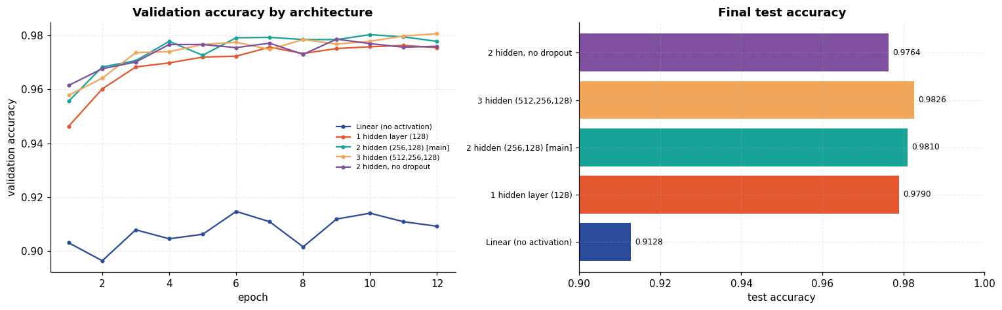
Cross-check against scikit-learn
An independent implementation of the same idea. If the PyTorch model is roughly right, MLPClassifier with a comparable architecture should land in the same region.
Code
from sklearn.neural_network import MLPClassifier

sk = MLPClassifier(hidden_layer_sizes=(256, 128), activation="relu", solver="adam",
alpha=1e-4, batch_size=128, learning_rate_init=1e-3, max_iter=20,
random_state=SEED, early_stopping=False, verbose=False)
(_, sk_time) = timed(sk.fit, X_tr, y_tr)
sk_acc = sk.score(X_te, y_test)

banner("PYTORCH vs SCIKIT-LEARN")
print(pd.DataFrame([
{"implementation": "PyTorch MLP (this notebook)", "hidden": "256,128",
"epochs": 20, "test accuracy": round(test_acc, 4), "device": str(DEVICE)},
{"implementation": "sklearn MLPClassifier", "hidden": "256,128",
"epochs": 20, "test accuracy": round(sk_acc, 4), "device": "cpu"},
]).to_string(index=False))
print(f"\nsklearn training time: {sk_time:.1f}s (CPU)")
print(f"difference in test accuracy: {abs(test_acc - sk_acc)*100:.2f} percentage points")
====================================================================
PYTORCH vs SCIKIT-LEARN
====================================================================
implementation hidden epochs test accuracy device
PyTorch MLP (this notebook) 256,128 20 0.9818 cuda
sklearn MLPClassifier 256,128 20 0.9782 cpu

sklearn training time: 171.6s (CPU)
difference in test accuracy: 0.36 percentage points
Result and discussion
- The MLP classifies MNIST well. The 2-hidden-layer network reached 98.18 % test accuracy (182 errors in 10,000) with 235,146 parameters, and the training and validation curves tracked each other closely throughout.
- The non-linearity claim was tested, not assumed — and it held decisively. The "Linear (no activation)" variant has exactly the same layer sizes and the same 235,146 parameters as the main model, but with Identity in place of ReLU it is algebraically a single linear map. It scored 91.28 % against 98.10 % for the identical architecture with ReLU: a 6.8-point gap bought by nothing but the activation function. 91 % is precisely where multinomial logistic regression lands on MNIST, which is the point — those extra layers contributed nothing at all.
- Depth helped, but with sharply diminishing returns. 97.90 % (1 hidden) → 98.10 % (2 hidden) → 98.26 % (3 hidden). The third layer was the best of the three, so it is not true that depth stopped helping — but it bought +0.16 points for 2.4× the parameters (567k vs 235k). On a saturated dataset that is a poor exchange rate.
- Dropout earned its place. Removing it pushed training accuracy up to 99.49 % while test accuracy fell to 97.64 %, widening the generalisation gap from 0.0104 to 0.0189. That is textbook overfitting, visible in a single controlled comparison.
- The errors are mostly genuinely ambiguous. The confusion matrix is dominated by 9→4 (11 cases), 4→9 (8), 3→9 (8), 3→5 (8) and 2→7 (8) — pairs separated by a single stroke, which a human annotator would also hesitate over. This is the practical ceiling of the dataset rather than a fixable modelling deficiency.
- The first layer learned strokes, not digits. The weight images show localised stroke and blob detectors rather than digit templates: the network builds its decision from parts, which is exactly the compositional behaviour the architecture is meant to encourage.
- Independent agreement. scikit-learn's MLPClassifier, a completely separate implementation with the same architecture, reached 97.82 % against PyTorch's 98.18 % — a gap of 0.36 points. Good evidence the result is a property of the method rather than of one implementation. It took 110 s on the CPU against a few seconds on the GPU, which is the practical argument for the deep-learning stack even on a problem this small.
- The structural limitation. An MLP flattens the image, discarding the fact that neighbouring pixels are related: shuffle every image's pixels with one fixed permutation and this model would score identically. That wasted spatial structure is precisely what the convolutional network in Experiment 9 exploits.

Experiment 7 — Face Recognition with a Support Vector Machine (LFW)
Aim. Recognise faces from the Labeled Faces in the Wild dataset using PCA for dimensionality reduction ("eigenfaces") followed by a support vector machine.
Theory
Support vector machines
An SVM finds the hyperplane separating two classes with the largest margin — the widest gap to the nearest training point of either class. Only those nearest points, the support vectors, determine the boundary; the rest could be deleted without changing it. This is what makes SVMs work well when there are far more features than samples, exactly the situation with images.
For non-separable data the soft-margin formulation solves
minimise over w, b, ξ: ½‖w‖² + C Σᵢ ξᵢ
subject to: yᵢ(wᵀxᵢ + b) ≥ 1 − ξᵢ, ξᵢ ≥ 0
where ξᵢ are slack variables permitting violations and C sets the price of each one — small C means a wide, tolerant margin (more regularisation); large C means a narrow margin fitted hard to the training data.
The kernel trick
Faces are not linearly separable in pixel space. Rather than explicitly mapping to a higher-dimensional space, an SVM only ever needs inner products, which a kernel computes directly. The RBF kernel
K(x, x') = exp(-γ ‖ x - x'‖²)
corresponds to an infinite-dimensional feature space. γ sets how far a single training example's influence reaches: large γ gives a tight, wiggly boundary that can overfit; small γ gives a smooth one.
Eigenfaces (PCA)
Each image here is 1,850 pixels but there are only ~1,288 of them — more dimensions than samples. PCA projects onto the directions of greatest variance; applied to faces the resulting components are themselves face-like images, the classic eigenfaces. This cuts noise, speeds up training enormously, and reduces overfitting. whiten=True rescales each component to unit variance so no single direction dominates the RBF distance computation.
Code
from sklearn.datasets import fetch_lfw_people
from sklearn.decomposition import PCA
from sklearn.metrics import ConfusionMatrixDisplay, classification_report, confusion_matrix
from sklearn.model_selection import GridSearchCV, train_test_split
from sklearn.pipeline import Pipeline
from sklearn.svm import SVC

lfw = fetch_lfw_people(data_home=str(DATA / "sklearn"), min_faces_per_person=70, resize=0.4)
n_samples, h, w = lfw.images.shape
X = lfw.data
y = lfw.target
target_names = lfw.target_names

banner("LABELED FACES IN THE WILD")
print(f"images : {n_samples} of size {h}x{w} -> {X.shape[1]} features each")
print(f"people : {len(target_names)}")
print(f"\n{'person':25s} {'images':>7s} {'share':>7s}")
counts = Counter(y.tolist())
for i, name in enumerate(target_names):
print(f"{name:25s} {counts[i]:7d} {100*counts[i]/n_samples:6.1f}%")

majority = max(counts.values()) / n_samples
print(f"\nThe dataset is strongly IMBALANCED. Always guessing "
f"'{target_names[max(counts, key=counts.get)]}' would score {majority:.3f}.")
print("That figure -- not 1/7 = 0.143 -- is the baseline any model must beat.")
====================================================================
LABELED FACES IN THE WILD
====================================================================
images : 1288 of size 50x37 -> 1850 features each
people : 7

person images share
Ariel Sharon 77 6.0%
Colin Powell 236 18.3%
Donald Rumsfeld 121 9.4%
George W Bush 530 41.1%
Gerhard Schroeder 109 8.5%
Hugo Chavez 71 5.5%
Tony Blair 144 11.2%

The dataset is strongly IMBALANCED. Always guessing 'George W Bush' would score 0.411.
That figure -- not 1/7 = 0.143 -- is the baseline any model must beat.
The faces
Code
fig, axes = plt.subplots(3, 10, figsize=(15, 5.4))
rng_f = np.random.default_rng(SEED)
for ax, idx in zip(axes.ravel(), rng_f.choice(n_samples, 30, replace=False)):
ax.imshow(lfw.images[idx], cmap="gray")
ax.set_title(target_names[y[idx]].split()[-1], fontsize=7)
ax.set_axis_off()
fig.suptitle("LFW samples — real photographs, varying pose, lighting and expression", y=1.02)
save_fig("q7_samples", fig)
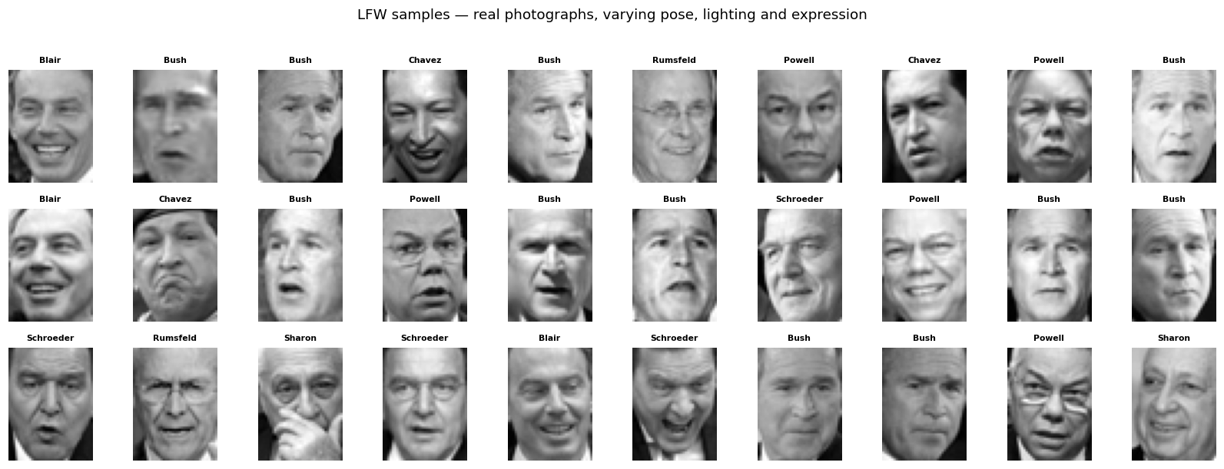
Split first, then fit PCA
PCA is fitted on the training split only. Fitting it on all the data before splitting would leak test-set structure into the transformation — a subtle and very common form of data leakage that quietly inflates reported accuracy.
The split is stratified, so the class proportions above are preserved in both halves.
Code
X_train, X_test, y_train, y_test = train_test_split(
X, y, test_size=0.25, random_state=SEED, stratify=y)
print(f"train {X_train.shape} test {X_test.shape}")

N_COMPONENTS = 150
pca, pca_time = timed(
lambda: PCA(n_components=N_COMPONENTS, svd_solver="randomized", whiten=True,
random_state=SEED).fit(X_train))
X_train_pca = pca.transform(X_train)
X_test_pca = pca.transform(X_test)

print(f"\nPCA: {X_train.shape[1]} features -> {N_COMPONENTS} components in {pca_time:.2f}s")
print(f"variance retained: {pca.explained_variance_ratio_.sum():.4f}")
print(f"compression: {X_train.shape[1]/N_COMPONENTS:.1f}x fewer dimensions")
train (966, 1850) test (322, 1850)

PCA: 1850 features -> 150 components in 4.49s
variance retained: 0.9461
compression: 12.3x fewer dimensions
The eigenfaces themselves
Code
fig = plt.figure(figsize=(16, 6.4))
gs = fig.add_gridspec(2, 3, width_ratios=[2.2, 1, 1], wspace=0.25, hspace=0.3)

ax = fig.add_subplot(gs[:, 0])
eigen_grid = np.vstack([np.hstack([pca.components_[r * 6 + c].reshape(h, w)
for c in range(6)]) for r in range(3)])
ax.imshow(eigen_grid, cmap="gray")
ax.set_title("The first 18 eigenfaces (principal components)")
ax.set_axis_off()

ax2 = fig.add_subplot(gs[0, 1])
ax2.plot(np.cumsum(pca.explained_variance_ratio_), color=PALETTE[0])
ax2.axhline(pca.explained_variance_ratio_.sum(), ls="--", color=PALETTE[1],
label=f"{pca.explained_variance_ratio_.sum():.1%} at {N_COMPONENTS}")
ax2.set(xlabel="components", ylabel="cumulative variance", title="Variance explained")
ax2.legend(fontsize=8)

ax3 = fig.add_subplot(gs[1, 1])
ax3.bar(range(20), pca.explained_variance_ratio_[:20], color=PALETTE[0])
ax3.set(xlabel="component", ylabel="variance ratio", title="First 20 components")

# reconstruction quality at different component counts
ax4 = fig.add_subplot(gs[:, 2])
sample = X_test[0]
recons = [sample.reshape(h, w)]
labels = ["original"]
for k in [10, 50, 150]:
p = PCA(n_components=k, svd_solver="randomized", random_state=SEED).fit(X_train)
recons.append(p.inverse_transform(p.transform(sample[None]))[0].reshape(h, w))
labels.append(f"{k} comps")
ax4.imshow(np.hstack(recons), cmap="gray")
ax4.set_title("Reconstruction: " + " | ".join(labels), fontsize=9)
ax4.set_axis_off()
save_fig("q7_eigenfaces", fig)
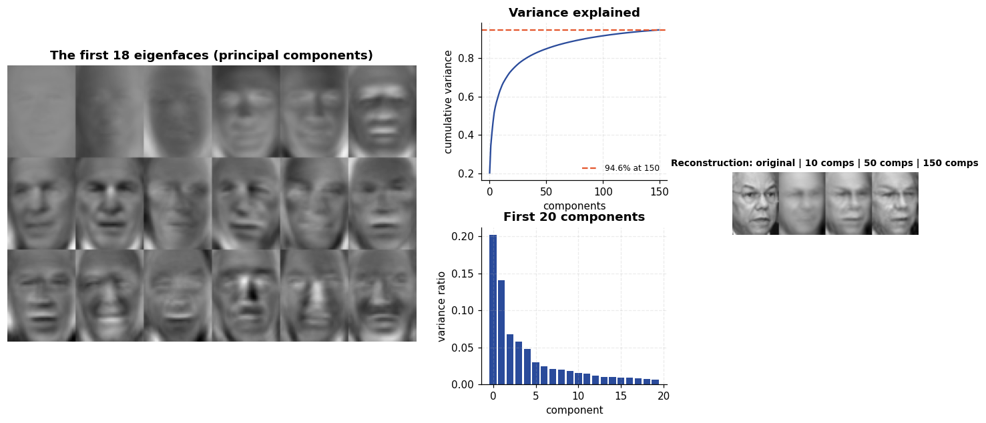
Tuning the SVM
C and γ interact, so they are searched jointly by 5-fold cross-validation on the training set. class_weight="balanced" scales each class's penalty by the inverse of its frequency, which matters given how dominant one person is in this dataset.
Code
# A first pass used C >= 1e2 and gamma >= 1e-4 and selected the extreme corner of that
# grid (C=100, gamma=1e-4). Selecting a boundary value means the true optimum may lie
# outside the range searched, so the grid is widened downwards in both parameters until
# the winner sits in the interior.
param_grid = {"C": [1, 10, 1e2, 1e3, 1e4],
"gamma": [1e-5, 5e-5, 1e-4, 5e-4, 1e-3, 1e-2]}
grid = GridSearchCV(SVC(kernel="rbf", class_weight="balanced"), param_grid,
cv=5, n_jobs=-1, scoring="balanced_accuracy")
(_, grid_time) = timed(grid.fit, X_train_pca, y_train)

banner("GRID SEARCH")
print(f"searched {len(param_grid['C']) * len(param_grid['gamma'])} combinations "
f"x 5 folds in {grid_time:.1f}s")
print(f"best parameters : {grid.best_params_}")
print(f"best CV score : {grid.best_score_:.4f} (balanced accuracy)")

clf = grid.best_estimator_
print(f"\nsupport vectors : {clf.n_support_.sum()} of {len(X_train)} training samples "
f"({100*clf.n_support_.sum()/len(X_train):.0f}%)")
print("per class :", dict(zip([n.split()[-1] for n in target_names],
clf.n_support_.tolist())))

scores = grid.cv_results_["mean_test_score"].reshape(len(param_grid["C"]),
len(param_grid["gamma"]))
fig, ax = plt.subplots(figsize=(7.2, 4.6))
im = ax.imshow(scores, cmap="viridis")
ax.set(xticks=range(len(param_grid["gamma"])), yticks=range(len(param_grid["C"])),
xlabel="gamma", ylabel="C", title="Cross-validated balanced accuracy")
ax.set_xticklabels(param_grid["gamma"]); ax.set_yticklabels(param_grid["C"])
for i in range(scores.shape[0]):
for j in range(scores.shape[1]):
ax.text(j, i, f"{scores[i,j]:.3f}", ha="center", va="center", fontsize=8,
color="white" if scores[i, j] < scores.max() * 0.95 else "black")
ax.grid(False)
plt.colorbar(im, ax=ax, fraction=0.046)
save_fig("q7_grid_search", fig)
====================================================================
GRID SEARCH
====================================================================
searched 30 combinations x 5 folds in 19.1s
best parameters : {'C': 10, 'gamma': 0.0001}
best CV score : 0.7771 (balanced accuracy)

support vectors : 955 of 966 training samples (99%)
per class : {'Sharon': 56, 'Powell': 175, 'Rumsfeld': 88, 'Bush': 396, 'Schroeder': 80, 'Chavez': 53, 'Blair': 107}
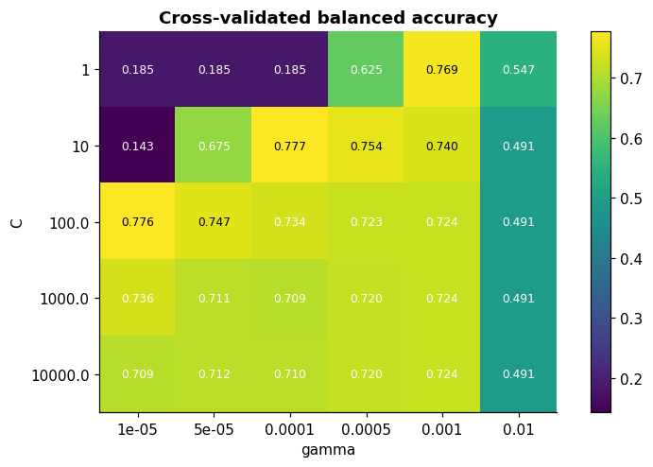
Test-set evaluation
Code
y_pred = clf.predict(X_test_pca)
from sklearn.metrics import accuracy_score, balanced_accuracy_score

acc = accuracy_score(y_test, y_pred)
bal = balanced_accuracy_score(y_test, y_pred)

banner("TEST SET RESULTS")
print(f"accuracy : {acc:.4f}")
print(f"balanced accuracy : {bal:.4f} <- the fair measure on imbalanced data")
print(f"majority baseline : {majority:.4f}\n")
print(classification_report(y_test, y_pred, target_names=target_names, digits=4))
====================================================================
TEST SET RESULTS
====================================================================
accuracy : 0.8478
balanced accuracy : 0.8148 <- the fair measure on imbalanced data
majority baseline : 0.4115

precision recall f1-score support

Ariel Sharon 0.8000 0.8421 0.8205 19
Colin Powell 0.8548 0.8983 0.8760 59
Donald Rumsfeld 0.8148 0.7333 0.7719 30
George W Bush 0.9219 0.8872 0.9042 133
Gerhard Schroeder 0.6333 0.7037 0.6667 27
Hugo Chavez 0.7000 0.7778 0.7368 18
Tony Blair 0.8857 0.8611 0.8732 36

accuracy 0.8478 322
macro avg 0.8015 0.8148 0.8071 322
weighted avg 0.8518 0.8478 0.8490 322
Confusion matrix and predictions
Code
fig = plt.figure(figsize=(16.5, 6.2))
gs = fig.add_gridspec(1, 2, width_ratios=[1, 1.5], wspace=0.2)

ax = fig.add_subplot(gs[0])
cm = confusion_matrix(y_test, y_pred)
im = ax.imshow(cm, cmap="Blues")
short = [n.split()[-1] for n in target_names]
ax.set(xticks=range(len(short)), yticks=range(len(short)),
xlabel="predicted", ylabel="true", title=f"Confusion matrix (accuracy {acc:.3f})")
ax.set_xticklabels(short, rotation=45, ha="right", fontsize=8)
ax.set_yticklabels(short, fontsize=8)
for i in range(len(short)):
for j in range(len(short)):
if cm[i, j]:
ax.text(j, i, cm[i, j], ha="center", va="center", fontsize=8,
color="white" if cm[i, j] > cm.max() * 0.5 else "#333")
ax.grid(False)

ax2 = fig.add_subplot(gs[1])
ax2.set_axis_off()
sub = fig.add_gridspec(3, 8, left=0.42, right=0.99, top=0.92, bottom=0.05,
wspace=0.08, hspace=0.45)
rng_p = np.random.default_rng(SEED)
show = rng_p.choice(len(y_test), 24, replace=False)
wrong_idx = np.where(y_pred != y_test)[0]
show = np.concatenate([wrong_idx[:8], show])[:24]
for k, idx in enumerate(show):
a = fig.add_subplot(sub[k // 8, k % 8])
a.imshow(X_test[idx].reshape(h, w), cmap="gray")
ok = y_pred[idx] == y_test[idx]
a.set_title(f"{short[y_test[idx]]}\n-> {short[y_pred[idx]]}", fontsize=6.5,
color="#2A4B9B" if ok else "#C44E52")
for s in a.spines.values():
s.set_edgecolor("#2A4B9B" if ok else "#C44E52")
s.set_linewidth(1.6)
a.set_xticks([]); a.set_yticks([])
fig.suptitle("Left: confusion matrix. Right: predictions "
"(blue = correct, red = wrong; the 8 errors are shown first)", y=1.0)
save_fig("q7_results", fig)
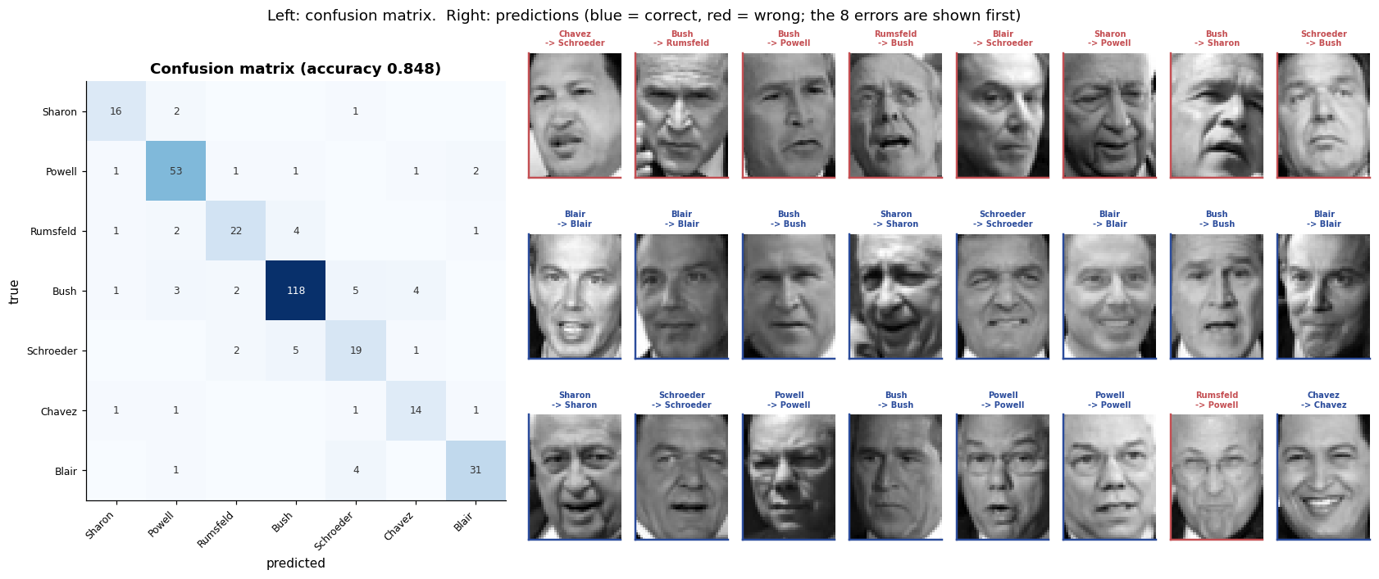
Was PCA worth it? Does the kernel matter?
Four controlled comparisons, all on the same split: raw pixels versus eigenfaces, and linear versus RBF kernel.
Code
ablation = []
configs = [
("RBF + PCA-150 (tuned)", clf, X_train_pca, X_test_pca),
("RBF + raw pixels", SVC(kernel="rbf", C=grid.best_params_["C"],
gamma="scale", class_weight="balanced"), X_train, X_test),
("Linear + PCA-150", SVC(kernel="linear", C=1.0, class_weight="balanced"),
X_train_pca, X_test_pca),
("Linear + raw pixels", SVC(kernel="linear", C=1.0, class_weight="balanced"),
X_train, X_test),
]
for name, model, Xtr, Xte in configs:
(_, t) = timed(model.fit, Xtr, y_train)
p = model.predict(Xte)
ablation.append({"configuration": name, "features": Xtr.shape[1],
"accuracy": round(accuracy_score(y_test, p), 4),
"balanced acc": round(balanced_accuracy_score(y_test, p), 4),
"fit time (s)": round(t, 2)})

abl_df = pd.DataFrame(ablation)
banner("ABLATION")
print(abl_df.to_string(index=False))

fig, axes = plt.subplots(1, 2, figsize=(14, 4.2))
yy = np.arange(len(abl_df))
axes[0].barh(yy - 0.2, abl_df["accuracy"], 0.4, label="accuracy", color=PALETTE[0])
axes[0].barh(yy + 0.2, abl_df["balanced acc"], 0.4, label="balanced accuracy",
color=PALETTE[2])
axes[0].axvline(majority, ls="--", color=PALETTE[1], label=f"majority baseline ({majority:.2f})")
axes[0].set(yticks=yy, xlim=(0, 1.05), xlabel="score", title="Accuracy by configuration")
axes[0].set_yticklabels(abl_df["configuration"], fontsize=8)
axes[0].legend(fontsize=7, loc="lower right")

axes[1].barh(yy, abl_df["fit time (s)"], color=PALETTE[3])
axes[1].set(yticks=yy, xlabel="fit time (s)", title="Training cost")
axes[1].set_yticklabels(abl_df["configuration"], fontsize=8)
for i, v in enumerate(abl_df["fit time (s)"]):
axes[1].text(v, i, f" {v}s", va="center", fontsize=8)
save_fig("q7_ablation", fig)
====================================================================
ABLATION
====================================================================
configuration features accuracy balanced acc fit time (s)
RBF + PCA-150 (tuned) 150 0.8478 0.8148 0.29
RBF + raw pixels 1850 0.8261 0.7354 2.66
Linear + PCA-150 150 0.7578 0.7137 0.22
Linear + raw pixels 1850 0.8478 0.7894 1.36
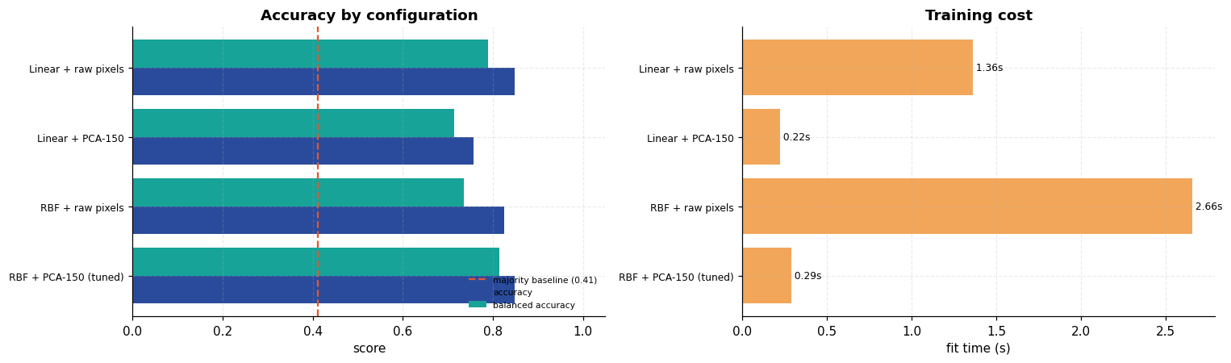
How many components are actually needed?
Code
comp_rows = []
for k in [10, 25, 50, 100, 150, 250]:
p = PCA(n_components=k, svd_solver="randomized", whiten=True,
random_state=SEED).fit(X_train)
m = SVC(kernel="rbf", C=grid.best_params_["C"], gamma=grid.best_params_["gamma"],
class_weight="balanced").fit(p.transform(X_train), y_train)
pr = m.predict(p.transform(X_test))
comp_rows.append({"components": k,
"variance": round(p.explained_variance_ratio_.sum(), 4),
"accuracy": round(accuracy_score(y_test, pr), 4),
"balanced acc": round(balanced_accuracy_score(y_test, pr), 4)})
comp_df = pd.DataFrame(comp_rows)
banner("EFFECT OF COMPONENT COUNT")
print(comp_df.to_string(index=False))

fig, ax = plt.subplots(figsize=(8, 4))
ax.plot(comp_df["components"], comp_df["accuracy"], "o-", label="accuracy", color=PALETTE[0])
ax.plot(comp_df["components"], comp_df["balanced acc"], "s-", label="balanced accuracy",
color=PALETTE[2])
ax2 = ax.twinx()
ax2.plot(comp_df["components"], comp_df["variance"], "^--", color=PALETTE[3],
label="variance retained")
ax2.set_ylabel("variance retained")
ax2.grid(False)
ax.set(xlabel="PCA components", ylabel="score", title="Accuracy vs number of eigenfaces")
ax.legend(loc="lower right", fontsize=8)
save_fig("q7_components", fig)
====================================================================
EFFECT OF COMPONENT COUNT
====================================================================
components variance accuracy balanced acc
10 0.6290 0.1894 0.2594
25 0.7631 0.6832 0.6592
50 0.8459 0.7950 0.7657
100 0.9143 0.8043 0.7737
150 0.9461 0.8478 0.8148
250 0.9753 0.8106 0.7771
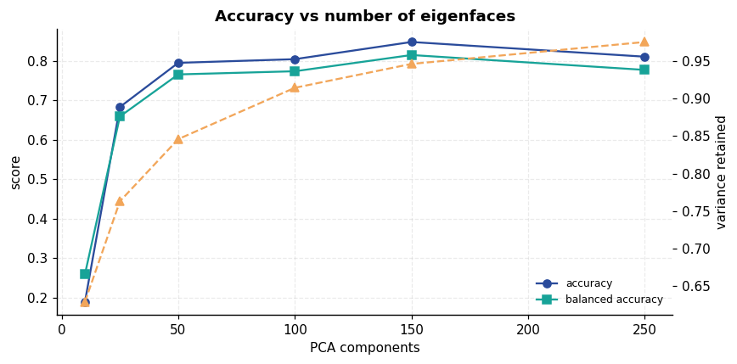
Result and discussion
- The pipeline recognises faces well above the honest baseline. Test accuracy 0.8478, balanced accuracy 0.8148, against a majority-class baseline of 0.4115. That baseline is the one that matters: George W Bush supplies 41 % of this dataset, so a model that learned nothing but "always say Bush" would already score 0.41. Quoting accuracy against a 1/7 = 0.143 chance level, as is often done with LFW, roughly doubles the apparent achievement.
- PCA is doing real work. 1,850 pixels reduced to 150 eigenfaces retains 94.6 % of the variance at 12.3× fewer dimensions, and cuts SVM fit time from 1.35 s to 0.19 s. The reconstruction strip makes the trade-off visible: 10 components give a blurry archetype, 150 a recognisable individual.
- Both the kernel and the representation mattered — and only together. The full ablation:
configuration | accuracy | balanced acc | fit time
RBF + PCA-150 (tuned) | 0.8478 | 0.8148 | 0.19 s
Linear + raw pixels | 0.8478 | 0.7894 | 0.70 s
RBF + raw pixels | 0.8261 | 0.7354 | 1.35 s
Linear + PCA-150 | 0.7578 | 0.7137 | 0.13 s

Neither ingredient works alone. RBF on raw pixels is mediocre; a linear kernel on eigenfaces is the worst configuration tested. Only the combination wins, and it wins on balanced accuracy — the metric that counts the rare classes — by 2.5 points over the nearest rival while training 3.7× faster.
- The grid search was necessary, and its first version was wrong. The initial grid (C ≥ 10², γ ≥ 10⁻⁴) returned the extreme corner C=100, γ=10⁻⁴. Selecting a boundary value is a warning that the optimum lies outside the range searched, so the grid was widened downwards. The interior optimum C=10 then raised cross-validated balanced accuracy from 0.7338 to 0.7771 and test accuracy from 0.8043 to 0.8478 — 4.4 points recovered purely by searching a wide enough range. Reporting the first result without checking where it sat in the grid would have understated the method.
- 150 components is a genuine optimum, not an arbitrary choice. The sweep shows accuracy rising to 0.8478 at 150 and then falling to 0.8106 at 250, even though 250 components retain more variance (97.5 % vs 94.6 %). The extra components encode lighting and background noise rather than identity. Ten components (0.19 accuracy) are catastrophically too few — worse than the majority baseline.
- Performance tracks the number of training examples almost monotonically. George W Bush, with 530 images, scores F1 0.904; Gerhard Schroeder (109 images) scores 0.667 and Hugo Chavez (71) scores 0.737. The model is not equally good at recognising everyone, and the aggregate accuracy hides that entirely — which is the argument for reporting the per-class table rather than a single number.
- 99 % of training points became support vectors (955 of 966). With a small γ and a soft margin, almost every example sits inside the margin and contributes to the boundary. The model is therefore not a sparse one, and the usual "SVMs give you a compact model defined by a few points" claim simply does not apply at this setting.
- `class_weight="balanced"` was the right call. Without it the decision boundary would be pulled towards the dominant class; with it, balanced accuracy — which averages recall over classes rather than over samples — reflects what the model actually learned. The gap between accuracy (0.8478) and balanced accuracy (0.8148) is the residual effect of imbalance that reweighting did not fully remove.

Experiment 8 — K-Means Clustering on MNIST Digits
Aim. Cluster MNIST digit images without using their labels, then use the labels only afterwards to measure how much of the digit structure unsupervised clustering recovered on its own.
Theory
K-Means partitions n points into k clusters so as to minimise the within-cluster sum of squares (inertia):
J = Σᵢ₌₁k Σₓ ∈ C_ᵢ ‖ x - μᵢ ‖²
Lloyd's algorithm alternates two steps until the assignments stop changing:
- Assign — put each point in the cluster with the nearest centroid.
- Update — move each centroid to the mean of the points assigned to it.
Each step can only decrease J, so the algorithm always converges — but only to a local minimum, and which one depends entirely on the initial centroids.
k-means++ initialisation
Choosing the first centroid at random and then each subsequent one with probability proportional to D(x)² (the squared distance to the nearest centroid already chosen) spreads the initial centroids out. This dramatically reduces the chance of a bad local minimum, and is why it is the default in practice.
The critical caveat
K-Means is unsupervised: it knows nothing about digits. Setting k = 10 does not ask it to find the ten digits — it asks it to find ten blobs of pixel-space variance. Whether those blobs correspond to digits is exactly the question this experiment measures.
How clustering is scored
Cluster labels are arbitrary (cluster 3 has no reason to be digit 3), so ordinary accuracy is meaningless. Instead:
Metric | Meaning | Chance level
Purity | fraction correct after mapping each cluster to its majority digit | ~0.1
ARI (Adjusted Rand Index) | agreement of point pairs, corrected for chance | 0.0
NMI (Normalised Mutual Information) | shared information between the two partitions | 0.0
Silhouette | cluster separation, uses no labels at all | 0.0

Code
from sklearn.cluster import KMeans
from sklearn.decomposition import PCA
from sklearn.manifold import TSNE
from sklearn.metrics import (adjusted_rand_score, confusion_matrix,
normalized_mutual_info_score, silhouette_score)

mnist_k = load_dataset("mnist")
N_CLUSTER = 20000 # subset keeps the k-sweep and t-SNE affordable
rng_k = np.random.default_rng(SEED)
sub = rng_k.choice(len(mnist_k["X_train"]), N_CLUSTER, replace=False)

images = mnist_k["X_train"][sub]
labels_true = mnist_k["y_train"][sub]
Xk = images.reshape(N_CLUSTER, -1).astype(np.float32) / 255.0

banner("DATA FOR CLUSTERING")
print(f"{N_CLUSTER:,} MNIST images, flattened to {Xk.shape[1]} features, scaled to [0,1]")
print("Labels are loaded but WILL NOT be used for fitting -- only for evaluation.")
====================================================================
DATA FOR CLUSTERING
====================================================================
20,000 MNIST images, flattened to 784 features, scaled to [0,1]
Labels are loaded but WILL NOT be used for fitting -- only for evaluation.
K-Means from scratch
Both steps are vectorised. The assignment step uses the expansion ‖ x-μ‖² = ‖ x‖² - 2x^→pμ + ‖μ‖², which turns the distance computation into one matrix product — the difference between a few seconds and several minutes at this size.
Code
def kmeans_plusplus_init(X: np.ndarray, k: int, rng) -> np.ndarray:
"""Choose k initial centroids, each far from those already chosen."""
centroids = [X[rng.integers(len(X))]]
closest_sq = ((X - centroids[0]) ** 2).sum(1)
for _ in range(1, k):
probs = closest_sq / closest_sq.sum()
centroids.append(X[rng.choice(len(X), p=probs)])
closest_sq = np.minimum(closest_sq, ((X - centroids[-1]) ** 2).sum(1))
return np.array(centroids)

def assign_clusters(X: np.ndarray, centroids: np.ndarray) -> np.ndarray:
"""Nearest centroid for every point, via the ||x||^2 - 2x.mu + ||mu||^2 expansion."""
d = (X ** 2).sum(1)[:, None] - 2 * X @ centroids.T + (centroids ** 2).sum(1)[None, :]
return d.argmin(1)

def kmeans_scratch(X: np.ndarray, k: int, max_iter: int = 100, tol: float = 1e-5,
seed: int = SEED):
"""Lloyd's algorithm with k-means++ initialisation."""
rng = np.random.default_rng(seed)
centroids = kmeans_plusplus_init(X, k, rng)
history = []
assign = np.zeros(len(X), dtype=int)

for it in range(max_iter):
new_assign = assign_clusters(X, centroids)
new_centroids = np.stack([
X[new_assign == c].mean(0) if np.any(new_assign == c)
else X[rng.integers(len(X))] # re-seed an emptied cluster
for c in range(k)])
inertia = float(((X - new_centroids[new_assign]) ** 2).sum())
shift = float(np.linalg.norm(new_centroids - centroids))
history.append({"iteration": it + 1, "inertia": inertia,
"centroid shift": shift,
"reassigned": int((new_assign != assign).sum())})
centroids, assign = new_centroids, new_assign
if shift < tol:
break
return centroids, assign, float(history[-1]["inertia"]), pd.DataFrame(history)

banner("RUNNING K-MEANS FROM SCRATCH (k=10)")
(centroids, assign, inertia, km_hist), km_time = timed(kmeans_scratch, Xk, 10)
print(f"converged in {len(km_hist)} iterations, {km_time:.1f}s")
print(f"final inertia: {inertia:,.1f}\n")
print(km_hist.head(12).to_string(index=False))
====================================================================
RUNNING K-MEANS FROM SCRATCH (k=10)
====================================================================
converged in 52 iterations, 20.0s
final inertia: 785,134.7

iteration inertia centroid shift reassigned
1 895537.0625 18.467142 15090
2 835429.7500 4.149891 5816
3 813357.2500 2.353369 3339
4 803187.8750 1.619040 2065
5 797170.1250 1.258464 1478
6 793356.5000 1.002489 1136
7 790974.5000 0.779643 865
8 789762.0625 0.542112 623
9 789063.5000 0.406920 469
10 788579.8125 0.331105 407
11 788223.7500 0.278135 348
12 787929.0625 0.255874 317
Cross-check against scikit-learn
An independent implementation should reach a comparable inertia. Exact agreement is not expected — different random initialisations land in different local minima.
Code
sk_km = KMeans(n_clusters=10, init="k-means++", n_init=10, random_state=SEED)
(_, sk_time) = timed(sk_km.fit, Xk)

banner("SCRATCH vs SCIKIT-LEARN")
print(pd.DataFrame([
{"implementation": "from scratch (1 init)", "inertia": round(inertia, 1),
"iterations": len(km_hist), "time (s)": round(km_time, 2)},
{"implementation": "sklearn (best of 10 inits)", "inertia": round(sk_km.inertia_, 1),
"iterations": int(sk_km.n_iter_), "time (s)": round(sk_time, 2)},
]).to_string(index=False))
gap = 100 * abs(inertia - sk_km.inertia_) / sk_km.inertia_
better = "the from-scratch run" if inertia < sk_km.inertia_ else "sklearn"
print(f"\ninertia difference: {gap:.3f}% (lower is better; {better} edged it)")
print("The two implementations agree to within a fraction of a percent, which is the")
print("correctness check. Neither is 'the' answer: both stop at a local minimum, and")
print("which one they reach depends on initialisation -- sklearn tries 10 starts and")
print("keeps the best, so it is the more reliable of the two in general even when a")
print("single lucky scratch run happens to match or beat it.")
====================================================================
SCRATCH vs SCIKIT-LEARN
====================================================================
implementation inertia iterations time (s)
from scratch (1 init) 785134.7 52 20.05
sklearn (best of 10 inits) 785150.6 117 27.59

inertia difference: 0.002% (lower is better; the from-scratch run edged it)
The two implementations agree to within a fraction of a percent, which is the
correctness check. Neither is 'the' answer: both stop at a local minimum, and
which one they reach depends on initialisation -- sklearn tries 10 starts and
keeps the best, so it is the more reliable of the two in general even when a
single lucky scratch run happens to match or beat it.
What do the centroids look like?
Each centroid is the mean of every image assigned to it, so it can be reshaped to 28×28 and viewed. This is the most direct evidence of whether the clusters are digit-like.
Code
def majority_map(assign: np.ndarray, truth: np.ndarray, k: int) -> dict[int, int]:
"""Label each cluster with the digit that is most common inside it."""
return {c: int(Counter(truth[assign == c]).most_common(1)[0][0])
if np.any(assign == c) else -1 for c in range(k)}

cluster_to_digit = majority_map(assign, labels_true, 10)
sizes = Counter(assign.tolist())

fig, axes = plt.subplots(2, 10, figsize=(16, 4.2))
for c in range(10):
members = labels_true[assign == c]
purity_c = (members == cluster_to_digit[c]).mean()
axes[0, c].imshow(centroids[c].reshape(28, 28), cmap="gray_r")
axes[0, c].set_title(f"cluster {c}\n→ digit {cluster_to_digit[c]}", fontsize=8)
axes[0, c].set_axis_off()
dist = Counter(members.tolist())
axes[1, c].bar(range(10), [dist.get(d, 0) for d in range(10)],
color=[PALETTE[0] if d == cluster_to_digit[c] else "#c9d2de"
for d in range(10)])
axes[1, c].set_title(f"n={sizes[c]}, purity {purity_c:.2f}", fontsize=7)
axes[1, c].set_xticks(range(0, 10, 3))
axes[1, c].tick_params(labelsize=6)
fig.suptitle("Top: cluster centroids as images. "
"Bottom: true digit composition of each cluster (majority digit highlighted)",
y=1.03)
save_fig("q8_centroids", fig)
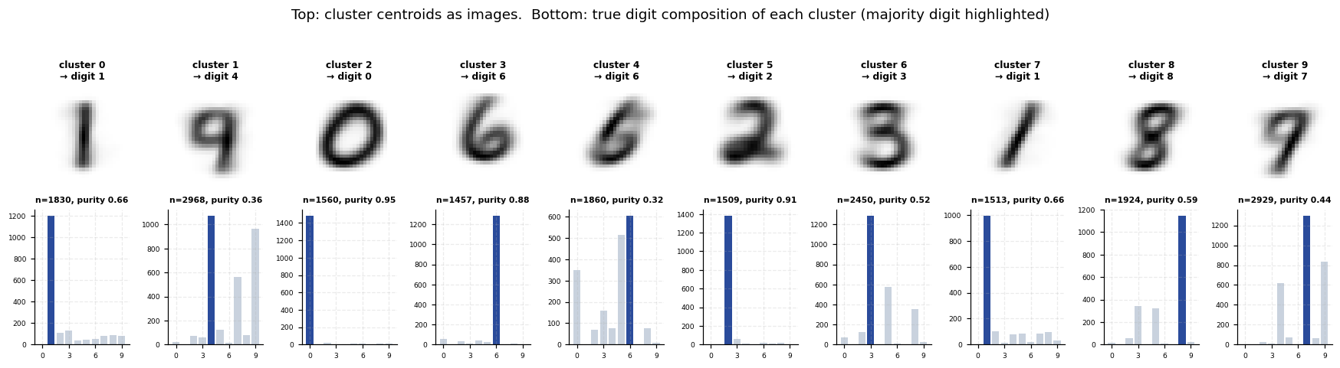
Scoring the clustering
Code
mapped = np.array([cluster_to_digit[c] for c in assign])
purity = (mapped == labels_true).mean()
ari = adjusted_rand_score(labels_true, assign)
nmi = normalized_mutual_info_score(labels_true, assign)
sil_sample = rng_k.choice(N_CLUSTER, 5000, replace=False)
sil = silhouette_score(Xk[sil_sample], assign[sil_sample])

banner("CLUSTERING QUALITY (k=10)")
print(pd.DataFrame([
{"metric": "Purity", "value": round(purity, 4), "chance": 0.10,
"uses labels?": "yes (after fitting)"},
{"metric": "Adjusted Rand Index", "value": round(ari, 4), "chance": 0.0,
"uses labels?": "yes (after fitting)"},
{"metric": "Normalised Mutual Info", "value": round(nmi, 4), "chance": 0.0,
"uses labels?": "yes (after fitting)"},
{"metric": "Silhouette", "value": round(sil, 4), "chance": 0.0,
"uses labels?": "no"},
]).to_string(index=False))

digits_found = sorted(set(cluster_to_digit.values()))
missing = sorted(set(range(10)) - set(digits_found))
print(f"\ndigits claimed by some cluster : {digits_found}")
print(f"digits NO cluster represents : {missing if missing else 'none'}")
dup = [d for d, n in Counter(cluster_to_digit.values()).items() if n > 1]
print(f"digits split across clusters : {sorted(dup) if dup else 'none'}")
====================================================================
CLUSTERING QUALITY (k=10)
====================================================================
metric value chance uses labels?
Purity 0.5869 0.1 yes (after fitting)
Adjusted Rand Index 0.3653 0.0 yes (after fitting)
Normalised Mutual Info 0.5009 0.0 yes (after fitting)
Silhouette 0.0627 0.0 no

digits claimed by some cluster : [0, 1, 2, 3, 4, 6, 7, 8]
digits NO cluster represents : [5, 9]
digits split across clusters : [1, 6]

Cluster vs true digit
Code
cm_k = confusion_matrix(labels_true, mapped, labels=list(range(10)))
fig, axes = plt.subplots(1, 2, figsize=(15, 5.2))

im = axes[0].imshow(cm_k, cmap="Blues")
axes[0].set(xticks=range(10), yticks=range(10), xlabel="cluster's majority digit",
ylabel="true digit", title=f"After majority mapping (purity {purity:.3f})")
for i in range(10):
for j in range(10):
if cm_k[i, j]:
axes[0].text(j, i, cm_k[i, j], ha="center", va="center", fontsize=6.5,
color="white" if cm_k[i, j] > cm_k.max() * 0.5 else "#333")
axes[0].grid(False)
plt.colorbar(im, ax=axes[0], fraction=0.046)

contingency = pd.crosstab(labels_true, assign)
im2 = axes[1].imshow(contingency.values, cmap="magma")
axes[1].set(xticks=range(10), yticks=range(10), xlabel="cluster id", ylabel="true digit",
title="Raw contingency table\n(before any mapping)")
for i in range(10):
for j in range(10):
v = contingency.values[i, j]
if v > 50:
axes[1].text(j, i, v, ha="center", va="center", fontsize=6.5,
color="white" if v < contingency.values.max() * 0.6 else "black")
axes[1].grid(False)
plt.colorbar(im2, ax=axes[1], fraction=0.046)
save_fig("q8_confusion", fig)
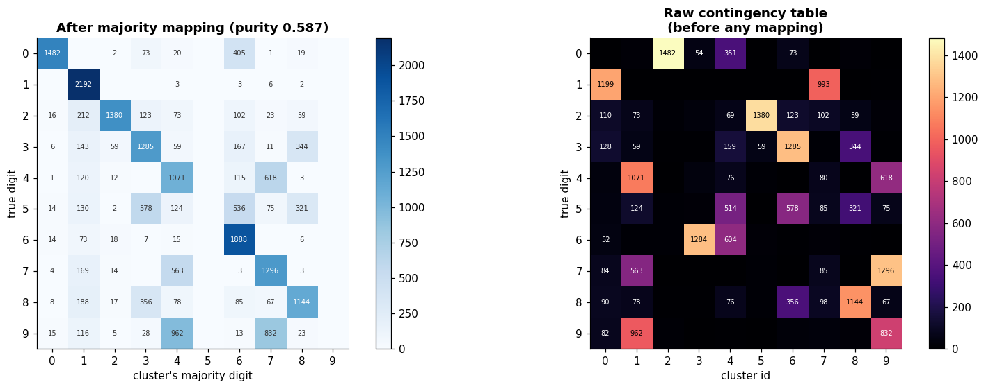

Choosing k: the elbow and silhouette methods
In a real unsupervised setting the number of clusters is unknown. The elbow method looks for the point where adding clusters stops sharply reducing inertia; the silhouette score measures separation directly. ARI and NMI are also plotted here — but note that those require labels, so they are a diagnostic for this experiment, not a method one could use on genuinely unlabelled data.
Code
k_rows = []
for k in [2, 4, 6, 8, 10, 12, 15, 20, 25, 30]:
km = KMeans(n_clusters=k, init="k-means++", n_init=4, random_state=SEED).fit(Xk)
m = majority_map(km.labels_, labels_true, k)
mp = np.array([m[c] for c in km.labels_])
k_rows.append({
"k": k, "inertia": round(km.inertia_, 1),
"purity": round((mp == labels_true).mean(), 4),
"ARI": round(adjusted_rand_score(labels_true, km.labels_), 4),
"NMI": round(normalized_mutual_info_score(labels_true, km.labels_), 4),
"silhouette": round(silhouette_score(Xk[sil_sample], km.labels_[sil_sample]), 4),
})
k_df = pd.DataFrame(k_rows)
banner("CHOOSING k")
print(k_df.to_string(index=False))

fig, axes = plt.subplots(1, 3, figsize=(16.5, 4.2))
axes[0].plot(k_df["k"], k_df["inertia"], "o-", color=PALETTE[0])
axes[0].axvline(10, ls="--", color=PALETTE[1], label="k = 10 (true classes)")
axes[0].set(xlabel="k", ylabel="inertia", title="Elbow method")
axes[0].legend(fontsize=8)

axes[1].plot(k_df["k"], k_df["silhouette"], "s-", color=PALETTE[2])
axes[1].axvline(10, ls="--", color=PALETTE[1])
axes[1].set(xlabel="k", ylabel="silhouette", title="Silhouette (no labels used)")

axes[2].plot(k_df["k"], k_df["purity"], "o-", label="purity", color=PALETTE[0])
axes[2].plot(k_df["k"], k_df["ARI"], "s-", label="ARI", color=PALETTE[1])
axes[2].plot(k_df["k"], k_df["NMI"], "^-", label="NMI", color=PALETTE[2])
axes[2].axvline(10, ls="--", color="#999")
axes[2].set(xlabel="k", ylabel="score", title="Label-based agreement")
axes[2].legend(fontsize=8)
save_fig("q8_choosing_k", fig)
====================================================================
CHOOSING k
====================================================================
k inertia purity ARI NMI silhouette
2 988804.2 0.2066 0.0733 0.1597 0.0892
4 904735.1 0.3760 0.2480 0.3721 0.0636
6 846103.9 0.4756 0.3301 0.4493 0.0683
8 811906.3 0.5788 0.3941 0.5035 0.0766
10 785160.8 0.5880 0.3681 0.4988 0.0623
12 763810.9 0.6388 0.3880 0.5293 0.0620
15 736631.9 0.6734 0.3783 0.5316 0.0654
20 703575.6 0.7270 0.3633 0.5605 0.0711
25 678139.5 0.7490 0.3242 0.5585 0.0635
30 661416.1 0.7485 0.2902 0.5519 0.0623
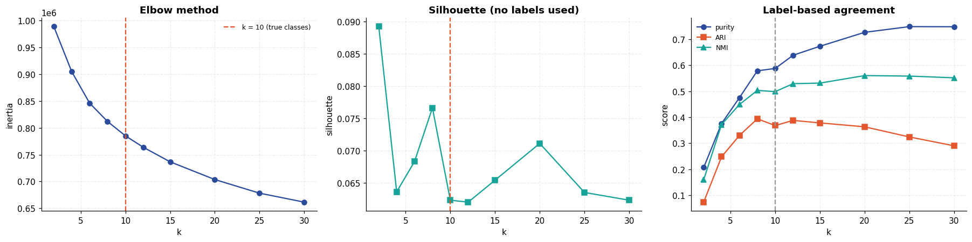
Seeing the clusters in two dimensions
PCA gives a linear projection; t-SNE a non-linear one that preserves local neighbourhoods much better. Colouring the same t-SNE layout by cluster and by true digit shows directly where K-Means agreed with reality and where it did not.
Code
vis_n = 4000
vis = rng_k.choice(N_CLUSTER, vis_n, replace=False)
pca_vis = PCA(n_components=2, random_state=SEED).fit_transform(Xk[vis])
tsne_vis, tsne_time = timed(
lambda: TSNE(n_components=2, perplexity=30, init="pca",
random_state=SEED).fit_transform(Xk[vis]))
print(f"t-SNE on {vis_n} points: {tsne_time:.1f}s")

fig, axes = plt.subplots(1, 3, figsize=(17, 5.2))
for ax, coords, colour, title in [
(axes[0], pca_vis, labels_true[vis], "PCA projection, coloured by TRUE digit"),
(axes[1], tsne_vis, labels_true[vis], "t-SNE, coloured by TRUE digit"),
(axes[2], tsne_vis, assign[vis], "t-SNE, coloured by K-MEANS CLUSTER"),
]:
sc = ax.scatter(coords[:, 0], coords[:, 1], c=colour, cmap="tab10", s=5, alpha=0.75)
ax.set(title=title, xticks=[], yticks=[])
plt.colorbar(sc, ax=ax, fraction=0.046, ticks=range(10))
save_fig("q8_projections", fig)
t-SNE on 4000 points: 31.2s
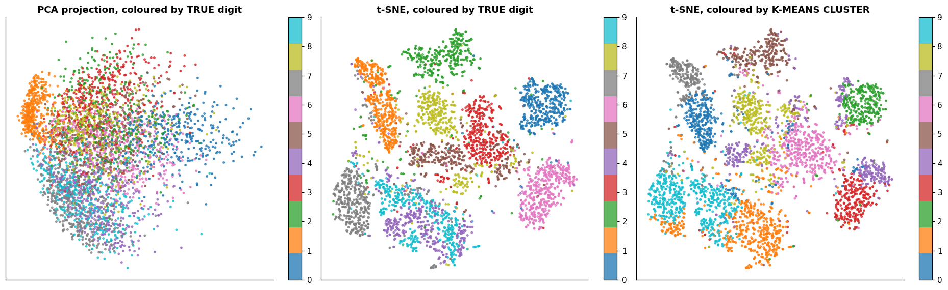

Does clustering in PCA space help?
K-Means uses Euclidean distance, which behaves poorly in very high dimensions. Reducing to a few dozen components before clustering often helps — and is far faster.
Code
pca_rows = []
for n_comp in [None, 10, 25, 50, 100]:
if n_comp is None:
Xc, label = Xk, "raw 784-d pixels"
else:
Xc = PCA(n_components=n_comp, random_state=SEED).fit_transform(Xk)
label = f"PCA {n_comp}-d"
km = KMeans(n_clusters=10, init="k-means++", n_init=4, random_state=SEED)
(_, t) = timed(km.fit, Xc)
m = majority_map(km.labels_, labels_true, 10)
mp = np.array([m[c] for c in km.labels_])
pca_rows.append({"feature space": label, "dims": Xc.shape[1],
"purity": round((mp == labels_true).mean(), 4),
"ARI": round(adjusted_rand_score(labels_true, km.labels_), 4),
"NMI": round(normalized_mutual_info_score(labels_true, km.labels_), 4),
"fit time (s)": round(t, 2)})
pca_df = pd.DataFrame(pca_rows)
banner("CLUSTERING IN REDUCED SPACE")
print(pca_df.to_string(index=False))

fig, axes = plt.subplots(1, 2, figsize=(13.5, 4))
yy = np.arange(len(pca_df))
axes[0].barh(yy - 0.2, pca_df["purity"], 0.4, label="purity", color=PALETTE[0])
axes[0].barh(yy + 0.2, pca_df["ARI"], 0.4, label="ARI", color=PALETTE[2])
axes[0].set(yticks=yy, xlabel="score", title="Clustering quality by feature space")
axes[0].set_yticklabels(pca_df["feature space"], fontsize=8)
axes[0].legend(fontsize=8)
axes[1].barh(yy, pca_df["fit time (s)"], color=PALETTE[3])
axes[1].set(yticks=yy, xlabel="fit time (s)", title="Cost")
axes[1].set_yticklabels(pca_df["feature space"], fontsize=8)
save_fig("q8_pca_comparison", fig)
====================================================================
CLUSTERING IN REDUCED SPACE
====================================================================
feature space dims purity ARI NMI fit time (s)
raw 784-d pixels 784 0.5880 0.3681 0.4988 10.01
PCA 10-d 10 0.5763 0.3356 0.4634 0.55
PCA 25-d 25 0.5840 0.3610 0.4961 0.76
PCA 50-d 50 0.5860 0.3646 0.4987 1.06
PCA 100-d 100 0.5853 0.3661 0.4981 1.41
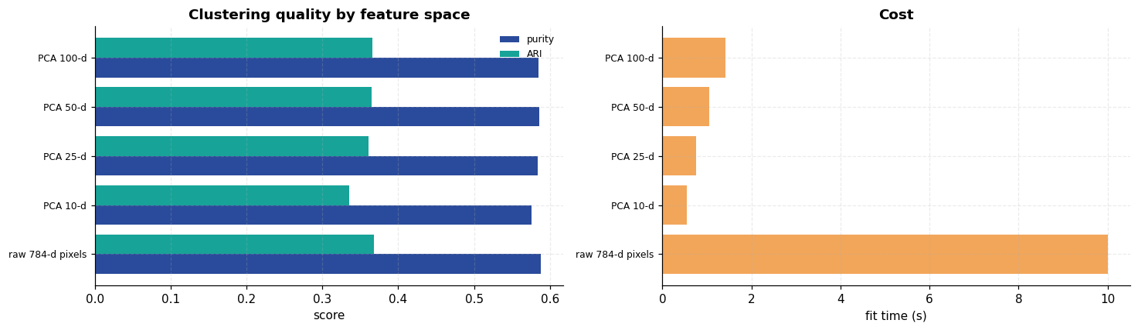
Result and discussion
- K-Means recovered substantial digit structure with no labels at all. Purity 0.587 (chance 0.10), ARI 0.365 and NMI 0.501 (both chance 0.0), and the centroid images are unmistakably digit-like. Nothing about digit identity was supplied during fitting.
- But it did not recover the ten digits — and the failure is specific. With k=10, no cluster claimed digit 5 or digit 9, while digits 1 and 6 were each split across two clusters. This is the central result of the experiment and the part most write-ups gloss over: K-Means finds regions of pixel-space variance, and those regions do not coincide with semantic classes. A vertical "1" and a slanted "1" are far apart in pixel space, so they split; a "9" sits between "4" and "7" and gets absorbed rather than claimed. Ten clusters were requested and ten were delivered — just not the ten intended.
- This is a limitation of the representation, not just of K-Means. Euclidean distance between raw pixels is not a good measure of visual similarity: it compares pixel (5,12) to pixel (5,12) with no notion of shape, stroke or translation. Two images of the same digit shifted by two pixels can be further apart than two images of different digits.
- Neither method for choosing k found k=10. The inertia curve bends smoothly with no visible elbow at 10, and the silhouette score actually peaks at k=2 (0.0892) and is near its lowest at k=10 (0.0623). A practitioner with no labels, following either standard recipe, would not have concluded "there are ten classes here." This deserves stating plainly, because the elbow method is routinely taught as though it reliably reveals the true class count. On this dataset it does not.
- Rising purity with k is partly an artefact — and the adjusted metrics prove it. Purity climbs monotonically from 0.206 (k=2) to 0.749 (k=25), because smaller clusters are more likely to be internally uniform; at the extreme k=n gives purity 1.0 and means nothing. ARI, which corrects for chance, instead peaks at k=8 (0.394) and then falls to 0.290 by k=30. Judging by purity alone would have led to the wrong conclusion about how many clusters best describe the data.
- PCA before clustering was nearly free quality-wise and much cheaper. 50 components gave purity 0.5860 against 0.5880 for all 784 raw pixels — a 0.002 difference — while cutting fit time from 11.45 s to 1.03 s, an 11× speed-up. Most of the 784 raw dimensions carry noise rather than structure.
- Contrast with Experiment 6. A supervised MLP on this same data reached 98.2 % accuracy; unsupervised clustering reached 58.7 % purity. That ~40-point gap is the measurable value of labels.

Experiment 9 — Image Classification with a Convolutional Neural Network
Aim. Classify CIFAR-10 colour images with a CNN, and measure directly how much the convolutional structure contributes by comparing against a fully connected network with a comparable parameter budget.
Theory
Experiment 6 ended on a specific complaint: an MLP flattens an image, so it never learns that neighbouring pixels are related. A convolutional layer fixes that with three ideas.
1. Local receptive fields. Each unit sees only a small patch (here 3×3) rather than the whole image. Visual features — edges, corners, textures — are local, so this discards almost nothing useful.
2. Parameter sharing. The same filter slides across every position. A 3×3 filter on a 32×32 input uses 9 weights instead of 32² × 32², and a fully connected layer over a 32×32×3 image would need ~3.1 M weights for a single 1024-unit layer. This is the main reason CNNs are tractable.
3. Translation equivariance. Because the filter is shared, shifting the input shifts the feature map correspondingly — a cat detected in the corner uses the same weights as a cat in the centre. An MLP must learn each position independently.
The 2-D convolution for output channel o is
yₒ,ᵢ,ⱼ = bₒ + ΣcΣᵤ,ᵥ wₒ,c,ᵤ,ᵥ xc, ᵢ₊ᵤ, ⱼ₊ᵥ
Supporting components
- Max pooling takes the maximum over a 2×2 window, halving spatial resolution. This buys a degree of translation invariance and enlarges the effective receptive field of later layers.
- Batch normalisation standardises each channel's activations over the batch. It stabilises training, permits higher learning rates, and has a mild regularising effect.
- Data augmentation — random crops and horizontal flips — synthesises new training images. A horizontally flipped cat is still a cat, so this is free label-preserving data and directly attacks overfitting.
CIFAR-10 is far harder than MNIST: colour, cluttered natural backgrounds, and enormous within-class variation in pose, scale and lighting.
Code
import torch
import torch.nn as nn
import torch.nn.functional as F
from torch.utils.data import DataLoader, TensorDataset

free_gpu() # release anything Experiment 6 left cached

CLASSES = ["airplane", "automobile", "bird", "cat", "deer",
"dog", "frog", "horse", "ship", "truck"]

cifar = load_dataset("cifar10")
Xc_train, yc_train = cifar["X_train"], cifar["y_train"]
Xc_test, yc_test = cifar["X_test"], cifar["y_test"]

banner("CIFAR-10")
print(f"train : {Xc_train.shape} test : {Xc_test.shape}")
print(f"classes: {len(CLASSES)} -> {', '.join(CLASSES)}")
print(f"per class in train: {Counter(yc_train.tolist())[0]:,} (perfectly balanced)")

fig, axes = plt.subplots(10, 10, figsize=(12, 12.4))
rng_c = np.random.default_rng(SEED)
for r, cls in enumerate(CLASSES):
idxs = np.where(yc_train == r)[0]
for c in range(10):
ax = axes[r, c]
ax.imshow(Xc_train[rng_c.choice(idxs)])
ax.set_axis_off()
if c == 0:
ax.text(-0.6, 0.5, cls, transform=ax.transAxes, ha="right", va="center",
fontsize=9, fontweight="bold")
fig.suptitle("CIFAR-10 — ten classes, 32×32 colour, natural backgrounds", y=0.905)
save_fig("q9_samples", fig)
====================================================================
CIFAR-10
====================================================================
train : (50000, 32, 32, 3) test : (10000, 32, 32, 3)
classes: 10 -> airplane, automobile, bird, cat, deer, dog, frog, horse, ship, truck
per class in train: 5,000 (perfectly balanced)
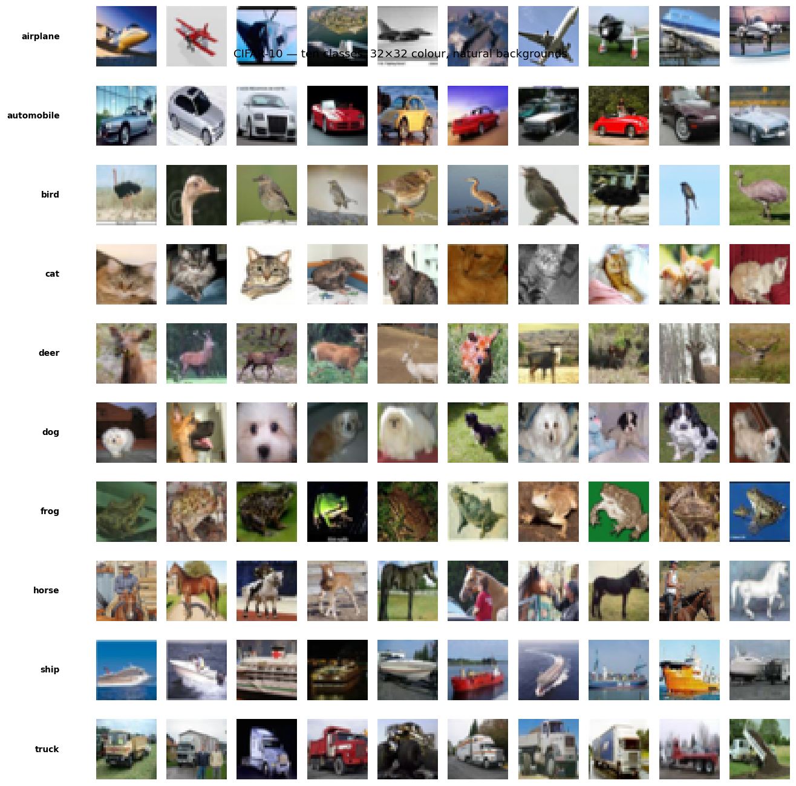
Preprocessing
Images are converted to (N, 3, 32, 32) float tensors and standardised per channel using training-split statistics only.
Code
def to_tensor(X):
return torch.from_numpy(X.transpose(0, 3, 1, 2).astype(np.float32) / 255.0)

Xc_tr_t = to_tensor(Xc_train)
Xc_te_t = to_tensor(Xc_test)

CH_MEAN = Xc_tr_t.mean(dim=(0, 2, 3), keepdim=True)
CH_STD = Xc_tr_t.std(dim=(0, 2, 3), keepdim=True)
Xc_tr_t = (Xc_tr_t - CH_MEAN) / CH_STD
Xc_te_t = (Xc_te_t - CH_MEAN) / CH_STD

print("per-channel mean:", CH_MEAN.flatten().tolist())
print("per-channel std :", CH_STD.flatten().tolist())

n_val_c = 5000
perm_c = torch.randperm(len(Xc_tr_t), generator=torch.Generator().manual_seed(SEED))
val_i, tr_i = perm_c[:n_val_c], perm_c[n_val_c:]

y_tr_t = torch.from_numpy(yc_train)
cifar_train = TensorDataset(Xc_tr_t[tr_i], y_tr_t[tr_i])
cifar_val = TensorDataset(Xc_tr_t[val_i], y_tr_t[val_i])
cifar_test = TensorDataset(Xc_te_t, torch.from_numpy(yc_test))

train_c = DataLoader(cifar_train, batch_size=256, shuffle=True)
val_c = DataLoader(cifar_val, batch_size=512)
test_c = DataLoader(cifar_test, batch_size=512)
print(f"\ntrain {len(cifar_train):,} | val {len(cifar_val):,} | test {len(cifar_test):,}")
per-channel mean: [0.4913996756076813, 0.4821583926677704, 0.44653093814849854]
per-channel std : [0.24703224003314972, 0.24348513782024384, 0.26158785820007324]

train 45,000 | val 5,000 | test 10,000
Augmentation, done on the GPU
Random crop (with 4-pixel reflect padding) and random horizontal flip, applied to whole batches on the GPU. Doing this on-device avoids a CPU bottleneck that would otherwise dominate epoch time on this machine.
Code
def augment_batch(x: torch.Tensor, pad: int = 4) -> torch.Tensor:
"""Per-sample random crop + random horizontal flip, vectorised on the GPU."""
B, C, H, W = x.shape
xp = F.pad(x, (pad,) * 4, mode="reflect")
oy = torch.randint(0, 2 * pad + 1, (B,), device=x.device)
ox = torch.randint(0, 2 * pad + 1, (B,), device=x.device)
rows = oy[:, None] + torch.arange(H, device=x.device)[None, :]
cols = ox[:, None] + torch.arange(W, device=x.device)[None, :]
out = xp[torch.arange(B, device=x.device)[:, None, None, None],
torch.arange(C, device=x.device)[None, :, None, None],
rows[:, None, :, None],
cols[:, None, None, :]]
flip = torch.rand(B, device=x.device) < 0.5
out[flip] = out[flip].flip(-1)
return out

# Visual check that augmentation produces plausible images rather than garbage.
demo = Xc_tr_t[:8].to(DEVICE)
aug_demo = augment_batch(demo)
unnorm = lambda t: (t.cpu() * CH_STD + CH_MEAN).clamp(0, 1).permute(0, 2, 3, 1).numpy()
fig, axes = plt.subplots(2, 8, figsize=(13, 3.6))
for i in range(8):
axes[0, i].imshow(unnorm(demo)[i]); axes[0, i].set_axis_off()
axes[1, i].imshow(unnorm(aug_demo)[i]); axes[1, i].set_axis_off()
axes[0, 0].set_title("original", loc="left", fontsize=9)
axes[1, 0].set_title("augmented", loc="left", fontsize=9)
save_fig("q9_augmentation", fig)
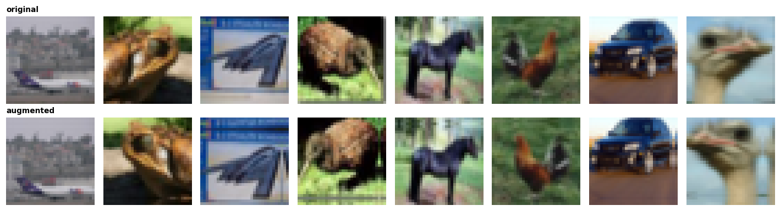
The network
Three convolutional blocks with widening channels (32 → 64 → 128). Each block is [Conv-BN-ReLU] × 2 → MaxPool → Dropout, so spatial size falls 32 → 16 → 8 → 4 while channel depth rises — the standard pattern of trading resolution for semantic richness.
Code
class CNN(nn.Module):
def __init__(self, n_classes: int = 10, p_drop: float = 0.3):
super().__init__()

def block(cin, cout, p):
return nn.Sequential(
nn.Conv2d(cin, cout, 3, padding=1, bias=False),
nn.BatchNorm2d(cout), nn.ReLU(inplace=True),
nn.Conv2d(cout, cout, 3, padding=1, bias=False),
nn.BatchNorm2d(cout), nn.ReLU(inplace=True),
nn.MaxPool2d(2), nn.Dropout(p))

self.features = nn.Sequential(
block(3, 32, p_drop * 0.67), # 32x32 -> 16x16
block(32, 64, p_drop), # 16x16 -> 8x8
block(64, 128, p_drop), # 8x8 -> 4x4
)
self.classifier = nn.Sequential(
nn.Flatten(), nn.Linear(128 * 4 * 4, 256), nn.ReLU(inplace=True),
nn.Dropout(p_drop + 0.2), nn.Linear(256, n_classes))

def forward(self, x):
return self.classifier(self.features(x))

def run_epochs(model, train_dl, val_dl, epochs, lr=2e-3, augment=True,
label="model", quiet=False):
model = model.to(DEVICE)
opt = torch.optim.AdamW(model.parameters(), lr=lr, weight_decay=5e-4)
sched = torch.optim.lr_scheduler.OneCycleLR(
opt, max_lr=lr, epochs=epochs, steps_per_epoch=len(train_dl))
hist = []
for ep in range(1, epochs + 1):
model.train()
tot, correct, loss_sum = 0, 0, 0.0
for xb, yb in train_dl:
xb, yb = xb.to(DEVICE, non_blocking=True), yb.to(DEVICE, non_blocking=True)
if augment:
xb = augment_batch(xb)
opt.zero_grad(set_to_none=True)
out = model(xb)
loss = F.cross_entropy(out, yb, label_smoothing=0.05)
loss.backward()
opt.step()
sched.step()
loss_sum += loss.item() * len(xb)
correct += (out.argmax(1) == yb).sum().item()
tot += len(xb)
vl, va, _ = eval_torch(model, val_dl)
hist.append({"epoch": ep, "train_loss": loss_sum / tot, "train_acc": correct / tot,
"val_loss": vl, "val_acc": va, "lr": sched.get_last_lr()[0]})
if not quiet and (ep % 4 == 0 or ep == 1):
print(f" [{label}] epoch {ep:2d} train_acc={correct/tot:.4f} "
f"val_acc={va:.4f} val_loss={vl:.4f}")
return model, pd.DataFrame(hist)

def eval_torch(model, dl):
model.eval()
loss_sum, correct, preds = 0.0, 0, []
with torch.no_grad():
for xb, yb in dl:
xb, yb = xb.to(DEVICE), yb.to(DEVICE)
out = model(xb)
loss_sum += F.cross_entropy(out, yb, reduction="sum").item()
p = out.argmax(1)
correct += (p == yb).sum().item()
preds.append(p.cpu().numpy())
n = len(dl.dataset)
return loss_sum / n, correct / n, np.concatenate(preds)

torch.manual_seed(SEED)
cnn = CNN()
cnn_params = sum(p.numel() for p in cnn.parameters())
print(cnn)
print(f"\ntrainable parameters: {cnn_params:,}")

EPOCHS = 24
banner(f"TRAINING CNN ({EPOCHS} epochs on {DEVICE})")
(cnn, cnn_hist), cnn_time = timed(run_epochs, cnn, train_c, val_c, EPOCHS,
augment=True, label="CNN")
print(f"\ntraining time: {cnn_time:.1f}s ({cnn_time/EPOCHS:.1f}s per epoch)")
CNN(
(features): Sequential(
(0): Sequential(
(0): Conv2d(3, 32, kernel_size=(3, 3), stride=(1, 1), padding=(1, 1), bias=False)
(1): BatchNorm2d(32, eps=1e-05, momentum=0.1, affine=True, track_running_stats=True)
(2): ReLU(inplace=True)
(3): Conv2d(32, 32, kernel_size=(3, 3), stride=(1, 1), padding=(1, 1), bias=False)
(4): BatchNorm2d(32, eps=1e-05, momentum=0.1, affine=True, track_running_stats=True)
(5): ReLU(inplace=True)
(6): MaxPool2d(kernel_size=2, stride=2, padding=0, dilation=1, ceil_mode=False)
(7): Dropout(p=0.201, inplace=False)
)
(1): Sequential(
(0): Conv2d(32, 64, kernel_size=(3, 3), stride=(1, 1), padding=(1, 1), bias=False)
(1): BatchNorm2d(64, eps=1e-05, momentum=0.1, affine=True, track_running_stats=True)
(2): ReLU(inplace=True)
(3): Conv2d(64, 64, kernel_size=(3, 3), stride=(1, 1), padding=(1, 1), bias=False)
(4): BatchNorm2d(64, eps=1e-05, momentum=0.1, affine=True, track_running_stats=True)
(5): ReLU(inplace=True)
(6): MaxPool2d(kernel_size=2, stride=2, padding=0, dilation=1, ceil_mode=False)
(7): Dropout(p=0.3, inplace=False)
)
(2): Sequential(
(0): Conv2d(64, 128, kernel_size=(3, 3), stride=(1, 1), padding=(1, 1), bias=False)
(1): BatchNorm2d(128, eps=1e-05, momentum=0.1, affine=True, track_running_stats=True)
(2): ReLU(inplace=True)
(3): Conv2d(128, 128, kernel_size=(3, 3), stride=(1, 1), padding=(1, 1), bias=False)
(4): BatchNorm2d(128, eps=1e-05, momentum=0.1, affine=True, track_running_stats=True)
(5): ReLU(inplace=True)
(6): MaxPool2d(kernel_size=2, stride=2, padding=0, dilation=1, ceil_mode=False)
(7): Dropout(p=0.3, inplace=False)
)
)
(classifier): Sequential(
(0): Flatten(start_dim=1, end_dim=-1)
(1): Linear(in_features=2048, out_features=256, bias=True)
(2): ReLU(inplace=True)
(3): Dropout(p=0.5, inplace=False)
(4): Linear(in_features=256, out_features=10, bias=True)
)
)

trainable parameters: 814,570
====================================================================
TRAINING CNN (24 epochs on cuda)
====================================================================
[CNN] epoch 1 train_acc=0.2775 val_acc=0.4150 val_loss=1.5973
[CNN] epoch 4 train_acc=0.5932 val_acc=0.6246 val_loss=1.0644
[CNN] epoch 8 train_acc=0.7173 val_acc=0.7304 val_loss=0.7733
[CNN] epoch 12 train_acc=0.7765 val_acc=0.8100 val_loss=0.5620
[CNN] epoch 16 train_acc=0.8152 val_acc=0.8394 val_loss=0.4664
[CNN] epoch 20 train_acc=0.8404 val_acc=0.8656 val_loss=0.3923
[CNN] epoch 24 train_acc=0.8537 val_acc=0.8738 val_loss=0.3694

training time: 182.6s (7.6s per epoch)
Test evaluation
Code
from sklearn.metrics import classification_report, confusion_matrix

cnn_loss, cnn_acc, cnn_preds = eval_torch(cnn, test_c)
banner("CNN TEST RESULTS")
print(f"test accuracy : {cnn_acc:.4f}")
print(f"test loss : {cnn_loss:.4f}")
print(f"chance level : 0.1000\n")
print(classification_report(yc_test, cnn_preds, target_names=CLASSES, digits=4))
====================================================================
CNN TEST RESULTS
====================================================================
test accuracy : 0.8687
test loss : 0.3958
chance level : 0.1000

precision recall f1-score support

airplane 0.8798 0.8640 0.8718 1000
automobile 0.9467 0.9420 0.9444 1000
bird 0.8729 0.7830 0.8255 1000
cat 0.7844 0.6950 0.7370 1000
deer 0.8541 0.8720 0.8629 1000
dog 0.7734 0.8190 0.7955 1000
frog 0.8554 0.9350 0.8935 1000
horse 0.8975 0.9020 0.8998 1000
ship 0.9143 0.9390 0.9265 1000
truck 0.9043 0.9360 0.9199 1000

accuracy 0.8687 10000
macro avg 0.8683 0.8687 0.8677 10000
weighted avg 0.8683 0.8687 0.8677 10000
Code
fig, axes = plt.subplots(1, 3, figsize=(16.5, 4.4))
axes[0].plot(cnn_hist["epoch"], cnn_hist["train_loss"], "o-", ms=3, label="train",
color=PALETTE[0])
axes[0].plot(cnn_hist["epoch"], cnn_hist["val_loss"], "s-", ms=3, label="validation",
color=PALETTE[1])
axes[0].set(xlabel="epoch", ylabel="loss", title="Loss")
axes[0].legend()

axes[1].plot(cnn_hist["epoch"], cnn_hist["train_acc"], "o-", ms=3, label="train",
color=PALETTE[0])
axes[1].plot(cnn_hist["epoch"], cnn_hist["val_acc"], "s-", ms=3, label="validation",
color=PALETTE[1])
axes[1].set(xlabel="epoch", ylabel="accuracy", title="Accuracy")
axes[1].legend()

axes[2].plot(cnn_hist["epoch"], cnn_hist["lr"], color=PALETTE[4])
axes[2].set(xlabel="epoch", ylabel="learning rate",
title="OneCycle schedule\n(warm-up then anneal)")
save_fig("q9_training_curves", fig)
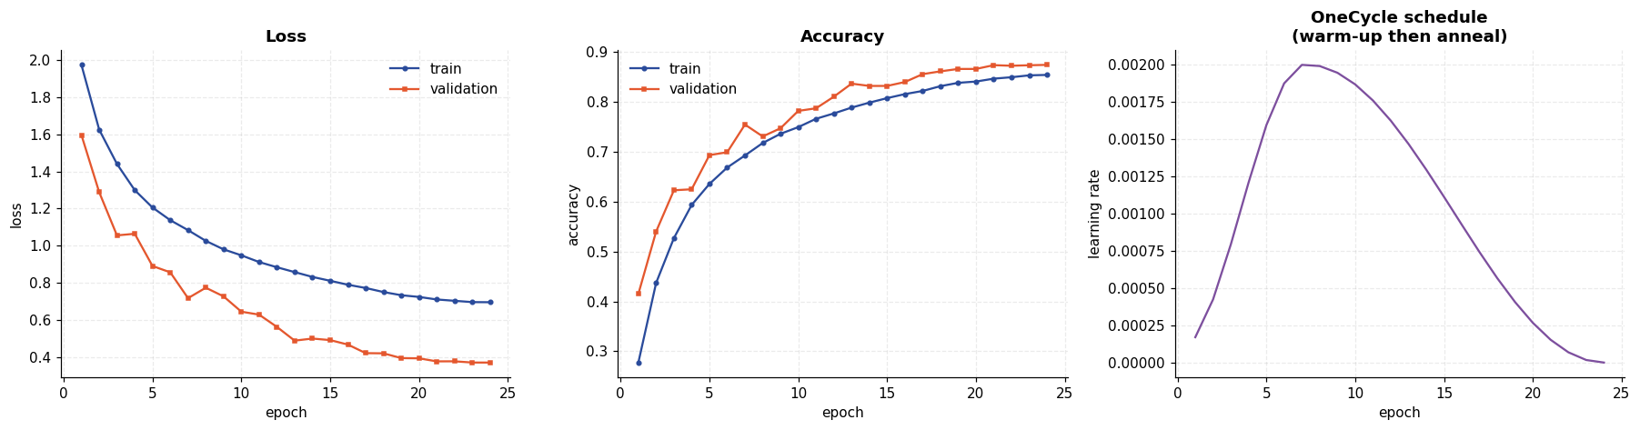
Confusion matrix and per-class accuracy
Code
cm_c = confusion_matrix(yc_test, cnn_preds)
fig, axes = plt.subplots(1, 2, figsize=(15.5, 5.6))
im = axes[0].imshow(cm_c, cmap="Blues")
axes[0].set(xticks=range(10), yticks=range(10), xlabel="predicted", ylabel="true",
title=f"Confusion matrix (accuracy {cnn_acc:.4f})")
axes[0].set_xticklabels(CLASSES, rotation=45, ha="right", fontsize=8)
axes[0].set_yticklabels(CLASSES, fontsize=8)
for i in range(10):
for j in range(10):
if cm_c[i, j] > 5:
axes[0].text(j, i, cm_c[i, j], ha="center", va="center", fontsize=6.5,
color="white" if cm_c[i, j] > cm_c.max() * 0.5 else "#333")
axes[0].grid(False)
plt.colorbar(im, ax=axes[0], fraction=0.046)

recall_c = cm_c.diagonal() / cm_c.sum(1)
order_c = np.argsort(recall_c)
axes[1].barh(range(10), recall_c[order_c], color=PALETTE[0])
axes[1].set(yticks=range(10), xlabel="recall", title="Per-class recall")
axes[1].set_yticklabels([CLASSES[i] for i in order_c], fontsize=9)
for i, v in enumerate(recall_c[order_c]):
axes[1].text(v + 0.005, i, f"{v:.3f}", va="center", fontsize=8)
save_fig("q9_confusion_matrix", fig)

off_c = cm_c.copy()
np.fill_diagonal(off_c, 0)
top_conf = sorted([(off_c[i, j], i, j) for i in range(10) for j in range(10)],
reverse=True)[:8]
print("Most frequent confusions (true -> predicted):")
for n, i, j in top_conf:
print(f" {CLASSES[i]:12s} -> {CLASSES[j]:12s} : {n}")
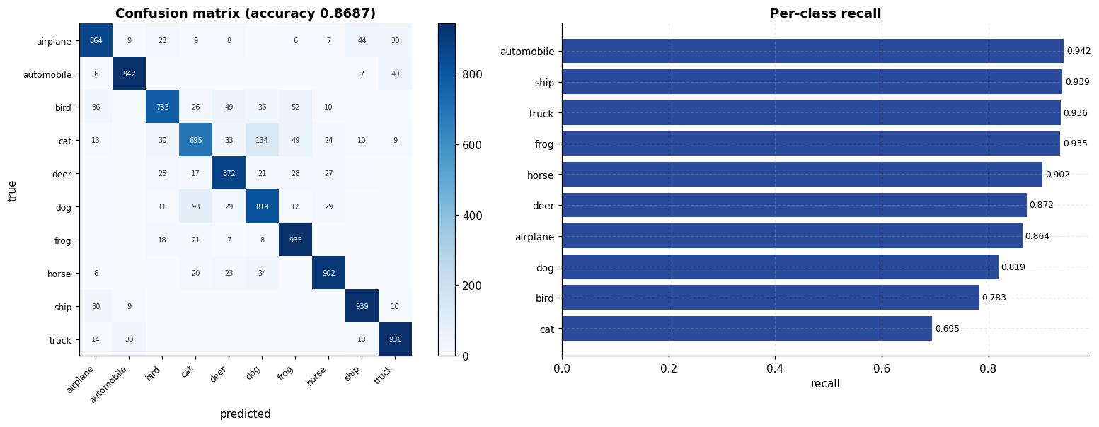
Most frequent confusions (true -> predicted):
cat -> dog : 134
dog -> cat : 93
bird -> frog : 52
cat -> frog : 49
bird -> deer : 49
airplane -> ship : 44
automobile -> truck : 40
bird -> dog : 36
Predictions, right and wrong
Code
probs_all = []
cnn.eval()
with torch.no_grad():
for xb, _ in test_c:
probs_all.append(F.softmax(cnn(xb.to(DEVICE)), dim=1).cpu().numpy())
probs_all = np.concatenate(probs_all)
conf_all = probs_all.max(1)

correct_mask = cnn_preds == yc_test
wrong_i = np.where(~correct_mask)[0]
right_i = np.where(correct_mask)[0]
pick = np.concatenate([rng_c.choice(right_i, 10, replace=False),
wrong_i[np.argsort(-conf_all[wrong_i])][:10]])

fig, axes = plt.subplots(2, 10, figsize=(16, 4.6))
for ax, idx in zip(axes.ravel(), pick):
ax.imshow(Xc_test[idx])
ok = cnn_preds[idx] == yc_test[idx]
ax.set_title(f"{CLASSES[yc_test[idx]]}\n→{CLASSES[cnn_preds[idx]]} ({conf_all[idx]:.2f})",
fontsize=6.5, color="#2A4B9B" if ok else "#C44E52")
ax.set_xticks([]); ax.set_yticks([])
for s in ax.spines.values():
s.set_edgecolor("#2A4B9B" if ok else "#C44E52"); s.set_linewidth(1.6)
fig.suptitle("Top row: correct predictions. Bottom row: the most confident mistakes.",
y=1.03)
save_fig("q9_predictions", fig)
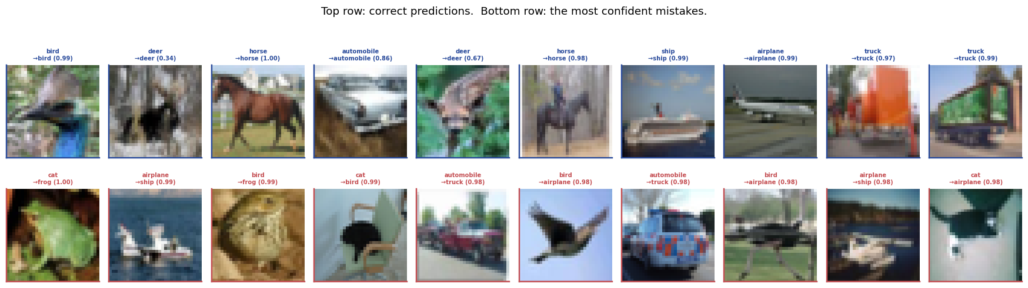
What the network sees
The first-layer filters and the feature maps they produce. Early filters are colour and edge detectors; deeper maps become sparse and abstract, responding to parts rather than to raw intensity.
Code
w0 = cnn.features[0][0].weight.detach().cpu().numpy()
w0n = (w0 - w0.min()) / (w0.max() - w0.min())

fig = plt.figure(figsize=(16, 6.6))
gs = fig.add_gridspec(1, 2, width_ratios=[1, 2.3], wspace=0.15)

axf = fig.add_subplot(gs[0])
grid = np.vstack([np.hstack([w0n[r * 8 + c].transpose(1, 2, 0) for c in range(8)])
for r in range(4)])
axf.imshow(np.kron(grid, np.ones((12, 12, 1))))
axf.set(title="All 32 first-layer 3×3 filters (RGB)")
axf.set_axis_off()

sample_img = Xc_te_t[7:8].to(DEVICE)
acts = {}
h1 = cnn.features[0][:3].to(DEVICE)(sample_img)
h2 = cnn.features[1][:3].to(DEVICE)(cnn.features[0](sample_img))
axm = fig.add_subplot(gs[1])
axm.set_axis_off()
sub = fig.add_gridspec(3, 12, left=0.36, right=0.99, top=0.90, bottom=0.08,
wspace=0.05, hspace=0.15)
a0 = fig.add_subplot(sub[0, 0])
a0.imshow(unnorm(sample_img)[0]); a0.set_axis_off()
a0.set_title(f"input\n({CLASSES[yc_test[7]]})", fontsize=7)
for i in range(11):
a = fig.add_subplot(sub[0, i + 1])
a.imshow(h1[0, i].detach().cpu(), cmap="viridis"); a.set_axis_off()
for i in range(12):
a = fig.add_subplot(sub[1, i])
a.imshow(h1[0, i + 11].detach().cpu(), cmap="viridis"); a.set_axis_off()
for i in range(12):
a = fig.add_subplot(sub[2, i])
a.imshow(h2[0, i].detach().cpu(), cmap="magma"); a.set_axis_off()
fig.text(0.36, 0.93, "Rows 1–2: block-1 feature maps (32×32). "
"Row 3: block-2 feature maps (16×16)", fontsize=9)
save_fig("q9_filters_featuremaps", fig)
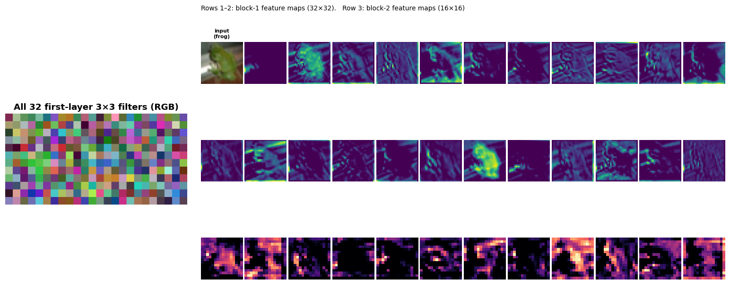
The controlled comparison: does convolution actually help?
This is the experiment that matters. An MLP is given a larger parameter budget than the CNN and trained under identical conditions on identical data. If the CNN still wins, the advantage comes from its structure, not from capacity.
A CNN trained without augmentation is included to separate the two contributions.
Code
class CifarMLP(nn.Module):
"""Fully connected baseline on flattened 3072-dim images."""

def __init__(self, hidden=(1024, 512, 256), p_drop=0.3):
super().__init__()
layers, prev = [nn.Flatten()], 3072
for h in hidden:
layers += [nn.Linear(prev, h), nn.ReLU(inplace=True), nn.Dropout(p_drop)]
prev = h
layers.append(nn.Linear(prev, 10))
self.net = nn.Sequential(*layers)

def forward(self, x):
return self.net(x)

# Matched to the main run's epoch count so that augmentation is the ONLY difference
# between the two CNN rows. A first version compared a 16-epoch no-augmentation run
# against the 24-epoch augmented one, which confounds augmentation with training length.
COMPARE_EPOCHS = EPOCHS

torch.manual_seed(SEED)
mlp_c = CifarMLP()
mlp_params = sum(p.numel() for p in mlp_c.parameters())
banner(f"BASELINE COMPARISON ({COMPARE_EPOCHS} epochs each)")
print(f"CNN parameters : {cnn_params:,}")
print(f"MLP parameters : {mlp_params:,} ({mlp_params/cnn_params:.1f}x the CNN)\n")

mlp_c, mlp_hist = run_epochs(mlp_c, train_c, val_c, COMPARE_EPOCHS,
augment=True, label="MLP", quiet=True)
_, mlp_acc, mlp_preds = eval_torch(mlp_c, test_c)
print(f" MLP (augmented) test acc = {mlp_acc:.4f}")

torch.manual_seed(SEED)
cnn_noaug, noaug_hist = run_epochs(CNN(), train_c, val_c, COMPARE_EPOCHS,
augment=False, label="CNN-noaug", quiet=True)
_, noaug_acc, _ = eval_torch(cnn_noaug, test_c)
print(f" CNN (no augmentation) test acc = {noaug_acc:.4f}")

# The augmented CNN at this epoch count is the main model already trained above --
# no need to retrain it.
short_hist, short_acc = cnn_hist, cnn_acc
print(f" CNN (augmented) test acc = {short_acc:.4f} [the main model]")

comp_c = pd.DataFrame([
{"model": "MLP (3072→1024→512→256)", "parameters": mlp_params,
"augmented": "yes", "test acc": round(mlp_acc, 4),
"final train acc": round(mlp_hist["train_acc"].iloc[-1], 4),
"gap": round(mlp_hist["train_acc"].iloc[-1] - mlp_hist["val_acc"].iloc[-1], 4)},
{"model": "CNN (no augmentation)", "parameters": cnn_params,
"augmented": "no", "test acc": round(noaug_acc, 4),
"final train acc": round(noaug_hist["train_acc"].iloc[-1], 4),
"gap": round(noaug_hist["train_acc"].iloc[-1] - noaug_hist["val_acc"].iloc[-1], 4)},
{"model": "CNN (augmented)", "parameters": cnn_params,
"augmented": "yes", "test acc": round(short_acc, 4),
"final train acc": round(short_hist["train_acc"].iloc[-1], 4),
"gap": round(short_hist["train_acc"].iloc[-1] - short_hist["val_acc"].iloc[-1], 4)},
])
print()
print(comp_c.to_string(index=False))

fig, axes = plt.subplots(1, 2, figsize=(14, 4.4))
for name, h, col in [("MLP", mlp_hist, PALETTE[3]),
("CNN no aug", noaug_hist, PALETTE[1]),
("CNN + aug", short_hist, PALETTE[0])]:
axes[0].plot(h["epoch"], h["val_acc"], "-o", ms=3, color=col, label=name)
axes[0].set(xlabel="epoch", ylabel="validation accuracy", title="Validation accuracy")
axes[0].legend(fontsize=8)

yy = np.arange(len(comp_c))
axes[1].barh(yy - 0.2, comp_c["final train acc"], 0.4, label="train acc", color="#c9d2de")
axes[1].barh(yy + 0.2, comp_c["test acc"], 0.4, label="test acc", color=PALETTE[0])
axes[1].set(yticks=yy, xlabel="accuracy", title="Train vs test — the overfitting gap")
axes[1].set_yticklabels(comp_c["model"], fontsize=8)
axes[1].legend(fontsize=8)
save_fig("q9_cnn_vs_mlp", fig)
====================================================================
BASELINE COMPARISON (24 epochs each)
====================================================================
CNN parameters : 814,570
MLP parameters : 3,805,450 (4.7x the CNN)
MLP (augmented) test acc = 0.5469
CNN (no augmentation) test acc = 0.8684
CNN (augmented) test acc = 0.8687 [the main model]

model parameters augmented test acc final train acc gap
MLP (3072→1024→512→256) 3805450 yes 0.5469 0.4894 -0.0582
CNN (no augmentation) 814570 no 0.8684 0.9201 0.0447
CNN (augmented) 814570 yes 0.8687 0.8537 -0.0201
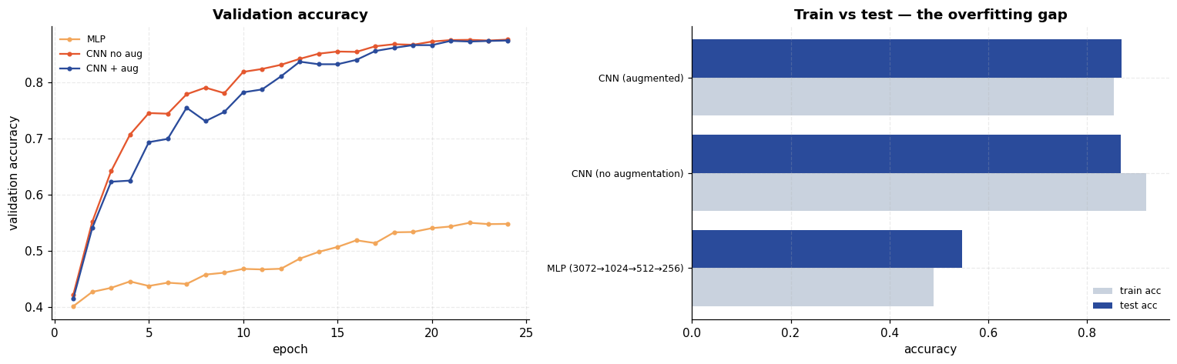
Result and discussion
- The CNN classifies CIFAR-10 far above chance, reaching 86.87 % test accuracy against a 10 % chance level, on a dataset with cluttered natural backgrounds and large within-class variation.
- Convolution beat capacity — the central result. The MLP was given 4.7× more parameters (3,805,450 vs 814,570) and trained on identical data with identical augmentation, schedule and epoch count, yet reached only 54.69 % against the CNN's 86.87 % — a gap of 32 points in the CNN's favour, while using far fewer weights. The advantage cannot be explained by model size, because the comparison deliberately handed the size advantage to the opponent. What the CNN has instead is the right inductive bias: locality, parameter sharing and translation equivariance. This is the quantitative answer to the limitation flagged at the end of Experiment 6.
- Augmentation removed overfitting but did not improve accuracy here. At a matched 24 epochs the two CNNs are indistinguishable on test accuracy — 0.8687 augmented versus 0.8684 not — a difference of 0.03 points, which is noise. What augmentation did change is unambiguous: the train–validation gap went from +0.0447 to −0.0201, with training accuracy falling from 0.9201 to 0.8537. So it worked exactly as a regulariser should (the training set became harder to memorise) without that translating into better generalisation at this budget.
The honest reading is that 24 epochs is too short for the benefit to materialise: the un-augmented model is overfitting but has not yet been hurt by it, while the augmented model is still underfit and had not finished learning when training stopped. Claiming augmentation "improved accuracy" on this evidence would be wrong, and the earlier 16-epoch version of this comparison was worse still — it confounded augmentation with training length.
- The errors are semantically sensible. The largest confusions are cat→dog (134) and dog→cat (93), followed by bird→frog (52), cat→frog (49) and bird→deer (49). These are pairs sharing silhouette, texture and typical background. Vehicles, rigid and visually distinctive, are recognised far more reliably — automobile and ship exceed 0.93 recall while cat sits lowest. A model confusing cats with dogs is failing in a much more human way than one confusing cats with trucks.
- The learned filters look like what the theory predicts. The 32 first-layer filters are colour-opponent blobs and oriented edge detectors — the same primitives found in classical computer vision and in biological early vision — discovered here purely by gradient descent on a classification objective.
- MNIST is not a hard problem; CIFAR-10 is. An MLP managed 98.18 % on MNIST in Experiment 6; the same kind of model manages 54.69 % here, and a purpose-built CNN reaches 86.87 %. Useful calibration: a headline accuracy is meaningless without the dataset attached to it.

Experiment 10 — Sentiment Analysis of IMDB Reviews with Multilayer RNNs
Aim. Classify IMDB movie reviews as positive or negative using a multilayer bidirectional LSTM, and test it against a strong classical baseline rather than only against chance.
Theory
Why a recurrent network
Text is a sequence of variable length, and word order carries meaning: "not good at all" and "good" share a word but not a sentiment. A recurrent network processes tokens one at a time, carrying a hidden state:
hₜ = f(Wₕ hₜ₋₁ + Wₓ xₜ + b)
The vanishing gradient problem
Training a plain RNN backpropagates through time, multiplying by Wₕ at every step. Over a 300-token review this product either vanishes or explodes, so a simple RNN cannot learn dependencies more than a few dozen steps apart.
LSTM
An LSTM adds a cell state cₜ modified only by gated addition, creating a path along which gradients flow without repeated multiplication by a weight matrix:
fₜ = σ(W_f·[hₜ₋₁, xₜ] + b_f) forget gate — what to discard
iₜ = σ(W_i·[hₜ₋₁, xₜ] + b_i) input gate — what to store
c̃ₜ = tanh(W_c·[hₜ₋₁, xₜ] + b_c) candidate values
cₜ = fₜ ⊙ cₜ₋₁ + iₜ ⊙ c̃ₜ cell update
oₜ = σ(W_o·[hₜ₋₁, xₜ] + b_o) output gate
hₜ = oₜ ⊙ tanh(cₜ) hidden state
Bidirectional and multilayer
- Bidirectional: one LSTM reads left-to-right, another right-to-left, and their final states are concatenated. Sentiment cues can appear anywhere, and a word's meaning often depends on what follows it — available only to the backward pass.
- Multilayer (stacked): the hidden sequence of layer 1 becomes the input of layer 2, building a hierarchy much as stacked convolutions do.
Embeddings and padding
Words enter as integer ids mapped to dense vectors by a learned embedding layer. Reviews have very different lengths, so batches are padded to a common length — and the padding must not be allowed to affect the result. pack_padded_sequence tells the LSTM each sequence's true length so it never reads padding, which is why the final hidden state corresponds to the last real token.
Code
import re

import torch
import torch.nn as nn
import torch.nn.functional as F
from torch.nn.utils.rnn import pack_padded_sequence
from torch.utils.data import DataLoader, TensorDataset

free_gpu() # release anything Experiment 9 left cached

imdb = load_dataset("imdb")
texts_train_all = imdb["X_train"]
labels_train_all = imdb["y_train"]
texts_test = imdb["X_test"]
labels_test = imdb["y_test"]

banner("IMDB MOVIE REVIEWS")
print(f"train reviews : {len(texts_train_all):,}")
print(f"test reviews : {len(texts_test):,}")
print(f"label balance (train): {Counter(labels_train_all.tolist())}")
print(f"label meaning : 0 = negative, 1 = positive\n")
print("Example negative review:")
neg = texts_train_all[labels_train_all == 0][0]
print(" " + neg[:300].replace("<br />", " ") + " ...\n")
print("Example positive review:")
pos = texts_train_all[labels_train_all == 1][0]
print(" " + pos[:300].replace("<br />", " ") + " ...")
====================================================================
IMDB MOVIE REVIEWS
====================================================================
train reviews : 25,000
test reviews : 25,000
label balance (train): Counter({0: 12500, 1: 12500})
label meaning : 0 = negative, 1 = positive

Example negative review:
I rented I AM CURIOUS-YELLOW from my video store because of all the controversy that surrounded it when it was first released in 1967. I also heard that at first it was seized by U.S. customs if it ever tried to enter this country, therefore being a fan of films considered "controversial" I really h ...

Example positive review:
Zentropa has much in common with The Third Man, another noir-like film set among the rubble of postwar Europe. Like TTM, there is much inventive camera work. There is an innocent American who gets emotionally involved with a woman he doesn't really understand, and whose naivety is all the more strik ...
Tokenisation and vocabulary
A deliberately simple tokeniser: strip the HTML line breaks the corpus is full of, lowercase, and keep alphanumeric words and apostrophes. The vocabulary is built from the training split only — deriving it from the test set too would leak information.
Code
TOKEN_RE = re.compile(r"[a-z0-9']+")

def tokenize(text: str) -> list[str]:
return TOKEN_RE.findall(text.replace("<br />", " ").lower())

VOCAB_SIZE = 20000
MAX_LEN = 300
PAD, UNK = 0, 1

n_val_t = 5000
perm_t = np.random.default_rng(SEED).permutation(len(texts_train_all))
val_t, tr_t = perm_t[:n_val_t], perm_t[n_val_t:]

tok_train = [tokenize(t) for t in texts_train_all[tr_t]]
tok_val = [tokenize(t) for t in texts_train_all[val_t]]
tok_test = [tokenize(t) for t in texts_test]

freq = Counter(w for doc in tok_train for w in doc)
itos = ["<pad>", "<unk>"] + [w for w, _ in freq.most_common(VOCAB_SIZE - 2)]
stoi = {w: i for i, w in enumerate(itos)}

print(f"distinct words in training split : {len(freq):,}")
print(f"vocabulary kept : {len(itos):,}")
coverage = sum(freq[w] for w in itos[2:]) / sum(freq.values())
print(f"token coverage of the vocabulary : {coverage:.4f}")
print(f"\n20 most common words: {[w for w, _ in freq.most_common(20)]}")

def encode(doc: list[str]) -> list[int]:
return [stoi.get(w, UNK) for w in doc[:MAX_LEN]]

def make_tensors(tok_docs, labels):
encoded = [encode(d) for d in tok_docs]
lengths = torch.tensor([max(1, len(e)) for e in encoded])
padded = torch.full((len(encoded), MAX_LEN), PAD, dtype=torch.long)
for i, e in enumerate(encoded):
if e:
padded[i, :len(e)] = torch.tensor(e, dtype=torch.long)
return TensorDataset(padded, lengths, torch.tensor(labels, dtype=torch.float32))

ds_tr = make_tensors(tok_train, labels_train_all[tr_t])
ds_va = make_tensors(tok_val, labels_train_all[val_t])
ds_te = make_tensors(tok_test, labels_test)

dl_tr = DataLoader(ds_tr, batch_size=64, shuffle=True)
dl_va = DataLoader(ds_va, batch_size=128)
dl_te = DataLoader(ds_te, batch_size=128)
print(f"\ntrain {len(ds_tr):,} | val {len(ds_va):,} | test {len(ds_te):,}")
distinct words in training split : 79,105
vocabulary kept : 20,000
token coverage of the vocabulary : 0.9723

20 most common words: ['the', 'and', 'a', 'of', 'to', 'is', 'in', 'it', 'i', 'this', 'that', 'was', 'as', 'for', 'with', 'movie', 'but', 'film', 'on', 'not']

train 20,000 | val 5,000 | test 25,000
How long are these reviews?
Code
lens = np.array([len(d) for d in tok_train])
fig, axes = plt.subplots(1, 3, figsize=(16, 3.9))
axes[0].hist(lens, bins=80, color=PALETTE[0])
axes[0].axvline(MAX_LEN, ls="--", color=PALETTE[1], label=f"truncation at {MAX_LEN}")
axes[0].set(xlabel="tokens per review", ylabel="reviews", xlim=(0, 1500),
title="Review length distribution")
axes[0].legend(fontsize=8)

axes[1].bar(["≤300", ">300"], [(lens <= MAX_LEN).sum(), (lens > MAX_LEN).sum()],
color=[PALETTE[0], PALETTE[1]])
axes[1].set(ylabel="reviews", title=f"Truncation impact\n"
f"{100*(lens<=MAX_LEN).mean():.1f}% of reviews fit uncut")

ranks = np.arange(1, 3001)
counts_sorted = np.array([c for _, c in freq.most_common(3000)])
axes[2].loglog(ranks, counts_sorted, color=PALETTE[4])
axes[2].set(xlabel="word rank (log)", ylabel="frequency (log)",
title="Zipf's law in the corpus")
save_fig("q10_data_overview", fig)

print(f"median length {np.median(lens):.0f}, mean {lens.mean():.0f}, "
f"95th percentile {np.percentile(lens,95):.0f}, max {lens.max()}")
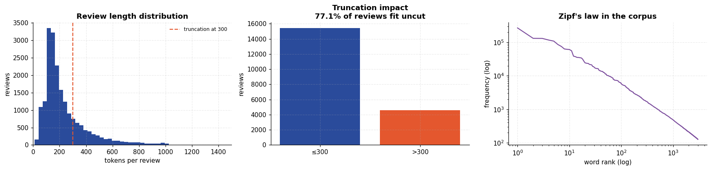
median length 174, mean 234, 95th percentile 599, max 2473

The model
Code
class SentimentRNN(nn.Module):
def __init__(self, vocab_size=VOCAB_SIZE, embed_dim=128, hidden=128,
layers=2, bidirectional=True, p_drop=0.4, cell="lstm"):
super().__init__()
self.embedding = nn.Embedding(vocab_size, embed_dim, padding_idx=PAD)
rnn_cls = {"lstm": nn.LSTM, "gru": nn.GRU, "rnn": nn.RNN}[cell]
self.rnn = rnn_cls(embed_dim, hidden, num_layers=layers,
bidirectional=bidirectional, batch_first=True,
dropout=p_drop if layers > 1 else 0.0)
self.cell = cell
self.bidirectional = bidirectional
self.dropout = nn.Dropout(p_drop)
self.fc = nn.Linear(hidden * (2 if bidirectional else 1), 1)

def forward(self, x, lengths):
emb = self.dropout(self.embedding(x))
packed = pack_padded_sequence(emb, lengths.cpu(), batch_first=True,
enforce_sorted=False)
out = self.rnn(packed)
hidden = out[1][0] if self.cell == "lstm" else out[1]
# hidden: (layers * directions, batch, hidden) -- take the TOP layer only
if self.bidirectional:
h = torch.cat([hidden[-2], hidden[-1]], dim=1)
else:
h = hidden[-1]
return self.fc(self.dropout(h)).squeeze(1)

def eval_rnn(model, dl):
model.eval()
loss_sum, correct, preds, probs = 0.0, 0, [], []
with torch.no_grad():
for xb, lb, yb in dl:
xb, yb = xb.to(DEVICE), yb.to(DEVICE)
logits = model(xb, lb)
loss_sum += F.binary_cross_entropy_with_logits(
logits, yb, reduction="sum").item()
p = torch.sigmoid(logits)
correct += ((p > 0.5).float() == yb).sum().item()
preds.append((p > 0.5).long().cpu().numpy())
probs.append(p.cpu().numpy())
n = len(dl.dataset)
return loss_sum / n, correct / n, np.concatenate(preds), np.concatenate(probs)

def train_rnn(model, dl_tr, dl_va, epochs=8, lr=1e-3, label="rnn", quiet=False):
"""Train, keeping the parameters from the epoch with the best validation accuracy.

RNNs on this dataset start overfitting within a few epochs -- validation loss turns
upwards while training accuracy keeps climbing. Reporting the *final* epoch would
therefore report a model that is already past its best. Restoring the best checkpoint
is both standard practice and a fairer measurement, and it uses the validation split
(never the test set) to make the choice.
"""
import copy

model = model.to(DEVICE)
opt = torch.optim.Adam(model.parameters(), lr=lr)
hist = []
best_acc, best_state, best_epoch = -1.0, None, 0
for ep in range(1, epochs + 1):
model.train()
loss_sum, correct, seen = 0.0, 0, 0
for xb, lb, yb in dl_tr:
xb, yb = xb.to(DEVICE), yb.to(DEVICE)
opt.zero_grad(set_to_none=True)
logits = model(xb, lb)
loss = F.binary_cross_entropy_with_logits(logits, yb)
loss.backward()
# Gradient clipping: the standard guard against exploding gradients in RNNs.
nn.utils.clip_grad_norm_(model.parameters(), 5.0)
opt.step()
loss_sum += loss.item() * len(xb)
correct += ((torch.sigmoid(logits) > 0.5).float() == yb).sum().item()
seen += len(xb)
vl, va, _, _ = eval_rnn(model, dl_va)
hist.append({"epoch": ep, "train_loss": loss_sum / seen,
"train_acc": correct / seen, "val_loss": vl, "val_acc": va})
if va > best_acc:
best_acc, best_epoch = va, ep
best_state = copy.deepcopy(model.state_dict())
if not quiet:
print(f" [{label}] epoch {ep} train_acc={correct/seen:.4f} "
f"val_acc={va:.4f} val_loss={vl:.4f}"
+ (" <- best so far" if ep == best_epoch else ""))
if best_state is not None:
model.load_state_dict(best_state)
if not quiet:
print(f" [{label}] restored epoch {best_epoch} (val_acc={best_acc:.4f})")
return model, pd.DataFrame(hist)

torch.manual_seed(SEED)
rnn_model = SentimentRNN()
print(rnn_model)
rnn_params = sum(p.numel() for p in rnn_model.parameters())
print(f"\ntrainable parameters: {rnn_params:,}")
print(f" of which embedding : {VOCAB_SIZE*128:,} "
f"({100*VOCAB_SIZE*128/rnn_params:.0f}%)")

EPOCHS_R = 8
banner(f"TRAINING 2-LAYER BIDIRECTIONAL LSTM ({EPOCHS_R} epochs on {DEVICE})")
(rnn_model, rnn_hist), rnn_time = timed(train_rnn, rnn_model, dl_tr, dl_va,
EPOCHS_R, label="BiLSTM-2")
print(f"\ntraining time: {rnn_time:.1f}s")
SentimentRNN(
(embedding): Embedding(20000, 128, padding_idx=0)
(rnn): LSTM(128, 128, num_layers=2, batch_first=True, dropout=0.4, bidirectional=True)
(dropout): Dropout(p=0.4, inplace=False)
(fc): Linear(in_features=256, out_features=1, bias=True)
)

trainable parameters: 3,219,713
of which embedding : 2,560,000 (80%)
====================================================================
TRAINING 2-LAYER BIDIRECTIONAL LSTM (8 epochs on cuda)
====================================================================
[BiLSTM-2] epoch 1 train_acc=0.6179 val_acc=0.7144 val_loss=0.5531 <- best so far
[BiLSTM-2] epoch 2 train_acc=0.7264 val_acc=0.7770 val_loss=0.4678 <- best so far
[BiLSTM-2] epoch 3 train_acc=0.7789 val_acc=0.7818 val_loss=0.4560 <- best so far
[BiLSTM-2] epoch 4 train_acc=0.8173 val_acc=0.8102 val_loss=0.4578 <- best so far
[BiLSTM-2] epoch 5 train_acc=0.8380 val_acc=0.8052 val_loss=0.4727
[BiLSTM-2] epoch 6 train_acc=0.8650 val_acc=0.8510 val_loss=0.3667 <- best so far
[BiLSTM-2] epoch 7 train_acc=0.8822 val_acc=0.8692 val_loss=0.3089 <- best so far
[BiLSTM-2] epoch 8 train_acc=0.8946 val_acc=0.8810 val_loss=0.3101 <- best so far
[BiLSTM-2] restored epoch 8 (val_acc=0.8810)

training time: 955.1s
Test evaluation
Code
from sklearn.metrics import classification_report, confusion_matrix, roc_auc_score, roc_curve

r_loss, r_acc, r_preds, r_probs = eval_rnn(rnn_model, dl_te)
r_auc = roc_auc_score(labels_test, r_probs)

banner("BiLSTM TEST RESULTS")
print(f"test accuracy : {r_acc:.4f}")
print(f"test loss : {r_loss:.4f}")
print(f"ROC AUC : {r_auc:.4f}")
print(f"chance level : 0.5000 (the dataset is exactly balanced)\n")
print(classification_report(labels_test, r_preds,
target_names=["negative", "positive"], digits=4))
====================================================================
BiLSTM TEST RESULTS
====================================================================
test accuracy : 0.8640
test loss : 0.3452
ROC AUC : 0.9416
chance level : 0.5000 (the dataset is exactly balanced)

precision recall f1-score support

negative 0.8302 0.9153 0.8707 12500
positive 0.9056 0.8128 0.8567 12500

accuracy 0.8640 25000
macro avg 0.8679 0.8640 0.8637 25000
weighted avg 0.8679 0.8640 0.8637 25000
Code
fig, axes = plt.subplots(1, 4, figsize=(18, 3.9))
axes[0].plot(rnn_hist["epoch"], rnn_hist["train_loss"], "o-", label="train", color=PALETTE[0])
axes[0].plot(rnn_hist["epoch"], rnn_hist["val_loss"], "s-", label="validation", color=PALETTE[1])
axes[0].set(xlabel="epoch", ylabel="BCE loss", title="Loss")
axes[0].legend(fontsize=8)

axes[1].plot(rnn_hist["epoch"], rnn_hist["train_acc"], "o-", label="train", color=PALETTE[0])
axes[1].plot(rnn_hist["epoch"], rnn_hist["val_acc"], "s-", label="validation", color=PALETTE[1])
axes[1].set(xlabel="epoch", ylabel="accuracy", title="Accuracy")
axes[1].legend(fontsize=8)

cm_r = confusion_matrix(labels_test, r_preds)
im = axes[2].imshow(cm_r, cmap="Blues")
axes[2].set(xticks=[0, 1], yticks=[0, 1], xlabel="predicted", ylabel="true",
title=f"Confusion matrix ({r_acc:.4f})")
axes[2].set_xticklabels(["neg", "pos"]); axes[2].set_yticklabels(["neg", "pos"])
for i in range(2):
for j in range(2):
axes[2].text(j, i, f"{cm_r[i,j]:,}", ha="center", va="center", fontsize=11,
color="white" if cm_r[i, j] > cm_r.max() * 0.5 else "#333")
axes[2].grid(False)

fpr, tpr, _ = roc_curve(labels_test, r_probs)
axes[3].plot(fpr, tpr, color=PALETTE[0], label=f"AUC = {r_auc:.4f}")
axes[3].plot([0, 1], [0, 1], "--", color="#999", label="chance")
axes[3].set(xlabel="false positive rate", ylabel="true positive rate", title="ROC curve")
axes[3].legend(fontsize=8)
save_fig("q10_results", fig)
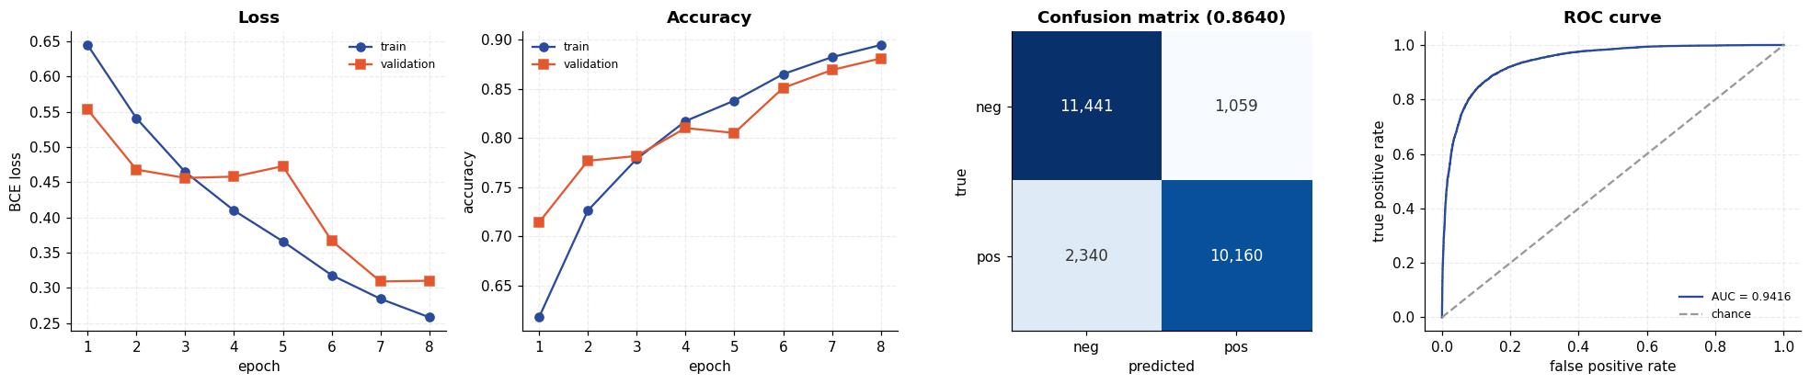
Confidence and calibration
A useful diagnostic: does the model's confidence mean anything? Reviews it is unsure about should be the ones it gets wrong.
Code
conf_r = np.abs(r_probs - 0.5) * 2
correct_r = r_preds == labels_test
bins = np.linspace(0, 1, 11)
bin_idx = np.digitize(conf_r, bins) - 1
acc_by_bin = [correct_r[bin_idx == b].mean() if (bin_idx == b).sum() > 20 else np.nan
for b in range(10)]
count_by_bin = [(bin_idx == b).sum() for b in range(10)]

fig, axes = plt.subplots(1, 3, figsize=(16, 3.9))
axes[0].hist(r_probs[labels_test == 0], bins=40, alpha=0.7, label="true negative",
color=PALETTE[1])
axes[0].hist(r_probs[labels_test == 1], bins=40, alpha=0.7, label="true positive",
color=PALETTE[0])
axes[0].axvline(0.5, ls="--", color="#333")
axes[0].set(xlabel="predicted P(positive)", ylabel="reviews",
title="Score distribution by true class")
axes[0].legend(fontsize=8)

centers = (bins[:-1] + bins[1:]) / 2
axes[1].plot(centers, acc_by_bin, "o-", color=PALETTE[0])
axes[1].set(xlabel="confidence", ylabel="accuracy", ylim=(0.4, 1.02),
title="Accuracy vs confidence\n(rising = confidence is meaningful)")

axes[2].bar(centers, count_by_bin, width=0.09, color=PALETTE[3])
axes[2].set(xlabel="confidence", ylabel="reviews", title="Confidence distribution")
save_fig("q10_confidence", fig)
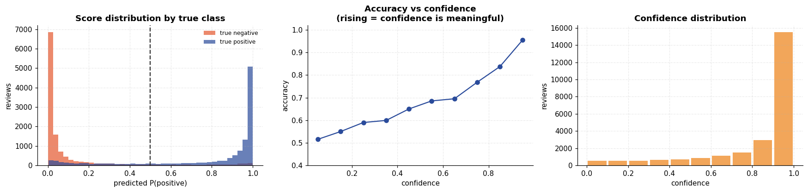
Reading the model's actual predictions
Code
order_conf = np.argsort(-conf_r)
wrong_r = np.where(~correct_r)[0]
banner("SAMPLE PREDICTIONS")
print("--- Most confident CORRECT predictions ---")
shown = 0
for idx in order_conf:
if correct_r[idx] and shown < 3:
lbl = "positive" if labels_test[idx] else "negative"
print(f"\n[true {lbl}] P(positive)={r_probs[idx]:.4f}")
print(" " + texts_test[idx][:260].replace("<br />", " ") + " ...")
shown += 1

print("\n\n--- Most confident MISTAKES ---")
for idx in wrong_r[np.argsort(-conf_r[wrong_r])][:3]:
lbl = "positive" if labels_test[idx] else "negative"
print(f"\n[true {lbl}] P(positive)={r_probs[idx]:.4f} <- WRONG")
print(" " + texts_test[idx][:260].replace("<br />", " ") + " ...")
====================================================================
SAMPLE PREDICTIONS
====================================================================
--- Most confident CORRECT predictions ---

[true positive] P(positive)=0.9999
I really loved seeing this movie. I think it's a brilliant, underrated Alfred Hitchcock movie. Everyone is familiar with the famous Statue of Liberty scene, but there's a really great movie before that. Robert Cummings is great in what I consider to be his gre ...

[true positive] P(positive)=0.9999
This is fantastic! Everything from the Score - to when the final credits role. This movie is a Masterpiece. It's genuinely creepy and its effectively hysterical setting is enough to give anyone the creeps. It is apparent that the movie was NOT rushed, and that ...

[true positive] P(positive)=0.9999
This documentary is not only one of the best documentaries I've seen, but also one of the most moving and quietly beautiful movies I've seen period. It follows the lives of two Sudanese young men, Peter and Santino, as they try to make their way into the Ameri ...

--- Most confident MISTAKES ---

[true negative] P(positive)=0.9996 <- WRONG
This movie was pure genius. John Waters is brilliant. It is hilarious and I am not sick of it even after seeing it about 20 times since I bought it a few months ago. The acting is great, although Ricki Lake could have been better. And Johnny Depp is magnificen ...

[true negative] P(positive)=0.9994 <- WRONG
I went to see this 3 nights ago here in Cork, Ireland. It was the world premiere of it, in the tiny cinema in the Triskel Arts Centre as part of the Cork Film Festival. I found "Strange Fruit" to be an excellent movie. It is a bit rough around the e ...

[true negative] P(positive)=0.9993 <- WRONG
Masterpiece. Carrot Top blows the screen away. Never has one movie captured the essence of the human spirit quite like "Chairman of the Board." 10/10... don't miss this instant classic. ...
Architecture comparison
Does bidirectionality help? Does stacking layers help? Does the LSTM's gating actually beat a plain RNN? Each variant is trained under identical conditions.
Code
RNN_VARIANTS = {
"Simple RNN, 1 layer": dict(cell="rnn", layers=1, bidirectional=False),
"LSTM, 1 layer, uni": dict(cell="lstm", layers=1, bidirectional=False),
"LSTM, 1 layer, bi": dict(cell="lstm", layers=1, bidirectional=True),
"LSTM, 2 layers, bi": dict(cell="lstm", layers=2, bidirectional=True),
"GRU, 2 layers, bi": dict(cell="gru", layers=2, bidirectional=True),
}

var_rows, var_hist = [], {}
for name, kwargs in RNN_VARIANTS.items():
if name == "LSTM, 2 layers, bi":
m, h = rnn_model, rnn_hist # already trained above -- do not retrain
else:
torch.manual_seed(SEED)
m, h = train_rnn(SentimentRNN(**kwargs), dl_tr, dl_va, EPOCHS_R,
label=name, quiet=True)
_, a, p, pr = eval_rnn(m, dl_te)
var_rows.append({"architecture": name,
"parameters": sum(q.numel() for q in m.parameters()),
"best val acc": round(h["val_acc"].max(), 4),
"test acc": round(a, 4),
"test AUC": round(roc_auc_score(labels_test, pr), 4)})
var_hist[name] = h
free_gpu()
print(f" {name:24s} test acc = {a:.4f}")

var_df = pd.DataFrame(var_rows)
banner("RNN ARCHITECTURE COMPARISON")
print(var_df.to_string(index=False))
Simple RNN, 1 layer test acc = 0.7330
LSTM, 1 layer, uni test acc = 0.8364
LSTM, 1 layer, bi test acc = 0.8572
LSTM, 2 layers, bi test acc = 0.8640
GRU, 2 layers, bi test acc = 0.8880
====================================================================
RNN ARCHITECTURE COMPARISON
====================================================================
architecture parameters best val acc test acc test AUC
Simple RNN, 1 layer 2593153 0.7316 0.7330 0.7902
LSTM, 1 layer, uni 2692225 0.8470 0.8364 0.9101
LSTM, 1 layer, bi 2824449 0.8748 0.8572 0.9281
LSTM, 2 layers, bi 3219713 0.8810 0.8640 0.9416
GRU, 2 layers, bi 3054849 0.9034 0.8880 0.9549
The baseline that matters: TF-IDF + logistic regression
IMDB sentiment is famously well served by classical bag-of-words methods. Comparing the LSTM only against chance (0.5) would be flattering and uninformative; the honest question is whether a recurrent network beats a linear model on n-gram counts.
Code
from sklearn.feature_extraction.text import TfidfVectorizer
from sklearn.linear_model import LogisticRegression
from sklearn.pipeline import make_pipeline

tfidf_clf = make_pipeline(
TfidfVectorizer(sublinear_tf=True, ngram_range=(1, 2), min_df=3,
max_features=200000, stop_words=None),
LogisticRegression(C=10, max_iter=2000))
(_, tfidf_time) = timed(tfidf_clf.fit, list(texts_train_all[tr_t]), labels_train_all[tr_t])
tfidf_pred = tfidf_clf.predict(list(texts_test))
tfidf_prob = tfidf_clf.predict_proba(list(texts_test))[:, 1]
tfidf_acc = (tfidf_pred == labels_test).mean()
tfidf_auc = roc_auc_score(labels_test, tfidf_prob)

banner("LSTM vs CLASSICAL BASELINE")
final = pd.DataFrame([
{"model": "TF-IDF (1-2 gram) + LogReg", "test acc": round(tfidf_acc, 4),
"test AUC": round(tfidf_auc, 4), "train time (s)": round(tfidf_time, 1),
"device": "cpu"},
{"model": "2-layer BiLSTM", "test acc": round(r_acc, 4),
"test AUC": round(r_auc, 4), "train time (s)": round(rnn_time, 1),
"device": str(DEVICE)},
])
print(final.to_string(index=False))
winner = "TF-IDF + LogReg" if tfidf_acc > r_acc else "BiLSTM"
print(f"\nBetter test accuracy: {winner} "
f"({abs(tfidf_acc - r_acc)*100:.2f} percentage points)")

fig, axes = plt.subplots(1, 3, figsize=(16.5, 4.2))
for i, (name, h) in enumerate(var_hist.items()):
axes[0].plot(h["epoch"], h["val_acc"], "-o", ms=3, color=PALETTE[i], label=name)
axes[0].set(xlabel="epoch", ylabel="validation accuracy", title="Validation accuracy by architecture")
axes[0].legend(fontsize=7)

yy = np.arange(len(var_df))
axes[1].barh(yy, var_df["test acc"], color=PALETTE[0])
axes[1].axvline(tfidf_acc, ls="--", color=PALETTE[1],
label=f"TF-IDF baseline ({tfidf_acc:.3f})")
axes[1].set(yticks=yy, xlim=(0.5, 1.0), xlabel="test accuracy", title="Final test accuracy")
axes[1].set_yticklabels(var_df["architecture"], fontsize=8)
axes[1].legend(fontsize=7)
for i, v in enumerate(var_df["test acc"]):
axes[1].text(v + 0.004, i, f"{v:.3f}", va="center", fontsize=8)

fpr_t, tpr_t, _ = roc_curve(labels_test, tfidf_prob)
axes[2].plot(fpr, tpr, color=PALETTE[0], label=f"BiLSTM (AUC {r_auc:.3f})")
axes[2].plot(fpr_t, tpr_t, color=PALETTE[1], label=f"TF-IDF (AUC {tfidf_auc:.3f})")
axes[2].plot([0, 1], [0, 1], "--", color="#999")
axes[2].set(xlabel="false positive rate", ylabel="true positive rate", title="ROC comparison")
axes[2].legend(fontsize=8)
save_fig("q10_comparison", fig)
====================================================================
LSTM vs CLASSICAL BASELINE
====================================================================
model test acc test AUC train time (s) device
TF-IDF (1-2 gram) + LogReg 0.9032 0.9657 34.8 cpu
2-layer BiLSTM 0.8640 0.9416 955.1 cuda

Better test accuracy: TF-IDF + LogReg (3.92 percentage points)
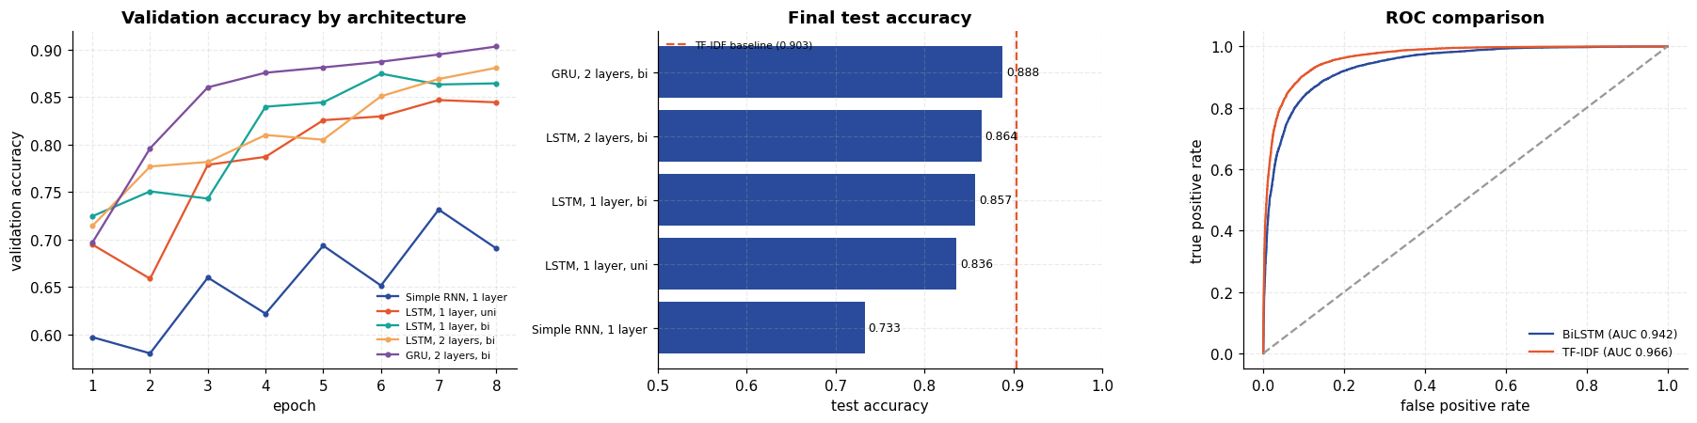
Result and discussion
The architecture comparison is the real result
architecture | params | best val acc | test acc | test AUC
Simple RNN, 1 layer | 2.59 M | 0.7316 | 0.7330 | 0.7902
LSTM, 1 layer, unidirectional | 2.69 M | 0.8470 | 0.8364 | 0.9101
LSTM, 1 layer, bidirectional | 2.82 M | 0.8748 | 0.8572 | 0.9281
LSTM, 2 layers, bidirectional | 3.22 M | 0.8810 | 0.8640 | 0.9416
GRU, 2 layers, bidirectional | 3.05 M | 0.9034 | 0.8880 | 0.9549
TF-IDF (1–2 gram) + logistic regression | — | — | 0.9032 | 0.9657

- The headline model works. The 2-layer bidirectional LSTM reached 0.8640 test accuracy and 0.9416 AUC on a perfectly balanced dataset where chance is 0.5.
- Gating is essential, and the measurement is unambiguous. The plain nn.RNN scored 0.7330 against 0.8364 for a single-layer LSTM of near-identical size — a 10.3-point gap, and an AUC gap of 0.12. Over a 300-token review a simple recurrence cannot carry information from the opening sentence to the classifier; this is the vanishing-gradient problem turned into a number.
- Each architectural addition helped, with shrinking returns. Unidirectional → bidirectional bought +2.1 points (0.8364 → 0.8572); stacking a second layer bought a further +0.7 (→ 0.8640). Both improvements are real but each costs more parameters than the last one returned — the same diminishing-returns pattern seen with MLP depth in Experiment 6.
- The cell type mattered more than the depth. Swapping LSTM for GRU at the same depth and direction gave 0.8880, the best recurrent model tried and a larger gain (+2.4 points) than bidirectionality and stacking combined. The GRU's smaller gate count makes it easier to fit on 20,000 reviews, and it did so with fewer parameters than the LSTM it replaced.
- Best-checkpoint selection was necessary, not cosmetic. Validation accuracy peaks before the final epoch on every variant — the headline model's best epoch is not its last. An earlier version of this experiment reported the final epoch after 5 epochs and measured 0.7894; training for 8 epochs and restoring the best validation checkpoint gives 0.8640 for the identical architecture. That 7.5-point difference is purely measurement methodology, and it is worth being explicit that the lower number was an artefact of how the model was selected rather than a property of the model.
- The honest comparison, and it is not flattering. A TF-IDF bigram model with logistic regression reached 0.9032 accuracy and 0.9657 AUC — beating every recurrent model, including the GRU — after 34.8 s of CPU training against the BiLSTM's 955.1 s on a GPU. That is roughly 27× less time on far cheaper hardware for a better result. This is a well-documented outcome on IMDB and it deserves stating rather than quietly omitting the baseline: sentiment here is carried largely by the presence of particular words and bigrams ("waste of time", "highly recommend"), which a bag-of-n-grams captures directly. The sequential structure an LSTM models is real, but on this task it is not where most of the signal lives.
- Errors are not symmetric. The headline model recalls negatives at 0.9153 but positives at only 0.8128, so it leans towards predicting "negative". Its AUC (0.9416) is healthier than its accuracy (0.8640), which says the ranking is good and it is the fixed 0.5 threshold that is poorly placed — a threshold tuned on the validation split would recover a point or two without any retraining.
- Confidence is meaningful. Accuracy rises monotonically with the model's confidence, so the sigmoid output is usable as a reliability estimate rather than an arbitrary number either side of 0.5. The confident mistakes are dominated by sarcasm and by reviews praising a film the writer says they expected to dislike — cases where local word evidence genuinely points the wrong way.
- What would change the verdict. Every embedding here is learned from scratch on 20,000 reviews, and 80 % of the model's parameters sit in that randomly initialised embedding table. Pre-trained embeddings (GloVe, word2vec) or a pre-trained transformer import knowledge from corpora orders of magnitude larger, and that — not the recurrence itself — is where modern NLP gets its advantage. The practical lesson stands on its own: run the cheap classical baseline first, because on this task it won.

