**SMART MONITORING USING IoT FOR POLYHOUSE**

**Class Diagram**

Code :

@startuml

abstract class Sensor {

- sensorId: String

- type: String

+ read(): float[]

}

class NPKSensor {

- nitrogenLevel: float

- phosphorusLevel: float

- potassiumLevel: float

+ getNPKLevels(): float[]

}

class LightSensor {

- lightIntensity: float

+ getLightIntensity(): float

}

class pHSensor {

- pHValue: float

- depth: float

- temperature: float

+ getPHValue(): float

+ getDepth(): float

+ getTemperature(): float

}

class MoistureSensor {

- moistureValue: int

- moisturePercentage: float

+ readMoisture(): tuple

}

class Camera {

- cameraId: String

- resolution: String

+ captureImage(): String

}

class RaspberryPi {

- deviceId: String

+ collectData(): void

+ processData(): void

+ sendData(): void

}

class DataProcessor {

+ analyzeData(data: dict): void

+ generateReport(): String

}

class PolyHouse {

- temperature: float

- humidity: float

- soilMoisture: float

- lightIntensity: float

+ adjustEnvironment(): void

}

class MongoDB {

- uri: String

- client: MongoClient

- db: Database

- collection: Collection

+ insertData(document: dict): void

}

Sensor <|-- NPKSensor

Sensor <|-- LightSensor

Sensor <|-- pHSensor

Sensor <|-- MoistureSensor

Sensor "1..*" -- "1" RaspberryPi : connects to

Camera "1" -- "1" RaspberryPi : connects to

RaspberryPi "1" -- "1" DataProcessor : sends data to

DataProcessor "1" -- "1" PolyHouse : controls

RaspberryPi "1" -- "1" MongoDB : stores data in

@enduml

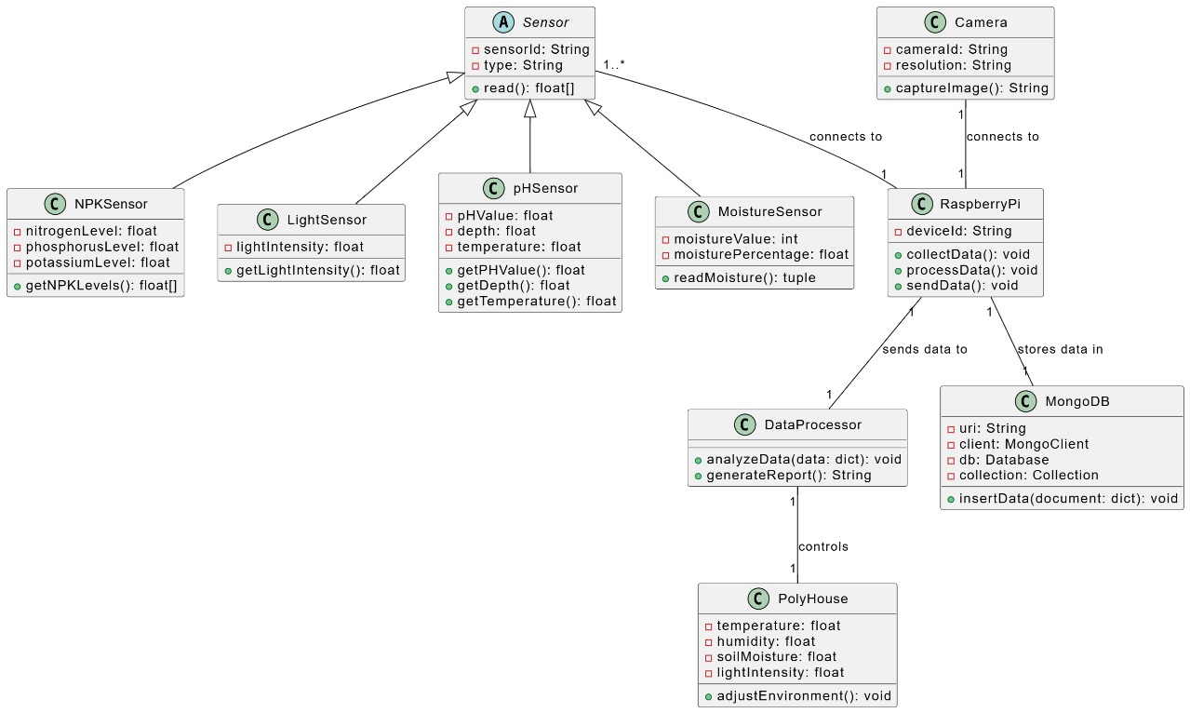

Sequence Diagram

@startuml

actor User

participant "Raspberry Pi" as RPI

participant "Moisture Sensor" as MS

participant "pH Sensor" as pH

participant "NPK Sensor" as NPK

participant Camera

database MongoDB

loop Daily at 6:00 AM and 6:00 PM

RPI -> MS: read_moisture_sensor()

MS --> RPI: moisture data

RPI -> pH: read_ph()

pH --> RPI: pH, depth, light, temperature data

RPI -> NPK: read_npk()

NPK --> RPI: nitrogen, phosphorus, potassium data

RPI -> Camera: capture_image()

Camera --> RPI: image filename

RPI -> RPI: collect_and_store_data()

RPI -> MongoDB: insert sensor data and image filename

MongoDB --> RPI: confirmation

end

User -> MongoDB: query data

MongoDB --> User: sensor readings and analysis

@enduml

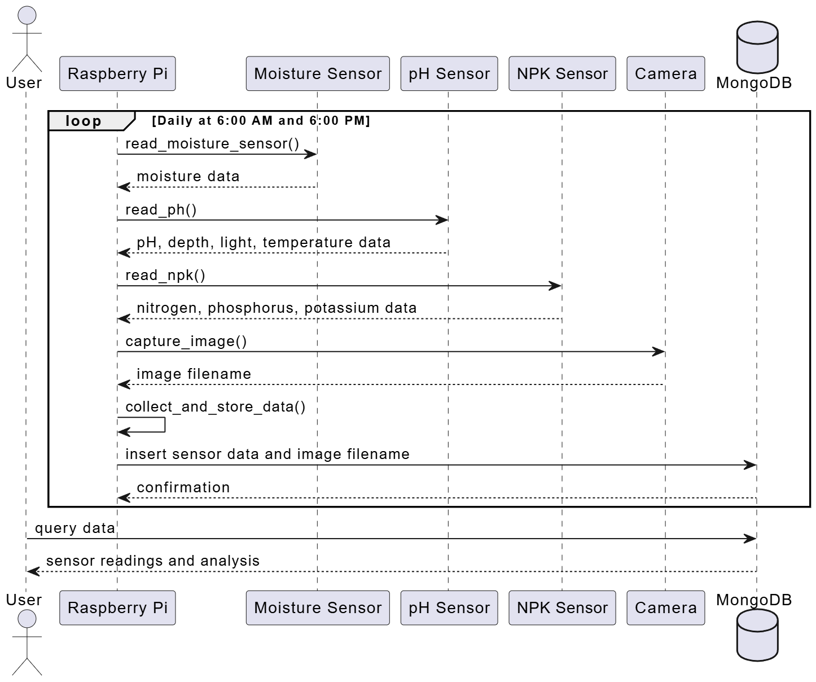

**Architecture Diagram**

**title** SMART MONITORING USING IoT FOR POLYHOUSE

Polyhouse [color: green, icon: home] {

  Sensors [icon: activity] {

    Temperature Sensor [icon: thermometer]

    Soil Moisture Sensor [icon: droplet]

    Light Sensor [icon: sun]

    pH Sensor [icon: sliders]

    NPK Sensor [icon: bar-chart]

  }

  Raspberry Pi [icon: raspberry-pi]

  Camera [icon: camera]

}

Cloud [color: blue, icon: gcp-cloud] {

  Cloud Database [icon: gcp-cloud-sql]

}

  WebUI [icon: laptop]

// Connections

Sensors **>** Raspberry Pi: send sensor data

Camera **>** Raspberry Pi: send visual data

Raspberry Pi **>** Cloud Database: sync data

Cloud Database **>** WebUI: fetch data

