Sensors

Plant Level

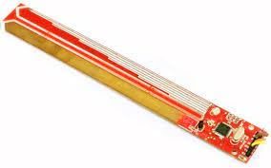Sensor: PH rod is designed on ATMEGA8 Ic

Link: <https://ibots.in/product/ph-sensor-module/>

Parameters

Temperature

Light

pH

Sensor:

Link: [Resistive type](https://amzn.in/d/cTmwB5U) [Capactive Type](https://amzn.in/d/eXX3bsH)

Cost: 120/- (Resistive type) 350/-(Capactive Type)

Parameters: Soil moisture

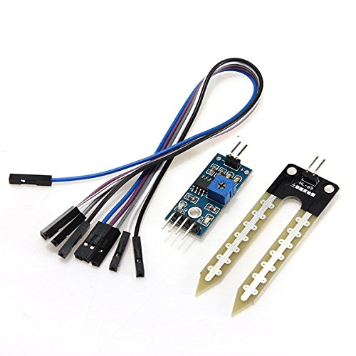 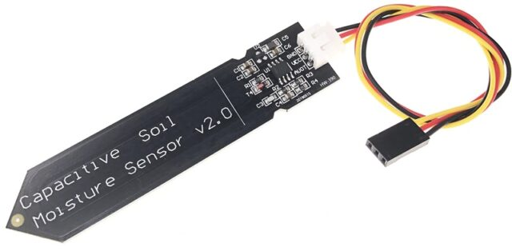

This is one is used Better sensor

(Resistive type) (Capactive Type)

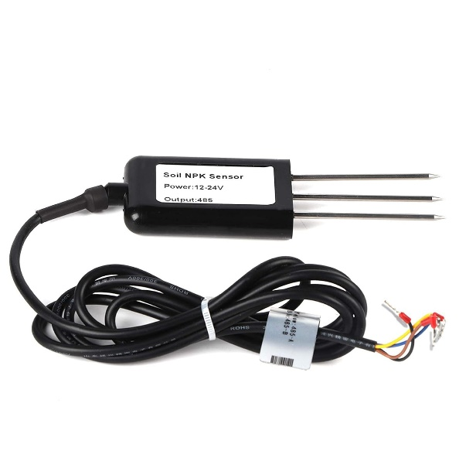

Sensor: NPK sesnor

Link: https://amzn.in/d/bI2Y82Q

Cost: 4000/-

Parameters: Nitrogen, Postassium, Phosphorus

Room Level Sensors

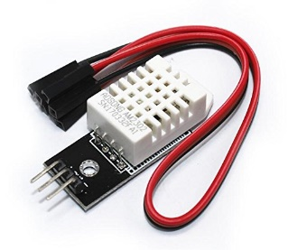

Sensor: DHT22 AM2302 Digital Temperature Humidity Sensor

Link: <https://amzn.in/d/hb8qRdj>

Cost: 330/-

Parameter: Humidity

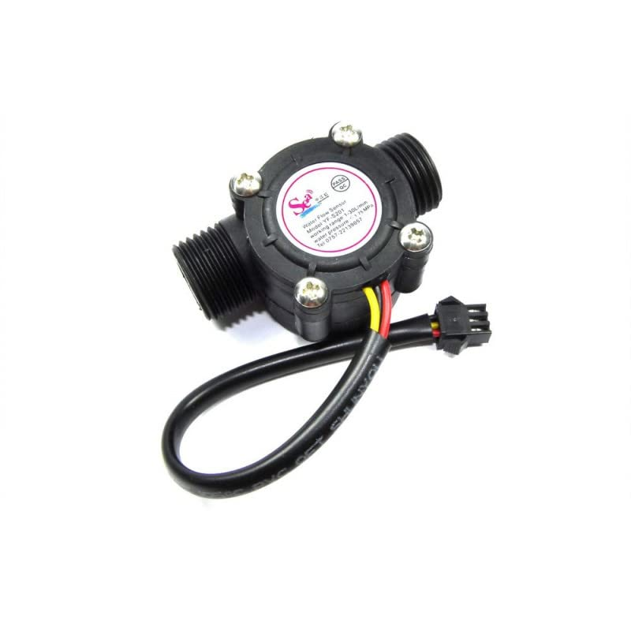Sensor: YF-S201 1-30L/min Water Flow Hall Counter/Sensor

Link: <https://amzn.in/d/0V7vffy>

Cost: 430/-

Parameter: Water flow rate

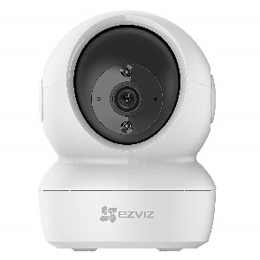

Sensor: EZVIZ Security Camera

Link: <https://amzn.in/d/70yVk1Q>

Cost: 2000/-

Parameter: Images

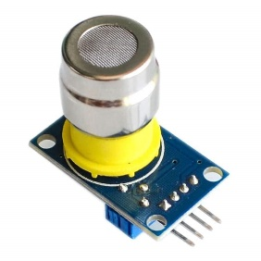Sensor: MG811

Link: <https://amzn.in/d/0TtgT02>

Cost: 4500/-

Parameter: Carbon Dioxide

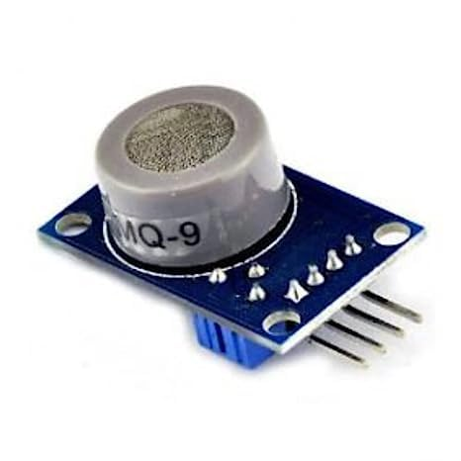

Sensor: MQ9

Link: <https://amzn.in/d/11cAwHn>

Cost: 200/-

Parameter: Carbon monoxide

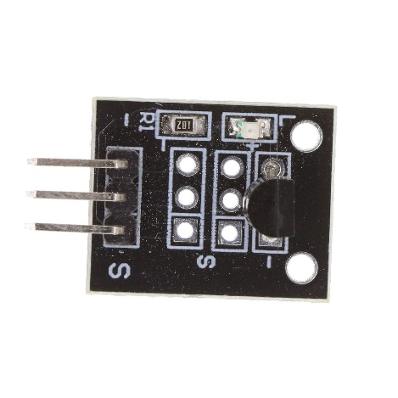Sensor: KY-001 Temperature Sensor

Link: https://amzn.in/d/5QBq6ml

Cost: 400/-

Parameter: Temperature