|  |  |  |
| --- | --- | --- |
|  | SRM INSTITUTE OF SCIENCE AND TECHNOLOGY  SCHOOL OF COMPUTING  DEPARTMENT OF DATASCIENCE AND BUSINESS SYSTEMS  21GNP301L Community Connect |  |
| WORK REPORT | | |
| Name: Ponnuri Aniruddha  Register Number: RA2112704010015  Mail ID: pp0783@srmist.edu.in  Department: Data science and business systems  Specialization: data science  Semester: 5 | | |
| NGO NAME and details  **Shraddha Foundation**  **H.NO. 946, SECTOR-15, FARIDABAD (HARYANA)**  **Mob: 9818076444, 9810651488**  **E-mail: shraddha.foundation12@gmail.com** | | |

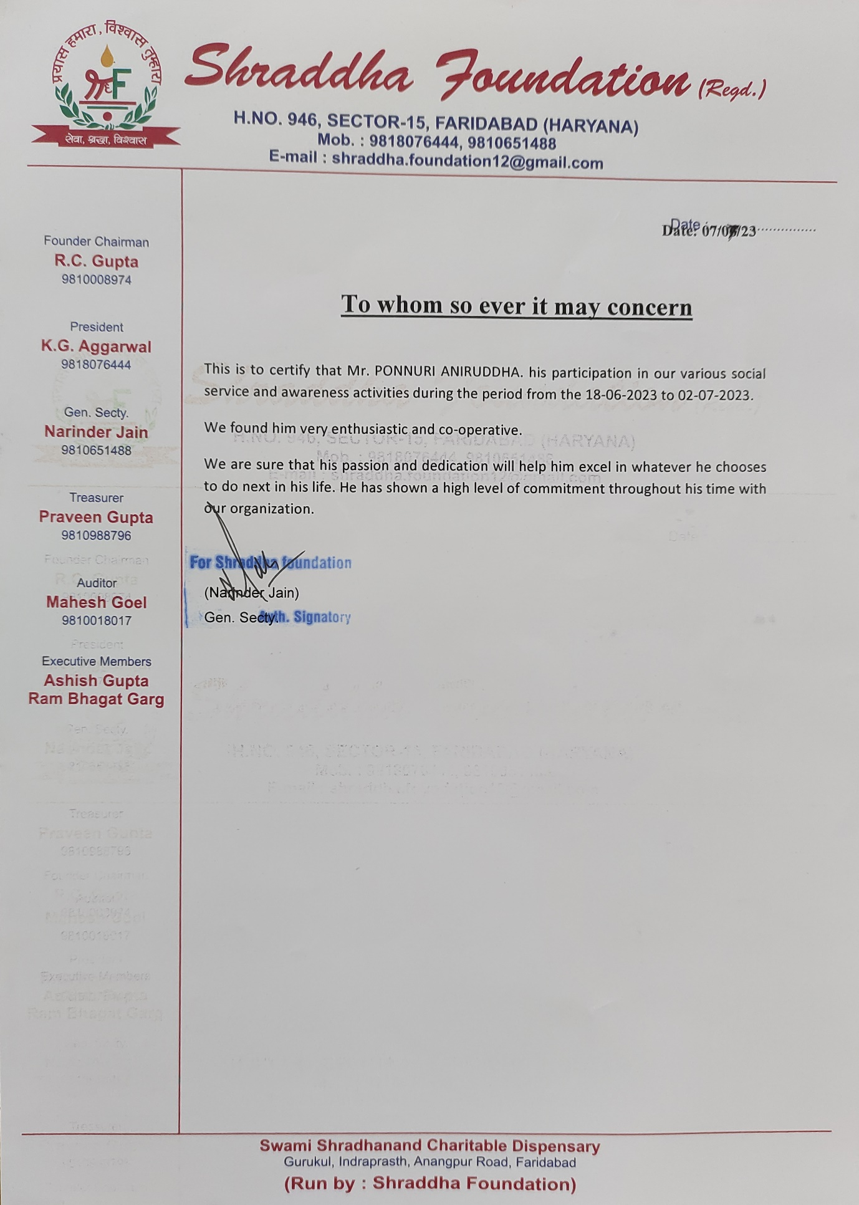

Introduction:

Community Service Projects at an Orphanage and a Plantation

I engaged in two unique community service activities over the course of two weeks: one at an orphanage to positively touch the lives of poor children, and the other a week-long plantation project to contribute to environmental protection.

Orphanage

I got the opportunity to contact with the children on a regular basis at the orphanage and assist them with their various needs. I assisted the children in developing their social and emotional abilities by providing academic help, facilitating recreational activities, and mentoring them. It was quite fulfilling to see their development and know that I was making a difference in their lives.

In addition to working with the children, I helped the orphanage's general well-being by maintaining its facilities. I cleaned and organized living rooms, cooked meals, and assisted with other routine tasks. I am grateful for the chance to provide a safe and supportive atmosphere for the children.

Plantation Development

I engaged in a week-long farming project during my second week of community service. This program entails planting trees and other vegetation in degraded regions in order to return them to their natural state. I worked alongside other volunteers to plant and care for hundreds of seedlings over the course of several days and weeks.

The tree planting project is both difficult and gratifying. It was physically tough work, but seeing the progress we made during the week was quite rewarding. We planted a range of native trees and shrubs, which will assist boost the area's biodiversity and provide food and shelter for wildlife.

The Influence of Community Service Initiatives

Both of these community service projects made a difference in the lives of others. My work at the orphanage aided the development of the children's academic ability, social and emotional skills, and overall well-being. My efforts on the plantation program contributed to the restoration of a degraded region and the improvement of biodiversity.I am grateful for the opportunity to engage in these community service projects. They've taught me important lessons about giving back to the community and making a difference in the lives of others. I'm also motivated by the youngsters and volunteers I've met's tenacity and determination. I am convinced that these projects will continue to benefit the community for many years to come.

Motivation:

I've always been interested in helping others and making a positive difference in the world. When I was given the opportunity to volunteer at an orphanage and a plantation project, I knew it would allow me to put my enthusiasm into action in meaningful and effective ways.

My strong desire to help youngsters facing misfortune drove me to volunteer at the orphanage. I think that every kid has a fundamental right to a safe and loving home, and I am dedicated to assisting them in obtaining that right. I had the opportunity to connect with children of all ages at the orphanage, from toddlers to teenagers. I assisted the children in developing their social and emotional abilities by providing academic help, facilitating recreational activities, and mentoring them. I was also involved in the orphanage's day-to-day operations, such as meal preparation and cleaning and maintaining the premises.

I was equally motivated to assist in the tree planting effort since I am deeply committed to environmental conservation. I believe we have a responsibility to maintain our world for future generations, and tree planting efforts are an important part of that endeavour’s assisted other volunteers in planting hundreds of plants in a deteriorated region. We planted a range of native trees and shrubs, which will contribute to the area's biodiversity and provide food and shelter for wildlife.

Over the next two weeks, we watered and cared for the seedlings to ensure their survival. Witnessing the progress, we achieved during the tree planting initiative was quite fulfilling. We changed a desolate environment into a thriving ecosystem in just a few weeks. I am convinced that the trees and bushes we planted will continue to grow and thrive for many years, benefiting the environment and the community for future generations.

My volunteer experiences at the orphanage and the plantation project were incredibly transforming. They have increased my resolve to help others and make a positive difference in the world. I am glad for the opportunity to serve, and I am motivated to do so in the future.

Work Report

**Plantation Drives Preparation**

Introduction

As a volunteer with the Shraddha Foundation, my 15-day journey commenced on the 18th of June 2023. The first few days, from the 18th to the 21st of June, were dedicated to the preparation for the upcoming plantation drives organized by the foundation. These preparation days were essential to ensure a smooth and successful execution of the drives.

**Day 1: Introduction and Orientation (18th June 2023)**

Orientation and Foundation Overview

The first day of my volunteer journey began with a comprehensive orientation session led by the foundation's volunteer coordinator. This session provided an in-depth understanding of the organization's mission, values, and the various ongoing projects in which I would be involved. We learned about the core values of the foundation, including environmental conservation, education, healthcare, and community development.

Project Briefing

Following the orientation, the coordinator conducted a detailed briefing on the plantation drives, which were the primary focus of our preparation. I learned about the goals of the drives, the specific tasks I would be assigned, and the importance of reforestation in our local community. This briefing helped me align with the foundation's objectives.

Paperwork and Legal Requirements

On this day, I also completed all the necessary paperwork. This included signing a volunteer agreement, providing emergency contact information, and ensuring that all legal and safety requirements were met. Clearing these administrative tasks was crucial for a well-organized volunteering experience.

Training

In the afternoon, I underwent training on the foundation's policies, procedures, and safety guidelines. This training covered important aspects such as how to handle equipment, safety protocols, and guidelines for interacting with the local community. It was essential to ensure that I was well-prepared for the tasks ahead and could contribute effectively to the foundation's mission.

**Day 2: Equipment and Site Inspection (19th June 2023)**

Equipment Distribution

The second day of our preparation was dedicated to preparing the required equipment. We received shovels, saplings, watering cans, and safety gear. The team leaders provided us with a hands-on demonstration of the proper techniques for planting trees. Understanding how to use the equipment correctly was vital for the success of the plantation drives.

Site Inspection

After equipment preparation, we conducted a site inspection of the plantation site selected for the upcoming drives. We assessed the soil conditions and ensured that the location was suitable for planting. This site inspection helped us identify any potential challenges or adjustments needed for the plantation drives, ensuring a smoother execution on the designated days.

**Day 3: Community Engagement (20th June 2023)**

Community Outreach

To ensure the success of the plantation drives and raise awareness about environmental conservation, community engagement was a crucial part of our preparation. We spent the day creating and distributing flyers and posters. These materials served to inform local residents about the plantation drives and encourage their participation. Building community involvement was a fundamental aspect of the foundation's mission.

Safety Briefing

In addition to community outreach, a safety briefing was conducted to ensure that all volunteers were aware of potential risks and hazards related to tree planting and how to respond to them. Safety was a top priority, and volunteers were educated on how to stay safe during the drives while actively participating in planting activities.

**Day 4: Final Preparations and Team Coordination (21st June 2023)**

Transportation Arrangements

On the final preparation day, we organized transportation to and from the plantation site for both volunteers and equipment. We ensured that vehicles were available and had sufficient space for the saplings and other equipment. Effective transportation planning was essential to ensure that all resources reached the plantation site on time.

Team Roles and Responsibilities

The team gathered to discuss individual roles and responsibilities for the plantation drives. We went over the plan in detail to ensure that everyone knew their tasks and was prepared for the drives. Clear allocation of roles and responsibilities helped in efficient execution on the actual planting days.

Communication Channels

We established clear communication channels for the team and volunteers to stay connected during the events. This included ensuring that everyone had contact information and knew the meeting point. Effective communication was crucial for coordinating efforts and addressing any issues that might arise during the drives.

Last-Minute Check

A final check of equipment, supplies, and logistics was conducted to ensure that everything was in order and ready for the next day's plantation drive. This check served as a final layer of quality control to ensure that nothing was overlooked and that all resources were in place for a successful start to the plantation drives.

**Day 1 of the Plantation Drive: June 22, 2023**

Preparation and Installation

* The day started early in the morning with a meeting at the scheduled meeting location. Volunteers assembled, and we were informed on the plantation drive's goals and the precise duties we were required to complete.
* We were given the appropriate tools, such as shovels, saplings, watering cans, and safety equipment. The team leaders demonstrated the right technique for planting trees to us.
* The plantation site had been chosen ahead of time, and we performed a last examination to check that the location was suitable and that the soil conditions were suitable for planting.

Planting Process

* We broke into teams, each in charge of a specific region. This strategy enabled us to work more effectively and cover a bigger planting area.
* Digging holes, carefully inserting saplings into the earth, and then fastening them with soil were all part of the planting procedure. It was critical to ensure that the saplings were placed at the proper depth to support healthy growth.
* Watering and mulching were applied after planting to provide the young trees with the moisture and protection they required.

Participation in the Community

* The active participation of the local community was one of the day's highlights. Many residents participated in the plantation drive, demonstrating their dedication to environmental conservation.
* We had discussions with community members to educate them on the importance of reforestation and how it contributes to the health of our ecosystem.
* By the end of the day, we had successfully planted a substantial number of trees. The visible improvement of the environment was a result of our teamwork.
* The plantation drive had a significant impact on improving community awareness about environmental issues. It inspired people to take responsibility for their surroundings.

While the day was mostly successful, we did run into some weather-related issues. It was quite hot, and the dirt was dry, making digging holes and ensuring sufficient hydration for the saplings significantly more difficult. However, our planning and the passion of the volunteers enabled us to overcome these obstacles.

**Day 2 of the Plantation Drive: June 23, 2023**

Planting Procedure

* Building on our initial drive experience, we were more efficient in assembling teams and coordinating our activities.
* The information and skills obtained from the first day's experience improved the quality of our planting, ensuring that each seedling had the best chance of prospering.

Participation in the Community

* The previous drive's success and positive impact on the community motivated more local citizens to participate in this second drive.
* We continued to connect with neighbourhood people, instilling in them a feeling of ownership and environmental responsibility.

Achievements and Influence

* The second plantation drive was equally successful, adding to our community's burgeoning greenery and reinforcing our dedication to environmental conservation.
* The combined effect of the two campaigns was considerable, transforming the chosen regions into lush, green landscapes.

**Week 2: Orphanage Community Service**

The first day will be on June 25, 2023.

My second week of community work at the orphanage started with greeting the children and staff. The kids' excitement was contagious, and their drive to learn and experience new things was very endearing.

Course on Self-Knowledge and Self-Esteem

I began the day by teaching the kids about self-awareness and self-esteem. The goal was to assist them discover their particular qualities and talents, develop confidence in them, and motivate them to reach their full potential. The youngsters enthusiastically participated in the lesson, offering their ideas and demonstrating a great desire to learn and grow as people.

Day 2 is scheduled for June 26, 2023.

We continued the self-knowledge and self-esteem course, building on the previous day's lessons. The children's interest and excitement for the topic was remarkable. They talked about their experiences and were eager to learn more about themselves.

In addition to the lesson, I planned a variety of enjoyable activities for the youngsters. We had fun playing games, singing songs, and making crafts. These activities not only provided entertainment but also aided in the development of friendship and trust.

Day three: June 27, 2023

Our time at the orphanage was still centered on the self-knowledge and self-esteem course. The children's enthusiastic participation and eagerness to investigate their own self-worth was incredibly inspiring.

Mentoring the children was one of the most fulfilling aspects of my stay at the orphanage. I worked with several children, offering emotional support and direction as well as assisting them with their homework. It was rewarding to watch them advance in their studies and personal growth.

Day 4: 28 June 2023

The children's knowledge of their own worth continued to improve. Their exchanges and discussions revealed their developing self-esteem and belief in their abilities.

I encouraged the kids to use art and creativity to express themselves. We spent time making art projects that allowed kids to show off their skills and imaginations.

Day 5: 29 June 2023

The children benefited greatly from the self-esteem course. Their increasing self-assurance was evident in their interactions and eagerness to face new difficulties.

We also did some outside activities to break up the monotony. The youngsters got the opportunity to play outside, which was both pleasurable and good to their physical well-being.

Day 6: 30 June 2023

The youngsters had a better awareness of themselves and their potential by the end of the self-knowledge and self-esteem training. It was a rewarding experience to observe their personal development.

Throughout the week, we honored the children's accomplishments. Each child was recognized for their unique traits and contributions, instilling pride and accomplishment in them.

7th day: July 1, 2023

I spent time with the children on the penultimate day of my work at the orphanage, reflecting on our time together. We discussed the lessons learnt as well as the value of self-belief and community support.

It was an emotional farewell as the week drew to an end. I had gotten attached to the youngsters, and saying goodbye was difficult. However, I departed with a grateful heart and the conviction that I had made a difference in their lives.

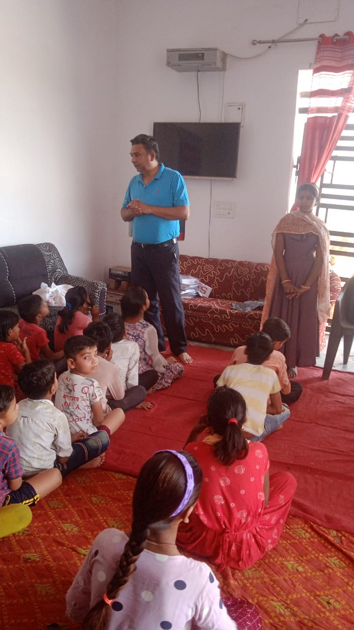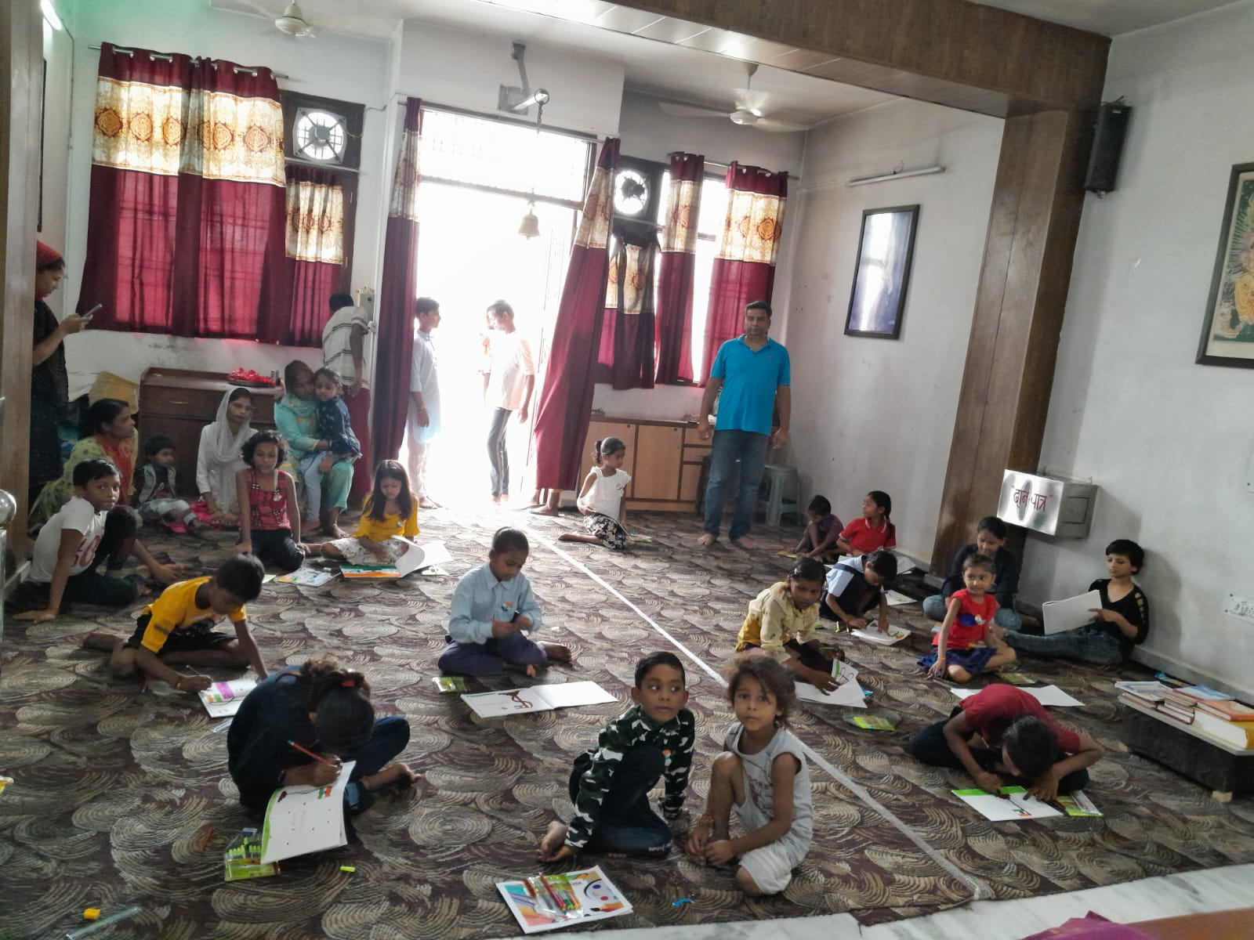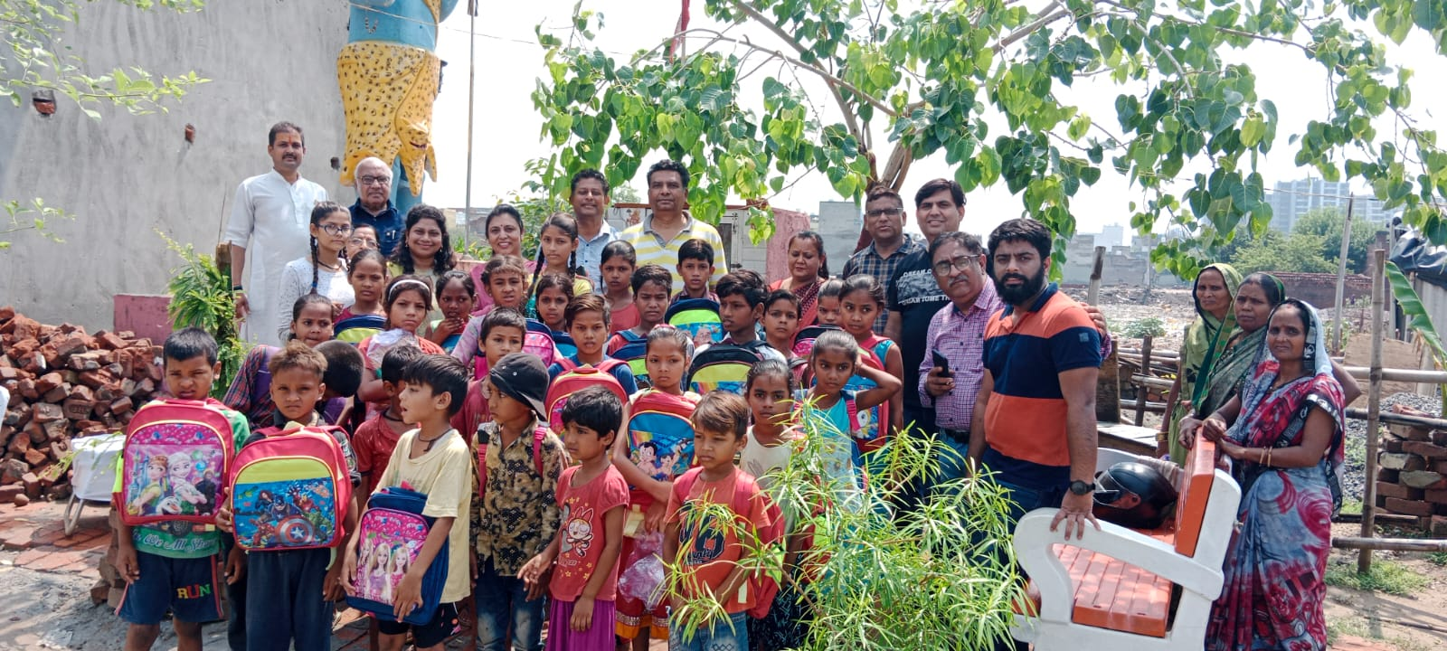

**Conclusion**

The four preparation days from June 18 to June 21st were critical in ensuring that the impending plantation drives were well-organized, safe, and effective. We were well-prepared to have a positive effect on the plantation drives and engage the local community in environmental conservation initiatives because to extensive orientation, equipment preparation, community outreach, and team coordination. These preparatory days lay the groundwork for a fruitful volunteer experience with the Shraddha Foundation.

The two days of plantation drives were not just about planting trees, but also about strengthening and greening the community. These events demonstrated the positive impact that collective efforts may have on our environment, as well as the importance of community participation in conservation efforts.

These experiences with the Shraddha Foundation have strengthened my dedication to environmental conservation and my conviction in the power of volunteering to make a difference in our local community.

My two weeks of community service at the orphanage were up. The encounter had been extremely fulfilling. It was an honour to work with the youngsters and assist them in reaching their full potential while also providing emotional support and advice. I learned a lot about myself as well as the significance of giving back to the community. The children's warmth, excitement, and resilience left an indelible impression on me, and I departed with a great sense of accomplishment and a renewed dedication to community service.

**Some suggestions to improve your volunteering work:**

* Be prepared. Before you start volunteering, take some time to learn about the organization and the role that you will be playing. This will help you to be more effective and to make a greater impact.
* Be reliable. Show up on time and be prepared to work hard. Volunteering is a commitment, and it is important to be reliable and dependable.
* Be flexible. Things don't always go according to plan, so it is important to be flexible and adaptable. Be willing to help out wherever you are needed.
* Be positive. A positive attitude is contagious. Be enthusiastic and supportive of your fellow volunteers.
* Be respectful. Treat everyone with respect, regardless of their age, background, or position.
* Be open to feedback. Be receptive to feedback from the organization and from other volunteers. This will help you to improve your work and to be more effective.
* Be willing to learn. Volunteerism is a great opportunity to learn new skills and knowledge. Be open to new challenges and be willing to step outside of your comfort zone.