**Exercise 3: Configuration of IP Address in Router Objective:** To demonstrate the configuration of IP Address in router

**Pre-requisite:** IP Address, Range of IP Address and Classes of IP Address

**Components**:

|  |  |
| --- | --- |
| **Devices** | **Required Nos** |
| PCs | 2 |
| Copper cross-over  Cables | 2 |
| Router | 1 |

**Addressing Table:**

|  |  |  |  |  |
| --- | --- | --- | --- | --- |
| **Device** | **Interface** | **IP Address** | **Subnet Mask** | **Gateway** |
| PC0 | Fa0/0 | 192.168.10.2 | 255.255.255.0 | 192.168.10.1 |
| PC1 | Fa0/0 | 192.168.11.2 | 255.255.255.0 | 192.168.11.1 |
| Router0 | Gigabit 0/0 | 192.168.10.1 | 255.255.255.0 | - |
| Router0 | Gigabit 0/1 | 192.168.11.1 | 255.255.255.0 | - |

**Procedure:**

**Step 1:** Drag 2 PCs and a router in the console area.

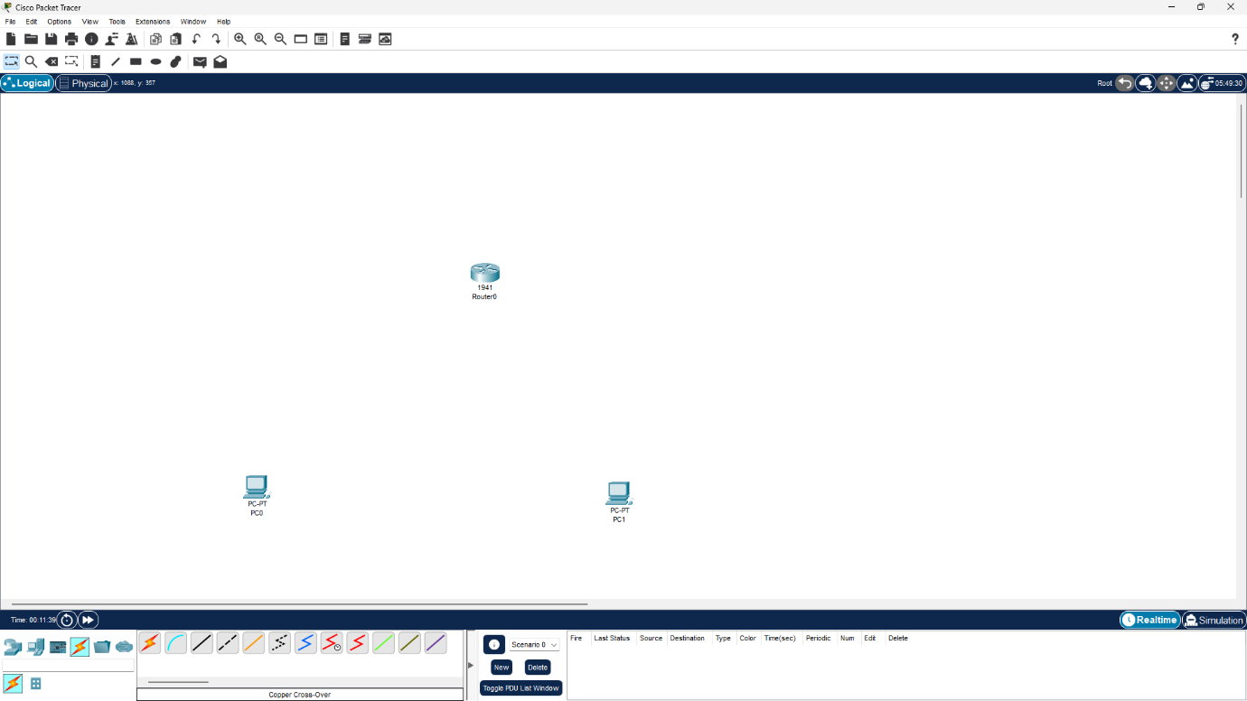

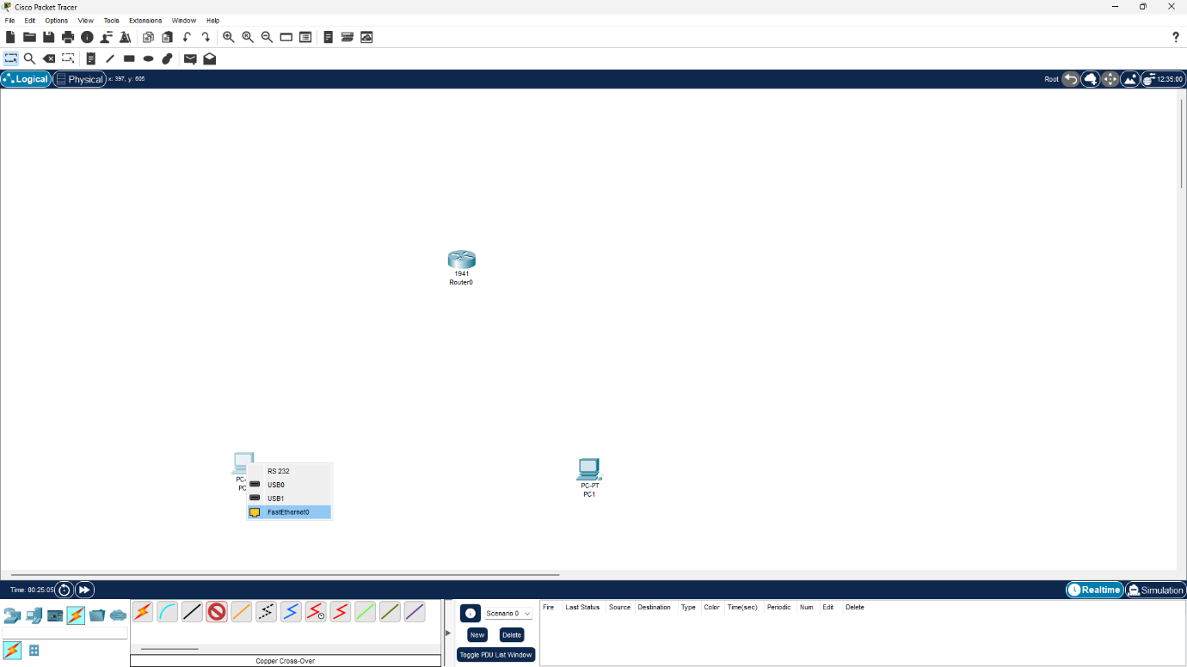**Step 2:** Select Connectivity & Copper cross-over cable. Click on PC0 to get the interface options. Select Fa0/0

**Step 3:** Click on router0 to get the interface options and select GigabitEthernet0/0.

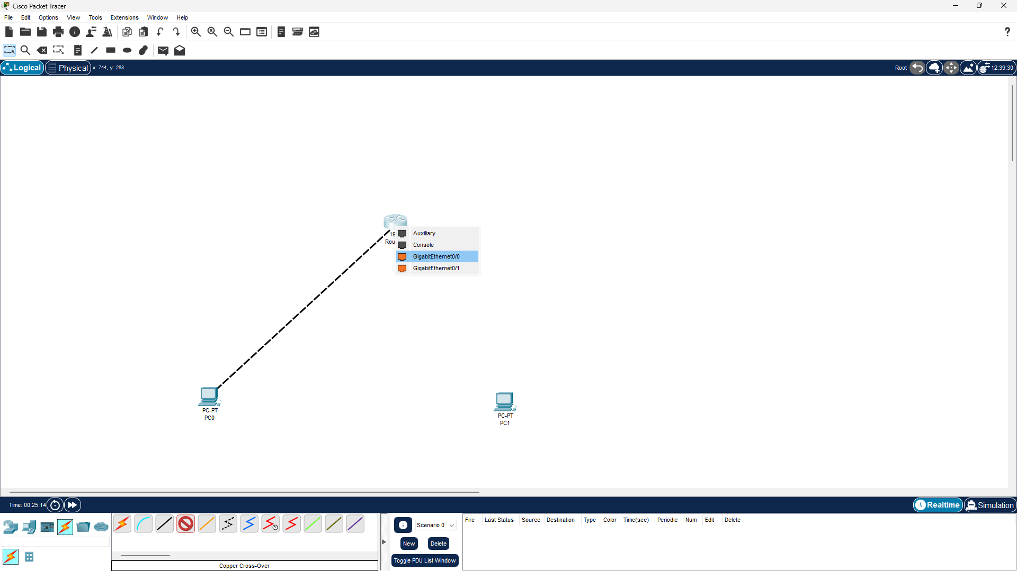

**Step 4**: Now PC0 and Router0 are physically connected. Again select copper cross-over cable and again click on Router0 to get the interface options and select GigabitEthernet0/1.

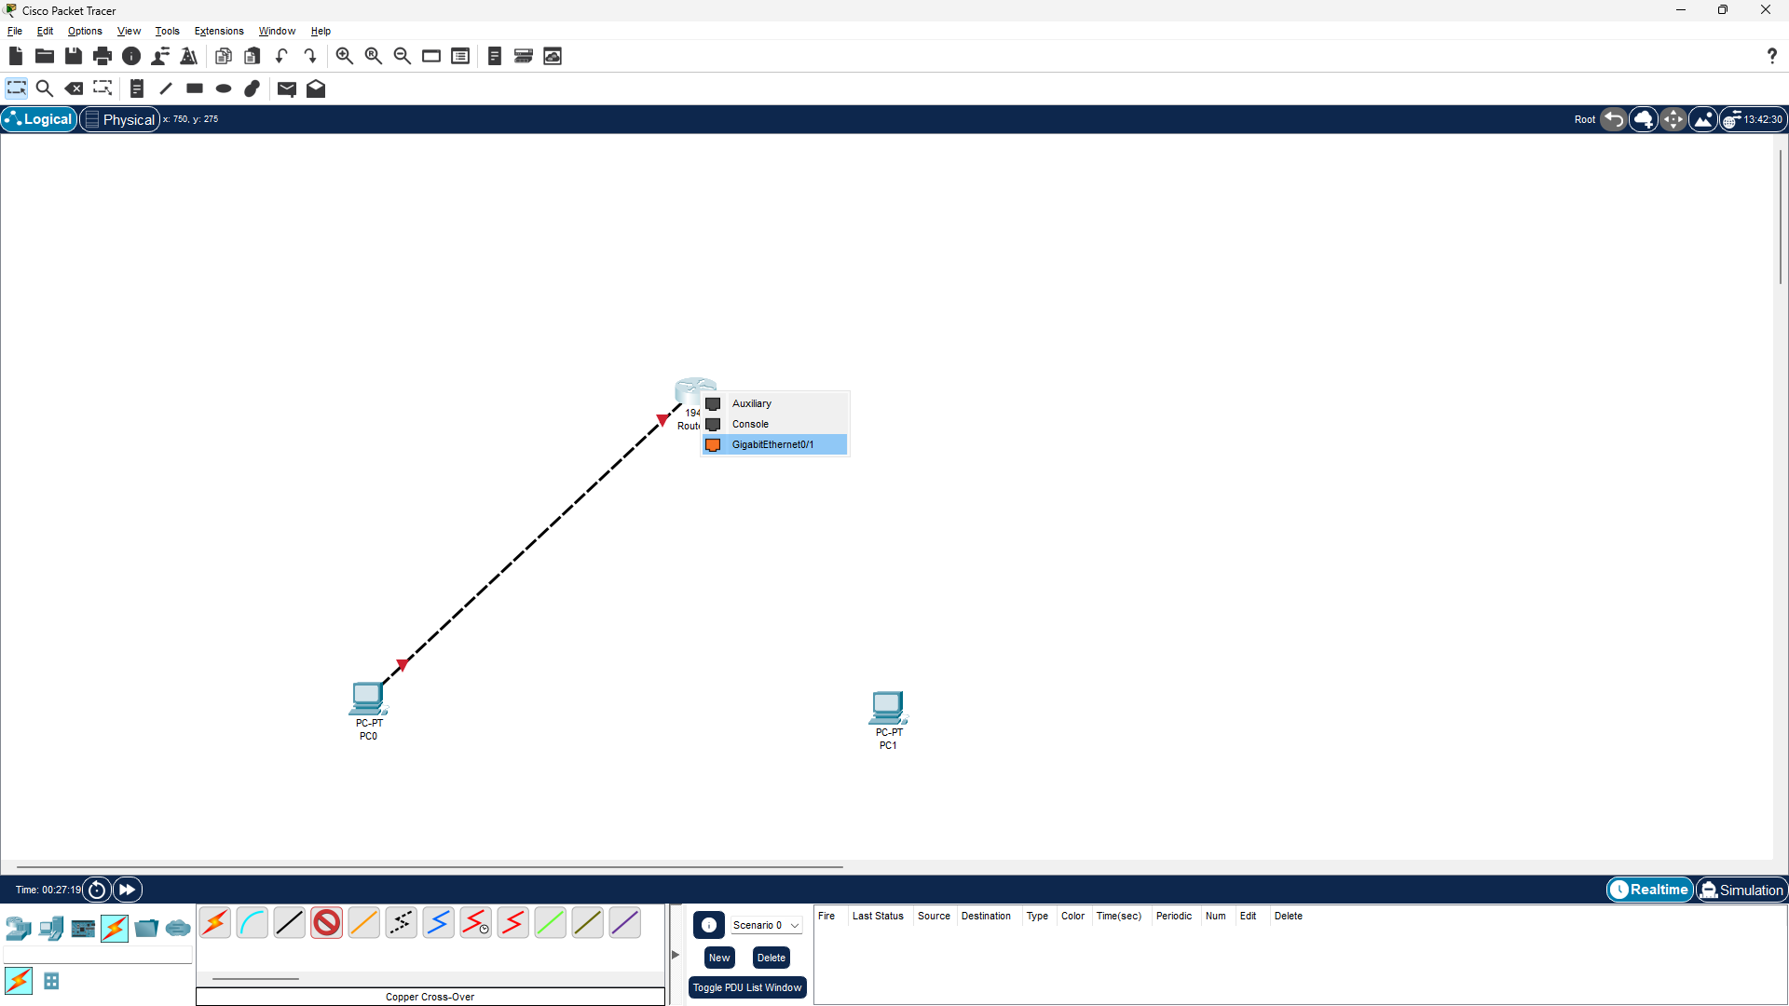

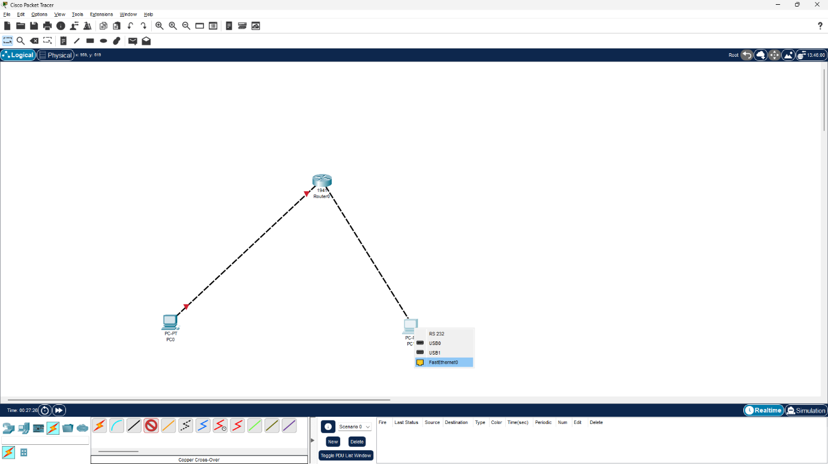

**Step 5:** Click on PC1 to get the interface options and select Fa0/0.

**Step 6:** Now the PCs are physically connected through Router. To establish logical connectivity,

* Click on PC0.
* Select Config tab.
* Click on FastEhternet0/0 in the left pane.
* 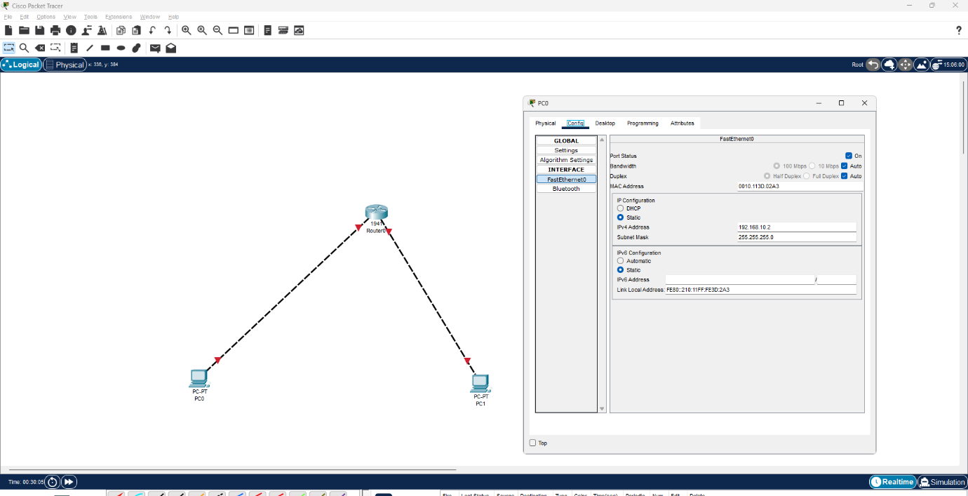Configure the ip address 192.168.10.2 and subnet mask 255.255.255.0

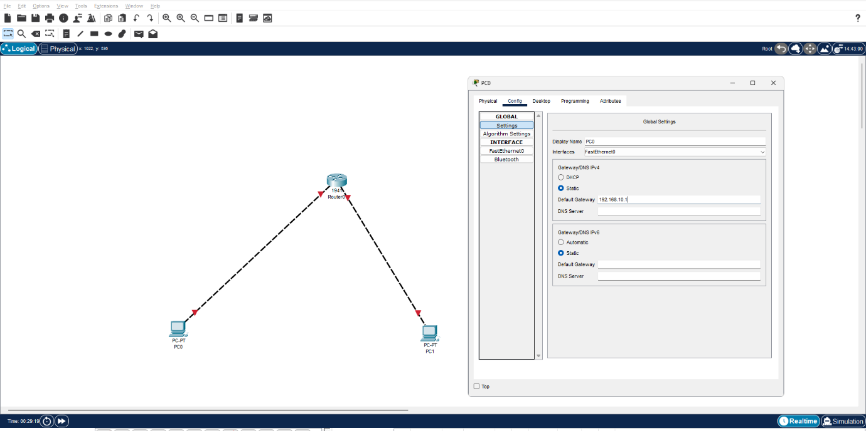

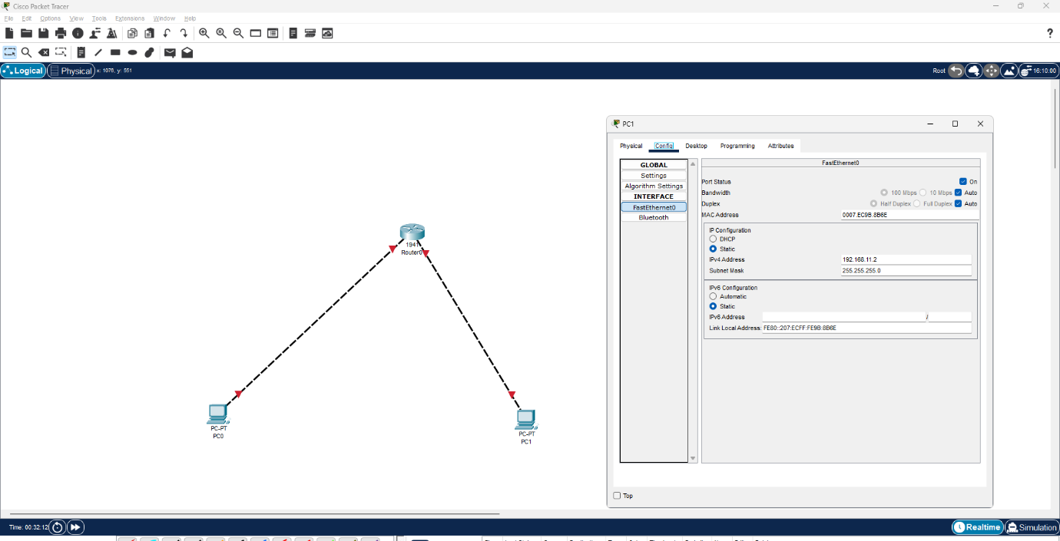**Step 8:** Repeat the same procedure for PC1 and Configure the ip address 192.168.11.2 and subnet mask 255.255.255.0

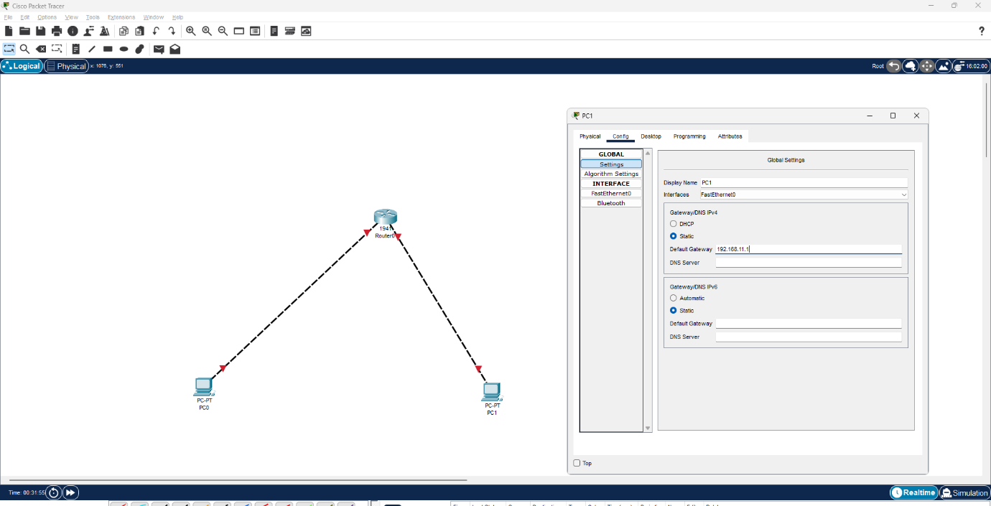

**Step 9:** Router configuration

* Click on Router0 and select CLI.
* Press ENTER to start configuring Router1.
* Type enable to activate the privileged mode.
* Type config t(configure terminal) to access the configuration menu.
* Configure interfaces of Router1:
* Type interface FastEthernet0/0 to access FastEthernet0/0 and Configure the FastEthernet0/0 interface with the IP address 192.168.10.1 and Subnet mask 255.255.255.0.
* Type interface FastEthernet0/1 to access GigabitEthernet0/0 and Configure the FastEthernet0/1 interface with IP address 192.168.20.1 and Subnet mask 255.255.255.0.
* 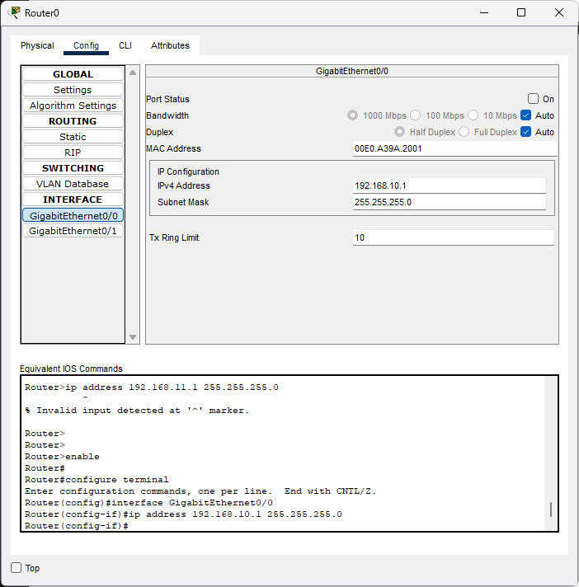Type no shutdown to finish.

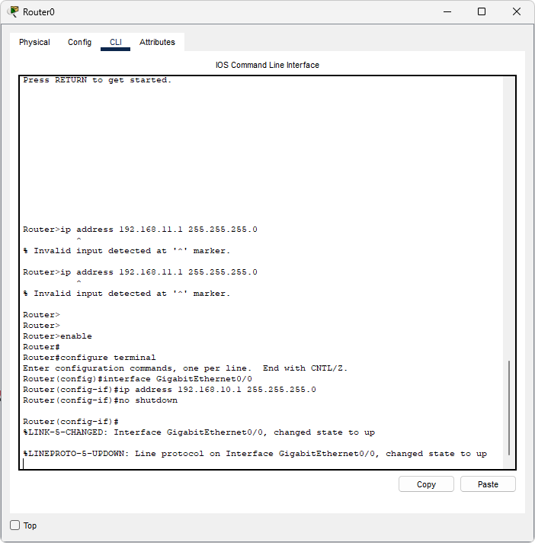 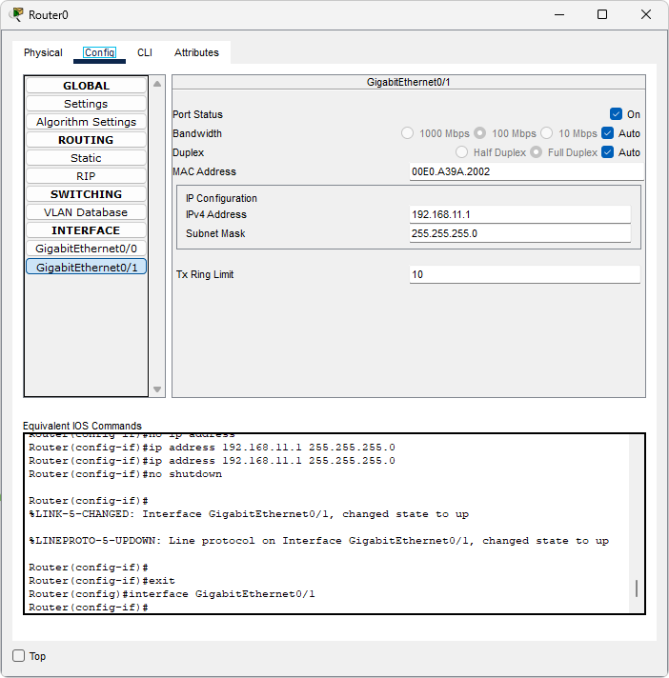 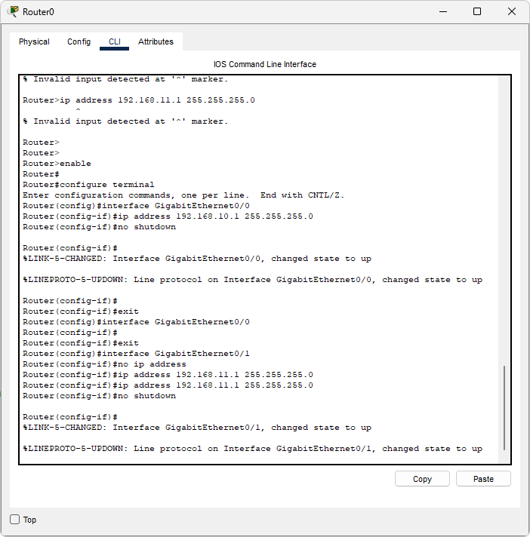

**Step 10:** Now both the PCs are physically and logically connected. To check the logical connectivity,

* Click on PC1.
* Select Desktop tab.
* Click on Command Prompt icon.
* Type ping 192.168.10.2 to fetch the output as follows

