**Exercise 4: Configuration of IP Address in Router And Switch**

**Objective:** To demonstrate the configuration of IP Address in router and switch

**Pre-requisite:** IP Address, Range of IP Address and Classes of IP Address

**Components**:

|  |  |
| --- | --- |
| **Devices** | **Required Nos** |
| PCs | 2 |
| Copper Straight Through | 2 |
| Copper cross-over  Cables | 1 |
| Router | 1 |
| Switch | 1 |

**Addressing Table:**

|  |  |  |  |  |
| --- | --- | --- | --- | --- |
| **Device** | **Interface** | **IP Address** | **Subnet Mask** | **Gateway** |
| PC0 | Fa0/0 | 192.168.0.2 | 255.255.255.0 | 192.168.0.1 |
| PC1 | Fa0/0 | 192.168.1.3 | 255.255.255.0 | 192.168.1.1 |
| Router0 | Gigabit 0/0 | 192.168.0.1 | 255.255.255.0 | - |
| Gigabit 0/1 | 192.168.1.1 | 255.255.255.0 | - |
| Switch | VLAN 1 | 192.168.1.2 | 255.255.255.0 | 192.168.1.1 |

**Procedure:**

**Step 1:** Drag 2 PCs , a router and a switch in the console area.

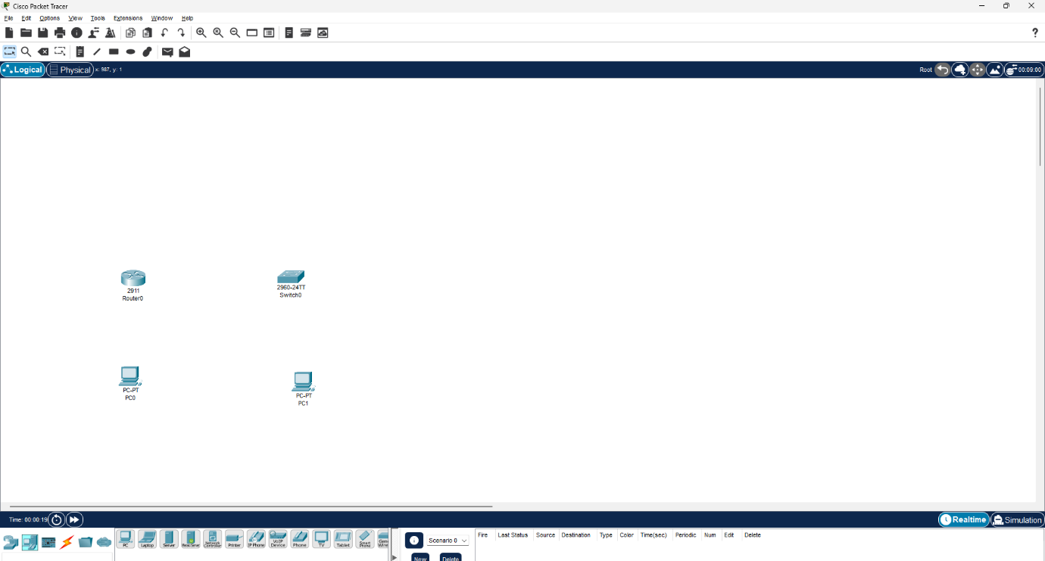

**Step 2:** Select Connectivity & Copper cross-over cable. Click on PC0 to get the interface options. Select Fa0/0

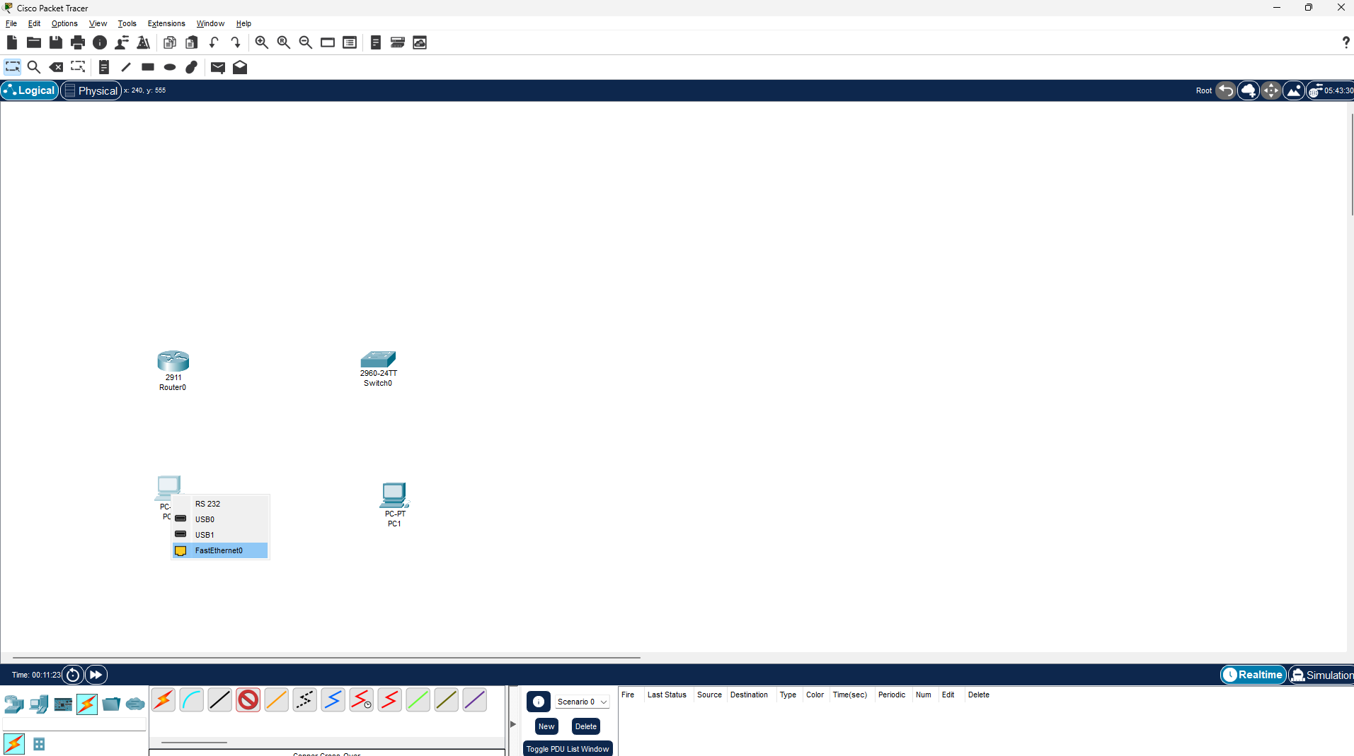

**Step 3:** Click on router0 to get the interface options and select GigabitEthernet0/0.

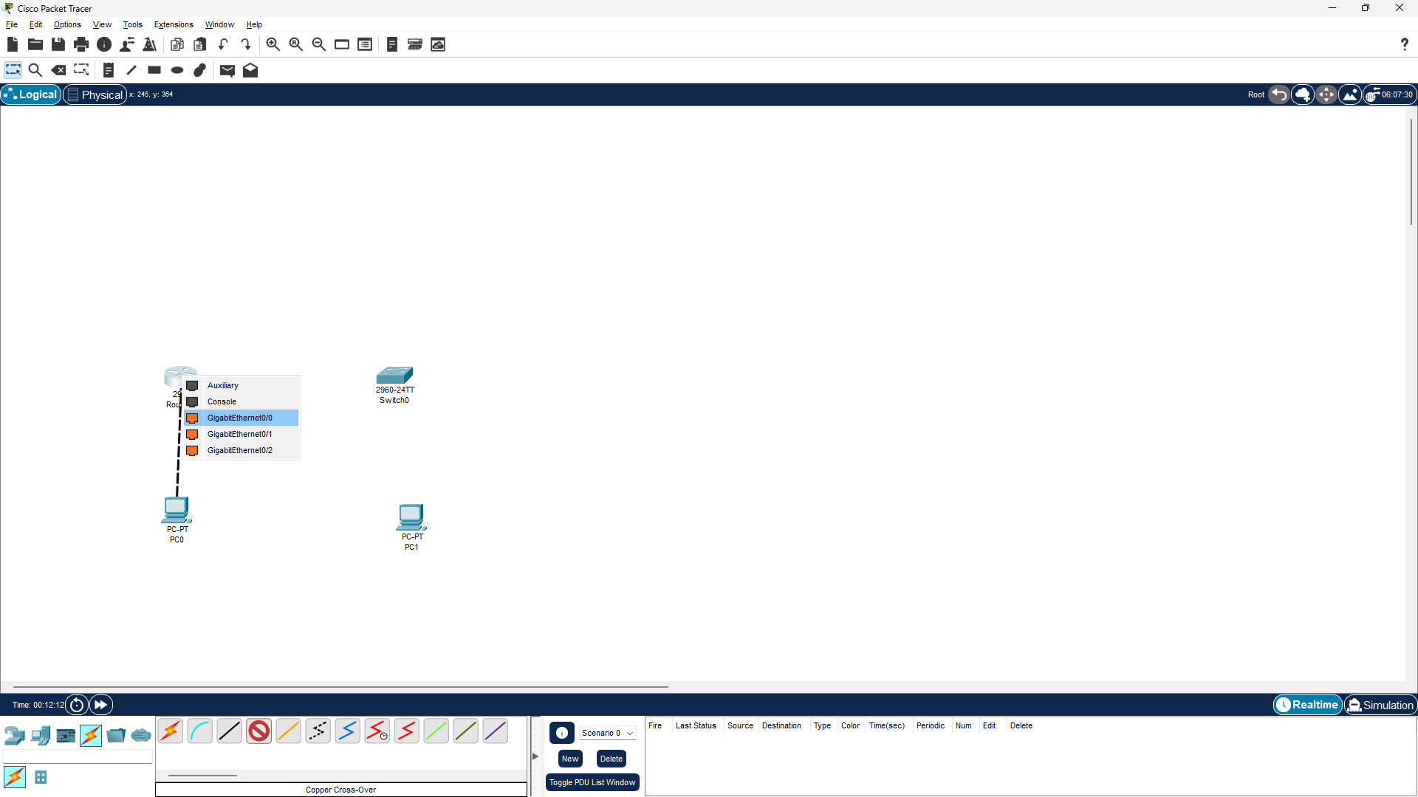

**Step 4**: Now PC0 and Router0 are physically connected. Again select copper Straight cable and again click on Router0 to get the interface options and select GigabitEthernet0/1.

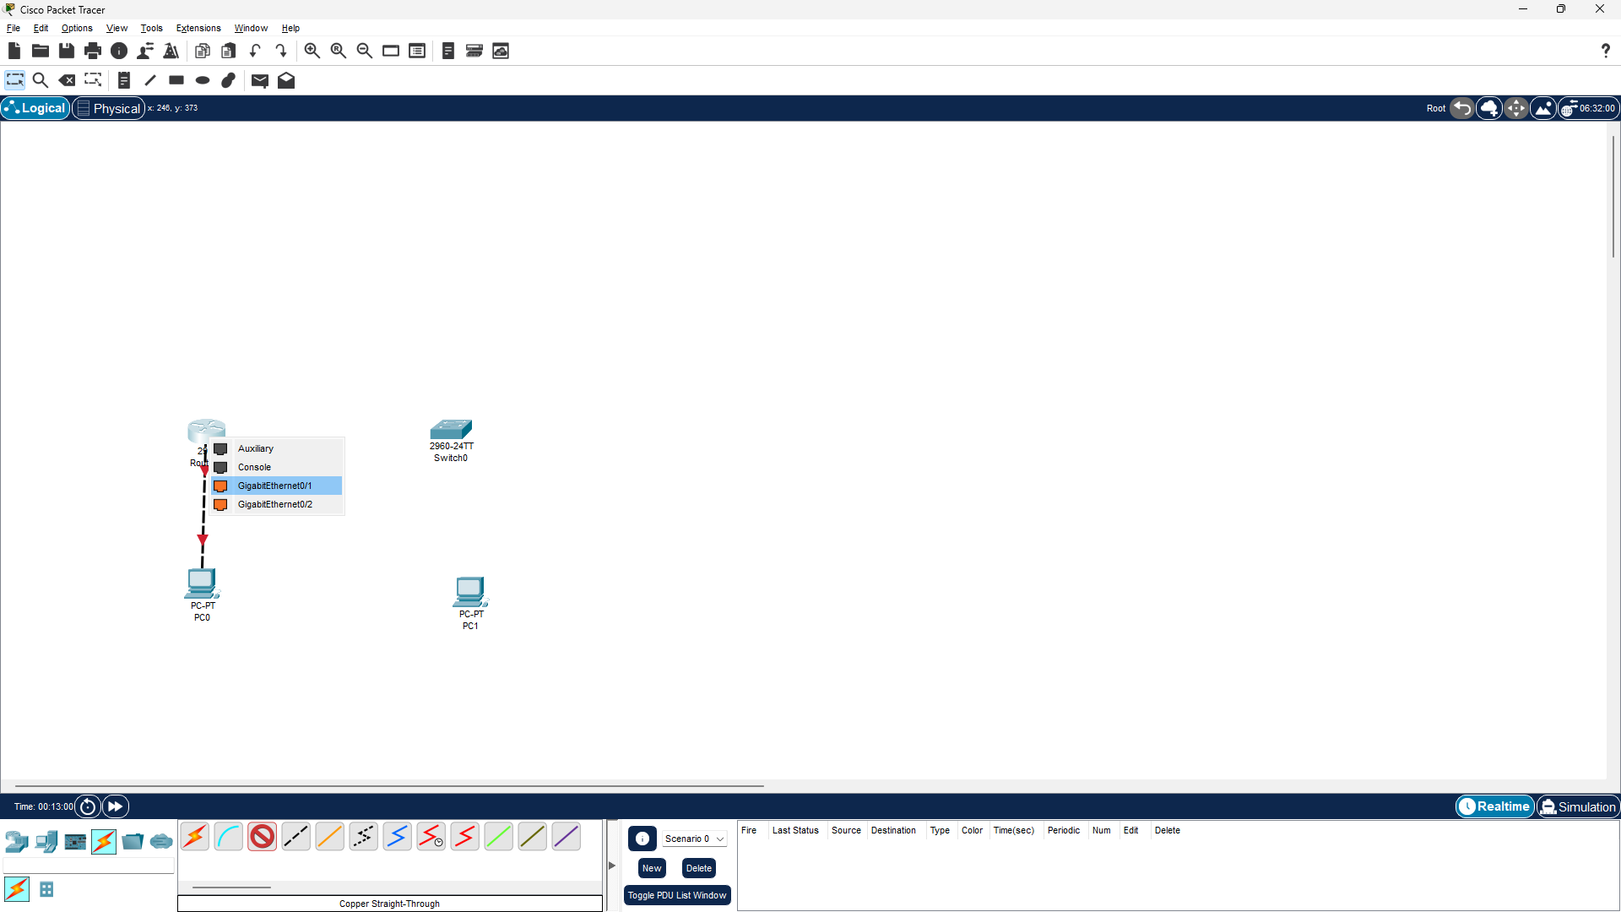

**Step 5:** Click on Switch router0 to get the interface options and select FastEthernet0/5.

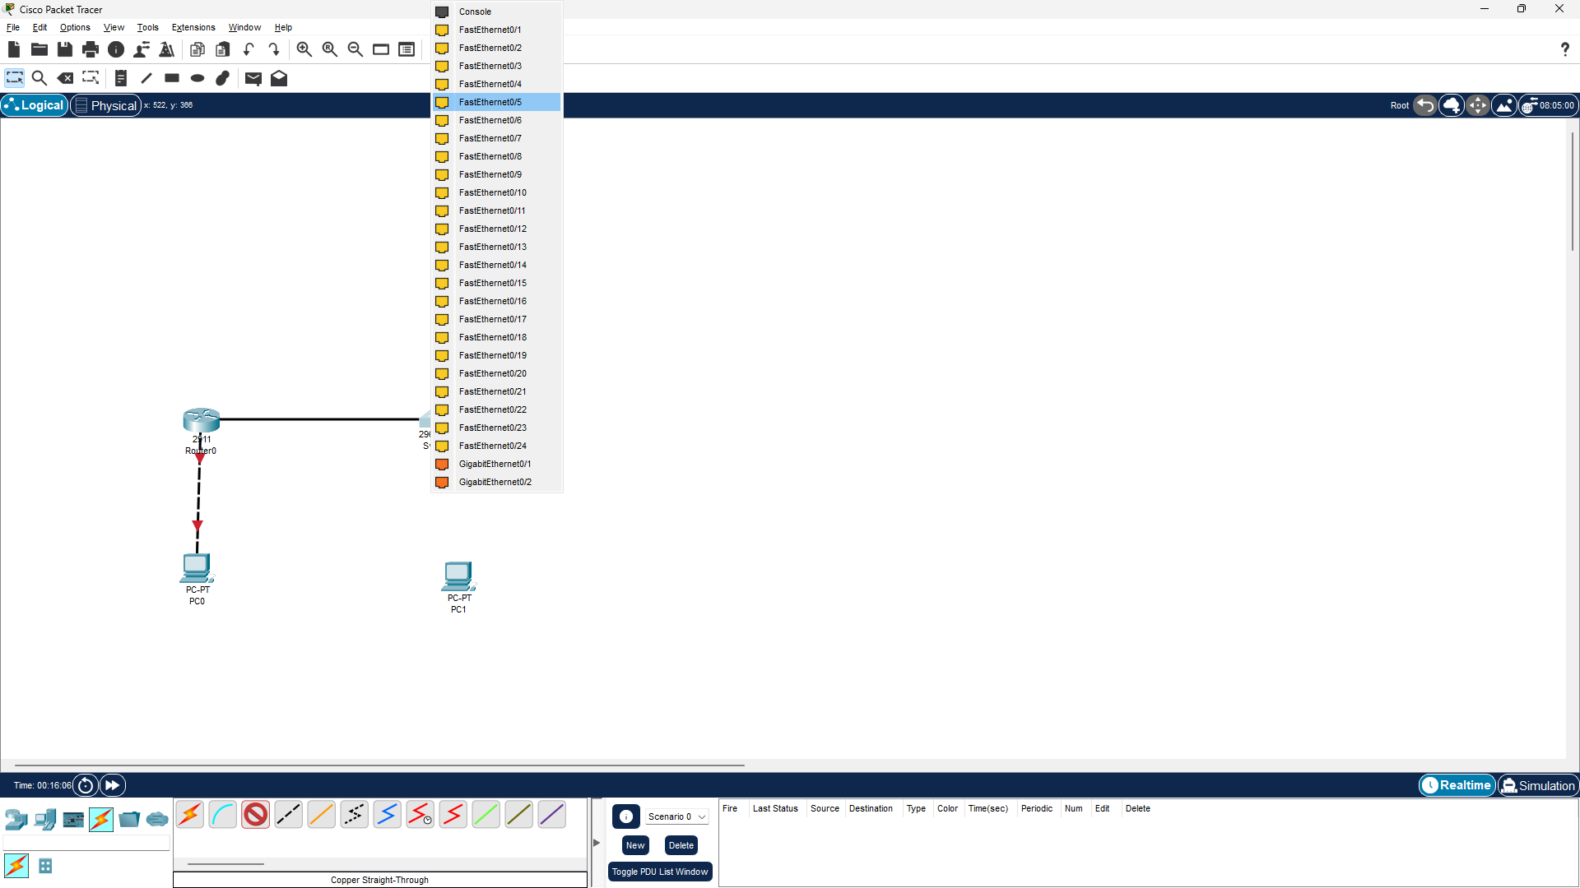

**Step 7:** Click on PC1 to get the interface options and select Fa0/0. And Connect it to FastEthernet0/6 port on the Switch similar to PC-0.

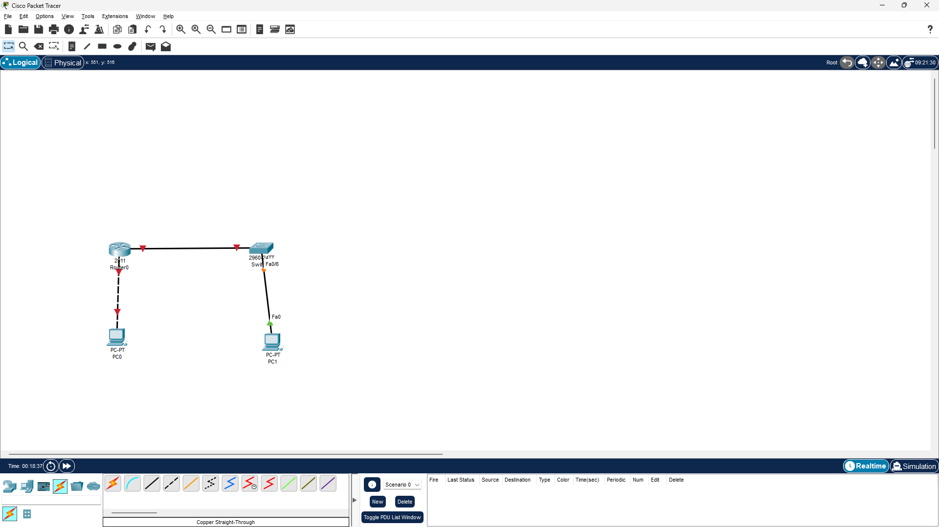

**Step 8:** Now the PCs are physically connected through Router and Switch.

To establish logical connectivity,

* Click on PC0.
* Select Config tab.
* Click on FastEhternet0/0 in the left pane.
* Configure the ip address 192.168.0.2 and subnet mask 255.255.255.0

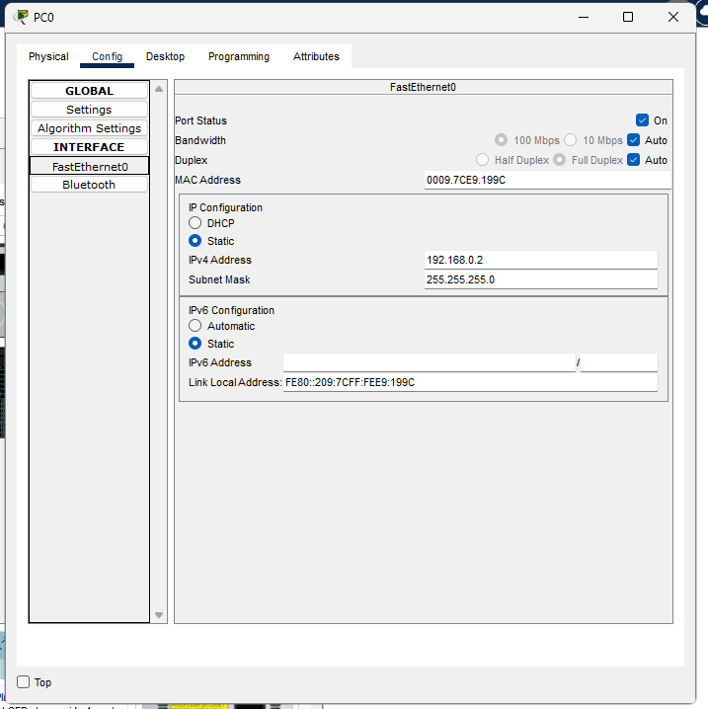

**Step 9:** Repeat the same procedure for PC1 and Configure the ip address 192.168.1.3 and subnet mask 255.255.255.0

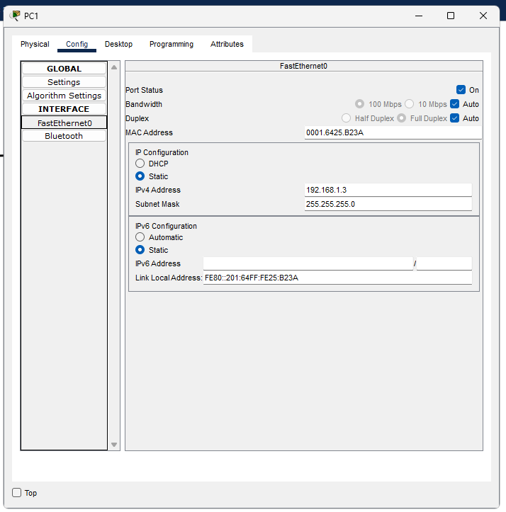

**Step 10:** Router configuration

* Click on Router0 and select CLI.
* Press ENTER to start configuring Router1.
* Type enable to activate the privileged mode.
* Type config t(configure terminal) to access the configuration menu.
* Configure interfaces of Router1:
* Type interface FastEthernet0/0 to access FastEthernet0/0 and Configure the FastEthernet0/0 interface with the IP address 192.168.10.1 and Subnet mask 255.255.255.0.
* Type interface FastEthernet0/1 to access GigabitEthernet0/0 and Configure the FastEthernet0/1 interface with IP address 192.168.20.1 and Subnet mask 255.255.255.0.
* Type no shutdown to finish.

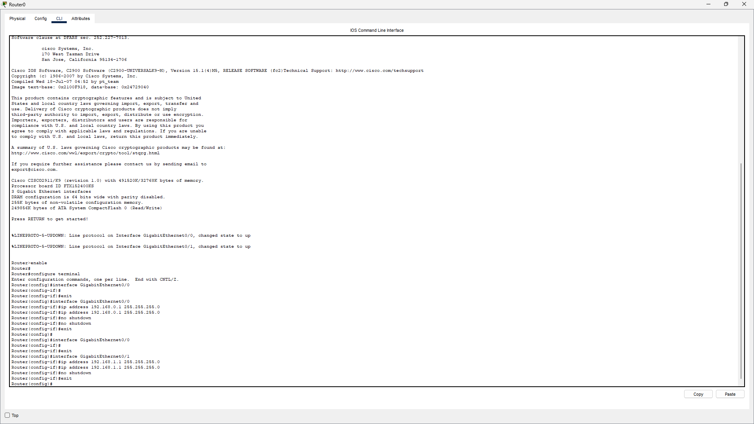

**Step 11**: Switch Configuration

1. Console into the switch and enable privileged EXEC mode.

Switch> **enable**

2. Enter configuration mode.

Switch# **config terminal**

3. Assign a device name to the switch.

Switch(config)# **hostname S1**

4. Configure and activate the VLAN interface on the switch S1.

S1(config)# **interface vlan 1**

S1(config-if)# **ip address 192.168.1.2 255.255.255.0**

S1(config-if)# **no shutdown**

S1(config-if)# **exit**

5. Configure the default gateway for the switch S1.

S1(config)# **ip default-gateway 192.168.1.1**

S1(config-if)# **exit**

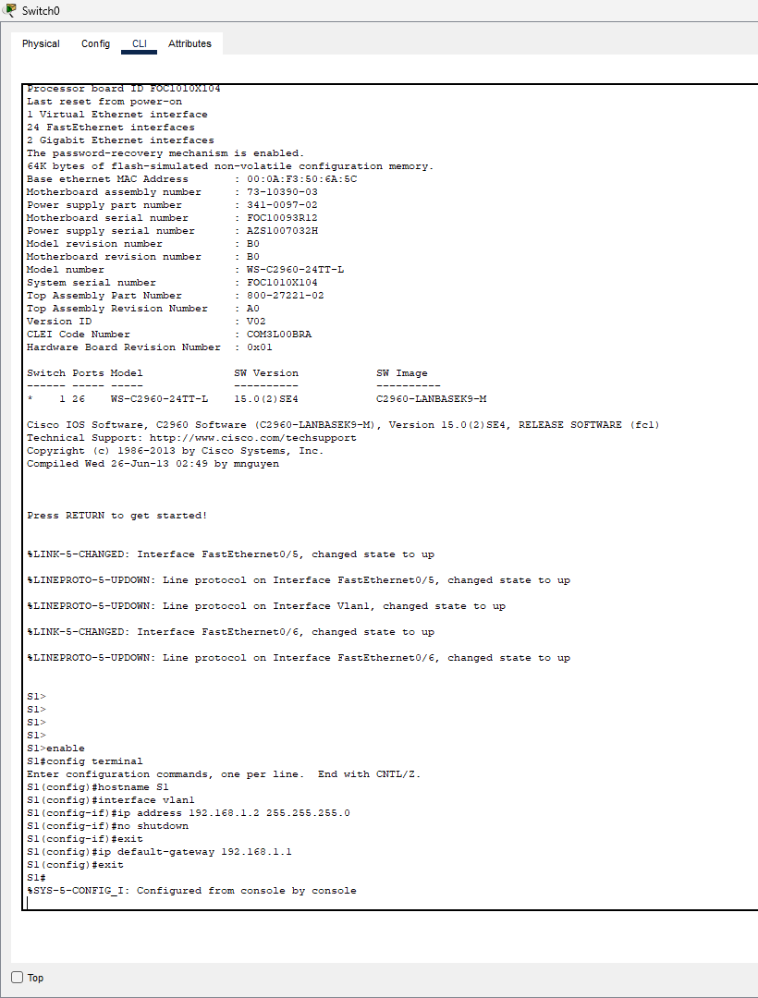

**Step 12:** Now both the PCs are physically and logically connected. To check the logical connectivity,

* Click on PC1.
* Select Desktop tab.
* Click on Command Prompt icon.
* Type ping 192.168.0.2 to fetch the output as follows

